
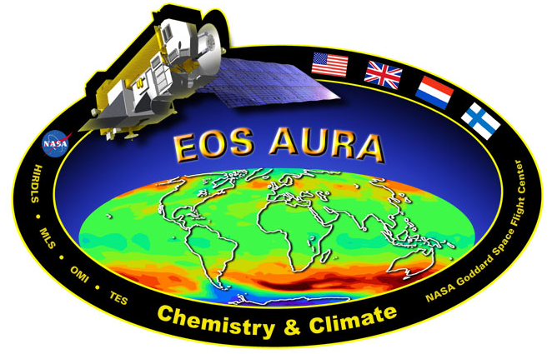

NRA-02-OES-06

AURA-OMI Validation

Using Two Coordinated Airborne Spectrometers
Dr. Jay Herman PI GSFC
Mr. Randy Pollock Hamilton-Sundstrand

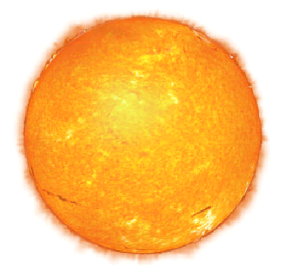

Solar Irradiance Spectrometer
SIS

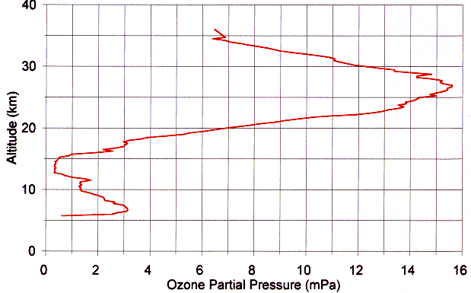
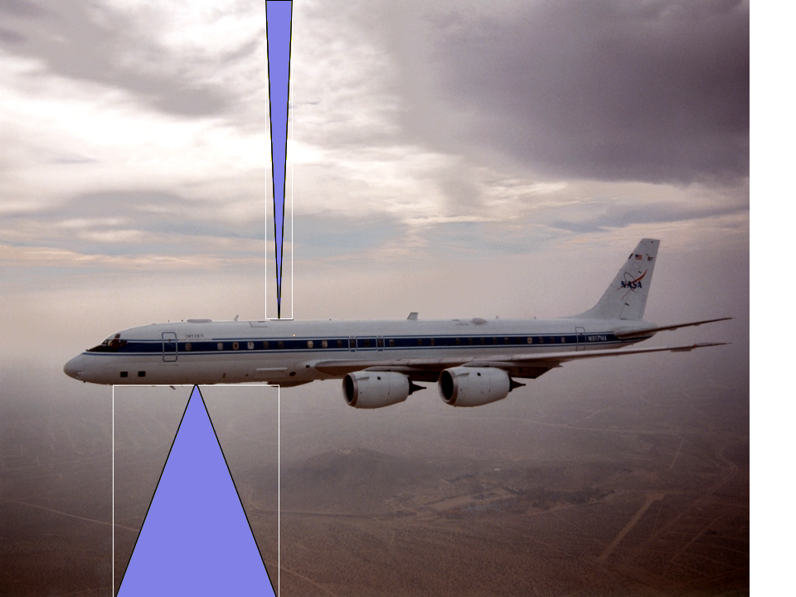
OZONE &
TRACE GASES

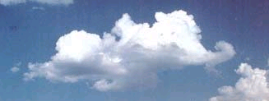

CLOUDS

12km

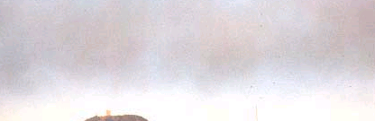
AEROSOLS

120º Wide Field Imaging Spectrometer
WFIS-UV

Lidar

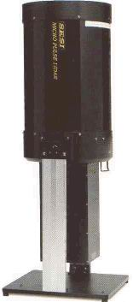

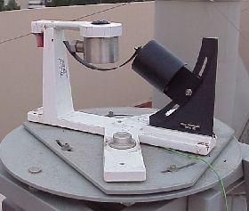
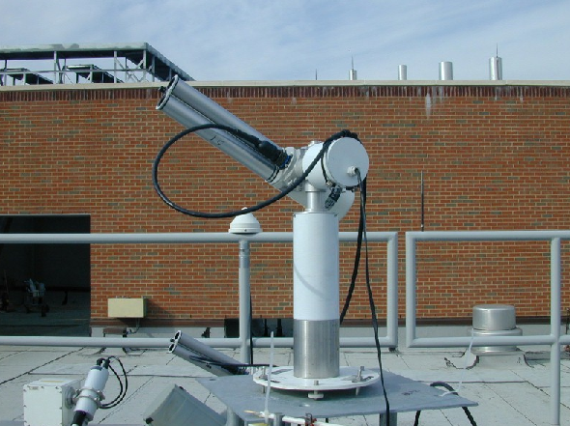
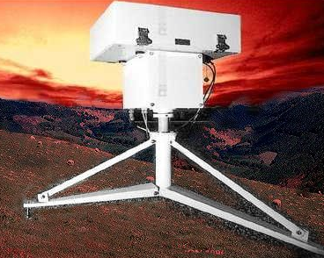
Shadowband Cimel-Sunphotometer Brewer Spectrometer

Existing Coordinated Ground-Based Instrument Program
* FCA = Full Cost Accounting DC = Direct Cost
 |  | Proposal Cover Page  Date: 12/09/2002 |  |  | Proposal Number:  RSP-0025-0173
Name of Submitting Institution: |  |  |  | Congressional District:
Proposal Title: | AURA-OMI Validation Using Two Coordinated Airborne Spectrometers

Name of Submitting Institution: | GSFC | Congressional Distinct: | 5th

Certification of Compliance with Applicable Executive Orders and US Code
By submitting the proposal identified in this Cover Sheet/Proposal Summary in response to this Research Announcement, the Authorizing Official of the proposing institution (or the individual proposer if there is no proposing institution) as identified below:
- certifies that the statements made in this proposal are true and complete to the best of his/her knowledge;
- agrees to accept the obligations to comply with NASA award terms and conditions if an award is made as a result of this proposal; and
- confirms compliance with all provisions, rules, and stipulations set forth in the two Certifications contained in this NRA [namely, (i) Assurance of Compliance with the NASA Regulations Pursuant to Nondiscrimination in Federally Assisted Programs, and (ii) Certifications, Disclosures, And Assurances Regarding Lobbying and Debarment & Suspension].
Willful provision of false information in this proposal and/or its supporting documents, or in reports required under an ensuing award, is a criminal offense (U.S. Code, Title 18, Section 1001).

NASA PROCEDURE FOR HANDLING PROPOSALS
This proposal shall be used and disclosed for evaluation purposes only, and a copy of this Government notice shall be applied to any reproduction or abstract thereof. Any authorized restrictive notices that the submitter places on this proposal shall also be strictly complied with. Disclosure of this proposal for any reason outside the Government evaluation purposes shall be made only to the extent authorized by the Government.

Principal Investigator Name: | Dr. Jay R. Herman | Authorized Institutional Official Name: | Dr. Franco Einaudi
Organization: | Goddard Space Flight Center | Organization: | Goddard Space Flight Center
Department: | Atmos. Chemistry & Dynamics Br. | Department: | Earth Sciences Directorate
Mailing Address: | Code 916 | Mailing Address: | Code 900
City, State Zip: | Greenbelt, MD 20771 | City, State Zip: | Greenbelt, MD 20771
Telephone Number: | (301) 614-6039 | Telephone Number: | (301) 614-5634
Fax Number: | (301) 614-5903 | Fax Number: | (301) 614-5620
Email Address: | Jay.R.Herman@nasa.gov | Email Address: | Franco.Einaudi@nasa.gov
Principal Investigator Signature: | _____________________________ | Authorized Institutional Official Signature: | _______________________________
Date: | _____06 Dec 2002 ___________ | Date: | _________06 Dec 2002___________

Co-Investigators:
Name | Telephone | Email | Institution | Address
Dr. Richard McPeters | 301-614-6038 | Richard.D.Mcpeters@nasa.gov | GSFC | Code 916 Greenbelt, MD 20771
Dr Ziauddin Ahmad | 301-614-6819 | Ziauddin.Ahmad@nasa.gov | SGT Inc.
Mr. Randy Pollock | 909.593.3581 | randy.pollock@hs.utc.com | H-Sundstrand | 2771 N. Garey Ave  Pomona, CA 91767

Budget:
Year | FCA(K$) - GSFC Contribution = DC(K$)*
1 | 306.1 51.5 254.6
2 | 317.0 53.2 263.9
3 | N/A
Total | 623.1 104.7 518.4

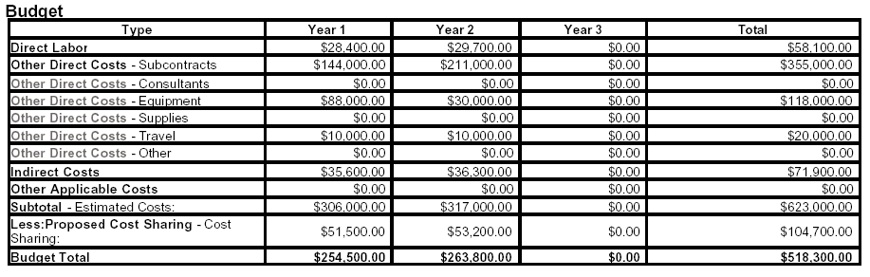
Abstract
We are proposing an AURA/OMI (Ozone Measuring Instrument) validation project using an airborne spectrometer with the same spectral characteristics as OMI, but with very high spatial resolution. This is a cooperative effort between Goddard Space Flight Center and Hamilton-Sundstrand scientists to improve the existing Wide Field Imaging Spectrometer (WFIS-UV 310 to 500 nm) for use as an aircraft instrument onboard the NASA-DC8 during an INTEX mission. The key idea is to view the troposphere at high spatial resolution (~100 meters at nadir), but over a wide enough swath (~41 km) to match 3 OMI pixels (each 13 km by 24 km). The 41-km swath and 100-meter WFIS resolution enables quantitative cloud contamination and pixel inhomogeneity observations. We will use high-resolution data to develop improvements in OMI algorithms that better represent tropospheric processes and validate current data products. In addition to the downward looking WFIS, accurate validation algorithms require the use of an existing airborne upward looking hemispherical Solar Irradiance Spectrometer (SIS, 300 to 950 nm). While this proposal focuses almost entirely on hardware improvement of the airborne spectrometers, as a secondary component, we will develop algorithms and plans whereby a coordinated a package of existing GSFC aircraft and ground-based validation instrumentation (Brewer Spectrometer, Cimel Sunphotometer, Shadowband Spectrometer, and a MicroPulse Lidar) will be used to effectively perform closure measurements on the WFIS remote sensing data and OMI science products. All measured radiances and science products will be compared with calculated radiance estimates from a proven vector radiative-transfer code (Dave 1978, upgraded and used for the TOMS project) that will also be the basis for improved OMI algorithm development.
Table of Contents
- Project Description ………………………………………………………….…..………1
  - Why should WFIS-UV and SIS be used to validate AURA-OMI?
  - Proposed Work Summary
  - Specific Science Data Product Examples
  - Applicability to Earth Science Enterprise (ESE) Measurements
  - Ocean/Land Observations
  - Technical Implementation
    - Requirements
    - Instrument Approach
    - Technical Readiness
  - Future WFIS Improvements
- Research Management Plan ………………………………………………..………… 18
  - Management Approach
  - Organization and experience of key personnel
  - Biographical Sketches of Key Personnel
- Facilities and Equipment …………………………………...………………………… 26
- Proposed Costs ……………………………………………...………………………… 26
  - Current Support
  - Description of the organization

1.0 Project Description
We are proposing to validate AURA/OMI science products using two coordinated airborne spectrometers that closely match the OMI characteristics, but at high spatial resolution (100 meters). The airborne spectrometers are designed to use slightly modified versions of the OMI algorithms, and to obtain additional science data beyond that observed by OMI. We also plan to directly validate OMI measured radiances from WFIS data using a radiative transfer calculations and a model of the ground bi-directional reflectance.
Validation of the Ozone Measuring Instrument (OMI) data received from the Aura satellite will be based on a UV-tailored version of an existing airborne downward-looking Hamilton-Sundstrand "pushbroom" Wide Field-of-View Imaging Spectrometer for UV (WFIS-UV, 310 to 500 nm) and an existing airborne upward looking Solar Irradiance Spectrometer (SIS, 300 to 950 nm). Plans and algorithms will be developed to use a separately funded existing coordinated GSFC package of ground-based instrumentation (Brewer Spectrometer, Cimel Sunphotometer, Shadowband Spectrometer, and a MicroPulse Lidar) to perform closure experiments on WFIS remote sensing data and OMI science products.
The two existing airborne spectrometers require hardware improvements needed for the required accuracy and sensitivity to validate AURA-OMI data. The upward-looking airborne spectrometer, SIS, is to measure the downward solar irradiance at the aircraft position, using the same spectral resolution as WFIS, as well as the column amounts of ozone above the aircraft. The downward irradiance at the aircraft is needed to improve the accuracy of WIFS – OMI algorithms that derive tropospheric composition and aerosols based on the ratio of backscatterd radiance to incident irradiance. All measured radiances and science products will be compared with calculated radiance estimates from a proven vector radiative-transfer code (Dave 1978, upgraded and used for the TOMS project). Almost all of the proposed work and funding is directed at the airborne spectrometer hardware improvements.
When flown on the NASA DC-8 at 12 km, WFIS-UV will provide data at 20 meters cross-track resolution (at nadir). The system is operated at 8 Hz. All data products will be analyzed with super-pixels that consist of 5 cross-track elements (100 meters at nadir) and 4 along track elements (113 meters at 450 knots ground speed). The spectrum between 310 and 500 nm will be sampled at approximately 0.25 nm, with a spectral resolution of between 0.7 and 0.9 nm. The typical signal to noise ratio is approximately 1000:1 for the 100-meter by 113-meter super-pixels.
1.1 Why should WFIS-UV and SIS be used to validate AURA-OMI?
- WFIS-UV is a “pushbroom” spectrometer that will obtain hundreds of data points under the orbit of OMI. This is sufficient to give a good statistical sampling of OMI radiances and all OMI science data products [e.g., O₃ , NO₂, SO₂, BrO, OClO, and aerosol properties]. WFIS-type remote sensing validation is required, since the small number of samples from in-situ techniques have too large a variance to be useful for nadir-looking satellite validation purposes.
- The spectral characteristics of WFIS-UV and SIS are similar to AURA-OMI enabling similar OMI-based algorithms to be used and validated when using the combined data.
- WFIS is a proven instrument built under an NASA Instrument Incubator Program (IIP) requiring only small modifications to operate over the wavelength range required in this proposal (310 to 500 nm).
- When WFIS-UV is airborne at 12 km, the 41-km swath with high spatial resolution (~100 meters at nadir, see Figure 1) enables WFIS-UV to observe cloud-free scenes within 3 nadir OMI pixels (13 x 26 km) to assess the effect of sub-pixel clouds on the OMI retrieval algorithms. At the same time, the view-angle corrected combination of WFIS pixels will have the same spatial characteristics as each of 3 OMI nadir pixels (see Figure 2) permitting algorithm improvement of cloud-caused OMI errors.
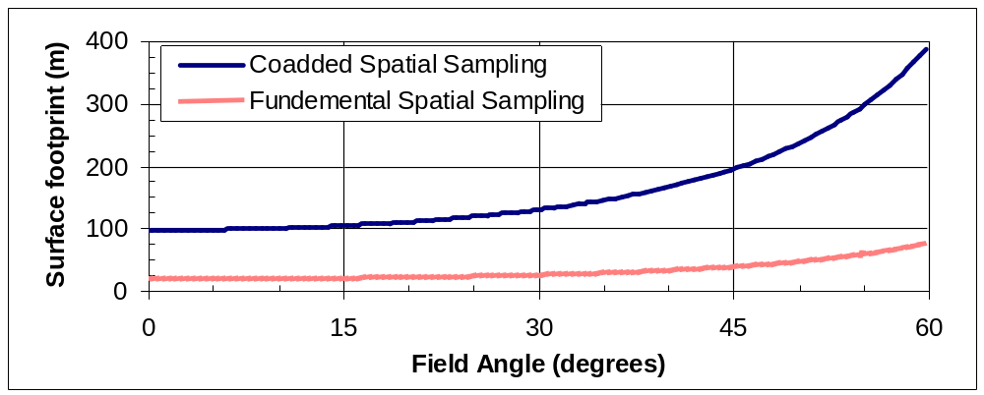
Figure 1: An example of WFIS-UV Cross-track Spatial Sampling from DC-8. Five pixels are added together to improve sensitivity (signal to noise ratio).
- Since the airborne WFIS-UV is located in the troposphere at about 10 to 12 km altitude, it can obtain trace-gas composition and aerosol measurements without interference from the stratosphere. This is especially important for tropospheric ozone and the validation of the corresponding OMI science product.
- SIS is a low-cost (~$5K) commercial hyperspectral spectrometer (310 to 900 nm) with good signal to noise ratio and low scattered light characteristics. This proposal adds a fiber optic front end that enables easy addition of a cosine corrected diffuser. With the modification, SIS will be suitable for measuring the downward irradiance at the aircraft altitude and for determination of the ozone column above the aircraft needed for the WFIS algorithms. SIS can also be used as an upward looking DOAS spectrometer for trace-gas detection.
1.2 Proposed Work Summary
The proposed work is to improve the existing spectrometers (SIS and WFIS) for the purpose of AURA/OMI validation, develop the coordinated instrument-cluster plans, develop the necessary algorithms, test WFIS-UV and SIS instruments in the laboratory, and test from a ground-observing site. Based on the AO, final preparation for an airborne mission is the subject of a future proposal.
AURA-OMI is an advanced hyperspectral instrument (270 to 500 nm) that will be flown on EOS Aura starting in mid-2004. It is nadir viewing, imaging a swath ±60° to give full global coverage on a daily basis with a spatial resolution of 13 km x 24 km at nadir. OMI is designed primarily to measure ozone, but will also measure column concentrations of NO₂ (400 to 460 nm), SO₂ (310 to 320 nm), BrO (310 to 380 mn), OClO (320 to 420 nm), and aerosol properties (340 to 500 nm) using its hyperspectral characteristics.
To prepare an effective validation approach for these data products, this proposal covers the following efforts. It is anticipated that this effort will take 18 months from the start of work.
- Optimize WFIS-IIP for UV coverage
Procure new grating and focal plane array to optimize the spectrometer for OMI validation, turning it into WFIS-UV
- Characterize WFIS-UV
Calibrate and characterize WFIS-UV at Hamilton-Sundstrand.
- Modify SIS to Measure Solar Irradiance
Calibrate, characterize, and field-test an existing portable upward looking spectrometer (~$5K), SIS, modified to measure solar irradiance by the addition of a diffuser to the fiber optic entrance optics. Evaluate other similar low- cost (~$3 to $5K) spectrometers to optimize characteristics for a flight instrument.
- Modify OMI Algorithms for WFIS/SIS
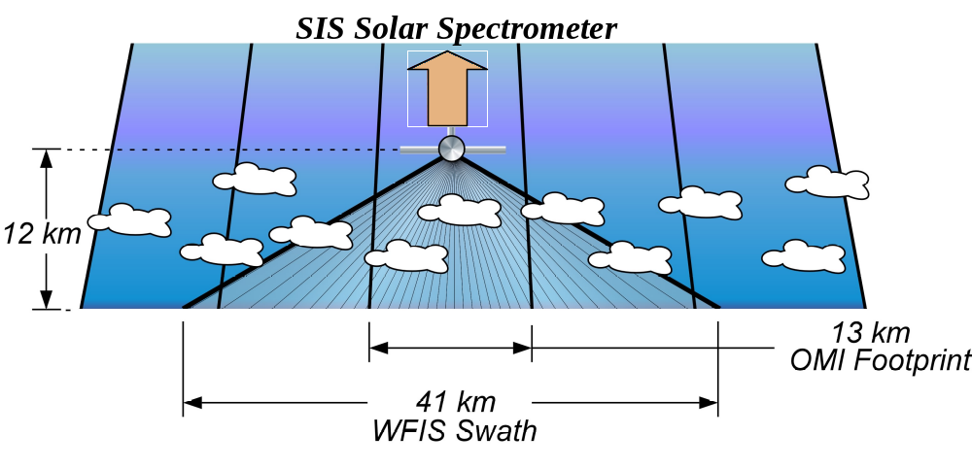
Figure 2 Illustration of WFIS field of view compared to the OMI pixel track on the ground. Here the WFIS is shown airborne at 12 km altitude viewing a 41 km total swath that encompasses more than 3 OMI 13 km wide pixels under the nadir point of OMI.
WFIS-UV Pixel FOV: 100 x 113 m
13 x 24 km
Modify existing algorithms used to process satellite and ground-based instrument data, and develop algorithms to combine their data.
- Simultaneous Field Test of WFIS/SIS
Simultaneous field-testing of WFIS and SIS will be done at Hamilton-Sundstrand with participation of GSFC personnel.
- Develop plans for WFIS/SIS flights
Develop plans and algorithms to coordinate the airborne WFIS (UV and Visible) and SIS (UV and Visible) with the existing ground-based instrumentation, Cimel sunphotometer (visible), MicroPulse Lidar (visible), Brewer Spectrometer (UV) to develop closure measurements for aerosols, clouds, and atmospheric trace gases.
After calibration and field-testing, HS will arrange to have WFIS-UV available for use in a proposal for flight of WFIS-UV and SIS as part of the AURA-validation (e.g., on INTEX-2 or on AMMA DC-8 flight programs).
Except for the stratospheric ozone profiling capability (270 to 300 nm), which cannot be effectively validated from an altitude of 12 km, the validation instrument, WFIS-UV, is well matched to the OMI optical characteristics over the wavelength range 310 to 500 nm. Accordingly, use of the low additional cost WFIS and SIS is ideal for the improvement of existing instrumentation in support of the draft EOS AURA validation plan.
Based on the goals of the Aura Science Data Validation Plan (12 July 2001) this proposal addresses scientific observations of the items in Table 1.
The Hamilton-Sundstrand WFIS-UV, successfully developed under a NASA-IIP (Instrument Incubator Proposal), provides Wide Field-of-View (120º) hyperspectral imaging suitable for aircraft measurements and future upgrade to a horizon-to-horizon satellite instrument. Using a novel optical concept and modern focal plane technology, the WFIS concept drastically shrinks instrument size and weight compared to older concepts such as TOMS. This technology can be applied to NASA Earth Observing System (ESE) objectives, resulting in a very compact, high performance sensor providing wide-swath coverage without moving parts. The improved airborne version of WFIS-UV will provide direct validation of AURA-OMI, and will provide unique measurements of tropospheric ozone and other trace gases without interference from the stratosphere.
Table 1: EOS AURA validation goals addressed by this proposal.

Item Subject - Section Heading Section
1. The properties of aerosols and clouds (III.2)
2. Column densities in the troposphere (III.3)
3. Total column densities (III.3)
4. Stratosphere corrected raw radiances (III.4)
5. Augmentation of existing ground-based networks. (III.6)
6. Coordinated aircraft and ground campaign (III.8)
Several specific science data products must be validated in order to show that OMI can meet its scientific goals - total column ozone, tropospheric ozone, aerosols (e.g., optical depth, absorption coefficients, particle size), trace gases (e.g., NO₂ and SO₂), and cloud properties (e.g., reflectivity, cloud height).
While total ozone can be validated using the large existing network of ground-based Dobson and Brewer instruments, the validation of tropospheric ozone and other trace gases, aerosol, and cloud properties requires the use of an airborne spectrometer such as WFIS-UV. OMI measurements of tropospheric ozone are based on a differential method using cloud-covered and cloud-free regions. Because of this, the measurements are of lower accuracy than for total ozone, and require careful validation. The combined data from the airborne upward- and downward-looking spectrometers will provide ozone values between the various aircraft cruising altitudes (3 to 12 km) and the ground, without the interference from stratospheric ozone, and between the aircraft and the upper troposphere and stratosphere (12 km to 60 km). The validation of the nadir-viewing OMI requires an airborne remote sensing instrument to obtain a large number of data samples covering the same field of view along the sub-satellite track sufficient to minimize the statistical sampling errors. This cannot be done by the few data points from in-situ instruments sampling the atmosphere during the aircraft ascent and descent.
The presence of clouds in the OMI field of view presents a major problem in the accurate retrieval of total column ozone and tropospheric constituent column concentrations (ozone, other trace gases and aerosols). Thin-cloud contamination causes errors of unknown magnitude that can only be quantified if sub-pixel information is available. By combining measured angle-corrected radiances in the 120º viewing swath of WFIS, the single-pixel OMI cloud contamination problem can be accurately simulated and corrected. Using the 256 WFIS viewed super pixels (composed of 1280 spatial samples with 5 samples summed together to form one pixel) distributed over a 41 km swath (at ~20 meters/sample with an effective spatial resolution of 100 meters) the sub-pixel cloud contamination for OMI can be accurately quantified so that errors in existing OMI algorithms can be identified and reduced.
For the portion of an orbit where OMI flies over the existing GSFC ground-based instruments, additional information will be obtained about aerosols (the optical properties of dust, smoke, and sulfate aerosols, refractive index, absorption, and particle size, as well as their altitude concentration profile). For satellite aerosol algorithms, one or more of these properties must be assumed, especially the altitude profile. Having these quantities accurately determined from the ground will improve the satellite retrieval and the retrieval of the same quantities form the airborne WFIS. This technique is an extension of the successful use of AERONET sunphotometers and lidars in the TOMS, SeaWiFS, and MODIS programs.
Plans and algorithms will be developed for use of a separately funded existing coordinated ground-based instrument package underneath the aircraft track. The package can provide measurements of total ozone column content (Brewer Spectrometer), aerosol characteristics in the UV (Brewer Spectrometer) and the visible (Cimel Sunphotometer and MicroPulse Lidar). Newly developed GSFC Brewer software permits operation of the spectrometer in the sun-viewing mode as well as in an almucantor mode (similar to the visible wavelength Cimel) for the first determination of UV aerosol properties as a function of wavelength. The 4-instrument package is currently operational at GSFC, where comparisons are being made between the instruments for the development of algorithms using combined observations. The aerosol characteristics (optical depth, absorption coefficients, particle size, and height profile) are extremely important, both for characterizing aerosol properties in the visible and UV and for providing the missing pieces needed for satellite algorithms deriving ozone, NO₂, SO₂, BrO, and OClO, and the amount of UV reaching the Earth’s surface.
Having detailed aerosol information will enable precise estimates of the modification of trace gas photolysis rates caused by absorption and scattering from tropospheric aerosols. Our calculations have shown that significant effects on photolysis rates (e.g., J[NO₂] ) can extend into the lower stratosphere.
1.3 Specific Science Data Product Examples
Cloud Height: One of the novel uses of OMI data will be the derivation of cloud properties (cloud height, cloud optical thickness, particle size estimates, and possibly geometric cloud thickness) from the use of Raman scattering measurements (393.5 nm and 396.8 nm), within the solar calcium-H and K lines (see Figures 3 and 4) and using O2:O2 dimer absorption effects (360, 380, and 477 nm). Measured cloud heights will help distinguish constituents in the planetary boundary layer (PBL, ~ 0 to 3 km) from those in the free troposphere (FT, ~ 3 to 20 km at mid-latitudes). The cloud heights determined using these remote-sensing techniques on both AURA-OMI and by WFIS-UV will be compared and validated by direct observation of cloud properties from the aircraft.

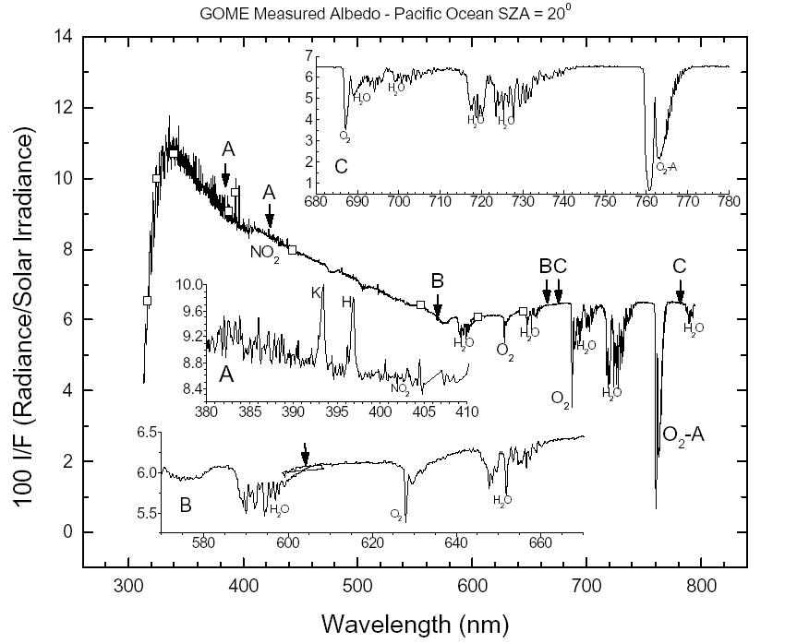
Figure 3: A measured albedo spectrum from GOME showing various species absorption features and the residual solar structure (e.g., the calcium H and K lines). The expanded insets A, B, and C are indicated on the main curve. The arrow in inset B indicates the overlap mismatch region between two independent focal planes.
An airborne WFIS type instrument would have the unique capability to compare various independent passive cloud height techniques to determine their differences and individual strengths as applied to the OMI observations. Unlike OMI, WFIS has the advantage of 100-meter high spatial resolution and 20-meter sub-pixel sampling to insure that it is viewing a single cloud in each 100-meter field of view. It is anticipated that the derived cloud heights would be compared with those obtained from IR measurements (MODIS) and those obtained from lidar (CALIPSO) flying on other satellites closely following OMI-AURA.
At the present time, spectral data from the European satellite GOME instrument provides the best test data set for the likely results from OMI. Of interest here are the key features labeled in Figure 3, especially the calcium H and K solar Fraunhofer lines at 393.5 and 396.5 nm (see Inset A). Because of Raman scattering in the atmosphere, photons from surrounding wavelengths scatter into the line centers at 393.5 and 396.8 nm. The amount of line filling is a function of the depth of penetration into the atmosphere. This property makes it possible to estimate the height of moderately thick clouds in the atmosphere (see Figure 4). In addition to this method, it is possible to measure the amount of absorption caused by the known presence and altitude distribution of the O2:O2 dimer (360 and 380 nm) in the atmosphere. The altitude distribution is a function of O₂ partial pressure and temperature. The total amount of observed absorption is a monotonic function of the depth of the clear atmosphere to the ground or cloud tops.
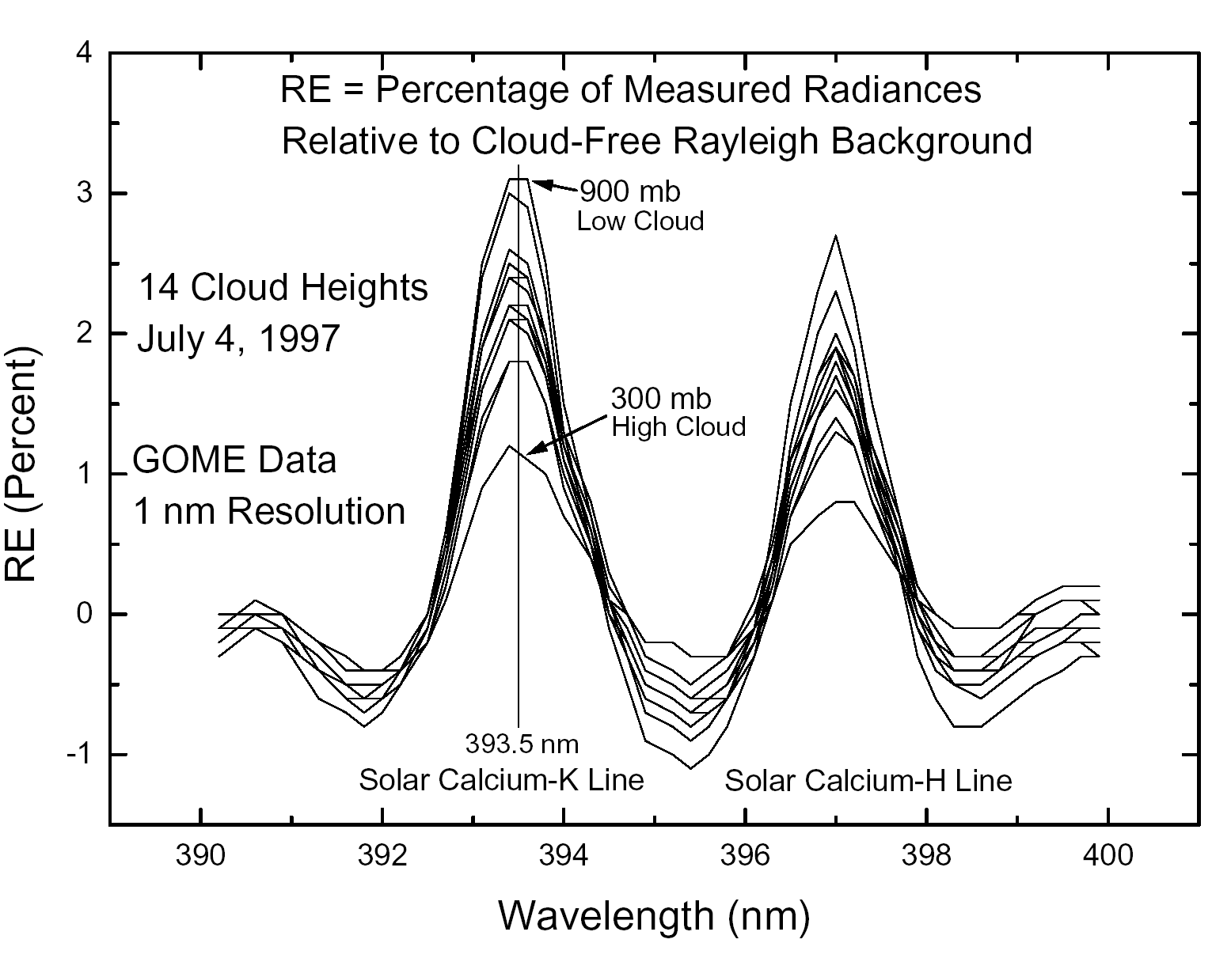
Figure 4: The effect of clouds in the field of view on the Raman scattering into the cores of the calcium H and K lines at 393.5 and 397 nm. The range of cloud top heights is from 300 to 900 mb.
For clear atmospheres or moderate cloudiness over water, the Raman scattering from water interferes with the Raman scattering in the Calcium H and K lines and at other wavelengths. In open oceans, a clean-water correction can be calculated. However, when chlorophyll or other absorbing material is present, the correction becomes uncertain. For clear atmospheres, the ocean Raman effect becomes a sensitive tool for estimation of chlorophyll or dissolved organic matter in the water. This is especially useful in coastal regions.
Aerosols: Aerosol properties are derived under the assumption of cloud-free scenes within each pixel’s field of view. While the situation for OMI (13x25 km) is much improved over TOMS (50 x 50 km), the spatial resolution is far from being adequate to insure that there are cloud-free pixels to derive optical properties. WFIS-UV will be able to resolve this issue by sampling the reflectivity at 20 meters and fully resolving at 100 meters. The resulting WFIS data will be used to assess the accuracy of the OMI derived aerosol properties, and to obtain an improved atmospheric correction for the ocean observing instruments (e.g., SeaWiFS and MODIS). An example of a cloud contaminated aerosol image is shown in Figure 5 where the atmospheric correction over the Gulf of Mexico would be highly inaccurate because of cloud contamination.
Trace Gases: One of the goals in the AO for AURA/OMI validation is the applicability of the DOAS technique (Differential Optical Absorption Spectroscopy-Method) that relies on a best fit to the measured spectral structure over a moderate wavelength range to deduce the amount of trace gases, O₃ (310 to 340 nm), NO₂ (400 to 460 nm), SO₂ (310 to 320 nm), BrO (310 to 380 mn), OClO (320 to 420 nm).
Figure 6 shows examples of species with very distinct spectral structure NO₂, O₃ and SO₂ that are plotted with approximately the expected spectral resolution of WFIS or OMI (0.5 to 0.8 nm).
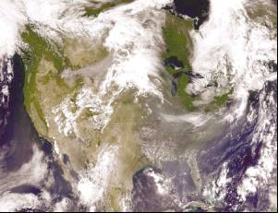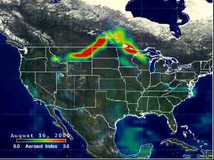
Figure 5: An example of SeaWiFS 4-km resolution observations of biomass burning smoke (Left panel) where large portions of the observing area are contaminated by clouds. This is especially the southeastern US where there are numerous small clouds over both land and ocean. Also shown is the UV TOMS image of the same scene showing the capabilities of UV observations to detect aerosols over bright surfaces; in this case, clouds.
An example of the DOAS technique is shown (Richter et al., 2002) where an approximate fit to the measured absorption spectrum for NO₂ can be obtained to accurately estimate the amount of NO₂ in a column after subtracting out the absorption features of other gases in the 430 to 450 nm wavelength range (i.e., O₃, H₂O, and the Raman scattering Ring effect, see Figure 6 Right panel). The advantage of this technique is that it is relatively insensitive to the absolute radiometric calibration, but very sensitive to the wavelength dependent structure.
Validation and Improvement: The use of WFIS-UV from an aircraft will give very high spatial resolution (100 meters) compared to that of OMI (~13x25 km). While OMI will give an average height estimate of clouds within the large pixel, WFIS’s 100 meter resolution and 20-meter sampling will be able to resolve cloud features and to make it much more likely that an entire pixel is cloud filled or cloud-free. Cloud heights and aerosol properties estimated from individual WFIS-UV pixels and the combination of WFIS-UV pixels during an OMI overpass will give a good estimate of the OMI errors as well as guide algorithm improvement. Radiative transfer theory indicates that there is sensitivity to the location of the lower boundary of clouds for clouds of moderate optical thickness. This sensitivity can be tested with WFIS-UV. In addition to the remote sensing cloud-height validation using instruments aboard the DC-8, the aircraft can descend to cloud top height and to the lower boundary of a cloud to make direct measurements using the pressure-calibrated aircraft altimeter and simple visual observations.
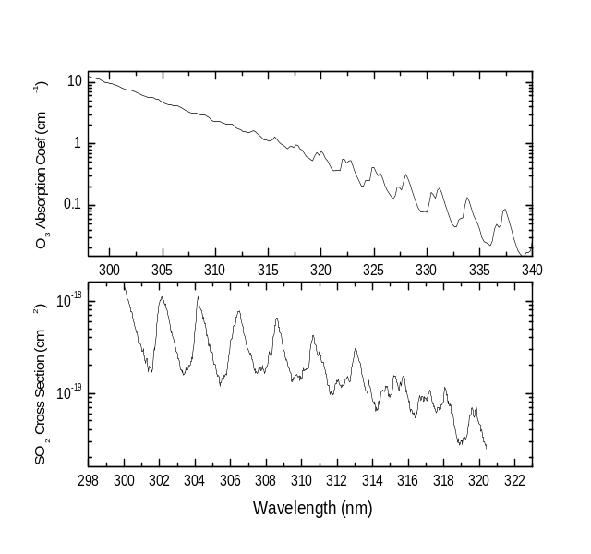 | 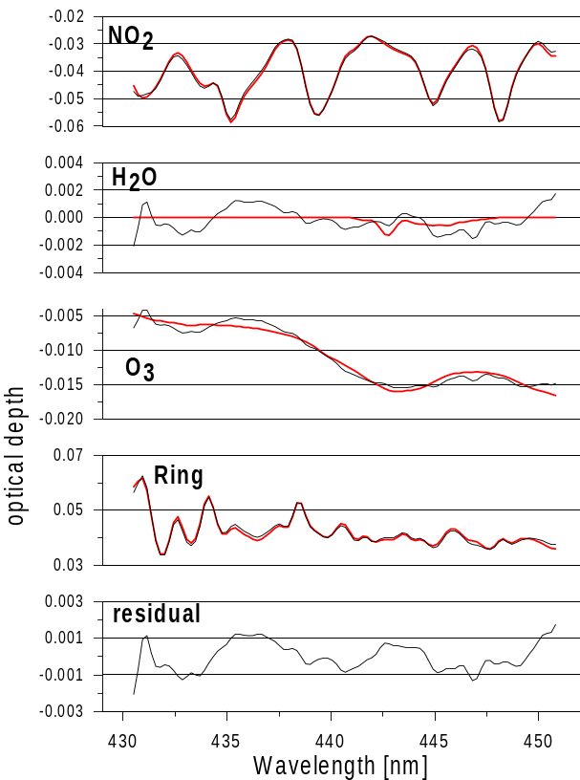
Figure 6: Left: O₃ and SO₂ absorption coefficients and absorption cross sections, respectively. Both species show the spectral structure needed for the use of the DOAS algorithm for deriving species column amounts requiring only relative spectral calibration. Right: An example of the DOAS technique applied to the GOME data for the estimate of column NO₂ amounts (Richter et al., 2002, and Lambert et al. ,1999).
WFIS and SIS will be calibrated in the laboratory both before and after each flight or set of ground-based measurements. WFIS airborne along-track data will be combined to insure that there is no cross-track bias (e.g. high angle ozone systematically different than nadir values).
1.4 Applicability to Earth Science Enterprise (ESE) Measurements
The primary objective of this project will be to provide AURA-OMI validation using instrumentation capable of addressing key scientific issues in both Atmosphere and Ocean/Land processes. The acquired data will also contribute to our understanding the of effects of short-term forcing processes on complex Earth ecosystems essential for the development of predictive and analytical models used to assess impacts of natural changes and human activities [NASA, 2000]. Compelling reasons for the use of the WFIS instrument include observing coastal and ocean pollution sources (see Figure 7), observation of aerosol plumes, and observations of chemically linked trace gases in the boundary layer and free troposphere. The wide spectral coverage and high spatial resolution have the potential to reveal currently hidden processes and relationships in the Earth’s oceans, on land surfaces, and in the atmosphere. WFIS-UV is the only UV-Visible observing instrument to combine high spatial and spectral resolution observations. For AURA-OMI validation, the high spatial resolution permits the combining of pixels to achieve extremely high signal to noise ratios for highly accurate measurements. For coastal and ocean observations, the WFIS-UV high signal to noise ratio, accurate calibration, and high spatial resolution make it ideal to estimate water leaving radiances (both UV and visible) needed for calculating in-water composition of chlorophyll, suspended sediments, and dissolved organic matter (DOM) both by traditional methods (e.g., SeaWiFS algorithms) or through the use of the Raman scattering signal.
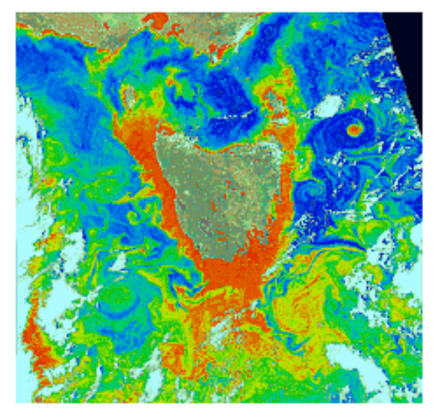
Figure 7: A SeaWiFS example of ocean fine structure from coastal run-off, chlorophyll and colored dissolved organic matter.
One of the key objectives of the AURA-OMI will be to derive estimates of tropospheric ozone from its hyperspectral observations. Because of the reduced sensitivity to tropospheric ozone from space-based observations of the entire ozone profile, the use of a comparable hyperspectral spectrometer located in the troposphere (~11 km) well below the ozone maximum (~25 km) will be able to accurately determine both the total tropospheric column below WFIS. In addition to the ozone measurements, WFIS will detect aerosol properties in the boundary layer including dust, smoke and industrial pollution. The addition of ground-based measurements to the AURA-OMI validation package provides missing pieces for ozone and aerosol validation. This information will be invaluable for AURA-OMI validation of both the data and algorithms.
Understanding the roles of tropospheric ozone and aerosols in perturbing the Earth system is a research priority for NASA and the US Global Change Research Program (USGCRP) [NAS, 1995]. A major challenge for the USGCRP is determining the controlling chemical and transport processes for tropospheric O₃ and aerosols [NSTC, 1999]. The WFIS validation of AURA-OMI answers this USGCRP challenge by addressing the question posed in the introduction:
- What are the effects of local and regional pollution on the global atmosphere, and what are the effects of global pollution on regional air quality?
WFIS validation of AURA-OMI enables us to investigate this important question by enabling measurements of the tropospheric column densities of chemically linked nitrogen dioxide (NO2), ozone (O3), sulfur dioxide (SO₂), and scattering and absorbing aerosols (i.e., aerosol optical depth and single scattering albedo). These constituents could be measured continuously along the aircraft track at very high spatial resolution, or by combining pixels, at very high signal to noise ratios (over 2000:1) to achieve the sensitivity required to resolve the weaker atmospheric trace gases. The high signal to noise ratio is important if we are to take advantage of the spectral structure used in the DOAS algorithm technique (see Figure 6). The use of this technique has been shown to remove the requirement for highly accurate absolute radiometric calibration, only requiring accurate relative calibration as a function of wavelength.
Both the AURA-OMI and WFIS-UV are quite able to determine the amounts of NO₂, SO₂, and O₃ using the spectral information in the UV and visible ranges. The retrieval can be based on either of two algorithms, 1) a method based on discrete bands selected for optimum sensitivity to the individual chemical species absorption, or 2) the DOAS technique that optimizes the spectral fit over a wide range for the assumed quantities of the chemical species. Direct validation comparisons can be made between OMI and WFIS-UV with the expectation that the combined-pixel WFIS data will have higher SNR and thus higher accuracy.
  - Ocean/Land Observations
At the same time as validating OMI data, WFIS-UV will obtain a unique set of observations in the UV and visible over coastal and nearby land regions at extremely high spatial resolution. Measurement of water-leaving radiances in coastal waters, especially in the shorter wavelengths (blue to the UV), has been an extremely difficult problem for remote sensing from space. WFIS will be capable of looking at guaranteed cloud-free scenes within an OMI pixel to determine both the atmospheric correction from aerosols and the water leaving radiance. The results will permit the distinguishing of different absorbing species in the water based on their differential absorption spectra between the visible and UV and with the use of the Raman scattering signal in the water leaving radiance.
The primary production of oceanic biomass is a major component of the global carbon cycle and in the atmospheric CO₂ balance. A large portion of photosynthetic variability, that affects atmospheric carbon variability, occurs in the coastal regions (and oceans) and not just the land. Human activity affects the productivity of the ocean (and especially the coastal zones) and sets fundamental limits on the amount of fish that can be harvested. Coastal oceanic regions and estuaries are also heavily impacted through land-use change, pollution runoff, oil spills, and other human activities. The combination of ocean biomass, ocean organic compounds, and land-vegetation observations by WFIS-UV and OMI will enable more accurate quantification of the carbon removal process for model calculations and an assessment of human impact because they will be able to resolve the primary physical forcing mechanisms at the proper scales.
1.6 Technical Implementation
The WFIS-UV instrument will utilize a hyperspectral imaging spectrograph coupled to an all-reflective telescope suitable for imaging a 120º wide field of view (FOV) on the Earth with 100-meter resolution at nadir covering a ground track of 41 km from the NASA DC-8 aircraft platform flying at 12 km. For AURA-OMI validation, WIFS-UV will be tailored for 310 to 500 nm. The basic WFIS footprint will be flown under the nadir-viewing orbital track of AURA-OMI.
WFIS will exploit technological advances in large area, high dynamic range 2-D detectors to provide simultaneous measurements at all wavelengths over a 120º wide FOV. The original NASA IIP development was aimed at developing low-cost low-weight hyperspectral sensors suitable for space flight with the high spatial and temporal resolution needed for observations of both atmospheric composition and land-ocean (especially coastal) processes. This proposal is an extension of the original concept into the UV wavelengths. The aircraft version of WFIS-UV will provide an excellent test bed for exploring these capabilities.

The first phase of the project will begin with a verification of the current requirements analysis guiding a refurbishment of the existing WFIS instrument, designed and tested under a NASA IIP grant, and fabricated with Hamilton Sundstrand corporate funding, to optimize its capabilities for AURA-OMI validation. Trade studies will be performed to assess the precise modifications that best meet the science requirements. This modified and refurbished instrument will be tested in the laboratory for verification of optical performance. The final WFIS-UV instrument will be prepared for a second phase of the project for use in an aircraft program. This proposal will include the complete design of a flight package including mounting hardware, control electronics, data facilities, and algorithm development. The algorithm development will use existing OMI algorithms as the starting point for the instrument being in the middle of the troposphere instead of above the atmosphere.
1.6.1 Requirements
The system design requirements are derived from the science product requirements that correspond to OMI. The need for a high signal-to-noise ratio (SNR) at the lower end of the spectral region of interest (310 nm) is a key driver for the instrument design and will enable the highest sensitivity to tropospheric trace gas absorption and contrast for the land/ocean measurements throughout the UV and visible regions. The first phase of the project will include a laboratory analysis of the WFIS instrument to detail this relationship for the complete measurement sets described in sections 1.0 to 1.3. The capabilities that we expect for this instrumentation regarding spectral coverage, bandpass, SNR and spatial resolution for their respective measurement targets will be further refined and updated following the conclusion of the laboratory analysis performed during the preliminary phases of the proposed work.
The Solar Irradiance Spectrometer (SIS) is based on an upgraded version of a low-cost (~$5K) commercially available linear diode array spectrometer operating over the same wavelength range and spectral resolution as WFIS-UV. The SIS is upgraded by the addition of a cosine-corrected diffuser at the end of a fiber-optic cable so as to view the whole sky and determine the downward irradiance at the altitude of the aircraft.
Trace gas retrieval products require a high SNR adequate to measure the differential signal that the absorber generates in the Sun normalized Earthshine spectra. Analysis of GOME data shows that the residual signal after the log-normalized main spectrum has been removed yields peak-to-peak levels of NO₂ that are in the ±0.4% level of the original spectrum. This implies that a SNR of 2000:1 is required to measure changes in NO₂ at the 10% level. This SNR can be achieved by combining spatial pixels and the use of the multispectral DOAS technique.
1.6.2 Instrument Approach
WFIS-UV is based on the recently completed Instrument Incubator Program (IIP) effort that was jointly funded by NASA ESTO and Hamilton Sundstrand (Figure 8). WFIS-IIP is a visible Hyperspectral instrument with coverage just into the near-UV and near-IR (380 to 1,000 nm). Technical requirements are summarized in Table 2.
WFIS uses a novel set of “field mirrors” to efficiently couple the wide field-of-view Scwartschild telescope to a conventional Offner spectrometer. This approach allows an all-reflective approach (except for a band isolation filter) that provides excellent performance.
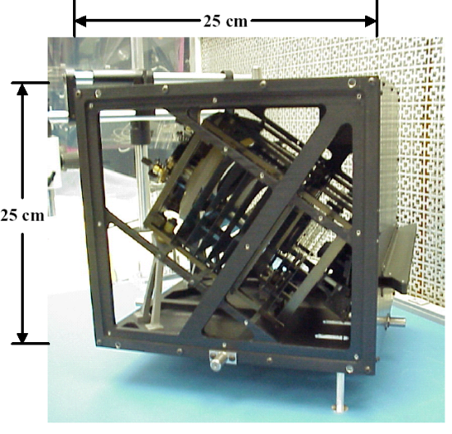  Figure 8: WFIS-IIP with the protective covers removed. The outside box is approximately 25 cm on a side. | 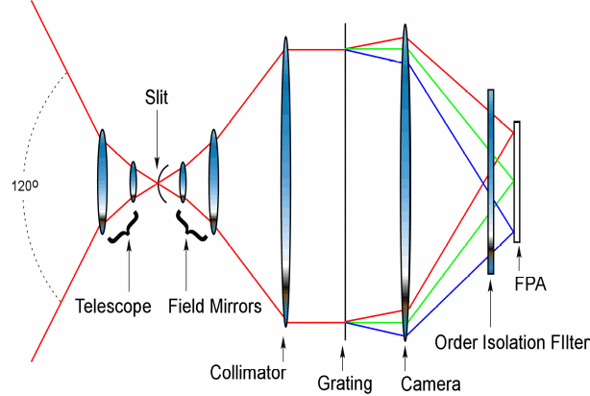  Figure 9: Equivalent lens diagram of WFIS Optics. WFIS-UV will use the WFIS-IIP spares for all optical components except the grating (requires finer groove structure) and filter (bandpass is shifted to shorted wavelengths)  .
Table 2: Top Level WFIS-UV Technical Requirements.

Parameter Value Comment
Total Swath 120º no mechanisms
Detector CCD (Frame Transfer) no shutter
Optical Speed f/3.0 typical
Wavelength Range 310 to 500 nm
Wavelength Resolution 0.7 to 0.9 nm ~0.25 nm sampling
Cross-Track Pixels 1280 IFOV 256 after 5x summing
Spatial Resolution (cross track) 100 meters @ 12 km
Spatial Resolution (along track) 113 meters @ 450 knots
Signal to Noise > 1000:1 typical
Spectrometer Size > 30 x 30 x 30 cm includes mounting structure
Data Rate < 10 Mbps 8 Hz for full frame

Since WFIS is an all-reflective design, most of the existing optics can be used for WFIS-UV without modification. To optimize the instrument for the proposed application, a new holographic diffraction grating, a new filter and a new focal plane are required (Figure 9). Examples of some of the internal optics are shown from spare copies of the optics (Figure 10).
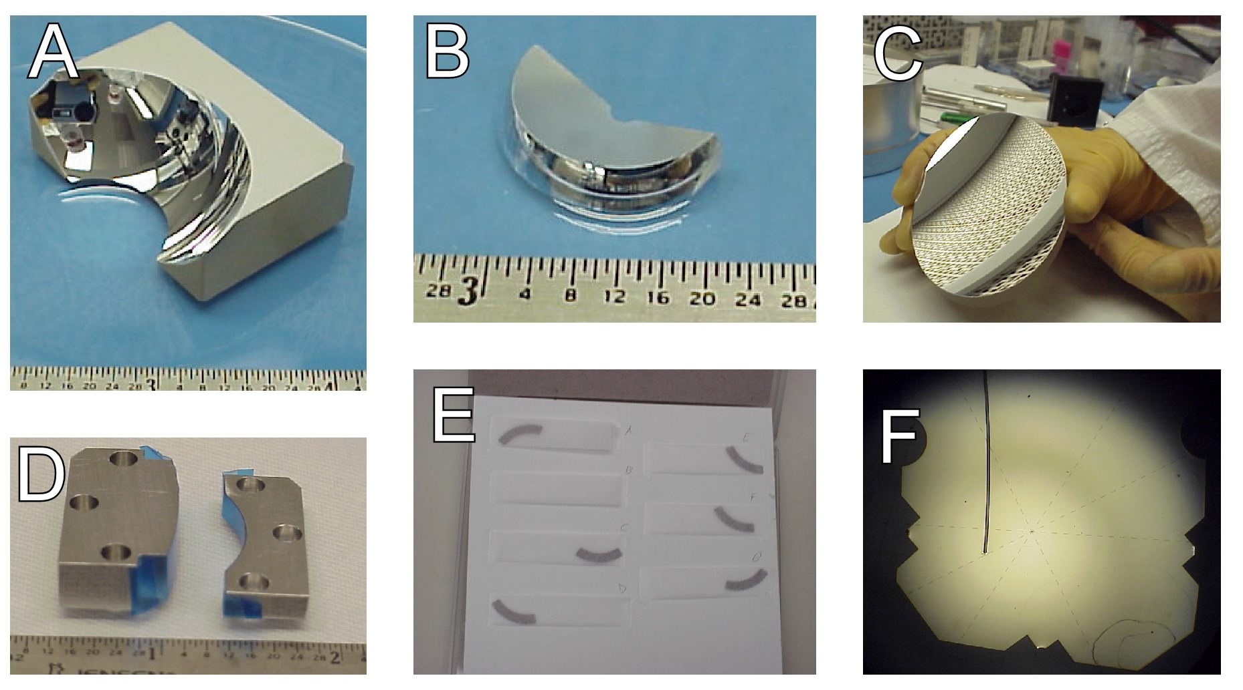
Figure 10: Examples of optics used in WFIS-UV: A) Telescope primary mirror, B) Telescope secondary mirror, C) Collimator mirror, D) Field mirrors, E) Laser machined slits, and F) Close-up of the slits.
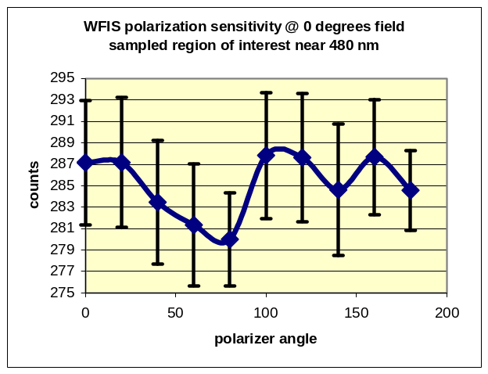 | 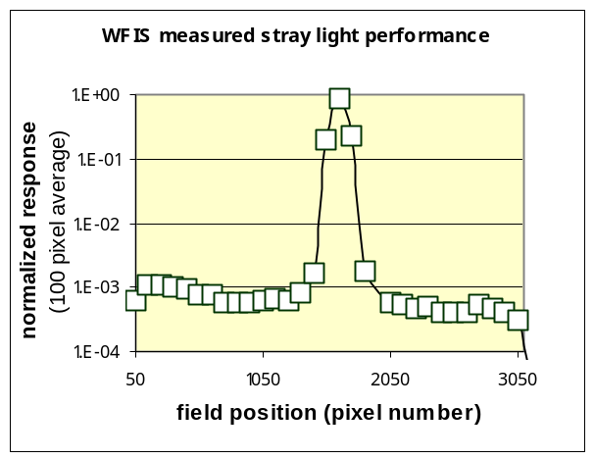
Figure 11: WFIS-IIP demonstrated polarization sensitivity of less than 1.5% (peak-to-peak). | Figure 12: Right: WFIS-IIP demonstrated stray-light rejection to better than 10⁻³, limited by laboratory set-up

The only changes to the structure required are a new mount for the detector and a new side panel to mount the readout electronics and provide the feed-thru for the different cables.
WFIS-UV will use a frame transfer device – eliminating the need for the shutter used in the original WFIS-IIP design; however, the shutter will be retained to allow periodic dark measurements to be easily made.
Testing on WFIS-IIP demonstrated several critical features required for successful use of WFIS-UV to calibrate OMI-Aura.
Polarization sensitivity is less than 1.5% (peak-to-peak) and even this number was limited by the measurement techniques errors of about 2% (Figure 11). This result is consistent with the design philosophy employed – all of the ray bounces in WFIS are near local-normal incidence. This inherently limits the possibility of polarization sensitivity being introduced into the incoming light. Stray-light rejection was also demonstrated to 10⁻³ (Figure 12). Again this measurement was limited by laboratory equipment and the test set-up and may underestimate the actual stray-light rejection of WFIS.
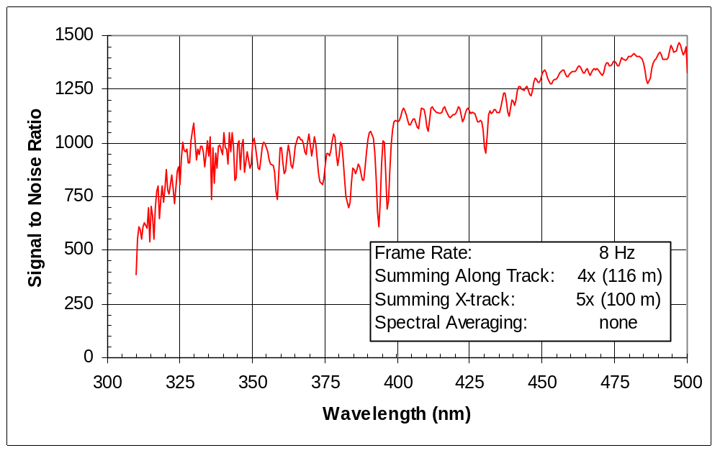
Figure 13: WFIS-UV Signal to Noise Ratio for a low albedo surface as view from 12 km.

Estimates for the WFIS-UV signal to noise ratio show good performance over the entire range for a simulated scene. The results of the SNR model are shown in Figure 13.
1.6.3 Technical Readiness
WFIS: As a result of the IIP program, WFIS is ready to move towards an aircraft instrument. The IIP unit was built using Invar structure and Zerodur optics, providing excellent stability over a range of temperatures. The required changes to shift the wavelengths to provide near-UV coverage are:
- UV sensitive 1280 x 1024 frame transfer device. This is a commercially available device.
- Design a mount for the new focal plane compatible with existing design of WFIS structure.
- Dispersion grating to provide the required wavelength range and dispersion using an existing design.
- Bandpass filter for the new wavelength range.
- Laboratory calibration with the new components.
- Configuring computer and power supplies into small rack-mounted system to allow easy portability for use in field and DC-8 tests.
SIS, Solar Irradiance Spectrometer: The spectrometer used to measure the downward irradiance, using a flat diffuser plate, is derived from a tested low-cost (~$5K) commercial instrument. Even though the technical readiness is high, there is additional work needed to upgrade the instrument to where it is suitable for the airborne validation program. The upgrades are:
- Adding and calibrating a cosine corrected Teflon diffuser plate for the entrance optics of the spectrometer.
- Improving the interface for digital readout into standard rack-mounted computers and stabilized power supplies.
- Improving the environmental temperature stabilization and adding temperature measurements at the detector for improved calibration.

1.7 Future WFIS Improvements
The original WFIS design project was supported by a NASA Instrument Incubator Program for designs leading to a space flight project. The result of this effort was a versatile instrument that can be extended to a wide wavelength range from the UV into the near-IR (1 to 4 microns) using an additional focal plane. In this configuration WFIS will be able to observe the important gases CH₂O, SO₂, CO, CH₄, N₂O, and H₂O.
By enhancing our capabilities to measure atmospheric trace gas profiles and Ocean/Land processes WFIS will help address the following elements from NASA’s Strategic Plan [NASA, 2000]:
- What are the primary causes of change in the Earth system?
- How does the Earth system respond to natural and human-induced changes?

- How do ecosystems respond to and affect global environmental change and the carbon cycle?

- What are the effects of regional pollution on the global atmosphere, and changes on regional air quality?

- Apply scientific and technical capabilities to enable the development of practical tools for public and private sector decision makers to accelerate the realization of economic and societal benefits.

1.8 References

Dave, J.V., Effect of Aerosols on the estimation of total ozone in an atmospheric column from the measurement of its ultraviolet radiance, J. Atmos. Sci. 35, 899-911, 1978.

Richter, A. and J.P. Burrows, Retrieval of Tropospheric NO₂ from GOME Measurements, Adv. Space Res., 29(11), 1673-1683, 2002 .

Lambert, J.C., J.P. Burrows, U. Platt, P. Stammes, Y.M. Timofeyev, Delta Validation of GOME Data Products, Proposal in Response to the Statement of Work ER-SW-APP-CZ-007, ESA, 1999. (see http://giger.iup.uni-heidelberg.de/Forschung/no2.html)
2.0 Research Management Plan

2.1 Management Approach
The basic management approach will use the proposal PI (Dr. Jay Herman) to coordinate and be responsible for setting the instrument science requirements, algorithm requirements and performance, and for the design of a coordinated plan of measurements that will achieve both the OMI data validation and acquisition of new science data. Because this is an instrument improvement proposal with most of the work taking place at Hamilton-Sundstrand, an Instrument Team Leader (Mr.Randy Pollock) will be used to make sure that the science requirements are met in terms of the optical design and calibration. Algorithms will be developed by a senior radiative transfer scientist (Dr Ziauddin Ahmad) who has extensive experience (TOMS and MODIS projects) in algorithm development for both UV and visible wavelengths. Overall responsibility for instrument performance and science will remain with the proposal PI.

2.2 Organization and experience of key personnel

Key personnel are drawn from two organizations, GSFC and Hamilton-Sundstrand Sensor Systems. The broad overview of responsibilities is that scientists from GSFC will define the instrument requirements and capabilities from the viewpoint of science applications and AURA-OMI validation while scientists and engineers from Hamilton-Sundstrand will have responsibility for completing the WFIS modifications and laboratory calibration.

GSFC personnel will develop the science algorithms necessary to derive the amounts of ozone, NO₂, SO₂, aerosols and aerosol properties (e.g., single scattering albedo and particle size), cloud height, cloud properties (cloud optical depth, thickness, and mean particle size), and scene reflectivity for an instrument in the middle of the troposphere. Most of the algorithms will be based on existing OMI algorithms developed at GSFC, but modified for airborne instrument altitude. Some of the algorithm development for Raman scattering and O₂:O₂ dimer analysis will be based on new work recently developed for the analysis of OMI, Schiamachy, and GOME science data. By the time that OMI data is available, these algorithms will be thoroughly tested against Schiamachy, and GOME data.

Both the teams from GSFC and Hamilton-Sundstrand have extensive experience in instrument design, construction, and calibration. The same team of scientists and engineers was responsible for the design and construction of the latest highly successful TOMS instrument (Earth-Probe TOMS) and for the design and construction of the existing version of WFIS. Laboratory characterization of WFIS shows that the current instrument meets all of the requirements for the proposed science and for OMI-AURA validation.
2.3 Biographical Sketches of Key Personnel

Dr. Jay R. Herman Principal Investigator

Astrophysicist, Atmospheric Chemistry and Dynamics Branch, NASA/ Goddard Space Flight Center, Code 916, (301) 614-6039, Jay.R.Herman@nasa.gov

RESEARCH AREA: Stratospheric and Tropospheric Ozone, Clouds and aerosols. UV radiation at the Earth’s surface, Ocean remote sensing, UV radiation in the Oceans and in-situ Ocean composition., Spacecraft instrument design.

EXPERIENCE: The most recent experience is as Project Scientist for the Triana mission that included setting instrument design and specifications, algorithm development, and overall scientific responsibility to see that the instrument and spacecraft met the design goals. There is additional experience as Principal Investigator for an interferometer spaceflight mission proposal that included advanced instrument design and algorithm development.

PRESENT POSITION: Project Scientist for Triana L1 deep-space mission
Principal Investigator for Ocean Radiation Studies
Principal Investigator for TOMS UV and aerosol projects
Lead Scientist for TOMS Project Data Acquisition

EDUCATION: 1959 B.S. Physics with minor in mathematics, (obtained
with high honor) Clarkson College, Potsdam,
New York
1963 M.S. Physics Penn. State Univ., State College, PA
1965 Ph.D. Physics Penn. State Univ., State College, PA

RECENT REFEREED PUBLICATIONS 1999 - 2002:

1. “Detection of mineral dust over the North Atlantic Ocean and Africa with the Nimbus-7/TOMS”, I. Chiapello, J.R.Herman, C. Hsu, J. Prospero, J. Geophys. Res. 104, 9277-9291, 1999.
2. “Comparisons of the TOMS aerosol index with sun photometer aerosol optical thickness”, N. Christina Hsu, Jay R. Herman, O.Torres, B.N. Holben,D. Tanre, T.F. Eck, A.Smirnov, B. Chatenet, and F. Lavenu, J. Geophys. Res. 104, 6269-6279, 1999.
3. “Distribution of UV Radiation at the Earth’s Surface From TOMS Measured UV-Backscattered Radiances”, J.R. Herman, N. Krotkov,E. Celarier, D. Larko and G. Labow, J. Geophys. Res. 104, 12059-12076, 1999.
4. “UV Radiation at the Earth’s Surface” Chapter 9, J. R. Herman, McKenzie, S. Diaz, J. Kerr, S. Madronich, and G. Seckmeyer, WMO 1999, UNEP/WMO Scientific Assessment of Ozone Depletion: 1999, edited by D. L. Albritton, R. T. Watson, and P. J. Aucamp, WMO Global Ozone Res. and Monit. Proj., Geneva, 19995. “Satellite and ground-based study of 1997 Indonesian forest fire aerosols”, Teruyuki, Nakajima, a. Higurashi, N. Takeuchi, and J.R. Herman, Geophysical Research Letters 26, 2421_2424, 1999.
6. “Satellite detection of smoke aerosols over a snow/ice surface by TOMS”, Hsu, N.C., J.R. Herman, J.F. Gleason, O. Torres., C.J. Seftor, Geophys. Res. Lett., 26, 1165-1168, 1999.
7. “Comparison of daily UV doses estimated from Nimbus-7/TOMS measurements and ground-based spectroradiometric data”, Kalliskota, S., J. Kaurola, P. Taalas, J.R. Herman, E. Celarier, and N. Krotkov, 105, 5059-5067, J. Geophys. Res., 2000.
8. “Satellite estimation of spectral surface UV irradiance 2: Effect of horizontally homogeneous clouds”, N. Krotkov, Herman, J.R., Bhartia, P.K., Ahmad, Z., Fioletov, V., J. Geophys. Res., 106, 11,743-11,759, 2001.
9. “Erythemally weighted UV trends over northern latitudes derived from Nimbus 7 TOMS measurements”, J.R. Ziemke, S. Chandra, J. Herman, and C. Varotsos, J. Geophys. Res., 105, 7373-7382, 2000.
10. “Trajectory modeling of aerosol clouds observed by TOMS”, Allen, D.R., M.R. Schoeberl, and J.R.Herman, J. Geophys. Res., 104, 27461-27471, 1999.
11. “Detecting the Recovery of Total Column Ozone”, Elizabeth C. Weatherhead, Gregory C. Reinsel, George C., Tiao, Charles H. Jackman, Eric L. Fleming, Lane Bishop, John DeLuisi, Teddie Keller, Jay Herman, Richard McPeters, David Hofmann, Samuel J. Oltmans, Donald J. Wuebbles, James B. Kerr, Alvin J. Miller, Ronald M. Nagatani, Stacey, Hollandsworth, and John E. Frederick, J. Geophys. Res., 105, 22201-22210, 2000.
12. “Changes in the Earth’s Global UV Reflectivity from Clouds and Aerosols”, J. R. Herman, D. Larko, and J. Ziemke, J. Geophys. Res. 106, 5353-5368, 2001.
13. "Response of the Climatic Temperature to Dust Forcing, inferred from TOMS Aerosol Index and the NASA Assimilation Model", P. Alpert, J. Herman, Y. J. Kaufman and I. Carmona, Atmos. Res. 53, 3-14, 2000.
14. “The impact of greenhouse gases and halogenated species on future solar UV radiation doses”, Petteri Taalas, Jussi Kaurola, Arve Kylling, Drew Shindell,Robert Sausen, Martin Dameris, Volker Grewe, Jay Herman, Juhani Damski, Benedikt Steil, Geophys. Res. Let., 27, 1127-1130, 2000.
15. "Global mapping of underwater uv fluxes and dna-weighted exposures using TOMS and SeaWifs data products", Alexander Vasilkov , Nickolay Krotkov, Jay Herman, C. McClain, K.Arrigo, and W.Robinson, J. Geophys. Res., accepted, 2001.
16. “Evaluating ultraviolet radiation exposures determined from TOMS satellite data at sites of amphibvian declines in Central and South America”, E. Middleton, J.R. Herman, E. Celarier, J.W. Wilkinson, C. Carey, and R.J. Rusin, 914-929, 15, Conservation Biology, 2001.
17. “Interannnual Variability of Ozone and UVB Ultraviolet Exposure”, J. R. Herman, R. D. Piacentini, J. Ziemke, E. Celarier, and D. Larko, J. Geophys. Res., 29189-29194, 105, 2000.
18. “UV 380 nm Reflectivity of the Earth’s Surface, Clouds, and Aerosols”, J.R. Herman, E. Celarier, and D. Larko, J. Geophys. Res. 106, 5335-5351, 2001.
19. “A note on the interannual variations of UV-B erythemal doses and solar irradiance from ground-based and satellite observations, Zerefos, C. , D. Balis, M. Tzortziou, A. Bais, K. Tourpali, C. Meleti, G. Bernhard, and J. Herman, Annales Geophysicae 19, 115–120, 2001.
20. “Determination of Radiative Forcing of Saharan Dust Using Combined TOMS and ERBE Data”, N. Christina Hsu, Herman, J.R., and Clark Weaver, J. Geophys. Res., 105, 20649-20662, 2000.
21. African dust in the Caribbean atmosphere: Microbiology and public health, Dale W. Griffin, Virginia H. Garrison, Jay R. Herman and Eugene A. Shinn, Aerobilogia, 17, 203-213, 2001.
22. “Tropical tropospheric ozone and biomass burning”, Thompson, A.M., J.C. Witte, R.D. Hudson, H. Guo, J.R. Herman, and M. Fujiwara, Science, 291, 2128-2132, 2001.
23. “Detecting the recovery of total column ozone”, E.C. Weatherhead, G.C. Reinsel, C. Tiao, C.H. Jackman, L. Bishop, S.M.H. Frith, J. DeLuisi, T. Keller, S.J. Oltmans, E.L. Flemming, D.J. Wuebbles, J.B. Kerr, A.J. Miller, J.R. Herman, R. McPeters, R.M. Nagatani, and J.M. Frederick, J. Geophys. Res., 105, 22201-22210, 2000.
24. “Comparison of TOMS land retrievals of aerosol optical depth to AERONET observations”, O. Torres, P.K. Bhartia, J.R.Herman, A.Sinyuk, B.N. Holben, and D. Tanre, submitted to J. Atmospheric Science, 2001.
25. “Long-Term Variability of Airborne Asian Dust observed from TOMS”, N. C. Hsu, J. R. Herman, C. J. Seftor, and B. N. Holben, submitted to J. Geophys. Res., 2001.
- “Comparisons of the TOMS Aerosol Index with Sun-photometer Aerosol Optical Thickness: Results and Applications”, N. Christina Hsu, Jay R. Herman, and O. Torres, submitted to J. Geophys. Res., 2001.
- “Erythemal weighted ultraviolet trends over northern latitudes”, Ziemke, J.R., S. Chandra, J. Herman, and C. Varotsos, Radiation Protection Dosimetry, 91, 157-160, 2000.
- “A note on the interannual variations of UV-B erythemal doses and solar irradiance from ground-based and satellite observations”, Zerefos, C., D. Balis, M. Tzortziou, A. Bais, C. Meleti, G. Bernhard, J. Herman, Annales Geophysicae, 19, 115-120, 2001.
- Qin, Wenhan ; Herman, Jay R. ; Ahmad, Ziauddin A fast, accurate algorithm to account for non-Lambertian surface effects on TOA radiance J. Geophys. Res. Vol. 106 , 22,671- 22684, 2001
- Papayannis, A., V. Amoiridis, J. Baldasana, J. Balin, D. Balis, A. Boselli, A. Chaikovsky, B. Chatenet, G. Chourdakis V. Freudenthaler, M. Frioux, J. Herman, M. Iarlori, S. Kreipl, G. Larcheveque, R. Matthey, I. Mattis, D. Muller, M. Pandolfi, G. Pappalardo, J. Pelon, M. R. Perrone, V. Rizi, A. Rodriguez, L. Sauvage, P. Sobolewski, N. Spinelli, F. de Tomasi, T. Trickl, and M. Wiegner, Continental-scale vertical profile measurements of free tropospheric Saharan dust particles performed by a coordinated ground-based European Aerosol Research Lidar Network (EARLINET project). Submitted to J. Geophys. Res., 2002.
- Vasilkov, A. P., J. Herman, N. A. Krotkov, B. G. Mitchell, and M. Kahru, Problems in assessment of the UV penetration into natural waters from space-based measurements. Submitted to Optical Engr., 2002.
- Fioletov, V. E., J. B. Kerr, D. L. Wardle, N. Krotkov, and J. R. Herman, Comparison of Brewer UV irradiance measurements with TOMS satellite retrivals. Submitted to Optical Engr., 2002.
- Chubarova, N. Y., Y. A. Yu, N. A. Krotkov, J. R. Herman, and P. K. Bhartia, Comparisons between ground measurements of broadband UV irradiance (300 - 380 nm) and TOMS UV estimates at Moscow for 1979-2000. Submitted to Optical Engr., 2002.
- O. Torres, P. K. Bhartia, J. R. Herman, A. Sinyuk, P. Ginous, and B. N. Holben,: A long term record of aerosol optical depth from TOMS observations and comparison to AERONET. J. Atmos. Sci., 59, 398-413, 2002
- Gobbi, G.P., F. Barnaba, M. Blumthaler, G. Labow, J.R. Herman, 2002: Observed effects of particles nonsphericity on the retrieval of marine and desert dust aerosol optical depth by lidar, Atmospheric Research, 61, 1-14, 2002.
Dr. Richard D. McPeters Algorithms and Science

Current Position:
Principal Investigator for Earth Probe TOMS
Principal Investigator for SOLSE-2
Atmospheric Chemistry and Dynamics Branch
NASA, Goddard Space Flight Center
Greenbelt, Maryland USA 20771

Relevant Research Areas:
Calibration and validation of TOMS total column ozone. Creation of a merged ozone data set from multiple satellite instruments. Radiative transfer and ozone inversion theory applied to backscattered ultraviolet data from SBUV and from TOMS instruments. Study of limb scattering for ozone inversion.

Education: 1969 - S.B. (Physics) Massachusetts Institute of Technology
1975 - Ph.D. (Physics) University of Florida

Selected Recent Publications:
“Global and zonal total ozone variations estimated from ground-based and satellite measurements: 1964-2002,” V. Fioletov, G. Bodeker, A. Miller, R. McPeters, and R. Stolarski, J. Geophys. Res, 107, in press 2002.
“Northern Hemisphere atmospheric effect due to the July 2000 solar proton event,” C. Jackman, R. McPeters, G. Labow, E. Fleming, C. Praderas, and J. Russell, Geophys. Res. Lett., 28, 2883-2886, 2001.
“The retrieval of ozone profiles from limb scatter measurements: Results from the Shuttle Ozone Limb Sounding Experiment,” R. D. McPeters, S. J. Janz, E. Hilsenrath, T. L. Brown, D. E. Flittner, and D. F. Heath, Geophys. Res. Lett., 27, 2597-2600, 2000.
“Results from the 1995 Stratospheric Ozone Profile Intercomparison at Mauna Loa (MLO3),” R. D. McPeters, et al., J. Geophys. Res., 104, 30505-30514, 1999.
“New TOMS Instrument Measures Ozone and Aerosols,” J. A. Kaye, R. D. McPeters, J. R. Herman, P. K. Bhartia, and A. J. Krueger, EOS, 79, 57-63, 1998.
"Earth Probe Total Ozone Mapping Spectrometer (TOMS) Data Products User's Guide," R.D. McPeters, P.K. Bhartia, A.J. Krueger, J.R. Herman, C.G. Wellemeyer, C.J. Seftor, G. Jaross, O. Torres, L. Moy, G. Labow, W. Byerly, S.L. Taylor, T. Swissler, and R.P. Cebula, NASA/TP-1998-206895, November 1998.
“Long-term trends derived from the 16-year combined Nimbus 7/Meteor 3 TOMS version 7 record,” R.D. McPeters, S.M Hollandsworth, L.E. Flynn, and J.R. Herman, Geophys. Res. Lett., 23, 3699-3702 1996.

Mr. Randy Pollock Instrument Leader  randy.pollock@hs.utc.com | 2771 North Garrey Ave  Pomona, CA 91767  909.593.3581 x4202
Education
BS - California Institute of Technology, 1991 (Engineering & Applied Science)

Experience
Hamilton Sundstrand Sensor Systems, Pomona CA 2000-present
- Principal Investigator/Program Manager – Wide Field Imaging Spectrometer (WFIS)
Managed Instrument Incubator Program (IIP) contract for development of WFIS during hardware build, assembly and test/calibration. Developed techniques for and conducted data analysis for novel 120º FOV pushbroom spectrometer.
- Instrument Systems Engineer – Orbiting Carbon Observatory (OCO)
Instrument Systems Engineer for OCO, an ESSP mission to measure CO₂ concentrations from space. Led instrument studies for proposal, worked with science team to balance requirements and approach with capabilities,

Jet Propulsion Laboratory, Pasadena CA 1996-2000
- Instrument Manager/System Architect – PABSI (CloudSat)
Managed development of near infrared imaging spectrometer to study cloud properties using the oxygen A-band for Cloudsat, an ESSP mission.
- System Architect - QWIP Orbital Radiation Experiment (STRV-1d)
Developed system requirements, operational scenarios and data reduction techniques. Responsible for detector arrays and cryogenic cooler. Lead laboratory testing can calibration. Coordinated interfaces with international group providing the spacecraft.
- Technology Development Manager - IMAS
Managed the development of technologies with several major sub-contractors. The major technology thrusts were small cryocoolers, Silicon-Carbide optics, 50-200 GHz MMICs and 15 μm QWIPs.
- System Architect – Europa Orbiter Payload Proposal
Systems Architect for a Europa Orbiter remote sensing package proposal. Designed a series of multispectral, stereo cameras, a high resolution imager/lidar receiver and a very long-wave infrared imager.

Loral Infrared & Imaging Systems, Lexington, MA 1991-1996
- System Engineer - Atmospheric Infrared Sounder (AIRS)
Developed instrument performance models and applied these to design trade studies and requirements allocation. Specific areas included optics, signal processing, calibration, orbital mechanics, and detector performance.

Dr. Ziauddin Ahmad Algorithms & Radiative Transfer Analysis

Education: Ph.D., Physics, State University of New York, Buffalo, NY, 1975
M.S., Physics, University of Karachi, Karachi, Pakistan, 1964
B.S. (Honors), Physics, University of Karachi, Karachi, Pakistan, 1963

Experience Radiative Transfer in the Visible and UV, Algorithm Development, Remote Sensing of Ozone and Aerosols, and UV Radiation on the Ground and in the Ocean

Professional Societies: American Geophysical Society

Positions: Chief Scientist, Science and Data Systems, Inc. Silver Spring, MD, (1973 to 1993); Project Manager and Chief Scientist, Hughes STX Corporation, Lanham, MD, (1973 to 1993).

Selected Publications

1. “Validation of MODIS Aerosol Retrieval Over Ocean”, L. A. Remer, D. Tanre, Y. J. Kaufman, C. Ichoku, S. Matto, R. Levy, D. A. Chu, B. N. Holben, O. Dubovik, A. Smirnov, J. V. Martins, R-R. Li, Z. Ahmad, Geophys. Res. Lett. 29(12), 10.1029/2001GL013204, 2002
2 “A fast, accurate algorithm to account for non-Lambertian surface effects on TOA radiance”, Qin, W., J. R. Herman, Z. Ahmad, J. Geophys. Res. 106, 22671-22684, 2001
3. Satellite estimation of Spectral surface UV irradiance 2: Krotkov, N., J. R. Herman, P. K. Bhartia, V. Fioletov, J. Geophys. Res. 106, 11743-11759, 2001
4. Atmospheric correction algorithm for hyperspectral remote sensing of ocean color from space”, B.-C. Gao, M. J. Monte, Z. Ahmad, and C. O. Davis, Appl. Opt., 39, 887-896, 2000.
5. “Satellite estimation of spectral surface UV irradiance 2: Effect of horizontally homogeneous clouds”, N. Krotkov, J. R. Herman, P. K. Bhartia, Z. Ahmad, and Fioletov, V., submitted to J. Geophys. Res., 1999.
6. “Derivation of aerosol properties from satellite measurements of backscattered ultraviolet radiation. Theoretical basis”, O. Torres, P. K. Bhartia, J. R. Herman, Z. Ahmad and J. F. Gleason, J. Geophys. Res., 103, 17099-17110, 1998.
7. “UV-B increases (1979-1992) from decrease in total ozone”, J. R. Herman, P. K. Bhartia, J. Ziemke, Z. Ahmad, and D. Larko, Geophys. Res. Lett. 23, 21107-21120, 1996.
8. "Effect of molecular anisotropy on the backscattered uv radiance", Z. Ahmad,, P. K. Bhartia, Appl. Opt., 34, 8309-8134, 1995
9 "Accuracy of total ozone retrieval from NOAA SBUV/2 measurements: Impact of instrument performance", Z. Ahmad, M. T. DeLand, R. P. Cebula, H. Weiess, C. G. Wellemeyer, W. G. Planet J. H. Lienesch, H. D. Bowman, A.J. Miller, and R. M. Nagatani, J. Geophys. Res., 99, 22975-22984,1994
10. "Properties of mt. Pinatubo aerosols as derived from Nimbus-TOMS measurements", O. Toress, J. R. Herman, P. K. Bhartia, and Z. Ahmad, J. Geophys. Res., 100, 14043-14055,1994.
11. “Ground based intercomparisons of SBUV/2 flight instruments, the World Standard Dobson spectrometer 83 and overpass observations from Nimbus 7 TOMS and NOAA-11 SBUV/2", D. F. Heath, Z. Ahmad, O. Toress, R. D. Evens, R. D. Grass, W. A. Komhyr, and W. Nelson, in the Proceedings of the Quadrennial International Ozone Symposium, Charlottesville, Va, 1992.
12. "Effect of stratospheric aerosol on the TOMS/SBUV ozone retrievals", O. Toress, and Z. Ahmad, J. R. Herman, in the Proceedings of the Quadrennial International Ozone Symposium, Charlottesville, Va, 1992.
13. “A new method for monitoring long term calibration of the SBUV and TOMS instruments”, Z. Ahmad, C. Seftor and C. Wellemeyer, in the Proceedings of the Quadrennial International Ozone Symposium, Charlottesville, Va, 1992.
14. "Optical effects of polar stratosphere clouds on the retrieval of toms total ozone," O. Toress, Z. Ahmad, and J. R. Herman, J. Geophys. Res., 97, 13015-13024, 1992.
15. "A new self-calibration method applied to TOMS/SBUV backscattered ultraviolet data to determine long-term global ozone change," J. R. Herman, R. Hudson, R. McPeters, R. Stolarski, Z. Ahmad, X-Y. Gu, S. Taylor, and C. Wellemeyer, J. Geophys. Res., 94, 7531-46, 1991.
16. "A regression method for estimating atmospheric aerosol properties from a modified AVHRR instrument," Z. Ahmad, J. Sutton, L. Stowe, and R. N. Nagaraja, In the IRS 88: Current Problems in Atmospheric Radiation, J. Lenoble and J. F. Geleyn (Eds.), 575-578, 1988.
17. "Satellite measurements of cloud reflectance and optical thickness," Z. Ahmad and R. S. Fraser, Adv. Space Res., 2, 29-34, 1983.
18. “An iterative radiative transfer code for ocean-atmospheric systems," Z. Ahmad, and R. S. Fraser, J. Atmos. Sci., 39, 656-665, 1982.
19. "Intensity and degree of polarization in models of ocean-atmospheric systems," Z. Ahmad and R. S. Fraser, in the International Radiation Symposium, Fort Collins, CO, 1980.
19. "The effect of surface reflection and clouds on the estimation of total ozone from satellite measurements," R. S. Fraser and Z. Ahmad, NASA-Weather and Climate program, Science Review, 1979.

3.0 Facilities and Equipment

1) The program will use existing calibration and laboratory facilities at Goddard Space Flight Center and at Hamilton-Sundstrand for work on the 2 spectrometers.
2) Facilities at GSFC will be used for existing ground-based instrumentation (Brewer Spectrometer, MicroPulse Lidar, and a Cimel Sunphotometer).
3) Scientific data processing algorithms will be developed using Code 916 GSFC computers consisting of Silicon Graphics 2-Processor Workstations and one SGI 8-Processor Workstation using existing development software (Fortran, IDL).
4) The Wide Field Imaging Spectrometer (WFIS) will be modified and calibrated at Hamilton-Sundstrand using their laboratories and instrumentation.
5) The ground-based instrument platform with a clear horizon view already exists at GSFC.

4.0 Proposed Costs

Direct Costs and Milestones from date of award (See 2. Other Direct Costs in Budget)

Year | Month |  |  | Hardware | Labor
1 |  |  |  | K$ | K$
HS | 1 to 12 | Refurbish and calibrate WFIS |  | 78 | 129
GSFC | 1 to 12 | Acquire and test SIS |  | 10 | 15
GSFC | 1 to 12 | Develop Algorithm Software |  |  | 10
 |  | Sub-Total |  | 88 | 154
 |  | Year-1 Direct Costs |  | 242
2
HS | 1 to 6 | Finish Refurbish and Calibration of WFIS |  | 20 | 166
GSFC | 1 to 6 | Operate SIS in Ground-based Mode |  | 10 | 25
HS+GSFC | 1 to 6 | Field test WFIS + SIS at HS |  |  | 10
GSFC | 1 to 12 | Test Algorithm Software |  |  | 20
 |  | Sub Total |  | 30 | 221
 |  | Year-2 Direct Costs |  | 251
Year 1 Item 1: Replace WFIS grating and CCD detector
HS costs include a fixed fee of $26K (Year 1) and $23K (Year 2)

HS = Hamilton Sundstrand GSFC = Goddard Space Flight Center

Note: GSFC already has an Ocean-Optics Spectrometer that may be suitable. However, it may be very desirable to acquire a model with high Signal to Noise Ratio designed to operate at high levels of light (direct Sun exposure). Part of the expense for the Solar Irradiance Spectrometer is the design and fabrication of a Teflon diffuser plate.

YEAR 1

Note: Of the $232K direct costs (see 2. Other Direct Costs), $197K is direct funding for Hamilton Sundstrand and the work on the WFIS instrument. $35K is for work on algorithms and the Solar Irradiance Spectrometer at GSFC.

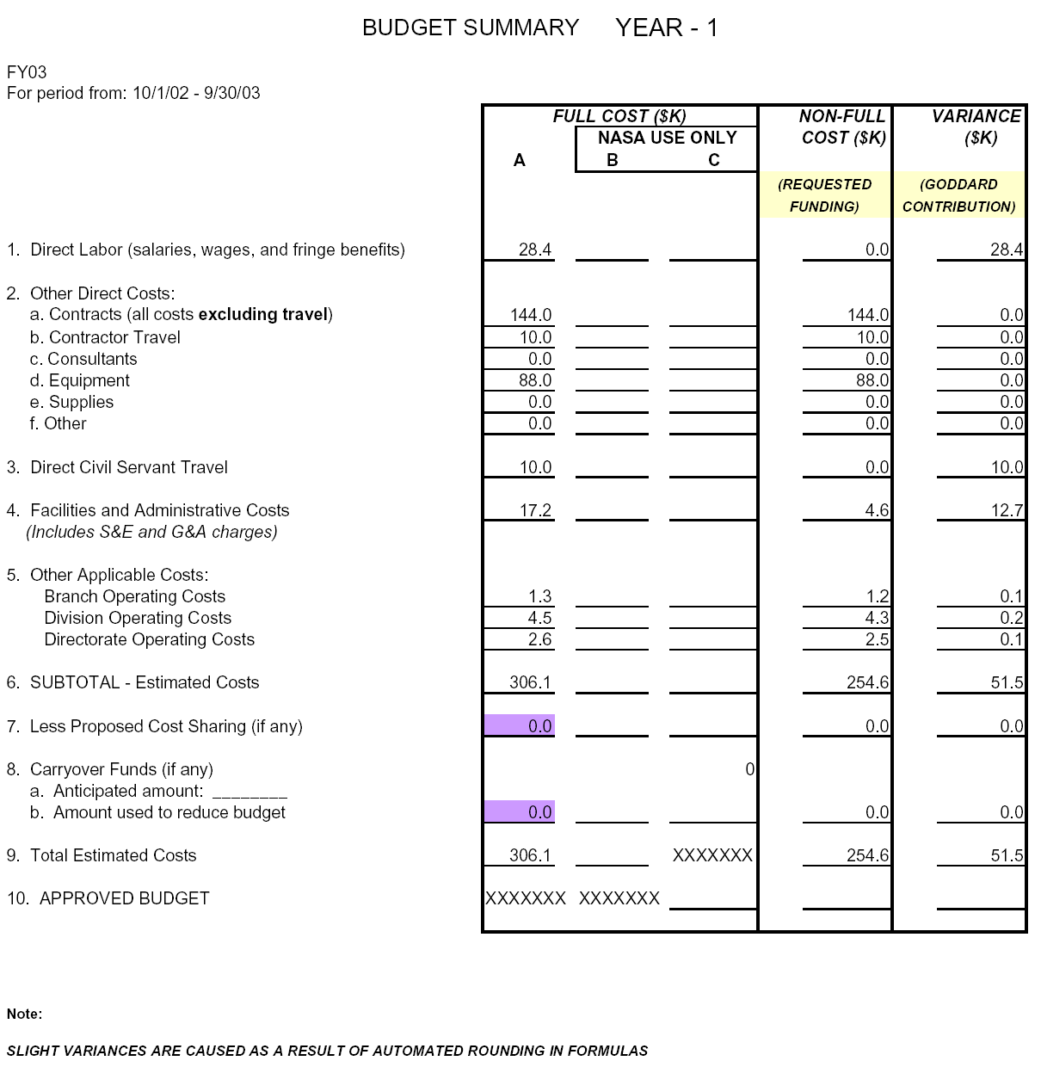
.
YEAR 2

Note: Of the $231K direct costs (see 2. Other Direct Costs), $176K is direct funding for Hamilton Sundstrand and the work on the WFIS instrument. $55K is for work on algorithms and the Solar Irradiance Spectrometer at GSFC.

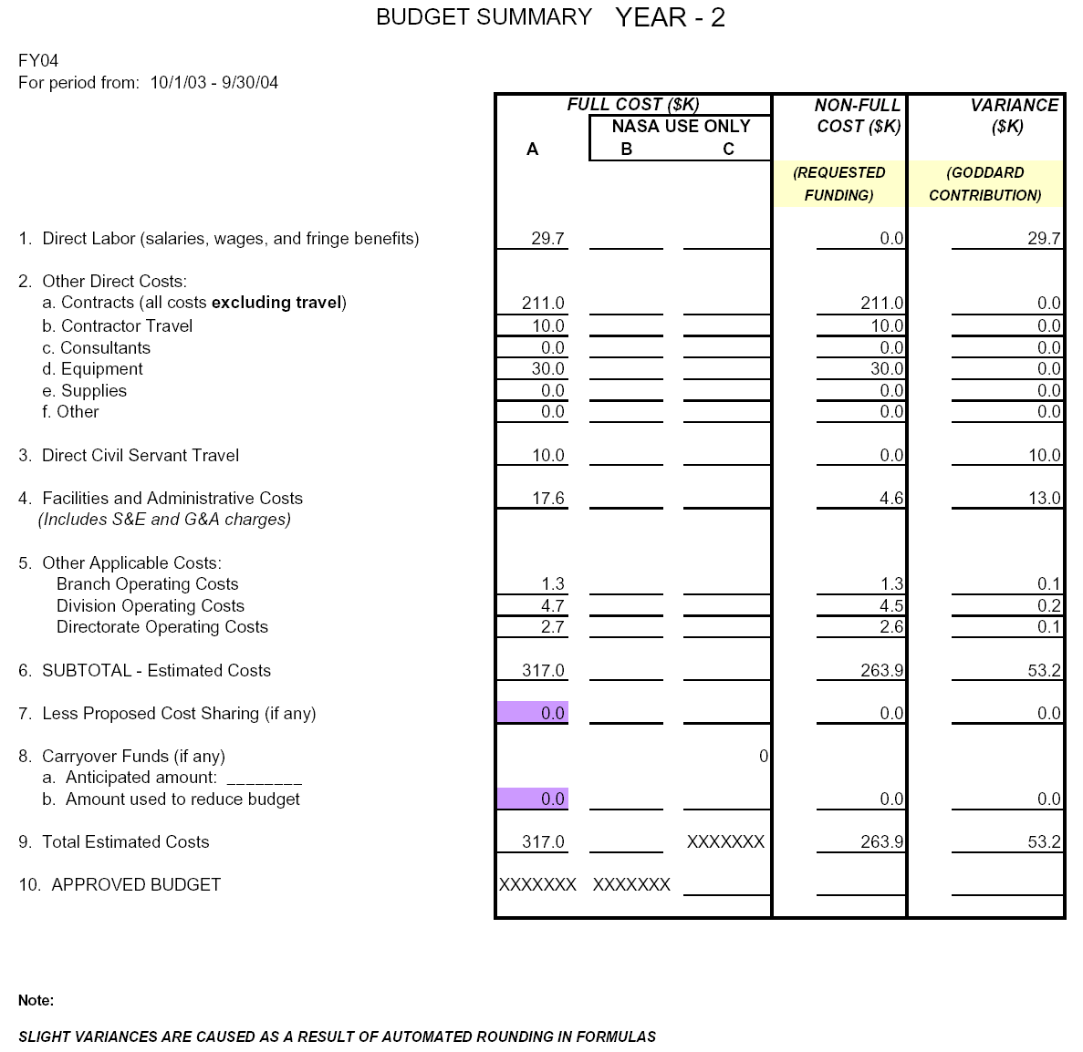
.
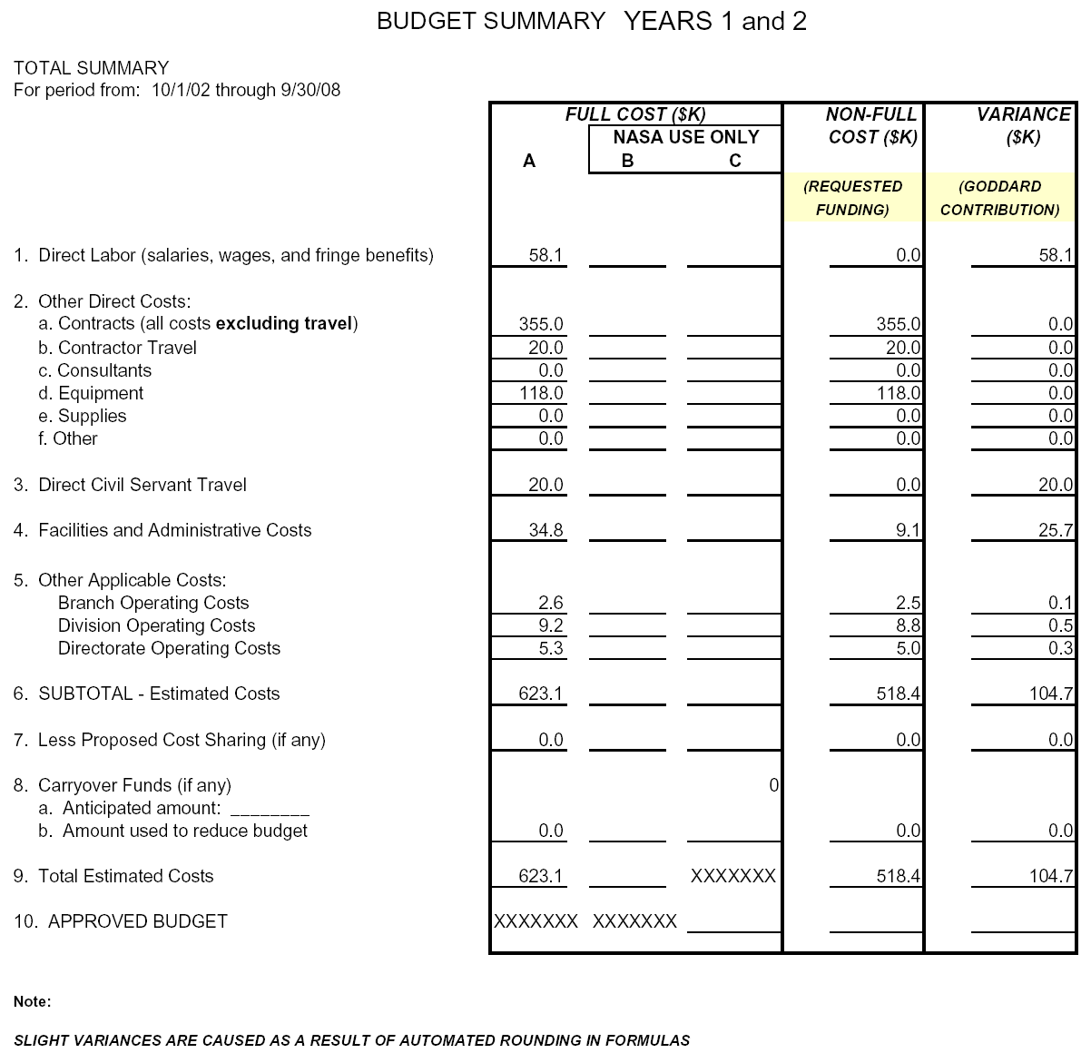
.
4.1 Current Support.

Principal Investigator | Source of Support and Principal Investigator | Award Amount and Period of Performance | Person-Months and Level of Effort | Project Title and Short Abstract (50 words or less)
Current Fiscal Year Support | NRA 00-OES-05 | $570K  FY 2000-2003 | 2.5 PM/Year for PI | Penetration of UV Radiation in the Earth’s Oceans
Current Fiscal Year Support | NRA 00-OES-09 | $445K  FY2000-2003 | 2.5 PM/Year for PI | Validation and Analysis of Improved TOMS Satellite Estimated UV Irradiances
Pending Proposals | NRA-02-OES-03 | FY2003 -2006 | 2.5 PM/Year | Solar Viewing Interferometer Prototype for L2

4.2 Description of the organization, its facilities, and previous work experience in the field of the proposal.

Goddard Space Flight Center–Laboratory for Atmospheres has broad experience designing and operating spacecraft instruments as well as airborne research programs for the past 25 years. Most notable among the various projects are the highly successful TOMS and SBUV spacecraft instruments (1979 to present), design and algorithms for the Lagrange 1 spectroradiometer, and participation in the MODIS and SeaWiFS projects algorithm design. The Laboratory for Atmospheres has a long history of successful tropospheric chemistry airborne instrument projects. The facilities include laboratories for instrument design, calibration, detector design, scientific research, and project management. Extensive computer facilities are available for the proposed project.

Hamilton-Sundstrand has extensive experience in designing and building scientific instruments. The most recent space instruments are TOMS and the Mass Constituent Analyzer (MCA) to monitor the atmosphere on the International Space Station. Hamilton Sundstrand also builds high precision instruments for atmospheric monitoring on submarines and chemical weapons detection systems. The more recent experience directly related to this proposal is the WFIS instrument built under partial funding from NASA IIP. Hamilton Sundstrand will build the high-resolution spectrometers for the Orbiting Carbon Observatory, an Earth System Pathfinder Program mission selected in the summer of 2002.

