Abstract— The Ozone Monitoring Instrument (OMI) on EOS/Aura offers unprecedented spatial and spectral resolution, coupled with global coverage, for space-based UV measurements of sulfur dioxide (SO₂). This paper describes an OMI SO₂ algorithm (the Band Residual Difference or BRD algorithm) that uses calibrated residuals at SO₂ absorption band centers produced by the NASA operational ozone algorithm (OMTO3). By using optimum wavelengths for retrieval of SO₂, the retrieval sensitivity is improved over NASA predecessor Total Ozone Mapping Spectrometer (TOMS) by factors of 10 to 20, depending on location. The ground footprint of OMI is 8 times smaller than TOMS. These factors produce two orders of magnitude improvement in the minimum detectable mass of SO₂. Thus, the diffuse boundaries of volcanic clouds can be imaged better and the clouds can be tracked longer. More significantly, the improved sensitivity now permits daily global measurement of passive volcanic degassing of SO₂ and of heavy anthropogenic SO₂ pollution to provide new information on the relative importance of these sources for climate studies.
Band Residual Difference algorithm for retrieval of SO₂ from the AURA Ozone Monitoring Instrument (OMI)
Nickolay A. Krotkov, Simon A. Carn, Arlin J. Krueger, Pawan K. Bhartia, and Kai Yang

Index Terms— AURA, OMI, SO2, volcanic degassing, anthropogenic pollution

INTRODUCTION
Sulfur dioxide is now recognized as the primary volcanic agent of climate change. SO₂ is converted to a sulfate aerosol that has a long lifetime in the stratosphere. The first quantitative data on the mass of SO₂ in a major eruption (El Chichon, 1982) was obtained from the six-UV band NASA Nimbus-7 Total Ozone Mapping Spectrometer (TOMS) [1]. All significant eruptions since 1978 have now been measured by the series of TOMS instruments (Nimbus-7, Meteor-3, ADEOS I, Earth Probe (EP)) [2-7]. The SO₂ detection sensitivity was limited to large volcanic clouds by the discrete TOMS wavelengths that were designed for total ozone measurements [8]. EP TOMS has had limited success in detecting non-eruptive degassing from exceptionally strong volcanic sources [9] and large SO₂ pollution events [10]. EP TOMS was also able to detect passive volcanic degassing of Popocatepetl volcano, Mexico, when operated in a one-time low-orbit, stare mode configuration in 1997 [11]. However, the 4-6 DU SO₂ noise levels in the vertical column (1 Dobson Unit (DU)=2.65x10¹⁶ molecules/cm²) are too high to measure background SO₂ amounts or most anthropogenic SO₂ [12]. Greatly improved sensitivity was demonstrated through detection of volcanic and anthropogenic SO₂ in Global Ozone Monitoring Experiment (GOME) and SCIAMACHY full spectrum UV data [13-15]. However, these sensors need several days to acquire a contiguous global map and hence could miss short-lived pollution events. Infrared detection of volcanic SO₂ has also been demonstrated with Atmospheric Infrared Sounder (AIRS) data [16], but IR sensors have low sensitivity to tropospheric and boundary layer SO₂ emissions.
The NASA EOS Aura platform [17], launched on July 15, 2004, carries the Ozone Monitoring Instrument (OMI) [18], a hyperspectral UV/Visible spectrometer with a 2600 km swath for daily, global contiguous mapping that was provided by the Netherlands Agency for Aerospace Programs (NIVR) in collaboration with the Finnish Meteorological Institute (FMI) to the NASA EOS Aura mission for continued monitoring of ozone and other trace gases [19]. KNMI (Royal Netherlands Meteorological Institute) is the Principal Investigator institute. Reflected sunlight in a fan-shaped narrow field of view is dispersed by a spectrometer and imaged in spatial – spectral dimensions on two-dimensional Charge Coupled Device (CCD) detectors, one for UV and one for visible bands [20]. We use data from the 310–365 nm UV-2 band of OMI with spectral resolution of ~0.45 nm [18,20]. Data are collected from the pushbroom swath in 2-second intervals corresponding to 13 km along-track resolution. Pixels are binned in 60 cross-track positions to provide a nadir resolution of 24 km. A solar calibration is taken at the northern terminator [21].
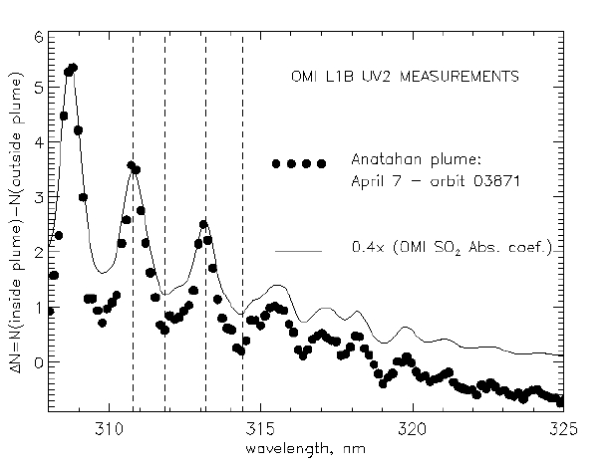
Fig. 1. OMI measured N-value spectra difference inside and outside the Anatahan volcanic plume on April 7, 2005 (orbit 3871) overlapped with a scaled SO₂ cross-section [25] smoothed with the nominal OMI UV-2 slit function (triangular, FWHM=0.45nm [18] ). Nadir observational direction, solar zenith angle 23º, Lambertian Effective Reflectivity, LER=0.1.

Currently, calibrated radiances are routinely produced for twelve UV2 OMI wavelengths for operational production of TOMS-like column ozone (OMTO3), SO₂ data (OMSO2) and vicarious calibrations [22,23]. We have developed a new technique termed the Band Residual Difference (BRD) algorithm that utilizes four of these wavelengths that are positioned at SO₂ band extrema between 310.8 nm and 314.4 nm. Being less computationally demanding than the spectral fitting Maximum Likelihood (ML) algorithm [24], the BRD method is also faster and applicable to generation of OMI SO₂ data in a near-real time operational scenario (e.g., for volcanic cloud advisories to aviation). The BRD algorithm will be used to produce initial Level 2 SO₂ data until such a time as the ML method can be implemented. This paper describes the BRD algorithm and includes examples of preliminary OMI SO₂ retrievals.

OMI SO₂ Algorithm

Algorithm Overview
The BRD algorithm makes use of OMTO3 ozone, Ω_{T}, Lambertian Effective Reflectivity (LER), and calibrated residuals at four UV-2 wavelengths centered on SO₂ bands (Figure 1) to estimate a total vertical column SO₂ amount, Σ_{o} assuming that the logarithm of the spectral reflectance ratio in wavelength pairs can be approximated as:

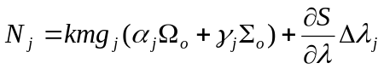 (1),

where Ω_{o} and Σ_{o} are true column ozone and SO₂ amounts, 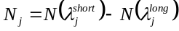 is the measured N-pair value (N=-100*log₁₀(I/F) ) where I is Earth radiance and F is solar irradiance ) for wavelength pair p_{j}, j=1,2,3 and γ_{j} and α_{j} are SO₂ and O₃ differential absorption coefficients for the pair; 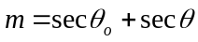 is the geometrical air mass factor (AMF; relative column average photon path of sunlight entering the atmosphere at solar zenith angle θ_{o} and exiting the atmosphere at the OMI viewing zenith angle θ) ; g_{j} is a correction to m accounting for absorber vertical distribution, column amount and LER (see sections C and D); k=100/ln10 is a scaling factor and the S(λ) term represents any systematic biases in either the measurements (calibration) or the model as well as the scattering atmospheric contribution. The main advantage of using pair N values is that wavelength-independent systematic errors are cancelled and wavelength-dependent error terms become proportional to 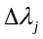; the latter is minimized by selecting close wavelength pairs: 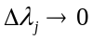 (Figure 1).

TABLE I
OMI SO₂ pair differential cross-sections
(smoothed with the OMI slit function , triangular FWHM=0.45nm).

Pair | λ^{short} - λ^{long}, [nm] | Pair differential absorption coefficients [atm-cm⁻¹]
Pair | λ^{short} - λ^{long}, [nm] | Ozone: α_{j} | SO₂: γ_{j}
P₁ | 310.8 - 311.9 | 0.29 | 5.65
P₂ | 311.9 - 313.2 | 0.34 | -3.3
P₃ | 313.2 - 314.4 | 0.27 | 4.16
P_{B} | 317.6 - 331.3 | 0.76 | 1.97

Table I shows the pair wavelengths currently used by the BRD algorithm, and differential 225K ozone and 295K SO₂ absorption coefficients [25]. Figure 1 shows an analysis of OMI UV-2 spectra from a SO₂ cloud discharged by Anatahan volcano (16.35ºN, 145.67ºE; Mariana Islands) on April 6, 2005. Using a pixel within the April 7, 2005 Anatahan cloud (lat: 14.34ºN) and a cloud-free pixel from the same scan position (31 – nadir) we obtain an OMI observed differential N-value spectrum to compare with a lab spectrum of SO₂ [25] with band center wavelengths from Table I. The SO₂ spectral band positions agree to within 0.1 nm, thus confirming the OMI wavelength calibration [20,21].

Equation (1) can be applied to the operational OMTO3 ozone retrieval. The OMTO3 algorithm [22,23] retrieves the total ozone amount, Ω_{T} and Lambertian Equivalent surface Reflectivity (LER) using the B-pair: P_{B}=(317.6nm, 331.3nm) under most conditions, and the C-pair: P_{C}=(331.3nm, 360.2nm) for high ozone and high solar zenith angle conditions. The longer of the two wavelengths is used to derive LER (or cloud fraction); the shorter wavelength provides total ozone. The residuals at the 10 other wavelengths are then calculated as the difference between the measured and the computed N-values that account for the
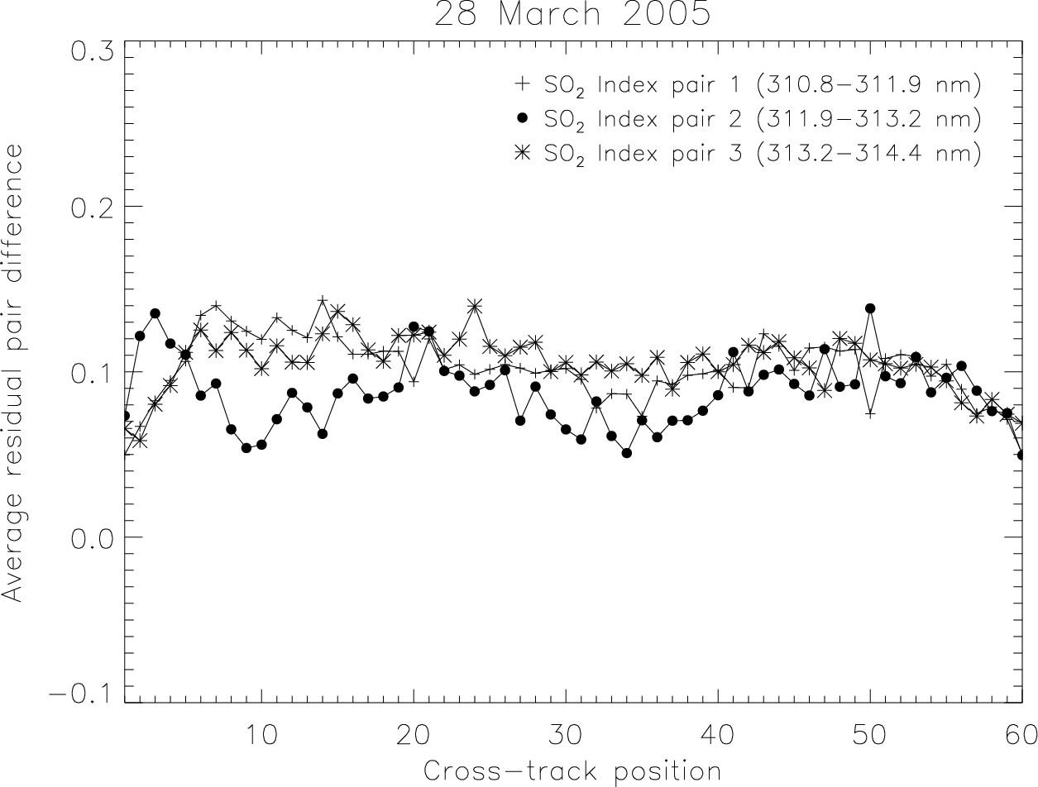
(a)
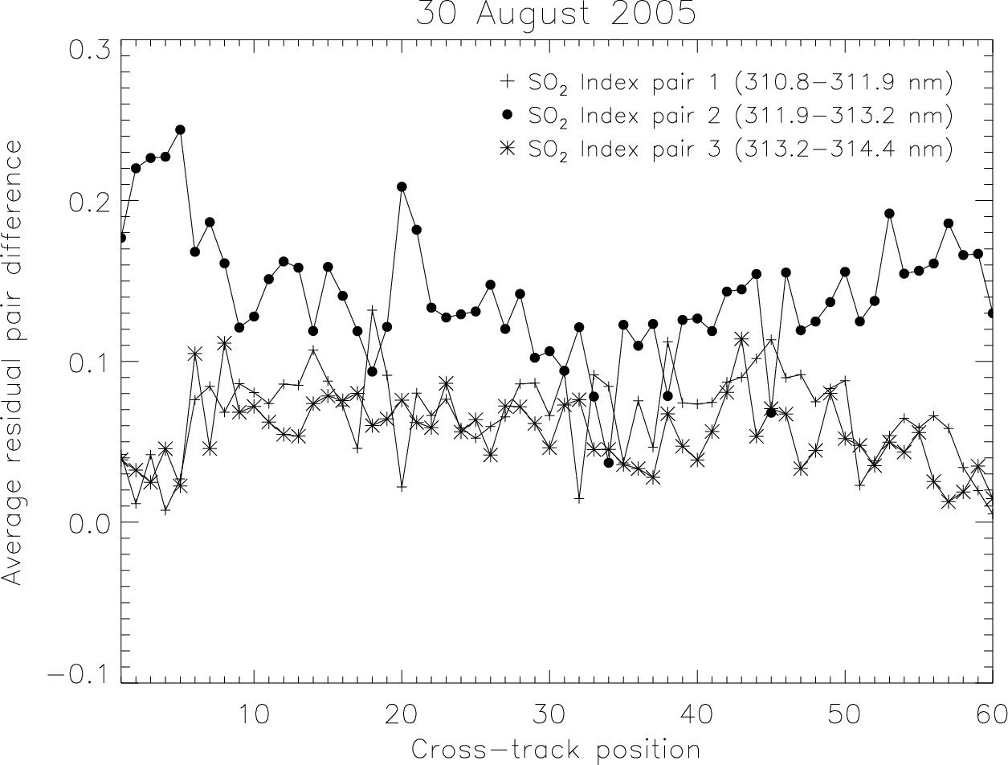
(b)
Fig. 2. Global equatorial pair residuals (daily average biases for each cross-track pixel within 20º latitude of the equator) on (a) March 28, 2005 and (b) August 30, 2005.

effects of multiple Rayleigh scattering, ozone absorption, Ring effect, and surface reflectivity. Using the B-pair and assuming that ozone is the only absorber:

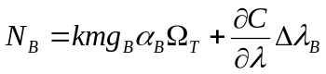 (2),

In equation (2) both Ω_{T} and 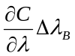 provide closure between the measured and calculated B-pair N values [22,23]. If SO₂ is present, Ω_{T} represents the combined effective column absorber amount:

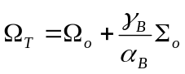 (3)

where Ω_{o} and Σ_{o} are the true column ozone and SO₂ amounts. The OMTO3 algorithm next uses retrieved values of Ω_{T} and LER to calculate residual N values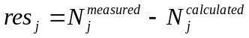 at SO₂ wavelength pairs: p_{J}, j=1,..,3. (Table I). In our notation, the 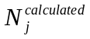can be represented similarly to (1):

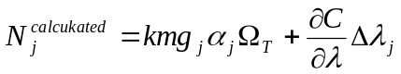 (4)

In the presence of SO₂, shorter wavelength pair residuals are strongly correlated with the differential SO₂ cross-sections and can be used for SO₂ estimation [22]. The equation for residuals is obtained by subtracting (4) from (1) and accounting for (3):

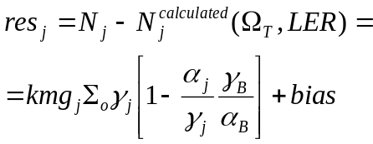 (5)

Background corrections
Biases resulting from non-perfect instrument calibration as well as from forward model simplifications are empirically corrected. Figure 2 shows examples of the cross-track variation of global equatorial pair residuals (the average bias for each cross-track position (constant viewing zenith angle, θ) within +/- 20º latitude of the equator, calculated after excluding heavily SO₂-contaminated pixels) and their variation over time. Biases are corrected by subtracting equatorial pair residuals from the raw pair values for each OMI orbit.
Following the equatorial bias correction SO₂ amounts can be analytically estimated from the single wavelength pair residual given by equation (5):

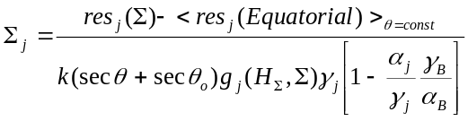 (6)

Using 3 different OMTO3 pair residuals one obtains independent estimates of SO₂ vertical column amounts within the same OMI pixel: Σ_{j}. These are further averaged to produce the operational SO₂ vertical column amount. The differences between individual Σ_{j} estimates are also written to the output file to provide a useful indicator of the overall accuracy of the OMI measurements and the BRD algorithm assumptions.

Air-mass corrections due to SO₂ height and amount
Initial SO₂ estimates could be made assuming a geometrical AMF (g_{pj}=1 in equation (6)). However, a geometrical approximation to the AMF (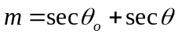) is a simplification because of atmospheric scattering and absorption as well as surface reflection. The approximation fails for low sun elevations because of Earth sphericity. Clouds and aerosols in the boundary layer also affect the AMF in complicated ways. For large SO₂ amounts, using a geometrical AMF will underestimate the SO₂ load, due to a reduced UV-light penetration effect. The effect depends on wavelength, reflectivity, observational geometry, SO₂ load and vertical profile. Figure 3 illustrates the saturation effect for the most favorable observational conditions: overhead sun, nadir view angle, 325 DU standard ozone profile [22,23], with no clouds or aerosol scattering. The SO₂ vertical profiles were assumed to be Gaussian for a volcanic cloud at 15 km (with 1 km standard deviation) and uniform mixing between the surface and 3 km (700mb) for the boundary layer case.
For more accurate consideration each absorption coefficient in equations (1)-(6) at each wavelength should be multiplied by its own effective AMF that depends also on the absorber amount and profile. In doing so, the equations become non-linear in absorber amounts and the retrieval problem becomes circular: the AMFs are required for column amounts estimates, but AMFs themselves require prior knowledge of absorber amounts. However, first-order corrections to the geometrical AMF approximation, g can be estimated using off-line forward RT calculations [26] :
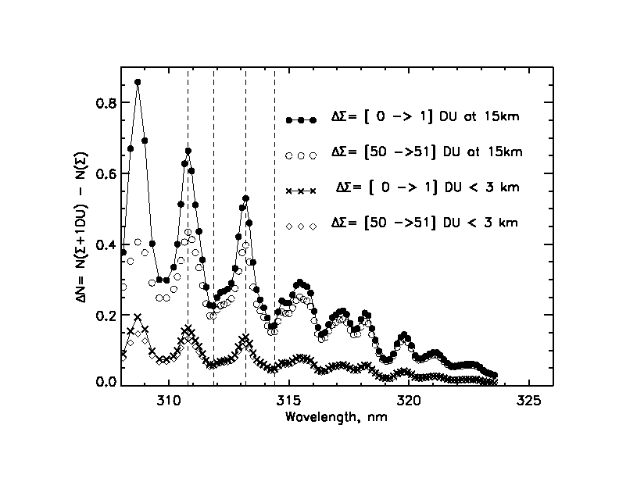
Fig. 3. Modeling of incremental effect of 1 Dobson Unit (1 DU=2.65x10¹⁶ molecules/cm²) of SO₂ on spectral N-values (N=-100log₁₀(I/F)) at the top of the atmosphere. SO₂ was placed at 15km (upper 2 curves represent small (1 DU) and high (50 DU) SO₂ loading) and in the boundary layer (lower curve, small loading). The N-values were smoothed with the OMI triangular slit function (FWHM=0.45 nm). OMTO3 SO₂ residual wavelengths (Table I) are shown as dashed lines. The assumptions used in RT calculations: Nadir observational direction, overhead sun, Lambertian Equivalent Reflectivity [22,23]: LER=0.05.

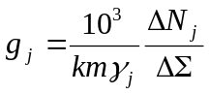 (7)

where ΔN_{j} is the pair N_{j} value increment due to a small column SO₂ change (assuming fixed SO₂ profile, reflectivity and geometry) and γ_{j} is the differential SO₂ absorption coefficient [atm-cm⁻¹] at wavelength pair p_{j}. The N_{j} values were calculated with a forward RT model assuming different SO₂ loads and vertical profiles (Figure 3). The g_{j} factors were calculated from equation (7) for different wavelength pairs P₁-P₃. As can be seen from Table II, g factors are close to 1 only for upper tropospheric/stratospheric plumes containing small SO₂ loads (<10 DU). Fresh stratospheric plumes typically have much larger SO₂ loads (>50 DU), in which case g is greatly reduced (~0.5-0.7) due to the reduced penetration of UV light. On the other hand, for small SO₂ sources that are expected to produce plumes in the boundary layer, the g factor is ~0.2-0.3, due to the penetration effect, especially at shorter UV wavelengths (Table II). The penetration problem is exacerbated at large solar zenith angles and large view angles (off-nadir pixels) as well as for increased ozone amounts. Therefore, the detection of small SO₂ plumes becomes more challenging for middle and high latitudes. In any case, both the SO₂ altitude and load should be known approximately beforehand to allow reasonable AMF corrections. The whole problem could then be solved iteratively by assuming a geometric air-mass factor as a first step, then calculating SO₂ amounts from (6) and AMF corrections from (7) (or interpolated g values from Table II), then re-calculating SO₂ amounts from (6) and estimating g and so on. However, the SO₂ vertical profile should be known (or estimated) from ancillary sources.

TABLE II
Correction factors to geometrical AMF
for 5% surface reflectivity and 325DU mid-latitude ozone profile [22,23], overhead sun and nadir viewing direction, no aerosol or clouds

SO₂ column  amount | SO₂= 0 - 10 DU |  | SO₂=50-60DU
Plume height | <3 km | 15km | < 3km | 15km
P1 | 0.21 | 0.89 | 0.16 | 0.48
P2 | 0.27 | 1.06 | 0.22 | 0.70
P3 | 0.25 | 0.99 | 0.21 | 0.68

The g factors given in Table II apply to the most favorable observational scenario: overhead sun, nadir viewing position, no aerosols or clouds. However, the impact of solar zenith angle (less than 70º) and viewing geometry (viewing angle less than 70º and azimuthal angle ~90º) on the AMF is reasonably well represented by the geometrical approximation (m). Therefore, the g factors in Table II are applicable to all clear pixels not far off-nadir with moderate solar zenith angles in low and middle latitudes. These cases can be easily identified in OMI data by looking at low reflectivity pixels. We concentrate on such clear cases first (see section III).

AMF corrections due to underlying reflectivity
The sensitivity of backscattered radiances to SO₂ increases with increasing reflectivity of the underlying surface [23]. Although enhanced surface reflectivity assists detection of small SO₂ plumes, especially those in the PBL that otherwise are undetectable by OMI, it will also produce overestimates of actual SO₂ loading if the AMF is not adjusted. Table III compares g factors at LER=5% (Table II) and LER=80%. We note that the largest increase in SO₂ sensitivity occurs for PBL SO₂ (up to factor of 5), while for stratospheric volcanic plumes sensitivity increases by only ~30%. At any given altitude the reflectivity effect is larger for larger SO₂ amounts.
The OMI total ozone algorithm (OMTO3) output file includes Lambertian effective reflectivity at 331 nm (LER). We correct g factors by interpolating values given in Table III to the actual OMI measured value of LER.

TABLE III
Ratio of correction factors at LER =80% to LER=5%

SO₂ column  amount | SO₂= 0 - 10 DU |  | SO₂=50 - 60DU
Plume Heigt | <3 km | 15km | < 3km | 15km
P1 | 4.8 | 1.2 | 4.5 | 1.5
P2 | 4.7 | 1.1 | 4.5 | 1.3
P3 | 4.7 | 1.1 | 4.5 | 1.3

OMI SO₂ data overview

The OMI SO₂ product (OMSO2) uses the HDF5-EOS format. Each OMSO2 granule corresponds to a single OMI orbit. In addition to standard geolocation and satellite ephemeris parameters, the OMSO2 product contains the residual pair difference values (N_{pj}); total column SO₂ for 3 different SO₂ cloud altitudes (PBL, 5 km and 15 km); aerosol index, ozone and reflectivity values; and data quality flags.

Explosive Eruptions
The AURA OMI SO₂ volcanic data set will continue the TOMS SO₂ record, which covers a quarter-century [1]-[7] (http://toms.umbc.edu). Using the BRD algorithm, we have been able to measure SO₂ emissions from every significant volcanic eruption that has occurred since OMI data became routinely available in September 2004. One example, the eruption of Manam volcano (Papua New Guinea) on January 27-28, 2005, can be seen in [27]. Figure 4 shows SO₂ emissions produced by an eruption of Anatahan volcano (Mariana Islands) on April 6 (this cloud was used for the analysis shown in Figure 1). The high sensitivity and contiguous coverage of OMI allows such emissions to be tracked for several days, providing opportunities for trajectory model validation.
Very few events remain undetected by OMI; the main factors impeding detection of lower tropospheric SO₂ emissions are extensive cloud cover and/or high ozone column amounts (both common over the volcanoes of Russia’s Kamchatka peninsula, for example). The latter can overwhelm the SO₂ absorption in lower tropospheric volcanic clouds (also see section IV).
OMI’s high sensitivity to SO₂ also permits one to conclude with more confidence whether an explosive eruption has produced SO₂ or if it has not (i.e. if it is a phreatic, or steam-driven event). This is very important in an aviation hazards context, since production of SO₂ indicates a magmatic eruption with the potential for buoyant upper tropospheric or stratospheric (i.e. aircraft cruising level) plumes.

Passive degassing
The OMI BRD algorithm has permitted the first daily, space-based measurements of passive volcanic SO₂ degassing (e.g., [28], [29]) in the lower troposphere. Strong SO₂ sources (e.g., [29]; Fig. 5) can be tracked on a daily basis with OMI (in the absence of significant cloud cover), whilst for weaker sources a successful approach has been to generate weekly or monthly averages of OMI SO₂ data to increase the signal to noise ratio (e.g., [29]).

Anthropogenic SO₂ pollution
We have also achieved very promising measurements of anthropogenic SO₂ emissions using the BRD algorithm. SO₂ emissions have been measured by OMI over known sources of air pollution, such as the Ohio valley in the USA, eastern China, and Eastern Europe (e.g., Fig. 6). The most significant discovery to date has been the detection of SO₂ emissions from individual copper smelters in South America and elsewhere. These measurements will be discussed in a separate paper [30].
Figure 6 shows OMI SO₂ retrievals in polluted regions of eastern Asia and Eastern Europe. These examples show that OMI can observe SO₂ emissions in the planetary boundary layer (PBL) on a daily basis, thereby improving on GOME and SCIAMACHY, which need several days to acquire a contiguous global map [13-15] and hence could miss short-lived pollution events. We note that the SO₂ enhancements detected by OMI in Eastern Europe in February 2005 (Fig. 6b) correspond in both location and approximate column amount to GOME observations from February 1998 reported in [14]. These SO₂ emissions are sourced from lignite-burning power plants in the Balkan region [14].

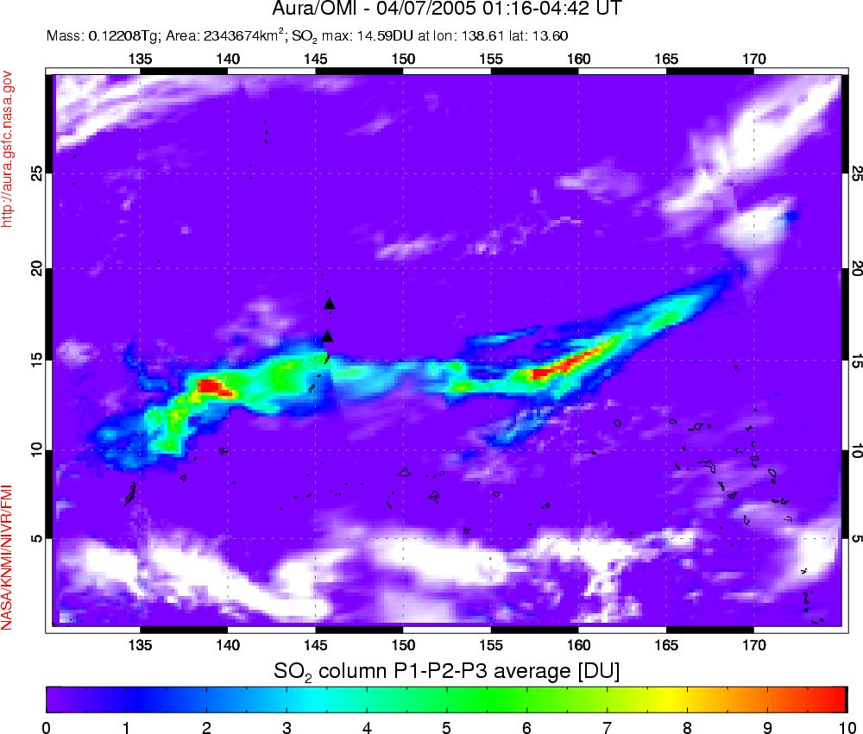
Fig. 4. OMI SO₂ image of the Anatahan (16.35ºN, 145.67ºE) eruption cloud on April 7, 2005, produced by an explosive eruption on April 6. White regions are meteorological clouds.

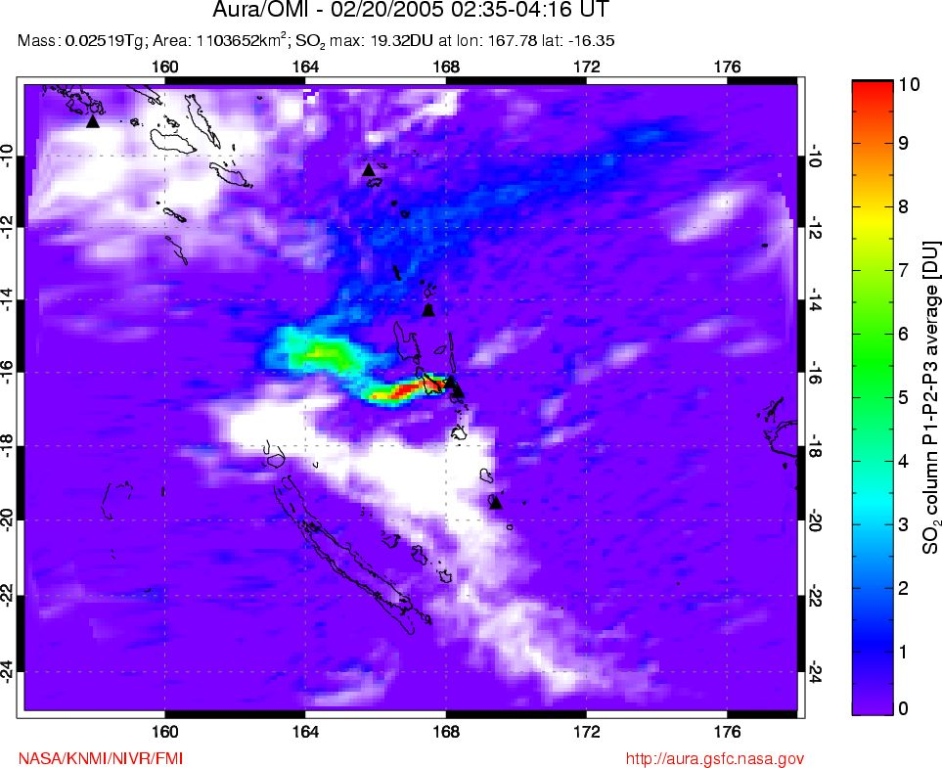
Fig. 5. OMI SO2 image of passive degassing from Ambrym volcano, Vanuatu (16.25ºS, 168.12ºE) on February 20, 2005. White regions are meteorological clouds.

DATA QUALITY ASSESMENT
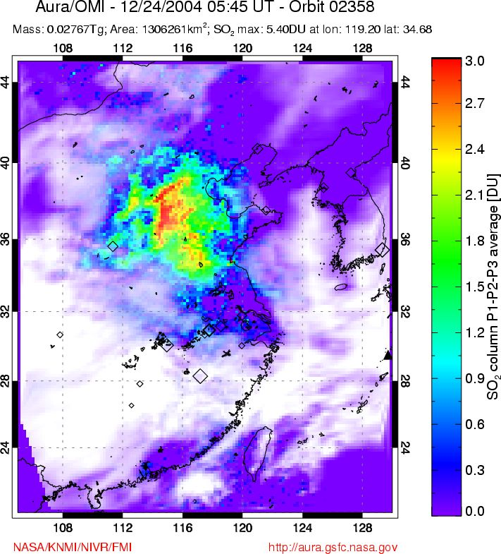
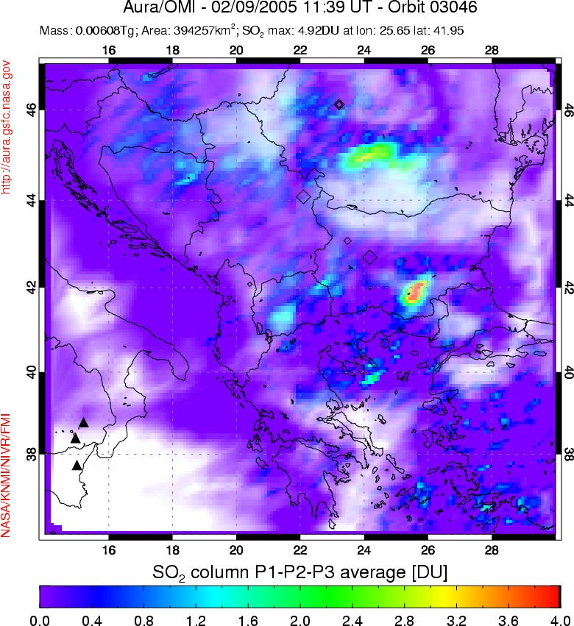
Fig. 6. OMI measurements of anthropogenic SO₂ emissions in the PBL. (a, top panel) Air pollution in a cloud-free region of eastern China on December 24, 2004. Clouds are shown in white. (b, bottom panel) SO₂ emissions from sources in S.E. Europe (chiefly in Romania and Bulgaria) on February 9, 2005. Note the low background noise (<0.5 DU) in both images.

(a)
(b)
Assessment of OMI data quality is difficult as minimal SO₂ validation data are currently available. Errors will not necessarily be randomly distributed over the globe, but will typically increase with solar zenith angle, large ozone or SO₂ column amounts and in the presence of clouds and heavy aerosol loading.
With a lifetime of about a day in the lower troposphere, the amount of SO₂ in the PBL is typically very small (less than 0.5 DU except very near to a source). In non-polluted regions, including most of the Southern hemisphere, the amount is near zero. Thus the retrieval sensitivity can be estimated from the noise level in background areas. An initial evaluation for two assumed SO₂-free regions, over the N. Atlantic (40-60ºN, 10-45ºW) and S. Pacific (0-40ºS, 120-180ºW) in January 2005, produces the results shown in Table IV. The N. Atlantic case assumes a boundary layer SO₂ profile and is applicable to a pollution scenario at mid-latitudes in winter. The S. Pacific example is for a volcanic SO₂ cloud at 15 km and therefore shows the noise expected under optimum retrieval conditions (overhead sun, upper tropospheric/stratospheric SO₂ cloud).

TABLE IV
OMI SO₂ background noise estimation

Region | Mean, DU | Standard deviation, DU
North Atlantic, January 2005, PBL SO₂ | -0.066 | 0.50
South Pacific, January 2005, SO₂ cloud at 15 km | -0.050 | 0.22

We therefore expect the standard deviation of OMI SO₂ retrievals to be 0.5 DU or less, which is ten times lower than TOMS SO₂ data [4]-[6].
When SO₂ is present, the retrieval depends on its vertical distribution and total amount. As most air pollution sources release the SO₂ into the PBL or lower troposphere, we assume a constant mixing ratio distribution in the PBL. The height of the PBL is currently assumed to be 3 km (700 mb), but in the future it could also be specified either from external data or from climatology. As the retrieval dependence on altitude becomes small in the upper troposphere and stratosphere, we assume that eruption clouds are at 15 km (close to the tropopause in the tropics, where most explosive eruptions occur). Passive emissions frequently take place from volcanic vents that release SO₂ into the free troposphere. We initially assume this occurs near 5 km.
The largest errors are expected for cloudy and partially cloudy conditions. Depending on their location relative to the SO₂, meteorological clouds can shield SO₂ at low altitudes from OMI, or artificially enhance the SO₂ signal above them. In addition, there is a small positive bias associated with reflective meteorological clouds, which produce a bias typically on the order of 0.2 DU SO₂ but up to ~1 DU in some cases. The bias is most apparent at the edges of clouds, or in the presence of small (sub-pixel sized), highly reflective clouds.
In polluted regions the sulfate haze from oxidation of older SO₂ constitutes a source of error in the retrievals if not accounted for in the atmospheric model used in AMF estimation. Retrieval errors arise from noise in the radiance measurements, and from simplifications in the atmospheric models and in cross-section data. Ash in volcanic clouds can produce as much as 30% overestimations if not accounted for in the AMFs [4], [6],[26]. Passive emissions typically have less than 50 DU SO₂ and are often free of ash so that no error occurs due to ash scattering.

SO₂ VALIDATION PLAN
Comparisons of OMI with Earth Probe TOMS data for explosive eruption clouds are needed to assure consistency between the databases for extension of the TOMS eruption mass time series. EP TOMS operations are planned for at least 2 years overlap with OMI.
Subsequently, we plan to compare OMI total column SO₂ with AURA Microwave Limb Sounder (MLS) SO₂ measurements. The advantage of such comparisons is that MLS provides the vertical distribution of SO₂ in the stratosphere and upper troposphere (down to 215 hPa) [31]. Using this information we will be able to specify the profile for the AMF g_{pj} in equation (7).
In addition to MLS, other A-Train sensors are capable of measuring SO₂ and will provide coincident or near-coincident correlative observations for validation of OMI SO₂ data. On Aura, the Tropospheric Emission Spectrometer (TES) [32] has IR channels suitable for SO₂ measurements. TES is a pointable Fourier Transform Spectrometer capable of tropospheric SO₂ profile retrievals in limb or nadir viewing mode. On Aqua, the IR AIRS instrument offers high sensitivity to SO₂ and a similar footprint dimension to OMI (~13.5 km) [16], and is therefore an important source of correlative observations. However, due to interference from water vapor AIRS is typically unable to provide correlative measurements of SO₂ in the PBL or lower troposphere [33]. Preliminary comparisons of OMI SO₂ data with AIRS and EP-TOMS data for explosive eruptions show that OMI SO₂ columns are accurate for upper tropospheric SO₂ clouds [33].
The Moderate Resolution Imaging Spectroradiometer (MODIS) on Aqua also has IR channels sensitive to SO₂. Although MODIS is inherently less sensitive to SO₂ than AIRS or OMI, its high spatial resolution (1 km) will provide information on SO₂ variability and/or meteorological cloud interference on sub-OMI pixel scales. This will be particularly important for evaluation of OMI SO₂ retrievals in the PBL.
Validation of OMI measurements of SO₂ located in the lower troposphere and PBL are more challenging. We plan to use low-altitude aircraft SO₂ measurements (spirals) [12] as well as ground-based column SO₂ measurements from double Brewer spectrometer stations and portable UV spectrometers near SO₂ sources. The latter endeavor will be facilitated by the current proliferation of compact UV spectrometers in the volcanological community [e.g., 34], which is improving the quantity and temporal resolution of ground-based differential optical absorption spectroscopy (DOAS) measurements of SO₂ at degassing volcanoes. The OMI validation effort will benefit from the imminent deployment of a global network of these instruments [35].

Conclusion
Almost a quarter-century of TOMS volcanic eruption SO₂ masses are now available (http://toms.umbc.edu) [6]-[8]. The OMI SO₂ data set will continue the TOMS record but the improved sensitivity and smaller footprint of OMI will extend the range of detection to smaller eruptions and older clouds, and to degassing volcanoes. A comparison of the volcanic cloud detection capability for TOMS and OMI is shown in Table V. A conservative cloud detection algorithm requires 5 adjacent pixels each containing more than 5 noise standard deviations. A dramatic 150-fold improvement is found.

Table V. Comparison of SO₂ detection limits for eruption clouds at or above 15 km from TOMS and OMI.

Instrument | Typical noise level, DU | Nadir footprint area, km² | Detection limit, tons  5 pixels@ 5 σ
TOMS | 5 | 2500 | 7000
OMI | 0.22 | 312 | 47

Using OMI data, we can directly compare daily global SO₂ emissions from anthropogenic and volcanic sources for the first time, and thus provide important new constraints on the relative magnitude of these fluxes. Such measurements are essential given the growing concern over the effects of anthropogenically-forced climate change and intercontinental transport of air pollution. The fast BRD SO₂ retrieval is also amenable to operational SO₂ alarm development, and near real-time application for aviation hazards and volcanic eruption warnings.
The BRD algorithm sensitivity does not represent the maximum sensitivity theoretically achievable with OMI, and hence future algorithm improvements should allow even weaker SO₂ sources to be monitored routinely. These measurements are expected to produce the best estimates to date of the volcanic contribution to global atmospheric SO₂ abundances.
Acknowledgment
The authors thank KNMI OMI team for producing L1B radiance data and US OMI operational team for continuing support. We also appreciate the work of Dave Flittner for help with radiative transfer calculations and thank Gregg Bluth and a second anonymous reviewer for suggesting improvements to the paper. The authors thank Pieternel Levelt and Johan de Haan (KNMI) and Johanna Tamminen (FMI) for their thorough reading of the manuscript and valuable comments.
References
- A. J. Krueger, “Sighting of El Chichon sulfur dioxide clouds with the Nimbus 7 Total Ozone Mapping Spectrometer”, Science, 220, 1983, pp. 1277-1379.
- G.J.S. Bluth, S.D. Dorion, C.C. Schnetzler, A.J. Krueger, and L.S. Walter, “Global tracking of the SO2 clouds from the June 1991 Mount Pinatubo eruptions”, Geophys. Res. Lett., 19(2), pp. 151-154,1992.
- G.J.S. Bluth, S.D. Dorion, C.C. Schnetzler, A.J. Krueger, and L.S. Walter, “The contribution of explosive volcanism to global atmospheric sulfur dioxide concentrations”, Nature, 366, 1993, pp. 327-329.
- A.J. Krueger, L. S. Walter, P. K. Bhartia, C. C. Schnetzler, N. A. Krotkov, I. Sprod, G. J. S. Bluth, Volcanic sulfur dioxide measurements from the total ozone mapping spectrometer instruments, J. Geophys. Res., 100(D7), pp. 14057-14076, 10.1029/95JD01222, 1995.
- C.C. Schnetzler, G.S.J. Bluth, A.J. Krueger, and L.S. Walter, “A proposed volcanic sulfur dioxide index (VSI)”, J. Geophys. Res., vol. 102, pp. 20,087-20,092, 1997
- A. J. Krueger, S. J. Schaefer, N. Krotkov, G. Bluth, and S. Barker, “Ultraviolet remote sensing of volcanic emissions”, in Remote Sensing of Active Volcanism, Geophys. Monogr. Ser., vol. 116, edited by P. J. Mouginis-Mark, J. A. Crisp, and J. H. Fink, pp. 25-43, AGU, Washington, D. C, 2000
- S. A. Carn, A. J. Krueger, G. J. S. Bluth, S. J. Schaefer, N. A. Krotkov, I. M. Watson, and S. Datta, Volcanic eruption detection by the Total Ozone Mapping Spectrometer (TOMS) instruments: a 22-year record of sulphur dioxide and ash emissions, in Volcanic Degassing, Spec. Publ. Geol. Soc. Lon., vol. 213, edited by C. Oppenheimer, D. M. Pyle, and J. Barclay, pp. 177-202, Geological Society, London, 2003
- G. S. Gurevich and A. J. Krueger, “Optimization of TOMS wavelength channels for ozone and sulfur dioxide retrievals”, Geophys. Res. Lett., 24: (17) pp. 2187-2190, 1997.
- S.A. Carn, “Eruptive and passive degassing of sulfur dioxide at Nyiragongo volcano (D.R. Congo): the 17 January 2002 eruption and its aftermath”, Acta Vulcanologica 14-15, pp.75-86, 2004.
- S.A. Carn, N. A. Krotkov, M.A. Gray, and A.J. Krueger, “Fire at Iraqi sulfur plant emits SO₂ clouds detected by Earth Probe TOMS”, Geophys. Res. Lett., 31, L19105, doi: 10.1029/2004GL020719, 2004
- S. J. Schaefer, J.B. Kerr, M.M. Millan, V.J. Realmuto, A.J. Krueger, N.A. Krotkov, C. Seftor, and I.E. Sprod, “Geophysicists unite to validate volcanic SO2 measurements”, Eos, Trans., AGU, 78,217,p. 223, 1997
- R. R. Dickerson, J.C. Hains, and J.P. Burrows, “Combining in-situ and remote measurements with models: picking the right tools”, EOS Trans. AGU, 85(17), Jt. Assem. Suppl., Abstract A31D-02, 2004
- J. P. Burrows, M. Weber, M. Buchwitz, V. Rozanov, A. Ladstätter-Weissenmayer, A. Richter, R. de Beek, R. Hoogen, K. Bramstedt, K.-U. Eichmann, M. Eisinger, and D. Perner, “The Global Ozone Monitoring Experiment (GOME): Mission concept and first scientific results”, J. Atm. Sci., 56, pp. 151-175, 1999.
- M. Eisinger and J. P. Burrows, “Tropospheric Sulfur Dioxide observed by the ERS-2 GOME instrument”, Geophys. Res. Lett, 25, pp. 4177-4180, 1998.
- H. Bovensmann, et al., “SCIAMACHY – Mission objectives and measurement modes”, J. Atmos. Sci., 56, pp. 127-150, 1999.
- S. A. Carn, L. L. Strow, S. de Souza-Machado, Y. Edmonds and S. Hannon, “Quantifying tropospheric volcanic emissions with AIRS: the 2002 eruption of Mt. Etna (Italy)”, Geophys. Res. Lett., 32, L02301, doi:10.1029/2004GL021034, 2005.
- M.R. Schoeberl, A. R. Douglass, E. Hilsenrath ,P.K. Bhartia, J. Barnett, J. Gille, R. Beer, M. Gunson, J. Waters, P. F. Levelt, and P. DeCola, “Earth Observing System Misions Benefit Atmospheric Research”, EOS Trans., American Geophysical Union, 85, 18, May 4, pp. 177-181, 2004
- P.F. Levelt, G. H. J. van den Oord, M.R. Dobber, A. Malkki, H. Visser, J. de Vries, P. Stammes, J. Lundell, H. Saari, “The Ozone Monitoring Instrument”, IEEE Trans. Geo. Rem. Sens. AURA special issue, to be published.
- P.F. Levelt, E. Hilsenrath, G.W. Lippelmeier, G.J.B. van den Oord, P.K. Bhartia, J. Tamminen, J. F. de Haan, and J.P. Veefkind, “Science Objectives of the Ozone Monitoring Instrument”, IEEE Trans. Geo. Rem. Sens. AURA special issue, to be published.
- M. R. Dobber, et al., “Ozone Monitoring Instrument description, performance and calibration”, IEEE Trans. Geo. Rem. Sens. AURA special issue, to be published.
- G.H.J. van den Oord et al., “OMI level 0 to 1b processing and operational aspects”, IEEE Trans. Geo. Rem. Sens. AURA special issue, to be published
- Bhartia,P.K. C. W. Wellemeyer, “TOMS-V8 total ozone algorithm” In OMI Algorithm Theoretical Basis Document, OMI Ozone Products, vol. 2 , version 2, Ed by P. K. Bhartia, NASA/Goddard Space Flight Center, 2002. Available: http://eospso.gsfc.nasa.gov/eos_homepage/for_scientists/atbd/docs/OMI/ATBD-OMI-02.pdf
- C. Wellemeyer, P.K. Bhartia, S.L. Taylor, W. Qin, C. Ahn, “ Version 8 Total Ozone Mapping Spectrometer (TOMS) algorithm”, In: Ozone, Volume I, Proceedings Quadrennial Ozone Symposium, KOS, Greece, pp. 635-636, 2004.

- A. J. Krueger N. Krotkov, S. Datta, O.Dubovik, D. Flittner, OMI SO2 algorithm, In OMI ATBD, vol. 4: “OMI trace gas algorithms”, Ed by K. Chance, NASA EOS Project Office, Science Mission Directorate, NASA/Goddard Space Flight Center, 2002. Available: http://eospso.gsfc.nasa.gov/eos_homepage/for_scientists/atbd/docs/OMI/ATBD-OMI-04.pdf
- T. McGee and J. Burris, “SO2 absorption cross sections in the near UV”, J. Quant. Spectrosc. Radiative Transfer, vol. 37(2), pp.165-182, 1987.
- N. A. Krotkov, A. J. Krueger, P. K. Bhartia “Radiative Transfer model of volcanic plumes”, J. Geophys. Res, vol. 102, (D18), pp. 21891-21904, 1997.
- NASA Earth Observatory (2005). Sulfur Dioxide Plume from Manam Volcano. [Online]. Available: http://earthobservatory.nasa.gov/Newsroom/NewImages/images.php3?img_id=16820
- NASA Earth Observatory (2005). Eruption of Anatahan. [Online] Available: http://earthobservatory.nasa.gov/NaturalHazards/natural_hazards_v2.php3?img_id=12711

- NASA Earth Observatory (2005). Sulfur Dioxide Leaks from Ambrym Volcano. [Online] Available: http://earthobservatory.nasa.gov/NaturalHazards/natural_hazards_v2.php3?img_id=12795
- S. A. Carn, N. A. Krotkov, and A. J. Krueger (2005), Peruvian copper smelter emissions measured by the Ozone Monitoring Instrument, Geophys. Res. Lett. (in preparation).
- W. G. Read, NASA Jet Propulsion Laboratory, California Institute of Technology, Pasadena, CA, private communication, April 2005.
- Tropospheric Emission Spectrometer (TES) [online] Available: http://tes.jpl.nasa.gov
- F. Prata, private communication, 2005

- Galle, B., C. Oppenheimer, A. Geyer, A.J.S. McGonigle, M. Edmonds, and L.A. Horrocks, “A miniaturised ultraviolet spectrometer for remote sensing of SO₂ fluxes: a new tool for volcano surveillance”, Journal of Volcanology and Geothermal Research, 119, pp. 241-254, 2003.
- B. Galle, personal communication, 2005


Nickolay A. Krotkov received BS (in Physics) and MS (in Remote Sensing) in 1985 from Moscow Institute of Physics and Technology (Russia). He received PhD in Oceanography (physics and mathematics) in 1990 from the P.P. Shirshov Institute of Oceanology, Russian Academy of Sciences, for research on using polarization properties of light in oceanic remote sensing. He joined NASA, Goddard Space Flight Center, in 1993 where he worked on applications of satellite data, such as global mapping of surface ultraviolet (UV) irradiance and generation of UV volcanic eruption data products from the NASA Total Ozone Mapping Spectrometer (TOMS) missions. His main field of research is radiative transfer modeling, satellite and ground based UV data analysis and inversions. He is currently a senior research scientist with Goddard Earth sciences and Technology (GEST) Center, University of Maryland Baltimore County at NASA/GSFC in Greenbelt, Maryland. Dr. Krotkov is a member of American Geophysical Society.


Simon Carn received a BA (in Earth Science) from Oxford University (UK) in 1993 and a DEA (in Volcanology/Magmatic Processes) from Université Blaise Pascal, Clermont-Ferrand (France) in 1994. He received a PhD in Volcanology in 1999 from the Department of Earth Sciences, Cambridge University (UK), for research on volcanism in Indonesia. From 2000-2001 he worked as a volcanologist on the active volcanic island of Montserrat (West Indies). In 2001 he joined the Joint Center for Earth Systems Technology (JCET) at the University of Maryland Baltimore County (UMBC), to work on remote sensing of volcanic sulfur dioxide (SO₂) emissions using UV satellite data from the NASA Total Ozone Mapping Spectrometer (TOMS) missions and lately from the Ozone Monitoring Instrument (OMI) on the EOS/Aura spacecraft. His main research interests are satellite and ground-based UV/IR data analysis applied to studies of volcanic degassing, eruption monitoring, and air pollution monitoring. He is currently an assistant research scientist in JCET.

Arlin Krueger is Research Professor in the Department of Physics at the University of Maryland, Baltimore County. He received his BA in Physics at the University of Minnesota in 1955 and his PhD in Atmospheric Sciences at Colorado State University in 1984. He initially developed rocket instruments to measure atmospheric ozone from 1959 to 1969 at the Naval Weapons Center, China Lake, CA. From 1969 to 2000, he developed satellite instruments and remote sensing techniques at Goddard Space Flight Center, Greenbelt, MD. His primary instrument, the Total Ozone Mapping Spectrometer (TOMS) was noted for the detection of the Antarctic Ozone Hole and for its measurements of volcanic eruption sulfur dioxide clouds. Currently at UMBC, he serves as PI for development of SO2 algorithms for the Aura/ OMI Science Team and for development of near real-time volcanic cloud products for aviation hazard avoidance.

Dr. Bhartia received his Ph.D. in Physics and MS in Computer Science degrees in 1977 from Purdue University, West Lafayette, Indiana. He is currently the Project Scientist of NASA's Total Ozone Mapping Spectrometer (TOMS) satellite mission and the US Science Team Leader of the Ozone Monitoring Instrument (OMI) on EOS Aura. He has over 60 scientific publications, dealing principally with the measurement of the Earth's ozone layer. He has received several NASA awards for his work, including the prestigious William Nordberg Medal in Earth Science from NASA Goddard Space Flight Center.

Kai Yang received BS in Physics in 1984 from Sun Yat-Sen University in Guangzhou, China and PhD in Physics in 1991 from Kansas State University. He joined the Chemistry Department at Princeton University where he conducted theoretical research on the scattering and absorption of atoms on solid surfaces. In 1993 he came to NASA Goddard Space Flight Center and performed radiative transfer simulations of the Moderate Resolution Imaging Spectroradiometer (MODIS) measurements and developed the MODIS level 2 gridded products. Later he joined the Ozone Monitoring Instrument (OMI) science support team in 2001, working on advanced algorithms for total ozone retrieval. His research interests include spectral fitting and optimal estimation methods for trace gas retrieval, atmospheric radiative transfer modeling, rotational Raman scattering, and remote sensing data analysis and applications. He is currently a senior scientist with SSAI in Lanham, Maryland.

 Manuscript received April 29, 2005. This work was supported in part by NASA under OMI and TOMS science teams. N. A. Krotkov is with the Goddard Earth Sciences and Technology Center, Greenbelt, MD 20771 USA (phone: 301-614-5553; fax: 301-614-5903; e-mail: krotkov@chescat.gsfc.nasa.gov ). S. A. Carn, is with the Joint Center for Earth System Technology (JCET), University of Maryland Baltimore County (UMBC), Baltimore, MD 21250 USA. (e-mail: scarn@umbc.edu). A. J. Krueger is with the JCET/UMBC, Baltimore, MD 21250 USA. (e-mail: akrueger@umbc.edu). P.K. Bhartia is with Laboratory for Atmospheres, NASA Goddard Space Flight Center,Greenbelt, MD 20771 USA (e-mail: Pawan.Bhartia@nasa.gov ) K. Yang is with Science Systems and Applications, Inc., Greenbelt, MD Science Systems and Applications, Inc. (e-mail: Kai.Yang.1@gsfc.nasa.gov ).

