SO₂ data from the Ozone Monitoring Instrument
N.A. Krotkov⁽¹⁾, K. Yang ⁽¹⁾ , A. Krueger⁽²⁾, S.A. Carn⁽²⁾, P.K. Bhartia⁽³⁾, P.F. Levelt⁽⁴⁾

⁽¹⁾GEST/UMBC, Baltimore, MD (USA), Emai:l Krotkov@mhatter.gsfc.nasa.gov
⁽²⁾JCET/UMBC, Baltimore, MD (USA), Email: akrueger@umbc.edu
⁽³⁾NASA/GSFC, Greenbet, MD (USA), Email:
⁽⁴⁾ Royal Netherlands Meteorological Institute (KNMI), DeBuilt (Netherlands), Email:

ABSTRACT

In this presentation we discuss the algorithm and error estimates of the operational OMI SO2 data. We show examples of passive degassing from several volcanoes and anthropogenic SO₂ emissions over eastern China, South America and Europe.

INTRODUCTION
Sulfur Dioxide (SO₂) is a short-lived gas primarily produced by volcanoes, power plants, refineries, metal smelting and burning of fossil fuels. SO₂ can be a noxious pollutant and a major player in global climate forcing, depending on altitude. Where SO₂ remains near the Earth’s surface, it is toxic, causes acid rain, and degrades air quality. SO₂ that moves into the free troposphere forms aerosols that can alter cloud reflectivity and precipitation. In the stratosphere, volcanic SO₂ forms long-lived sulfate aerosols that can result in climate change. The first quantitative data on the mass of SO₂ in a major eruption (El Chichon, 1982) was obtained from the six-UV band NASA Nimbus-7 Total Ozone Mapping Spectrometer (TOMS) [1]. All significant eruptions since 1978 have now been measured by the series of TOMS instruments (Nimbus-7, Meteor-3, ADEOS I, Earth Probe (EP)) [2-7]. The SO₂ detection sensitivity was limited to large volcanic clouds by the discrete TOMS wavelengths that were designed for total ozone measurements [1,4]. However, the 4-6 DU SO₂ noise levels in the vertical column (1 Dobson Unit (DU)=2.65x10¹⁶ molecules/cm²) are too high to measure background SO₂ amounts or most anthropogenic SO₂. This is not a fundamental limitation of satellite UV technique but instead due to the initial selection of TOMS wavelengths for ozone retrievals [4].
Greatly improved sensitivity was demonstrated through detection of volcanic and anthropogenic SO₂ in Global Ozone Monitoring Experiment (GOME) and SCIAMACHY full spectrum UV data [8-10]. However, these sensors need several days to acquire a contiguous global map and hence could miss short-lived pollution events. Infrared detection of volcanic SO₂ has also been demonstrated with Atmospheric Infrared Sounder (AIRS) data [11], but IR sensors have low sensitivity to tropospheric and boundary layer SO₂ emissions.

The NASA EOS Aura platform [12], launched on July 15, 2004, carries the Ozone Monitoring Instrument (OMI) [18], a hyperspectral UV/Visible spectrometer with a 2600 km swath for daily, global contiguous mapping that was provided by the Netherlands Agency for Aerospace Programs (NIVR) in collaboration with the Finnish Meteorological Institute (FMI) to the NASA EOS Aura mission for continued monitoring of ozone and other trace gases [13]. KNMI (Royal Netherlands Meteorological Institute) is the Principal Investigator institute. Reflected sunlight in a fan-shaped narrow field of view is dispersed by a spectrometer and imaged in spatial – spectral dimensions on two-dimensional Charge Coupled Device (CCD) detectors, one for UV and one for visible bands [14]. OMI SO2 algorithm uses data from the 310–365 nm UV-2 band of OMI with spectral resolution of ~0.45 nm [13,15]. Data are collected from the pushbroom swath in 2-second intervals corresponding to 13 km along-track resolution. Pixels are binned in 60 cross-track positions to provide a nadir resolution of 24 km. A solar calibration is taken at the northern terminator. The Aura-OMI Level-2 Sulfur Dioxide Product, 'OMSO2,' is publicly available from the NASA's GSFC Earth Sciences (GES) Data and Information Services Center (DISC) at http://disc.gsfc.nasa.gov/Aura/OMI/omso2.shtml. This paper describes the algorithm, soft calibration and includes examples of the OMI SO₂ retrievals with collection 2 OMI data). The three reported total SO2 values correspond to three a-priori vertical profiles for the SO2 vertical distribution used in the retrieval algorithm. The three vertical profiles were selected to represent typical SO2 vertical distributions for three SO2 source regimes: SO2 in the Planetary Boundary Layer (PBL, below 2 km) from anthropogenic sources, SO2 distributed between 5 and 10 km emitted by passive volcanic degassing in the free troposphere, and SO2 distributed between 15 and 20 km representing injection from explosive volcanic eruptions. The user is advised to select one SO2 value most consistent with the expected SO2 vertical distribution for their specific application. Details about software versions and known issues are available in the OMSO2ReleaseDetails file (http://so2.umbc.edu/omi/ click on Documentation).

ALGORITHM
Currently, calibrated radiances are routinely produced for twelve UV2 OMI wavelengths for operational production of TOMS-like column ozone (OMTO3) [17,18] and SO₂ data (OMSO2). This set of bands samples the various parts of SO₂ and ozone absorption spectra (see Figure 1), including both strong and weak absorbing regions.

In the OMSO2 product, all PBL data are processed with the Band Residual Difference (BRD) algorithm [19], while all 5 km and 15 km data are processed with the Linear Fit (LF) algorithm [20]. Both algorithms use the OMTO3 retrieval as a linearization step to derive initial estimate of total ozone (assuming zero SO2) and the wavelength independent Lambertian effective surface reflectivity (LER). The OMTO3algorithm accomplishes this linearization by matching the calculated radiances to the measured radiances at a pair of wavelengths (317.5 nm and 331.2 nm under most conditions, and 331.2 nm and 360 nm for high ozone and high solar zenith angle conditions). The residuals at the 10 other wavelengths are then calculated as the difference between the measured and the computed N-values (N=-100*log₁₀(I/F), where I is Earth radiance and F is solar irradiance ) that account for the effects of multiple Rayleigh scattering, ozone absorption, Ring effect, and surface reflectivity. In the presence of SO₂, the residuals contain wavelength dependence structure that correlates with the differential SO₂ absorption cross sections [19]. The residuals also have contributions from other error sources that are added on top of the SO₂ structure, interfering with the SO₂ retrievals. To reduce this interference, the empirical correction to the residuals is performed before retrieval of the final state is attempted.

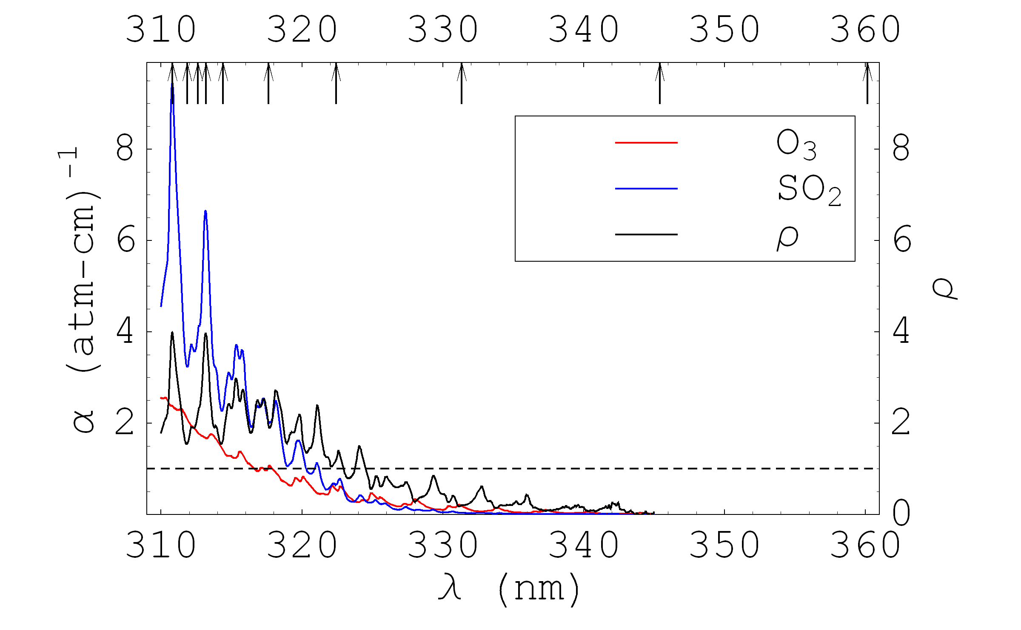
Figure 1. Absorption coefficients of SO2 and O3 and their ratio as a function of wavelength. The arrows indicate the central wavelengths used in the algorithm.

Specifically, a median residual for a band is calculated for each across-track position from a sliding group of pixels along the orbit track. This sliding group pixels, centered on the pixel selected for correction, cover about 30 degrees of latitude range while in the middle of the sunlit portion of the orbit, but the spatial extent is reduced when the selected pixel is near the terminator. Bad pixels identified in the linearization step and SO₂-contaminated pixels, as determined by their residuals that are consistent with real SO₂ and with slant column SO₂ greater than 2 DU (estimated using the BRD method [19]), are excluded from the sliding group. All band residuals of a pixel are corrected by subtracting from them the corresponding median residuals. This correction essentially demands that the local median residuals of the background pixels equal to zero for all the bands. Doing so, the cross track and latitudinal biases are corrected.

Both the BRD [19] and LF [20] algorithms use the corrected residuals as their inputs to derive atmospheric SO₂ column amount. In particular, the BRD algorithm converts differential residuals to the SO2 slant column at 3 most SO2 sensitive OMI UV2 wavelength pairs, and the pair average is used to produce all PBL data [19]. A constant air mass factor (AMF) of 0.36 is used to estimate total PBL SO2 (vertical column). For strong volcanic degassing and explosive eruptions larger AMF is used [19], but the BRD algorithm may still fail when the SO2 loading is very large. The LF algorithm [20] minimizes the sum of the squares of the larger subset of residuals by simultaneously adjusting total SO2, total column ozone, reflectivity at 331nm, and polynomial coefficients (linear and quadratic) to retrieve SO2 under these conditions. The LF retrieval is accomplished by exclusion of those residuals that are strongly affected by non-linear SO₂ absorption effect. In practice, the LF algorithm picks the largest SO₂ value as the retrieval result from the process (started only when SO₂ from full bands retrieval is greater than 10 DU) of dropping from the shortest wavelength bands one at a time until the band centered at 322.42 nm is reached. As a result the high SO₂ retrievals from LF are nearly always obtained with the set of measurements that start at this wavelength band. Figure 2 compares SO₂ retrievals from LF (5km) and BRD (AMF for 5km) algorithms for OMI observation (on October 23, 2005) of the Sierra Negra volcanic plume. Both algorithms show the same spatial extent but very different dynamic range in the total SO2 distributions. The LF retrieval produces much higher SO₂ concentrations near the vent of the volcano, and the concentrations drop off quickly as this plume is dispersing. The BRD image is quite similar to that of the LF, particularly in the area with low LF SO₂ concentrations, but the conspicuous difference is the complete lack of high SO₂ concentrations in the BRD image.

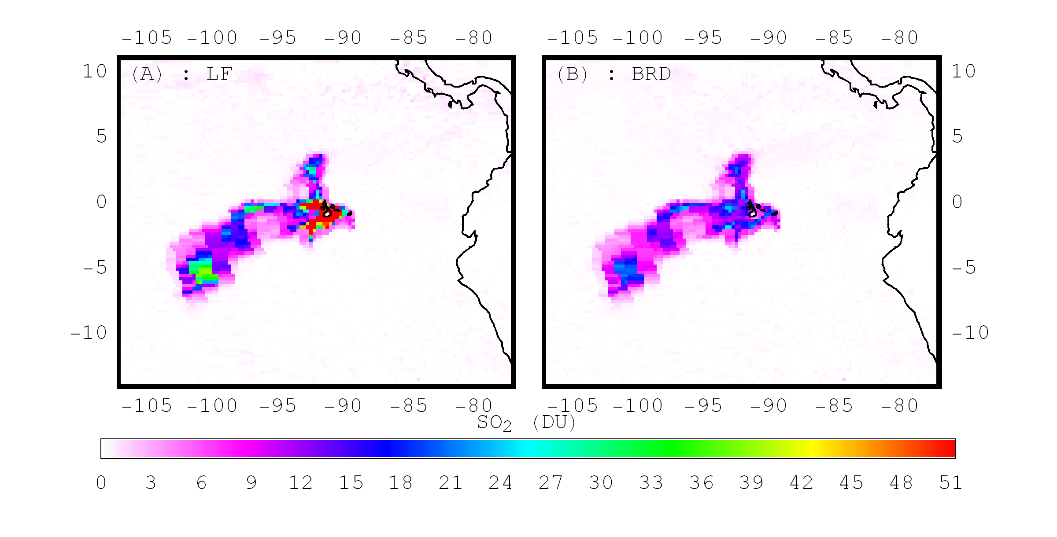
Figure 2. OMI observations of the volcanic plume on 23 October 2005, emitted from Sierra Negra Volcano (summit elevation of 1124 km) in the Galapagos Islands. (A) 5 KM retrievals from LF algorithm. (B) 5 KM retrievals from BRD algorithm

DATA QUALITY ASSESMENT
The accuracy and precision of the SO2 data vary significantly with the SO2 loading and vertical profile, observational geometry, slant column ozone and in the presence of sub-pixel clouds and aerosols. Preliminary error estimates are discussed below (see Data Quality Assessment). However, due to the combination of a smaller footprint and measurements at wavelengths that are highly sensitive to SO2 absorption, the minimum SO2 mass detectable by OMI is two orders of magnitude lower than the detection threshold of the NASA Total Ozone Mapping Spectrometer ( [4,6] http://toms.umbc.edu ).

The slant column (SC) PBL SO2 data produced with the BRD algorithm feature a practically zero global mean bias (typically within 0.1DU) and a global background noise level of about 0.6 DU (1 standard deviation).. Using a constant AMF of 0.36, this translates into a ~0.2 DU bias and 1.7 DU noise in global total SO2 values, while regional noise levels vary significantly. With this sensitivity, daily detection of plumes from strong volcanic degassing and anthropogenic sources of SO₂ (such as smelters and coal burning power plants) may be possible. However, any individual SO2 value for a specific pixel may be questionable due to the large standard deviation of PBL SO2 values. Therefore, at least weekly or longer time period maps of PBL SO2 are of greater value, but artifacts are still possible. Assuming that detected SO2 is real, additional errors arise if observational conditions differ from those assumed in the AMF parameterization. For example, AMF of 0.36 is underestimated by 20% for SCO=700 DU (small ozone, solar zenith and nadir angles), but overestimated by ~30% for SCO=1500 DU. For even larger SCO values (high ozone and/or high solar and viewing angles, mostly at high latitudes), AMF becomes very small, so no good PBL SO2 retrieval is expected. Therefore, fill values are reported for pixels with SCO>1500DU. In addition, aerosols and subpixel clouds can affect the AMF in different ways depending on their location. The assumption is that clouds always screen PBL SO2, but no AMF correction is attempted to account for this invisible SO2. This cloud related AMF error becomes larger with increasing sub-pixel cloudiness, so that fill values are used if OMTO3 cloud fraction is larger than ~20%, which corresponds to LER ~30%.

The 5 km retrievals are intended to represent typical volcanic outgassing from tall volcanoes and emissions from effusive eruptions. We recommend that the 5 km retrievals be used for volcanic degassing cases at all altitudes because the PBL retrievals are restricted to clear sky situations and contain large artifacts when sub-footprint clouds are present. The cloud-related fill values are possible in 5km data when the assumed cloud top (from OMTO3 climatology) is higher than 10 km. Examples are given in OMSO2ReleaseDetails file (http://so2.umbc.edu/omi/ click on Documentation). In general, SO2 releases at altitudes less than 5 km will be underestimated due to errors in the AMF, but these could be corrected in an off-line processing if degassing altitude is known. Biases in the 5 km retrievals due to latitude and viewing angle are removed to the 0.1 DU level by the median residual background offset corrections. The standard deviation of 5 km retrievals in background areas is about 0.3 DU at low and mid-latitudes. Both the bias and standard deviations increase for solar zenith angles greater than 80º and in the region of South Atlantic Anomaly.

The 15 km retrievals are intended for use with explosive volcanic eruptions where the cloud is placed in the upper troposphere or stratosphere. At these altitudes the AMF is weakly dependent on altitude, so that differences in actual cloud height from 15 km produce only small errors. The biases with latitude and viewing angle are generally less than 0.1 DU. The noise level in background data is about 0.2DU. Both the bias and standard deviation increase near the northern terminator, similar to but reduced from the 5 km results. Artifacts due to ozone profile errors and cloud edges are reduced from the 5 km data by about 30%. One should see no fill values due to cloud screening in the 15KM data.

The LF algorithm still has large error when it comes to high SO2 loading cases. The LF algorithm as implemented in the v1.0.0 OMSO2 is expected to provide good retrieval when SO2 loading is less than ~30 DU. When SO2 loadings are higher than ~50DU the LF algorithm underestimates the true SO2 amount, the higher the loading the larger the underestimation [20].

OMI SO2 DATA OVERVIEW
Aura-OMI Level-2 Sulfur Dioxide Product, 'OMSO2,' is now publicly available from the NASA's GSFC Earth Sciences (GES) Data and Information Services Center (DISChttp://disc.gsfc.nasa.gov/Aura/OMI/omso2.shtml). The public data set is suitable for detecting anthropogenic SO₂ emissions and quantification of SO₂ tonnage from volcanic degassing and eruptions.

Volcanic So2 emissions
OMI volcanic algorithm has been improved (LF) to provide quantitative estimates of SO2 loadings in large volcanic clouds. Visualization of daily OMI SO2 data allowed rapid appraisal of the most significant volcanic SO₂ emitters, which in 2006 included Merapi (Indonesia), Tungurahua (Ecuador), Soufriere Hills (Montserrat), Aoba (Vanuatu), Nyiragongo (DR Congo) and Ubinas (Peru). These measurements highlight the deficiencies of previous compilations of volcanic SO₂ emissions, which were biased towards accessible, frequently monitored volcanoes. The eruption of Soufriere Hills volcano (Montserrat) on May 20, 2006 resulted in a stratospheric injection of ~0.2 Tg of SO₂. Despite the modest size of the SO₂ cloud (2 orders of magnitude lower in mass than Pinatubo), OMI was able to track it for over 3 weeks and ~16,000 miles as it traveled westwards from the volcano (Figure 3). Near-coincident CALIPSO lidar measurements of the stratospheric sulfate aerosol derived from the SO₂ demonstrate the value of joint A-Train observations of volcanic clouds [21]. The Soufriere Hills eruption and one of similar magnitude at Rabaul (Papua New Guinea) in October 2006 were the largest volcanic SO₂ injections of 2006.

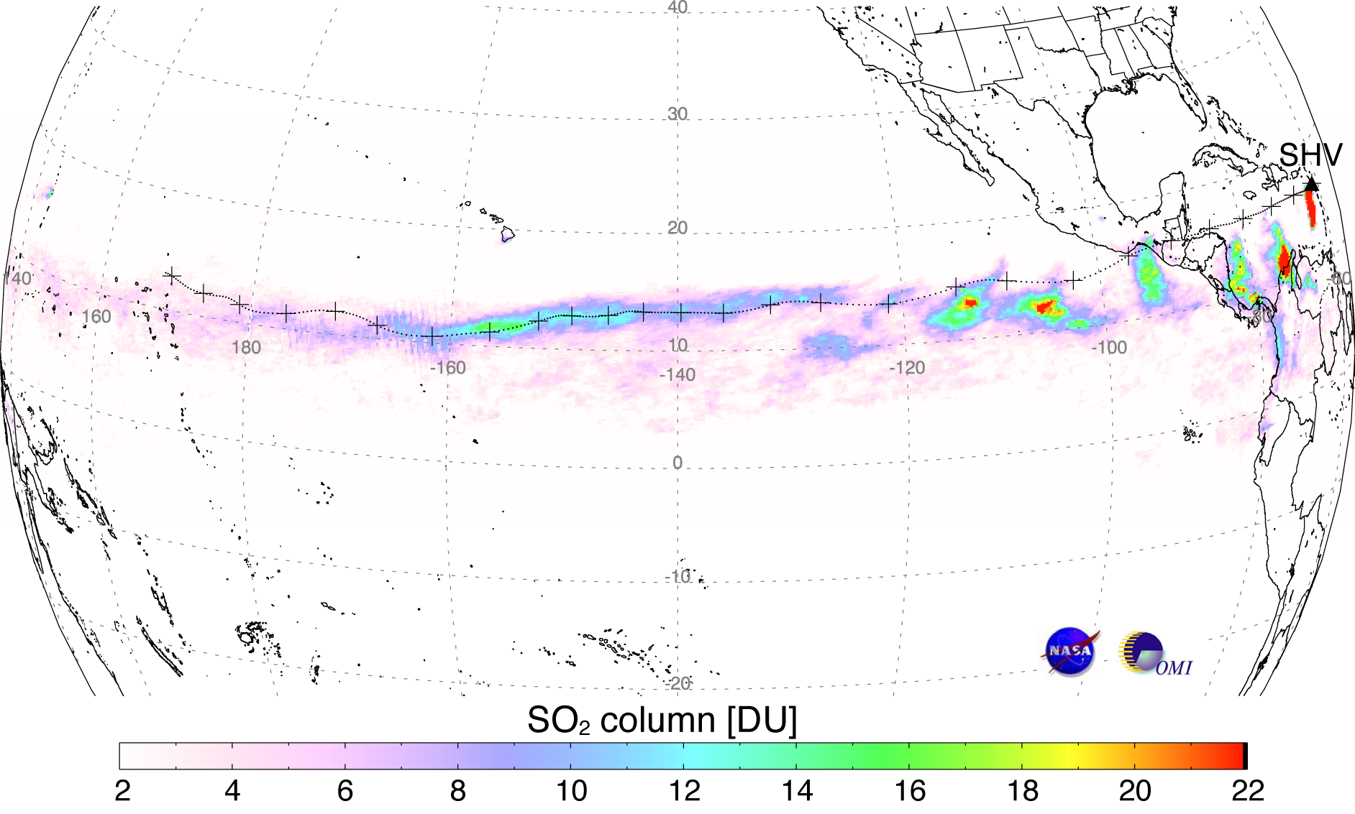

Figure 3 Cumulative SO₂ measured by OMI in the Soufriere Hills volcano (SHV Montserrat, Lesser Antilles) volcanic cloud from 20 May - 6 June 2006 as the cloud crossed the Pacific Ocean. The dotted line is a HYSPLIT forward trajectory for a cloud at 20 km altitude, initialized at 11UT on 20 May at SHV, with crosses plotted every 12 hours. The trajectory covers 315 hours (~13 days) of cloud transport [21].

Anthropogenic SO2 pollution
Anthropogenic SO₂ emissions have been measured by OMI over known sources of air pollution, such as the Ohio valley in the USA, eastern China, and Eastern Europe. Heavy anthropogenic emissions were detected on a daily basis (e.g., http://aura.gsfc.nasa.gov; http://www.knmi.nl/omi/research/product/SO2/introduction.html. For example, emissions from two Peruvian smelters (La Oroya and Ilo) were detected in up to 80% of OMI overpasses between September 2004 and June 2005 (Figure 4). SO₂ production by each smelter in this period was quantified and compared with contemporaneous emissions from active volcanoes in Ecuador and southern Colombia (Figure 4)[22].
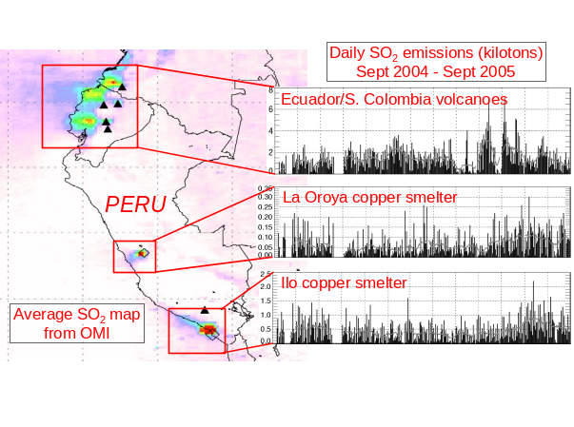
Figure 4. Left: Average OMI SO2 vertical column over southern Colombia, Ecuador and Peru, Sep 2004 – June 2005. Image is scaled from low (white) to high (red) values of average SO2 vertical column amount. Weak SO2 plume continuing off Ecuador is due to higher altitude, longer lifetime and greater dispersion of the volcanic S emissions. Average concentrations are higher close to the smelters due to lower dispersion of these boundary layer emissions.

Right: Daily SO2 burdens for 3 main source regions measured by OMI. Note that the vertical scale varies on the SO2 burden plots [22].

First OMI SO2 validation study was conducted using aircraft in-situ SO2 data collected over Shenyang in NE China as part of EAST-AIRE field campaign in April 2005. SO₂ observations from instrumented aircraft flights were compared with OMI SO₂ maps on clear and polluted days under favorable observational conditions (no clouds, near nadir viewing directions). This comparison demonstrates that OMI can distinguish between background SO2 conditions and heavy pollutions on a daily basis. The regional plume of SO₂, detected on 5 April over Shenyang area, was tracked for 4 days by OMI providing evidence for pollution lofting from the PBL and a large-scale impact of Chinese pollutant emissions. The lofting and plume position were confirmed with trajectory modeling and plume mass was refined for estimated altitude and underlying cloud reflectivity.
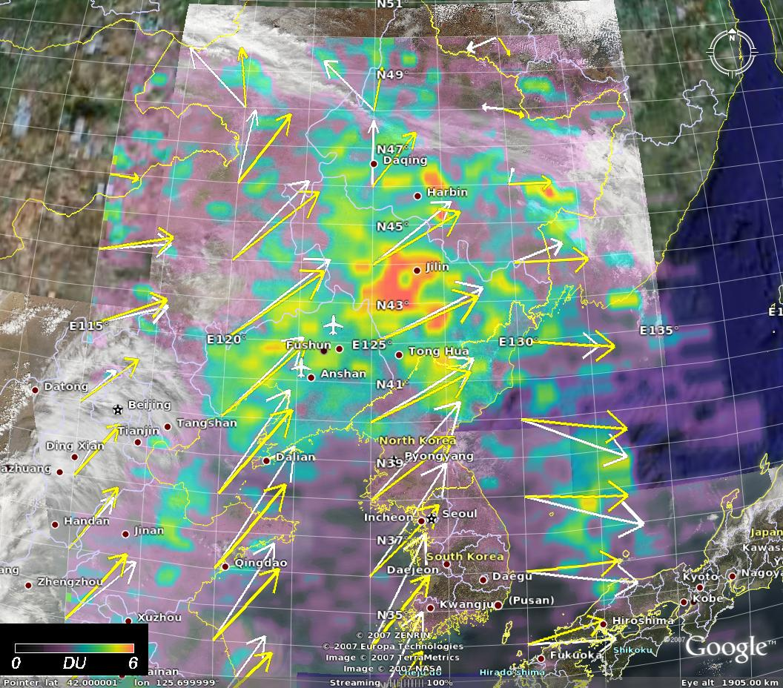 | 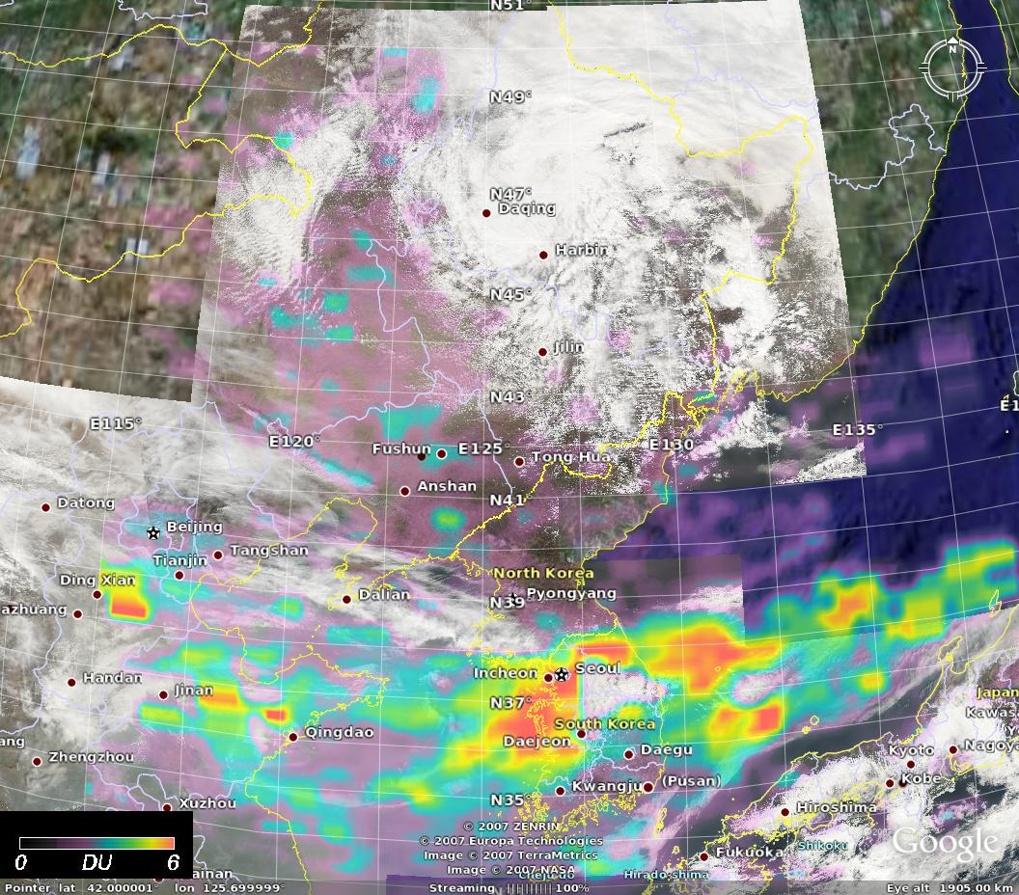
Figure 5. OMI SO2(color) – AQUA/MODIS RGB composites during East Aire aircraft campaign in April 5 (left) and April 7 (right) 2005. The OMI-derived measurements of SO2 confirm the in situ observations of high concentrations of SO2 (ca ~2 DU) ahead of the front and lower concentrations behind it.

a

Using weekly, monthly or annual average SO₂ maps we evaluate longer-term trends, and detect weaker degassing and pollution (e.g., http://aura.gsfc.nasa.gov/science/top10_smelters.html).

CONCLUSION
Almost a quarter-century of TOMS volcanic eruption SO₂ masses are now available (http://toms.umbc.edu) [6]-[8]. The OMI SO₂ data set is continuing the TOMS record but the improved sensitivity and smaller footprint of OMI will extend the range of detection to smaller eruptions and older clouds, and to degassing volcanoes.

REFERENCES
1. Krueger, A. J. (1983). Sighting of El Chichon sulfur dioxide clouds with the Nimbus 7 Total Ozone Mapping Spectrometer”, Science, 220, 1277-1379.
2. Bluth, G.J.S. ,S.D. Dorion, C.C. Schnetzler, A.J. Krueger, and L.S. Walter, “Global tracking of the SO2 clouds from the June 1991 Mount Pinatubo eruptions”, Geophys. Res. Lett., 19(2), pp. 151-154,1992.
3. Bluth, S.D. Dorion, C.C. Schnetzler, A.J. Krueger, and L.S. Walter, “The contribution of explosive volcanism to global atmospheric sulfur dioxide concentrations”, Nature, 366, 1993, pp. 327-329.
4. Krueger, A.J., L. S. Walter, P. K. Bhartia, C. C. Schnetzler, N. A. Krotkov, I. Sprod, G. J. S. Bluth, (1995). Volcanic sulfur dioxide measurements from the total ozone mapping spectrometer instruments, J. Geophys. Res., 100(D7),14057-14076.
5. Schnetzler, C.C., G.S.J. Bluth, A.J. Krueger, and L.S. Walter, “A proposed volcanic sulfur dioxide index (VSI)”, J. Geophys. Res., vol. 102, pp. 20,087-20,092, 1997
6. Krueger, A.J., S. J. Schaefer, N. Krotkov, G. Bluth, and S. Barker, “Ultraviolet remote sensing of volcanic emissions”, in Remote Sensing of Active Volcanism, Geophys. Monogr. Ser., vol. 116, edited by P. J. Mouginis-Mark, J. A. Crisp, and J. H. Fink, pp. 25-43, AGU, Washington, D. C, 2000
7. Carn, S.A., A. J. Krueger, G. J. S. Bluth, S. J. Schaefer, N. A. Krotkov, I. M. Watson, and S. Datta, Volcanic eruption detection by the Total Ozone Mapping Spectrometer (TOMS) instruments: a 22-year record of sulphur dioxide and ash emissions, in Volcanic Degassing, Spec. Publ. Geol. Soc. Lon., vol. 213, edited by C. Oppenheimer, D. M. Pyle, and J. Barclay, pp. 177-202, Geological Society, London, 2003
8. Burrows,J.P., M. Weber, M. Buchwitz, V. Rozanov, A. Ladstätter-Weissenmayer, A. Richter, R. de Beek, R. Hoogen, K. Bramstedt, K.-U. Eichmann, M. Eisinger, and D. Perner, (1999). The Global Ozone Monitoring Experiment (GOME): Mission concept and first scientific results”, J. Atm. Sci., 56, pp. 151-175, 1999.
9. Eisinger, M. & J. P. Burrows, (1998). Tropospheric Sulfur Dioxide observed by the ERS-2 GOME instrument, Geophys. Res. Lett, 25, 4177-4180, 1998.
10. Bovensmann, H. et al., (1999). SCIAMACHY – Mission objectives and measurement modes, J. Atmos. Sci., 56, 127-150.
11. S. A. Carn, L. L. Strow, S. de Souza-Machado, Y. Edmonds and S. Hannon, “Quantifying tropospheric volcanic emissions with AIRS: the 2002 eruption of Mt. Etna (Italy)”, Geophys. Res. Lett., 32, L02301, doi:10.1029/2004GL021034, 2005
12. M.R. Schoeberl, A. R. Douglass, E. Hilsenrath ,P.K. Bhartia, J. Barnett, J. Gille, R. Beer, M. Gunson, J. Waters, P. F. Levelt, and P. DeCola, “Earth Observing System Misions Benefit Atmospheric Research”, EOS Trans., American Geophysical Union, 85, 18, May 4, pp. 177-181, 2004
13. P.F. Levelt, G. H. J. van den Oord, M.R. Dobber, A. Malkki, H. Visser, J. de Vries, P. Stammes, J. Lundell, H. Saari, “The Ozone Monitoring Instrument”, IEEE Trans. Geo. Rem. Sens. AURA special issue.
14. P.F. Levelt, E. Hilsenrath, G.W. Lippelmeier, G.J.B. van den Oord, P.K. Bhartia, J. Tamminen, J. F. de Haan, and J.P. Veefkind, “Science Objectives of the Ozone Monitoring Instrument”, IEEE Trans. Geo. Rem. Sens. AURA special issue, to be published.
15. M. R. Dobber, et al., “Ozone Monitoring Instrument description, performance and calibration”, IEEE Trans. Geo. Rem. Sens. AURA special issue, to be published.
16. G.H.J. van den Oord et al., (2006) OMI level 0 to 1b processing and operational aspects”, IEEE Trans. Geo. Rem. Sens. AURA special issue.
17. Bhartia,P.K. C. W. Wellemeyer, “TOMS-V8 total ozone algorithm” In OMI Algorithm Theoretical Basis Document, OMI Ozone Products, vol. 2 , version 2, Ed by P. K. Bhartia, NASA/Goddard Space Flight Center, 2002. Available: http://eospso.gsfc.nasa.gov/eos_homepage/for_scientists/atbd/docs/OMI/ATBD-OMI-02.pdf
18. C. Wellemeyer, P.K. Bhartia, S.L. Taylor, W. Qin, C. Ahn, “ Version 8 Total Ozone Mapping Spectrometer (TOMS) algorithm”, In: Ozone, Volume I, Proceedings Quadrennial Ozone Symposium, KOS, Greece, pp. 635-636, 2004.
19. Krotkov, N., A., S. A. Carn, A.J. Krueger, P.K. Bhartia, and K. Yang (2006), Band residual difference algorithm for retrieval of SO2 from the AURA Ozone Monitoring Instrument (OMI), in print, IEEE Transactions on Geoscience and Remote Sensing, AURA special issue, 44, doi:10.1109/TGRS.2005.861932.
20. Yang, K., N.A. Krotkov, A.J.Krueger, S.A. Carn, P.K. Bhartia, P.F. Levelt. (2007) Retrieval of large volcanic SO2 columns from the AURA OMI: comparison and limitations, under review, J. Geophys. Res., AURA validation special issue.
21. Carn, S.A., N.A. Krotkov, K. Yang, R.M. Hoff, A.J. Prata, A.J. Krueger, S.C. Loughlin, P.F. Levelt, Extended observations of volcanic SO2 and sulfate aerosol in the stratosphere, Atmos. Chem. Phys. Discussions, 2007a
22. Carn, S.A., N.A. Krotkov, A.J. Krueger, K. Yang, P.F. Levelt, (2007b) Sulfur dioxide emissions from Peruvian copper smelters detected by the Ozone Monitoring Instrument", Geophys. Res. Lett.

