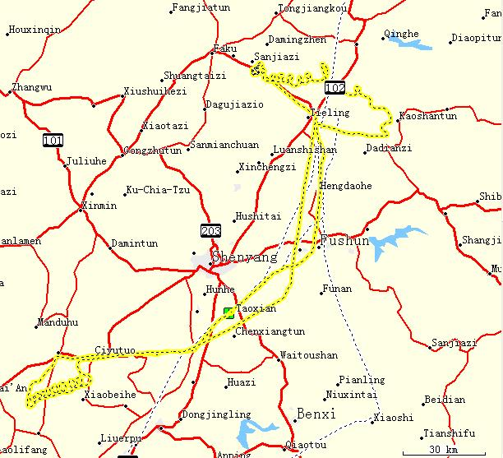 | 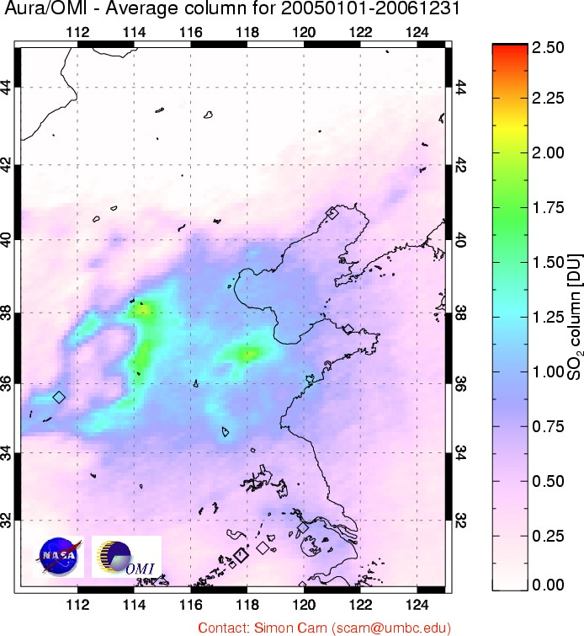
Figure 1. (Left) Flight path on April 5, 2005. Spiral locations were performed near Xiaoming ( 42.450N, 123.70E) and Liaozhong (41.350N, 122.648E ). All flights departed from Taoxian International Airport (41.640ºN, 123.488ºE) in the Liaoning region of China.
Flight paths were similar on Apr 1, 7 and 10 2005.
(http://www.atmos.umd.edu/~zli/EAST-AIRE/air_camp/air_camp.htm).
(Right) 2-year average OMI SO₂ map over Eastern China in Dobson Units (1 DU=2.69 ·10¹⁶ molecules/cm²) showing persistent areas of high SO₂ concentrations in a triangle between Beijing, Shanghai, and Sichuan basin in agreement with emission inventory [Zhang and Streets, 2007, unpublished data]. Smaller SO₂ enhancements (i.e. ~0.5 DU) over the Shenyang region in North East China (black square) are significant as compared to the background regions.

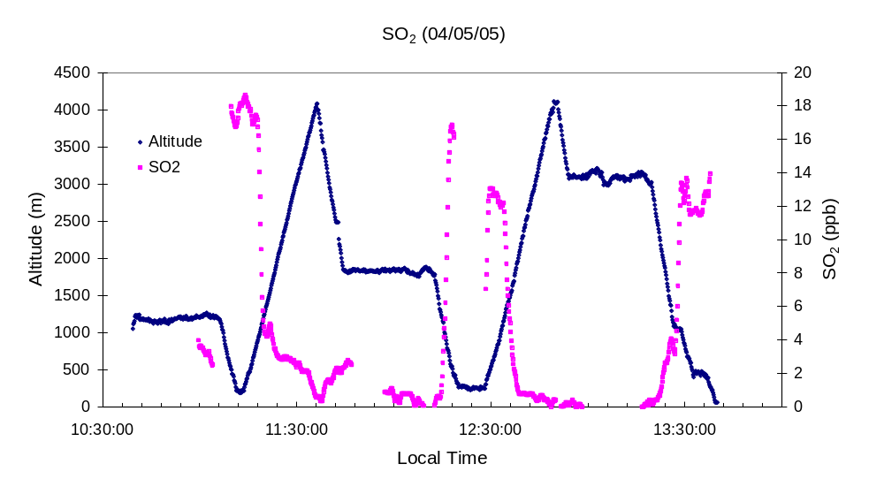
Figure 2. Altitude (blue) and in-situ SO₂ (red) aircraft data as function of flight time (Local Time (LT): LT = UT + 8hours) on 5 April 2005 over northeastern China (figure 1). The amount of SO₂ increases as the altitude decreases during the flight. These raw data were converted into 3 SO₂ vertical profiles over Liaozhong (11:30LT); Xiaoming (12:30LT) and on the descent to Taoxian International airport (13:30LT). OMI overpass time (5UT) corresponds to 13LT.

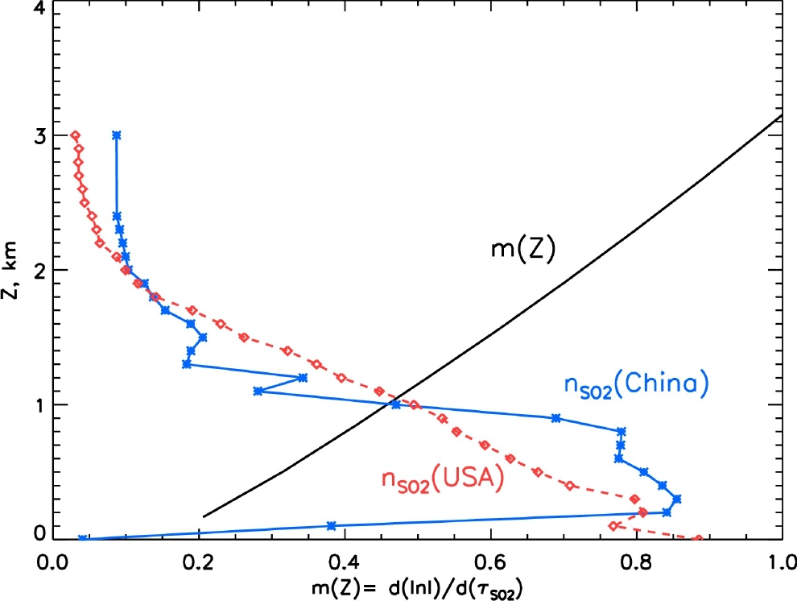 | 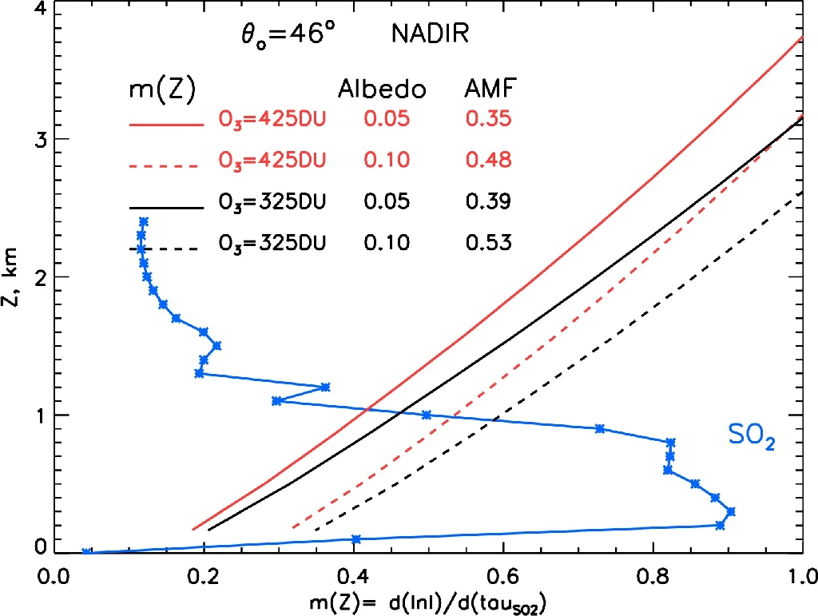
Figure 3. Local AMF m(z) calculated for OMI nadir direction; Solar zenith angle 46º, 0.05 surface reflectivity, 325DU mid latitude TOMS climatological ozone profile; no aerosols and clouds;
Left: SO₂ vertical profile: Normalized profiles: Measured during EAST-AIRE campaign on April 5 2005 over Liaozhong, NE China (blue stars); Median summer SO₂ profile over mid Atlantic US [Taubman et al 2006] (Red diamonds). Both SO₂ profiles are dimensionless, normalized to a unit column SO₂ amount.
Right: Local AMF dependence on surface albedo (solid line – 0.05; dashed line – 0.1) and total ozone (red- TOMS 325DU mid latitude ozone profile and black color: 425DU TOMS mid latitude ozone profile).

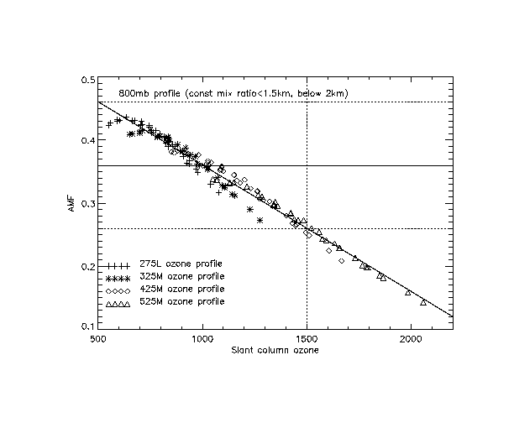

Figure 4. AMF parameterization as function of Slant Column Ozone amount (SCO): 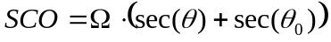 for the TOMS V8 climatological mid latitude ozone profiles, different view and solar zenith angles, solar azimuth 90 deg and 0.05 surface albedo. No aerosols or clouds.
The operational AMF of 0.36 is shown as solid horizontal line.

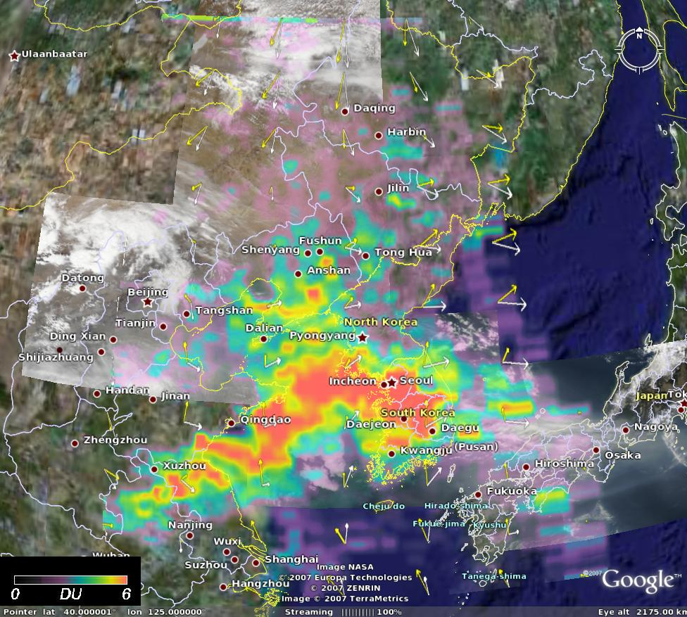  a | 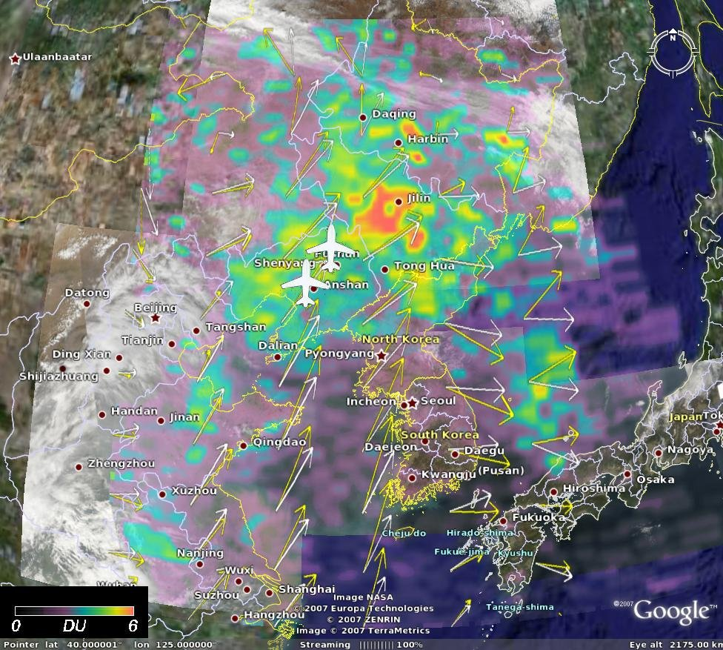
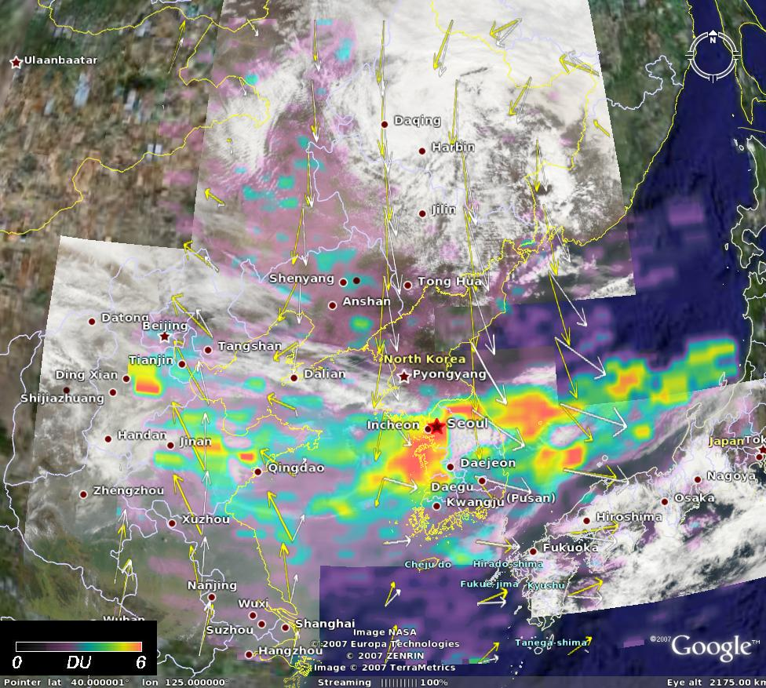 | 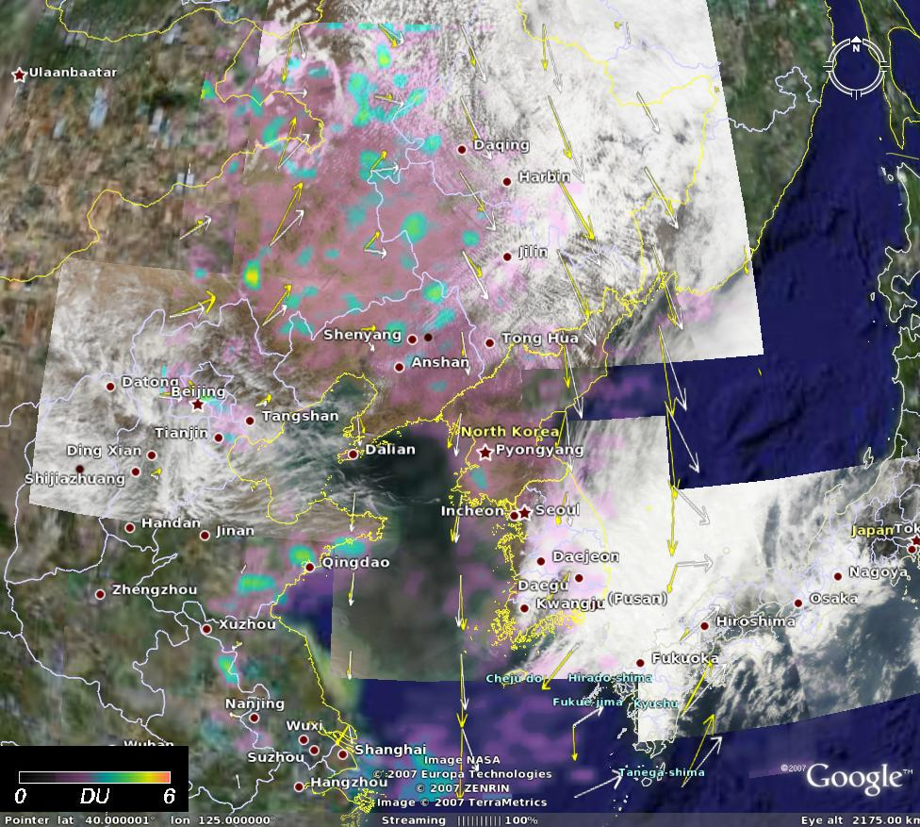
Figure 5 OMI PBL SO₂ maps (Linear color scale from 0 to 6 DU) superimposed on AQUA MODIS RGB images acquired 15 minutes prior OMI measurements during EAST-AIRE field campaign on April 1,5,7,and 10 2005. The aircraft spiral locations are shown with white symbols.
Apparently high SO₂ values (red colors) indicate SO₂ lifting above PBL and /or above low level clouds, where OMI sensitivity is enhanced. Tropospheric winds are shown with yellow/blue (surface) and white (850mb) arrows.
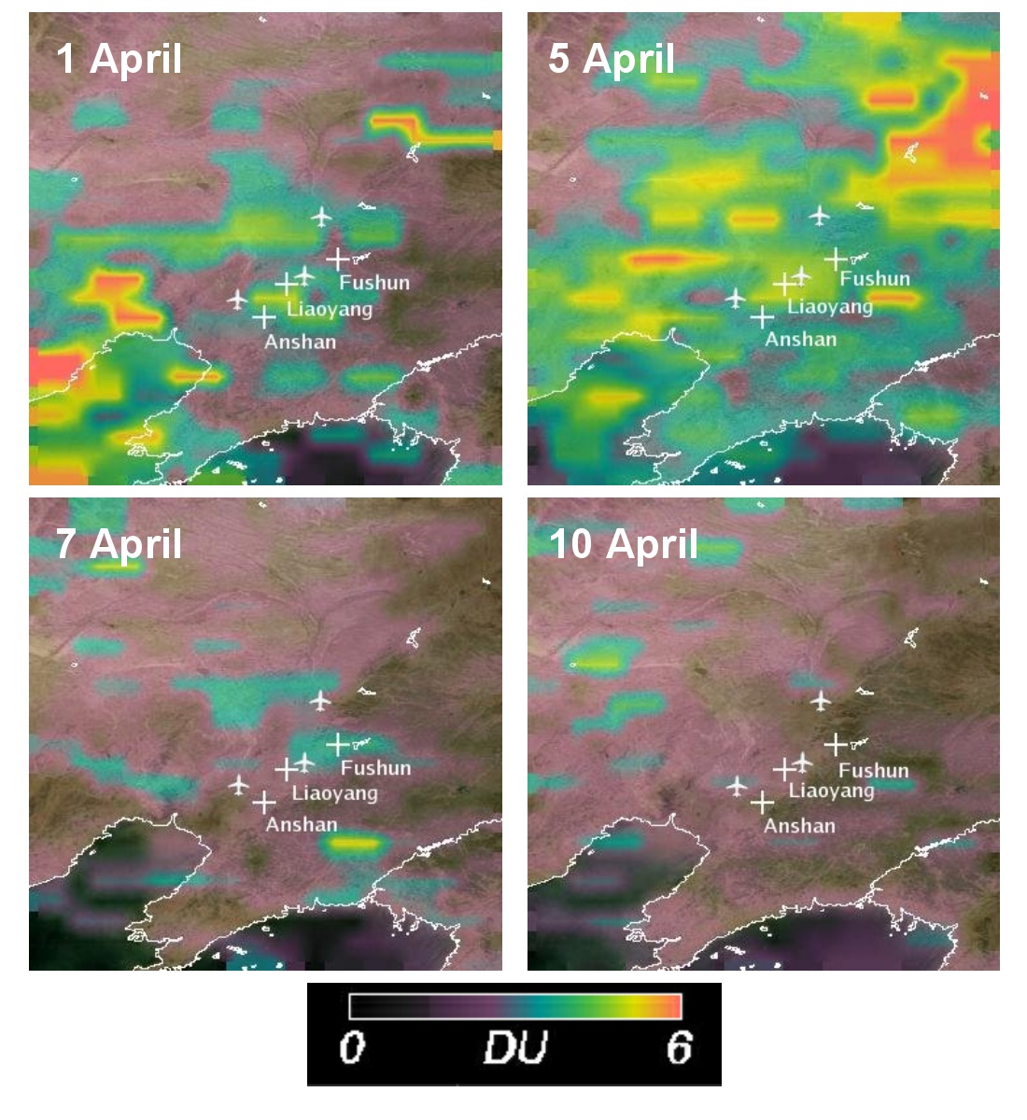

Figure 6. Operational (collection 2) and un-corrected OMI PBL SO₂ data over EAST-AIRE flight region in April 2005.

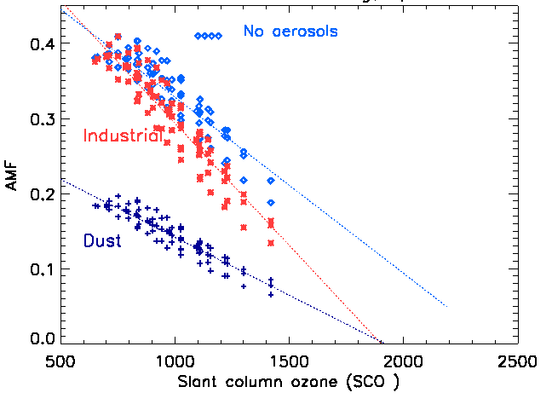 | 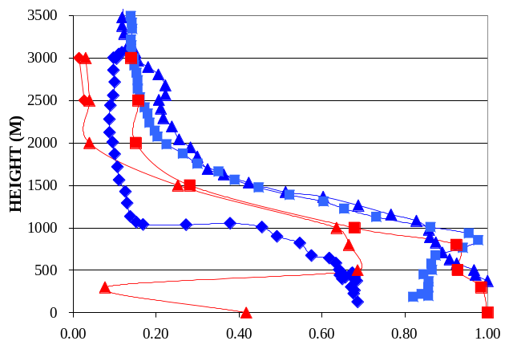
Figure 7 (Left) SO₂ AMF parameterization as function of SCO for 275DU ozone profile, different view and solar zenith angles, solar azimuth 60º -120º and 0.05 surface albedo. Blue diamonds - no aerosols or clouds. Red stars – OMI Industrial aerosol model (sulfate and soot mixture).
Right: Blue lines: Normalized vertical profile of Aerosol scattering coefficient from aircraft in-situ measurements
Red lines: Normalized So2 concentration profile from aircraft in-situ measurements on April 5
Symbols indicate spiral location: Xiaoming(triangle); Taoxian (diamond) and Liaozhong (square).

