SO2 striping needs to be removed before releasing pictures

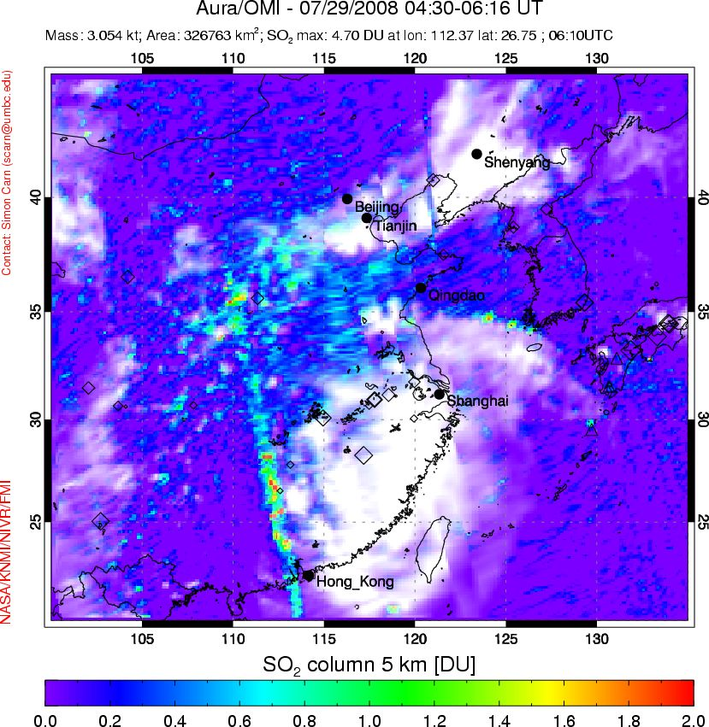

Definitive data:

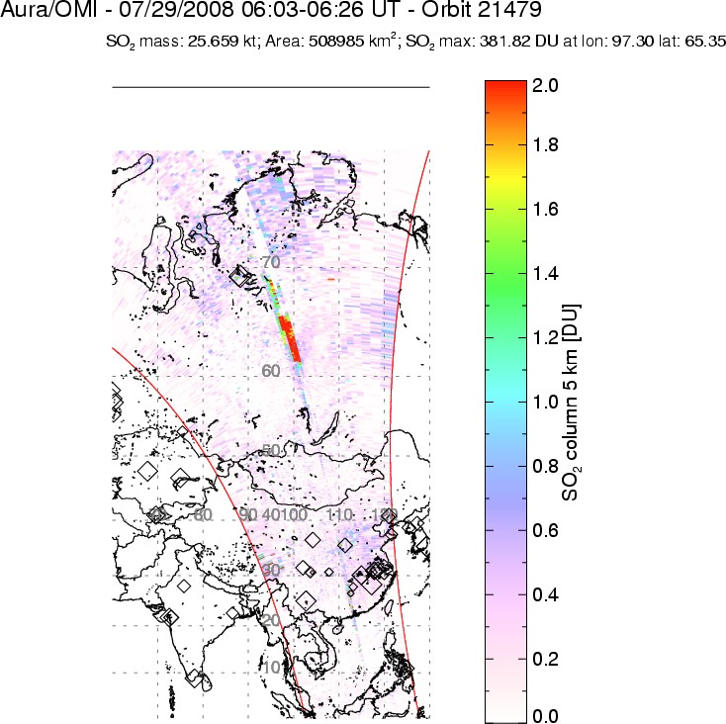 | 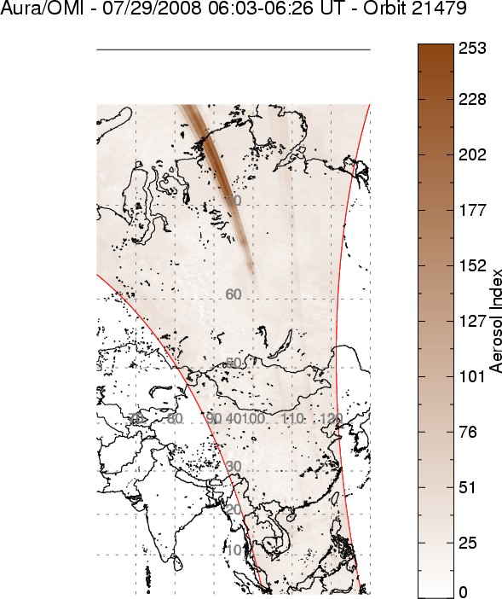
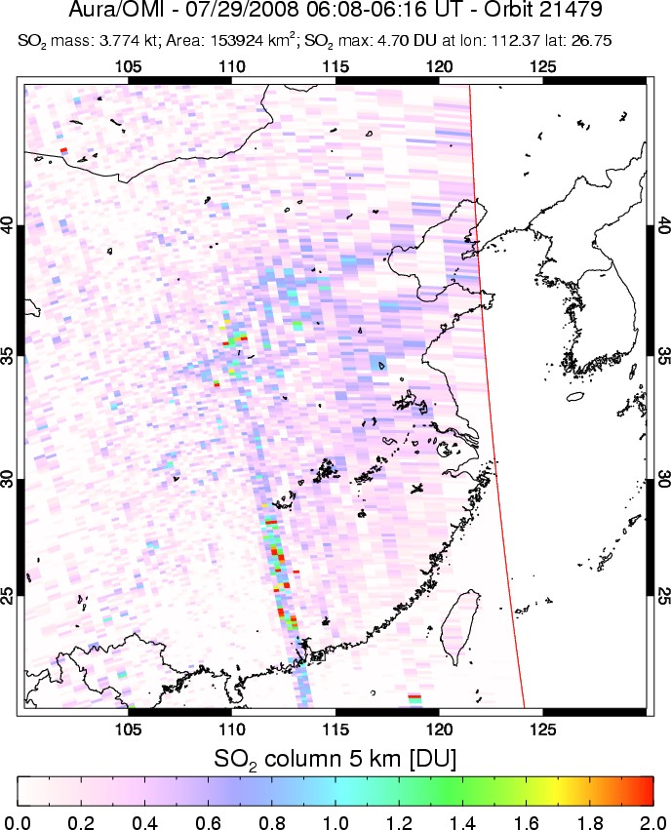 | 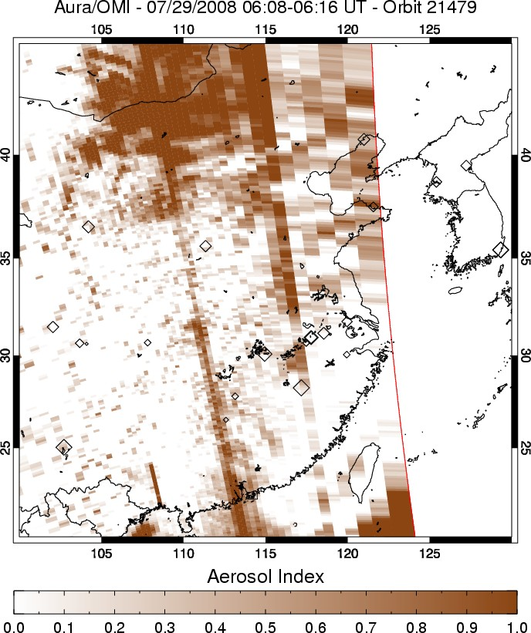
Loaded orbit /omi/live/col3/OMSO2/2008/07/29/OMI-Aura_L2-OMSO2_2008m0729t0519-o21479_v003-2008m0729t121314.he5

OMTO3 Ozone and OMCLDRR:
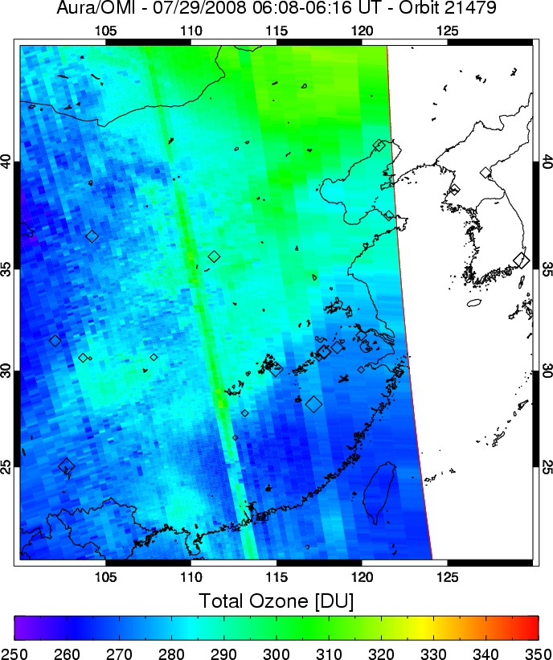 | 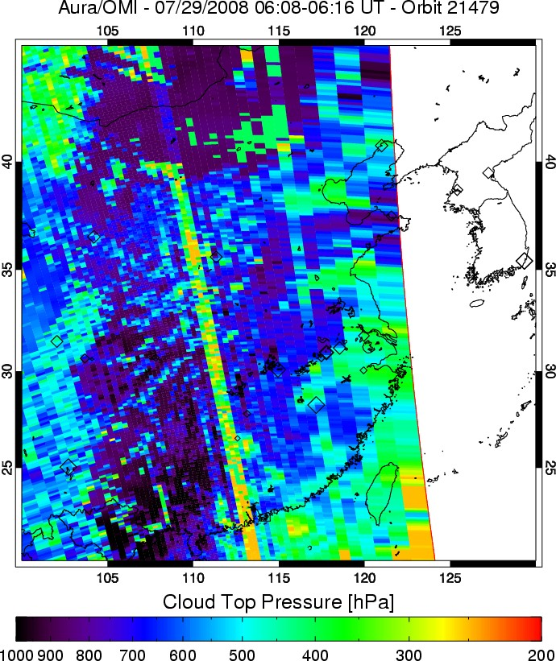

NRT data
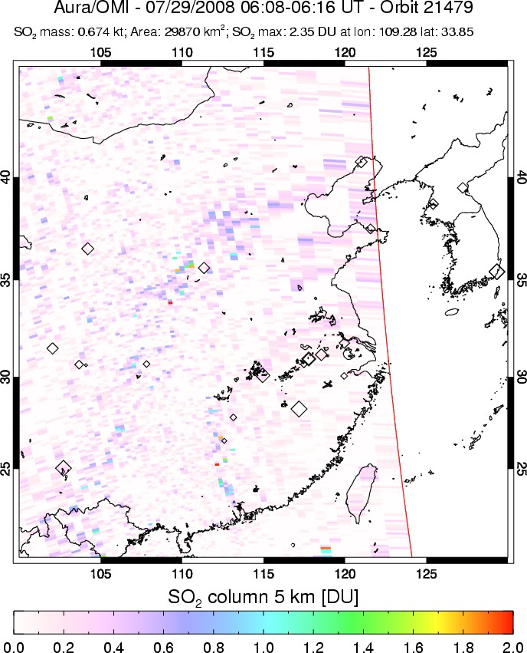 | 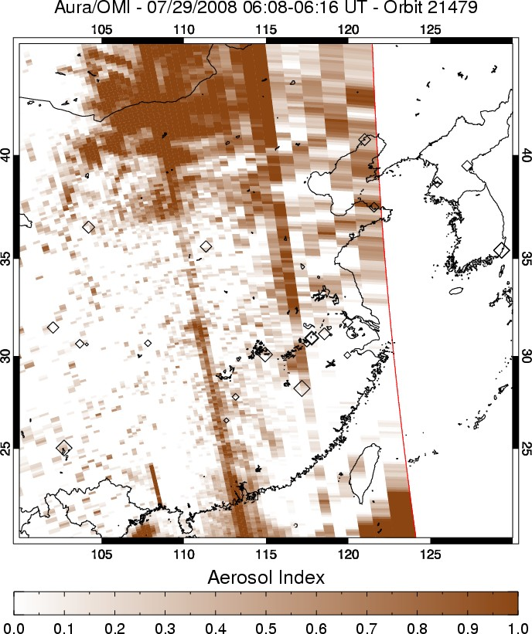
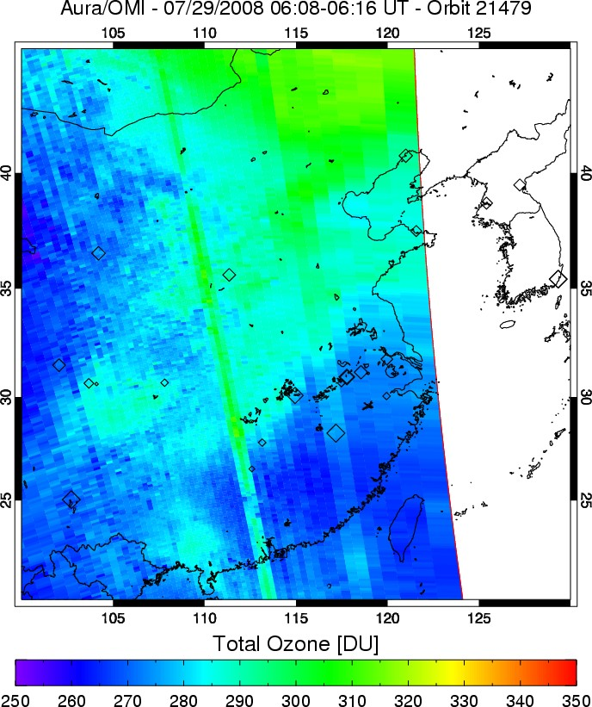 | 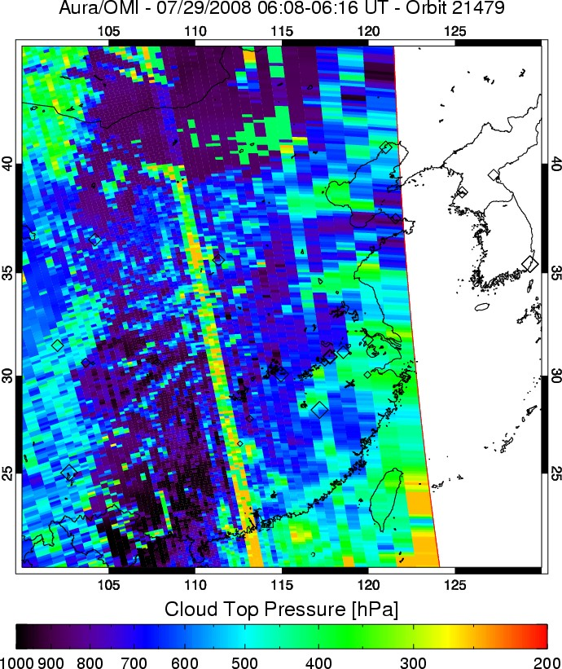
Loaded orbit /omi/home/simon/nrt/OMSO2NRT/2008/07/29/OMI-Aura_L2-OMSO2NRT_2008m0729t0440-o21479_v883-2008m0729t074945.he5

