Janus: Observing the Sun-Earth Connection. A Lunar Mission Design Study

Dr Joseph Davila, PI (GSFC)
Dr Jay Herman, Co-I (GSFC)
Dr Clarence Korendyke (NRL)

Proposal Submitted to the
Concept Studies for Lunar Sortie Science Opportunities
in Response to
NNH06ZDA001N-LSSO

Abstract:

The Moon presents a useful and stable platform for obtaining unique simultaneous views of the Earth and Sun using two basic proven instrument packages to accomplish the science goals. These instrument designs are based on previously developed satellite design studies. In addition to a well-developed science mission, we intend to study the means of implementation in a manner suitable for astronaut deployment and semi-autonomous operation. The instruments we are proposing are all based on high TRL telescope designs that either have flown before or are very similar to flight models. The Sun observations will be made by two spectrometers and a solar coronagraph, while the Earth observations will be made by three spectrometers ranging from short wavelength UV for mesospheric airglow to the near UV and near IR (310 to 960 nm) to study processes in the stratosphere and troposphere. The emphasis in this study proposal will be on the differences caused by operation and deployment in the harsh lunar environment. The key science goal of a study for implementation of a joint Earth-Sun mission located on the lunar surface is to understand the relationship between solar activity and the structure and dynamics of Earth’s atmosphere from the surface to the thermosphere-ionosphere, for a range of seasons, solar radiation and energetic particle inputs. The study will discuss instrument designs and packaging suitable for semi-autonomous deployment with minimal assistance from lunar astronauts.

FY07 Budget
$98,662 with Civil Service Labor cost sharing
Table of Contents

- Introduction  - Expected science results from the investigation  - Mission description  - Specific Science Objectives of Janus | 1  2  3  6
- Earth Observing Module  - J-NUV, Visible, and NIR (300 to 960 nm) Spectrometer J-UVIS  - Earth Viewing Mid-UV Spectrometer J-MUV  - Earth viewing EUV/FUV Spectrometer J-EVES | 7  7  8  8
- Solar Observing Module  - Solar EUV Spectrometer J-SES  - Solar Soft Xray Irradiance J-XI  - Solar Coronagraph J-COR  - Space Environment Instruments J-Plasma | 9  9  9  10  10
4.0 CDH&T Module | 10
5.0 Power Module | 10
6.0 Lunar Environment and Instrument Deployment | 11
7.0 Resource requirements for the proposed investigation including cost, mass, volume, telemetry, astronaut intervention, and crew safety | 13
8.0 Research and development required for the proposed investigation | 14
9.0 Period of performance (8 months) | 13
10.0 Summary | 14
11.0 References | 15
12.0 Management | 15
13.0 Biographical Sketches | 16
14.0 Budget Justification | 18
15.0 Current And Pending Support | 19

Janus: Observing the Sun-Earth Connection: A Lunar Mission Design Study

Introduction

Life on Earth is dependent on the precise state of the Sun, its long-term stability as well as its day-to-day activity. From the viewpoint of radiation and particles, the Earth is bathed in the extended atmosphere of the Sun. Electromagnetic radiation from the Sun drives circulation and chemistry in the atmosphere, determines the climate, and makes life itself possible on Earth. The solar wind transports energetic particles, and magnetic flux from the Sun altering the atmospheric composition and structure of Earth’s atmosphere. There have been very few simultaneous observations of both solar events and the response of Earth’s atmosphere. Janus will provide the complete data needed to fully understand the processes that couple solar events to Earth’s atmosphere. This proposal will study and develop the instrumental configuration needed for these observations and the methods and technology used for Janus’ deployment on the lunar surface.
Study Name | Janus
Proposal Objectives | • Describe Mission Science and Instruments  • Describe major deployment problems that we expect to encounter  Power during night conditions  Thermal Control  Dust  Instrument deployment and initialization  • Propose solutions and studies for these problems
  
Science Objectives | • Understand the processes and interactions that determine the composition of the Earth’s whole atmosphere including the connections to solar activity. Janus will obtain the first synoptic global measurements of aerosols and chemical composition from sunrise to sunset, and from the surface to outer space, together with the critical solar and space weather inputs that drive the upper terrestrial atmosphere.  • Understand the role of solar plasma dynamics in coronal heating, solar wind acceleration, flares and transients, and UV irradiance variations.  • Quantify the sources and transport of environmentally important atmospheric species (greenhouse gases, aerosols, ozone) using high-resolution synoptic mapping of concentrations.  • Understand the fundamental physical processes within the active solar corona which lead to coronal mass ejections/solar flares and contribute to irradiance variability.  • Provide real-time space weather data for predictive modeling of the space environment and for protecting satellite communication, astronaut safety, and ground power distribution assets.

While the Moon presents a useful and stable platform for obtaining unique simultaneous views of the Earth and Sun, it also presents some difficult problems for implementing any proposed observations from the lunar surface. This proposal will present a basic proven instrument package needed to accomplish the science goals based on a previously developed satellite design. The instruments we are proposing are all based on high TRL telescope designs that have either flown before or are very similar to flight models. The emphasis in this study proposal will be on the differences caused by operation and deployment in the harsh lunar environment. The overall science goal of this study is for implementation of a joint Earth-Sun mission located on the lunar surface is to understand the relationship between solar activity and the structure and dynamics of Earth’s atmosphere from the surface to the thermosphere-ionosphere, for a range of seasons, solar radiation and energetic particle inputs. The study will discuss instrument designs and packaging suitable for safe, semi-autonomous deployment, with minimal operational assistance from lunar astronauts. The main task for the astronauts will be for initial deployment and setup, initial instrument pointing and monitoring of the pointing, and correcting the subsequent calculated pointing so that software can be corrected for operation when the astronauts are not present. The study will form the basis for the development of lightweight, low-power instrumentation that can obtain new scientific information on the relationship between solar activity and the composition and dynamics of the Earth’s atmosphere. The results will provide crucial information on Sun-Weather relationships and long-term climate factors.

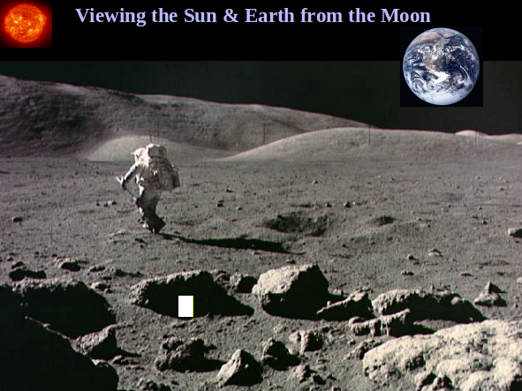

Figure 1 View from the Moon when the Earth and Sun are in the field of view
1.1 Expected science results from the investigation
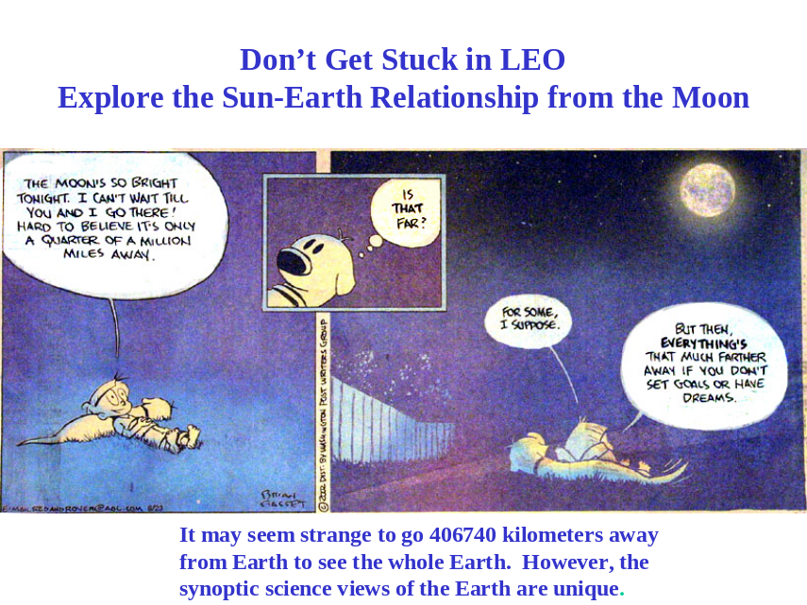

For Earth observations, the lunar vantage point offers the opportunity for synoptic observations at high time and space resolution of the day and night Earth. Ground observations of tropospheric variability of trace gases (e.g., NO₂, SO₂) and aerosol plumes (e.g., biomass burning and desert dust) show that they change significantly on an hourly time scale over the course of the day [Cede et al., 2006]. Continuous Earth observations will afford us the first opportunity to observe the global evolution of tropospheric phenomena with high time resolution, as well as rapidly changing phenomena in the upper stratosphere and mesosphere. In contrast, a polar orbiting satellite only gives us a single measurement per day at each location (2 in the IR). Geostationary observations would require 6 separate satellites for full coverage, which even then would not extend to polar regions.
High temporal resolution combined with day and night global coverage, as available uniquely from the Moon, is of central importance for studies of tropospheric sources and transport. Emissions can fluctuate considerably from hour to hour (fires, lightning, aerosols, trace gases…). Transport mechanisms involving convection and frontogenesis can take place on very short time scales. Inverse model analyses exploiting the Janus data will enable the global mapping of emissions of environmentally important gases (greenhouse gases, aerosols, trace-gas pollutants) with unprecedented coverage and detail. The Janus data will also allow the tracking of chemical and aerosol plumes as they are transported and dispersed on scales ranging from regional to global. They will provide an unmatched perspective for observing intercontinental transport of pollution.
Stratosphere-troposphere exchange chemically links the upper troposphere and the lower stratosphere, while the chemistry of the stratosphere is driven by solar radiation and the photolysis of tropospheric source gases (CH₄, N₂O, and CFC’s). The upper portions of Earth’s atmosphere respond strongly to external variations in the Sun’s ultraviolet and energetic particle output. Quantifying the variations in the solar driver, anthropogenic forcing, and the coupling between the upper and lower atmosphere, is one of the most significant problems in Earth science if we are to understand and model climate changes.

Table 1 Statement of Work for the Concept Study
Concept study report section | Description
Expected science results from the mission | The expected science results will be addressed in this section. We expect this section to be similar to what we have included in this proposal.
Instrument and operations concept | A more detailed description of the instrumentation and operations than was presented in the proposal. In particular, we will develop a more detailed opto-mechanical description of the instrument. The operations scenario will be refined.
Resource requirements | Based on the instrument concept, we will develop a more detailed description of the resource requirements (cost, mass, volume, telemetry, astronaut intervention, etc.) of the investigation.
Crew safety issues | We will examine and suggest mitigation strategies for possible crew safety issues. The hazards assessed include: trip hazards, high voltage dangers, sharp edges/corners hazards, as well as hazards related to the physical handling and assembly of the payload.
Technology development issues | The principal challenges identified are: 1) the thermal environment/night time operations and 2) the contamination of critical optical and detector surfaces by dust. We will suggest mitigation strategies for both these challenges in the concept study report. Based on our experience of deploying these instruments in challenging environments, we feel that these issues can be addressed. However, identifying and validating a final approach will require detailed design and verification, which are beyond the scope of the proposed work.
Other technical issues | We will also address other technical issues. The battery capacity and configuration will be studied and sized appropriately for the long lunar night. The antennae and transmitter selection will be more carefully examined. A simple FEM model of the instruments will be developed to answer certain obvious questions as well as assess handling, stowing and deployment issues.

1.2 Mission Description
The Moon affords us a unique view of the Earth’s whole atmosphere and its coupling to solar activity (Figure 2). Janus will concurrently observe sources of upper atmospheric forcing from space weather phenomena and solar disk activity. Janus includes instrumentation for terrestrial atmospheric composition and airglow analysis, solar weather, and solar activity (soft x-rays and EUV, solar coronal flares, and mass ejections).
The key to this proposed science observations is the careful selection of measurements and scientific objectives to target NASA’s exploration goals. The Earth-viewing portion of Janus will augment existing satellite and ground-based measurements and provide a unique measurement set enabled by the lunar vantage point.
In addition to simultaneously observing the Sun (discussed later), Janus will provide global mapping of atmospheric composition every 30 to 60 minutes over the Earth’s sunlit disk with high spatial resolution (5 km at nadir) needed to observe tropospheric trace gas changes and motions of aerosol plumes. From a lower atmospheric perspective, this will enable improved quantification of emissions responsible for climate forcing and regional air quality degradation (Figure 2). Janus measurements will provide continuous tracking of anthropogenic and natural plumes (generated by megacities, dust storms, volcanoes, etc.) over scales extending from 5 km to the dimensions of the Earth. They will provide improved estimates of radiative forcings from aerosols including cloud effects, and improved monitoring of the stratospheric ozone layer and the chemicals affecting it. Spectral measurements of the Earth’s surface from Janus will also be of considerable interest to the land and ocean science communities through global and continuous observations of fires, chlorophyll, red tides, etc. Because of its unique view and observations in the UV, Janus will detect volcanic eruptions and the locations of ash plumes needed for avoidance by commercial aircraft.
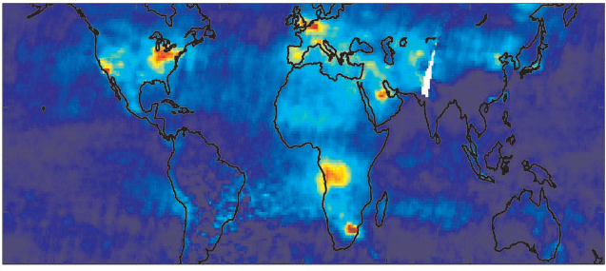
Figure 2 Tropospheric nitrogen dioxide columns seen from space
Beyond the Earth’s troposphere and stratosphere, the unique suite of Janus measurements will enable continuous observation of the mesosphere and thermosphere extending to outer space, with vertical resolution in the stratosphere and ionosphere allowing exploration of the couplings between these domains. Janus will provide the first comprehensive global observations of the ionosphere. It will allow exploration of where, when, and how forcings, responses, and variability in the lowest atmospheric layers segue into the forcings, responses, and variability of the upper atmosphere. This exploration of atmospheric coupling will involve climate dynamics (ENSO, AO, etc.), ionization and photochemical reactions in the upper atmosphere, and the global electric circuit. The Janus concept responds to ongoing initiatives in the United States and elsewhere to develop whole-atmosphere models of dynamics and composition (e.g., MAGCM, WACCM, NOGAPS).
By observing both the Sun and the Earth, Janus is the first comprehensive exploration of the couplings of solar activity and the Earth. Solar activity affects climate dynamics, e.g., the strength and phase of the Arctic Oscillation (AO) [Kodera, 2002] with implications for the winds, temperature, and rainfall in northern middle and high latitudes. Solar radiation below 100nm is the primary source of energy for the thermosphere and creates the embedded ionosphere. Solar variability is known to drive major changes in the energy and composition of the upper atmosphere and ionosphere (e.g., airglow Figure 3), but the perturbations extend to the middle and lower atmosphere as well. Stratospheric ozone is observed to experience significant variance in response to solar changes. The variance is comparable in amplitude to the effect of chlorofluorocarbons (CFCs) on ozone during the past 25 years. Solar effects are manifest in the phase of the Quasi-Biennial Oscillation (QBO) [McCormack, 2003], and thus may also influence ozone indirectly. Transport of nitrogen oxides produced by solar soft X-rays near 100 km can deplete ozone during the polar night, thereby coupling the lower thermosphere and stratosphere. Janus includes short wavelength solar imaging and irradiance instrumentation to directly observe the short wavelength variability and to directly image and characterize the responsible structures in the solar atmosphere.
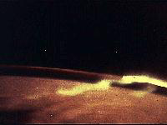
Figure 3 Airglow at 100 km seen from space
As modern society becomes increasingly reliant on technologically advanced systems for power distribution and satellite-based communications, our ability to predict and respond to the impacts of space weather and solar activity becomes increasingly important. The upper atmosphere responds dramatically to solar activity and solar flares. Neutral and ion densities increase an order of magnitude or two during the 11.3-year solar activity cycle, and as much as 40-70% during energetic events, such as the Bastille day flare (Meier et al. 2003). Enhanced atmospheric densities increase the drag on satellites in low-earth-orbit, including the International Space Station (at 400 km). Changes in electron density in these layers of the atmosphere directly impact various forms of communication and navigation systems critical to operational systems. Solar CMEs (Figure 4) cause space-weather disturbances that affect the Earth’s magnetosphere, represent a serious hazard for geostationary satellites, astronauts in space or on the Moon, and for power systems and communications at the Earth’s surface.
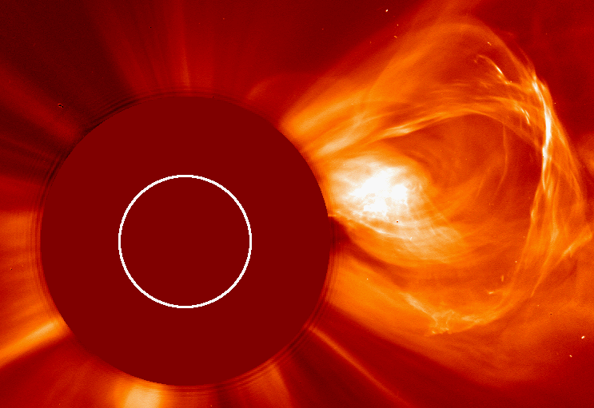
Figure 4 CME event viewed by a solar coronagraph
Unfortunately, the fundamental physical processes responsible for the generation of space weather events such as coronal mass ejections and solar flares are largely unknown. Imaging observations have shown that these energetic events typically arise near magnetic neutral lines or active region areas with high magnetic shear. The physical processes responsible for the evolution of these fields toward an unstable condition is not well understood although it is thought that magnetic reconnection plays a significant role. Magnetic field models suggest that these are the sites of some of most strongly nonpotential fields in the corona. However, the energy found in these events is typically higher than that available along a filament channel or neutral line. The conditions leading to a trigger of these events is unknown.
High speed imaging of the Sun with TRACE has shown that rapid motions and reconnection are central to the physics of CMEs and other solar transient events, yet TRACE imaging does not provide sufficient diagnostic capability into the dynamics of the solar plasma to resolve, for example, differences between propagating phenomena and bulk motion. Previous/existing spectrographs such as SoHO/CDS and SoHO/SUMER have yielded intriguing measurements of motion and heating in the solar atmosphere, but their time resolution is on the order of minutes to hours. J-Spec will capture spectral information in the chromosphere, transition region, and corona on the ~0.1-10 Hz time scale required for 1-500 second cadence spectral imaging and rapid dynamics studies.
The JANUS imaging solar observations are specifically targeted to determine the physical processes leading to these large-scale geospace events. The observations required are challenging. The events occur on large scales comparable to half a solar radius and evolve rapidly. The observations must cover a broad temperature range with unambiguous measurement of plasma densities and velocities with sufficient spatial resolution. Knowledge of the geometry, density and morphology of the event after its initiation is also required. Detailed comparisons between the measurements and 3D models of the solar atmosphere incorporating the candidate physical processes (reconnection, Alfven wave heating, etc.) will provide a much higher fidelity understanding of the physics behind these events and is the first step to a predictive capability.
The JANUS solar instrument package includes a high resolution, next generation EUV spectrograph and a white light coronagraph to provide the necessary, comprehensive view of these events. The spectrographic observations will discriminate between various physical processes responsible for generating large-scale solar events. These "Trace-like" observations with comprehensive temperature coverage and sensitive velocity information will discriminate among the possible physical processes leading to these events. Janus will observe enough of these events to accumulate a statistically significant sample. The coronagraph will observe the physical structure and speeds of the resulting coronal mass ejections. The combined coronagraph and spectrograph observations and the in-situ observations will provide a complete picture of the resulting energetic particle and space weather environment.
Janus will also provide a real-time warning of space weather events. The Janus coronagraph and spectrograph will detect CMEs at least one day before they could reach the Earth, so that appropriate safeguarding measures can be taken. Space weather instruments in the Janus package will detect which subsets of observed CMEs will affect the astronauts on the Moon providing time for them to seek shelter.
Sunlit disk observation of the Earth by Janus will offer a unique testbed for interpreting extrasolar planet spectra and enabling exploration of life outside our solar system. Observations of extrasolar planets from the Terrestrial Planet Finder (TPF) mission are also for the whole disk, but limited to one pixel. By spatially combining the Janus terrestrial spectra, and interpreting the resulting information against our independent knowledge of the Earth system, we will develop an improved capability to interpret extra-solar planetary spectra in terms of the properties of these planets, including in particular their potential to harbor life. This will be extended by Janus to a wider variety of planetary conditions by observations of the outer planets and the moons of Jupiter and Saturn as a single spectrally resolved pixel.
The Earth-viewing portion of the Janus mission consists of a combination of instruments that observe the Earth’s atmosphere from the surface to outer space in an extended wavelength range (58 nm to 2.4 μm) and with 15-minute temporal resolution. These use a high precision (1 nm surface smoothness) 0.15-meter parabolic primary mirror in order to obtain 5 km scale spatial resolution (nadir at 500 nm) on the entire sunlit Earth disk.
The space weather instrument suite consists of a magnetometer capable of high time resolution measurement of magnetic field fluctuations and shocks, and two Faraday cup particle energy analyzers capable of measuring energy resolved charged particle spectra.
Solar observations are accomplished using three flight proven instruments: (1) An EUV spectrometer with full-disk, high spatial-resolution capability to observe EUV variations and their relationships to flares, active regions, etc.; (2) A white light solar coronagraph with FOV from 3-15 R_{sun} to observe Coronal Mass Ejections (CMEs) in near-Sun interplanetary space; and (3) A soft x-ray irradiance spectrometer to measure short wavelength variations not available from the Solar Dynamics Observatory (SDO) mission. Depending on mission technical considerations, it may be possible to add an existing Sun-viewing cavity radiometer for total solar irradiance.

1.3 Specific Science Objectives of Janus:
- Observe the instantaneous state of the Earth’s whole atmosphere simultaneously in time and space from the surface to the thermosphere and ionosphere, repeatedly over different seasons and for a range of solar radiation and energetic particle energies.
- Use these observations for high-resolution mapping of emissions of environmentally important species, tracking of pollution plumes, and monitoring of ozone layer dynamics.
- Explore the dynamical and chemical linkages between the different vertical domains of the Earth’s atmosphere, including the effect of solar forcing on the upper atmosphere.
- Directly observe the sources of solar and space weather radiation and particle inputs relevant to the upper atmosphere and ionosphere over many solar rotations.
- Provide real time information for predicting space weather events in the Sun’s heliosphere. Determine atmospheric conditions and dominant physical processes responsible for coronal mass ejections and solar flares.
- Provide information for predicting space weather events in the Sun’s heliosphere.
- Provide a testbed for interpreting spectra from extrasolar planets in terms of planetary surface, atmospheric composition, and potential to harbor life.

1.3 Instrument and operations concepts
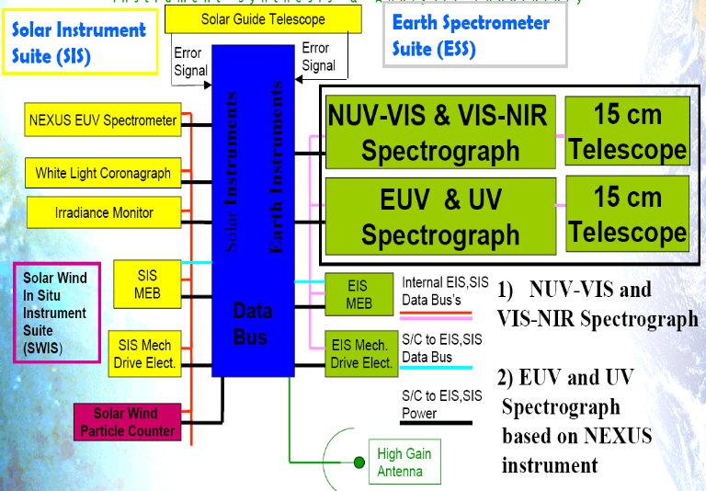
Figure 5 Janus observing system block diagram showing both solar and earth observing instruments and telemetry system. Spectrographs and telescopes are one package, one each for Earth and Sun viewing.

The Janus observatory consists of four major components (Figure 5), a solar observing module, and Earth observing module, a power module (not shown), and a telemetry, command and data handling system module. Each module is packaged in an individual container/structure. Astronauts will deploy these "suitcase" components on the lunar surface. Then the components will be cabled together to make a working observatory. After deployment, tests will be conducted by remotely activating the power switch and observing green on-lights. Once deployed, the observatory will operate with minimal on-site interaction.
Science investigations on the Moon will require power and telemetry services. Isolation of the science experiments by deploying them a distance from the lunar lander/habitat ensures that the instrumentation does not impact the activities near the habitat. If data is taken continuously, then the transmission rate must be approximately twice the average data accumulation rate of the instrument. Sufficient memory to store 2 weeks worth of data must also be available in case telemetry power is not available during the dark period. The Modular Instrument Support System meets all of these needs, yet remains adaptable to accommodate a broad range of scientific instrumentation.
To accomplish these objectives, the optimum Janus payload features a unique combination of solar and earth viewing instruments to (1) enable detailed global mapping of atmospheric composition, (2) observe solar disturbances and their effect on space weather, and (3) explore dynamical and chemical couplings over the scale of the Earth’s whole atmosphere including the forcing by the Sun.

- Earth Observing Module

All instruments described below have been developed as part of a previous spaceflight development effort, and have been through full engineering design including cost, weight and power requirements.

2.1 J-NUV, Visible , and NIR (300 to 960 nm) Spectrometer J-UVIS (Figure 5).
Full-disk observation of the Earth in the 300-960 nm range will enable sensitive tropospheric and stratospheric measurements of aerosols and a number of gases including O₃, H₂O, NO₂, HCHO, SO₂, and BrO. The capability for these observations has been demonstrated previously from nadir instruments in low-Earth orbit (LEO) (e.g., TOMS, GOME, MODIS, SCIAMACHY, OMI). The lunar vantage point provides frequent synoptic global observation for these species, in contrast to the much sparser coverage (particularly when considering cloud interferences) of once per day achievable from LEO. The stratospheric O₃, NO₂, and BrO measurements from J-UVIS will improve understanding of the chemical dynamics of the stratosphere including its coupling to the troposphere and mesosphere. The tropospheric aerosol, H₂O, NO₂, and HCHO measurements will be used in combination with global chemical transport models (CTMs) for high-resolution inversion of the sources of aerosols, nitrogen oxides, and reactive volatile organic compounds (VOCs). This aerosol measurements will allow tracking of anthropogenic and natural plumes on scales ranging from regional to global, including, in particular, the intercontinental scale for the Moon offers a unique capability. Desert dust and volcanic ash plumes have important radiative and chemical consequences and can also pose a hazard to aviation.
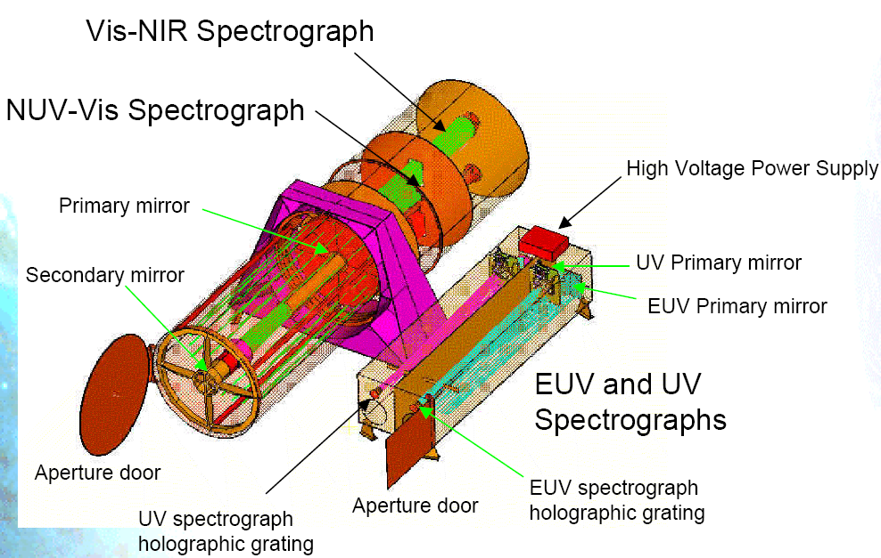
Figure 6 Earth-Viewing telescope module showing 3 spectrometers. The larger telescope is for stratosphere and troposphere measurements, while the two smaller telescopes are for airglow and line emissions in the mesosphere. Aperture doors can be closed to protect against dust.
2.2 Earth Viewing Mid-UV Spectrometer J-MUV:
The mid-UV spectrometer will obtain imaging spectroscopic measurements from 200-300nm where it can detect NO amounts and measure mesospheric ozone profiles. Solar backscatter measurements of the Earth’s atmosphere in the UV contain the signature of numerous NO fluorescent bands to explore vertical coupling between atmospheric layers. Examples of previous nadir measurements using SBUV-like instruments include Stevens et al [1995] and McPeters [1989]. Stevens et al. [1995] were able to document geomagnetic variations in the NO while McPeters documented geomagnetic and solar variations. The spectral resolution of the above data was 1 nm. A key limitation of previous measurements is the lack of altitude resolution (as well as the generally poor spatial sampling which will be vastly improved upon by Janus). It was thus hard to localize the enhanced NO to a particular altitude level and thus quantify vertical coupling between atmospheric layers. J-MUV will resolve that limitation in two ways. First, measurement of NO in different bands that are subject to different atmospheric opacities will allow better localization of the emitters. Second, measurement of the NO rotational temperature will localize the emission to either the warm lower thermosphere (300-400K) or the cold middle atmosphere (< 300K).

2.3 Earth viewing EUV/FUV Spectrometer J-EVES:
J-EVES will obtain complete dayside spectrally resolved images of the Extreme-UV/Far-UV (EUV/FUV) airglow. These global images will provide the distribution of the major thermospheric species (N₂, O, O⁺, He) along with opportunity to investigate distributions of minor species (N, H). N₂ LBH and atomic oxygen 135.6 nm emissions. J-EVES full-dayside images will give unprecedented observation of thermospheric disturbances associated with geomagnetic storms and substorms in tandem with direct observation of the solar events driving these disturbances. Direct EUV observations of OII 83.4 nm in conjunction with the atomic oxygen abundance retrievals will give complete maps of the O⁺ abundance distribution, allowing for the very first time global viewing of the earth’s dayside ionosphere. Another feature of genuine interest is the He 58.4 nm resonance line. Since helium is chemically inert, the abundance distributions derived from the He 58.4 nm images will capture purely dynamical upper atmospheric responses to space weather events, enabling a comparison with the FUV O/N₂ distribution resulting from local processes (energy deposition, chemistry).
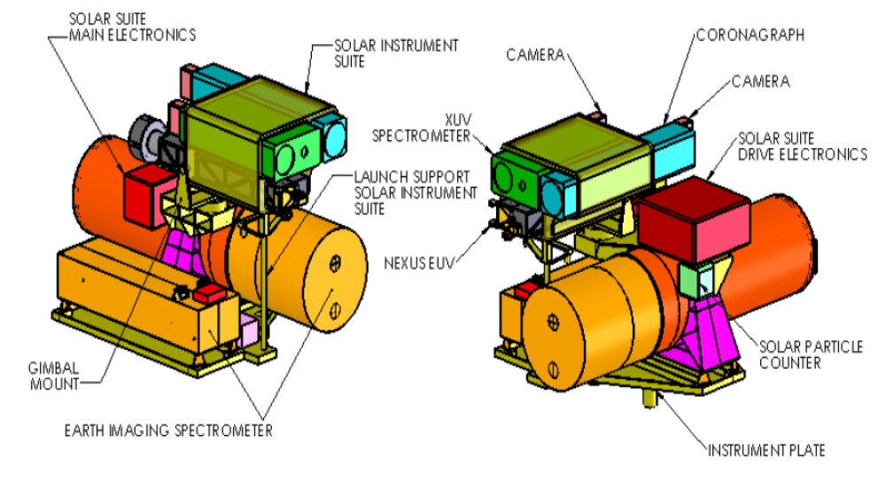
Figure 7 Janus observing system block diagram showing both solar and earth observing telescopes. Solar package points independently from the Earth observing telescopes.

3.0 Solar Observing Module

3.1 Solar EUV Spectrometer J-SES:
The Janus normal-incidence imaging Extreme Ultraviolet Spectrograph (based on NEXUS) will obtain the necessary spectrally and spatially resolved spectroscopic measurements to address the physical processes driving soft x-ray and EUV irradiance variations and large scale solar energetic phenomenon (CMEs and flares). J-SES measurements will quantify the role of plasma flows in a range of dynamic phenomena, revealing the fundamental physics of energy and mass transport in the solar corona. The intermittent flow of energy from the transition region to the solar corona, determined by the complex interplay between the magnetic field and plasma motions, is poorly understood. A wide variety of solar activity phenomena, ranging from slowly evolving small-scale features such as active region loops to rapid energetic events like Coronal Mass Ejections (CME), result from this energy flow. These events shape and modify the entire heliosphere, driving the near-Earth environment and producing space weather effects that can have significant societal impacts.
J-SES measurements (10 to 120 nm) will spatially resolve the source regions with selectable spatial resolutions 0.5, 1, 2, and 4 arcsec/pixel over a slit that is 16 arcmin (1 Rsun) long. The emission lines in this spectral range are formed at temperatures from 0.02-15 MK, giving EUS an unprecedented simultaneous view of the chromosphere, transition region, and corona. The large effective area will result in exposure times of order 1.5 s, which allows for rapid raster imaging of flaring active regions, CME initiation events, and the full solar disk. A velocity resolution of order 5 km/s will provide essential information on the convective energy flux, which is the primary uncertainty in existing models.
Solar radiation at extreme ultraviolet (EUV) and soft X-ray wavelengths (0.1-120 nm) is a major energy loss from the transition region and corona. This radiation largely determines the baseline properties of the Earth’s environment at altitudes above about 100 km. Variations in solar EUV radiation drive substantial changes in thermospheric temperature, density, and ionization that produce space weather impacts over multiple time scales. J-SES observations are well-characterized spectral lines with excellent temperature coverage that will provide the necessary inputs for physics based modeling of solar irradiance variability such as NRLEUV.

3.2 Solar Soft Xray Irradiance J-XI
J-XI will directly measure the primary source of energy input into the upper atmosphere using 1-63nm,with the measurements unique to Janus from 1 to 5nm. This ionizing radiation penetrates down to the lower thermosphere Soft X-rays play a critical role in the Nitrogen Oxide chemistry in the thermosphere and mesosphere. Siskind et al. [1995] discuss the desirability of quantifying the spectrum down to wavelengths as short as 1 nm. Previous measurements of soft X rays (SNOE, SEE) have been limited by the lack of knowledge of the spectrum at high resolution. Thus, contradictory results have been obtained and we still do not know if the solar output matches the terrestrial chemical requirements.
3.3 Solar Coronagraph J-COR
The solar coronagraph on Janus (J-COR) will observe the rotating panorama of the outer solar corona. It will image the evolving coronal streamer belt and directly detect coronal mass ejections. CMEs are the primary solar drivers of large, nonrecurring geomagnetic storms and solar energetic particle (SEP) events. Their statistical properties (line of sight topology, mass and velocity) have been studied extensively with the Solwind, SMM, and SOHO coronagraphs. Determining the 3D topology and propagation through interplanetary space is a primary objective of the STEREO mission, which will develop and test models for predicting the propagation of space weather phenomena through interplanetary space. The J-COR will be a copy of the Secchi COR-2 coronagraph instrument with proven heritage and optical performance.
3.4 Space Environment Instruments J-Plasma
The Janus Plasma instruments are intended to characterize the solar wind proton and alpha particle populations at high time resolution in the lunar surface environment. The Halloween storms of 2003 demonstrate clearly that Solar Energetic Particle (SEP) events drive significant changes in the atmosphere, including drastic loss of polar ozone. Therefore, to understand atmospheric variability, it is important for J-Plasma to measure the particle inputs as a proxy to the Earth’s atmosphere to allow the separation of changes driven by UV variation from particle driven changes. The J-Plasma instruments are intended to provide this information characterizing the solar wind composition and energy (Faraday Cup) at high time resolution on a continuous basis from the Moon.

4.0 CDH&T (Command Data and Telemetry) Module

The baseline system will be designed to support a telemetry rate of 2 Mbps (S-band) using a 0.75 meter antenna (55 Watt of power and 8 kg). This baseline is derived from current capabilities. The 6U cPCI cards on LRO are capable of storing 200 Gb. Six cards along with CPU and I/O cards in an 8-card cage will provide 1200 Gb of total storage (40 Watts of power and 25 kg of mass). This will support an average instrument data generation rate of just under 1 Mbps. The data system will be packaged in a single container with a deployable antenna that will use daily updates to track the position of Earth.

5.0 Power Module

Advances in photovoltaic array designs now provide the capability to easily achieve up to 300 W/kg, in this case excluding the structural battery utilized as a substrate, while LiIon battery energy density capabilities of 200 Watt-hr/kg are also nearing successful achievement. Space qualified power system control electronics for battery charge control are generally viewed as capable of achieving 50 Watts/kg densities. For a theoretical 50 kg portable power system "package" providing a 28Vdc output capability, assuming conservatively 1 kg for electronics and 1 kg for solar array added mass, the remaining 48 kg will be divided between the structure/battery and electrical harnessing. Thus, assuming 3 kg for harness mass, the portable power system capability for "continuous" power output at the lunar surface will be almost 27 Watts. A novel approach utilizing structural LiIon batteries will be implemented to serve as the physical container for the power system electronics, energy storage medium, and the substrate (lid) for a deployable photovoltaic solar array.
Janus requires 50 W of continuous power. Using the figures above, this requirement can be met with 100 kg of Lithium-Ion batteries. For this proposal we envision packaging these batteries in two identical boxes of 50 kg each. In the lower gravity of the Moon, two astronauts can easily place this mass on the deployment pallet.
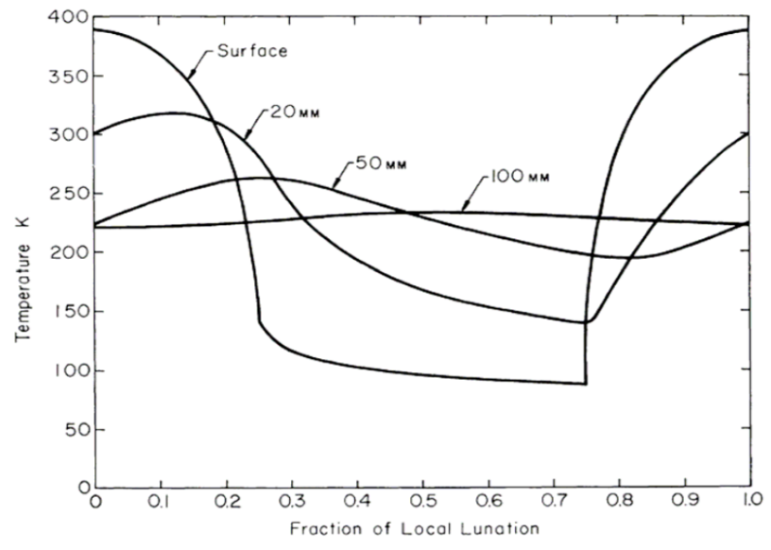
Figure 4-1 Measured Temperatures of the lunar surface and subsurface (20 mm, 50mm, 100mm) during Apollo 12 [Cremers et al., 1971]

6.0 Lunar Environment and Instrument Deployment

In many ways, the lunar environment is far more difficult for scientific instruments than a similar mission in space. The instrument package is faced with extremes of temperature that last about 13 Earth days. In direct sunlight the solar input directly to the instrument package is similar to space flight, but there is additional radiant thermal input from the lunar surface, which can reach 140C with an average sunlit temperature of about 110C. Of course, well-understood properly reflective and insulating material can control the high solar energy input so as to produce moderate internal temperatures within the instrument package. However, the 13-day night presents unique problems because of the prolonged lack of solar power and extreme cold. With temperatures dropping below −200C (night average of ~ −150C) and no solar power, the survival of the instruments depends on novel solutions being developed.
One possibility starts with conductively isolating the instrument package from the lunar surface with four non-conducting supports (titanium and ceramic sandwich posts) of very small area. The package is insulated on all sides and covered with a thermal and light reflecting material. We suggest deploying a modest skirt around the instrument to isolate both the instrument and the underlying regolith from these thermal excursions. A portable lithium-ion battery pack (~100 kg) can supply the moderate amount of power needed for night survival and instrument operation. This simple solution is not intended to be an engineering answer, but just a starting point for the work proposed for this study.
The second problem that we intend to address for the Janus package is dust contamination of the optical and mechanical systems. There is little experience after the Apollo series, but that experience suggests both positive and negative outcomes. The negative outcomes showed that the lunar dust is highly abrasive so that it must be kept away from mechanisms and optics. Part of the problem comes from the extremely jagged nature of the dust particles (Figure 8), many of them in the 1-micron class, and part from the electrostatic clinging of dust particles to exposed surfaces.

The astronauts would stir up clouds of dust during deployment, so that the instruments can only be opened and activated hours later. The problem may be mitigated by some form of electric curtain based on the 1971 ideas of Prof. Senichi Masuda. However, this idea has never bee tried with real moon dust. The problem of electrostatic suspension of dust was described in a story by the novelist Hal Clement and then confirmed by observations shown in hand drawings of suspended dust seen in sunlight (Figure 9). To quote one of the Apollo astronauts,
"…The [Moon's] surface material is one of the lousiest imaginable electrical conductors, so the dust normally on the surface picks up and keeps a charge. And what, dear student, happens to particles carrying like electrical charges?"
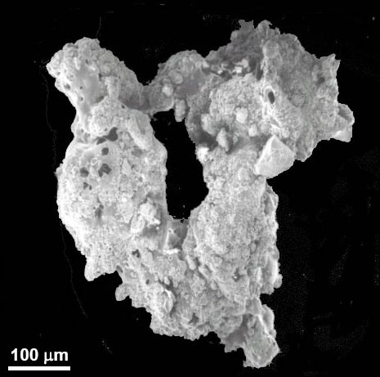
Figure 8 A particle of extremely jagged lunar dust
"They are repelled from each other."
"Head of the class. And if a hundred-kilometer circle with a rim a couple of [kilometers] high is charged all over, what happens to the dust lying on it?"
Theory suggests that the terminator will cause horizontal flows between oppositely charged day (positive) and night (negative) regions, putting a steady layer of dust above the surface (A Dynamic Fountain Model for Lunar Dust by Timothy J. Stubbs, Richard R. Vondrak, and William M. Farrell, 2005). While the details of the lunar dust environment are clearly lacking, the problem is real and cannot be ignored in the design of an instrument package.
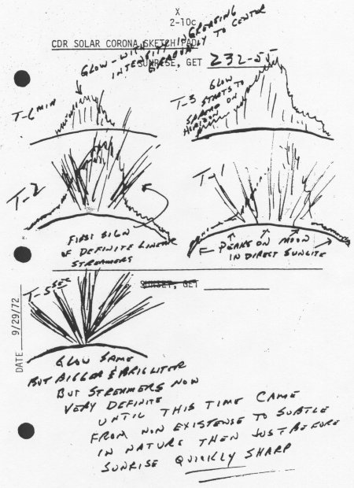
Figure 9 Observations of electrostatic suspension of dust by the Apollo astronauts.
Part of this study will address the design of sealed moving parts, either by sealing the joints or by enclosing as much of the package as possible in a dust-free sealed environment. Unfortunately, some of the proposed instruments operate in a wavelength range (EUV) where transparent windows are not available. This is where an implementation of Masuda’s idea of an electric curtain may have to be deployed. We propose to study this clever idea of phased electrodes to repel dust from surfaces and openings.
We expect to mitigate these risks using several techniques. The primary defense against this type of contaminant is by using quasi hermetic seals to maintain the cleanliness of the critical volumes. The instruments will be designed using hermetic seals with reclosable doors. In this case, we expect that these doors will cover not only the instrument apertures but also the vacuum vents for the instrumentation. The doors could be closed to protect the instrument against further ground operations at or near the site or during a terminator dust storm. The ascent venting for the instruments will be accomplished using a combination of pore filters and labyrinth type sealing to prevent migration of particles into the critical volumes. If necessary, the ascent filters could be covered prior to deployment on the lunar surface. A likely combination of these strategies will be developed during the concept study report.
Deployment of a spectrometer package on the lunar surface observing the Earth and Sun will answer one of the possible observations mentioned by Stubbs et al. (2005), namely, “There was also evidence for 0.1 μm-scale lunar dust present sporadically at much higher-altitudes (~100 km) [11]. The scale height for this dust population was determined to be ~10 km.”
Finally, we will study the means by which the astronauts will deploy the packages after transporting them by hand a sufficient distance from their base. We anticipate that the total mass of each package in the Janus system will be less than 50 kg. The packages will consist of 1 Earth-viewing package of three small aperture spectrometers (15 cm), 1 package of 3 sun-viewing instruments, a battery package (20 kg) and solar power elements (20 kg), a lightweight instrument stand, and a communications package (20 kg). The exact configuration, weight and connecting strategy between the packages will be studied as part of the proposed work.

7.0 Resource requirements for the proposed investigation including cost, mass, volume, telemetry, astronaut intervention, and crew safety

All elements will be designed as sealed modules requiring only placement on the surface on a pre-designed layout pallet that permits only a unique placement of the modules. Electrical connections will be contained in the layout pallet and will not have to be made by the astronauts. All elements will be electrically inactive during astronaut placement and will be activated by a remote controlled on/off radio switch. This minimizes astronaut exposure to possible electrical and mechanical hazards during initialization or future servicing. Each of the five modules will be designed for carrying by two astronauts as a balanced package with appropriate astronaut-designed carrying handles. The modules will be rectangular in form with dimensions 0.3 x 0.3 x 1.0 meters, except for the power module, which will be split into two smaller modules of 50 kg each.
The instrument, power, and communications packages fall between autonomous space-flight instruments and automated Earth-based instruments. That is, it is assumed that the modules are astronaut replaceable on successive missions, but that considerations of astronaut safety will keep necessary interactions with the modules to deployment and initialization, and perhaps remote controlled instrument pointing, if needed.

8.0 Research and development required for the proposed investigation

The areas of research are in the mitigation of dust effects, temperature control during the lunar night, and operating power (discussed in section 6.0). Of these, the dust control represents the biggest challenge, since it is a new area of development affecting all proposed lunar science and operations. From the returned lunar dust samples, the dust consists of fine and coarse particles with sharp broken glass-like edges that can cut soft moving materials and work its way into hard joints to cause abrasive lockup. This proposal will explore to approaches. First, engineering design of dust resistant joints, and second dust minimization using electrical repulsion. The electrical repulsion device is known to work on some forms of dust, but not necessarily on lunar dust. An engineering study will be done to investigate its feasibility.

9.0 Period of performance (8 months)
Since the instrument packages are largely designed based on previous spaceflight investigations, only a small effort will be required to make the small packaging modification needed to create the lunar modules. The modifications will be completed in 1 to 2 months.
The remaining studies of temperature control, power, and dust mitigation will be completed in 6 months.

Janus |  | Mass [kg] | Avg Power [W] |  | Size | Cost $M
 |  | Mass [kg] | Day | Night | Size | Cost $M
Earth Module
 | Spectrometer | 30 | 15 | 15 | 1.2 x 0.5 x 0.3 | 25
 | Structure | 10 |  | 10 | 1.2 x 0.5 x 0.3 | 25
 | Total | 40 | 15 | 25 | 1.2 x 0.5 x 0.3 | 25
Solar Module
 | Spectrometer | 30 | 30 | 10 | 1.2 x 0.5 x 0.3 | 25
 | Coronagraph | 15 | 20 |  | 1.2 x 0.5 x 0.3 | 25
 | EUV Monitor | 1 | 5 |  | 1.2 x 0.5 x 0.3 | 25
 | Structure | 15 |  | 10 | 1.2 x 0.5 x 0.3 | 25
 | Total | 61 | 55 | 20 | 1.2 x 0.5 x 0.3 | 25
¹TC&DH Module
 | Transmitter | 8 | 55 | 27.5 | 1.0 x 0.8 x 0.4 | 2
 | CPU & Memory (1200Gb) | 15 | 40 | 0 | 1.0 x 0.8 x 0.4 | 2
 | Structure | 10 |  | 5 | 1.0 x 0.8 x 0.4 | 2
 | Total | 33 | 95 | 32.5 | 1.0 x 0.8 x 0.4 | 2
¹Power Module
 | Battery | 100 |  |  | 0.7 x 0.3 x 0.3 | 2
 | Structure | 10 |  |  | 0.7 x 0.3 x 0.3 | 2
 | Solar Array | 10 |  |  | 0.7 x 0.3 x 0.3 | 2
 | Total | 120 |  |  | 0.7 x 0.3 x 0.3 | 2
Deployment Pallet
 | Pallet | 20 |  |  | 1.2 x 1.0 x 0.1 | 0.5
 | Structure | 10 |  |  | 1.2 x 1.0 x 0.1 | 0.5
 | Total | 30 |  |  | 1.2 x 1.0 x 0.1 | 0.5
Total Mass and Power |  |  |  |  |  | 54.5
 |  | 284 | 165 | 77.5 |  | 54.5
¹The capabilities of the power and telemetry modules are described in sections 4 and 5

10.0 Summary

Using the Moon as a platform for scientific observations of the Earth and Sun is highly attractive for its unique views of the Earth compared to GEO and LEO orbits. In addition, the Moon offers exceptional stability compared to satellite platforms. Based on the positive aspects of the Moon as an instrument platform we have designed a unique astronaut deployable package of Sun and Earth observing spectrometers and a solar coronagraph to investigate the relationship between solar activity and the processes in the Earth’s atmosphere. We know that there is an observed relationship between solar activity and the photochemical processes in the stratosphere for ozone and coupled chemical species. Observations clearly show a similar relationship for photochemistry at even higher altitudes in the mesosphere. What is not well known is if any effects propagate into the troposphere and even down into the boundary layer. The instrument package will have the capability of observing tropospheric trace gases (e.g., NO₂ and O₃) and the amount of cloud cover on a continuous daytime synoptic basis from the Earth’s day-night terminator and for a week each month, nearly the entire Earth’s disk. At the same time, we will observe solar activity and the response of emission lines originating in the Earth’s mesosphere. These are unambiguous indicators of solar activity perturbing the Earth’s atmosphere. We will attempt to follow this activity down in to the lower atmosphere in the form of observed perturbations relative to periods when there is little or no solar activity.
Unfortunately, the Moon also causes challenges to the successful operation of instrumentation that are not present on satellite platforms. As discussed above, these are the interference of lunar dust with the mechanical and optical portions of instrumentation, the survival of the instruments through the long and cold lunar night, and the need for operating power during the lunar night. This study is designed to specify both a survivable scientific instrument package and possible solutions to the dust, power, and cold problems. Wherever possible, we will draw on proven spacecraft technology for thermal problems, but will have to devise creative solutions for lunar night power and thermal survivability. We will also have to employ creative solutions for the dust problem such as the electric curtain to repel dust from critical areas. Solving these problems for Janus, will also solve the problems for other scientific remote sensing instrumentation that may be employed on the Moon. We will attempt to make the study as general as possible so that it will solve Janus’ specific problems and also be applicable to other situations.

11.0 References:

Cede, Alexander, Jay Herman, Andreas Richter, Nickolay Krotkov and John Burrows, Measurements of Nitrogen Dioxide Total Column Amounts at Goddard Space Flight Center Using a Brewer Spectrometer in Direct Sun Mode, accepted, Journal Of Geophysical Research, Vol. 111, D05304, doi:10.1029/2005JD006585, 2006.

Cremers, C.J., R.C. Birkebak, and J.E. White, Kluwer, The Moon 3, (1971), pp. 346-351

Crisp, D, et al., The orbiting carbon observatory (OCO) mission, Adv. Space Res., 34,, 700-709, 2004.

Kodera, K., Solar cycle modulation of the North Atlantic Oscillation: Implication in the spatial structure of the NAO, Geophys. Res. Lett., 29, 1218, 10.1029/2001GL014557, 2002.
McCormack, J. P., The influence of the 11-year solar cycle on the quasi-biennial oscillation, Geophys. Res. Lett., 30, doi:10.1029/2003GL018314, 2003.
Pittock, A. B. Solar cycles and the weather: successful experiments in autosuggestions? pp 181-191 in Solar-Terrestrial influences on weather and climate, B. M. McCormack and T. A. Seliga (eds), D. Reidel Publishing Company, Dordrecht, Holland, 1978.
Salby, M. and P. Callaghan, Evidence of the Solar Cycle in the General Circulation of the Stratosphere, J. Clim., 17, 34-46, 2004.
Sassi, F., D. Kinnison, B. A. Boville, R. R. Garcia, and R. Roble, Effect of El Nin˜o--Southern Oscillation on the dynamical, thermal, and chemical structure of the middle atmosphere, J. Geophys. Res., 109, D17108, doi:10.1029/2003JD004434, 2004
Shindell, D. T., G. A. Schmidt, R. L. Miller, and D. Rind, Northern Hemisphere winter climate response to greenhouse gases, ozone, solar and volcanic forcing, J. Geophys. Res., 106, 7193-7210, 2001.
Stubbs, T.J., R.R. Vondrak and W.M. Farrell, Workshop on Dust in Planetary Systems (2005)a, p. 4075.
Rind, D. D. Shindell, J. Perlwitz, J. Lerner, P. Lonergan, J. Lean, and C. McLinden, The relative importance of solar and anthropogenic forcing of climate change between the Maunder Minimum and the present, J. Clim., 17, 906-929, 2004.

12.0 Management

Dr. Joseph Davila (Goddard Space Flight Center) will be the Principal Investigator for the proposed study. In addition to managing the design and packaging of the solar pointing instruments, he will coordinate the entire study and be responsible for the required final report to NASA Headquarters

Dr. Jay Herman (Goddard Space Flight Center) will be a co-Investigator and will be responsible for the design and packaging of the earth pointing instruments. He will assist in the creation of th efinalk report.

Dr. Clarence Korendyke (Naval Research Laboratory) will be a co-Investigator And will assist in the design of both the solar and earth instrument pacakages. He will take responsibility for the power and telemetry modules, and the instrument pallet.

The PI will be responsible for obtaining engineering support during the period of performance of this proposal (8 months) from GSFC, NRL, and private contractors, as needed.
13.0 Biographical Sketches

Dr. Joseph Davila (GSFC)

RESEARCH AREA EXPERIENCE:
PRESENT POSITION
EDUCATION:

Recent Refereed Publications (2005 –2006)

Up to 2 pages

Dr Jay R. Herman co-I (NASA/GSFC)

RESEARCH AREA EXPERIENCE: | Ion chemistry, earth ionosphere, planetary ionospheres, radio wave propagation in plasmas, stratospheric chemistry and modeling, radiative transfer, atmospheric spectroscopy, uv solar flux measurements, ozone inversion algorithms, and long-term ozone trend analysis, volcanic aerosols, tropospheric trace gas detection, physical oceanography.
PRESENT POSITION | Project Scientist DSCOVR Mission  Principal Investigator UV and aerosol from satellite data  Principal Investigator Ground-based Measurements Project for UV, Aerosols, and Trace Gases  Principal Investigator L-2 SVIP Interferometer/Spectrometer  Principal Investigator Ocean Radiation  Atmospheric Chemistry and Dynamics Branch,  NASA/Goddard Space Flight Center, Code 613.3  Greenbelt, MD 20771 USA
EDUCATION: | 1959 - B.S. - Physics, with minor in mathematics, (obtained with high honor) Clarkson College, Potsdam, New York  1963 - M.S. - Physics, Penn. State Univ., State College, PA  1965 - Ph.D. - Physics, Penn. State Univ., State College, PA

Recent Refereed Publications (2005 –2006)
- Meloni, D., A. di Sarra, J. R. Herman, F. Monteleone, and S. Piacentino, Comparison of ground-based and TOMS erythemal UV doses at the island of Lampedusa in the period 1998-2003: the role of tropospheric aerosols, J. Geophys. Res., 110, D01202, doi:10.1029/2004JD005283, 2005.
- Tzortziou, Maria, Jay R. Herman, Ajit Subramaniam, Patrick J. Neale, Charles L Gallegos and Lawrence W. Jr Harding, Optical properties and radiation in the Chesapeake Bay estuarine waters: An in-water optical closure experiment, submitted to J. Geophys. Res., 2005.
- Patra, P.K., S. K. Behera, J. R. Herman, S. Maksyutov, H. Akimoto, T. Yamagata, The Indian summer monsoon rainfall: interplay of coupled dynamics, radiation and cloud microphysics, Atmos. Chem. Phys. Discuss, 5, 2879-2895, 2005.
- Fromm, Michael, R. Bevilacqua, R. Sevranckx, J. Rosen, J.P. Thayer, J. Herman, and D. larko, Pryo-cumulonimbus, injection of smoke to the stratosphere: Observations and impact of a super blowup in northwestern Canada on 3-4 August 1998, J. Geophys. Res., 110, D08205, doi:101029/2004JD005350, 2005.
- Arola, Antti, Stelios Kazadzis, Nickolay Krotkov, Alkis Bais, Julian Grobner, and Jay R. Herman, Assessment of TOMS UV bias due to absorbing aerosols, J. Geophys. Res., VOL. 110, D23211, doi:10.1029/2005JD005913, 2005.
- Tanskanen, A., N. Krotkov, J.R. Herman, and P.K. Bhartia, “A. Arola, Surface UV Irradiance from OMI, IEEE, TGRS AURA,” special issue, 44, 1267-1271, 2005.
- Cede, Alexander, M. Kowalewski, Stelios Kazadzis, Alkis Bais, Natalia Kouremeti, Mario Blumthaler, and Jay Herman, Solar zenith angle effect for direct-sun measurements of Brewer spectrophotometers due to polarization, Geophysical Research Letters, Vol. 33, L02806, doi:10.1029/2005GL024860, 2006.
- Cede, Alexander, Jay Herman, Andreas Richter, Nickolay Krotkov and John Burrows, Measurements of Nitrogen Dioxide Total Column Amounts at Goddard Space Flight Center Using a Brewer Spectrometer in Direct Sun Mode, accepted, Journal Of Geophysical Research, Vol. 111, D05304, doi:10.1029/2005JD006585, 2006.

Dr Clarence Korendyke co-I (Naval Research Laboratory)

RESEARCH AREA EXPERIENCE:
PRESENT POSITION
EDUCATION:

Recent Refereed Publications (2005 –2006)

1 page

14. Budget Justification

We are requesting funding over a 1-year period to develop the Janus concept to the point where the technical feasibility is raised to the point where it is reasonable to develop a flight proposal. All the work is for study, so that funds are used almost entirely for labor. In addition, there is 0.5 FTE of approved cost sharing ($86,532).

Category | Amount | Justification FY2007
1. Direct Labor  Salary  Overhead | $155,016  124,910  30,105 | The labor includes  Dr Jay Herman (Co-II) scientist 25%  Dr. Joeseph Davila (PI) scientist 25%  Dr. Clarence Korendyke scientist 08%  Engineering Support 35%
2. Other Direct Costs (Total) | $8,000
Equipment | 0
Travel  Domestic  Foreign | 0 | Total for meetings and field campaigns. 1 or 2 science meetings plus 1 domestic campaign and 1 foreign campaign
Other  Materials  Consulting | $8,000  3,000  5,000 | The materials are miscellaneous laboratory materials and other small items incidental to developing, analyzing, and maintaining instrumentation. Acquisition will be by small purchases as needed. It is assumed that there will be two publications per year in refereed journals.
3. F & A (Total)  Mandatory Institutional Costs | $25,828  8,107  17,721 | Research and Development Multiple Support  Directorate Assessment including Branch and Division
4. Other Costs | 0
Subtotal | $188,844 | Sum of Bolded amounts.
- Cost Sharing | -86,532
Total | $102,312 | Sum of Bolded amounts.

15. Current and pending support
OTHER SUPPORT | Source of Support | Award Amount and Period of Performance | Person-Months and Level of Effort (PM/Year) | Project Title and Short Abstract (50 words or less)
Dr Davila PI
Dr. Herman Co-I
PI  Year 3 of 3 | NNH04ZYS004N | $1070K  FY2005 to FY2007 | 3 PM/Year | Development of DS-DOAS for OMI Validation and Analysis of Trace Gases
PI  Year 2 of 3 | NNH04Z  YS004N | $706K  FY2006 to FY2008 | 3 PM/Year | Ocean Atmospheric Correction 340 – 440 nm

Dr. Korendyke Co-I

