Proposal due on 5/14/10

NPP is expected to launch during the periods of performance for the awards solicited under this element, and proposers should plan to profile their work and cost plans to reflect somewhat less intense activity prior to the launch of NPP and during the immediate post-launch instrument check-out period and to reflect greater activity once the SDRs and EDRs are available for evaluation. Proposers also are encouraged to consider proposing as small teams collaborating on the evaluation of groups of related data products if greater efficiency and cost savings might be achieved in doing so.

These properties include, but are not limited to, the temporal and spatial distribution of aerosol optical depth (AOD) and aerosol size. (EDRs: Aerosol Optical Thickness, Aerosol Particle Size, Suspended Matter)

Ozone total column and vertical profile and other atmospheric constituents: Satellite measurements of total column ozone are the global standard for monitoring the response of the ozone layer to the Montreal Protocol mandated reductions in atmospheric chlorine and bromine emissions. The NPP OMPS instruments will continue the ozone data record, started in 1978, by the Total Ozone Mapping Spectrometer (TOMS) series of instruments and carried on by the Ozone Monitoring Instrument (OMI) instrument on EOS Aura. The limb observing component of OMPS will continue the data records of ozone profile observations that started with the Upper Atmosphere Research Satellite (UARS) and were continued by the Microwave Limb Sounder (MLS) instrument on EOS Aura. The changing climate is affecting the speed and timing of ozone layer recovery, adding to the importance of maintaining continuous data records. (EDRs: Ozone Column, Ozone Profile) Evaluation of the OMPS nadir products is being solicited under this program element. Such work could involve comparisons with EOS Aura’s OMI, the European Global Ozone Monitoring Experiment-2 (GOME-2), ground based observations (such as those in the Network for the Detection of Atmosphere Composition Change (NDACC) network), global ozone sondes, etc. OMPS limb EDRs are not being produced by the IDPS because the OMPS limb capability was a late readdition to NPP. Production and evaluation of these products are being covered now by the activities of the NASA SDS Ozone PEATE, NPP Science Team members, and other NASA programs. Successor proposals to continue the NPP Science Team work on OMPS Limb algorithms and data production are welcome under this solicitation.

2.1.2 Calibration and Validation
Some members of the current NPP Science Team have been preparing to provide scientific inputs on, or to make available certain EOS calibration and validation capabilities in support of, critical calibration and validation approaches for science-quality data. Successor proposals in these areas are welcome.
New research activities to add scientific calibration/validation expertise or to complement planned IPO activities for work essential to the evaluation of EDRs will be considered. Proposers must avoid duplicating calibration/validation work that is the responsibility of NGST and the IPO and should offer studies that complement and add value to those efforts while maintaining a tight focus on activities essential for completing the evaluation of the EDRs and/or offering improvements necessary to create an ESDR or CDR. New field validation campaigns will not be considered.

Investigations to explore and demonstrate options for obtaining systematic time series data records that cannot be provided by NPP are sought. Due to performance limitations documented during instrument testing for NPP, a few of the measurements planned are not expected to be of a sufficient quality to usefully extend the current multi-sensor time series. These data products include Ocean Color/Chlorophyll and some aerosol properties (potentially Aerosol Optical Depth) from VIIRS. NASA will continue to evaluate the EDRs for those data products (and such proposals are requested in Section 2.1.1 above) so as to fully document their character and quality and to explore any potential adjustments or algorithmic solutions that might allow for scientific utility. However, NASA is also interested in identifying options to extend these critical time series data products in other ways. In some cases, the performance limitations for an NPP instrument may be mitigated for the instrument version to fly on NPOESS; in these cases there will only be a short potential gap to fill. In other cases, this may not be the case and alternative data sources will be needed for a longer period of time.

Evaluation of Ozone Data Records and other key Atmospheric Constituents from NPP/OMPS,
Using Multi-Angle Spectrally Resolved Retrievals
From a network of Pandora Ground-Based Spectrometer Systems

Proposal Submitted to:
Earth Science Division

Science Mission Directorate

NPP SCIENCE TEAM FOR CLIMATE DATA RECORDS

Solicitation: NNH10ZDA001N-NPP

National Aeronautics and Space Administration
Washington D.C.

Principal Investigator:
Jay R. Herman
Joint Center for Earth Systens Technology
University of Maryland, Baltimore County
Phone: 301-614-6039

Co - Principal Investigator:
Maria Tzortziou
Earth System Science Interdisciplinary Center
University of Maryland, College Park
Phone: 301-614-6048

Co-Investigators

Co-I | Dr. Nader Abuhassan | University of Maryland, Baltimore County
Co-I | Dr. Alexander Cede | University of Maryland, College Park

TABLE OF CONTENTS (REDO) | page
ABSTRACT | iii
1. Summary of Personnel and Work Efforts | iv
2. Scientific / Technical / Management Section | 1
2. 1. Introduction  2. 1. 1. Background---------------------- ------------------------------------------------  2. 1. 2. Purpose of proposed Research------------------------------------------------  2. 1. 3. Basis in NRA----------------------------------------------------------------------  2.1.4 Proposal Objectives And Goals------------------------------------------------- | 1  1  2  3  4
2. 2. Research Objectives and Work Statement | 6
2. 3. Technical Approach and Methodology  2. 3. 1. Description of Ground Based Instruments -----------------------------------  2. 3. 2. Ozone and NO₂ Profile Inversion Algorithm --------------------------------  2. 3. 3. Ozone Retrieval Results --------------------------------------------------------  2. 3. 4.Profile Retrieval Performance -------------------------------------------------  2.3.4.1 Ozone retrievals using measured sky radiances ----------------------  2.3.4.2 Effect of Aerosols on Ozone Profile Retrievals ----------------------- | 7  7  8  10  11  12  13
2. 4. Summary | 15
2.5 Impact of proposed work | 15
2.6 References | 16
3. Management APPROACH | 18
4. Facilities and Equipment | 19
5. Budget Justification | 20
6. BIOGRAPHICAL SKETCHES | 22
7. Current & Pending Support | 30
8. Letters of ComMitment | 30
Abstract

Ensuring continuous science-quality satellite data records of tropospheric and stratospheric ozone amounts and vertical distribution is among the key objectives of the National Polar-Orbiting Operational Environmental Satellite System (NPOESS) and the NPOESS Preparatory Project (NPP). Maintaining ozone data continuity is critical not only for monitoring the response of the ozone layer to the Montreal Protocol mandated reductions in atmospheric chlorine and bromine emissions, but also for studying feedbacks between climate change, ozone changes, and air quality. This proposal targets the above NPP mission objective and focuses on the evaluation and validation of the Total Column Ozone environmental data records (EDRs) and Ozone Vertical Profile products that will be derived from both the nadir and limb observing components of the NPP Ozone Mapping and Profiler Suite (OMPS). In addition to ozone, the OMPS system will provide other products useful to the atmospheric community, including amounts of Nitrogen Dioxide (NO₂) from biomass burning and urban pollution and aerosol optical thickens and vertical distribution. The innovative aspect of this proposal is that we plan to use a new network of recently developed, highly accurate, extensively tested and validated Pandora ground-based spectrometer systems. The Pandora systems have the capability of providing the needed ground-based information on trace gas (O₃, NO₂, SO₂, HCHO, CHOCHO, H₂O) and aerosol variability at the accuracy and temporal/spatial scales required for NPP data validation.

The high sensitivity Pandora CCD system uses a small spectrometer, which is fiber optic coupled to an optical head and pointing device. The entire spectrometer is kept in a temperature controlled chamber to obtain the necessary precision of the spectral radiance measurements. The proposed altitude profile retrieval method uses our recently published Multiple-Angle Spectrally Resolved MASR algorithm for measuring stratospheric and tropospheric O₃ total column amounts and vertical distribution. Ozone profile retrievals can be obtained every 10 minutes with an altitude resolution of 2.5 to 3 km starting at the ground using measured direct-sun and sky radiances in the spectral range 280 – 525 nm (spectral resolution of 0.5 nm). The MASR troposphere plus stratosphere technique is a major improvement over the traditional Umkehr method of obtaining stratospheric ozone profiles only twice per day. The Pandora MASR method is designed as an alternative to balloon sondes or lidars, which are too expensive to obtain continuous diurnal profile data at multiple sites.
Should not be here

Pandora spectrometers also provide simultaneous measurements of other trace gases and aerosols, information that is critical for accurate ozone profile retrievals. Moreover, the proposed measured correlations between boundary layer O₃ and NO₂ and HCHO amounts, in combination with the spectrally resolved measurements of aerosol properties in the UV-Visible, will provide a unique dataset that will be used for testing/validating model photochemistry. We are proposing to deploy several existing copies of the Pandora CCD system with high signal to noise ratio (1000:1) needed for O₃ and NO₂ profile retrievals, at several key locations as needed for capturing satellite sub-pixel and pixel-to-pixel variability. Frequent (10 minutes) ozone and NO₂ profiles will insure coincidence with NPP satellite overpass times. The results will be used to validate and improve NPP retrieval algorithms so that the NPP O₃ and trace gas retrievals can be used for monitoring the response of the ozone layer to future atmospheric changes, bounding tropospheric photochemical models, and studying the evolution of tropospheric ozone, trace gases, and aerosols and their impacts on climate and air quality.

1. Summary of Personnel and Work Efforts

Name | Time %/Yr | Responsibilities | ORG
Dr. Jay Herman, PI | 30 | Overall responsibility for management, algorithms, and data analysis. | UMBC
Dr. Maria Tzortziou, Co-PI | 33 | Management and Coordination of Efforts, data and radiative transfer analysis, algorithm development. | UMCP
Dr. Alexander Cede, Co-I | 33 | Spectrometer scientist | UMCP
Dr. Nader Abuhassan, Co-I | 33 | Spectrometer Scientist and Engineer | UMBC

UMCP University of Maryland, College Park
UMBC University of Maryland, Baltimore County

2. Scientific / Technical / Management Section

2. 1. Introduction

This proposal is for the evaluation of the Total Column Ozone environmental data records (EDRs), Ozone Vertical Profile, and NO₂ products that will be derived from both the nadir and limb observing components of the NPP Ozone Mapping and Profiler Suite (OMPS) (Fig. 1 Top).
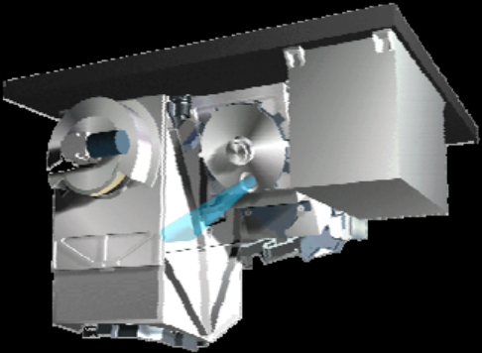
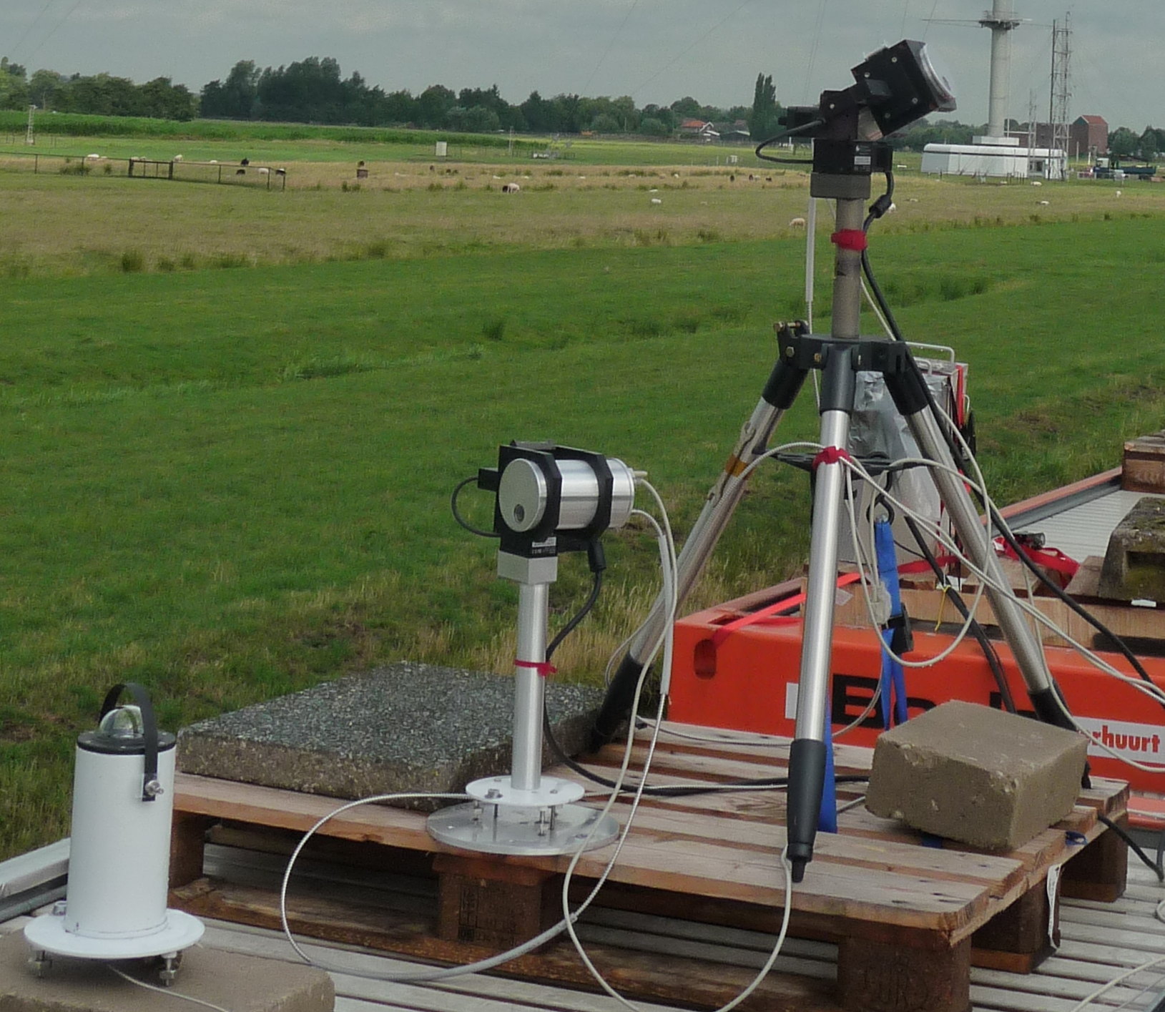
Figure 1 (Top) OMPS sensor suite. (Bottom) Pandora System

The innovative aspect of this proposal is that we plan to use a network of recently developed, highly accurate, extensively tested and validated Pandora ground-based spectrometer systems (Fig 1 Bottom). Pandora has the capability of providing needed information on trace gas (O₃, NO₂, SO₂, HCHO, CHOCHO, H₂O) and aerosol variability at the accuracy and temporal/spatial scales and coverage required for NPP data validation.

Pandora ozone (O₃) and nitrogen dioxide (NO₂) profile retrievals can be obtained every 10 minutes. Ozone profiles will have an altitude resolution of 2.5 to 3 km starting at the ground using measured direct-sun and sky radiances in the spectral range 280 – 525 nm (spectral resolution of 0.5 nm). NO₂ profiles, using the MAXDOAS technique [REF], will have higher resolution, since most of the NO₂ is in the boundary layer (1 to 3 km). Existing copies of the Pandora spectrometers will be deployed at key locations to map out the NPP/OMPS sub-pixel and pixel-to-pixel variability, and evaluate and improve the NPP satellite retrievals. Previous methods for determining O₃ profiles from ground-based relied on balloon flights or on specially designed lidars. Both of these methods are expensive to use for frequent measurements at multiple sites, and lidar tropospheric ozone profile data cannot be acquired at times corresponding to mid-day NPP satellite overpasses. The retrieval method proposed here is a significant improvement over the above methods, and is based on our recently published [Tzortziou et al., 2008] Multiple-Angle Spectrally Resolved (MASR) retrieval method for measuring stratospheric and tropospheric ozone and trace gas profiles. For both NO₂ and O₃ profile retrievals, the MASR data will be constrained by direct-sun retrievals of TC (total column amounts [Cede et al., 2006b; Herman et al., 2008]. A critical element for accurately determining O₃ profiles is the simultaneous determination of aerosol optical properties (scattering and absorption). Aerosol properties will be determined simultaneously with the ozone retrieval using both PANDORA and our newly deployed shadowband spectrometer CLEO (300 to 900 nm with 1 nm resolution, see Figure 1 Bottom Left).

2. 1. 1. Background
Ozone and nitrogen dioxide are critical atmospheric constituents involved in the photochemistry of the troposphere and stratosphere. The details of their altitude distributions are vital to understanding boundary layer air quality and photochemistry. Thus, long term, highly accurate and stable satellite observations of total column amounts and vertical distribution of ozone and other atmospheric constituents by the OMPS Nadir and Limb sensors are key objectives expected to be achieved by the NPOESS mission. Evaluation, validation, and improvement of these products is the main objective of our proposal.

In addition to regulating the oxidation capacity of the lower atmosphere and influencing background levels of trace chemicals, O₃ is an important greenhouse gas, affecting radiative balance and global climate. Ozone absorption in the UV-B (280 nm < λ < 320 nm) region of the solar spectrum affects many photochemical and biological processes as well as shielding the Earth’s surface from UVB radiation. Boundary layer ozone and its chemical reactions with nitrogen oxides are major contributors to urban smog, which continues to pose a health risk to a large percentage of the US population. Nearly 100 major cities in the United States are periodically exposed to concentrations of ozone that exceed EPA health-based air-quality standards. Increased ground-level ozone concentrations are toxic upon inhalation or contact, posing serious threats to agricultural productivity and human health.
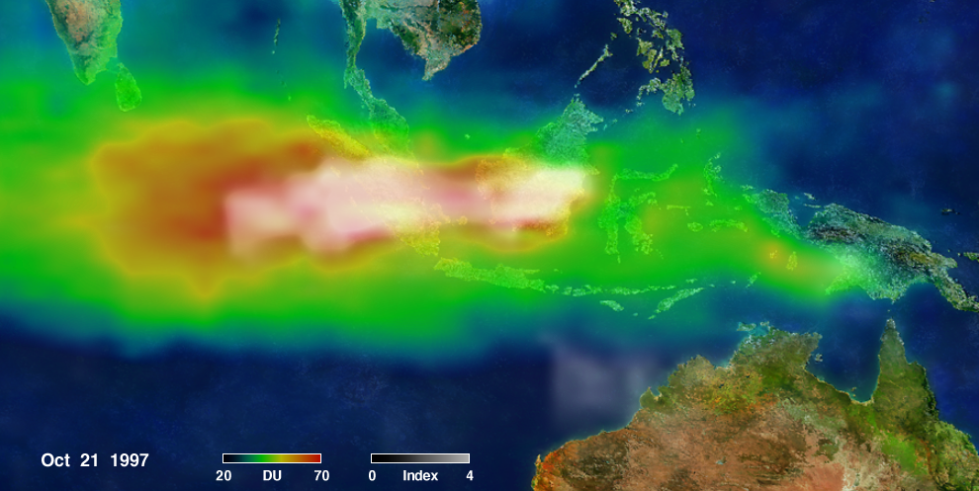(a)
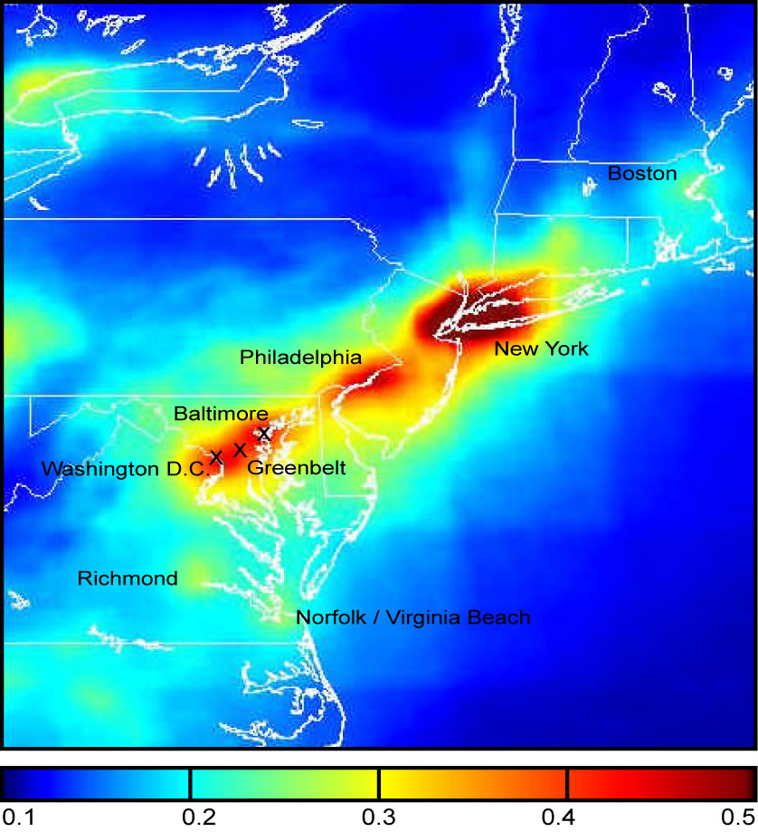(b)
Figure 2: Satellite observed spatial variability in (a) smog or tropospheric ozone, and aerosol index (over Indonesia on October 21, 1997) derived by TOMS/TOMS and Terra/MODIS; (b) tropospheric column NO₂ (DU) derived from OMI measurements (one year averaged for 2005). NO₂ hot-spots coincide approximately with the locations of the labeled cities.
One of the main precursors of tropospheric ozone (smog) is NO_{2,} via photochemical reactions with hydrocarbons. Elevated concentrations of NO2 in the boundary layer contribute directly (it is a toxic gas) and indirectly (through particle formation) to adverse health effects including lung damage, increased susceptibility to respiratory illnesses, and aggravation of heart and lung conditions [e.g. Environmental Protection Agency, 1998]. Observations over Boulder and Fritz Peak, Colorado, showed that high concentrations of NO₂, due both to pollution and to production by lightning in convective clouds, can reduce downwelling visible radiation by about 5-12% [Solomon et al., 1999], corresponding to an estimated local radiative forcing effect that exceeds that of CO₂ [IPCC, 2001].
Tropospheric O₃ and NO₂ amounts are highly variable in time and space (Figure 2), and are influenced by both natural and anthropogenic emissions. Fossil fuel combustion for transportation, industrial activities (power generation) and biomass-burning are the major NO₂ sources, contributing about 70% on a regional scale and even more in local urban environments. Understanding the processes that affect O₃ and NO₂ changes and impacts on air quality, as well as feedbacks on climate change, requires an integrated observational strategy using frequent (e.g. hourly) measurements of the concentrations and vertical distributions of both constituents. Recent analysis of data obtained from space-borne ozone monitoring instruments such as SBUV and AURA-OMI has shown that it is possible to obtain information on O₃ vertical distribution, tropospheric NO₂, trace gas and aerosol amounts from satellite observations, but with considerable uncertainties. For these data and for NPP/OMPS, ground-based validation is essential to drive improvements in satellite retrieval algorithms. Detailed ground-based O₃ and NO₂ profile measurements, such as those proposed here, will help validate satellite retrievals, and quantify the role of both chemical constituents on local and regional environmental degradation, tropospheric chemistry, surface UV-B budgets, human health, and radiative forcing.
Two main techniques have been available for measuring O₃ vertical profiles at high vertical resolution: (i) in-situ sensing from balloon sondes and aircraft [e.g. Thompson et al., 2003], and (ii) remote sensing using ozone lidars [e.g. Browell et al., 1985; Uthe et al., 1992, McGee et al., 1995]. However, these measurement approaches are not suited for long-term hourly measurements at multiple sites. Moreover, active ozone-lidar techniques usually do not detect changes in the boundary layer (altitudes below 7 km), and are limited to night, early morning, and late evening observations [McDermid et al., 1995, 2002; McGee et al., 1995]. This makes the lidar technique unsuitable for validating mid-day satellite retrievals of highly variable tropospheric ozone amounts. Several techniques have been developed for obtaining limited tropospheric information from satellites and ground-based observations. The ground-based Umkehr zenith-sky radiance technique [e.g. Mateer, 1965; Petropavlovskih et al., 2005] provides information on stratospheric and limited information on upper tropospheric O₃ profiles. While satellite overpasses are midday, Umkehr observations are restricted to measurements near sunrise and sunset (solar zenith angles, SZAs, between 60º and 90º), and last approximately 2 hours, during which significant changes in atmospheric conditions can occur, causing significant retrieval errors.
The proposed MASR method, based on automated passive remote sounding from the ground, is a significant improvement over the Umkehr method, and is designed as an alternative to balloon sondes or lidars, which are too expensive to obtain continuous diurnal profile data over long periods at multiple sites. The MASR algorithm uses an optimal estimation technique [Rodgers, 2000] applied to ground-based observations of sky radiances measured simultaneously at 315 wavelengths (300-340 nm with 0.13 nm steps), multiple viewing zenith angles (0º to 90º), for different solar zenith angles, every 10 minutes during the day, to derive high accuracy and high vertical resolution (~2 km in the lower troposphere) trace gas retrievals. Since the wavelength ranges for NO₂ (400 nm – 450 nm) and O₃ (300 nm – 340 nm) retrievals are independent, the technique can be optimized for retrievals of both O₃ and NO₂ profiles. Boundary layer NO₂ profiles have been obtained by the MAX-DOAS technique [Bruns et al., 2006], which is a subset of our proposed method. The major improvements of the NO₂ retrieval method proposed here are the use of more observing angles, the use of the simultaneous direct-sun retrieved value of total column NO₂ to constrain the altitude profile retrieval, and the simultaneous information on O₃ profiles and aerosol properties. The simultaneous suite of measurements is essential to understand the build up of smog in industrial urban areas.
In addition to O₃ and NO₂, the Pandora spectrometers provide simultaneous measurements of aerosols, information that is critical for accurate ozone profile retrievals. Moreover, the proposed measured correlations between boundary layer O₃ and NO₂ and HCHO amounts, in combination with the spectrally resolved measurements of aerosol properties in the UV-Visible, will provide a unique dataset that will be used for testing/validating model photochemistry. We are proposing to deploy several existing copies of the Pandora CCD system with high signal to noise ratio (1000:1) needed for O₃ and NO₂ profile retrievals, at several key locations as needed for capturing satellite sub-pixel and pixel-to-pixel variability. Frequent (10 minutes) ozone and NO₂ profiles will provide a unique dataset for insuring coincidence with NPP satellite overpass times. The results will be used to validate and improve NPP retrieval algorithms so that the NPP O₃ and trace gas retrievals can be used for monitoring the response of the ozone layer to future changes, bounding tropospheric photochemical models, and studying the evolution of tropospheric ozone, trace gases, and aerosols and their impacts on climate and air quality.

No review/comments on the rest of the document yet.

2. 1. 2. Purpose of Proposed Research
The main objective of the proposed MASR method is the implementation of an integrated ground-based measurement program that will validate seasonal and diurnal changes in tropospheric and stratospheric O₃ and NO₂ amounts and their vertical distributions at different locations in the US, especially in polluted areas (e.g., Los Angeles, Atlanta, and Washington, DC). The O₃ and NO₂ profile measurements program will be integrated into an ongoing trace-gas (e.g., column NO₂, SO₂ aerosol) set of measurements from direct-sun viewing spectroscopy. The proposed measurement method uses our previously developed small spectrometer system (PANDORA) [Herman et al., 2008], and is based on, and enhances the abilities of, an established O₃ profile retrieval technique [Tzortziou et al., 2008]. The MASR method, based on automated passive remote sounding from the ground, is a new alternative to either balloon sondes or lidars. The MASR algorithm uses an optimal estimation technique [Rodgers, 2000] applied to ground-based observations of sky radiances measured at 315 wavelengths (300-340 nm with 0.13 nm steps), multiple viewing zenith angles (0º to 90º), for different solar zenith angles, every 10 minutes during the day. This guarantees coincidence between the ground-based measurements and the NPP/OMPS satellite overpasses. The original retrieval technique was applied to GSFC’s modified ground-based Brewer double spectrometer (Figure 1), where it was developed using 6 wavelengths measured quickly, but sequentially at several view angles. The retrieved O₃ profiles have been successfully compared with ozone sondes and satellite data. The use of 315 simultaneously measured wavelengths greatly enhances the signal-to-noise ratio SNR, especially by eliminating the effect of atmospheric changes that occur while sequentially measuring single radiances. This results in increased accuracy and vertical resolution (~2 km in the lower troposphere) in a low-cost portable system. Since the wavelength ranges for NO₂ (400 nm – 450 nm) and O₃ (300 nm – 340 nm) retrievals are independent, the technique can be optimized for retrievals of both O₃ and NO₂ profiles.
As part of the 10-minute sky-scanning procedure used to derive O₃ and NO₂ profiles, we will also derive information on other trace gas amounts (SO₂, NO₂, HCHO, CHOCHO, and H₂O) and aerosol optical properties (aerosol optical depth AOD and single scattering albedo SSA). UV and visible AOD and absorption (SSA) will be obtained from PANDORA sky radiance and direct-sun observations. AOD and SSA will also be obtained from our newly deployed spectrometer version (300 nm to 800 nm; 1 nm resolution) of a shadowband-type instrument (CLEO, Figure 2).

2. 1. 3 Basis in NRA Solicitation: NNH10ZDA001N-NPP

The research we propose is related to NASA’s strategic goal and Science objective (as stated in the Strategic Plan) to: “Conduct a program of research and technology development to advance Earth observation from space, improve scientific understanding, and demonstrate new technologies with the potential to improve future operational systems”. This proposal addresses the goal through much needed satellite validation of data and algorithms for critical measurements in the troposphere and stratosphere.

The proposed measurements are in support of Calibration and Validation efforts during the NPP mission at pre-existing sites where PANDORA spectrometers are located. We are not proposing new field campaigns for ozone profile and trace gas validation. As part of the validation effort, we will produce systematic time series of day-to-day diurnal variation that cannot be provided by NPP. We will also provide high quality measurements of aerosol optical properties (optical depth and single scattering albedo) as a function of wavelength in both the visible and UV wavelength ranges to extend the measurements expected from VIIRS and OMPS.

The proposed work also fulfills the following NASA objectives, “Atmospheric composition determines air quality and affects weather, climate, and critical constituents such as ozone… NASA’s research for furthering our understanding of atmospheric composition is geared to providing an improved prognostic capability for the recovery of stratospheric ozone and its impacts on surface ultraviolet radiation, the evolution of greenhouse gases and their impacts on climate, and the evolution of tropospheric ozone and aerosols and their impacts on climate and air quality”. The result of this effort will be an automated, passive measurement of diurnal variation of tropospheric O₃ and NO₂ as a function of altitude from the lower troposphere to the stratosphere. The data (ozone, aerosol, trace gas amounts) will be readily available to NASA and the scientific community for NPP/OMPS validation of retrieved data, for bounding tropospheric photochemical models, and will provide a unique dataset for studying the evolution of tropospheric ozone and aerosols and their impacts on climate and air quality at each location where PANDORA spectrometers are deployed.

Our proposed measurements of O₃ and NO₂ altitude profiles every 10 minutes using ground-based spectrometer systems provide a new capability for satellite validation and for understanding tropospheric composition and the sources driving composition changes in the stratosphere, troposphere, and boundary layer.

2.1.4 Proposal Objectives and Goals
The primary objectives of this proposal are:
Science: Long-term data records of O₃ and NO₂ profiles, trace-gas amounts, and aerosols from strategic sites will help determine how the atmospheric composition is changing, and how atmospheric trace constituents respond to and affect environmental change. In combination with satellite data, the more detailed ground-based measurements will contribute to calculations of radiative forcing needed for estimates of climate change. The measurements will yield primary data for characterizing air quality at each site.

- Determine the diurnal, day-to-day, and seasonal variability of the ozone and NO₂ vertical distributions at several different sites in the US and other locations as a measure of changing stratospheric and tropospheric composition and tropospheric air quality.
- Determine aerosol optical properties from PANDORA and CLEO data as part of the ozone profile retrieval residual minimization.
- Apply results to validation and augmentation of satellite data products for NPP/OMPS for ozone profiling, trace gas amounts (e.g., NO₂), and aerosol properties.

Instruments and algorithms: The instruments used in this proposal are the GSFC modified Brewer spectrometer (Figure 1), the CLEO UV-Vis-NIR spectrometer shadow-band type instrument for aerosols (Figure 2), and the main instruments, PANDORA (Figure 3), for determining ozone and NO₂ profiles from measured sky radiances and direct-sun solar irradiance. We have internally validated the measurements using the GSFC modified commercial UV-Vis shadowband, the GSFC modified Brewer, and AERONET’s CIMEL sunphotometers.

- Apply the MASR O₃ profile optimal estimation algorithm using 315 wavelengths (300 to 340 nm with 0.13 nm steps)
- Use PANDORA and CLEO aerosol optical depth (AOD) and single scattering albedo (SSA) retrievals to correct the O₃ profile retrievals for aerosol absorption and aerosol extinction.

During the period of performance we will use at least five existing sun- and sky-viewing PANDORA CCD spectrometers deployed at strategic sites to provide O₃ and NO₂ profiling and aerosol capability along with the CLEO spectrometers to provide additional aerosol data. The derived ozone profiles will also be compared with balloon sonde measurements during annual campaigns that occur near GSFC in Beltsville, MD.

2. 2. Proposal Objectives and Work Statement
Objectives: We are proposing to measure tropospheric ozone profiles and column ozone amounts every 10 minutes throughout each partly cloudy or clear-sky day and stratospheric ozone profiles twice per day near sunrise and sunset. The measurements will be combined with aerosol characteristics (particle size, optical depth, and absorption) and separately measured trace gas amounts (NO₂, SO₂, H₂O, HCHO, CHOCHO) every 10 minutes. For this purpose we will use measured radiances obtained from the PANDORA CCD spectrometer systems (Figure 3), and will apply our MASR algorithm for determining ozone profiles using measured radiances and aerosol characteristics.

Year | Statement of Work (Years 1 to 3)
1 | - Apply the MASR algorithm to PANDORA O₃ profile retrievals using enhanced aerosol data to optimize the tropospheric profile retrieval capability. Apply the data for OMPS and SBUV-2 ozone profile comparisons.  - Apply the enhanced MAX-DOAS technique for the retrieval of tropospheric NO₂ altitude profiles and total column amount and compare with OMPS retrievals.  - Continue the Brewer and PANDORA ozone profile validation at GSFC with existing balloon-sonde campaigns to validate the PANDORA ozone profile retrievals.  - Continue the comparison of the operational small aerosol spectrometer shadowband system with aerosol results obtained from PANDORA and from AERONET.
2 | - Combine the data from the five operational sites into a regional map of O₃ and NO₂ spatial variability to estimate the effect of sub-pixel variability on the OMPS retrievals.  - Since PANDORA NO₂ retrievals can be performed in the presence of clouds, evaluate the effect of clouds in the OMPS field of view on satellite based retrievals of NO₂.  - Use both NPP/OMPS and NOAA/SBUV-2 data for real-time ozone profile comparisons and validations.
3 | - Produce a multi-year data record of comparisons between NPP/OPMS trace gas retrievals at all five regional sites and at additional PANDORA sites that will exist by year 3 of this proposal.  - Create a long-term record of diurnal variation of ozone profiles, trace gas amounts, and aerosol properties.

2. 3. Technical Approach and Methodology

2.3.1 Description of Ground Based Instruments

The instruments we propose to use are the GSFC (#171) modified Brewer double-grating spectrometer (Figure 1), the CLEO UV-Vis-NIR spectrometer shadow-band type instrument for aerosols (Figure 2), and the main instruments, PANDORA (Figure 3) for determining ozone and NO₂ profiles from measured sky radiances and solar irradiance. In addition we will use PANDORA (Figure 3) for direct-sun trace gas measurements and sky-radiance enhanced MAX-DOAS profile retrievals.
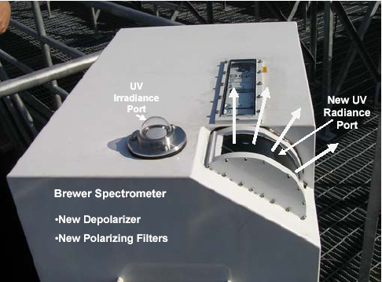
Figure 1: The modified Mark III Brewer (#171) double spectrometer, showing the curved radiance entrance port on the lower right to remove the Fresnel polarizing effect. An internal depolarizer is located in front of the grating.

The retrieval technique was originally applied to GSFC’s modified ground-based Brewer double spectrometer (Figure 1), which allows nearly simultaneous radiance measurements with a 1.5 degree FOV at six wavelengths that are about 3 nm apart. The PANDORA CCD spectrometer (Figure 3) has a 1.6º FOV, and operates from 280 to 525 nm with 0.5 nm resolution with 4 pixels per resolution element. Stray light is reduced for O₃ measurements by blocking visible light using UV bandpass filters. For successful O₃ retrieval, both instruments require excellent radiometric and wavelength stability needed to remove the Solar Fraunhofer line structure, which permits the accurate detection of the small residual underlying trace-gas absorption spectra. In addition to the higher spectral resolution of the measured radiances and the higher SNR, the portable PANDORA spectrometer system has the advantage of being able to measure all wavelengths simultaneously. Previous field experiments have shown that this greatly reduces the measurement noise compared to the Brewer spectrometer (Cede et al., 20xx).

The PANDORA and Brewer measurement datasets consist of: 1) direct-sun irradiances, 2) sky radiances in the principal plane and almucantar. Ancillary data needed for the O₃ profile retrieval algorithm (total ozone and aerosol measurements) will be provided from both the CLEO shadowband-type spectrometer (Figure 2) and the sky-radiance and direct-sun PANDORA spectrometers (Figure 3), along with co-located AERONET Cimel sunphotometers [Holben et al., 1998]) that will provide additional aerosol information (e.g. AOT, particle size distribution (PSD) and SSA at visible wavelengths λ > 440 nm) [e.g. Dubovik et al., 2002].
For total column amounts of O₃ and trace gases (SO₂ and NO₂), PANDORA will be operated in direct-sun viewing mode using a sun-centroiding algorithm. Ozone and NO₂ profiles will be retrieved from multiple angle views of sky radiance in the solar principal plane (0º to 90º) and 1731 wavelength steps (300 nm to 525 nm with 0.13 nm steps and 0.4 nm resolution). The O₃ and NO₂ retrieval algorithms will be a direct optimal estimation radiance fitting technique compared to those computed from laboratory measured cross sections. The O₃ profiling algorithm, column NO₂ algorithm, and comparison with SCIAMACHY and OMI satellite data are discussed in published papers (Liu et al., 2006; Cede et al., 2006b; Tzortziou et al., 2008; Herman et al., 2008).
Replace this figure

The PANDORA system (Figure 3) consists of an Avantes fiber optic spectrometer with a UV sensitive backthinned 2048 x 16 pixel CCD with two 9-position filter wheels (Open, Opaque, 280-315 nm-Bandpass, 280-380 bandpass, Polarizer-1 Polarizer-2, and Polarizer-3, and neutral density filters), which is connected to an electronics control box and mounted on a computer controlled sun-tracker and sky-scanner (~0.01 arcsecond pointing accuracy). The opaque position is for the measurement of spectrometer dark current after each measurement. The spectrometer is temperature stabilized (within 1ºC) inside of a small enclosure. To further minimize instrumental variability, the dark current is measured after each radiance measurement using the opaque filter wheel setting. Wavelength calibration and the slit function are determined from lamp emission lines (Hg, Cd, Cu, In, Mg, Zn), three lasers at 325 nm, 442 nm, and 488 nm. Wavelength stability is validated by an analysis of the solar Fraunhofer line structures. Because of stray light at short wavelengths (290-305nm), two UV bandpass filters (280-315 and 280-380 nm with a cutoff at 315 and 380 nm, respectively) are used to greatly reduce stray light.
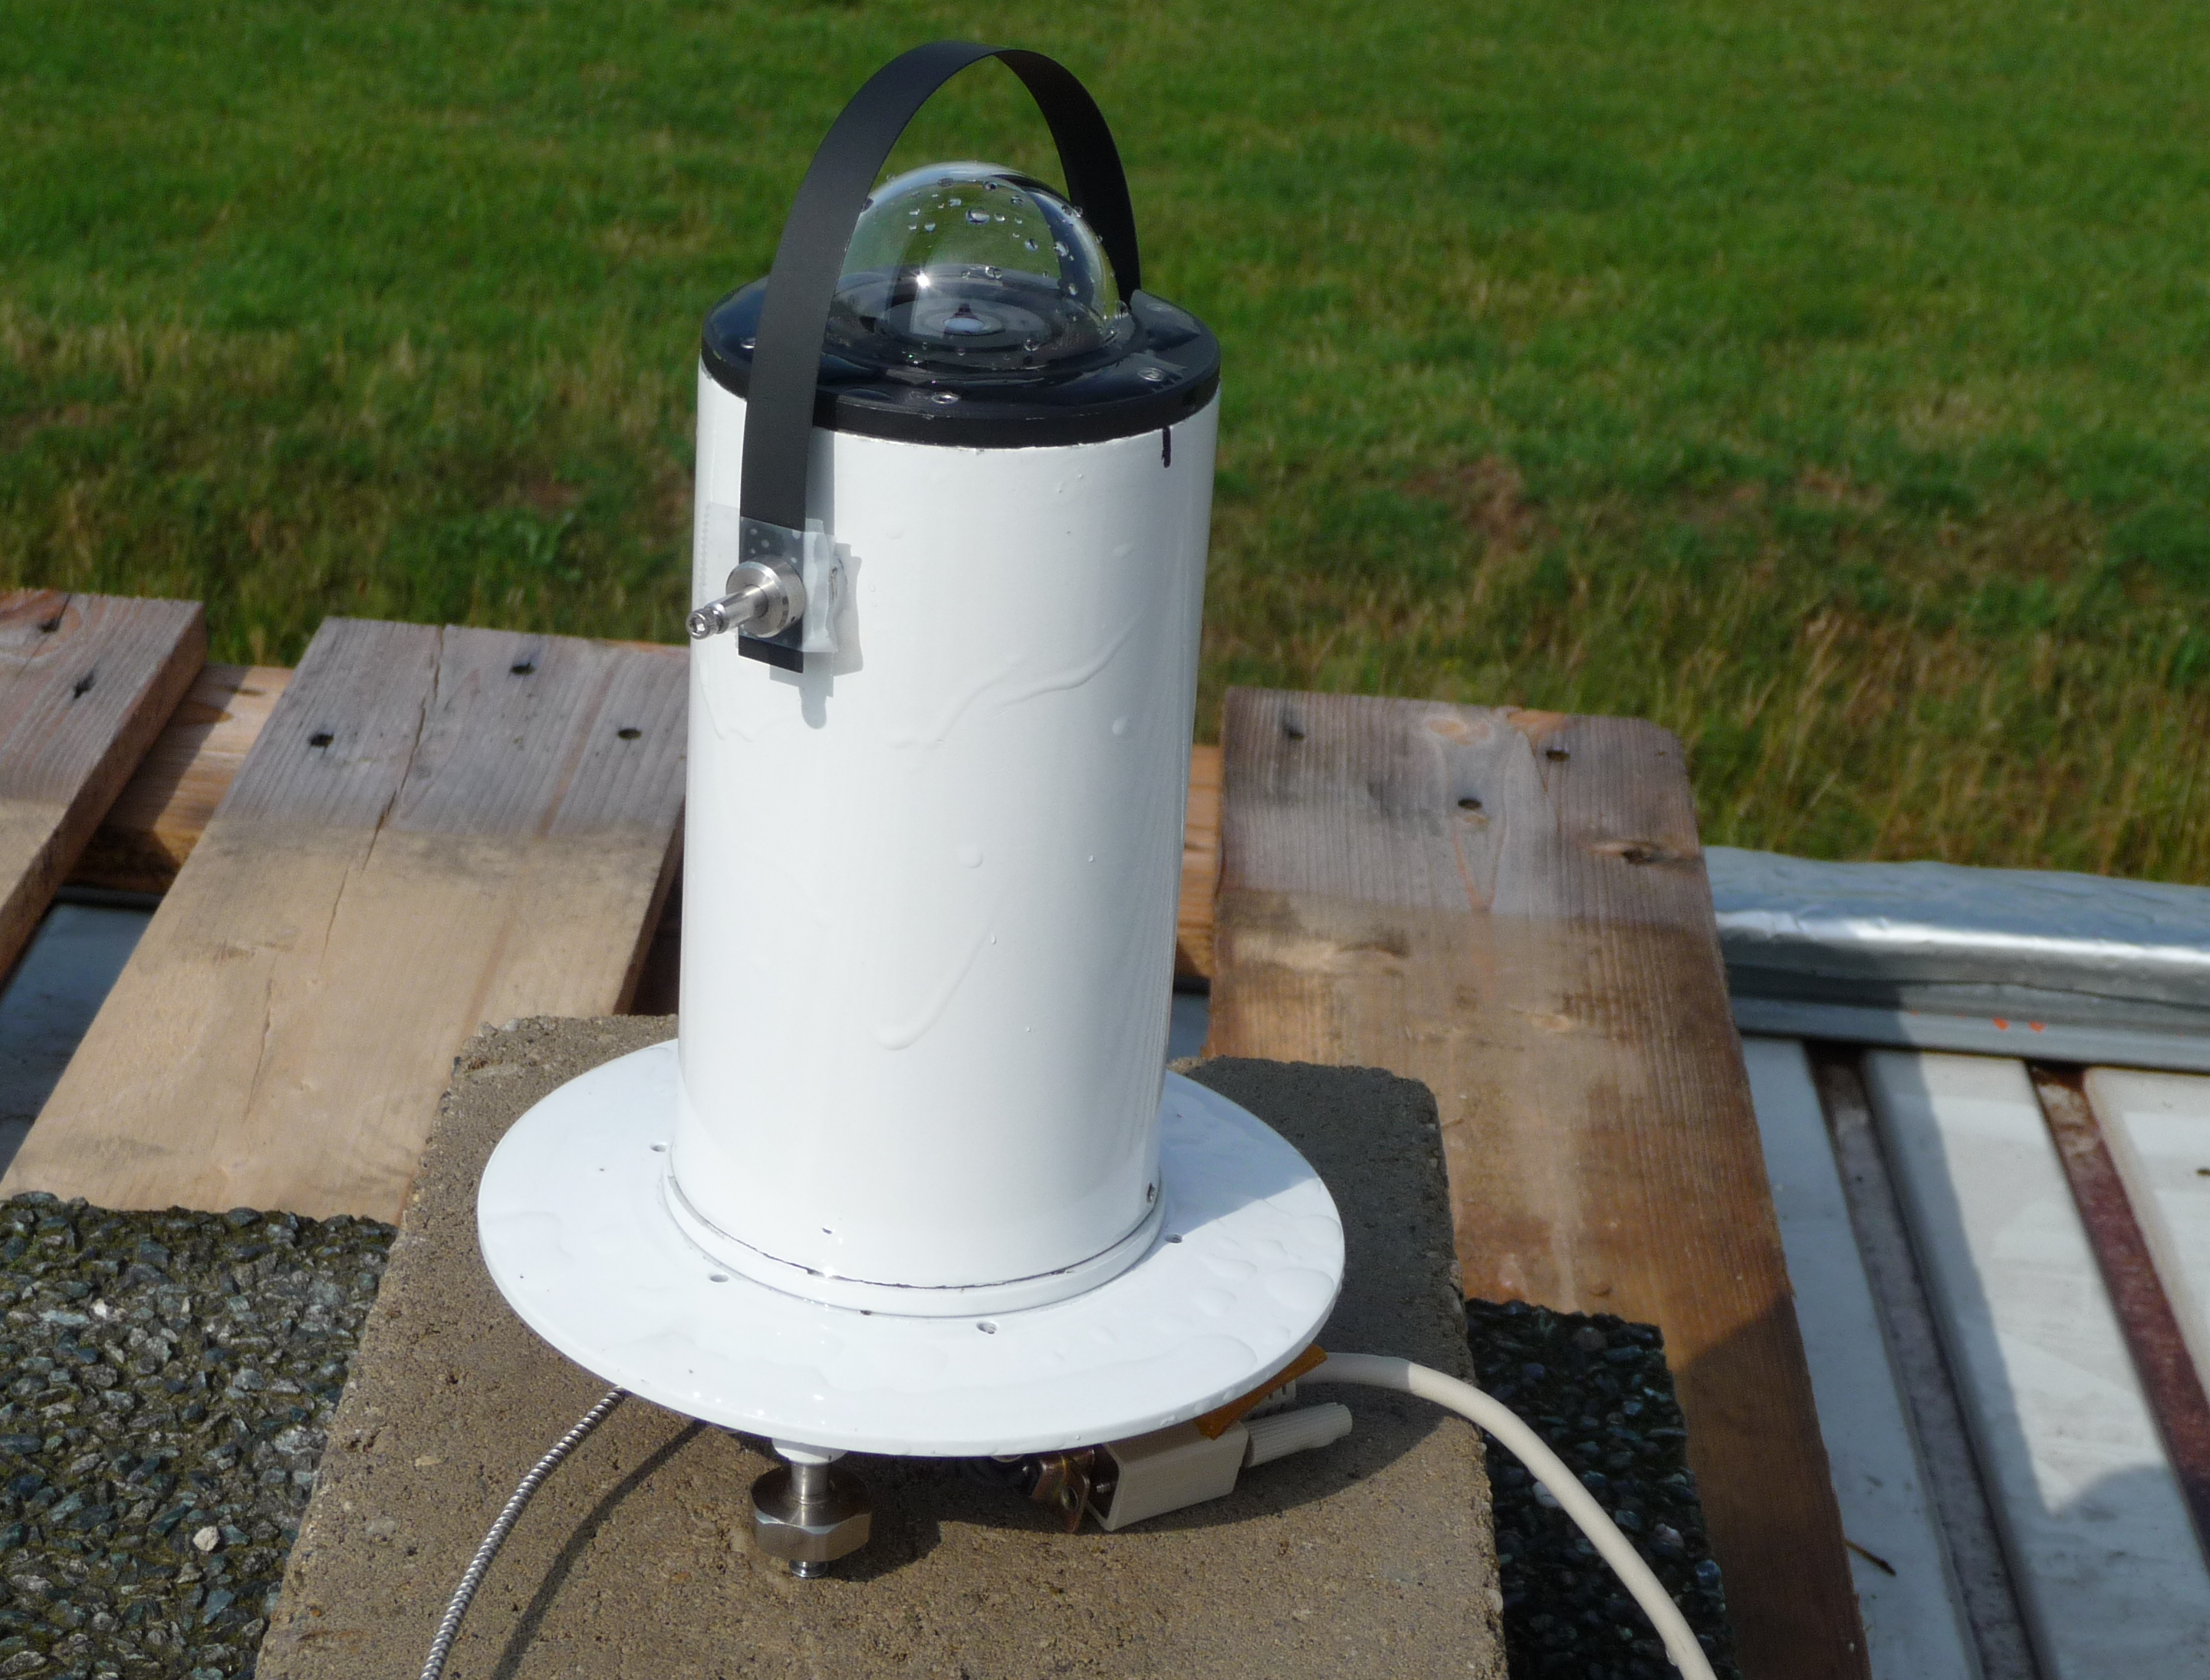
Figure 2: The CLEO optical head, sun-blocking band, and small spectrometer (inset approximately to scale). The final version of CLEO will be smaller.
Replace this figure

The PANDORA system has already successfully measured NO₂ and other trace gases (O₃, SO₂, HCHO, H₂O, O₂:O₂) and aerosol optical depth AOD) in direct-sun mode once per minute for use as a constraint for profile retrieval. The results have been validated against the Washington State University MF-DOAS instrument [Herman et al., 2009]. The PANDORA CCD system will acquire direct sun and sky-radiance data for measuring O₃ and NO₂ profiles every 10 minutes. The PANDORA design (measurements of total column ozone, NO₂, aerosol optical depth etc) is proven and is operating continuously.
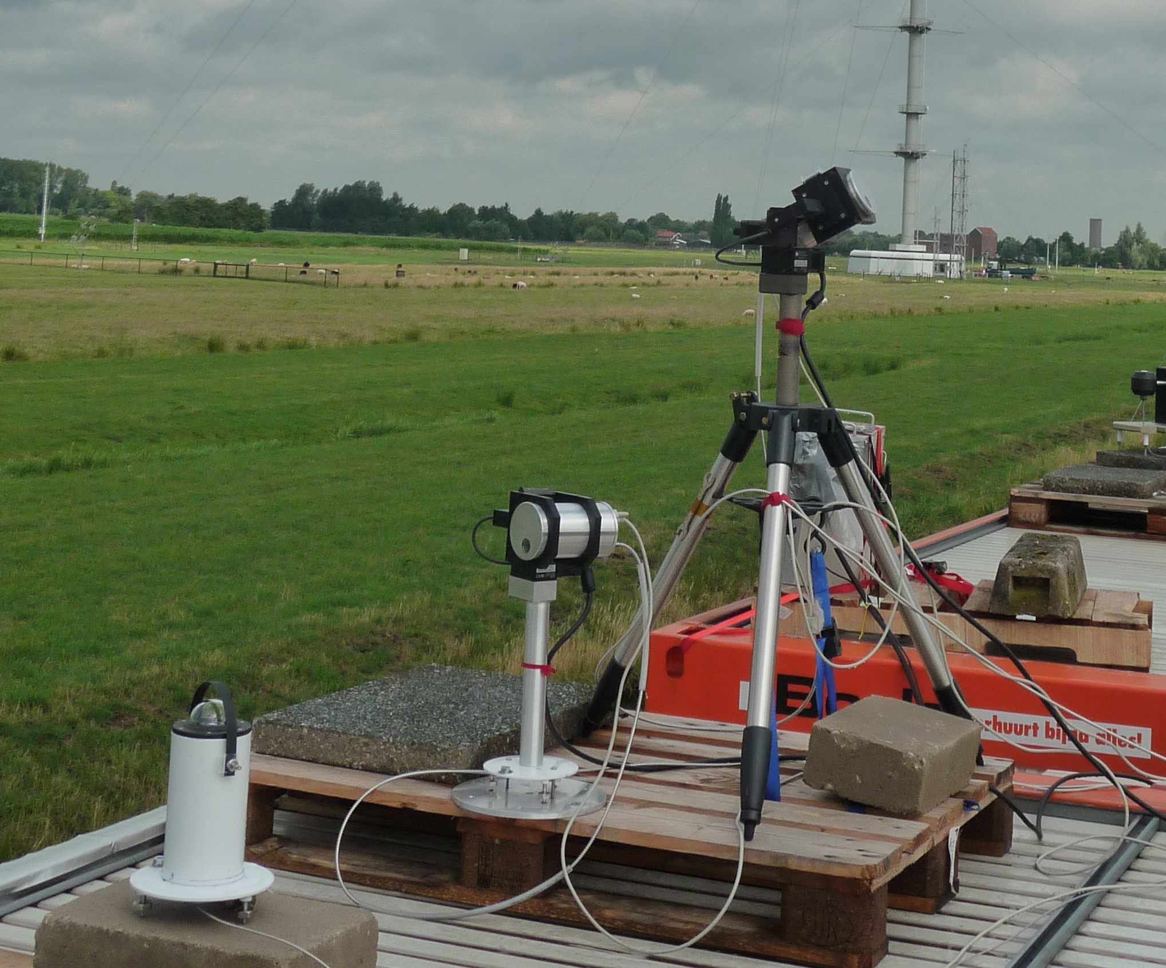

Figure 3: Sky-radiance plus direct-sun PANDORA (center) and direct-sun only PANDORA (right) mounted on a high precision pan and tilt head with 0.01 degree pointing accuracy. The system, including the portable temperature control chamber (±1ºC) is less than $10K to duplicate. The entire system is weather resistant to permit automatic operation.

2.3.2. Ozone and NO₂ Profile Inversion Algorithms

The inversion strategy for O₃ profile retrieval uses a vector multiple scattering forward radiative transfer (RT) model f(x) to simultaneously fit angular and spectral measurements of sky radiance constrained by nearly simultaneous direct-sun total column ozone measurement (TCO). The inversion algorithm is based on the optimal estimation approach [Rodgers, 2000], and uses climatological a-priori O₃ profile information [McPeters et al., 2007] to stabilize the retrieval. The basic matrix equations used are:
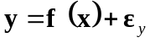  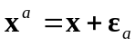 | [1a]  [1b]
where: x = [x_{j}] = [ln(ω_{j})], is the ozone profile solution vector, defined here as the natural logarithm of the ozone amount, ω_{j}, in a given layer j
xª is the a-priori ozone profile
ε_{a} is the error in the a-priori ozone profile, with covariance matrix S_{a}
y is the vector containing the measured radiances and total column ozone, TCO
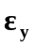is the error in the measurement vector with covariance matrix S_{y}
A statistically best solution x_{o} is obtained by minimizing a quadratic cost function ψ(x) (minimum residuals) using Gauss-Newton iterations of a linearized approximation K of the forward model f(x) at each iteration step [Tzortziou et al., 2008].
The mathematical technique for obtaining NO₂ profiles is similar to that for O₃. The main difference arises from NO₂ being mostly in the troposphere except on extremely clean days. This requires that PANDORA measure at more elevation angles near the horizon than are needed for O₃ in order to resolve the profile information. This has been described previously in terms of the MAX-DOAS technique [Bruns et al., 2006]. Here this technique will be optimized for the PANDORA data, and the retrieval will be constrained by the direct-sun observation of NO₂ column amount. Stratospheric information can only be obtained in the early morning when tropospheric amounts of NO₂ are usually small and the total column measurements contain mainly stratospheric amounts of about 0.2 DU (1 DU = 2.67 x 10¹⁶ molecules/cm²). Based on averaging kernel studies [Spurr, 2003; Spurr et al., 2005], the inversion technique for NO₂ should yield at least 3 pieces of information between 0 and 5 km, which is sufficient to determine the profile shape for polluted regions. Key to the accuracy of this measurement is knowledge of the aerosol optical properties in the 400 nm to 450 nm range, which will be provided by simultaneous measurements using AERONET and CLEO. The following sections give details of the method based on the published O₃ profile retrieval paper [Tzortziou et al. 2008].

2.3.3. Ozone Retrieval Results
Since PANDORA O₃ retrieval data are not yet published, the following discussion is given in terms of the published Brewer spectrometer retrievals (Tzortziou et al., 2008). We have extended the published 6-wavelength method to the 331-wavelength PANDORA spectrometer. The biggest differences between the Brewer and PANDORA retrievals are PANDORA’s greatly improved SNR, the higher spectral resolution of the measurements, and approximately double the altitude resolution.
Brewer spectrometer O₃ profile retrievals have been obtained at 11 Umkehr layers (5 km each) corresponding to an altitude range of about 0 to 55 km. The proposed MASR method is a significant improvement over the traditional Umkehr approach for obtaining stratospheric O₃ profiles, since each profile measurement takes only two minutes instead of two hours in the Umkehr method. Moreover, Umkehr retrievals are limited near sunrise and sunset, while the MASR retrieved profiles are obtained every 10 minutes throughout the day. The improved time resolution in the MASR method is accomplished by using multiple wavelengths and viewing angles in place of multiple solar zenith angles.
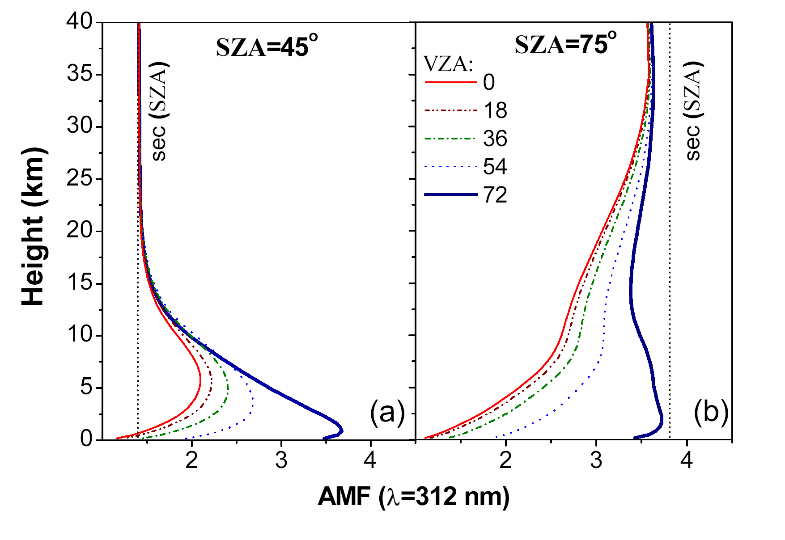
Figure 4: The Air Mass Factor for (a) SZA=45º and (b) SZA= 75º. Results are shown at 312 nm and five VZAs (0, 18, 36, 54, 72). The dotted line is the value of the sec(SZA) path.

2.3.4 Profile retrieval performance

Air-Mass Factor – We have used the air mass factor, AMF, concept to examine the sensitivity of the sky radiance measurements to relative changes in ozone amount in a given vertical layer. Calculated AMFs are shown in Figure 4 for Brewer measurements at 312 nm, five VZA’s (0, 18, 36, 54, 72º) and two solar zenith angles (45, 75º).
Results show that zenith sky measurements (VZA=0º ) at SZA=45º are most sensitive to O₃ changes at an altitude of about 6 km (Fig. 4a). As SZA increases, zenith sky measurements become more sensitive to higher altitudes (data not shown here; see Tzortziou et al., 2008). As the VZA increases, the altitude of maximum AMF decreases and the absolute value of AMF increases, suggesting that measurements at large VZAs (i.e. 72º) become increasingly sensitive to O₃ changes closer to the surface (Figs. 4a). At higher SZAs (e.g. 75º , Fig. 4b) and VZAs smaller than ~54º, the AMF increases with increasing altitude suggesting that sky-radiance measurements at large solar zenith angles are sensitive to stratospheric O₃ changes. Moreover, measurements at large VZAs (e.g. 72º) are equally sensitive to O₃ changes in the lower troposphere regardless of SZA. This means that sky-radiance data at different SZAs can provide information on diurnal changes in surface and tropospheric O₃ amounts. (e.g. Figs. 5b). The vertical resolution will be improved with PANDORA’s better SNR and increased number of wavelengths.

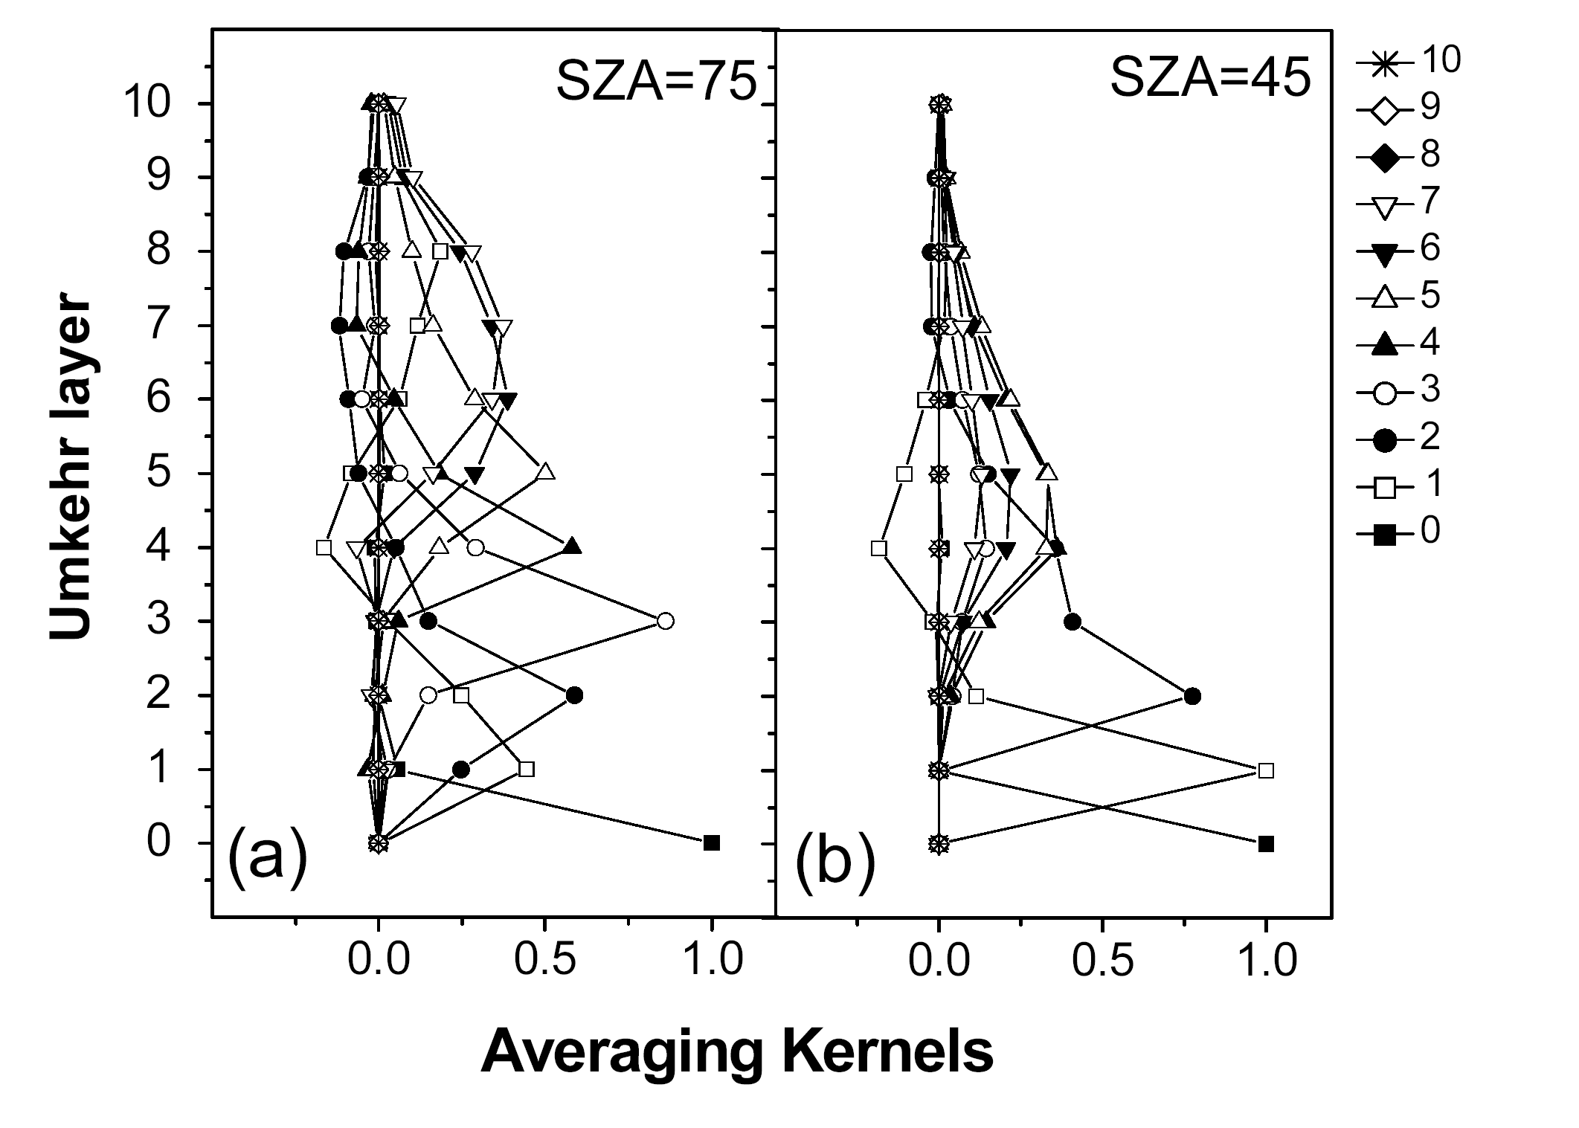
Figure 5: Averaging Kernels at SZAs (a) 75º and (b) 45º. Umkehr layers are just 5 km thick layers.
Ozone Retrieval Sensitivity - Ozone retrievals were performed at large (75º) and relatively small (45º) SZAs. To demonstrate the sensitivity of the retrieval at different altitudes, simulations were performed for an atmosphere with an assumed “true” O₃ vertical distribution that was different from the climatological O₃ profile in all Umkehr layers (see Figure. 6). In addition, the simulations included some diurnal variation in the “true” column and tropospheric O₃ amounts. Stratospheric O₃ in the “true” profiles was kept constant throughout the day. The retrieval results were consistent with expectations based on the results of AMF and averaging kernel calculations.
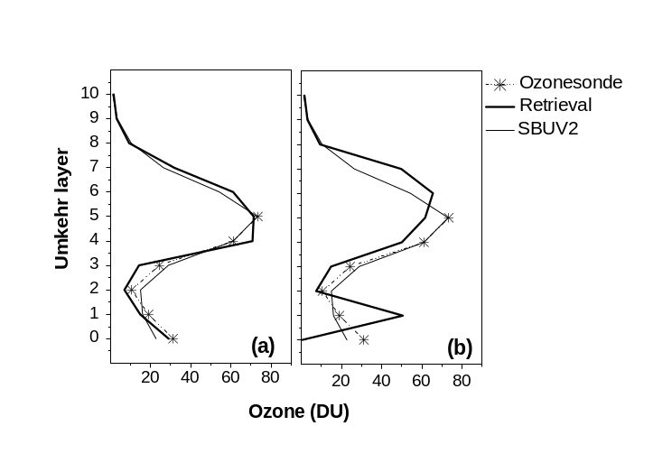
Figure 7: Brewer ozone profile retrieval (sza=75) for 23 July 2005 (a) for the real atmosphere with aerosols and (b) for a pure Rayleigh atmosphere. The SBUV2 O₃ profile and the ozonesonde measurement are also shown.

For the retrieval at SZA=75º (Fig. 6a), a climatological O₃ profile was used as a-priori information (dashed line in Figure. 6a). The retrieved O₃ values in Umkehr layers 3 through 9 (15 to 45 km) were in good agreement with the “true” O₃ as expected based on the AMF and Averaging Kernel analyses. These results show that at large SZAs, the retrieval method provides an improved alternative to the traditional Umkehr technique [Mateer, 1965; Petropavlovskih et al., 2005]. The two improvements are: (i) that the measurement only takes a few minutes, and (ii) that the retrieval has better vertical resolution in the lower stratosphere (i.e. Umkehr layer 3). In addition, the SZA=75º retrieval at Umkehr layer 0 was in good agreement with the “true” O₃ at SZA=75º showing that measurements at large SZAs can also provide accurate tropospheric O₃ retrievals.
For the retrieval at SZA=45º (Fig. 6b), the retrieval at SZA=75º was used as a-priori information to constrain O₃ at high altitudes. Retrieved O₃ values were in good agreement with the “true” O₃ close to the ground, despite the fact that the “true” tropospheric O₃ at SZA=45º was considerably different than that at SZA=75º because of assumed diurnal variation.

2.3.4.1 Ozone retrievals using measured sky radiances

In addition to the studies using synthetic datasets, we applied our retrieval to measured radiances obtained by GSFC’s modified double Brewer spectrometer. The retrievals are shown below for data collected under cloud-free conditions on 23 July 2005. Brewer TCO during that day varied between 312 and 323 DU. The SBUV TCO, measured the same day over GSFC (SZA=34º), was 312 DU. Climatological O₃ data for July and the latitude zone 30-40º N was used as a-priori information for the retrieval at SZA=75º. The O₃ profile retrieved from measurements at SZA=75º was then used as a-priori for the retrievals at smaller SZAs. RT model calculations were performed for the exact values of measured Brewer wavelengths, SZAs, and VZAs to avoid look-up table interpolation errors.
The O₃ profiles retrieved (after accounting for the effects of aerosols on the solar principle plane radiance distributions) are shown in Figure 7a for SZA=75º. Estimated O₃ amounts in the upper troposphere and in the stratosphere were in good agreement with the SBUV measurements. The retrieved O₃ amount in Umkehr layer 0 was 29 DU at SZA=75º. This is consistent with ozonesonde measurements performed at nearby Beltsville, MD, which showed that O₃ amount at Umkehr layer 0 was 29DU and 30 DU on 21 and 26 July 2005, respectively (there were no ozonesonde measurements made on 23 July 2005). However, the SBUV O₃ value at Umkehr layer 0 was 22 DU, considerably lower than the ozonesonde measurements.
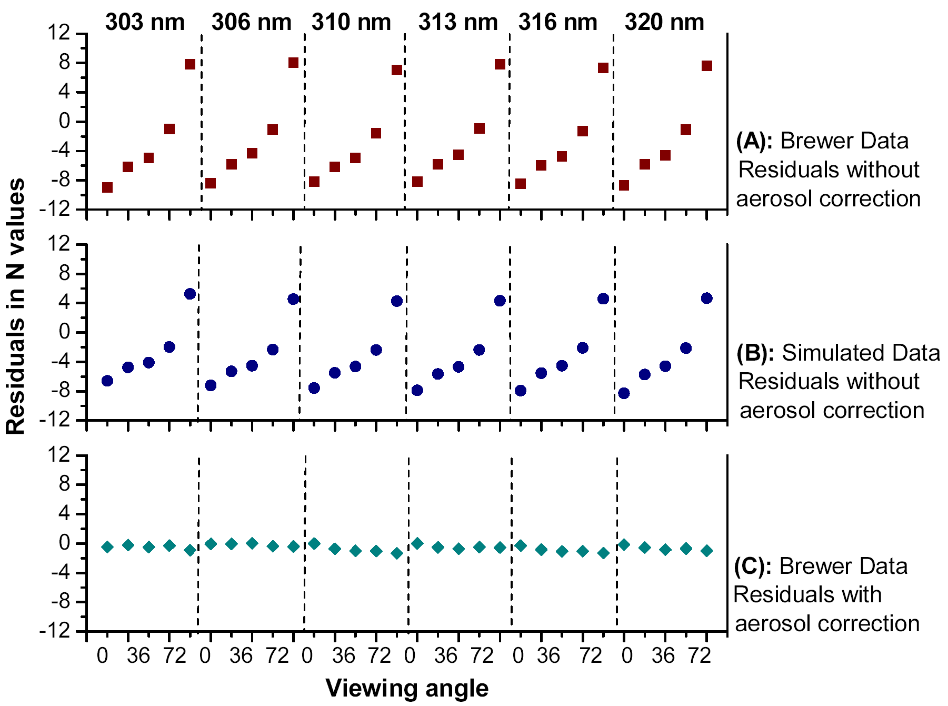
Figure 8: Residuals in N values (each point corresponds to specific vertical angles (zenith (0º) on the left, to 72º on the right) and wavelengths shown in upper panel) (a) without correction for aerosol effect; (b) simulated Brewer data without correction for aerosol effect; (c) between Brewer data and model estimations after correcting for the effect of aerosols. Note, a change of 1 N-value ~ 2.3% in measured – modeled radiances.
Neglecting the effect of aerosols in the retrieval, resulted in incorrect O₃ profiles that were considerably different than the SBUV-2 measured O₃ profile both in the troposphere (e.g. Umkehr layer 0) and in the stratosphere (Fig. 7b).

2.3.4.2 Effect of Aerosols on Ozone Profile Retrievals

Accounting for the aerosol effect in the retrieval by using aerosol information from co-located Cimel and UV-shadowband instruments improved the residuals (both N-values and radiance ratios) (Figure 8-bottom). These results show that incorporation of an aerosol correction based on co-located aerosol measurements is necessary for removing the large effect of even small aerosol amounts when retrieving O₃ profiles from measurements of sky radiances. Detailed results on the sensitivity of the O₃ retrieval to aerosol model (aerosol optical thickness, single scattering albedo, particle size distribution, and aerosol plume height) are presented in Tzortziou et al. [2008].

2.3.5 NO₂ Retrievals

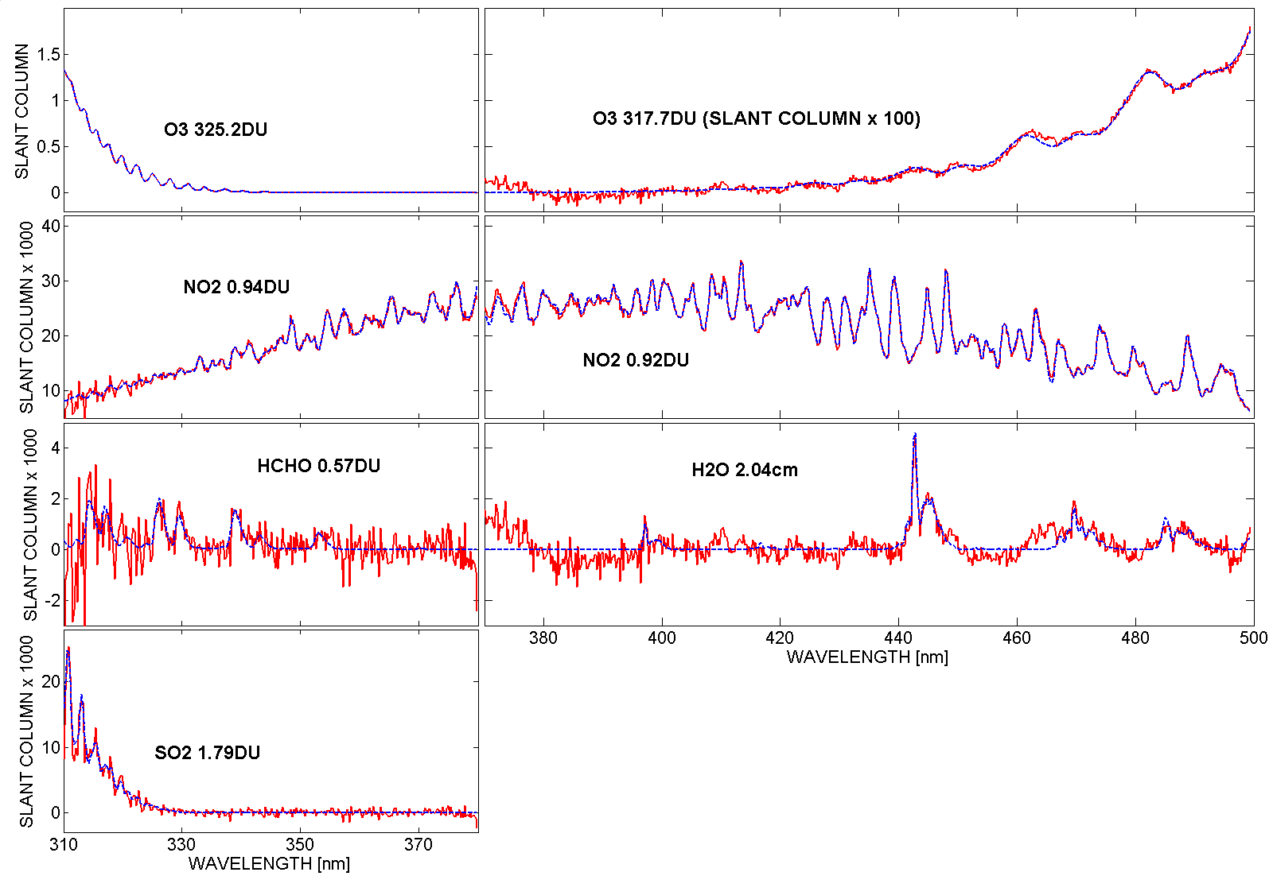
Figure xx Fitted Pandora slant column optical depths (blue) for a measurement on July 22, 2006, during the campaign in Greece (red). Left side shows the measurement with the 380nm low pass filter, right side the measurement without filter. Note that the wavelength range 370-380nm appears on both sides. The black legends give the final retrieved vertical column amounts for each atmospheric absorber.

Vertical column amounts of nitrogen dioxide, C(NO₂), have been derived from ground-based direct solar irradiance measurements using the Pandora spectrometer system. C(NO₂) data are presented from field campaigns using Pandora at Aristotle University (AUTH), Thessaloniki, Greece and a second field campaign at Goddard Space Flight Center (GSFC), Greenbelt, Maryland. Two independent instruments, Pandora and MFDOAS, were compared at GFSC and found to closely agree, with both instruments having a clear-sky precision of 0.01 DU (1 DU = 2.67x10¹⁶ molecules/cm²) and a nominal accuracy of 0.1 DU. The high precision is obtained from careful laboratory characterization of the spectrometers (temperature sensitivity, slit function, pixel to pixel radiometric calibration, and wavelength calibration), and from sufficient measurement averaging to reduce instrument noise. The 0.01 DU precision is sufficient to track minute-by-minute changes in C(NO₂) throughout each day with typical daytime values ranging from 0.2 to 2 DU. Since direct-sun measurements can be made in the presence of light to moderate clouds, but with reduced precision (~0.2 DU for moderate cloud cover), a nearly continuous record can be obtained, which is important when matching NPP/OMPS overpass times for satellite data validation. To illustrate satellite validation, comparisons between Pandora and MFDOAS with OMI are discussed for the moderately polluted GSFC site and between Pandora and OMI at the AUTH site. Validation of OMPS measured C(NO₂) is essential for the scientific use of the satellite data for air-quality, atmospheric photolysis and chemistry, and for retrieval of other quantities (e.g., accurate atmospheric correction for satellite estimates of ocean reflectance and bio-optical properties).

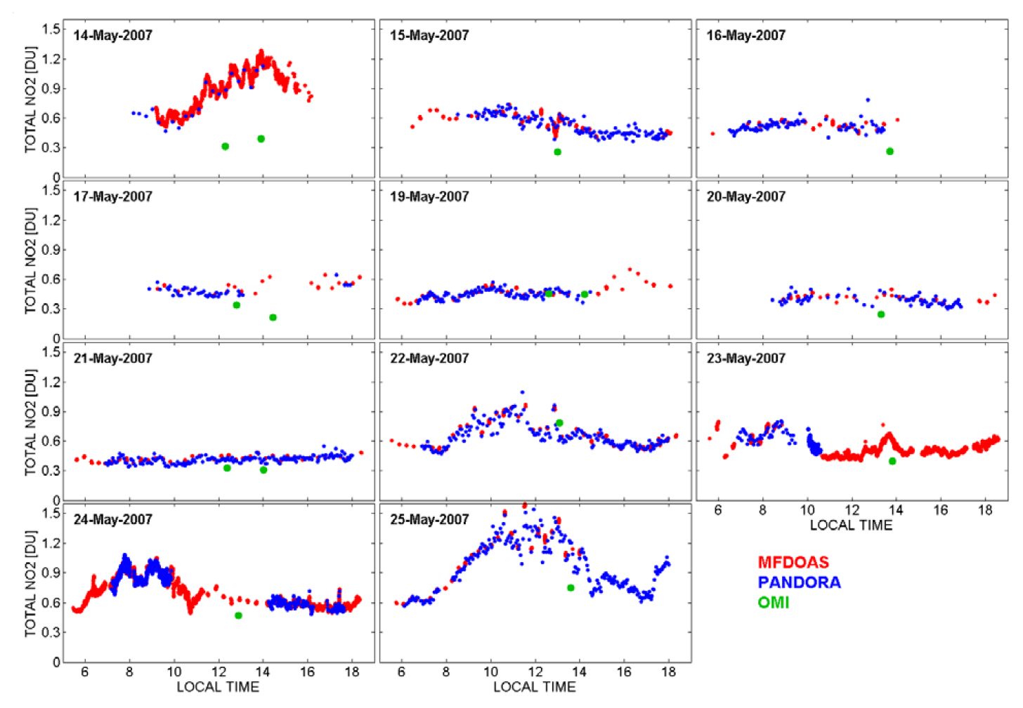
Figure xxx MFDOAS and Pandora C(NO₂) data from GSFC during May 2007. Also shown are the OMI overpass data (green).
A direct-sun NO₂ inversion method is described in detail in papers by Cede et al. [2006] and Herman et al., [2009]. The biggest advantages of direct-sun measurements are 1) high photon flux, 2) simple geometric determination of the air-mass factor (optical path), and 3) no Ring effect polarization corrections are needed.

The first step in the NO₂ retrieval algorithm is to subtract the irradiance logarithm of the measured spectra from the irradiance logarithm of the reference spectrum. Then, a simultaneous least-squares fit is applied to the difference between measured and reference spectra. The fitted functions are a low-order polynomial, the absorption spectra of NO₂ and other atmospheric absorbers, and wavelength shift and squeeze functions. The shift and squeeze functions are to provide the best match of the measured spectrum compared to a solar reference spectrum containing the solar Fraunhofer line structure. All the Pandora NO₂ retrievals are from a 370 to 500 nm fitting window. As part of the retrieval of C(NO₂), additional trace gas and aerosol amounts are always simultaneously retrieved. Figure xx illustrates the Pandora DOAS retrieval of slant column O₃, NO₂, HCHO, H₂O, and SO₂ from clear-sky direct-sun irradiance measurements at Thessaloniki for July 22, 2006. Only a small wavelength shift (0.0016 nm) and squeeze (4x10⁻⁶ nm) was needed to match the solar spectrum.

In order to obtain absolute NO₂ amounts, we use a top of the atmosphere reference spectrum derived from the instrument’s own measurements for two statistical approaches, the “Minimum-Amount Langley-Extrapolation” (MLE) and the “Bootstrap-Estimation” (BE) method [Cede et al., 2006; Herman et al., 2009]. The results are NO₂ measurements with a precision of 0.01 DU and an accuracy of 0.1 DU. Cloudy sky precision is reduced to 0.2 DU.

A field campaign at GSFC was designed to compare Pandora with similar measurements made by the MFDOAS spectrometer in a moderately polluted area using the same algorithm, cross sections, and field-calibration methods (Figure xxx). The two independent ground-based spectrometer systems agreed quite well, but the comparison with OMI retrieved data shows some disagreement. The main reason for this is the high spatial variability of NO₂ and the error in OMI retrievals caused by clouds in the OMI field of view 13 x 24 km². The cloud contamination problem for OMPS will be worse since the FOV is larger. For this reason it is vital to validate the OMPS retrievals and to derive corrections for these retrievals for different sources of error (clouds, surface reflectivity, and aerosols).
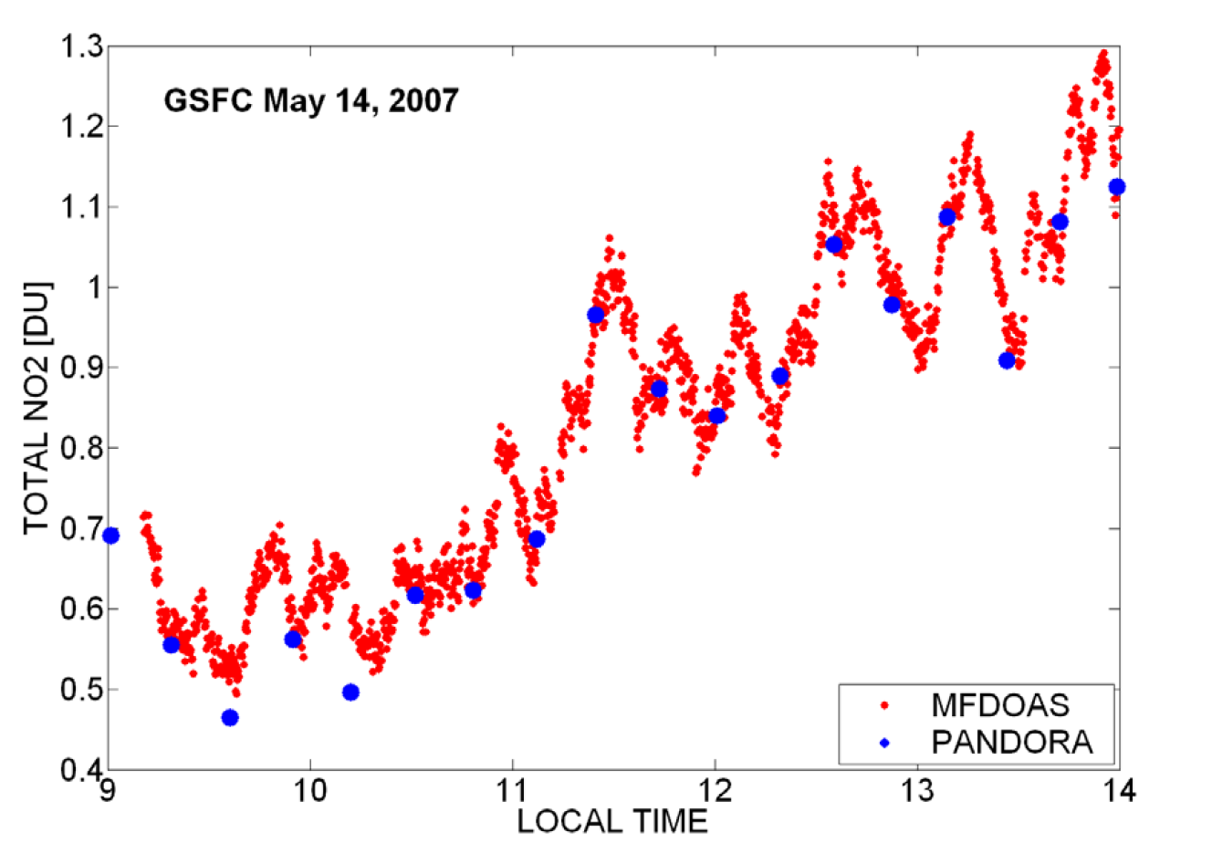
Figure xxxx High time variability at GSFC observed on 14 May 2007 by Pandora and MFDOAS. The time resolution of PANDORA has now been inproved to match MFDOAS.

The suite of 5 Pandoras will be used to correct for spatial variability witin a field of view. An example of NO₂ temporal variation is shown (Figure xxxx) that leads to spatial variability as the time-varying NO₂ plumes are carried by surface winds. These have a typical speed of about 1.5 m/s or 5.4 km per hour. For the particular example, the variation within an OMPS pixel could be 50% of the mean value.

2.4 SUMMARY
The proposed work is to develop the capability for O₃ and NO₂ profile retrievals at least every 10 minutes throughout each day using the accurate PANDORA sun-sky observing spectrometers at multiple sites combined with aerosol measurements that are essential for the profile retrieval. The goal is to obtain a multi-year record that can be used for NPP/OMPS data validation. It will also show the diurnal, daily, and seasonal variations in tropospheric profiles of these critically important atmospheric constituents and the twice daily and seasonal variation in stratospheric ozone profiles. using autonomous passive remote sensing. AURA/OMI and SBUV-2 data will be used as test cases for NPP/OMPS data validation.

The profile retrieval method presented in this proposal is based on our previously published papers for O₃ profiles and aerosols and trace gases [Liu et al., 2006; Cede et al., 2006a,b; Tzortziou et al., 2008; Herman et al., 2008].

The main purpose of the proposed work is to use the ground-based atmospheric ozone and NO₂ profile data to validate satellite retrievals tropospheric and stratospheric ozone profiles and NO₂ profiles every 10 minutes that can be used to match the satellite overpass time.

2.5 IMPACT OF THE PROPOSED WORK (is this needed?????)
The results from this work will be the first remote sensing passive simultaneous retrieval of the diurnal changes in tropospheric O₃ and NO₂ profiles, other trace gas amounts, and aerosol properties. The retrievals will provide the first practical technique for diurnal profile measurements of tropospheric NO₂ and O₃ every day, along with simultaneous retrievals of stratospheric ozone, aerosols and trace gases, at a number of sites in the US and worldwide, both over land and over the ocean. Among our study sites will be sites collocated with AERONET, for measurements in conjunction with existing CIMEL sunphotometers, as well as sites where data coverage needed for satellite retrieval validation (or application of tropospheric photochemical models) is currently extremely sparse (e.g. South America). The proposed work will also develop the capability for O₃ and NO₂ profile (as well as aerosol characteristics) measurements over oceans, where there is almost no data available.
Deployment of the CCD instrumentation and application of the profile retrieval technique will lead to a network of stations suitable for understanding the interaction between diurnally varying tropospheric ozone, NO₂ amounts, and aerosols under different local conditions (e.g. high pollution, smoke fires dust events). Incorporation of these results into atmospheric chemistry models will place constraints on the dynamics and chemistry rates, especially the tropospheric photolysis rates such as J_{NO2}. The results will provide much needed validation of the current AURA/OMI and future NPOESS ozone profiling and trace gas measurements. The diurnal measurement capability will provide the only practical method of comparing retrievals from morning and afternoon satellites over multiple sites. The retrieval of trace gas, ozone, and aerosol absorption can be used for an improved atmospheric correction for satellite estimated water-leaving radiances, as needed for improved retrievals of biogeochemical variables especially in coastal regions.
2.6 References

Ahmad Z, C.R. McClain, J.R. Herman, B. Franz, E. Kwiatkowska, W. Robinson, E.J. Bucsela, and M. Tzortziou, 2007, Atmospheric correction for NO₂ absorption in retrieving water-leaving reflectances from the SeaWiFS and MODIS measurements”. Applied Optics (Laser, Photonics, and Environmental Optics), 46(26): 6504-6512.
Bates, D.R., Rayleigh Scattering by Air, Planet. Sp. Sci., 32, 785-790, 1984.
Browell, E., S. Ismail, and S. Shipley (1985), Ultraviolet DIAL measurements of O₃ profiles in regions of spatially inhomogeneous aerosols. Appl. Opt., 24(17), 2827–2836.
Bruns, M., S. A. Buehler, J. P. Burrows1, A. Richter1, A. Rozanov1, P. Wang, K. P. Heue, U. Platt, I. Pundt, And T. Wagner, No2 Profile Retrieval Using Airborne Multi Axis Uv-Visible Skylight Absorption Measurements Over Central Europe, Atmos. Chem. Phys., 6, 3049-3058, 2006.
Cede, A., and J. Herman, Measurements of O₃, SO₂, NO₂ and HCHO column amounts using a Brewer spectrometer, in Ultraviolet Ground- and Space-based measurements, Models, and Effects V, July 31 to August 1, 2005, San Diego, USA, Proceedings of SPIE Vol. 5886, Pages 7-15, SPIE-The International Society for Optical Engineering, G. Bernhard, J. R. Slusser, J.R. Herman, W. Gao, and G. Bernhard Editors, 2005.
Cede, A., J. Herman, A. Richter, N. Krotkov, and J. Burrows, Measurements of nitrogen dioxide total column amounts using a Brewer double spectrometer in direct Sun mode, J. Geophys. Res., 111, D05304, doi:10.1029/2005JD006585, 2006b.
Cede, A., S. Kazadzis, M. Kowalewski, A. Bais, N. Kouremeti, M. Blumthaler, and J. Herman, Correction of direct irradiance measurements of Brewer spectrophotometers due to the effect of internal polarization, Geophys. Res. Lett., 33 (2), L02806, doi: 10.1029/2005GL024860, 2006a.
Dubovik, O., B. Holben, T. Eck, A. Smirnov, Y. J. Kaufman, M. D. King, D. Tanre, and I. Slutsker (2002), Variability of Absorption and Optical properties of key aerosol types observed in worldwide locations, J. Atmos. Sciences, 59, 590-608.
Environmental Protection Agency, 1998, National air quality and emissions trends report 1997, Research Triangle Park, N. C..
Fishman, J., C. E. Watson, J. C. Larsen, and J. A. Logan (1990), Distribution of tropospheric ozone determined from satellite data, J. Geophys. Res.-Atm., 95 (D4): 3599-3617.
Gao, W., J. Slusser, J. Gibson, G. Scott, D. Bigelow, J. Kerr, and B. McArthur (2001), Direct-Sun column ozone retrieval by the ultraviolet multifilter rotating shadow-band radiometer and comparison with those from Brewer and Dobson spectrophotometers, Applied Optics, 40, (19), 3149-3155.
Guo, X., V. Natraj, D. R. Feldman, R. J. D. Spurr, Run-Lie Shia, S. P. Sander, Y.Yung, Retrieval of ozone profile from ground-based measurements with polarization: A synthetic study, in press, JSQRT, 2006.
Herman, J.R., Elena Spinei, Alexander Cede, George Mount, Thomas. Pongetti, Stanley Sander, Maria Tzortziou, Nader Abuhassan, NO2 Column Amounts from Direct-Sun DOAS Technique and Ground-based PAN-1 MF-DOAS, and FTUVS Spectrometers; Intercomparisons and Application to OMI Validation, in preparation, 2008.
Holben, B. N., T. F. Eck, I. Slutsker, D. Tanre, J. P. Buis, A. Setzer, E. Vermote, J. A. Reagan, Y. Kaufman, T. Nakajima, F. Lavenu, I. Jankowiak, and A. Smirnov (1998), AERONET - A federated instrument network and data archive for aerosol characterization, Rem. Sens. Environ., 66, 1-16.
Hoogen, R., V. V. Rozanov, K. Bramstedt, K. U. Eichmann, M. Weber, and J. P. Burrows (1999), O₃ profiles from GOME satellite data-I: Comparison with ozonesonde measurements, Physics and Chemistry of the Earth Part C – Solar-Terrestrial and Planetary Science 24 (5), 447-452.
Intergovernmental Panel on Climate Change (IPCC), 2001, Summary for policy makers, in Climate Change 2001: The Scientific Basis, edited by J. T. Houghton et al., 8 pp., Cambridge Univ. Press, New York.
Krotkov, N., J. Herman, A. Cede, G. Labow (2005), Partitioning between aerosol and NO2 absorption in the UVA, in Ultraviolet Ground- and Space-based Measurements, Models, and Effects V, edited by Germar Bernhard, James R. Slusser, Jay R. Herman, Wei Gao, Proceedings of SPIE, 5886, (SPIE , Bellingham, WA, 2005), 588601, 2005c
Krotkov, N.A., P.K. Bhartia, J.Herman, Jim Slusser, G. Scott, G. Janson, G. Labow, T. Eck, and B. Holben, Aerosol UV absorption experiment (2002 to 2004): 1. UV-MFRSR calibration and intercomparison with CIMEL sunphotometers, Opt. Eng., 44 (4), Opt. Eng., 44 (4), 141004, doi:10.1117/1.1886818, 2005a.
Krotkov, N.A., P.K. Bhartia, J.Herman, Jim Slusser, G. Scott, G. Labow, A. Vasilkov, T. Eck, O. Dubovik, and B. Holben, Aerosol UV absorption experiment (2002 04): 2. Absorption optical thickness, refractive index, and single scattering albedo, Opt. Eng., 44(4), 041005, doi:10.1117/1.1886819, 2005b.
Krotkov,N.A., P. K. Bhartia, J. R. Herman, V. Fioletov, and J. Kerr, Satellite estimation of spectral surface UV irradiance in the presence of tropospheric aerosols 1. Cloud-free case, J. Geophys. Res. 103(D8), 8779-8793, 1998.
Liu, X., C. E. Sioris, K. Chance, T. P. Kurosu, M. J. Newchurch, R. V. Martin, and P. I. Palmer (2005), Mapping tropospheric ozone profiles from an airborne ultraviolet–visible spectrometer, Applied Optics, 44, 3312-3319.
Liu, X., K. Chance, and T. P. Kurosu (2007), Improved ozone profile retrievals from GOME data with degradation correction in reflectance, Atmos. Chem. Phys. Discuss., 7, 1575-1583.
Mateer, C. L. (1965), On the information content of Umkehr observations, J. Atmos. Sci., 22, 370-381.
McDermid, I. S., T. D. Walsh, A. Deslis, and M. L. White (1995), Optical-systems design for a stratospheric lidar system. Appl. Opt. 34 (27), 6201-6210.
McGee, T. J., M. R. Gross, U. N. Singh, J. J. Butler, and P. E. Kimvilakani (1995), Improved statrospheric ozone lidar, Opt. Engineering 34(5), 1421-1430.
McPeters R.D., Labow G.J., Logan J.A., Ozone Climatological Profiles for Satellite Retrieval Algorithms, JGR, in press, 2006.
Palm, M., C. von Savigny, T. Warneke, V. Velazco, J. Notholt, K. Kunzi, J. Burrows, and O. Schrems (2005), Intercomparison of O₃ profiles observed by SCIAMACHY and ground based microwave instruments, Atmosph.c Chem. and Phys., 5, 2091-2098.
Petropavlovskikh I., P. K. Bhartia, J. DeLuisi, New Umkehr ozone profile retrieval algorithm optimized for climatological studies, Geophys. Res. Lett., 32, L16808, doi:10.1029/2005GL023323, 2005.
Rault, D. F. , Ozone profile retrieval from Stratospheric Aerosol and Gas Experiment (SAGE III) limb scatter measurements, J. Geophys. Res., 110, D09309, doi:10.1029/2004JD004970, 2005.
Rodgers, C, Inverse methods for Atmospheric Sounding: Theory and Practice, World Scientific Publishing Company, 2000.
Schoeberl, M. R., A. R. Douglass, E. Hilsenrath, P. K. Bhartia, R. Beer, J. Barnett, J. W. Waters, M. Gunson, L. Froidevaux, J. C. Gille, J. J. Barnett, P. F. Levelt, and P. DeCola (2006), Overview of the EOS Aura Mission, IEEE Trans., Geoscience and Remote Sensing, 44, 5, 1066-1074, 10.1109/TGRS.2005.861950.
Slusser, J. R., D. Kolinski, W. F. Mou, G. Koenig, J. H. Gibson, and D. S. Bigelow (1999), Comparison of column ozone retrievals from 3 different ground-based spectral measurements, Appl. Opt., 38, 1543-1551.
Solomon, S., R. W. Portmann, R. W. Sanders, J. S. Daniel, W. Madsen, B. Bartram, and E. G. Dutton, 1999, On the role of nitrogen dioxide in the absorption of solar radiation, J. Geophys. Res., 104(D10), 12,047– 12,058.
Spurr, R., D. Loyola, W. Thomas, W. Balzer, E. Mikusch, B. Aberle, S. Slijkhuis, T. Ruppert, M. Van Roozendael, J.-C. Lambert, and T. V. Soebijanta, GOME Level 1-to-2 Data Processor Version 3.0: A Major Upgrade of the GOME/ERS-2 Total Ozone Retrieval Algorithm, Applied Optics, 2005.
Spurr, R., LIDORT V2PLUS: a comprehensive radiative transfer package for nadir viewing spectrometers, remote Sensing of clouds and atmosphere, Proceedings SPIE conference 5235, Barcelona, Spain, 2003.
Taubman, B. F., J. C. Hains, A. M. Thompson, L. T. Marufu, B. G. Doddridge, J. W. Stehr, C. A. Piety, and R. R. Dickerson (2006), Aircraft vertical profiles of trace gas and aerosol pollution over the mid-Atlantic United States: Statistics and meteorological cluster analysis, J. Geophys. Res, 111, D10S07, doi:10.1029/2005JD006196.
Thompson, A. M., J. C. Witte, S. J. Oltmans, F. J. Schmidlin, J. A. Logan, M. Fujiwara, V. W. J. H. Kirchhoff, F. Posny, G. J. R. Coetzee, B. Hoegger, S. Kawakami, T. Ogawa, J. P. F. Fortuin, and H. M. Kelder (2003), Southern Hemisphere Additional Ozonesondes (SHADOZ) 1998-2000 tropical ozone climatology 2. Tropospheric variability and the zonal wave-one, J. Geophys. Res., 108, D2,8241, doi: 10.1029/2002JD002241.
Tzortziou, M., N. A. Krotkov, A. Cede, J. R Herman, and A. Vasilkov (2008), A new technique for retrieval of tropospheric and stratospheric ozone profiles using sky radiance measurements at multiple view angles: Application to a Brewer spectrometer, J. Geophys. Res., 113, D06304, doi:10.1029/2007JD009093.
Uthe, E., J. Livingston, and N. Nielsen (1992), Airborne lidar mapping of ozone concentrations during the Lake Michigan ozone study. J. Air Waste Manage. Assoc., 42,1313–1318.
WMO, Report of the International Ozone Trends Panel 1988, Global ozone research and monitoring project, Report No 18, Chapter 3: Information content of ozone retrieval algorithms. Panel Members: C. Rodgers (Chair), P.K. Bhartia, W.P. Chu, R. Curran, J. DeLuisi, J. Gille, R. Hudson, C. Mateer, D. Rusch, R.J. Thomas, R. Turco, W Wiscombe.
Ziemke, J. R., S. Chandra, B. N. Duncan, L. Froidevaux, P. K. Bhartia, P. F. Levelt, and J. W. Waters (2006), Tropospheric ozone determined from Aura OMI and MLS: Evaluation of measurements and comparison with the Global Modeling Initiative's Chemical Transport Model, J. Geophys. Res., 111, D19303, doi:10.1029/2006JD007089.

3. Management Approach
Dr. Jay Herman, PI The PI will have overall responsibility for algorithms, instrument operation, data acquisition, and validation of AURA trace gas (NO₂, SO₂, O₃) amounts, aerosol properties, and UV irradiance and the overall management of the project. This will include the arrangements for remote site campaigns and coordination with other ongoing AURA validation and science team projects. He will make arrangements for getting other sites to install the modifications to their Brewer spectrometers, arrange support for installation and inversion algorithms, and organize joint measuring programs for satellite validation. Dr. Herman will be responsible for archiving all data and data analysis, and making it available to the AURA science team and other interested investigators. He will also write at least one refereed journal publication on the results of the proposed study.

Dr. Alexander Cede CoI Dr. Cede will be responsible for the operation of the Brewer spectrometer, obtaining and archiving its data, continuing the development of the algorithms and error analysis, and arranging for data acquisition such that comparison with AURA data is optimum. Dr. Cede will be responsible for acquiring the trace gas amounts of NO₂, SO₂, and O₃. Working with other CoI’s, he will combine the Brewer data with the UV-MFRSR and CLEO data to internally verify the measured aerosol properties and ozone amounts. In addition, he will help calibrate and analyze the data from the CCD instrument and compare with Brewer data.

Dr. Nickolay Krotkov CoI Dr. Krotkov will be responsible for the operation and acquisition of data from the UV-MFRSR in conjunction with other members of the proposal team. He will work closely with Dr. Cede to combine data from the CIMEL, MPL, UV-MFRSR, PANDORA, and CLEO to produce aerosol properties that are valid for both visible and UV wavelength ranges. He will obtain ozone amounts and UV-irradiances from both the PANDORA, CLEIO, and UV-MFRSR and will internally verify the data before using it for AURA validation. He will also help develop the theoretical basis for the inversion algorithm used to derive tropospheric and stratospheric ozone profiles from the small spectrometer data.

Dr. Maria Tzortziou CoI Dr Tzortziou will be responsible for the theoretical and practical development and optimization of the tropospheric/stratospheric O₃ retrieval algorithm. She will be responsible for performing the data inversions to derive simultaneous solutions for hourly values of tropospheric and stratospheric ozone, NO₂, aerosols, and other trace gases from the small spectrometers.

Dr. Nader Abuhassan, CoI Dr. Abuhassan will be responsible for completing the development of the small spectrometer hardware and control software so that a complete temperature controlled operating system is available. He will then be responsible for building the 3 final operating versions of the small spectrometer based on the existing prototype. Dr. Abuhassan will also participate in the data analysis of the measured spectra so as to produce tropospheric and stratospheric ozone values and trace gas amounts. He will also acquire the CIMEL and MPL data as processed by AERONET and MPLNET, and make sure that the data quality is good.

Dr. Xiong Liu, CoI Dr. Liu will provide some of the radiative transfer software based on the new LIDORT development and his generalized interface for performing optimal estimation retrievals of ozone profiles.

4. Facilities and Equipment

We currently have a modified double Brewer with 4 years of field use since the modifications, a modified UV-shadowband (UV-MFRSR) with 2 years of operation, a Cimel sunphotometer with several years of operation, and a completed versions of the small PANDORA spectrometer systems with 1 year of operation. We have access to the AERONET instruments and facilities.

All four of the instruments we propose to use are calibrated and operating at GSFC. The modifications to the Brewer spectrometer are complete and tested. The addition of the 440 nm channel to the UV-MFRSR has been completed, tested, and been in operation for over 2 years.

The facilities include calibration laboratories with large spherical diffuse light sources using NIST FEL lamps, laser calibration facilities (HeNe and dye lasers), and various support equipment for calibration. A small amount of additional laboratory equipment will have to be purchased (~$2000/year) consisting of calibration lamps, small electronics, and small optical components.

We have a 4-KW portable gasoline generator for use at remote sites, if needed, along with portable PC’s suitable for data logging.

Computation facilities include 4 Linux high-speed quad-processor data computer/servers with 28 terabytes of data storage, and several high speed Windows PCs.

5. BUDGET JUSTIFICATION

We are requesting a 4-year budget to validate AURA/OMI, GOME-2, SCIAMACHY, and the future NPOESS/OMPS satellite retrievals of NO₂ and O₃ altitude profiles using an existing network (5 or more) of small sun and sky viewing spectrometer systems PANDORA. As an essential part of the profile retrieval algorithm, we will measure aerosol properties using PANDORA radiance data. The results will be validated over a wide spectral range by the GSFC developed spectrometer version of a shadowband type instrument, CLEO. The CLEO aerosol results will be used to validate and improve OMI and OMPS retrievals, as well as to fully characterize the absorption properties of the atmosphere in both the UV and visible as needed for photochemical and climate studies.

The major portion of the proposed effort involves the PI and 4 of the Co-I’s. One of the Co-I’s will continue the calibration and testing of the small spectrometers based on an already deployed small spectrometer systems. This includes operating the spectrometer to obtain science data for NO₂, ozone and aerosols, and comparison with data obtained from the GSFC Brewer spectrometer, CIMEL sunphotometer, and the commercial UV shadowband instrument. The small spectrometer systems (PANDORA and CLEO) will also be deployed on field campaigns along with the commercial UV Shadowband, and Cimel sunphotometer to further validate the results. The entire team will participate in this effort. Additional small spectrometer systems will be enhanced and deployed during the 2nd and 3rd year (FY10) for deployment at AERONET and selected sites other than GSFC. At least 1 paper will be published.

5.1 Work Effort

Administrative Support: 0.25 FTE per year.
Personnel and Work Efforts – PI and Co-I for which funding is requested
 |  |  | Yr-1 | Yr-2 | Yr-3 | Yr-4
Individual | Role | Institution | Year | Year | Year | Year | Total
Dr. Jay Herman | PI | GSFC | 0.33 | 0.33 | 0.33 | 0.33 | 1.32
Dr Maria Tzortziou | Co-I | UMCP | 0.5 | 0.5 | 0.5 | 0.5 | 2.00
Dr. Alexander Cede | Co-I | UMCP | 0.5 | 0.5 | 0.5 | 0.5 | 2.00
Dr. N. Krotkov | Co-I | UMBC | 0.25 | 0.25 | 0.25 | 0.25 | 1.00
Dr. N. Abuhassan | Co-I | SSAI | 0.5 | 0.5 | 0.5 | 0.5 | 2.00
Dr. Xiong Liu | Co-I | UMBC | 0.17 | 0.17 | 0.17 | 0.17 | 0.68
TBD Technician | Supp. | SSAI | 0.25 | 0.25 | 0.25 | 0.25 | 1.00
Resource Admin | Admin | GSFC | 0.25 | 0.25 | 0.25 | 0.25 | 1.00
Total |  |  | 2.75 | 2.75 | 2.75 | 2.75 | 11.0

5.2. Other Direct Costs: (see Table in 5.6)
a. Consultants - None.
b. Equipment – See Chart below
c. Supplies – The budget includes software in the amount of 2K/year
d. Travel – Campaign and calibration travel domestic and foreign 25K/Year*
e. Fabrication – Machine shop and circuit boards: None
f. Publications – 2 publications/year at about $2500 each
g. ADP/Computer Services – Nomad
h. Other Direct Support, SED - the GSFC Sciences and Exploration Directorate provides support for information technology security, local area networks, logistics, administration, and other direct services. This budget includes requirements to sustain those services, derived by applying a percent to all costs except those related to off-site participants (pass through funding).
- Subawards/Consortium – None

*Travel: The $25K/Year travel budget is for field campaigns that last from 10 to 30 days and involve 2 to 3 people for each campaign. It is anticipated that there will be at least one foreign trip per year to sites in Europe, South America, Canada, and Japan, and a calibration trip to Hawaii in conjunction with the AERONET calibration site. We also anticipate 2 or more domestic campaigns per year to sites in different cities and at an ARM site in conjunction with ozonesonde balloon flight campaign such as those conducted by Prof. Anne Thompson and her SHADOZ project.

5.3. Facilities and Administrative (F&A) Costs, GSFC - Beginning in FY07, the indirect costs for Facilities, Information Technology (IT), and General and Administrative (G&A) will be administered directly from NASA/HQ. Beginning in FY08, GSFC’s Research & Development Multiple Support (RDMS) will also be administered directly from NASA/HQ. These items are therefore excluded from this proposal.
5.4. Other Applicable Costs: None
5.5. Proposed Cost Sharing (if any): None

5.6 Budget Justification: Detail
As required by ROSES-2007 NRA, section IV(iii), the Budget Detail given here is restricted to Other Direct Costs and Other Applicable Costs, and does not specify Total Estimated Cost, Direct Labor costs, or Administrative costs. Fractional ADP costs are now added for NOMAD

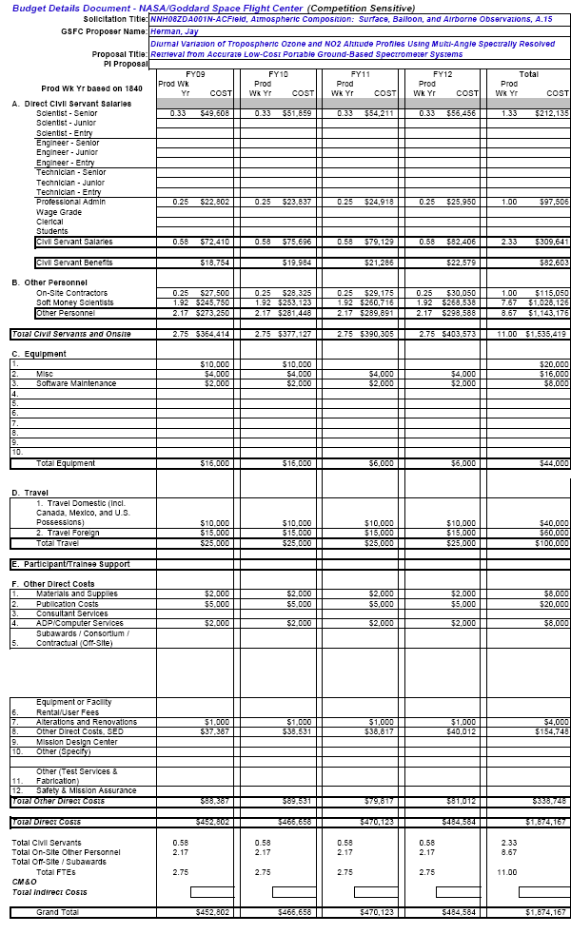
6. Biographical Sketches
RESEARCH AREA EXPERIENCE: | Ion chemistry, earth ionosphere, planetary ionospheres, radio wave propagation in plasmas, stratospheric chemistry and modeling, radiative transfer, atmospheric spectroscopy, uv solar flux measurements, ozone inversion algorithms, and long-term ozone trend analysis, volcanic aerosols, tropospheric trace gas detection, physical oceanography.
PRESENT POSITION | Principal Investigator Proposed JANUS Mission Project  Project Scientist DSCOVR Mission  Principal Investigator UV and aerosol from satellite data  Principal Investigator Ground-based Measurements Project for UV, Aerosols, and Trace Gases  Principal Investigator L-2 SVIP Interferometer/Spectrometer  Principal Investigator Ocean Radiation  Atmospheric Chemistry and Dynamics Branch,  NASA/Goddard Space Flight Center, Code 613.3  Greenbelt, MD 20771 USA
EDUCATION: | 1959 - B.S. - Physics, with minor in mathematics, (obtained with high honor)  Clarkson College, Potsdam, New York  1963 - M.S. - Physics, Penn. State Univ., State College, PA  1965 - Ph.D. - Physics, Penn. State Univ., State College, PA
PREVIOUS POSITIONS: | Principal Investigator for FM-5 TOMS Project  Principal Investigator for TOMS/Meteor Project  Principal Investigator Atmos. Chem. Model  1960 - 1961 Solid State Devices Engineer, I.B.M., Poughkeepsie, New York  1965 - 1967 National Academy of Sciences Research Associate  1967 - 1970 NASA/GSFC, Ionospheric Physics  1970 - 1975 NASA/GSFC, Planetary Atmospheres, Radiative Transfer  1976 - 1986 NASA/GSFC, Principal Investigator, Stratospheric photochemical  modeling and physics. Solar UV Data Analysis, Solar Spectroscopy  1986 - 1990 NASA/GSFC TOMS/SBUV Ozone Data Analysis and TOMS  Recalibration  1991 - TOMS Lead Scientist for Data Acquisition and Analysis.

Dr Jay R. Herman PI (NASA/GSFC)

Recent Refereed Publications (2005 –2008)

- Krotkov, P.K. Bhartia and J.R.Herman, Jim Slusser, Gwen Scott, G. Labow T. F. Eck,and B. N. Holben, UV aerosol absorption experiment (2002-04): 1. UV-MFRSR calibration and performance at GSFC, Optical Engineering 44(4), 041004, 2005.
- Krotkov, P.K. Bhartia and J.R.Herman, Jim Slusser, Gwen, Scott, G. Labow T. F. Eck,and B. N. Holben, Aerosol UV absorption experiment (2002-04): 2. Absorption optical thickness and single scattering albedo, Opt. Eng., 44, 4, 041005, 2005
- Vasilkov, A.P., J.R. Herman, Z. Ahmad, M. Kahru, and G. Mitchell, Assessment of the ultraviolet radiation field in ocean waters from space-based measurements and full radiative transfer calculations, Opt. Eng. 44, 2863-2869, 2005.
- Meloni, D., A. di Sarra, J. R. Herman, F. Monteleone, and S. Piacentino, Comparison of ground-based and TOMS erythemal UV doses at the island of Lampedusa in the period 1998-2003: the role of tropospheric aerosols, J. Geophys. Res., 110, D01202, doi:10.1029/2004JD005283, 2005.
- Tzortziou, Maria, Jay R. Herman, Ajit Subramaniam, Patrick J. Neale, Charles L Gallegos and Lawrence W. Jr Harding, Optical properties and radiation in the Chesapeake Bay estuarine waters: An in-water optical closure experiment, J. Geophys. Res., 2005.
- Patra, P.K., S. K. Behera, J. R. Herman, S. Maksyutov, H. Akimoto, T. Yamagata, The Indian summer monsoon rainfall: interplay of coupled dynamics, radiation and cloud microphysics, Atmos. Chem. Phys. Discuss, 5, 2879-2895, 2005.
- Fromm, Michael, R. Bevilacqua, R. Sevranckx, J. Rosen, J.P. Thayer, J. Herman, and D. larko, Pryo-cumulonimbus, injection of smoke to the stratosphere: Observations and impact of a super blowup in northwestern Canada on 3-4 August 1998, J. Geophys. Res., 110, D08205, doi:101029/2004JD005350, 2005.
- Arola, Antti, Stelios Kazadzis, Nickolay Krotkov, Alkis Bais, Julian Grobner, and Jay R. Herman, Assessment of TOMS UV bias due to absorbing aerosols, J. Geophys. Res., VOL. 110, D23211, doi:10.1029/2005JD005913, 2005.
- Tanskanen, A., N. Krotkov, J.R. Herman, and P.K. Bhartia, “A. Arola, Surface UV Irradiance from OMI, IEEE, TGRS AURA,” special issue, 44, 1267-1271, 2005.
- Cede, Alexander, M. Kowalewski, Stelios Kazadzis, Alkis Bais, Natalia Kouremeti, Mario Blumthaler, and Jay Herman, Solar zenith angle effect for direct-sun measurements of Brewer spectrophotometers due to polarization, Geophysical Research Letters, Vol. 33, L02806, doi:10.1029/2005GL024860, 2006.
- Cede, Alexander, Jay Herman, Andreas Richter, Nickolay Krotkov and John Burrows, Measurements of Nitrogen Dioxide Total Column Amounts at Goddard Space Flight Center Using a Brewer Spectrometer in Direct Sun Mode, accepted, Journal Of Geophysical Research, Vol. 111, D05304, doi:10.1029/2005JD006585, 2006.
- Antón, M., V.E. Cachorro, J.M. Vilaplana, N.A. Krotkov, A. Serrano, C. Toledano, B. de la Morena, J.R. Herman, Toms Retrievals Of Erythemal-Cie Uv Irradiance And Daily Cie Doses Compared With Brewer Ground-Based Measurements At El Arenosillo (Spain), submitted JGR as Manuscript # 2006JD007254, 2006.
- Mark O. Wenig, Eric J. Bucsela, Edward A. Celarier, Jim F. Gleason, Alexander M. Cede, Jay R. Herman, Pepijn Veefkind, Ellen Brinksma, Validation Study of Two Years of OMI NO_2 Data, Advanced Environmental Monitoring, 2006.
- Tzortziou M., A. Subramaniam, J. Herman, C. Gallegos, P.Neale, and L. Harding "Remote Sensing Reflectance and Inherent Optical Properties in the Mid Chesapeake Bay", Estuarine, Coastal, and Shelf Science, doi:10.1016/j.ecss.2006.09.018 2006,
- Tzortziou M., J. Herman, C. Gallegos, P.Neale, A. Subramaniam, L. Harding, and Z. Ahmad, "Bio-Optics of the Chesapeake Bay from Measurements and Radiative Transfer Closure", Estuarine Coastal and Shelf Science, 68(2), 348-362, 2006.
- Hsu, N. Christina, Si-Chee Tsay, Michael D. King, and Jay R. Herman, Deep Blue Retrievals of Asian Aerosol Properties During ACE-Asia, IEEE Transactions On Geoscience And Remote Sensing, 44, 3180-3195, 2006.
- Kazantzidis, A. A. F. Bais, J. Grobner, J. R. Herman, S. Kazadzis, N. Krotkov, E. Kyro, P. N. den Outer, K. Garane, P. Gorts, K. Lakkala, C. Meleti, H. Slaper, R. B. Tax, T. Turunen, and C. S. Zerefos., Comparison of satellite-derived UV irradiances with ground-based measurements at four European stations, J. Geophys. Res., 111, D13207, doi:10.1029/2005JD006672, 2006
- Ziauddin, Ahmaad, Charles R. McClain, Jay R. Herman, Bryan A. Franz, Ewa J. Kwiatkowska, Wayne D. Robinson, Eric J. Bucsela, and Maria Tzortziou, Atmospheric Correction For NO₂ Absorption In Retrieving Water-Leaving Reflectances From The Seawifs And MODIS Measurements, J. Applied Optics, Accepted, 2007.
- Tzortziou M., A. Subramaniam, J. Herman, C. Gallegos, P.Neale, and L. Harding, “Remote sensing reflectance and inherent optical properties in the Mid Chesapeake Bay”. Estuarine, Coastal, and Shelf Science, 72(1): 16-32, 2007.
- Tzortziou, M., N. Krotkov, A. Cede, J.R. Herman, and A. Vassilkov, “A new technique for retrieval of tropospheric and stratospheric ozone profiles using sky radiance measurements at multiple view angles – Application to a Brewer”, spectrometer, accepted, J. Geophys. Res., 2007JD009093, 2008.
- Herman, J.R., G. Labow, N.C. Hsu, D. Larko, Changes in Cloud Cover (1998-2006) Derived From Reflectivity Time Series Using SeaWiFS, N7-TOMS, EP-TOMS, SBUV-2, and OMI Radiance Data, accepted, J. Geophys. Res., 2008.

Dr. Maria Tzortziou, CoI

RESEARCH AREA EXPERIENCE: | Radiative transfer in ocean and atmosphere; Bio-optics of coastal waters; UV, Aerosols, Ozone remote sensing; Remote sensing of Case 2 waters
PRESENT POSITION | Research Scientist - Earth Science System Interdisciplinary Center, University of Maryland at College Park
EDUCATION: | 1997 B.S. Physics (with high honor), Aristotle University, Greece  1999 M.Sc. Environmental Physics (with high honor), Aristotle University, Greece  2001 M.Sc. Meteorology, University of Maryland College Park (UMCP)  2004 Ph.D. Ocean and Atmospheric Sciences, UMCP
PREVIOUS POSITIONS: | 2004-2005 Post-doctoral Fellow - Smithsonian Institution, Smithsonian Environmental Research Center (SERC), MD  1999-2004 Graduate Research Assistant - University of Maryland, UMCP  2001-2003 Pre-doctoral Fellow - Smithsonian Institution, SERC  1998 Visiting Scientist - NASA, Goddard Space Flight Center  1997-1999 Graduate Research Assistant - Aristotle University, Greece, Dept of Physics, Laboratory of Atmospheric Physics.  1996-1997 Research assistant - Aristotle University of Thessaloniki, Dept of Physics, Laboratory of Atmospheric Physics.
RECENT PUBLICATIONS | Tzortziou M., N.A. Krotkov, A.Cede, J. R. Herman, A. Vassilkov. "A new technique for retrieval of tropospheric and stratospheric ozone profiles using sky radiance measurements at multiple view angles - Application to a Brewer spectrometer." J. Geophys. Res., 113, D06304, doi:10.1029/2007JD009093  Tzortziou M., J. Herman, C. Gallegos, P.Neale, A. Subramaniam, L. Harding, and Z. Ahmad, “Bio-Optics of the Chesapeake Bay from Measurements and Radiative Transfer Closure”, Estuarine Coastal and Shelf Science, 68,348-362, 2006.  Zerefos C, Syrakov D, Ganev K, Vasaras A, Kourtidis K, Tzortziou M, Prodanova M, Dimitrova R, Georgieva E, Yordanov D, and Miloshev N, “Study of the pollution exchange between Bulgaria and northern Greece”, International Journal of Environment and pollution, 22 (1-2): 163-185 2004  Formenti, P., T. Reiner, D. Sprung, M. O. Andreae, M. Wendisch, H. Wex, D. Kindred, K. Dewey, J. Kent, M. Tzortziou, A. Vasaras, and C. Zerefos, “The STAAARTE-MED 1998 summer airborne measurements over the Aegean Sea: I. Aerosol particles and trace gases”, JGR, Vol 107, No D21, 2002  Zerefos C., D. Balis, M. Tzortziou, A. Bais, K. Tourpali C. Meleti, G. Bernhard and J. Herman, "A note on the interannual variations of UV-B erythemal doses and solar irradiance from ground-based and satellite observations", Annales Geophysicae 19: 115-120, 2001  Zerefos C., K. Ganev, K. Kourtidis, M. Tzortziou, A. Vasaras, E. Syrakov, “On the origin of SO₂ above Northern Greece”, GRL, Vol. 27, 3, 365-368, 2000  Ahmad Z., Herman J.R.,Vasilkov A., Tzortziou M.,Mitchell G., Kahru M., “Seasonal variation of UV radiation in the ocean under clear and cloudy conditions”, Proc. SPIE Vol. 5156, p. 63-73, UV Ground- and Space-based Measurements, Models, and Effects III; Slusser, Herman & Gao; Eds., 2003.

Dr. Nader Abuhassan, CoI

RESEARCH AREA EXPERIENCE: | Over 16 years of experience in Industry, National and International Research Centers. Actively participated in the design, development and scientific validation of several instruments and radiation sensors for remote sensing of greenhouse gases and monitoring of atmosphere optical properties.
PRESENT POSITION | Sr. Scientist/Engineer at Science Systems & Applications Inc.
EDUCATION: | 1991-1995Ph.D. Development of a Portable Multi-spectral Infrared Radiometer, first applications. Department of Physics at the University Pierre and Marie Curie, Paris 6, France (Financial support for the project was provided by the French Space Agency 93/CNES/373 and Cimel Electronique).  1990-1991 DESS Geophysics, (Post Graduate), University Pierre and Marie Curie, Paris6, France.  1986-1987 French language Certification, University of Paris 5 (La Sorbonne), France.Diploma of Electronic Engineering, Damascus University, Faculty of Electrical Engineering, Syria, 1979-1983.
PREVIOUS POSITIONS: | 2000- present SSAI Sr. staff Scientist/Engineer supporting the Atmospheric Chemistry &Dynamics branch at NASA/GSFC.  1997-2000 SSAI Sr. staff Scientist/Engineer Sensor Systems supporting the Aeronet Network. at NASA/GSFC.  2000 Ciena Corporation Sr. Engineer 10GHZ Transceiver.  1991-1997 Cimel Electronique R&D Engineer Paris, France  1988-1990 CNRS visiting Scientist /Engineer at the French National Research Center (CNRS\CRG).
RECENT PUBLICATIONS | “Solar Viewing Interferometer Prototype”,Richard G. Lyon, Jay R. Herman,Nader Abuhassan, Cathy T. Marx, Semion Kizhner, Julie Crooke, RonaldToland, Albert Mariano, Cheryl Salerno, Gary Brown, Tony Cazeau, SPIEAstronomical Telescopes and Instrumentation, June 21-25, 2004, Glasgow Scotland.  ·Analysis of the performance characteristics of the five-channel Microtops II sun photometer formeasuring Aerosol Optical Thickness and Precipitable Water Vapor.Charles Ichoku , Robert Levy , Yoram J. Kaufman , Lorraine A.Remer , Rong-Rong Li ,Vanderlei J. Martins , Brent N. Holben , NaderAbuhassan, Ilya Slutsker, Thomas F. Eck ,Christophe Pietras , IGR.2001.  ·Aerosol optical properties climatology at selected globally distributed sites fromAERONET Holben, B.N., O.Dubovik, A.Smirnov, T.F.Eck, N.Abuhassan,I.Slutsker,W.Newcomb, D.Tanre, Y.Kaufman, N.T.O'Neill, M.King and T.Nakajima, The CCSR COE Symposium/3rd Aerosol-Cloud Remote SensingWorkshop, Kyoto, Japan, December 1-3, 1999.  Mineral dust optical properties on the AERONET (Aerosol Robotic Network)sites Smirnov, A., B.N.Holben, O.Dubovik, T.F.Eck, I.Slutsker, andN.Abuhassan,,IGARSS99, Hamburg, Germany, June 26-July 3, 1999.

Dr. Nickolay Krotkov, CoI

RESEARCH AREA EXPERIENCE: | Geophysics, Atmospheric and Oceanic optics; Theory and numerical methods in Radiative transfer; Ultraviolet and visible passive remote sensing of the Earth (atmosphere, oceans, and volcanic plumes monitoring). Satellite and ground based passive spectral data analysis and inversions (aerosols and minor gases). Theoretical work experience includes radiative transfer modeling of the polarization effects of the scattered solar radiation in the atmosphere-ocean system, as applied to passive spectral and polarization remote sensing of the atmospheric gases, aerosols and natural waters. Research on the retrieval of the aerosol absorption properties in UV using a combination of ground based passive radiometers and spectrometers.
PRESENT POSITION | 2000- Senior Research Scientist, Goddard Earth Sciences and Technology Center, University of Maryland Baltimore County
EDUCATION: | 1983 B.S. Physics, Moscow Institute of Physics and Technology (MIPT)  1985 M.S. Remote Sensing, MIPT  1990 Ph.D. Oceanography, P.P.Shirshov Institute of Oceanology, Russian Academy of Sciences
PREVIOUS POSITIONS: | 1996-2000 Principal Scientist, Raytheon ITSS Co  1994-1996 Research Associate, UMD College Park  1993-1994 Reaserch Associate, Universities Space  Research Association, NASA/GSFC  1990-1992 Research Associate, Central Aerological  Observatory, Dolgoprudny, Russia  1986-1990 Graduate Research Assistant, Graduate student, Moscow Institute of Physics and Technology, Dolprudny, Russia
RECENT PUBLICATIONS | Krotkov, N, A. , S. A. Carn, A.J. Krueger, P.K. Bhartia, K. Yang, Band residual difference algorithm for retrieval of SO2 from the AURA Ozone Monitoring Instrument (OMI), IEEE Transactions on Geoscience and Remote Sensing, AURA special issue, 44(5), 1259-1266, doi:10.1109/TGRS.2005.861932, 2006  Tanskanen, A., N. Krotkov, J.R. Herman, P.K. Bhartia, A. Arola, Surface UV Irradiance from OMI, IEEE Transactions on Geoscience and Remote Sensing, AURA special issue, 44(5), 1267-1271, doi:10.1109/TGRS.2005.861932, 2006.  Krotkov, N.A., P.K. Bhartia, J.Herman, J. Slusser, G. Scott, G. Janson, G. Labow, T. Eck, and B. Holben, Aerosol UV absorption closure experiment (2002 –04): 1. UV-MFRSR calibration and performance at GSFC, Opt. Eng., 44,4, 2005  Krotkov, N.A., P.K. Bhartia, J.Herman, J. Slusser, G. Scott, G. Labow, A. Vasilkov, T. Eck, O. Dubovik, and B. Holben, Aerosol UV absorption closure experiment (2002 –04): 2. Absorption optical thickness and single scattering albedo, Opt. Eng.,44(4), 2005.

Dr. Alexander Cede, CoI
RESEARCH AREA EXPERIENCE: | Calibration of (spectro) radiometers, Radiative transfer, UV irradiance at the Earth’s surface, Aerosols, Cloud studies, Atmospheric spectroscopy
PRESENT POSITION | Scientist at Science Systems & Applications Inc., since 2002 and now at University of Maryland ESSIC
EDUCATION: | 1996 M.S. Physics, University of Innsbruck, Austria  2001 Ph.D. Physics, University of Innsbruck, Austria
PREVIOUS POSITIONS: | 1994-1996 Laboratory Assistant at Institute of Medical Physics, University of Innsbruck, Austria  1997-1999 Scholarship of the “Skin Cancer Foundation” of Argentina  2000 Scientist at “Mag. Ing. Schreder – Calibrations, Measurements, Softwaresolutions”  2001-2002 Scientist Institute of Medical Physics, University of Innsbruck, Austria
RECENT PUBLICATIONS | Cede, A., and J. Herman, Measurements of O3, SO2, NO2 and HCHO column amounts using a Brewer spectrometer, in Ultraviolet Ground- and Space-based measurements, Models, and Effects V, July 31 to August 1, 2005, San Diego, USA, Proceedings of SPIE Vol. 5886, Pages 7-15, SPIE-The International Society for Optical Engineering, G. Bernhard, J. R. Slusser, J.R. Herman, W. Gao, and G. Bernhard Editors, 2005.  Cede, A., S. Kazadzis, M. Kowalewski, A. Bais, N. Kouremeti, M. Blumthaler, and J. Herman, Correction of direct irradiance measurements of Brewer spectrophotometers due to the effect of internal polarization, Geophys. Res. Lett., 33 (2), L02806, doi: 10.1029/2005GL024860, 2006a.  Cede, A., J. Herman, A. Richter, N. Krotkov, and J. Burrows, Measurements of nitrogen dioxide total column amounts using a Brewer double spectrometer in direct Sun mode, J. Geophys. Res., 111, D05304, doi:10.1029/2005JD006585, 2006b.  Cede, A., B. Bojkov, J. Herman, M. Wenig, E. Bucsela, E. Celarier, and J. Gleason, Validation of OMI Vertical Column NO2 with Brewer Direct Sun Measurements, in preparation, 2006c.  Cede, A., E. Luccini, R.D. Piacentini, L. Nuñez, M. Blumthaler, and J. Herman, TOMS-derived erythemal irradiance versus measurements at the stations of the Argentine UV Monitoring Network, J. Geophys. Res., 109 (D8), D08109, 10.1029/2004JD004519, 2004.  Cede, A., G. Labow, M. Kowalewski, N. Krotkov and O. Dubovik, Deriving aerosol parameters from absolute UV sky radiance measurements using a Brewer double spectrometer, in Ultraviolet Ground- and Space-based measurements, Models, and Effects III, 4-6 August 2003, San Diego, USA, Proceedings of SPIE Vol. 5156, Pages 323-329, SPIE-The International Society for Optical Engineering, J. R. Slusser, J.R. Herman, and W. Gao Editors, 2003.

Dr. Xiong Liu, CoI
RESEARCH AREA EXPERIENCE: | Remote sensing of atmospheric trace gases (especially tropospheric ozone), aerosols, and clouds, Atmospheric radiative transfer, Instrument calibration, Data validation and analysis, air quality and climate change
PRESENT POSITION | Research Scientist at Goddard Earth Sciences and Technology Center, University of Maryland, Baltimore County
EDUCATION: | 2002 Ph.D. Atmospheric Science, University of Alabama in Huntsville  2002 M.S. Computer Science, University of Alabama in Huntsville  1998 M.S. Environmental Chemistry, RCEES, CAS, China  1995 B.S. Environmental Chemistry, Nankai University, China
PREVIOUS POSITIONS: | 2004–2007, Research Scientist, Harvard-Smithsonian Center for Astrophysics  2003–2003, Visiting Scientist, Harvard-Smithsonian Center for Astrophysics  1998–2002, Research Assistant, University of Alabama in Huntsville  1996–1998, Research Assistant, RCEES, Chinese Academy of Sciences
SELECTED REFEREED PUBLICATIONS | Says-Lopez, A., K. Chance, X. Liu, T.P. Kurosu and S.P. Sander, First observations of iodine oxide from space, Geophys. Res. Lett., 34(12), L12812, doi:10.1029/2007GL030111, 2007.  Liu, X., K. Chance, C.E. Sioris, and T.P Kurosu, Impact of using different ozone cross sections on ozone profile retrievals from GOME ultraviolet measurements, Atmos. Chem. Phys., 7, 3571-3578, 2007.  Liu, X., K. Chance, T.P. Kurosu, Improved ozone profile retrievals from GOME data with degradation correction in reflectance, Atmos. Chem. Phys., 7, 1575-1583, 2007.  Worden, J., X. Liu, K. Bowman, K. Chance, R. Beer, A. Eldering, M. Gunson, H. Worden, Improved tropospheric ozone profile retrievals using OMI and TES radiances, Geophys. Res. Lett., 34(1), L01809, 10.1029/2006GL027806, 2007.  Liu, X., K. Chance, C.E. Sioris, T.P. Kurosu, M.J. Newchurch, Intercomparison of GOME, ozonesonde, and SAGE-II measurements of ozone: Demonstration of the need to homogenize available ozonesonde datasets, J. Geophys. Res., 101(D14), D114305,10.1029/2005JD006718, 2006.  Liu, X., K. Chance, C.E. Sioris, M.J. Newchurch, T.P. Kurosu, Tropospheric ozone profiles from a ground-based ultraviolet spectrometer: a new retrieval method, Appl. Opt., 45(10), 2352-2359, 2006.  Liu X., et al., First directly-retrieved global distribution of tropospheric column ozone: comparison with the GOES-CHEM model, J. Geophys. Res., 111(D2), D02308, 10.1029/2005JD006564, 2006.  Liu, X., et al., Ozone profile and tropospheric ozone retrieval from GOME: Algorithm description and validation, J. Geophys. Res., 110(D20), D20307, 10.1029/2005 JD006240, 2005.  Liu, X., C.E. Sioris, K.V. Chance, T.P. Kurosu, M.J. Newchurch, R.V. Martin, P.I. Palmer, Mapping tropospheric ozone profiles from an airborne UV/Visible spectrometer, Appl. Opt., 44(16), 3312-3319, 2005.  Liu, X., M.J. Newchurch, R. Loughman, and P.K. Bhartia, Errors resulting from assuming opaque Lambertian cloud surfaces in TOMS ozone retrieval, J. Quant. Spectro. & Radiat. Transfer, 85, 337-365, 2004.  Liu, X., J. Wang, and S.A. Christopher, Shortwave direct radiative forcing of dust aerosols over the Atlantic Ocean, Int. J. Rem. Sensing, 24, 5147-5160, 2003.  Liu, X., M.J. Newchurch, and J.H. Kim, Occurrence of ozone anomalies over cloudy areas in TOMS data, Atmos. Chem. and Phys., 3, 1113-1129, 2003.  Wang, J., X. Liu, S.A. Christopher, J.S. Reid, E. Reid, and H. Maring, The Effect of Non-Sphericity on GOES-8 Dust Aerosol Retrievals during PRIDE, Geophys. Res. Lett., 30(24), 229310.1029/2003GL018697, 2003.  Newchurch, M.J., X. Liu, J.H. Kim, and P.K. Bhartia, On the accuracy of TOMS retrievals over tropical cloudy regions, J. Geophys. Res., 106, 32,315-3227, 2001.

7. Current and pending support
OTHER SUPPORT | Source of Support | Award Amount and Period of Performance | Person-Months and Level of Effort (PM/Year) | Project Title
Dr. Herman PI
PI  Year 4 of 4 | NNH04ZYS004N | $1070K  FY2005 to FY2008 | 3 PM/Year | OMI Validation and Analysis of NO₂, HCHO, and SO₂
PI  Year 3 of 3 | NNH04Z  YS004N | $706K  FY2006 to FY2008 | 3 PM/Year | Ocean Atmospheric Correction 340 – 440 nm
PI  Year 1 of 5 | NNH06ZDA001N | $2020K  FY2008 to  FY2012 | 1 PM/Year | Reflectivity Climate Data Record from SBUV, TOMS, SeaWiFS.

Dr. Krotkov Co-I
Co-I  Year 4 of 4 | NNH04ZYS004N | $1070K  FY2005 to FY2008 | 3 PM/Year | OMI Validation and Analysis of NO₂, HCHO, and SO₂
PI  Year 2 of 3 | NNH05ZDA001N-AC | $801784  FY2006 to FY2008 | 6 PM/Year | Mapping SO2 emissions with Aura/OMI

Dr. Cede Co-I
Co-I  Year 4 of 4 | NNH04ZYS004N | $1070K  FY2005 to FY2008 | 6 PM/Year | OMI Validation and Analysis of NO₂, HCHO, and SO₂

Dr. Tzortziou Co-I
Co-I  Year 3 of 3 | NNH04Z  YS004N | $706K  FY2006 to FY2008 | 6 PM/Year | Ocean Atmospheric Correction 340 – 440 nm

Dr. Abuhassan Co-I
Co-I  Year 4 of 4 | NNH04ZYS004N | $1070K  FY2005 to FY2008 | 6 PM/Year | OMI Validation and Analysis of NO₂, HCHO, and SO₂

Dr Xiong Liu
 | N/A

