General Instrument Interface Document (GIID)

For

NATIONAL POLAR-ORBITING OPERATIONAL ENVIRONMENTAL SATELLITE SYSTEM (NPOESS)

And the

NPOESS PREPARATORY PROJECT (NPP)

Prepared by

Systems Engineering
NPOESS Integrated Program Office

Integrated Program Office
Silver Spring MD 20910

Table of Contents
1.0 SCOPE 1
1.1 IDENTIFICATION 1
1.2 Terminology 1
1.3 DOCUMENT OVERVIEW 1
1.3.1 NPOESS DOCUMENTATION 1
1.3.2 NPP DOCUMENTATION 3
1.4 Conflicts 3
1.5 Requirement Weighting Factors 3
2 APPLICABLE DOCUMENTS 4
2.1 GOVERNMENT REQUIREMENT DOCUMENTS 4
2.2 NON-GOVERNMENT REQUIREMENT DOCUMENTS 6
2.3 REFERENCE DOCUMENTS 7
3 REQUIREMENTS 10
3.1 DEFINITION 10
3.1.1 reserved 10
3.1.2 reserved 10
3.1.3 Instrument Modes/functionalities 10
3.1.3.1 OFF Mode 11
3.1.3.2 ACTIVATION 11
3.1.3.3 EARLY ORBIT CHECKOUT 12
3.1.3.4 OPERATIONAL Mode 13
3.1.3.5 DIAGNOSTIC Mode 13
3.1.3.6 SAFE Modes 13
3.1.3.6.1 INSTRUMENT SAFE Mode 13
3.1.3.6.2 SPACECRAFT SAFE Mode 14
3.1.3.7 SURVIVAL Mode 15
3.1.3.8 AUTONOMOUS 16
3.1.4 Operational Concept 17
3.1.4.1 Pre-launch 17
3.1.4.2 Launch and Injection 17
3.1.4.3 On-orbit Operational Concept 18
3.2 INTERFACE CHARACTERISTICS 19
3.2.1 General 19
3.2.2 Reserved 19
3.2.3 Interface Requirements 19
3.2.4 Physical and Interface Characteristics 21
3.2.4.1 Mass Properties 21
3.2.4.1.1 Instrument Mass Properties Documentation 21
3.2.4.1.2 Instrument Mass Variability Documentation 21
3.2.4.1.3 Center of Mass 22
3.2.4.1.3.1 Center of Mass Location 22
3.2.4.1.4 Moments and Products of Inertia 22
3.2.4.1.4.1 Moments and Products of Inertia Measurement 22
3.2.4.1.4.2 Moments and Products of Inertia Accuracy 22
3.2.4.1.4.3 Moments and Products of Inertia Documentation 22
3.2.4.1.4.4 Moments and products of Inertia Variation Documentation 23
3.2.4.2 Mechanical Requirements 23
3.2.4.2.1 Dimensions 23
3.2.4.2.2 Spacecraft Reference Coordinate Frame 24
3.2.4.2.3 Physical Interface 26
3.2.4.2.3.1 Stowed and Critical Clearances 26
3.2.4.2.3.1.1 Instrument Envelope Documentation 27
3.2.4.2.3.2 Mounting Provisions 27
3.2.4.2.3.2.1 Mounting Method 27
3.2.4.2.3.2.2 Mounting Interface 28
3.2.4.2.3.2.2.1 Mounting Interface Documentation 28
3.2.4.2.3.2.2.2 Mounting Hole Coordinates and Dimensions 28
3.2.4.2.3.2.3 Drill Templates 28
3.2.4.2.3.2.3.1 Drill Template Usage 28
3.2.4.2.3.2.3.2 Drill Template Fabrication Requirements 28
3.2.4.2.3.2.3.3 Drill Template Provider 29
3.2.4.2.3.2.4 Mounting Hardware 29
3.2.4.2.3.2.4.1 Mounting Hardware Provider 29
3.2.4.2.3.2.4.2 Mounting Hardware Documentation 29
3.2.4.2.3.2.4.3 Mounting Hardware Delivery 29
3.2.4.2.3.2.4.4 Mounting Surface Requirements 29
3.2.4.2.3.2.5 Mounting Location and Documentation 30
3.2.4.2.3.2.6 Special Mounts 30
3.2.4.2.3.3 Alignment 30
3.2.4.2.3.3.1 Alignment Responsibilities 30
3.2.4.2.3.3.2 Alignment References 31
3.2.4.2.3.3.3 Alignment Control 32
3.2.4.2.3.3.4 Alignment Knowledge 32
3.2.4.2.3.3.4.1 Measurement Uncertainty 32
3.2.4.2.3.3.4.2 On-orbit Stability 33
3.2.4.2.3.3.5 Spacecraft Attitude Reference 33
3.2.4.2.3.3.5.1 Attitude Reference Knowledge 33
3.2.4.2.3.3.5.2 High Frequency Attitude Reference Errors 33
3.2.4.2.3.3.5.3 Attitude Reference Control 33
3.2.4.2.3.3.5.4 Attitude Reference Rate Error 33
3.2.4.2.3.3.6 Position Knowledge 34
3.2.4.2.3.4 Structural Support 34
3.2.4.2.3.5 Instrument Structural Dynamics 34
3.2.4.3 Power 34
3.2.4.3.1 Power Bus Requirements 34
3.2.4.3.1.1 Electrical Interface Definitions 34
3.2.4.3.1.2 Power Allocation 35
3.2.4.3.1.2.1 Instrument Power Allocations 35
3.2.4.3.1.2.1.1 Operational Power Allocation 35
3.2.4.3.1.2.1.2 Survival Power Allocation 35
3.2.4.3.1.2.1.3 Launch-phase Power Allocation 35
3.2.4.3.1.2.1.4 Power Interface Allocation 36
3.2.4.3.1.2.1.5 1394 Power Allocation 36
3.2.4.3.1.3 Power Control 36
3.2.4.3.1.3.1 Power Connections 36
3.2.4.3.1.4 Power Application 37
3.2.4.3.1.4.1 Power Fault Tolerance 37
3.2.4.3.1.4.2 Instrument Heater Power Separation 37
3.2.4.3.1.4.3 Instrument Internal Power 37
3.2.4.3.1.4.4 Instrument External (Spacecraft) Power 37
3.2.4.3.1.5 Electrical Power Interface Requirements 38
3.2.4.3.1.5.1 Ripple 38
3.2.4.3.1.5.1.1 Voltage Ripple 38
3.2.4.3.1.5.1.2 Reflected Ripple 38
3.2.4.3.1.5.2 Transients 38
3.2.4.3.1.5.2.1 Voltage Transients 39
3.2.4.3.1.5.2.2 Current Transients 39
3.2.4.3.1.5.2.2.1 Instrument Turn-on Transients 39
3.2.4.3.1.5.2.2.2 Instrument Turn-off Transients 40
3.2.4.3.1.5.2.2.3 Instrument Operational Transients 40
3.2.4.3.1.5.3 Abnormal Operation Voltage Limits 40
3.2.4.3.1.5.4 Impedance 41
3.2.4.3.1.5.5 Survival Heater Bus 41
3.2.4.3.1.5.6 Safety Bus Operation 42
3.2.4.3.1.5.7 Overcurrent Protection Device Size 42
3.2.4.3.1.6 Unannounced Removal of Power 43
3.2.4.3.1.7 Instrument High-Voltage Restriction 43
3.2.4.3.2 Grounds, Returns, and References 44
3.2.4.3.2.1 Grounding Responsibility 45
3.2.4.3.2.2 General 45
3.2.4.3.2.3 Power Returns 46
3.2.4.3.2.4 Signal Reference 47
3.2.4.3.2.5 Chassis Ground 47
3.2.4.3.2.6 External Ground Tie Point 48
3.2.4.3.2.7 Thermal Blanket Grounding 48
3.2.4.3.3 Harnesses 48
3.2.4.3.3.1 Electrical Connectors 48
3.2.4.3.3.1.1 General Considerations 48
3.2.4.3.3.1.2 Connector Location and Types 49
3.2.4.3.3.1.3 Keying 49
3.2.4.3.3.1.4 Flight Plugs 50
3.2.4.3.3.1.5 Breakout Boxes 50
3.2.4.3.3.1.6 Buffer Connectors and Connector Savers 50
3.2.4.3.3.1.7 Test Connectors 50
3.2.4.3.3.2 Wiring 51
3.2.4.3.3.2.1 Harnesses Provider 51
3.2.4.3.3.2.2 Harness Documentation 52
3.2.4.3.3.2.3 Harness Wiring Requirements 52
3.2.4.3.3.2.4 Harness Tie Points 53
3.2.4.3.3.2.5 Harness Bakeout 53
3.2.4.4 Survivability 53
3.2.4.5 Parts, Materials, and Processes 53
3.2.4.6 Protective Coatings and Finishes 53
3.2.4.7 Thermal 55
3.2.4.7.1 General 55
3.2.4.7.2 Thermal Recovery 55
3.2.4.7.3 Heat Transfer 55
3.2.4.7.3.1 Heat Transfer To Spacecraft 56
3.2.4.7.3.2 Radiation 56
3.2.4.7.4 Temperature 57
3.2.4.7.4.1 Interface Temperature Range 57
3.2.4.7.4.2 Thermal Uncertainty Margins 58
3.2.4.7.5 Temperature Monitoring 58
3.2.4.7.5.1 Mechanical Mounting Interface Temperature Monitoring 58
3.2.4.7.5.2 Instrument Temperature Monitoring 58
3.2.4.7.5.3 Temperature Sensor Locations 58
3.2.4.7.6 Thermal Control Design 59
3.2.4.7.6.1 Thermal Control Responsibility 59
3.2.4.7.6.2 Survival Heaters 59
3.2.4.7.6.3 Multilayer Insulation 60
3.2.4.7.6.4 Other Considerations 60
3.2.4.7.6.5 Ambient Tests 60
3.2.4.8 Command and Data Handling 61
3.2.4.8.1 Common Electrical Interface 61
3.2.4.8.1.1 Interface Conductors 62
3.2.4.8.1.2 Interface Circuitry Isolation 62
3.2.4.8.1.3 Interface Fault Tolerance 62
3.2.4.8.1.4 Power Bus 63
3.2.4.8.2 Data Bus Requirements 63
3.2.4.8.2.1 Bus Functions 63
GPSOS 63
3.2.4.8.3 Interface Characteristics 64
3.2.4.8.3.1 Mil-STD-1553 Characteristics 64
3.2.4.8.3.1.1 Electrical Interface 64
3.2.4.8.3.2 IEEE 1394a Interface Characteristics 66
3.2.4.8.3.3 Pulse Commands 66
3.2.4.8.3.4 Time of Day Pulse 67
3.2.4.8.3.5 Synchronization 67
3.2.4.8.4 Instrument Commands and Data Load 68
3.2.4.8.4.1 Commands 68
3.2.4.8.4.1.1 Real-time Ground Commands 68
3.2.4.8.4.1.2 Stored Commands 68
3.2.4.8.4.1.3 Command Uniqueness 69
3.2.4.8.4.1.4 Command Sequence 69
3.2.4.8.4.1.5 Command Restraints 69
3.2.4.8.4.2 Command and Data Load Packets 70
3.2.4.8.4.3 Reserved 70
3.2.4.8.4.4 Reserved 70
3.2.4.8.4.5 Critical Command 70
3.2.4.8.4.6 Squib Commands 71
3.2.4.8.4.7 Documentation 71
3.2.4.8.5 Instrument Health and Status Telemetry 71
3.2.4.8.5.1 Telemetry Diagnostic Data 72
3.2.4.8.5.2 Point-to-Point Telemetry 72
3.2.4.8.5.3 Command Verification 73
3.2.4.8.5.4 Instrument Memory Dump 74
3.2.4.8.5.5 Telemetry Monitor 74
3.2.4.8.6 Mission Data 74
3.2.4.8.7 Data Packetization 75
3.2.4.8.8 Command & Data Interface Test Packets 76
3.2.5 Instrument Quality Factors 77
3.2.5.1 Reliability 77
3.2.5.1.1 Operational Service Life 77
3.2.5.1.2 Maintainability 77
3.2.6 Environmental Conditions 78
3.2.6.1 Natural Environment Characteristics 78
3.2.6.1.1 Total Ionizing Dose Environment 78
3.2.6.1.2 Cosmic Ray and High Energy Proton Environment 81
3.2.6.1.2.1 Single Events Radiation Environment 81
3.2.6.1.2.1.1 Galactic Cosmic Ray (GCR) Linear Energy Transfer (LET) Spectrum 81
3.2.6.1.2.1.2 High Energy Proton Fluence 82
3.2.6.1.2.1.3 Peak Fluxes 83
3.2.6.1.2.2 Displacement Damage 84
3.2.6.1.3 Reserved 84
3.2.6.1.4 Reserved 84
3.2.6.1.5 Spacecraft Magnetic Fields 84
3.2.6.1.6 Atomic Oxygen 85
3.2.6.1.7 Spacecraft Charging from All Sources 86
3.2.6.2 Launch Environment 86
3.2.6.2.1 Thermal 86
3.2.6.2.1.1 Temperatures 87
3.2.6.2.1.2 Free Molecular Heating 87
3.2.6.2.2 Shock 87
3.2.6.2.3 Deleted 88
3.2.6.2.4 Vibration 88
3.2.6.2.5 Acoustics 89
3.2.6.2.6 Launch Pressure Decay 90
3.2.6.2.7 Physical Environment 90
3.2.6.3 On-orbit environment 90
3.2.6.3.1 Acceleration 90
3.2.6.4 Test Environments 90
3.2.7 Transportability 91
3.2.8 Flexibility and Expansion 91
3.2.8.1 Operational Computer Resource Reserves 91
3.2.8.1.1 Computer Resource Reserves for Operational Space Elements 91
3.2.8.1.1.1 Data Processing Processor Reserves 91
3.2.8.1.1.2 Data Processing Primary Memory Reserves 91
3.2.8.1.1.3 Data Processing Peripheral Data Storage (Secondary Memory) Reserves 92
3.2.8.1.1.4 Data Processing Data Transmission Media 92
3.2.8.1.1.5 Data Processing Software/Firmware 92
3.3 DESIGN AND CONSTRUCTION 92
3.3.1 Materials 92
3.3.1.1 Toxic Products and Formulations 93
3.3.1.2 Parts Selection 93
3.3.1.3 Material Selection 93
3.3.2 Electromagnetic Radiation 94
3.3.2.1 Electromagnetic Interference (EMI) Filtering of Spacecraft Power 94
3.3.2.2 Electromagnetic Compatibility 95
3.3.2.2.1 Scope 95
3.3.2.2.2 Baseline Requirements 95
3.3.2.2.2.1 General 95
3.3.2.2.2.2 Interface Margins 95
3.3.2.2.3 External Environment 96
3.3.2.2.3.1 External RF Environment 96
3.3.2.2.3.2 Spacecraft Charging from All Sources 97
3.3.2.2.4 Wiring 97
3.3.2.2.5 Conducted and Radiated Interface Requirements 97
3.3.2.2.5.1 Magnetic Field Radiated Emissions, RE101 97
3.3.2.2.5.2 Electric Field Radiated Emissions, RE102 98
3.3.2.2.5.3 Radiated Susceptibility, RS101 107
3.3.2.2.5.4 Radiated Susceptibility RS103 107
3.3.3 Reserved 108
3.3.4 Workmanship 108
3.3.5 Interchangeability 108
3.3.6 Safety Requirements 108
3.3.6.1 Design Safety Criteria 109
3.3.7 Human Engineering 111
3.3.8 Nuclear Control 111
3.3.9 Security 111
3.3.9.1 Communications Security (COMSEC) 111
3.3.9.2 Computer Security (COMPUSEC) 111
3.3.10 Reserved 112
3.3.11 Computer Resources 112
3.3.11.1 Operational Computer Resources 112
3.3.11.1.1 Operational Computational Equipment 112
3.3.11.1.2 Operational Application Software (TBS) 112
3.3.11.1.3 Operating Systems Used in Operational Computers 112
3.3.11.1.3.1 Instruments Flight Software Requirements 112
3.3.11.1.3.1.1 Instrument Flight Software Version Control 112
3.3.11.1.3.1.2 Instrument Flight Software Load 112
3.3.11.1.3.1.3 Instrument Flight Software On-Orbit Installation and Verification 112
3.3.11.1.3.2 Programming Language 113
3.3.11.1.3.2.1 Language Standards 113
3.3.11.1.4 Software Coding Conventions 113
3.3.11.2 Instrument GSE to Spacecraft I&T GSE Interface 113
3.3.12 Instrument Design Requirements 114
3.3.12.1 Structural Analyses 114
3.3.12.2 Strength Requirements 114
3.3.12.2.1 Yield Load 114
3.3.12.2.2 Ultimate Load 114
3.3.12.3 Stiffness Requirements 115
3.3.12.3.1 Dynamic Properties 115
3.3.12.3.2 Structural Stiffness 115
3.3.12.3.3 Component Stiffness 115
3.3.12.4 Structural Factors of Safety 116
3.3.12.4.1 Flight Limit Loads 116
3.3.12.4.2 Pressure Loads 118
3.3.12.5 Design Load Conditions 119
3.3.12.6 Instrument Fluid Subsystems 119
3.3.12.6.1 Tubing 119
3.3.12.6.2 Separable Fittings 119
3.3.12.7 Moving Mechanical Assemblies 120
3.3.12.7.1 Actuating Devices (See Section 3.3.6.1) 120
3.3.12.7.2 Instrument Disturbance Allocation 120
3.3.12.7.3 Instrument Mechanisms 121
3.3.12.7.4 Uncompensated Momentum 121
3.3.12.7.5 Instrument Disturbance Allocations 121
3.3.12.7.5.1 Periodic Disturbance Torque Limits 121
3.3.12.7.5.2 Constant Disturbance Torque Limits 122
3.3.12.7.5.3 Disturbance Torque Limits for Linear Forces 123
3.3.12.7.5.4 Spacecraft Non-Operational Deployment Disturbance 123
3.3.12.7.5.5 Torque Profile Documentation 124
3.3.12.7.5.6 Thrust Direction Definition 124
3.3.12.8 Magnetics 124
3.3.12.9 Access 124
3.3.12.9.1 Access Identification 124
3.3.12.9.2 General Access 124
3.3.12.10 Mounting/Handling 125
3.3.12.10.1 Handling Fixtures 125
3.3.12.10.2 Mounting Orientation 125
3.3.12.10.3 Instrument-to-Spacecraft Integration and Test Mounting 125
3.3.12.10.4 Non-Flight Equipment 126
3.3.12.11 Venting 126
3.3.13 Reserved 126
3.3.14 Ground support equipment 126
3.3.15 General Construction Requirements 127
3.3.15.1 Processes and Controls for Space Equipment 127
3.3.15.1.1 Assembly Lots 128
3.3.15.1.2 Contamination 129
3.3.15.1.2.1 Contamination Control Requirements 130
3.3.15.1.2.2 Facility Environmental Requirements 130
3.3.15.1.2.2.1 Ground Support Equipment (GSE) Cleanliness Requirements 131
3.3.15.1.2.3 Instrument Inspection and Cleaning During I&T 131
3.3.15.1.2.4 Instrument Purge Requirements 131
3.3.15.1.2.5 Fabrication and Handling 132
3.3.15.1.2.6 Device Cleanliness 132
3.3.15.1.2.7 Outgassing Instrument Sources of Contamination 132
3.3.15.1.2.8 Atomic Oxygen Contamination 133
3.3.15.1.3 Electrostatic Discharge 134
3.4 DOCUMENTATION 134
3.4.1 Specifications 134
3.4.2 Interface Control Documents 134
3.4.3 Drawings and Associated List 135
3.4.4 Software (Including Databases) 135
3.4.5 Technical Manuals 135
3.4.6 Data Package 135
3.4.7 Documentation Delivery Format 136
3.5 LOGISTICS 136
3.5.1 Maintenance Planning 136
3.5.1.1 Instrument Maintenance Concepts 136
3.5.2 Support Equipment 136
3.5.3 Packaging, Handling, Storage, and Transportation (PHS&T) 136
3.5.4 Facilities (TBR) 137
3.6 PERSONNEL AND TRAINING 137
4 QUALITY ASSURANCE AND TESTING PROVISIONS 138
4.1 QUALITY ASSURANCE 138
4.1.1 Special Tests and Examinations 138
4.1.1.1 Inspections and Tests of the Instrument 138
4.1.1.1.1 Instrument Parts, Materials, and Process Controls 138
4.1.1.1.2 Instrument Records 138
4.1.1.1.3 Instrument Manufacturing Screens 139
4.1.1.1.4 Non-conforming Material 139
4.1.1.1.5 Instrument Design Verification Tests 139
4.2 TESTING 140
4.2.1 Testing Philosophy 140
4.2.2 Location of Testing 141
4.2.3 Physical Models 141
4.2.3.1 Engineering Development Unit (EDU) 141
4.2.3.4 Spacecraft/Instrument Electrical Interface Simulator (TBR) 141
4.2.4 Math Model Requirements 141
4.2.4.1 Finite Element Model 142
4.2.4.1.1 Model Representation 142
4.2.4.1.2 Finite Element Model (FEM) Requirements 142
4.2.4.1.3 Deliverable NASTRAN Model Data 143
4.2.4.1.4 Deliverable Model Validity Checks 144
4.2.4.1.5 NASTRAN Model Verification 145
4.2.4.2 Thermal Math Models 145
4.2.4.2.1 Instrument Thermal Math Model Requirements 146
4.2.4.2.2 Surface Model Requirements 147
4.2.4.2.3 Reduced Node Thermal Model Requirements 148
4.2.4.3 Instrument Performance Math Model 150
4.2.5 Not used 151
4.2.6 Developmental Testing 151
4.2.7 Acceptance and Protoqualification Testing 151
4.2.7.1 Random Vibration Testing 152
4.2.7.1.1 Acceptance Level Random Vibration Testing 152
4.2.7.1.2 Protoqualification Level Random Vibration Testing 153
4.2.7.2 Sine Vibration Testing 154
4.2.7.2.1 Acceptance Level Sine Vibration Testing 154
4.2.7.2.2 Protoqualification Level Sine Vibration Testing 155
4.2.7.2.3 Design Strength Testing 155
4.2.7.3 Acceleration Testing 156
4.2.7.4 Shock Testing 156
4.2.7.4.1 General 156
4.2.7.4.2 Protoqualification Level Instrument Shock Testing 157
4.2.7.5 Acoustic Testing 157
4.2.7.5.1 Acceptance Level Acoustic Testing 157
4.2.7.5.2 Protoqualification Level Acoustic Testing 157
4.2.7.6 Thermal Testing 158
4.2.8 EMC/EMI Testing 158
4.2.9 Current Margin Testing 160
4.2.10 Deployment Testing 160
4.2.11 Outgassing 160
4.2.12 Requalification of Existing Designs 161
4.2.13 Lifetime Testing 161
4.2.14 Pre-launch Validation Tests (TBR) 161
4.3 VERIFICATION 161
4.3.1 Reserved 161
4.3.2 Verification Methods 161
4.3.3 External/Built-in Testing 162
5 PREPARATION FOR DELIVERY 163
5.1 PRESERVATION AND PACKAGING 163
5.2 MARKINGS 163

Tables
Table of Contents ii
Tables x
Figures x
Table 3.1.3-1 Mode Characterization 11
Table 3.2.4.7.3.2 Worst-Case Hot and Cold Flux 57
Table 3.2.4.7.6.1 Thermal Control Hardware Responsibility 59
Table 3.2.4.8.2.1-1 Instrument Data Bus Assignment 63
Table 3.3.2.2.3.1 External EMI Environment 96
Table 3.3.2.2.5.2a Transmitter Radiated Emissions at Receiver Locations 98
Table 3.3.2.2.5.2b Unintentional Radiated Emissions At Receiver Locations 99
Table 3.3.2.2.5.2c DCS Band EMI 101
Table 3.3.2.2.5.2d SARP Band EMI 102
Table 3.3.2.2.5.2e Spurious Signal Limits at SARR Receiver Inputs 102
Table 3.3.2.2.5.2f Spurious Signal Limits at ATMS Aperture 103
Table 3.3.2.2.5.2g GPSOS EMI 106
Table 3.3.12.4.1 Structural Design Factors of Safety 116
Table 3.3.12.4.2 Factors of Safety for Pressurized Components 118
Table 3.3.12.7.5.1 Allowable Transmitted Torque Transition Points 122
Table 4.2.7.1.1 Random Vibration - Acceptance Test Levels 152
Table 4.2.7.1.2 Random Vibration - Protoqualification Levels 153
Table 4.2.7.2.2 Sinusoidal Test Levels 155
APPENDIX A Applicability of the GIID to the NPP Spacecraft Contractor 164
APPENDIX B Key for Referencing NPP Interface Documentation in place of UIID 166

Figures

Figure 3.2.3 Partial System Internal Interfaces 20
Figure 3.2.4.2.2. Coordinate Axes 25
Figure 3.2.4.3.2.1. Spacecraft Grounding Scheme 45
Figure 3.2.4.8.1 Spacecraft-Instrument Electrical Interfaces 62
Figure 3.2.4.8.2 Data Transfer Interface 64
Figure 3.2.6.1.1a Depth Dose Curve 79
Figure 3.2.6.1.1b Integral Trapped Proton Fluence 80
Figure 3.2.6.1.1c Integral Electron Fluence 80
Figure 3.2.6.1.2.1.1 Integral Galactic Cosmic Ray Linear Energy Transfer Spectrum 81
Figure 3.2.6.1.2.1.2a Integral Proton Flux 82
Figure 3.2.6.1.2.1.2b Total Integral Proton Fluence 83
Figure 3.2.6.1.2.2 Depth Displacement Damage Curve 84
Figure 3.2.6.1.6 Atomic Oxygen Fluence 85
Figure 3.2.6.2.1.1 Maximum PLF Inner Temperature 87
Figure 3.2.6.2.2 EELV Shock Specification 88
Figure 3.3.12.4 Acceleration Load Factors (Limit) 117
Figure 3.3.12.7.5.1 Allowed Transmitted Torque 122
Figure 3.3.12.7.5.2 Constant Torque vs. Duration of Application 123
Figure 4.2.7.1.1 Random Vibration - Acceptance Levels 153
Figure 4.2.7.1.2 Random Vibration - Protoqualification Levels 154
Figure 4.2.7.2.2 Sinusoidal Protoqualification Test Levels 155

1.0 SCOPE

1.1 IDENTIFICATION

This General Instrument Interface Document (GIID) sets forth the general, common interface requirements imposed on both the instruments and spacecraft for the National Polar-orbiting Operational Environmental Satellite System (NPOESS). The GIID is also imposed on instruments for the NPOESS Preparatory Project (NPP) instruments, and on the NPP spacecraft to the extent specified herein (see Appendix A).

1.2 Terminology
The term “(TBD)” , which means “to be determined”, applied to a missing requirement means that the instrument contractor should determine the missing requirement in coordination with the spacecraft contractor.

The term “(TBS)”, which means “to be specified”, means that the spacecraft contractor will supply the missing information in the course of the contract. These serve as a placeholder for future requirements. The instrument contractor is not liable for compliance with these “placeholder” requirements, as insufficient information is provided on which to base a design.

The term “(TBR)”, which means “to be refined/reviewed”, means that the requirement is subject to review for appropriateness by both contractors, and subject to revision. The instrument contractor is liable for compliance with the requirement as if the “TBR” notation did not exist. The “TBR” merely provides an indication that the value is more likely to change in a future modification than requirements not accompanied by a “TBR”.

The term “Instrument”, rather than “Sensor”, is used within this document. “Instrument” is used as a more general descriptor, on the assumption that all sensors are instruments, but not all instruments are sensors (Search and Rescue, for example). Requirements within this GIID apply to the instrument as a whole, unless noted otherwise (e.g., “all separately mountable components”).

1.3 DOCUMENT OVERVIEW

1.3.1 NPOESS DOCUMENTATION
The NPOESS interfaces between the instrument and spacecraft are controlled through the use of two documents. In hierarchical order, these are:

a. Unique Instrument Interface Document (UIID) (one per instrument) – see text
b. General Instrument Interface Document (GIID) (this document)

The GIID is imposed on both the instrument contractor and the spacecraft contractor. It specifies the general instrument interface requirements and defines the general environments to which the satellite will be subjected.

Once an NPOESS spacecraft contractor been selected, the GIID will be controlled and maintained by the NPOESS spacecraft contractor. However, changes which affect instrument interfaces for instruments to be flown on the NPP spacecraft also require approval by the NASA NPP project office. Until selection of the NPOESS spacecraft contractor, the GIID is under control of the NPOESS Integrated Program Office, in conjunction with the NASA NPP office for changes which affect interfaces with instruments to be flown on NPP.

The unique instrument interface document (designated UIID within this GIID) is a generic term for the document which complements the GIID in defining the interface requirements for a given instrument. That term refers to different documents, depending on the phase of the NPOESS program, as described below.

The UIID for an instrument defines specific resource allocations, documents exceptions to the general GIID requirements, defines instrument-specific interface conditions and constraints, and defines special requirements not specifically covered in the GIID. The combination of the GIID/UIID fully document the instrument/spacecraft interfaces.

Prior to selection of the NPOESS spacecraft contractor, the instrument contractors create and maintain , (with government approval), the unique interface information described above. On a given contract, this may be called Interface Definition Document (IDD), Interface Requirements Document (IRD), Interface Control Document, (ICD), or other contract-unique terms. Until a spacecraft contractor is selected, it is these documents which are referred to generically as UIIDs within this GIID.

Once an NPOESS spacecraft contractor is selected, that contractor will develop the unique instrument-spacecraft interface documentation, based on the IDD,IRD, ICD, etc. described above. That instrument-unique documentation (one per instrument) will be named, controlled and maintained by the spacecraft contractor, and will represent an agreement between the instrument contractor and the spacecraft contractor. It serves the same purpose as the IDD, IRD, ICD, etc. described above, but applies to a later phase of the program. Regardless of actual name or phase of the program, these instrument-unique documents are referred to generically as UIIDs within this GIID.

Until a Total System Performance Responsibility (TSPR) contractor is selected, the government will be responsible for instrument resource allocation (weight, power, space, bandwidth), and interface issues.

1.3.2 NPP DOCUMENTATION

The contents of this section are currently TBR.

1.4 Conflicts
GIID1.4-1
In the event of conflict between the referenced documents (other than the UIID) and the contents of this specification, the contents of this specification shall be the superseding requirements.
GIID1.4-2
In the event of a conflict involving the external interface requirements, or in the event of any other unresolved conflict, the spacecraft contracting officer shall determine the order of precedence (after the time of spacecraft contract award), with the provision that changes affecting NPP also require NPP concurrence. The government contracting officer will determine the order of precedence prior to selection of a spacecraft contractor.

This requirement is not meant to imply that the order of precedence of the UIID over the GIID can be reversed.

1.5 Requirement Weighting Factors
The requirements stated in this specification are not of equal importance or weight. The following three paragraphs define the weighting factors incorporated in this specification.

a. Shall designates the most important weighting level; that is, mandatory. Any deviations from these contractually imposed mandatory requirements require the approval of the TSPR contracting officer, as well as the NPP contracting officer if the change affects interfaces for instruments being provided to NPP.

b. Should designates “requirements” which are requested, but are not mandatory. Unless required by other contract provisions, noncompliance with the should paragraphs does not require approval of the contracting officer, but does require technical substantiation.

c. Will/may designates the lowest weighting level. These will or may “requirements” designate intent and are often stated as examples of acceptable designs, items, and practices. Unless required by other contract provisions, noncompliance with the will or may paragraphs does not require approval of the contracting officer and does not require documented technical substantiation.

In the remainder of this document, those paragraphs which are intended for information or clarification, but do not represent requirements, will be shown in italics. Following such introductory text, it is possible that the same basic information may exist as a requirement, but it will be properly numbered as a requirement.

2 APPLICABLE DOCUMENTS
It is understood that some of the documents below are not the most recent revision as of the date of issue of the GIID, and that some have been superceded or cancelled. However, the documents listed still apply to the NPOESS and NPP programs.

Tailoring of documents in this section is permitted by the spacecraft contractor, or with spacecraft contractor concurrence.

2.1 GOVERNMENT REQUIREMENT DOCUMENTS
The following documents of the exact issue shown form a part of this GIID to the extent specified herein. In the event of conflict between the documents referenced herein and the contents of this specification, see Section 1.3.1.

SPECIFICATIONS:
Military
MIL-C-24308  Apr 97 * | General Specification for Connectors, Electric, Rectangular, Non-Environmental, Miniature, Polarized Shell, Rack, and Panel
MIL-C-38999  Dec 97 * | Connectors, Receptacle, Electrical, Circular, Breakaway Wall Mounting Flange, Removable Crimp Contacts, Sockets, Series III, Shell Size 25, Metric
* or replacement documents called out by these two connector specifications
STANDARDS:
Federal
FED-STD-209E  Sep 92 | Airborne Particulate Cleanliness Classes in Cleanrooms and Clean Zones

Military
DOD 5200.28-STD  Mar 88 | Department of Defense Trusted Computer System Evaluation Criteria
MIL-HDBK-5H  Dec 98  MIL-STD-461EAug 20, 1999  (tailored) | Metallic Materials and Elements for Aerospace Vehicle Structures  Requirements for the Control of Electromagnetic Interference Characteristics of Subsystems and Equipment
MIL-STD-889B May 93  MIL-STD-1246C Apr 94 | Dissimilar Metals (notice 3)  Military Standard Product Cleanliness Levels and Contamination Control Program (inactive 6/15/98)
MIL-STD-1540C  Sep 94 | Test Requirements for Launch, Upper Stage, and Space Vehicles
MIL-STD-1541A  Dec 87 | Electromagnetic Compatibility Requirements for Space Systems
MIL-STD-1553B  Jan 96 | Digital Time Division Command/Response Multiplex Data Bus
NASM1515  Jul 99 | Fastener Systems for Aerospace Applications

Department of Commerce/NOAA None (TBR)

OTHER PUBLICATIONS:

Regulations
AFM 91-201  1 May 99 | Explosive Safety Standards
USAF EWR 127-1  31 Oct 97 | Eastern and Western Range Safety Requirements

Handbooks None

Bulletins None

Other
ASTM D3951  10 Nov 98  ANSI/ISO/IEC 8652:1995  ANSI/ISO/IEC 9899:1990  (formerly ANSI  STD X3.159-1989)  ISO/IEC 14882:1998  Interface Specification  For the 1394 Data Bus  (2000)  1553 Interface Requirements  July 27, 2001 | Packaging, Commercial  Programming Languages – Ada  Programming Languages – C  Programming Languages – C++  NPOESS Interface Specification for the 1394 Data Bus  1553 Interface Requirements Document for NPOESS  (Draft)

(Contractors requiring copies of specifications, standards, handbooks, drawings, and publications in connection with specified acquisition functions may obtain them from the contracting activity or as directed by the contracting officer.)

2.2 NON-GOVERNMENT REQUIREMENT DOCUMENTS
The following documents of the exact issue shown form a part of this GIID to the extent specified herein. In the event of conflict between the documents referenced herein and the contents of this specification, see Section 1.3.1.

SPECIFICATIONS: None (TBR)

STANDARDS:
CCSDS 301.0-B-2  Apr 90  CCSDS 701.0-B-2  Nov 92 | CCSDS Recommendations for Space Data System Standards. Time Code Formats  CCSDS Recommendations for Advanced Orbiting Systems, Networks and Data Links, Architectural Specification

ISO/TC 209 (ISO/DIS 14644-1)  Jan 97 | Cleanrooms and Associated Controlled Environments
National Aerospace Standard (NAS) 411  Rev 2, 29 Apr 94 | Hazardous Materials Management Program
IEEE Std 1394a-2000 | IEEE Standard for a High Performance Serial Bus-Amendment 1 May 31, 2000

DRAWINGS: None (TBR)

OTHER PUBLICATIONS:
ASTM E-595-93  (1999) | Standard Test method for Total Mass Loss and Collected Volatile Condensable Materials for Outgassing in a Vacuum Environment

ASTM E-1559-93 Standard Test Method for Contamination Outgassing Characteristics of Spacecraft Materials

TBS TSPR Contractor’s EMC control plan
TBS Satellite-Launch Vehicle ICD
TBS Unique Instrument Interface Document (for each instrument)

2.3 REFERENCE DOCUMENTS
The following documents are for reference only and compliance with these documents is not a requirement.

SPECIFICATIONS:

Military
Mil-A-83577B  Feb 88 | Moving Mechanical Assemblies for Space Launch Vehicles

STANDARDS:
EIA/IEEE J-STD-016 30 Sep 95 | Standard for Information Technology, Software Life Cycle Processes, Software Development, Acquirer-Supplier Agreement
MIL-STD-882D  10 Feb 00 | System Safety Program Requirements
MIL-STD 961D  Aug 95 | DoD Standard Practice for Defense Specifications, w/ Notice 1
MIL-STD-975M  Aug 94 | NASA Standard Electrical, Electronic, and Electro-mechanical (EEE) Parts List, (through Notice 2)
MIL-STD-1522A  May 84 | Standard General Requirements for Safe Design and Operation of Pressurized Missile and Space Systems, Notice 2: 20 Nov 86; Notice 3: 4 Sep 92
MIL-STD-1542B  Nov 91 | Electromagnetic Compatibility (EMC) and Grounding Requirements for Space Systems Facilities
MIL-STD-1543B  Oct 88 | Reliability Program Requirements for Space and Launch Vehicles (cancelled 5/4/98)
MIL-STD-1576  Sep 1992  MIL-STD-2401  Jan 11, 1994 | Electroexplosive Subsystem Safety Requirements and Test Methods for Space Systems  Department of Defense World Geodetic System (WGS)

Department of Commerce

NOAA
S24.801  Nov 72 | Preparation of Operations and Maintenance Manuals, Revised Apr 97
S24.806  Jan 86 | Software Development, Maintenance, and User Documentation, Revised Apr 94
S24.809  Dec 89 | Grounding Standards

NASA
PPL-21  March 1995 | Preferred Parts List, Goddard Space Flight Center (Updated May 1996)
SP-R-0 022A (JSC)  9 Sep 74  GSFC 429-01-07-07 (Draft) | General Specification, Vacuum Stability Requirements of Polymeric Material for Spacecraft Application  NPP Satellite Electromagnetic Interference (EMI) Requirements Document

OTHER PUBLICATIONS:

Regulations None

Handbooks

MIL-HDBK-263B  1994 | Electrostatic Discharge Control Handbook for Protection of Electrical and Electronic Parts, Assemblies, Equipment
MIL-HDBK-340A  1 Apr 99 | Application Guidelines for MIL-STD-1540
MIL-HDBK-1547A  6 Jul 98  MIL-HDBK-83578  1 Jan 99  MIL-I-46058 | Parts and Materials Program for Space and Launch Vehicles  Handbook for Explosive Ordnance for Space Vehicles  Insulating Compound, Electrical (for Coating Printed Circuit Assemblies) (inactive: 11/30/98)

Bulletins None

Other
NIMATR 8350.2  (latest edition) | World Geodetic System 1984, Its Definition and Relationship with Local Geodetic Systems

(Technical society and technical association specifications and standards are generally available from reference libraries. They are also available in technical groups and using federal agencies. Contact the contracting officer regarding any referenced document not readily available from other sources.)

3 REQUIREMENTS

3.1 DEFINITION

3.1.1 reserved

3.1.2 reserved

3.1.3 Instrument Modes/functionalities
GIID3.1.3-1
The instrument shall implement the following modes and functionalities, as appropriate, with the mode characterizations shown in Table 3.1.3-1.

Note that the first four modes/functionalities follow a normal transition from full off to full operational mode. The next three represent modes for abnormal conditions. The final one represents the ability to continue providing science data without ground commanding. The requirement is that the instrument provide the functionalities described in the following paragraphs. They do not have to be separate and distinct commandable modes. For example, Autonomous mode could be the same as Operational.

- OFF Mode
- ACTIVATION (functionality)
- EARLY ORBIT CHECKOUT (functionality)
- OPERATIONAL Mode

- DIAGNOSTIC Mode
- SAFE Mode
- SURVIVAL Mode

- AUTONOMOUS (functionality)

GIID3.1.3-2
Additional modes shall be defined, as required, by the instrument contractor for documentation in the UIID.
GIID3.1.3-3
All instrument commands, and command functions performed by the spacecraft on behalf of the instrument, shall be defined in the UIID.
GIID3.1.3-4
Each instrument shall be separately commandable into any of the above conditions which represent distinct modes, regardless of the operational mode of any other instrument on the spacecraft.
GIID3.1.3-5
Although preferred sequences may be defined, the instrument shall cause no damage to any instrument or the spacecraft when transitioning from any mode to any other mode.

Table 3.1.3-1 Mode Characterization

 |  | OFF | ACTIVATION | CHECKOUT | OPERATION | DIAG. | SAFE | SURVIVAL | AUTONOM.
Operational Power |  |  | Y | Y | Y | Y | Y |  | Y
Survival Power |  |  | * | * | * | * | * | Y | *
Safety Bus Power |  |  | Y
Commanding |  |  | Y | Y | Y | Y | Y |  | Y
Telemetry |  |  | Y | Y | Y | Y | Y |  | Y
Functional Performance |  |  |  |  | Y | Y |  |  | Y
 | Y= capability pertains to that mode/functionality
 | * = survival heater bus enabled in survival mode.
 | May or may not be enabled in other modes

3.1.3.1 OFF Mode
GIID3.1.3.1-1
In the Instrument OFF mode, the instrument shall receive no external power, including survival heater power and operational power.
GIID3.1.3.1-2
The instrument shall be capable of withstanding, without damage, the sudden entry into the OFF mode. This refers specifically to the sudden removal of operational power without first going through an orderly shut-down sequence.
GIID3.1.3.1-3
Any special sequences required to re-configure from sudden entry into OFF mode, shall be documented in the UIID.
GIID3.1.3.1-4
Instrument OFF mode may be used for ground storage & transportation, launch, and spacecraft power crisis situations.

3.1.3.2 ACTIVATION
ACTIVATION e refers to instrument turn-on, and subsequent instrument component warm up, or cool down, to the operating temperatures. ACTIVATION terminates when all instrument temperatures, biases, and currents have stabilized within specified operational limits. For some instruments, this may refer to a period of time, rather than a different state of the instrument. ACTIVATION also includes any deployments and opening of covers or shutters.

GIID3.1.3.2-1
The instrument contractor shall define, for documentation in the UIID, what activation sequences / events are required, where they are necessary, and specific spacecraft control requirements, including appropriate algorithms to be implemented .
GIID3.1.3.2-2
During power up, the instrument shall enable the command and telemetry functions, and provide for orderly turn-on (channel enable, scan motor turn-on, etc.) based on commands to the instrument.

3.1.3.3 EARLY ORBIT CHECKOUT
The initial on-orbit period is devoted to a complete spacecraft checkout and the calibration and performance verifications of the payloads. The spacecraft and payload performance verification tests may be repeated at appropriate times during the operational phase of the mission.

EARLY ORBIT CHECKOUT is a test period in which the instrument collects data to verify that performance complies with design and meets requirements. This may be regarded as a submode of the DIAGNOSTIC Mode.

GIID3.1.3.3-1
To support early orbit checkout, and for anomaly resolution, the instrument contractor shall provide the capability to selectively disable any on-orbit processing operation that combines or compresses raw data in any manner.

This requirement may not apply to every instrument, depending on the type of data produced.

Examples of such processing operations are: spatial aggregation of pixel samples; temporal aggregation of pixel samples; averaging of pixel data acquired while viewing calibration sources; averaging of calibration instrumentation data such as source temperature measurements; and data compression.

During this mode, instrument peak data rate must still be observed. The instrument contractor may maintain the data rate within requirements in this mode by limiting the portion of the swath or number of bands for which data are transmitted, or by any other means consistent with providing maximum flexibility and utility for performing diagnostics.

3.1.3.4 OPERATIONAL Mode
GIID3.1.3.4-1
In the OPERATIONAL mode the instrument shall be fully functional, providing all data , originating within the instrument, necessary to produce the raw data records used to create the specified EDR’s for that instrument.

For instruments which are not associated with EDR’s, OPERATIONAL mode means the instrument is to provide normal mission data, housekeeping telemetry, and periodic calibration information, as required.
GIID3.1.3.4-2
All allocated spacecraft resources shall be available to the instrument in OPERATIONAL mode.
GIID3.1.3.4-3
Instruments shall be capable of remaining in normal operational mode while the spacecraft performs orbit correction within the rates specified in this GIID.

3.1.3.5 DIAGNOSTIC Mode
GIID3.1.3.5-1
The instrument DIAGNOSTIC mode shall support housekeeping and software updates.
GIID3.1.3.5-2
The DIAGNOSTIC mode shall support trouble shooting, allowing different sampling of telemetry as documented in the UIID.

3.1.3.6 SAFE Modes
In the event of certain in-orbit spacecraft bus subsystem anomalies, the instrument must be properly configured to protect against prolonged exposure to abnormal environments such as those caused by abnormal pointing of the spacecraft. When possible, and documented in the UIID, the spacecraft will send pre-defined reconfiguration commands to the instrument. In addition, the instrument must put itself into a safe mode upon detection of an internal anomaly which could be detrimental to the instrument or any other part of the satellite.

3.1.3.6.1 INSTRUMENT SAFE Mode
GIID3.1.3.6.1-1
For instances of an instrument-detected on-orbit failure, where failure to take prompt corrective action could result in damage to the instrument, the instrument shall place itself into a safe mode.
GIID3.1.3.6.1-2
If so indicated in the UIID, the instrument shall notify the spacecraft that it has placed itself into the Instrument Safe Mode and then await specific further commands via the spacecraft.
GIID3.1.3.6.1-3
The conditions monitored by the instrument, and associated instrument responses, shall be documented in the UIID to ensure that the response is not detrimental to the spacecraft as a whole (such as a sudden momentum shift).
GIID3.1.3.6.1-4
In this mode, health and status data shall continue to be collected and transmitted, but not mission or calibration data.
GIID3.1.3.6.1-5
The instrument shall configure itself such that no damage will occur if the next action from the spacecraft is to turn off the instrument, even though that may not be the normal flow.
The instrument may, by choice, utilize this mode as an intermediate state between OPERATIONAL and OFF, or OPERATIONAL and SURVIVAL modes.
GIID3.1.3.6.1-6
The instrument shall also enter this mode upon receipt of a command from the spacecraft.

This could be a forwarded ground command, or could be generated by the spacecraft in response to a power system anomaly, for example. It could also mean that the spacecraft has either lost lock on the Earth and will be transitioning to Sun pointing orientation ,or that the spacecraft is about to enable thrusters for attitude control or momentum unloading. The instrument may elect to be commanded to enter INSTRUMENT SAFE Mode when the Spacecraft is performing scheduled thruster activity, such as for orbit maintenance.
GIID3.1.3.6.1-7
The instrument shall autonomously configure to its safe mode within 45 seconds after entry into Safe mode is initiated.
GIID3.1.3.6.1-8
Autonomous INSTRUMENT SAFE-mode entry initiation, by the instrument, shall be inhibitable by command from the spacecraft, or by other mechanism documented in the UIID.
GIID3.1.3.6.1-9
The command from the spacecraft for the instument to enter SAFE mode (i.e., “forcing” instrument safe mode) shall not be inhibitable by the instrument.
GIID3.1.3.6.1-10
The instrument shall not autonomously transition from INSTRUMENT SAFE mode to any other mode.

3.1.3.6.2 SPACECRAFT SAFE Mode
In the event of certain anomalous conditions, as determined by the spacecraft, the spacecraft will place itself, and the instruments, into a total SPACECRAFT SAFE mode. Power system anomalies and attitude system anomalies are examples of conditions which could result in the entry into the SPACECRAFT SAFE mode. This mode could involve abnormal attitude of the spacecraft. This is an emergency mode, and as such is a power conservation mode.

GIID3.1.3.6.2-1
As part of the process of entering a complete SPACECRAFT SAFE mode, the spacecraft shall initiate the INSTRUMENT SAFE mode described above, and may also turn off the instrument, while ensuring the survival heater bus is enabled. (see Survival Mode).

It is intended that, whenever possible, the instrument will be permitted to undergo an orderly shut-down prior to removal of operational power.

From the perspective of an individual instrument, SPACECRAFT SAFE mode will involve INSTRUMENT SAFE mode, SURVIVAL mode, or in extreme situations, OFF mode, all of which are defined elsewhere.
GIID3.1.3.6.2-2
As part of SPACECRAFT SAFE mode, the instrument shall enter SAFE mode upon:
a) receipt of a spacecraft command to enter SAFE mode
or
b) failing to receive twelve (12) consecutive time code data packets from the spacecraft,

GIID3.1.3.6.2-3
The number of missed time code packets which result in SAFE mode shall be alterable on-orbit.

3.1.3.7 SURVIVAL Mode
Survival mode is entered when a critical power shortage has been identified by the spacecraft. Survival mode is a low power mode from which the satellite can eventually recover to full operational status. Only those functions required for satellite safety, diagnostics and recovery will be powered. Instrument operational power will be off and instrument survival power will be enabled, if sufficient power is available (instrument in SURVIVAL mode).
GIID3.1.3.7-1
The spacecraft shall place the instrumentinto SURVIVAL mode in the event of a severe spacecraft emergency.

This may be the end state of the SPACECRAFT SAFE mode described above. The intent is that all instruments on the spacecraft will be reactivated by ground command upon spacecraft recovery.
GIID3.1.3.7-2
Initiation of SURVIVAL mode shall not require commands to the instrument.

Due to the emergency nature of the situation, ideally no instrument reconfiguration should be necessary before operating power is cut off by the spacecraft, although a recommended command sequence may be provided by the instrument contractor to the spacecraft contractor. The command to go to INSTRUMENT SAFE mode could be used as the precursor. The purpose of the re-configuration is to protect the instrument against potential prolonged exposure to abnormal environments such as those caused by abnormal pointing of the spacecraft while in the SURVIVAL mode.
GIID3.1.3.7-3
As part of entry into the SURVIVAL mode, the Spacecraft may, if time permits, issue the instrument-defined command or sequence of commands to each instrument to transition the instrument into its SURVIVAL mode.
GIID3.1.3.7-4
The spacecraft shall remove instrument operational power during SURVIVAL mode.
GIID3.1.3.7-5
The spacecraft shall ensure instrument survival heater power is enabled during SURVIVAL mode.
Note: if survival heater power consumption threatens survival of the satellite, the spacecraft may turn off the survival heaters. At that point, the instrument is in the OFF mode, rather than the SURVIVAL mode.
GIID3.1.3.7-6
In those cases where an agreed-upon sequence of commands is sent to the instrument prior to removing instrument operational power, the instrument shall transition into its SURVIVAL mode within 45 seconds after
initiation of that command sequence.
GIID3.1.3.7-7
In SURVIVAL mode, the spacecraft shall be responsible for sampling critical instrument temperatures via the instrument passive analog temperature sensors (normal instrument telemetry is not available with operational power off).

3.1.3.8 AUTONOMOUS
AUTONOMOUS operation refers to an extended period during which there is no commanding contact between the ground and the spacecraft. Therefore, instruments must continue to operate without ground commands.

Although AUTONOMOUS operation will not be used on the NPP satellite, NPP/NPOESS-common instruments must still meet the requirements below.
GIID3.1.3.8-1
The instrument shall be capable of performing normal science routine operational functions and housekeeping tasks, to stated performance levels, for 60 days , in the absence of a spacecraft failure, without additional ground commands, i.e., AUTONOMOUS operation.
GIID3.1.3.8-2
If an instrument requires notification from the spacecraft upon entry into AUTONOMOUS operation, that requirement shall be documented in the UIID.
GIID3.1.3.8-3
Commands, if any, required from the spacecraft during this AUTONOMOUS functionality shall be identified by the instrument contractor for documentation in the UIID.

3.1.4 Operational Concept

3.1.4.1 Pre-launch
The satellite will be transported to the launch site where final vehicle preparations and checkout will be accomplished. Final inter-segment and system verification tests will be accomplished prior to launch.
GIID3.1.4.1-1
Instrument testing and inspection to be accomplished at the launch site shall be documented in the UIID.

3.1.4.2 Launch and Injection
During launch and injection to the operational orbit, the various spacecraft subsystems may be powered on or turned off in order to provide protection from the launch and injection environments or to comply with other specified requirements. Spacecraft telemetry to monitor vehicle status may be provided during launch and injection. Transmission of launch vehicle telemetry may satisfy this requirement during the launch phase. Spacecraft telemetry transmission to ground monitoring stations would be used to the extent practicable during the injection phase. After insertion into its operational orbit and separation from the launch vehicle, appropriate deployments would be initiated by memory command, if not pre-empted by the ground. Early orbit check-out will be conducted through the control center for the respective NPOESS/NPP satellites.
GIID3.1.4.2-1
The “normal” mode of an instrument at the time of launch will be OFF. The instrument contractor shall identify for documentation in the UIID the required configuration of the instrument for the launch environment, and the power required, in the event the mode is to be anything other than OFF, and also to document required sequences leading up to the pre-launch OFF mode..

3.1.4.3 On-orbit Operational Concept
The NPP satellite will operate in a near-circular, sun-synchronous orbit, with an altitude of 824 km and a descending nodal crossing time of 10:30 ± 10 minutes, with ground track repeat within ± 20 km of 16 days, nominally.

The NPOESS satellite will operate in a near circular, sun-synchronous orbit. The nominal orbit for the satellite is 833 km altitude (above a spherical Earth radius of 6371.747 km), 98.7 degrees inclination. The orbit will be “precise” (nodal crossing times maintained to ± 10 minutes throughout the mission lifetime) to minimize orbital drift (precession). Typically, NPOESS will use local mean solar equatorial crossing times of 1330, 1730, and 2130 (ascending). However, the NPOESS system must be capable of operating, within specification at any ascending node time, keeping the sun off the “cold” side of the satellite. The ground-based processing of instrument data will utilize the WGS84 reference geoid defined in MIL-STD-2401 and NIMATR 8350.2.
GIID3.1.4.3-1
The spacecraft shall, in the absence of failure, remain oriented so as to keep direct sunlight off the “cold” side of the instrument.
GIID3.1.4.3-2
In the event of a failure, the spacecraft shall minimize exposure of the instruments to solar input onto sensitive surfaces, to the extent feasible.
GIID3.1.4.3-3
The instrument’s ability to survive, without permanent performance degradation, arbitrary pointing conditions, due to a spacecraft failure, shall be documented in the UIID.
GIID3.1.4.3-4
In determining the survival ability, the following casesw, as a minimum, shall be considered:

- Worst case hot pointing
- Worst case cold pointing
- Worst case sun pointing directly upon various components part of the instrument aperature
- Effects of slow rotation about the Y axis, with the X axis pointed toward the sun
- Effects of slow rotation about the Z axis, with the X axis pointed toward the sun
GIID3.1.4.3-4
Instruments shall provide the necessary observed science data to meet specified EDR performance at any equatorial nodal crossing time, except as explicitly contractually limited, so long as the spacecraft attitude remains in control, and the spacecraft does not permit the sun to shine on the “cold side” of the instrument.

Note that this requirement for ‘any nodal crossing time’ means that the instrument must accommodate a velocity vector nominally in the +X or the –X direction, depending on the nodal crossing time of the selected orbit. This requirement means that the instrument must be able to fly in either the RAM or anti-RAM direction.

3.2 INTERFACE CHARACTERISTICS

3.2.1 General
GIID3.2.1-1
The uncertainty values specified in this document shall be considered one sigma unless specified otherwise.

3.2.2 Reserved

3.2.3 Interface Requirements
GIID3.2.3-1
The system interfaces relevant to the instruments are depicted in Figure 3.2.3
VIIRS
CMIS
CrIMS
OMPS
OTHER
SPACECRAF T
GPSOS
IDPS
FRONT
END
VIIRS Data
Other Data
GPSOS Data
OMPS Data
CrIMS Data
CMIS Data
SDR

DATABASE
EDR 1
EDR 2
EDR M
EDR N
EDR

DATABASE
E
X
T
E
R
N
A
L
C³ Segment
Space Segment
IDPS Segment

Note: CrIMS refers to the combination of the CrIS and the ATMS, each of which is a separate instrument.
Figure 3.2.3 Partial System Internal Interfaces

3.2.4 Physical and Interface Characteristics

3.2.4.1 Mass Properties
Throughout the remainder of this document, the expression ‘separately-mounted instrument components’ refers to each part of an instrument which is separately mounted onto the spacecraft by the spacecraft contractor. An example would be a scan head and an electronics box which are purposefully separated. Where an instrument is divided into multiple pieces, but is mounted onto the spacecraft via a single baseplate, that is not considered ‘separately-mounted’ instrument components in this document.

In the paragraphs below, the term “actual” refers to values which apply to a given serial number. As indicated below, these are generally provided in a data package associated with delivery of each individual serial numbered instrument.

The terms “typical” and “predicted” are used to document a nominal value in the UIID. These may be the result of calculations or measurements on a non-flight unit which is expected to be representative of the value for a flight unit.

3.2.4.1.1 Instrument Mass Properties Documentation
GIID3.2.4.1.1-1
The instrument contractor shall provide to the spacecraft contractor a report containing the actual mass, center of mass, moments of inertia, products of inertia, uncompensated momentum and relevant alignment measurements for each separately-mounted component of the instrument, for each delivered unit, as well a composite total, where applicable.
GIID3.2.4.1.1-2
If the instrument contains movable masses, expendable masses, or deployables, the respective variations shall be documented in the report delivered to the spacecraft contractor.
GIID3.2.4.1.1-3
The instrument mass shall be less than or equal to that allocated in the UIID.
GIID3.2.4.1.1-4
The mass of the instrument shall be measured to ± 0.1 kg.
GIID3.2.4.1.1-5
The instrument mass variation among production units shall be within 2% or 1kg, whichever is smaller.

3.2.4.1.2 Instrument Mass Variability Documentation
GIID3.2.4.1.2-1
Instrument mass expulsion rates and substances, if any, and any other variability of the mass of the instrument over the mission life shall not exceed the values allocated by the UIID.

3.2.4.1.3 Center of Mass

3.2.4.1.3.1 Center of Mass Location
GIID3.2.4.1.3.1-1
The typical launch and on-orbit center of mass of each separately mounted instrument component shall be documented in the UIID, referenced to the instrument coordinate axes.
GIID3.2.4.1.3.1-2
The actual stowed (launch) and deployed (on-orbit) centers of mass of each separately-mounted instrument component shall be measured by the instrument contractor , reported to ± 6 mm, referenced to the instrument coordinate axes and documented in the data package for that serial number instrument.
GIID3.2.4.1.3.1-3
The meaqsured or calculated instrument center-of-mass shall be repeatable across all production units within 2% or 2mm, whichever is smaller.
GIID3.2.4.1.3.1-4
The instrument coordinate axes shall be defined to be in the same orientation as the spacecraft axes (described later), but not the same origin.

3.2.4.1.4 Moments and Products of Inertia

3.2.4.1.4.1 Moments and Products of Inertia Measurement
GIID3.2.4.1.4.1-1
The moments and products of inertia shall be measured or calculated for each separately-mounted instrument component, using coordinates based on the spacecraft axes (refer to section 3.2.4.2.2) but passing through the instrument component center of mass.

3.2.4.1.4.2 Moments and Products of Inertia Accuracy
GIID3.2.4.1.4.2-1
Moments and products of inertia values shall be accurate to within ± 5 % for calculated values, and the greater of 5% or 300 kg-cm² for measured values.

3.2.4.1.4.3 Moments and Products of Inertia Documentation
GIID3.2.4.1.4.3-1
The typical moments and products of inertia of each separately-mounted instrument component , referenced to the instrument coordinate axes, shall be provided to the spacecraft contractor for documentation in the UIID.
GIID3.2.4.1.4.3-2
The moments and products of inertia of each separately-mounted instrument component shall be measured or calculated, referenced to the instrument coordinate axes, and documented in the delivered instrument data package.
GIID3.2.4.1.4.3-3
The measured or calculated instrument moments and products of inertia shall be repeatable across all production units within the tolerance allocation specified in GIID section 3.2.4.1.4.2.

3.2.4.1.4.4 Moments and products of Inertia Variation Documentation
GIID3.2.4.1.4.4-1
If the instrument contains movable masses, expendable masses, or deployables, the typical respective moments and products of inertia variations shall be provided to the spacecraft contractor for documentation in the UIID.
GIID3.2.4.1.4.4-2
If an instrument contains movable masses or deployable items, the respective moments and products of inertia variations shall be measured or calculated and documented in the delivered data package.
GIID3.2.4.1.4.4-3
If the instrument contains movable masses, expendable masses, or deployable items, the respective measured or calculated moments and products of inertia shall be repeatable across all production units within the tolerance specified in GIID section 3.2.4.1.4.2.

3.2.4.2 Mechanical Requirements
GIID3.2.4.2-1
All mechanical requirements specified shall be met at the mechanical interface, the surface(s) of the spacecraft where the instrument is in contact with the spacecraft, unless otherwise specifically indicated.

Where kinematic mounts are used, the mechanical interface is the surface of the mount that contacts the spacecraft.

3.2.4.2.1 Dimensions
GIID3.2.4.2.1-1
All documents shall provide units in metric (primary) and English (converted).
GIID3.2.4.2.1-2
All interfaces shall be specified in the international system of units, System Internationale (SI), unless design heritage precludes this, and concurrence exists between the spacecraft contractor and the instrument contractor, and a waiver has been granted.

Regardless of the selection of units, both the primary (as-designed) units and converted units shall be shown on all drawings as either Primary/Converted or Primary (Converted).
GIID3.2.4.2.1-3
Dimensioning shall be in the as-designed units, and identified when other than SI.
GIID3.2.4.2.1-4
Analysis results produced by existing software tools can be in heritage units.
GIID3.2.4.2.1-5
The design of the instrument shall meet the dimensional envelope constraints defined in the UIID under a combination of static, dynamic, and thermal conditions encountered during factory assembly, system test, transportation and handling, launch, deployment, and on-orbit operations. The envelope includes those items identified in GIID3.2.4.2.3.1.

3.2.4.2.2 Spacecraft Reference Coordinate Frame
GIID3.2.4.2.2-1
A right-hand, orthogonal, body-fixed XYZ coordinate system shall be used, as shown in Figure 3.2.4.2.2. This figure illustrates the case where the spacecraft axes are perfectly aligned with the orbit reference frame

For any NPOESS orbit, the +Z axis is nominally downward towards nadir and the +Y axis is directed toward the “cold” side of the spacecraft. The +X axis completes the system, according to the right hand rule.

Although the coordinate system is body-fixed, orientation is such that the Y-axis is nominally along the orbit normal, and the X-axis is nominally along the spacecraft velocity vector.

For orbits with ascending nodal crossing times between noon and midnight, +Y is opposite the orbital angular momentum vector and +X is toward the direction of spacecraft travel.

For orbits between midnight and noon, the sense of the X and Y axes will be reversed with regard to orbital motion (+Y is nominally in the same direction as orbital angular momentum, and –X is nominally in the velocity direction) if the satellite flies “backwards” in those orbits.

Roll, pitch, and yaw are defined as rotations about the X, Y, Z axes respectively.

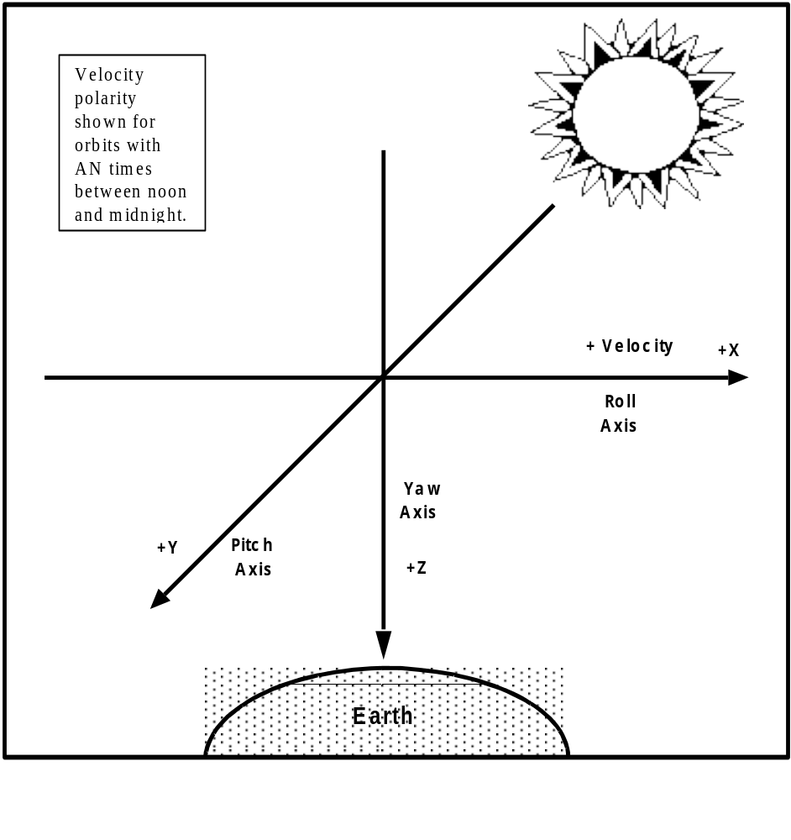

Figure 3.2.4.2.2. Coordinate Axes

3.2.4.2.3 Physical Interface
The responsibility for providing interface hardware shall be as shown below.

HARDWARE PROVIDER
Standard mounting hardware (e.g., std. fasteners) Spacecraft
Special mounting hardware (instrument-unique) Instrument
Mounts (e.g., kinematic, flexure, etc.) Instrument
Optically aligned component drill template Instrument
Non-optically aligned component drill template Instrument
Instrument optical alignment target /cube and cover Instrument
Holding and lifting fixtures Instrument
Test and alignment hardware Instrument
GSE – special, electrical and mechanical Instrument
GSE – general, electrical and mechanical Spacecraft
Shipping containers Instrument

3.2.4.2.3.1 Stowed and Critical Clearances
Both the spacecraft contractor and the instrument contractor must work together to insure that the stowed, deploying, and final deployed positions of the instrument will clear all obstacles, including obstacles on the spacecraft, other instruments, and the launch vehicle.
GIID3.2.4.2.3.1-1
The spacecraft contractor shall define and maintain the available instrument volume, making sure the instruments fit within the dynamic envelope of launch vehicle’s fairing.
GIID3.2.4.2.3.1-2
Instrument components in all configurations shall be contained within the instrument envelopes as allocated within the UIID, but different envelopes may be defined for launch configuration, on-orbit (deployed) configuration, and during deployment .

The defined not-to-exceed envelope includes, but is not limited to, the basic instrument structure, instrument-unique mounts (including kinematic mounts, where used), instrument-unique mounting hardware, mounting feet, thermal blankets, connectors (instrument-side only), and intra-instrument harness (with connectors), as well as any other items that constitute any part of a deliverable instrument.

The intent of this requirement is that everything provided as part of a deliverable instrument, including the items identified above, be allocated against the instrument size, weight, and power allocations, and that everything provided by the spacecraft contractor be held against the spacecraft allocation.
GIID3.2.4.2.3.1-3
The spacecraft contractor shall lay out the instruments on the spacecraft so as to maintain adequate clearance between the instrument and surrounding structures, in order to provide access to instrument mounting hardware, access to instrument connectors, and space for instrument interfacing harness service loops.
GIID3.2.4.2.3.1-4
The spacecraft contractor shall conduct an analysis to ensure critical instrument-to-spacecraft, and critical instrument to fairing clearances are not violated.

3.2.4.2.3.1.1 Instrument Envelope Documentation
GIID3.2.4.2.3.1.1-1
The instrument contractor shall provide to the spacecraft contractor information on the instrument subsystem envelope (including thermal blankets, instrument connectors, mounting feet, instrument-supplied harnesses, and unique mounts) for documentation in the UIID. Documentation is to be in the form of engineering drawings with a set of “not to exceed” dimensions for the launch, deployed on-orbit, and installation envelopes.

The instrument installation envelope is defined as the volume of the instrument including the attached lifting sling.

GIID3.2.4.2.3.1.1-2
The instrument contractor shall ensure that the “swept” or deployed volume is verified, accounting for all distortions and misalignments.
GIID3.2.4.2.3.1.1-3
All instrument fields of view, including, where applicable, optical, glint, thermal cryo-radiator, electronics radiator, and solar diffuser fields of view, shall be documented in the UIID.
GIID3.2.4.2.3.1.1-4
The instrument contractor shall provide, for documentation in the UIID, information on field-of-view-related issues such as clearances, multi-path tolerances, indirect effects such as glint and allowable secondary radiation, and percent interference allowed.

3.2.4.2.3.2 Mounting Provisions

3.2.4.2.3.2.1 Mounting Method
GIID3.2.4.2.3.2.1-1
The mounting method shall accommodate manufacturing tolerance, structural distortion, thermal distortions, and alignment requirements.
GIID3.2.4.2.3.2.1-2
The instrument contractor shall comply with the mounting specification in the UIID.
GIID3.2.4.2.3.2.1-3
The instrument mounting method shall not require access from inside the spacecraft.
GIID3.2.4.2.3.2.1-4
Specific requirements for provision for pinning the instrument in place shall be documented in the UIID.

3.2.4.2.3.2.2 Mounting Interface

3.2.4.2.3.2.2.1 Mounting Interface Documentation
GIID3.2.4.2.3.2.2.1-1
The spacecraft mounting interface requirements for each separately-mountable instrument component shall be as defined in the UIID.

3.2.4.2.3.2.2.2 Mounting Hole Coordinates and Dimensions
GIID3.2.4.2.3.2.2.2-1
The instrument contractor shall comply with the coordinates and dimensions of the holes for mounting hardware as specified at the mechanical interface and defined in the UIID.

3.2.4.2.3.2.3 Drill Templates

3.2.4.2.3.2.3.1 Drill Template Usage
GIID3.2.4.2.3.2.3.1-1
If drill templates are used, then instrument equipment, spacecraft, and test fixture interfaces shall be drilled using the same drill templates.

3.2.4.2.3.2.3.2 Drill Template Fabrication Requirements
GIID3.2.4.2.3.2.3.2-1
The following requirements shall apply to drill template fabrication by the instrument contractor:
a. Aluminum plate with nominal thickness of 12.7 mm.
CH-1
b. Steel slip-fit drill bushings for drilling both sides of the interface in all mounting holes.
c. Surface flatness to be better than 1.00 mm (TBR) peak-to-peak.
CH-1
d. Surface finish to be better than 3.2 micrometers (TBR) root mean square (RMS).
e. Marked with the Spacecraft reference coordinate frame, marked to indicate proper template orientation, and marked to indicate which side is used for Spacecraft or Instrument drilling.
f. Drill templates for each component which requires alignment shall include an optical alignment target or cube bonded to the template.
If the instrument precision alignment is dependent on the alignment of the drill template, then there are two alignment budget allocations: 1) drill template alignment target or cube to instrument alignment target or cube when drilling the instrument; and 2) drill template alignment target or cube to spacecraft alignment or cube
g. Drill templates for components which do not requirement alignment shall not exceed the Instrument foot print.
h. Provided in a suitable, clean room compatible container which will contain all related hardware.

3.2.4.2.3.2.3.3 Drill Template Provider
GIID3.2.4.2.3.2.3.3-1
The instrument contractor shall provide the spacecraft contractor with the drill template containing appropriate alignment, orientation, and location reference information.
CH-1

3.2.4.2.3.2.4 Mounting Hardware

3.2.4.2.3.2.4.1 Mounting Hardware Provider
GIID3.2.4.2.3.2.4.1-1
The instrument contractor shall provide all unique instrument mounting hardware (e.g., bolts, washers, etc. which have limited-off-the-shelf availability or require a special fabrication lot).
GIID3.2.4.2.3.2.4.1-2
The spacecraft contractor shall provide all standard instrument mounting hardware (e.g., bolts, washers, etc. which are procurable off-the-shelf from multiple hardware vendors).
GIID3.2.4.2.3.2.4.1-3
Mounting bolts shall be per NASM 1515

3.2.4.2.3.2.4.2 Mounting Hardware Documentation
GIID3.2.4.2.3.2.4.2-1
Instrument mounting hardware shall be defined and documented in the UIID, including indication of the source of the hardware (spacecraft or instrument).

Mounting Hardware Delivery
GIID3.2.4.2.3.2.4.3-1
Delivery of mounting hardware with the instrument shall be accomplished with each separately-mounted or attached element to be separately kitted.
GIID3.2.4.2.3.2.4.3-2
Each unique hardware type or size shall be separately packaged and clearly identified with its relationship to the instrumenttop assembly drawing.

3.2.4.2.3.2.4.4 Mounting Surface Requirements
GIID3.2.4.2.3.2.4.4-1
Finish requirements for the mounting surfaces shall be specified by the spacecraft contractor and documented in the UIID.
GIID3.2.4.2.3.2.4.4-2
The spacecraft mounting surface shall be flat to less than 0.83 mm/meter peak to peak.

Flatness is a tolerance, defined by two parallel planes, within which the surface must lie.
GIID3.2.4.2.3.2.4.4-3
The instrument mounting surface flatness shall be as documented in the UIID.
GIID3.2.4.2.3.2.4.4-4
The Spacecraft mounting surface planarity shall be as documented in the UIID.
GIID3.2.4.2.3.2.4.4-5
The instrument mounting surface planarity shall be as documented in the UIID.

3.2.4.2.3.2.5 Mounting Location and Documentation
GIID3.2.4.2.3.2.5-1
The instrument contractor shall support the spacecraft contractor in determining the location of the instrument on the spacecraft.
GIID3.2.4.2.3.2.5-2
The instrument contractor shall provide necessary mounting information to the spacecraft contractor for documentation in the UIID.
GIID3.2.4.2.3.2.5-3
The instrument mounting location shall be documented in the UIID.

3.2.4.2.3.2.6 Special Mounts

GIID3.2.4.2.3.2.6-1
Instrument components shall be mounted using kinematic mounts unless the instrument contractor demonstrates that kinematic mounts are not required.
GIID3.2.4.2.3.2.6-2
The instrument contractor shall provide all kinematic mounts (where used) including those required for the EDU and Ground Support Equipment (GSE).
GIID3.2.4.2.3.2.6-3
The instrument shall be delivered to the spacecraft contractor with the flight kinematic mount installed.

3.2.4.2.3.3 Alignment

3.2.4.2.3.3.1 Alignment Responsibilities
GIID3.2.4.2.3.3.1-1

The angle between the instrument boresight and the drill template mechanical data shall be provided to the spacecraft contractor 6 months prior to the delivery of the instrument
GIID3.2.4.2.3.3.1-2
The spacecraft contractor shall align the instrument to the spacecraft attitude reference.
GIID3.2.4.2.3.3.1-3
The UIID shall contain specific requirements for oversized holes on the instrument side of the instrument mounting interface, necessary for rotational alignment in the mounting plane.
GIID3.2.4.2.3.3.1-4
The spacecraft contractor shall provide shims as required, up to a thickness of 2.5 mm, to attain the required alignment where rotation out of the mounting plane is required.
GIID3.2.4.2.3.3.1-5
The instrument contractor shall allocate for the spacecraft, in the instrument performance budget, no less than 25 arcseconds instrument baseplate to spacecraft frame of reference, not including the uncertainty between the instrument alignment cube and the instrument baseplate (which remains part of the instrument allocation).

3.2.4.2.3.3.2 Alignment References
GIID3.2.4.2.3.3.2-1
The instrument contractor shall provide an instrument alignment reference, composed of an alignment target or cube with relational boresight and a mounting surface datum.
GIID3.2.4.2.3.3.2-2
All pointing uncertainties between the instrument alilgnment reference, its boresight, and its mounting interface, including all life cycle effects (thermal distortion, vibration, etc.) shall be a part of the instrument performance budget.
GIID3.2.4.2.3.3.2-3
The spacecraft shall provide a spacecraft alignment reference.
GIID3.2.4.2.3.3.2-4
The spacecraft shall use the attitude reference frame to determine satellite pointing.
GIID3.2.4.2.3.3.2-5
The instrument alignment target or cube shall be viewable from two orthogonal directions.
GIID3.2.4.2.3.3.2-6
The type, location, and orientation of instrument alignment targets or cubes shall be mutually agreed upon between the instrument contractor and the spacecraft contractor, and documented in the UIID.
GIID3.2.4.2.3.3.2-7
The instrument contractor shall provide, for specification in the UIID, the pointing accuracy, knowledge and stability requirements as 3-sigma values required at the instrument alignment target or cube with respect to the spacecraft alignment reference.
GIID3.2.4.2.3.3.2-8
Optical targets or cubes shall have a per-face surface area of at least 360 mm2.
GIID3.2.4.2.3.3.2-9
The mounting surface and at least two viewing surfaces of the optical alignment target or cube shall be orthogonal to within ± 1 Arc Second (arcsec).
GIID3.2.4.2.3.3.2-10
All optical targets or cubes shall have a minimum reflectance of 80%, surface figure of ¼ wave peak value at 0.63 microns, and a surface quality of 80/50 scratch/dig or better.
GIID3.2.4.2.3.3.2-11
Each optical target or cube shall be covered with a flight quality (and flight capable) cover, provided by the instrument contractor, meeting the following provisions:
a) cover must be removable during Integration and Test
b) cover must provide protection against optical reflections, on-orbit, onto any light-sensitive surface
c) cover must provide restraint against loose pieces, if the cube is bonded in place and comes loose

3.2.4.2.3.3.3 Alignment Control
Alignment control is the error between the actual orientation of the instrument and the desired orientation of the instrument.

GIID3.2.4.2.3.3.3-1
Using the instrument alignment reference and data provided by the instrument contractor, the spacecraft contractor shall control the initial placement of the instrument “boresight” with respect to the spacecraft attitude reference to within 0.25 degrees (3 sigma) per axis (not including alignment uncertainties between the instrument boresite and the instrument alignment reference).

3.2.4.2.3.3.4 Alignment Knowledge
Alignment knowledge is the difference between the actual orientation of the instrument and the estimated orientation of the instrument. This difference is the result of uncertainties and shifts.

3.2.4.2.3.3.4.1 Measurement Uncertainty
GIID3.2.4.2.3.3.4.1-1
The spacecraft contractor shall measure the alignment between the instrument alignment reference and the spacecraft attitude reference.

GIID3.2.4.2.3.3.4.1-2
The root mean square (RMS) uncertainty, from all sources, in the knowledge of the alignment between the spacecraft attitude reference and the instrument alignment reference shall be less than 25 (TBR) arcsec per axis, as required to meet EDR performance. This uncertainty shall include (if applicable), but not be limited to, measurement uncertainties, alignment shifts due to vibration environments in both ground processing and launch, uncompensated gravity effects, hygroscopic effects of composite materials, and component removal and replacement.
GIID3.2.4.2.3.3.4.1-3
All delivered instruments shall, using the same drill template, have instrument cube-to-boresight and instrument cube-to-baseplate (as measured to the drill template alignment cube) alignment variation from unit to unit of less than 30 (TBR) arc seconds.

3.2.4.2.3.3.4.2 On-orbit Stability
Not all instruments require precise alignment or alignment knowledge to the spacecraft reference frame. For those which do require such precision, the general requirement is given below. The UIID will indicate how the requirement applies to a given instrument.

GIID3.2.4.2.3.3.4.2-1
The spacecraft contractor shall limit the RMS uncertainty in the alignment between the instrument mechanical interface with the spacecraft and the spacecraft attitude reference cube, caused by all on-orbit cyclic distortions, to be less than 10 arcsec per axis, unless indicated otherwise in the UIID.

3.2.4.2.3.3.5 Spacecraft Attitude Reference

3.2.4.2.3.3.5.1 Attitude Reference Knowledge
GIID3.2.4.2.3.3.5.1-1
The spacecraft shall supply a three-axis attitude of the spacecraft attitude reference for ground processing.

GIID3.2.4.2.3.3.5.1-2
The spacecraft-supplied attitude shall be time-tagged and possess an angular RMS accuracy per axis of 10 (TBR) arcsec over a bandwidth of 0 to 10 Hz (TBR) .

3.2.4.2.3.3.5.2 High Frequency Attitude Reference Errors
GIID3.2.4.2.3.3.5.2-1
The RMS of all components of the attitude error of the spacecraft attitude reference with a frequency greater than 10 Hz (TBR) shall be less than 5 (TBR) arcsec per axis.

3.2.4.2.3.3.5.3 Attitude Reference Control
GIID3.2.4.2.3.3.5.3-1
The RMS of the attitude reference control error over a bandwidth of 0 to 10 Hz (TBR) shall be less than 0.01 deg per axis.

3.2.4.2.3.3.5.4 Attitude Reference Rate Error
GIID3.2.4.2.3.3.5.4-1
The rate error of the attitude reference frame shall be less than 0.03 deg/sec during all mission data collection periods.

3.2.4.2.3.3.6 Position Knowledge
GIID3.2.4.2.3.3.6-1
The spacecraft shall provide a spacecraft position estimate with an RMS uncertainty of 25/25/25 meters for radial/in-track/cross-track components.

3.2.4.2.3.4 Structural Support
GIID3.2.4.2.3.4-1
The spacecraft shall provide structural support for the instruments such that the loads transmitted across the interface into the instruments do not exceed the interface limit loads determined by the spacecraft contractor.
GIID3.2.4.2.3.4-2
The instrument and interface equipment shall be designed to meet the design load factors (a function of launch vehicle acceleration levels) specified in the UIID.

3.2.4.2.3.5 Instrument Structural Dynamics

Refer to section 3.3.12.3.3 for detailed instrument structural dynamics requirements.

3.2.4.3 Power

3.2.4.3.1 Power Bus Requirements

3.2.4.3.1.1 Electrical Interface Definitions
Electrical Interface Location:
All requirements apply at the electrical interface, which is at the instrument end of the instrument-to-spacecraft bus harness connector mating surfaces.

Operational Power:
Operational power is used for instrument operational modes such as Science Data Collection, Calibration, and Standby.

Peak Operational Power:
Peak power is the maximum power required by an instrument. Peak power does not include transients with a duration less than 20 milliseconds.

Average Operational Power:
The one-orbit average power is the average power utilized by an instrument over any one-orbit period commencing with the crossing of the night-to-day terminator. The two-orbit average power is the average power utilized by an instrument over any two-orbit period commencing with the crossing of the night-to-day terminator.

Survival-Mode Power:
Survival-mode power is power required by the instrument in Survival Mode, in order to operate survival heaters.

Safe-Mode Power:
Safe-mode power is the power required by the instrument in instrument safe mode.

Launch-Phase Power:
Launch-phase power is the power required by the instrument in launch phase.

1394 Power
1394 power is the power required by the 1394 data bus physical layer.

3.2.4.3.1.2 Power Allocation
This section specifies the characteristics, connections, and control of the Spacecraft power provided to the instrument and requirements at this interface.

3.2.4.3.1.2.1 Instrument Power Allocations
GIID3.2.4.3.1.2.1-1
The Spacecraft shall provide suitable power harnesses to support the allocated power levels specified at the instrument interface.

3.2.4.3.1.2.1.1 Operational Power Allocation
GIID3.2.4.3.1.2.1.1-1
The instrument power consumed in operational modes shall be less than or equal to the average and peak worst case life cycle operational power levels allocated in the UIID.

3.2.4.3.1.2.1.2 Survival Power Allocation
GIID3.2.4.3.1.2.1.2-1
The instrument power consumed in survival mode shall be less than or equal to the worst case life cycle survival power allocated in the UIID.

3.2.4.3.1.2.1.3 Launch-phase Power Allocation
GIID3.2.4.3.1.2.1.3-1
The instrument power consumed in launch phase shall be less than or equal to the launch-phase power allocated in the UIID.

3.2.4.3.1.2.1.4 Power Interface Allocation
GIID3.2.4.3.1.2.1.4-1
The number of power interfaces used by an instrument shall be consistent with the number allocated in the UIID.

GIID3.2.4.3.1.2.1.4-2
Power Bus connections and power profiles for all instrument modes shall be provided by the instrument contractor and documented in the UIID.

GIID3.2.4.3.1.2.1.4-3
If the instrument power requirements vary as a function of orbit position, that duty cycle shall be supplied by the instrument contractor and documented in the UIID.

3.2.4.3.1.2.1.5 1394 Power Allocation
GIID3.2.4.3.1.2.1.5-1
1394 power consumed shall be as specified in the IEEE1394 specification, as tailored by the NPOESS IPO Interface Specification for the 1394 Data Bus.

3.2.4.3.1.3 Power Control

3.2.4.3.1.3.1 Power Connections
GIID3.2.4.3.1.3.1-1
Four supply circuits types shall be provided by the spacecraft, with specific allocations by instrument listed in the UIID:
a) A 0-5 ampere (low power bus) steady-state power connection made through an appropriately-sized overcurrent protection device and relay switch, both on the spacecraft side of the interface
b) A 5-20 ampere (high power bus) steady-state power connection made through an appropriately-sized overcurrent protection device and relay switch, both on the spacecraft side of the interface
c) A power connection (survival heater bus) made through an appropriately-sized overcurrent protection device and a relay switch, both on the spacecraft side of the interface
d) A bus (safety bus) to supply power for safety-related functions such as explosive bolts, thermal release mechanisms, etc.

Power for the 1394 interface is described in the NPOESS Interface Specification for the 1394 Data Bus, called out in the Command and Data Handling portion of this GIID.

Note: Other than current carrying capacity, there is no required difference between items a) and b) above. As such, they could both be derived from the same source.

GIID3.2.4.3.1.3.1-2
Each power interface shall consist of redundant two (isolated) power feeds routed via two separate connectors. These connections are designated as power feeds A and B.

GIID3.2.4.3.1.3.1-3
The nominal and maximum load currents for each power interface line, for each instrument mode, shall be provided by the instrument contractor and documented in the UIID.

GIID3.2.4.3.1.3.1-4
The state of primary and redundant power supply during normal operations shall be identified in the instrument telemetry.

If the power configuration is totally under the control of the spacecraft, no additional power status telemetry is needed from the instrument.

3.2.4.3.1.4 Power Application
GIID3.2.4.3.1.4-1
In the absence of a fault (hardware, software, or operator) on either power feed (i.e., an open fuse), the spacecraft shall apply power to neither operational power feed (instrument OFF) or a single operational power feed (instrument ON), but never to both operational power power feeds simultaneously.

3.2.4.3.1.4.1 Power Fault Tolerance
GIID3.2.4.3.1.4.1-1
The instrument and spacecraft shall not propogate a single fault occurring on either the A or B power interface circuit, on either side of the interface, to the redundant interface or instrument.

3.2.4.3.1.4.2 Instrument Heater Power Separation
GIID3.2.4.3.1.4.2-1
Instrument survival heaters and operational heaters shall be separate and distinct, using separate electrical control, operating independently of each other.

3.2.4.3.1.4.3 Instrument Internal Power
GIID3.2.4.3.1.4.3-1
Usage and distribution of primary power shall be compatible with system and subsystem Electromagnetic Compatibility (EMC) and magnetic field performance requirements.

GIID3.2.4.3.1.4.3-2
Secondary power distribution to power components shall be compatible with system and subsystem EMC performance requirements.

3.2.4.3.1.4.4 Instrument External (Spacecraft) Power
GIID3.2.4.3.1.4.4-1
Instruments shall be designed to operate from a 28 +6, -6 volt dc, negative ground, unregulated power subsystem.

GIID3.2.4.3.1.4.4-2
The spacecraft shall be able to remove bus power to all instruments if the spacecraft power system indicates an emergency energy imbalance. This (removal of power) will not apply to survival heaters unless survival of the spacecraft is at stake.

GIID3.2.4.3.1.4.4-3
All instrument components shall remain undamaged when subjected to gradual ramp up (as low as 1 volt per minute) of voltage in the range from 0-22 Volts, for a duration not exceeding 10 (TBR) seconds.

3.2.4.3.1.5 Electrical Power Interface Requirements

3.2.4.3.1.5.1 Ripple

3.2.4.3.1.5.1.1 Voltage Ripple
GIID3.2.4.3.1.5.1.1-1
Under nominal conditions (no fault clearing), the spacecraft power source-generated ripple, including repetitive spikes, shall not exceed 1.0 volts peak-to-peak as measured over the bandwidth of 30 Hz to 1.0 kHz, and 0.5 volts peak-to-peak from 1.0 kHz to 10 MHz.

GIID3.2.4.3.1.5.1.1-2
Under nominal conditions (no fault clearing), the differential instrument-induced ripple, as seen at the instrument, between the power and return lines on the operational power buses (not the survival heater bus), including repetitive spikes, shall not exceed 1.0 volts peak-to-peak as measured over the bandwidth of 30 Hz to 1.0 kHz, and 0.5 volts peak-to-peak from 1.0 kHz to 10 MHz when the power system is delivering the maximum rated current into the instrument, and the power-to-return-line impedance is as specified in this GIID.

3.2.4.3.1.5.1.2 Reflected Ripple
GIID3.2.4.3.1.5.1.2-1
Instruments shall not produce reflected ripple greater than the limits of MIL-STD-461E, CE101 (Figure CE101-4, curve #1), and CE102. CE101 and CE102 maximum levels apply to loads that are 15 amps/450 watts and greater.

GIID3.2.4.3.1.5.1.2-2
The maximum conducted emissions, CE101 and CE102, shall be reduced by 1 dB microampere or 1 dB microvolt for each db ampere reduction in the average load current below 15 amperes. Measurements shall be made at the instrument interface.

3.2.4.3.1.5.2 Transients

3.2.4.3.1.5.2.1 Voltage Transients
GIID3.2.4.3.1.5.2.1-1
Positive and negative voltage surges from the spacecraft shall decay to within steady state limits in less than 5 and 100 milliseconds, respectively.

GIID3.2.4.3.1.5.2.1-2
All instrument components shall remain undamaged when subjected to step changes of the input voltage from 0 % to 140 % and from 125 % to 0 % of the nominal load voltage (28 volts). The step changes, exclusive of spikes, are the instantaneous surge amplitudes produced by load switching and the clearing of faults on the space-vehicle power bus.

3.2.4.3.1.5.2.2 Current Transients
GIID3.2.4.3.1.5.2.2-1
The instrument shall not generate net negative back current into the spacecraft during any operating mode.
GIID3.2.4.3.1.5.2.2-2
When the spacecraft removes power from the instrument, the spacecraft shall not be required to discharge the power bus at the instrument

3.2.4.3.1.5.2.2.1 Instrument Turn-on Transients
Instruments which exceed 4-times steady state current for >10 microseconds during turn-on, may be subject to current ramping by the spacecraft during turn-on.

GIID3.2.4.3.1.5.2.2.1-1
The instrument shall limit turn-on inrush current transient rate of change to no more than 50 mA per microsecond.

GIID3.2.4.3.1.5.2.2.1-2
Inrush current on the 0-5 ampere power bus, at initial power application to the instrument via relay closure in the spacecraft, shall be limited by the instrument to no more than 4-times the maximum steady-state current, defined as when the instrument is operational.

GIID3.2.4.3.1.5.2.2.1-3
The instrument design shall be such that the inrush current on the low-current bus, at initial power application to the instrument via relay closure in the spacecraft, shall decay to within 10% of the maximum steady-state current in less than 3 milliseconds.

GIID3.2.4.3.1.5.2.2.1-4
Current drawn on the low-current bus for events after the instrument has been powered ON, shall be limited by the instrument to be no more than 4-times the maximum steady-state current.

GIID3.2.4.3.1.5.2.2.1-5
Current drawn on the low-current bus for events after the instrument has been powered ON, shall be controlled by the instrument to decay to less than 2% of the maximum steady-state current in less than 100 milliseconds.

GIID3.2.4.3.1.5.2.2.1-6
Inrush current on the 5-20 ampere power bus, at initial power application to the instrument via relay closure in the spacecraft, shall be limited by the instrument to be no more than 4-times the maximum steady-state current.

GIID3.2.4.3.1.5.2.2.1-7
The instrument design shall be such that the inrush current on the high-current bus, at initial power application to the instrument via relay closure in the spacecraft, shall decay to within 10% of the maximum steady-state current in less than 3 milliseconds.

GIID3.2.4.3.1.5.2.2.1-8
Current drawn on the high-current bus for events after the instrument has been powered ON, shall be limited by the instrument to be no more than 4-times the maximum steady-state current.

GIID3.2.4.3.1.5.2.2.1-9
Current drawn on the high-current bus for events after the instrument has been powered ON, shall be controlled by the instrument to decay to within 10% of the maximum steady-state current in less than 20 milliseconds.

3.2.4.3.1.5.2.2.2 Instrument Turn-off Transients

GIID3.2.4.3.1.5.2.2.2-1
All instruments shall use suppression devices, such as diodes, located at the source of the inductive transient, across all filter inductors, relay coils, or other energy sources, which could induce transients on the power lines during turn-off.

GIID3.2.4.3.1.5.2.2.2-2
The instrument shall limit the absolute range of peak voltage of transients generated on the instrument side of the power relay caused by inductive effects of the load to the range of -2 Vdc to +45 Vdc differentially between power and return.

3.2.4.3.1.5.2.2.3 Instrument Operational Transients
GIID3.2.4.3.1.5.2.2.3-1
Operational transients that occur after initial turn-on shall be limited by the instrument so as not exceed 125 (TBR) percent of the peak operational current drawn during normal operation. Predicted typical transient waveforms shall be provided for documentation in the UIID.

GIID3.2.4.3.1.5.2.2.3-2
The maximum duration of the operational transients shall be controlled by the instrument so as not exceed 100 microseconds.

GIID3.2.4.3.1.5.2.2.3-3
During normal operations the instrument shall limit current transient rate of change to no greater than 20 milliamps per microsecond.

3.2.4.3.1.5.3 Abnormal Operation Voltage Limits
GIID3.2.4.3.1.5.3-1
Under abnormal conditions the instrument shall survive, without permanent degradation, overvoltages as follows:

- Twice main peak bus voltage for 10 microseconds
- 50 volts for 2 milliseconds

This voltage and duration is intended to reflect conditions which could exist on the 28 volt bus as the result of a failure and switchover to the redundant side of a spacecraft power system component.:

3.2.4.3.1.5.4 Impedance
GIID3.2.4.3.1.5.4-1
The spacecraft design shall be such that the power bus impedance at the interface between the instrument and the spacecraft harness, looking back at the spacecraft source, shall be less than 200 milliohms from 10 Hz to 250 kHz, and 500 milliohms from 250 kHz to 1MHz (including all switching and circuit protection.
GIID3.2.4.3.1.5.4-2
The input filter of the instrument shall have a Q < 2 below 2kHz, and impedance as documented in the UIID.

3.2.4.3.1.5.5 Survival Heater Bus
GIID3.2.4.3.1.5.5-1
The spacecraft shall provide to the instruments power for survival heaters, meeting the same voltage range requirements as the main 28 volt bus.

GIID3.2.4.3.1.5.5-2
Instrument design shall be such that having both primary and redundant survival heater circuits enabled does not violate any thermal or power requirement.

GIID3.2.4.3.1.5.5-3
Survival power shall be used within the instrument only for resistive heaters (and associated thermal control device) which maintain the instrument at minimum turn-on temperature when the main power bus is disconnected from the instrument.

Note: ‘minimum turn-on’ refers to the temperature at which the instrument can be sustained indefinitely without degradation in performance, once operational power has been restored and a turn-on sequence followed. The initial application of operational power by the spacecraft (turn-on) can be made at this ‘minimum turn-on’ temperature. Restoration of full operational status will likely involve a sequence of events following that initial turn-on, and may involve intermediate temperature constraints which must be observed.

GIID3.2.4.3.1.5.5-4
Survival power required by the instrument shall be no more than 30% (TBR) of the lowest-power operational mode). The “30%” relates to the average power consumed over a 15 minute period.

GIID3.2.4.3.1.5.5-5
The instrument contractor shall identify (for documentation in the UIID) if more than 2 circuits are required (1 primary and 1 redundant).

GIID3.2.4.3.1.5.5-6

The instrument shall provide thermal control of the survival heaters which is single-fault tolerant against both excessive and insufficient application of heat, and document the extent of the redundancy in the UIID.

The thermal control arrangement is intended to protect the spacecraft from excessive current drain from the instrument if the control fails ON, and to protect the instrument from becoming too cold if the control fails OFF. Whether parallel redundancy, series redundancy, or both is needed depends on the current drain, allowable instrument temperatures, and other factors.

GIID3.2.4.3.1.5.5-7
Survival heater circuit impedance shall be documented in the UIID.

GIID3.2.4.3.1.5.5-8
The survival heaters shall be functionally redundant.

GIID3.2.4.3.1.5.5-9
Survival heater power buses shall be electrically isolated from each other, from other instrument thermal control, from chassis, and shall have independent power returns.

GIID3.2.4.3.1.5.5-10
The spacecraft shall ensure that both the primary and redundant survival heater circuits are normally enabled on-orbit when an instrument is off. However, even the survival heaters may be turned off in the event of an emergency where the survival of the spacecraft is in jeopardy.

3.2.4.3.1.5.6 Safety Bus Operation
The spacecraft will turn on the safety bus during those periods where it is intended to be used for safety critical activities. The primary and redundant safety bus power may or may not be on at the same time, depending on spacecraft operations.
GIID3.2.4.3.1.5.6-1
The instrument design shall not rely on presence of the Safety Bus at any time other than for initial activation of safety-critical items.

3.2.4.3.1.5.7 Overcurrent Protection Device Size
GIID3.2.4.3.1.5.7-1
The sizes of the overcurrent protection devices for each instrument shall be established per an agreement between the spacecraft contractor and the instrument contractor, and documented in the UIID. Turn-on, operational, and turn-off transients shall be considered in the analysis.
GIID3.2.4.3.1.5.7-2
Harness wire sizes shall be consistent with overcurrent protection device sizes.

GIID3.2.4.3.1.5.7-3
Spacecraft power supply output capability shall be adequate to clear the selected size fuse in addition to providing full rated load to the satellite.

GIID3.2.4.3.1.5.7-4

Instruments shall not contain fuses.

GIID3.2.4.3.1.5.7-5
Capability shall be provided by the instrument for external override (reset) of any non-fuse overcurrent protection device (such as electronic circuit breakers) within the instrument.
GIID3.2.4.3.1.5.7-6
The inswtrument design shall be such that twice the maximum transient current load can be sustained for 200 ms without propagating damage to the redundant portion of the instrument.

3.2.4.3.1.6 Unannounced Removal of Power
GIID3.2.4.3.1.6-1
Excluding the thermal effects of removing instrument power, unannounced removal of power shall not cause damage or degraded performance (following re-application of power) to the instrument.

The exclusion refers specifically to the fact that unannounced removal of ALL power (operational and survival) for an indefinite period could have permanent detrimental thermal effects.

3.2.4.3.1.7 Instrument High-Voltage Restriction
GIID3.2.4.3.1.7-1
To allow ambient testing, instrument high-voltage supplies shall be capable of being operated at atmospheric pressure.
GIID3.2.4.3.1.7-2
The output of each instrument's high-voltage supply shall be current limited to prevent the spacecraft and other instruments from being damaged by the supply's discharge.

GIID3.2.4.3.1.7-3
If an instrument high-voltage supply cannot be operated at atmospheric pressure, it shall be appropriately disabled by manual means to allow ambient testing.

GIID3.2.4.3.1.7-4

Instruments high-voltage restrictions shall be specified in the UIID.

3.2.4.3.2 Grounds, Returns, and References
The following terms are defined to facilitate specification of the ground, return, reference and bonding requirements.

Bond: A low-impedance electrical connection between two conductive elements.

Chassis Reference: The point within a component at which signal reference and secondary power return leads are referenced to the instrument chassis.

Instrument Chassis: The metal enclosure which shields the instrument’s electronics.

Instrument Chassis Ground Terminal: External connection to the instrument’s chassis reference.

Isolated Secondary Power: Isolated secondary power is power derived from another power source whose loads of which are completely isolated from instrument to Spacecraft interface electronics.
Prime Power Reference: The point on the Spacecraft where all primary power returns are referenced. The Prime Power Reference is the reference point for Spacecraft voltage control.

Primary Power Return: The isolated return lead from the primary side of the instrument power dc-to-dc converter back to the Spacecraft power distribution point.

Secondary Power: Power which has been derived and isolated from primary power by a dc-to-dc converter or other means and used to power Spacecraft interface circuits.

Secondary Power Reference: The point within the instrument where all current returns from the secondary power (except isolated secondary power) circuits are referenced.

Signal Reference: The reference within the instrument for digital and analog signals.

Signal Reference Ground: The Spacecraft conducting plate or other structure to which all ground interconnections are connected.

Signal Return: The wire which carries the current of a digital or analog signal back to its source.

3.2.4.3.2.1 Grounding Responsibility
GIID3.2.4.3.2.1-1
Figure 3.2.4.3.2.1 shows the grounding scheme which shall be used on the spacecraft and within the instrument.

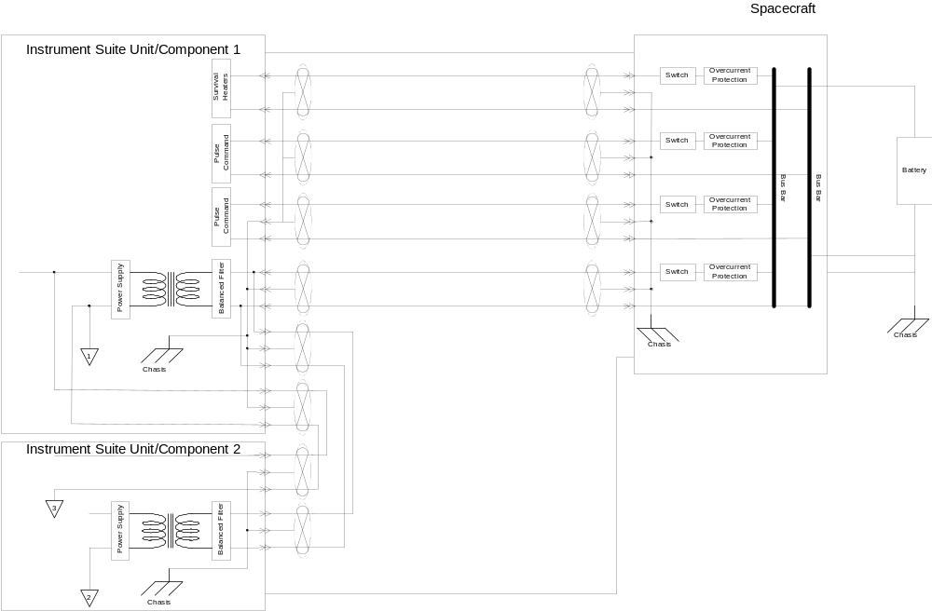

Figure 3.2.4.3.2.1. Spacecraft Grounding Scheme

3.2.4.3.2.2 General
GIID3.2.4.3.2.2-1
Instrument pulse command returns shall be referenced as described in the pulse command section of this GIID (section 3.2.4.8).
GIID3.2.4.3.2.2-2
Instrument passive analog telemetry returns shall be isolated from all other grounds within the instrument by greater than 1 megohm.
Note: the passive analog telemetry returns will be referenced appropriately on the spacecraft, but are to be isolated, as required above, within the instrument itself.
GIID3.2.4.3.2.2-3
Bilevel telemetry returns shall be referenced as described in the point-to-point telemetry section of this GIID (section 3.2.4.8).

3.2.4.3.2.3 Power Returns
GIID3.2.4.3.2.3-1
Each instrument primary power lead shall have a distinct, separate, and isolated return. Power on feed A shall be returned only on return A, and power on feed B shall be returned only on return B.
GIID3.2.4.3.2.3-2
Prime power and return shall be isolated ,within the instrument, from the instrument chassis and structure by more than 1 Meg-ohm.
GIID3.2.4.3.2.3-3
The prime power return shall be tied to the vehicle single-point ground by the spacecraft contractor.
The single-point ground is the spacecraft conducting plate or other structure to which all ground planes are connected.
GIID3.2.4.3.2.3-4
The Spacecraft shall connect all power returns to the Signal Reference Plane only at the Spacecraft Primary Power Reference Point. (See Figure 3.2.4.3.2.1).
GIID3.2.4.3.2.3-5
Secondary power circuits, between components of an instrument suite, shall provide current return leads from each instrument component which utilizes secondary power to the secondary power converter using shielded twisted pair wire. These secondary power returns shall be connected at a single point referred to as the Instrument Secondary Power Reference.
GIID3.2.4.3.2.3-6
The instrument shall bond the Secondary Power Reference to the chassis reference.
GIID3.2.4.3.2.3-7
If isolated secondary power is used within the instrument, the isolated returns
shall not be left floating. In this instance isolated returns shall be referenced to chassis ground through a resistive impedance, the value of which shall be selected by the instrument contractor, but which shall be less than (TBS).
GIID3.2.4.3.2.3-8
The instrument shall provide the capability to form a low impedance electrical path (a bond) between the power conductor shield and the instrument chassis via the connector shell at the instrument primary power input.

3.2.4.3.2.4 Signal Reference
GIID3.2.4.3.2.4-1
The instrument shall be designed such that the Secondary Power Reference and the signal reference for Spacecraft interface circuits are electrically the same point, except for the 1394 and 1553 data buses.

GIID3.2.4.3.2.4-2
All instrument signal references for the spacecraft interface circuits shall be electrically connected within the instrument.
GIID3.2.4.3.2.4-3
Signal ground shall not be used as a power conductor.
GIID3.2.4.3.2.4-4
The spacecraft contractor shall electrically connect the instrument ground interconnection to the spacecraft single-point ground.
GIID3.2.4.3.2.4-5

For differential receivers, the instrument shall provide a balanced impedance of between 3 and 10 kilohms to signal reference ground. This connectivity should be AC isolated, but must provide adequate high frequency coupling to meet EMI requirements stated in this GIID.

3.2.4.3.2.5 Chassis Ground
GIID3.2.4.3.2.5-1
The spacecraft contractor shall provide a common electrically conductive
ground “plane” or bond straps to which all instrument chassis shall be electrically connected by the spacecraft contractor..
GIID3.2.4.3.2.5-2
The instrument shall provide a designated chassis ground terminal on each separately-mounted component, as close to all electrical connectors as feasible, for connection to the spacecraft ground.
GIID3.2.4.3.2.5-3
The spacecraft contractor shall provide a low impedance (10 milli-ohms or less (TBR))
electrical connection between the instrument chassis ground terminal of each separately-mounted instrument component and the common spacecraft ground point.
GIID3.2.4.3.2.5-4
Where direct bonding is not possible and/or movable metal-to-metal joints are present, bonding straps shall be used.
GIID3.2.4.3.2.5-5
Instruments shall not use chassis ground to conduct power and signal currents under normal conditions. Only fault and leakage currents are permitted through chassis grounds.
GIID3.2.4.3.2.5-6
The instrument shall electrically bond all instrument interface connectors to the instrument chassis, with a resistance of less than 2.5 milli-ohms (TBR).

3.2.4.3.2.6 External Ground Tie Point
GIID3.2.4.3.2.6-1
Each instrument shall identify an external chassis ground tie point to be used for external connections while the instrument is being moved. This shall be documented in the UIID.
This point may be the same point used as the connection point to the spacecraft common ground path.

3.2.4.3.2.7 Thermal Blanket Grounding
GIID3.2.4.3.2.7-1
All thermal insulation blankets shall be designed with metallized and conductive layers electrically interconnected such that the resistance between layers is < 100 Ω dc .
GIID3.2.4.3.2.7-2
Both spacecraft and instrument thermal insulation blankets shall be connected to chassis ground with a resistance of less than 100 Ω dc .
GIID3.2.4.3.2.7-3
The spacecraft contractor shall ensure that the thermal insulation blankets which are used for closeout between the instrument blanket and the spacecraft blanket, are electrically grounded with a resistance of less than 100 Ω dc .

3.2.4.3.3 Harnesses

3.2.4.3.3.1 Electrical Connectors

3.2.4.3.3.1.1 General Considerations
GIID3.2.4.3.3.1.1-1
The electrical connectors shall be MIL-C-38999 or MIL-C-24308 connectors, or other connectors allowed by the spacecraft contractor’s program approved parts list, using MIL-STD-975 and MIL-HDBK-1547A as guides.
GIID3.2.4.3.3.1.1-2
The contractor shall derate electrical connectors, using MIL-HDBK-1547A as a guide.
GIID3.2.4.3.3.1.1-3
Primary and redundant connectors shall be differentiated by clearly marking all boxes and cables.
GIID3.2.4.3.3.1.1-4
The instrument contractor shall provide two sets of interface mating connectors, for use on the spacecraft harness, for each instrument.
GIID3.2.4.3.3.1.1-5
The instrument contractor shall provide static-discharging connector covers, delivered in-place with the instrument.
GIID3.2.4.3.3.1.1-6
The instrument interface mating connectors dimensions and locations shall be documented in the UIID.
GIID3.2.4.3.3.1.1-7
The connector half which sources operational power and/or survival heater power shall be the most protected half of the connector. This generally means the half with socket contacts.
GIID3.2.4.3.3.1.1-8
Connectors shall be capable of being mated and demated without the use of special tools.
GIID3.2.4.3.3.1.1-9
For instrument connections to the spacecraft harness, the spacecraft contractor shall provide adequate clearance around the outside of mated connectors so that there is no need for “blind mate/demates”, nor a need for removing adjacent instruments in order to mate or demate a harness connection.
GIID3.2.4.3.3.1.1-10
Captive covers shall be provided by the instrument contractor for all instrument connectors which are not mated to harnesses or flight plugs.

3.2.4.3.3.1.2 Connector Location and Types
GIID3.2.4.3.3.1.2-1
Connectors shall be located on the anti-cold-space side (sun side) of the instrument, except in those cases where local conflicts exist on the sun side, and that exception is documented in the UIID.
GIID3.2.4.3.3.1.2-2

Connector locations, types, and orientations shall be documented in the UIID.
CH-4

3.2.4.3.3.1.3 Keying
GIID3.2.4.3.3.1.3-1
Connectors shall be different sizes, different types, different orientation, color coded or uniquely keyed (in order of preference) to the extent feasible in order to prevent improper connection.

3.2.4.3.3.1.4 Flight Plugs
GIID3.2.4.3.3.1.4-1
Flight plugs requiring installation prior to launch shall be capable of being installed at the Spacecraft level.
GIID3.2.4.3.3.1.4-2
Flight plugs, if required, which mate directly to an instrument connector, shall be provided by the instrument contractor.
GIID3.2.4.3.3.1.4-3
Flight plugs and their locations shall be documented in the UIID.

3.2.4.3.3.1.5 Breakout Boxes
GIID3.2.4.3.3.1.5-1
Intra-instrument test tees, interrupt boxes, and breakout boxes shall be provided by the instrument contractor.
GIID3.2.4.3.3.1.5-2
Test-tees, interrupt boxes, and breakout boxes for instrument-to-spacecraft interfaces shall be provided by spacecraft contractor.

3.2.4.3.3.1.6 Buffer Connectors and Connector Savers
GIID3.2.4.3.3.1.6-1
Instrument buffer connectors and connector savers shall be utilized prior to spacecraft-level system tests.
GIID3.2.4.3.3.1.6-2
Instrument buffer connectors and connector savers shall be provided by the instrument contractor.

3.2.4.3.3.1.7 Test Connectors
Test points for use at the Spacecraft Integration level are discouraged except as expressly approved and documented in the UIID. However, if test points from the instrument to the Spacecraft Ground Support Equipment (GSE) are used, the following requirements apply:
GIID3.2.4.3.3.1.7-1
Test points shall be designed and implemented in accordance with all applicable flight standards and component ratings.
GIID3.2.4.3.3.1.7-2
All test points shall be brought out to a separate, keyed connector(s) which shall be easily accessible. All test connectors shall be sockets.
GIID3.2.4.3.3.1.7-3
Operational instrument circuitry shall not be powered through a test point, or any pin on a test connector, from an external power supply, during any qualification or acceptance test, or at any time while mounted on the spacecraft
GIID3.2.4.3.3.1.7-4
Test point interface circuitry shall not compromise instrument-grounding requirements.
GIID3.2.4.3.3.1.7-5
Test point interface circuit and equipment failures shall not be capable of propagating failures into the instrument. This includes credible failures in GSE connected externally to the test point interface connectors.
GIID3.2.4.3.3.1.7-6
The instrument shall operate within specification in the event that any test point is shorted to ground or to another test point on that same connector, regardless of whether or not the test connector is connected to its normal external source/sink of signals.

GIID3.2.4.3.3.1.7-7
Test points shall not be used for acceptance or qualification verification of the instrument performance requirements.
GIID3.2.4.3.3.1.7-8
Captive flight quality and flight capable test connector covers shall be installed whenever the test connector is not in use.
GIID3.2.4.3.3.1.7-9

Test connectors and their locations shall be documented in the UIID.

3.2.4.3.3.2 Wiring
GIID3.2.4.3.3.2-1
The spacecraft shall route each instrument primary power return conductor in an electrically shielded harness with the primary power supply lead.

3.2.4.3.3.2.1 Harnesses Provider
GIID3.2.4.3.3.2.1-1
All harnessing used on the spacecraft to connect the spacecraft to the instrument shall be provided by the spacecraft contractor (but using connectors provided by the instrument contractor).
GIID3.2.4.3.3.2.1-2
Intra-instrument harnessing, exterior to the instrument housing and connecting different parts of a single-unit instrument, or different parts of a multiple-assembly instrument mounted on a single baseplate, shall be provided by the instrument contractor.
GIID3.2.4.3.3.2.1-3
External harnesses interconnecting a multi-assembly instrument which is not mounted on a baseplate (i.e., with separately mountable components such that the harness is attached to the spacecraft structure) shall be provided by the instrument contractor, unless otherwise agreed and identified in the UIID. In any case, all instrument testing shall be accomplished utilizing flight-design and flight-quality harness.
GIID3.2.4.3.3.2.1-4
Instrument-level testing shall be done using flight-design harness, manufactured by the manufacturer of the flight harness, between components of an instrument suite.

3.2.4.3.3.2.2 Harness Documentation
GIID3.2.4.3.3.2.2-1
Harnesses, connectors, ground straps, and associated service loops shall be documented in the UIID, including all requirements for harness construction, pin-to-pin wiring, cable type, etc.

3.2.4.3.3.2.3 Harness Wiring Requirements

MIL-STD-975 and MIL-HDBK-1547A should be used as guides for all interface wiring.
GIID3.2.4.3.3.2.3-1
Instrument power harnesses, within the instrument and within the spacecraft harness, shall be appropriately sized to support the peak allocated power levels and spacecraft fusing.
GIID3.2.4.3.3.2.3-2
The delivery of instrument power by the Spacecraft Contractor shall be through twisted, shielded, conductor (pair, quad, etc.) cables to reduce the electromagnetic interference.
GIID3.2.4.3.3.2.3-3
Wires carrying in excess of 0.25 amperes shall be treated as power lines, not signal lines, regardless of the intended function, as regards harnessing and use of single point ground.
GIID3.2.4.3.3.2.3-4
The characteristics of the power bus with respect to power returns shall be as specified in the Electromagnetic Compatibility (EMC) Control Plan.
GIID3.2.4.3.3.2.3-5
Data and telemetry signals shall be segregated and routed from any power circuitry via a separate connector.
GIID3.2.4.3.3.2.3-6

Pyro power shall utilize connectors separate from those utilized for any other purpose.
GIID3.2.4.3.3.2.3-7
All signal interface wiring shall use shielded conductors. Conductors may include, but are not limited to, twisted shielded pair, coaxial, twinaxial, and dual coaxial types.
GIID3.2.4.3.3.2.3-8
Individual and combined signal shields shall be referenced to the signal ground path.
GIID3.2.4.3.3.2.3-9

Overall cable shields shall be terminated circumferentially on the connector backshells.

3.2.4.3.3.2.4 Harness Tie Points
GIID3.2.4.3.3.2.4-1
The provider and the locations of harness tie points shall be an agreement between the instrument contractor and the spacecraft contractor, as required.
GIID3.2.4.3.3.2.4-2
The provider and the locations of tie points shall be documented in the UIID.

3.2.4.3.3.2.5 Harness Bakeout
GIID3.2.4.3.3.2.5-1
The provider of any harness shall bake out the harness prior to delivery.

3.2.4.4 Survivability
GIID3.2.4.4-1
The NPOESS System Survivability requirements are classified. If applicable to a given
instrument, as indicated in the UIID, the requirements shall be provided to the instrument
contractor.

3.2.4.5 Parts, Materials, and Processes
GIID3.2.4.5-1
For life-limited items, instrument design, qualification and verification shall account for multiple activation during spacecraft level tests.
GIID3.2.4.5-2
After delivery of instruments to the spacecraft contractor, no sanding/scribing/shaving/machining of any beryllium material shall be allowed.

3.2.4.6 Protective Coatings and Finishes
GIID3.2.4.6-1
The finishes used shall ensure that completed devices are resistant to degradation caused by environmental conditions and galvanic action.
GIID3.2.4.6-2
Instrument external surfaces, except where such coatings degrade performance, shall have special coatings, exhibiting less than (TBS) ohms/square inch for electrostatic discharge suppression in all environments.
GIID3.2.4.6-3
The instruments shall not use materials or coating known to flake or outgas, such as cadmium or zinc platings.
GIID3.2.4.6-4
Pure tin or tin alloy (> 98 % Sn) plating shall not be used on electrical devices and hardware. The guiding document for this prohibition is MIL-HDBK-1547A, “Electronic Parts, Materials, and Processes for Space and Launch Vehicles.”
GIID3.2.4.6-5
Both metallic and insulating surfaces in electronic boxes, such as printed wiring assemblies, where contamination could cause electrical malfunction shall be conformally coated unless otherwise insulated or hermetically sealed.
GIID3.2.4.6-6
The use of conformal coatings shall apply to electrical components in instruments and their associated ground equipment. MIL-I-46058, or equivalent can be used in selection of conformal coatings and their thicknesses.
GIID3.2.4.6-7
The use of conformal coatings shall neither lessen the dielectric strength, nor cause deterioration of any electronic components.
GIID3.2.4.6-8
Unjacketed flexible shielded cable and ground straps shall be specifically excluded from this conformal coating requirement.
GIID3.2.4.6-9
Certain components will suffer significant performance degradation if conformally coated. In these situations, non-use of conformal coatings on electrical components and hardware shall be supported by a thorough analysis and be specifically approved by the NPOESS spacecraft contractor (for NPOESS, and the NPP government Program Office for NPP) on a case by case basis.
GIID3.2.4.6-10There shall be no destructive corrosion of the completed devices if exposed to environments normally associated with manufacture, test, transportation, and launch.
GIID3.2.4.6-11
Nickel Plating shall not be used (unless an electroless process is employed) in any instrument design.
GIID3.2.4.6-12
Dissimilar materials defined in MIL-STD-889 shall not be used in direct contact.

3.2.4.7 Thermal

3.2.4.7.1 General
GIID3.2.4.7.1-1
The operating and survival temperatures, as well as the thermal isolation requirements specified in this section (3.2.4.7) shall be met at the mechanical interface between the spacecraft and the instrument.

Note: The passive analog survival temperature sensors described later, may indicate temperatures at other, critical, locations within the instrument, and do not necessarily represent interface temperatures.

GIID3.2.4.7.1-2
The instrument contractor shall be responsible for the thermal design of the instrument,maintaining the instrument within operating and survival temperature limits.
GIID3.2.4.7.1-3
The instrument thermal design shall provide for maintaining the instrument at or above the minimum turn-on temperature via survival power,
GIID3.2.4.7.1-4
The spacecraft shall not be used as a heat source or sink, except as described below.
GIID3.2.4.7.1-5
Instrument thermal control devices, including electronic circuitry and all active and passive devices shall be mounted to the instrument (within the defined instrument envelope).

3.2.4.7.2 Thermal Recovery
GIID3.2.4.7.2-1
The instrument shall take no more than 60 minutes to return from a z-axis earth pointed and x-axis velocity pointed SAFE mode to a temperature condition capable of normal operation, assuming no anomalies, after spacecraft application of operational power.
This time limitation does not include passive radiative detector coolers.
GIID3.2.4.7.2-2
The instrument shall take no more than 102 minutes to return from a z-axis earth pointed and x-axis velocity pointed SURVIVAL mode (survival heaters ON but main power OFF) to a temperature condition capable of normal operation, after spacecraft application of operational power .
This time limitation does not include passive radiative detector coolers.

3.2.4.7.3 Heat Transfer

3.2.4.7.3.1 Heat Transfer To Spacecraft
GIID3.2.4.7.3.1-1
The instruments shall be thermally isolated to the maximum extent possible to minimize heat transfer to the spacecraft and other adjacent instruments.

To maintain flexibility in the placement of instruments on the spacecraft, it is necessary to limit the total heat transfer to the spacecraft and to adjacent instruments. This heat transfer (less than 10 watts) is a combination of conduction through the baseplate, conduction through spacecraft harness, and radiation to the spacecraft or other instruments. Radiation to the earth or to cold space is intended to be the primary means of dissipating waste heat from the instrument. Heat transfer to the spacecraft for dissipation via a spacecraft-provided coldplate can be used, in agreement with the spacecraft contractor.

GIID3.2.4.7.3.1-2
The heat transfer distribution at the spacecraft mechanical interface shall be documented in the UIID.
GIID3.2.4.7.3.1-3
The total heat transfer (conducted and radiated) between the instrument and the spacecraft, as well as between the instrument and adjacent instruments, shall not exceed 10.0 watts into or out of the instrument.
GIID3.2.4.7.3.1-4
For design purposes, the 10.0 watts maximum heat transfer shall be applied in a worst-case scenario.
GIID3.2.4.7.3.1-5
The worst case radiative instrument heat transfer in any direction shall be limited to 2 watts from each instrument orthogonal surface to all other spacecraft or spacecraft body mounted surfaces, totaled,, excluding defined radiator surfaces documented in the UIID.
GIID3.2.4.7.3.1-6
The instrument total conducted and radiated heat transfer flux to or from the spacecraft, divided by the footprint area, shall not exceed 15 watts per square meter, including heat conducted onto the spacecraft harnessing and other spacecraft integrating appendages.

Note: The term ‘footprint area” as used in this requirement means the area under the instrument, projected onto the spacecraft.It does not refer to the area of the footprint of the kinematic mounts.
GIID3.2.4.7.3.1-7
Peak localized conducted flux shall not exceed 0.05 watts per square centimeter.

3.2.4.7.3.2 Radiation
GIID3.2.4.7.3.2-1
The spacecraft contractor shall provide to the instrument contractor the direct radiative loads and reflected environmental radiative loads between that instrument and the spacecraft, as well as between that instrument and other instruments.

Alternatively, with agreement between the spacecraft contractor and the instrument contractor, radiation connections (Rad K’s) between the instrument and the spacecraft, and between the instrument and other instruments, along with associated temperatures, may be exchanged.

Note that direct environmental fluxes are given in the table below.
GIID3.2.4.7.3.2-2
Radiation exchange between the spacecraft and an instrument, on any given surface, shall be minimized.
GIID3.2.4.7.3.2-3
The environmental fluxes, shown in Table 3.2.4.7.3.2 below for solar, albedo, and earth infrared (IR) hot case fluxes and cold case fluxes, shall be used for the instrument thermal analyses.

Table 3.2.4.7.3.2 Worst-Case Hot and Cold Flux
 | Hot Case |  | Cold Case
 |  | W/m2 |  |  | W/m2
Solar Radiation |  | 1400 |  |  | 1308
Earth IR Radiation |  | 262 |  |  | 222
Albedo (ratio) |  | 0.387 |  |  | 0.275

CH-1

3.2.4.7.4 Temperature

3.2.4.7.4.1 Interface Temperature Range
GIID3.2.4.7.4.1-1
In normal operational mode, the spacecraft shall maintain the temperature of the mechanical instrument-to-spacecraft mounting surface within the range of -10°C and +40°C so long as the instrument does not exceed the allowed heat transfer between the instrument and the spacecraft. This temperature range includes analytical uncertainty in the spacecraft prediction.
GIID3.2.4.7.4.1-2
The instrument shall meet all EDR performance requirements when the temperature of the mechanical instrument-to-spacecraft mounting surface is in the range of -10°C to +40 °C (normal operating range).
GIID3.2.4.7.4.1-3
The instrument shall be able to survive when the temperature of the mechanical instrument-to-spacecraft mounting surface is in the range of -30°C to +65°C (TBR) (survival range), unless otherwise specified in the UIID, and return to normal operations after the instrument temperature returns to the normal operating range.

Note: the interface on the NPP spacecraft will remain in the range -20°C to +50°C during survival mode.

GIID3.2.4.7.4.1-4
Temperature limits for instrument components during ground test and orbital operations shall be provided to the spacecraft contractor for documentation in the UIID.
GIID3.2.4.7.4.1-5
Turn-on temperature requirements, relative to the passive analog temperature sensors, shall be provided to the spacecraft contractor.

3.2.4.7.4.2 Thermal Uncertainty Margins
GIID3.2.4.7.4.2-1
Thermal uncertainty margins used during the design and validation shall be applied to determine acceptance ranges in accordance with MIL-STD-1540C.

If heaters are employed, 25 % heater control authority (demonstrated by measurement)
can be used in place of 11 °C uncertainty margin, as per MIL-STD-1540C. Protoqualification ranges can be calculated by adding additional margins ± 5 °C.

3.2.4.7.5 Temperature Monitoring

3.2.4.7.5.1 Mechanical Mounting Interface Temperature Monitoring
GIID3.2.4.7.5.1-1
The spacecraft shall monitor and report, in the spacecraft telemetry, the temperature of the spacecraft at the instrument mechanical mounting interfaces.

3.2.4.7.5.2 Instrument Temperature Monitoring
GIID3.2.4.7.5.2-1
All critical instrument temperatures shall be reported by the instrument in the health and status telemetry data.

3.2.4.7.5.3 Temperature Sensor Locations
GIID3.2.4.7.5.3-1
The location of all instrument contractor-supplied temperature sensors shall be provided to the spacecraft contractor, along with calibration data, for documentation in the UIID.

3.2.4.7.6 Thermal Control Design
GIID3.2.4.7.6-1
The instrument thermal-control subsystem shall be designed to minimize heater power requirements.
GIID3.2.4.7.6-2
Use of passive thermal control techniques shall be maximized.

3.2.4.7.6.1 Thermal Control Responsibility
GIID3.2.4.7.6.1-1
The instrument contractor shall provide to the spacecraft contractor information on instrument- provided thermal control hardware for documentation in the UIID. The responsibility for providing the thermal control hardware is defined in Table 3.2.4.7.6.1.

Table 3.2.4.7.6.1 Thermal Control Hardware Responsibility
Hardware | Responsibility
Survival Heaters | Instrument Contractor
Instrument thermal control hardware, including blankets, louvers, and heat pipes | Instrument Contractor
Thermal close-out blankets to interface between the instrument thermal blankets and the spacecraft thermal blankets | Spacecraft Contractor

3.2.4.7.6.2 Survival Heaters
Requirements relating to the survival heater bus and its usage can be found in the power section of this GIID. Requirements relating to the temperature sensors associated with usage of survival heaters can be found in the command and telemetry section of this GIID.
GIID3.2.4.7.6.2-1
Instruments shall utilize survival heaters to maintain temperatures at or above minimum survival limits, when the operational power bus has been disconnected from the instrument.
GIID3.2.4.7.6.2-2
When the instrument operational power bus is active, operational heaters located inside the instrument, and controlled by the instrument, shall be used for normal thermal control.
GIID3.2.4.7.6.2-3
Survival heaters shall not be required to provide heat when the operational bus is active to the instrument.

In agreement with the instrument contractor, the spacecraft contractor may elect to leave the survival heater bus powered during the initial phase of warm-up upon exit from SURVIVAL mode, but the instrument must be capable of achieving thermal control, once the operational power bus is activated, without use of the survival heaters.

3.2.4.7.6.3 Multilayer Insulation
GIID3.2.4.7.6.3-1
The spacecraft contractor shall approve the Multilayer Insulation (MLI) selection in the Parts, Materials and Processes Control Board (PMPCB) review process.
GIID3.2.4.7.6.3-2
MLI used in thermal control design shall have the following provisions: venting, interfacing with spacecraft thermal control surfaces, and electrical grounding to prevent Electro-Static Discharge (ESD).

3.2.4.7.6.4 Other Considerations
GIID3.2.4.7.6.4-1
Thermal control surfaces shall be cleanable to visibly clean or better.
GIID3.2.4.7.6.4-2
Thermal blankets shall be cleaned and baked prior to installation.
GIID3.2.4.7.6.4-3
Any sealed or closed system such as heat pipes, thermal control enclosures, or fluid loops shall be analyzed to demonstrate that no safety hazard exists.
GIID3.2.4.7.6.4-4
Instrument heat pipes shall function with a 1g field in a direction compatible with spacecraft thermal vacuum testing, unless an alternate means of thermal control during spacecraft thermal vacuum is specified in the UIID.

3.2.4.7.6.5 Ambient Tests
GIID3.2.4.7.6.5-1
The instrument shall be capable of being functionally tested in an ambient environment, to the maximum extent possible.
GIID3.2.4.7.6.5-2
Constraints related to this testing capability shall be provided to the spacecraft contractor for documenting in the instrument-spacecraft UIID.

3.2.4.8 Command and Data Handling
GIID3.2.4.8-1
Unless specified otherwise, the requirements in this section apply to all Command and Data Handling (C&DH) interfaces.

3.2.4.8.1 Common Electrical Interface
GIID3.2.4.8.1-1
All electrical interfaces except test point interfaces shall be functionally redundant.

The electrical interfaces (see Figure 3.2.4.8.1) include the following. The requirements for each interface are identified later in Section 3.2.4.8:

Command and Data Bus
CrIMS Synchronization (ATMS and CrIS only)
Time of Day Pulse
Pulse Command Interface *

Squib Bus *
Bilevel Telemetry Interface *
Passive Analog Telemetry Interface
Operational Power Bus
Survival Heater Power Bus
Grounding Interface
Test Point Interface

* = minimal utilization of these interfaces
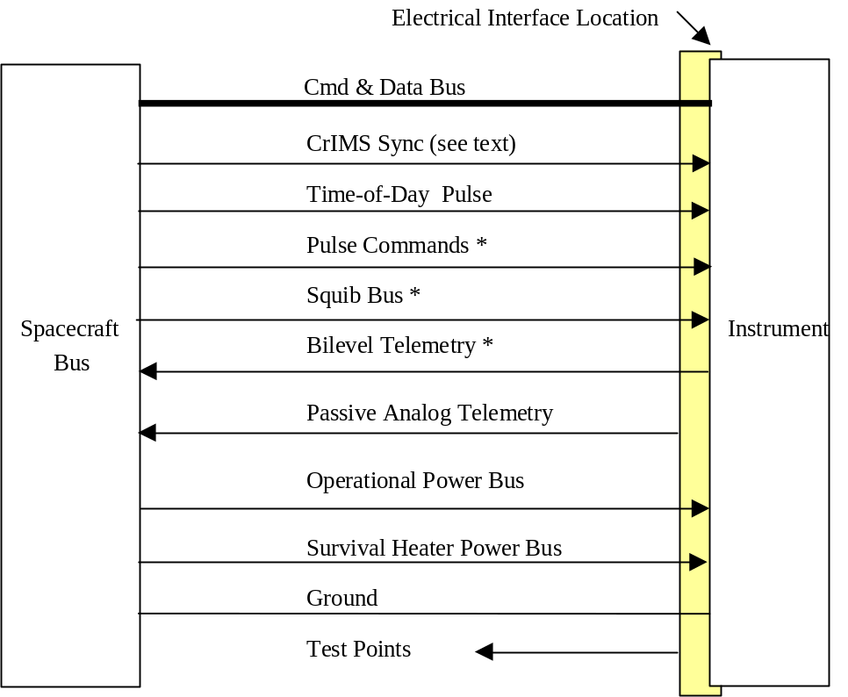

* = minimal use

Figure 3.2.4.8.1 Spacecraft-Instrument Electrical Interfaces

3.2.4.8.1.1 Interface Conductors
GIID3.2.4.8.1.1-1
All signal interfaces shall use shielded conductors.

3.2.4.8.1.2 Interface Circuitry Isolation
GIID3.2.4.8.1.2-1
The instrument shall maintain electrical isolation of greater than 100 kohm between the primary and redundant interface circuitry to the spacecraft.

3.2.4.8.1.3 Interface Fault Tolerance
GIID3.2.4.8.1.3-1
A single fault on either the spacecraft side of the interface or the instrument side of the interface shall not prevent the full and complete digital data transfer needed to fulfill mission requirements.

3.2.4.8.1.4 Power Bus
GIID3.2.4.8.1.4-1
The characteristics of the power bus with respect to power return shall be as specified in the Electromagnetic Compatibility (EMC) Control Plan.

3.2.4.8.2 Data Bus Requirements

3.2.4.8.2.1 Bus Functions
GIID3.2.4.8.2.1-1
Instruments shall interface to either Mil-Std-1553 or IEE 1394a-2000 data bus as called out in Table 0-1 and shall comply with the appropriate NPOESS 1394 or 1553 Interface Requirements Document called out in section 2.0 of this document.
Table 3.2.4.8.2.1-1 Instrument Data Bus Assignment
Table 0-1 Instrument Data Bus Assignment
Intrument | Data Bus
VIIRS | 1394
CMIS | 1394
CrIS | 1394
OMPS | 1553
ERBS | 1553
TSIS | 1553
SESS | 1553
GPSOS | 1553
SARSAT | 1553
ADCS | 1553
Survival Sensor | 1553
ALT | 1553
ATMS | 1553
CAPS | 1553

GIID3.2.4.8.2.1-2
The following functions (see Figure 3.2.4.8.2), where appropriate, shall be provided between the spacecraft and the instruments.

a)Spacecraft to instrument transfers consisting of:
- real-time ground commands
- stored commands
- memory loads
- state of health indications
- auxiliary data (e.g., time code, satellite ephemeris)

b)Instrument to spacecraft transfers consisting of:
- mission data, including auxiliary data received from spacecraft
- instrument health and status telemetry
- instrument transition to safe mode indicator
- instrument diagnostic data
- memory dumps
- survival mode temperatures (not part of the data bus)
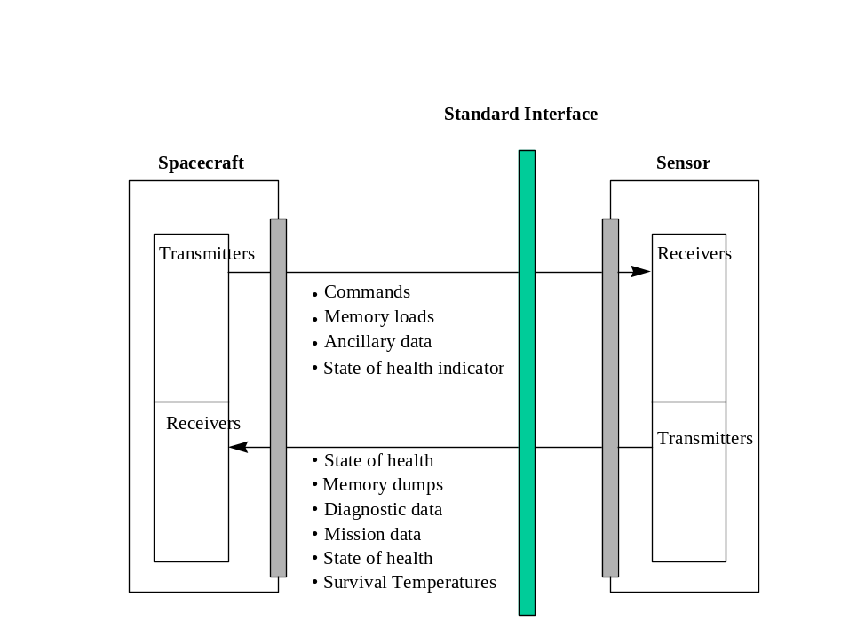
Figure 3.2.4.8.2 Data Transfer Interface

3.2.4.8.3 Interface Characteristics

3.2.4.8.3.1 Mil-STD-1553 Characteristics

3.2.4.8.3.1.1 Electrical Interface
GIID3.2.4.8.3.1.1-1
The spacecraft contractor shall define the bus implementation characteristics not defined in Mil-STD-1553 and not specified in the NPOESS 1553 Interface Requirements Document (IRD).
GIID3.2.4.8.3.1.1-2
Unspecified parameters shall not be assumed or assigned by the instrument contractor without concurrence from the spacecraft contractor, at which time they are to be documented in the UIID

3.2.4.8.3.2 IEEE 1394a Interface Characteristics
The spacecraft contractor will resolve 1394 interface implementation issues not defined below, or in the referenced documents.
GIID3.2.4.8.3.2-1
The interface shall comply with the requirements of IEEE-1394a, all sections, or as tailored in the NPOESS Interface Specification for the 1394 Data Bus.
GIID3.2.4.8.3.2-2
The spacecraft contractor shall define the bus implementation characteristics not defined in IEEE 1394a-2000 and not specified in NPOESS 1394 Interface Requirements Document (IRD).
GIID3.2.4.8.3.2-3
Unspecified parameters shall not be assumed or assigned by the instrument contractor without concurrence from the spacecraft contractor, at which time they are to be documented in the UIID.

3.2.4.8.3.3 Pulse Commands
GIID3.2.4.8.3.3-1
Pulse commands from the spacecraft shall not be used for functions which could be accomplished by the instrument itself, or by command from the spacecraft via the data bus.

The primary means of commanding the instrument is through the command & data interface. If necessary, and as approved by the spacecraft contractor and documented in the UIID, selected commands may utilize pulse (relay driving) commands, having the characteristics given below.

GIID3.2.4.8.3.3-2
Instrument discrete pulse commands shall have redundant interfaces per function, one primary, and one redundant, each controlled by one wire pair (command/return).
GIID3.2.4.8.3.3-3
The pulse command characteristics shall be as follows:
a. Logic 0 -2.0 to 4.0 VDC @ 4 microamps load source current
b. Logic 1 22 VDC to bus voltage @ 350 ma load sink current
c. Load Impedance 97 Ohms minimum
d. Pulse Width 70 ± 10 milliseconds
e. Voltage Rise Time 4 msec maximum
f. Voltage Fall Time 6 msec maximum
g. Instrument Inductive Spike Suppression 750mA clamp to < 1.75 volts
h. No contact chatter allowed when subjected to vibration environment specified
in this GIID. This requirement (i) only applies to functions which will be powered during the vibration environment, and where a change in state of the relay would affect instrument status or performance.

GIID3.2.4.8.3.3-4
The Instrument shall provide series redundant suppression diodes in parallel with all inductive loads.
GIID3.2.4.8.3.3-5
The spacecraft shall not issue pulse commands to the instrument spaced more closely than 2 times the pulse width (i.e., one pulse width between the end of one command and the start of the next command).

3.2.4.8.3.4 Time of Day Pulse
GIID3.2.4.8.3.4-1
The spacecraft shall provide a 1 Hz Time of Day pulse to indicate the point in time at which to apply the time code which was previously transmitted over the data bus (refer to section 3.2.4.8.4.3).
GIID3.2.4.8.3.4-2
The instrument shall utilize the rising edge of the Time of Day pulse, together with the time code data, in order to establish the time reference for instrument data.
GIID3.2.4.8.3.4-3
The Time-of-Day pulse shall utilize an EIA RS-422 interface circuit, with the following characteristics:

Termination impedance – 120 +/- 10 ohms center-tapped to ground via a 0.001 μf capacitor
Harness – shielded twisted pair. Shield terminated in connector to chassis ground
Rise time – Less than 1 μ second
Pulse width – Greater than 10 µ second
GIID3.2.4.8.3.4-4
The spacecraft shall issue the Time of Day pulse rising edge within 5 microseconds (TBR) of each spacecraft 1-second time occurrence.

3.2.4.8.3.5 Synchronization
GIID3.2.4.8.3.5-1
Where instruments require synchronization to each other, the spacecraft shall provide a means whereby synchronization can be accomplished via the data bus interface, as detailed in the UIID for the affected instrument.
GIID3.2.4.8.3.5-2
If synchronization accuracy requirements cannot be met using the data bus alone, the spacecraft shall provide a synchronization pulse using the electrical characteristics of an EIA RS-422 interface.
GIID3.2.4.8.3.5-3
Where the synchronization period is integer multiples of seconds, the rising edge of the EIA RS-422 Time-of-Day pulse shall be used as the synchronization signal described above, with the data bus indicating which Time-of-Day pulse is the synchronization signal.

3.2.4.8.4 Instrument Commands and Data Load
The spacecraft, through the Mil-STD-1553 bus will deliver the instrument command and data load to the specified instrument RT-receive address/sub-address by conducting BC-to-RT Transfers or RT-to-RT Transfers (from a spacecraft RT to an instrument RT). Command and data load through the IEEE-1394a will be performed as specified in theUIID.

The spacecraft will provide discrete commands for instrument operational and survival heater power switching, fault recovery, and squib functions as necessary. The spacecraft will provide time synchronization and Time-of-day pulses. The spacecraft will provide auxiliary data and spacecraft ephemeris, where appropriate.

GIID3.2.4.8.4-1
All commands to be transferred to the instrument via the point-to-point (discrete) command interfaces and the command and telemetry bus, shall be documented in the UIID.
GIID3.2.4.8.4-2
The standard means of transmitting commands and data loads from the spacecraft to the instrument shall be via the data bus.

3.2.4.8.4.1 Commands

3.2.4.8.4.1.1 Real-time Ground Commands
GIID3.2.4.8.4.1.1-1
The instrument shall accept and execute all valid commands issued to the instrument by the Mission Management Center (MMC) via the spacecraft command system.

3.2.4.8.4.1.2 Stored Commands
GIID3.2.4.8.4.1.2-1
Each instrument command which is intended to be stored by the spacecraft and distributed at the desired time-of-execution shall be limited to 4(TBR) 16-bit data words in length.
GIID3.2.4.8.4.1.2-2
Instrument commands which should not be allowed as stored commands (i.e., real-time only), if any, shall be documented in the UIID.
GIID3.2.4.8.4.1.2-3
The spacecraft time tag for stored commands shall have a resolution of 1 second or finer.
GIID3.2.4.8.4.1.2-4
Spacecraft stored commands shall be sent to the instrument within 1 second after the instant when the command time tag and spacecraft time are equal, but not at a rate exceeding the normal instrument command rate as documented in the GIID.

3.2.4.8.4.1.3 Command Uniqueness
GIID3.2.4.8.4.1.3-1
Each command shall be unique and have the same effect in all instrument modes for which the command is applicable.

3.2.4.8.4.1.4 Command Sequence
GIID3.2.4.8.4.1.4-1
The instrument shall be designed such that commands, including test-only commands, may be sent or executed in any sequence, in any mode, without damage to the instrument.

A test-only command is any decodable bit sequence, some of which are used for special testing and others that may be residual, as they were not specifically excluded by the design.

3.2.4.8.4.1.5 Command Restraints
GIID3.2.4.8.4.1.5-1
No state-dependant or “toggle” commands shall be allowed.

This means that the same command (all bits being the same values) shall not cause different effects depending on the previous state of the item being commanded.
GIID3.2.4.8.4.1.5-2
For any command , the command format shall be identical for every mission phase and every instrument mode for which the command is applicable.
GIID3.2.4.8.4.1.5-3
All commands that will be accepted as valid shall be documented in the UIID along with the result of the command, and the telemetry indicator that can be used to verify execution.
GIID3.2.4.8.4.1.5-4
Within commands that control multiple discrete conditions, each controlled function shall have an enabling bit (or a unique code) which shall be able to be changed individually or in any combination.
GIID3.2.4.8.4.1.5-5
Instrument mechanisms which require uncaging and/or caging on-orbit shall be capable of being caged and uncaged by command.
GIID3.2.4.8.4.1.5-6
Commands shall be available to disable or override all automatically triggered instrument functions that change the configuration or operational state of the instrument, including instrument-induced transition to instrument safe mode.

3.2.4.8.4.2 Command and Data Load Packets
GIID3.2.4.8.4.2-1
All non-discrete commands (serial bus commands) and all memory loads delivered to the instrument shall be formatted in accordance with the CCSDS AOS Path Protocol Unit (CP PDU) format version 1 defined in CCSDS 701.0-B-2 .
GIID3.2.4.8.4.2-2
Instrument data bus command and memory load source packet length shall be specified in the UIID.
GIID3.2.4.8.4.2-3
Instrument data bus command and memory load source packets shall be decrypted by the spacecraft before transmission to the instruments in clear text.
GIID3.2.4.8.4.2-4
Instrument data bus command and memory load source packets shall be transmitted to their destination according with their APID (Application Process Identifier).
GIID3.2.4.8.4.2-5
The APIDs shall be documented in the UIID.

3.2.4.8.4.3 Reserved

3.2.4.8.4.4 Reserved

3.2.4.8.4.5 Critical Command
GIID3.2.4.8.4.5-1
Initiation of critical or hazardous functions shall use, as a minimum, separate enable and execute command sequences to the commanded unit, to prevent inadvertent execution of critical commands.
GIID3.2.4.8.4.5-2
Enables shall be disabled by the instrument after the critical function is commanded, or after 30 (TBR) seconds have elapsed following receipt of the enable, if the command itself has not been received.
GIID3.2.4.8.4.5-3
Commands which involve critical or hazardous functions, or which create critical or hazardous conditions, shall be identified in the UIID.

3.2.4.8.4.6 Squib Commands
Instruments are discouraged from utilizing pyrotechnic devices for release mechanisms.
GIID3.2.4.8.4.6-1
Instrument pyrotechnic and non-explosive release mechanisms shall be functionally single fault tolerant.
GIID3.2.4.8.4.6-2
Instrument pyrotechnic and non-explosive release mechanisms shall meet range safety requirements of EWR 127-1.

3.2.4.8.4.7 Documentation
GIID3.2.4.8.4.7-1
All instrument commands and data load descriptions shall be documented in the UIID.

3.2.4.8.5 Instrument Health and Status Telemetry
GIID3.2.4.8.5-1
Instrument health and status telemetry packet shall include housekeeping data required for instrument status and health monitoring. Instrument health and status telemetry includes:
- Instrument mode and configuration
- Instrument temperatures
- Instrument internal (converter) power supply voltage
- Relay status, scan mirror rotation, and other rotating mechanism rates
- Verification of commands received and commands executed
- Other telemetry data required to support instrument performance evaluation
GIID3.2.4.8.5-2
Instruments shall provide Health and Status telemetry packets in format(s) and data rates specified in the UIID.

GIID3.2.4.8.5-3
The same instrument telemetry stream format shall be usable on-orbit as well as for I&T activities.
GIID3.2.4.8.5-4
All telemetry used for determining instrument configuration shall be invariant to instrument mode.
GIID3.2.4.8.5-5
Instrument health and status telemetry stream packetization shall be as specified in paragraphs of section 3.2.4.8.7.
GIID3.2.4.8.5-6
No single point failure shall prevent spacecraft access to critical telemetry points.

3.2.4.8.5.1 Telemetry Diagnostic Data
GIID3.2.4.8.5.1-1
The instrument shall provide sufficient telemetry to diagnose failures to the lowest switchable level, and to track variations in performance of critical functions.
GIID3.2.4.8.5.1-2
During instrument anomaly resolution, the instrument shall have the capability to dwell (multiple samples per second) on particular telemetry measurands, as required to support ground diagnostic investigations.
GIID3.2.4.8.5.1-3
All diagnostic dwell data required to diagnose failures and track variations in performance shall be documented in the UIID along with the required sampling rates and a definition of how the data is to be used.
GIID3.2.4.8.5.1-4
Telemetry dwell shall be in response to a ground-initiated process.
GIID3.2.4.8.5.1-5
The diagnostic telemetry shall be placed within selected packets, identified with a unique packet APID.

3.2.4.8.5.2 Point-to-Point Telemetry
Point-to-point telemetry is intended to represent “static” information (for example: relay status associated with pulse commands where knowledge of the relay position is required even when the instrument is off) such that sampling rates in the seconds, or tens of seconds, is adequate.

GIID3.2.4.8.5.2-1
The instrument shall provide as a minimum the following telemetry to the spacecraft via the point-to-point telemetry interfaces:
a. Status of functions commanded via point-to-point interfaces
b. Telemetry for the determination of instrument health and safety not otherwise attainable via the command and data bus, such as telemetry that is required to be available when the operational power is off (goal is none).
GIID3.2.4.8.5.2-2
All spacecraft-instrument point-to-point telemetry interfaces shall be documented in the UIID.
GIID3.2.4.8.5.2-3
Redundant passive analog temperature measurement devices shall be used to indicate temperature at up to five locations per instrument for a maximum total of 10 sensing devices.

Redundancy may be accomplished by thermally overlapping regions for non-critical measurements. These analog lines are separate and in addition to any state of health (SOH) input being transmitted over the command and data interface and are intended to provide insight during periods when the instrument operational power is not present; therefore, excitation of the passive analog temperature measurement devices is provided by the spacecraft.

GIID3.2.4.8.5.2-4
Electrical connections to these dedicated passive analog temperature measurement devices shall be made only thorough an electrical connector interfacing the instrument with the spacecraft.
GIID3.2.4.8.5.2-5
The electrical connection between these passive analog temperature measurement devices and any instrument electronics, chassis, or ground shall be isolated to at least 1 megohm.
GIID3.2.4.8.5.2-6
Characteristics of the spacecraft-excited passive analog temperature interface shall be as follows at the instrument connector:

Sense Current During Sample : 1 mA ± 5%
Instrument Resistance Range: 100 ohms to 5 kilo-ohms
Capacitance: <1800 picofarads (includes <1600 picofarads cable and sampling circuit capacitance, and <200 picofarads instrument capacitance)
CH-4

GIID3.2.4.8.5.2-7
The instrument shall provide relay contact closure (wire pair) to indicate bilevel point-to-point telemetry status. Appropriate ground referencing will be provided by the spacecraft.
This requirement refers to telemetry associated with pulse commands, not to internal discrete telemetry, which comes over the data bus.

3.2.4.8.5.3 Command Verification
GIID3.2.4.8.5.3-1
Receipt of individual commands via the Command & Data bus shall be verifiable via instrument Health and Status telemetry.
GIID3.2.4.8.5.3-2
Execution of serial commands (data bus) shall be verifiable via instrument Health and Status telemetry.
GIID3.2.4.8.5.3-3
The instrument’s method for verifying each command shall be documented in the UIID.
GIID3.2.4.8.5.3-4
Execution of discrete commands shall be verified via discrete instrument telemetry points sampled by the spacecraft..

3.2.4.8.5.4 Instrument Memory Dump

GIID3.2.4.8.5.4-1
Instrument Memory Dump data shall be transferred to the spacecraft C&DH via the data bus.
GIID3.2.4.8.5.4-2
Instrument Memory Dump data shall span one or more telemetry packets.
GIID3.2.4.8.5.4-3
Instrument Memory Dump packetization shall be as specified in section 3.2.4.8.7

3.2.4.8.5.5 Telemetry Monitor
GIID3.2.4.8.5.5-1
Any requirement for the spacecraft to monitor selected telemetry points ( including telemetry from the command and telemetry bus and point-to-point interfaces) and initiate action to the instrument based upon a pre-determined telemetry state shall be negotiated with the spacecraft contractor and documented in the UIID.
GIID3.2.4.8.5.5-2
All instrument telemetry points to be monitored by the spacecraft, for spacecraft action, shall be documented in the UIID, along with the action to be taken and the algorithm for such action, as specified by the instrument contractor.

3.2.4.8.6 Mission Data
GIID3.2.4.8.6-1
The combined output rate of science data, engineering data and diagnostic data shall not exceed the data rate allocation in the UIID, including all CCSDS packetization overhead.
GIID3.2.4.8.6-2
Instrument Mission Data shall be transferred to the spacecraft C&DH via the Command & Data Interface.
GIID3.2.4.8.6-3
Instrument Mission Data packetization shall be as specified in section 3.2.4.8.7
GIID3.2.4.8.6-4
Unless fixed continuous output packet data rate is provided, the instrument mission data packet profile over a periodic period shall be provided and specified in the UIID
GIID3.2.4.8.6-5
The instrument shall not be required to produce a constant data rate over any one second period (i.e., no requirement for “fill” data).

3.2.4.8.7 Data Packetization
The spacecraft C&DH Subsystem collects instrument Health & Status Telemetry, instrument Memory Dump, and Mission Data packets through the Command & Data interface. The C&DH Subsystem multiplexes these packets and attaches appropriate protocol for downlink and storage.
GIID3.2.4.8.7-1
All instrument Health & Status telemetry, instrument Memory Dump, and Mission Data shall be packetized using the CCSDS AOS Path Protocol Data Unit format (CP_PDU) version 1 defined in CCSDS 701.0-B-2.
GIID3.2.4.8.7-2
All instrument Health & Status telemetry, instrument Memory Dump, and Mission Data source packets (CP_PDU) shall contain the appropriate APID (Application Process Identifier).
GIID3.2.4.8.7-3
The instrument shall provide the capability, through APID assignment, to support the selection of source packets, as necessary, by the Spacecraft.

This is intended to support selective data denial, and routing of various types of data to different links on the spacecraft.

GIID3.2.4.8.7-4
The same data shall have unique APID’s for non-compressed, lossless compressed, and lossy compressed packets, or any other such unique applied algorithm information necessary to process the data.
GIID3.2.4.8.7-5
APID’s not used for a specific spacecraft configuration shall not be reassigned to another use unless the original assignment is permanently retired.
GIID3.2.4.8.7-6
The instrument shall correlate the time code, contained within packets generated by the instrument, to the time of sampling data with sufficient accuracy to enable the TSPR to produce the desired Environmental Data Record performance identified in the TRD.
GIID3.2.4.8.7-7
The time correlation accuracy shall be specified in theUIID.
GIID3.2.4.8.7-8
The instrument contractor shall include in the algorithms for EDR performance, the RDR packet loss effects, based on the instrument contractor’s selection for packet size, applied against the total 10E-8 Bit Error Rate in a CCSDS CP-PDU system. The 10E-8 BER includes the effects of RS and convolutional coding. Packet level encryption by the spacecraft can be assumed.

Note: the NPP BER for all links is 10E-7.

GIID3.2.4.8.7-9
Instrument Health & Status telemetry, instrument Memory Dump, and Mission Data packet length and descriptions shall be documented in the UIID.
GIID3.2.4.8.7-10
The data commutation scheme for Health and Status telemetry shall be identical for each packet of the same APID.
GIID3.2.4.8.7-11
Data packet transfers over the data bus shall take place at the bus rate for the respective data bus (1553 or 1394), subject to total data transfer limits identified in the respective bus section of this document.
GIID3.2.4.8.7-12
Data packet transfers over the data bus shall take place at the bus rate for the respective data bus (1553 or 1394), subject to total data transfer limits identified in the respective bus sections of this document.

3.2.4.8.8 Command & Data Interface Test Packets
GIID3.2.4.8.8-1
The instrument shall be capable of generating and transmitting, on command, a continuous sequence of packets containing a fixed data pattern. The fixed data pattern shall be repeated within each packet or repeated over an integral number of packets.
GIID3.2.4.8.8-2
The test packet(s) shall consist of a fixed packet header and a fixed data pattern within the data zone. The packet header shall contain a fixed bit sequence not repeated within the data zone of the packet. The packet header “type” bit shall be set to logical zero. Each test packet type shall be identified with a unique APID.

GIID3.2.4.8.8-3
Instrument test packets shall have a unique APID
GIID3.2.4.8.8-4
Test Packet APIDs, patterns and lengths shall be documented in the UIID.

3.2.5 Instrument Quality Factors

3.2.5.1 Reliability
Reliability is defined as the probability that an item can perform its intended function for a specified interval under stated conditions.
GIID3.2.5.1-1
Each instrument ’s total system reliability, as defined in the UIID, at the end of 7 years on-orbit life shall be no less than 0.86, unless otherwise specified in the UIID.
GIID3.2.5.1-2
The instrument shall be operational 24 hours per day with no on-orbit repair capability.

3.2.5.1.1 Operational Service Life
GIID3.2.5.1.1-1
The on-orbit design life of the instrument shall be no less than 7 years.
GIID3.2.5.1.1-2
The design of the instrument shall be such that instrument storage, under controlled conditions, may be planned for as long as 8 years, including up to 3 years for intermittent testing, for a total equivalent of one year of on-ground testing..
The above two requirements mean that the design service life of the instrument needs to be at least 15 years. This includes the time allowed for test, storage, prelaunch checkout, launch and injection, on-orbit, recovery, and contingency time.
GIID3.2.5.1.1-3
The instrument shall be capable of undergoing testing at periodic intervals (e.g., 6-month periods) while remaining on the spacecraft. This periodic test will include a limited performance test for verifying critical elements of the instrument (i.e. detectors, power supplies, and digital logic), inspection and cleaning as required.
GIID3.2.5.1.1-4
The instrument shall be capable of undergoing the periodic testing described above while oriented with gravity in any direction

3.2.5.1.2 Maintainability
GIID3.2.5.1.2-1
The instrument design shall include maintainability features, if applicable, to ensure timely replacement or test of instrument subsystems or modules prior to launch.
GIID3.2.5.1.2-2
Only remove-and-replace maintenance actions shall be performed on the satellite and instruments after acceptance by the spacecraft contractor.
GIID3.2.5.1.2-3
Except for software updates, the instrument shall not require maintenance or repair on-orbit.
GIID3.2.5.1.2-4
Single-point failures of the instruments shall be identified, and eliminated where practical, if they cause loss or serious degradation of the instrument’s on-orbit mission.
GIID3.2.5.1.2-5
Redundancy shall be provided where practical to eliminate critical single-point failures in the instruments and to ensure that the reliability requirements are satisfied.
GIID3.2.5.1.2-6
The instrument contractor shall perform failure analysis to determine failures for which automatic switchover to redundant components is appropriate.
GIID3.2.5.1.2-7
The instrument shall remain in a readiness condition following integration and system performance verification so that it will be available for launch within 60 days (objective is 45 days) of notification of launch call-up. The allocation to the instrument for availability, integration and testing prior to launch for instruments that are replaced is 10 days duringthat 60 day period.

3.2.6 Environmental Conditions

3.2.6.1 Natural Environment Characteristics
Specified below are natural environment characteristics in the presence of which the instrument must meet all other requirements.
GIID3.2.6.1-1
The instruments shall be compatible with the natural environments for their operational orbits.

3.2.6.1.1 Total Ionizing Dose Environment
GIID3.2.6.1.1-1
The instrument shall be capable of meeting the proton and electron total dose levels for a 7-year mission, given in Table 3.2.6.1.1 below.
Table 3.2.6.1.1 Trapped Proton/Electron Dosage
SHIELDING  Mils (AL) | Trapped Protons Rad(Si)/7 Yr | Trapped Electrons Rad(Si)/7 Yr | Solar Flare Protons  Rad(Si)/7 Yr | Total  Rad(Si)/7 Yr
100 | 6.50 E03 | 1.81 E04 | 1.56 E03 | 2.62 E04
200 | 4.79 E03 | 2.06 E03 | 7.12 E02 | 7.56 E03
400 | 3.67 E03 | 6.76 E01 | 4.06 E02 | 4.14 E03
600 | 3.05 E03 | 4.35 E01 | 0.00 E00 | 3.09 E03
1000 | 2.25 E03 | 3.04 E01 | 0.00 E00 | 2.28 E03

GIID3.2.6.1.1-2
Two times the total dose shall be used to provide a design margin factor of two (Note: aE+N=a x 10^{N}, e.g., 3.264E+06 = 3.264 x 10⁶; one mil is 10⁻³ inch). The depth dose curve is provided in Figure 3.2.6.1.1a, and the total mission trapped proton and electron fluences are provided in Figure 3.2.6.1.1b and Figure 3.2.6.1.1c (the 2x margin has not been applied).
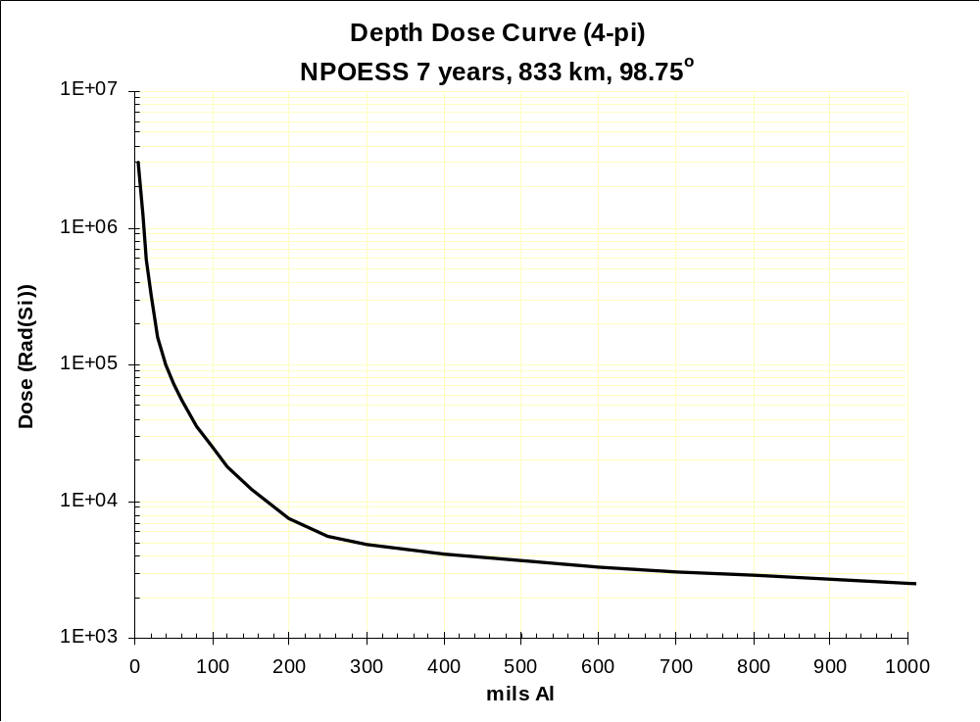
Figure 3.2.6.1.1a Depth Dose Curve
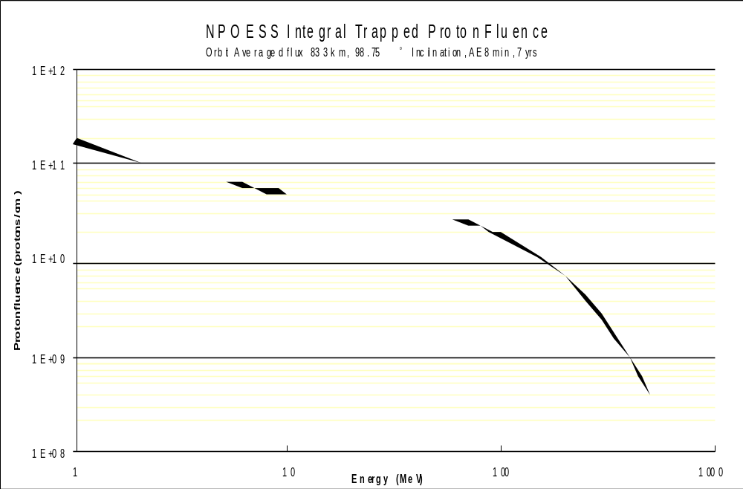
Figure 3.2.6.1.1b Integral Trapped Proton Fluence
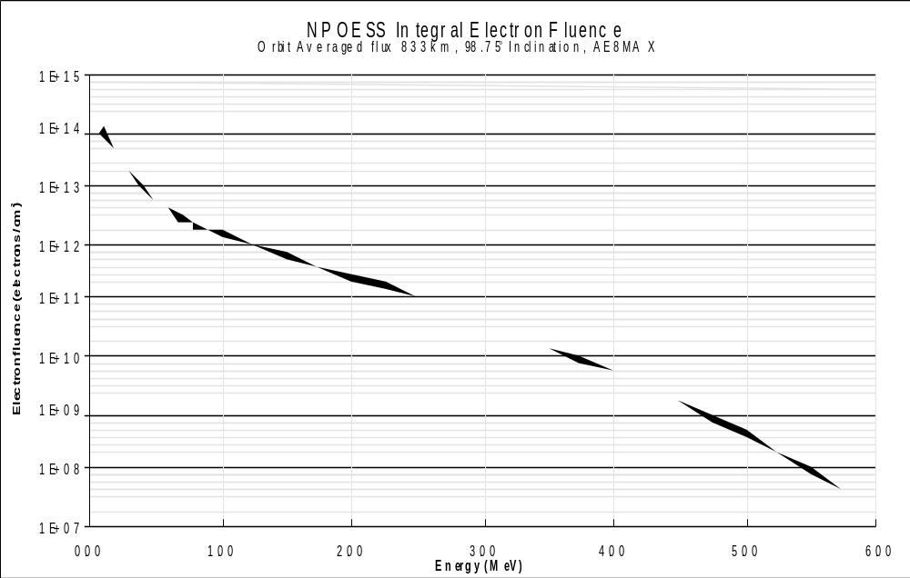
Figure 3.2.6.1.1c Integral Electron Fluence

3.2.6.1.2 Cosmic Ray and High Energy Proton Environment

3.2.6.1.2.1 Single Events Radiation Environment
GIID3.2.6.1.2.1-1
The instrument shall be capable of meeting all performance requirements in the Background Cosmic Ray and Background Radiation Environments specified in 3.2.6.1.2.1.1 and 3.2.6.1.2.1.2.
GIID3.2.6.1.2.1-2
Predictions of single events (i.e., single event latch-up, single event upset, and single event burn-out) induced by heavy ions and high energy protons shall be performed separately and the results combined.

3.2.6.1.2.1.1 Galactic Cosmic Ray (GCR) Linear Energy Transfer (LET) Spectrum
GIID3.2.6.1.2.1.1-1
The integral GCR heavy ion linear energy transfer spectrum in Figure 3.2.6.1.2.1.1 shall be used for prediction of ion-induced single events.
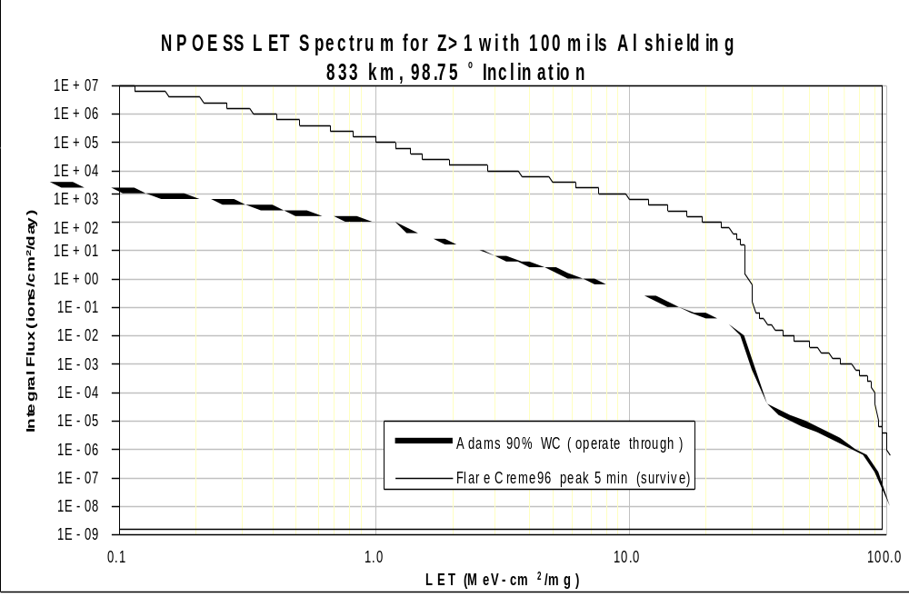
Figure 3.2.6.1.2.1.1 Integral Galactic Cosmic Ray Linear Energy Transfer Spectrum
GIID3.2.6.1.2.1.1-2
The instrument and the spacecraft shall be capable of meeting all performance requirements in the background (90% worst case) environment.
GIID3.2.6.1.2.1.1-3
The instrument and the spacecraft shall survive the heavy ion peak fluxes from a large solar flare (CREME96 Peak).

3.2.6.1.2.1.2 High Energy Proton Fluence
The integral proton flux is provided in Figure 3.2.6.1.2.1.2a for the background environment (trapped protons plus 90% worst case galactic cosmic ray protons) and the peak flux of a large solar flare.
GIID3.2.6.1.2.1.2-1
Fluxes in Figure 3.2.6.1.2.1.2a shall be used to determine the single proton-induced event rates for the background environment and during a flare.

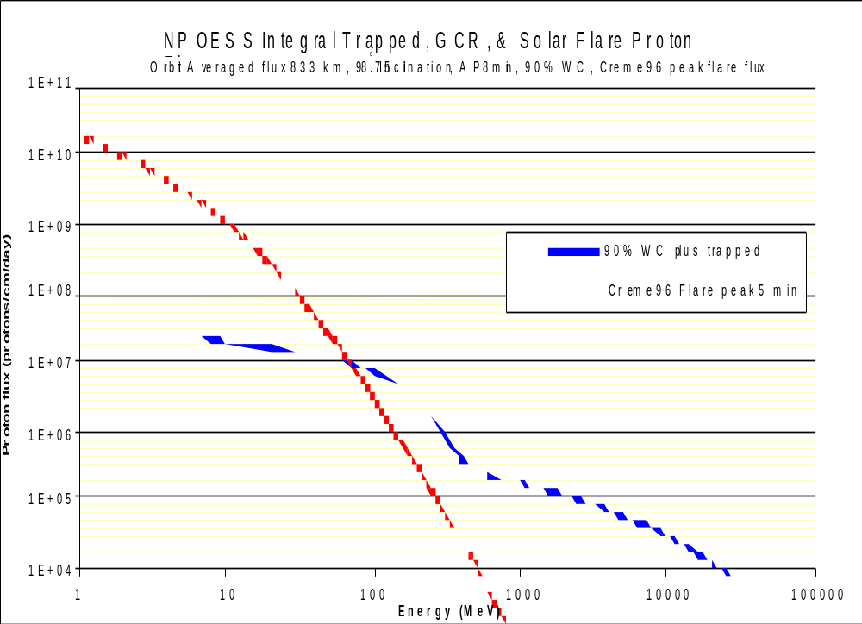

Figure 3.2.6.1.2.1.2a Integral Proton Flux

GIID3.2.6.1.2.1.2-2
The instrument shall meet all performance requirements for the background environment.
GIID3.2.6.1.2.1.2-3
The instrument shall survive the peak proton flux of the solar flare.
GIID3.2.6.1.2.1.2-4
The total number of proton-induced single events shall be determined from the total proton fluence as provided in Figure 3.2.6.1.2.1.2b, which combines the trapped, galactic cosmic ray, and flare total fluences.
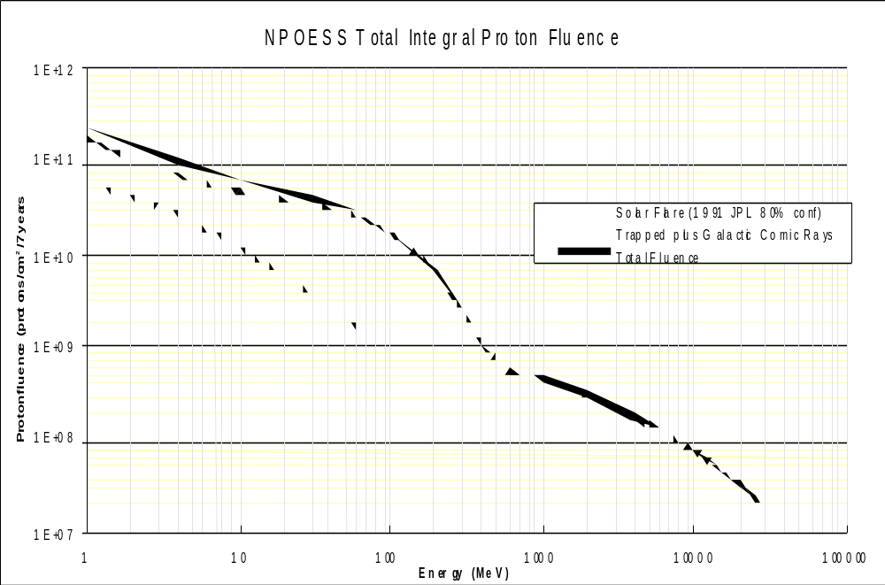
Figure 3.2.6.1.2.1.2b Total Integral Proton Fluence

3.2.6.1.2.1.3 Peak Fluxes
Note: at the time of release of this draft GIID, it is believed that the total event integral fluence shown below may be “high”. The values shown are subject to revision.
GIID3.2.6.1.2.1.3-1
The instrument shall be capable of meeting all performance requirements when exposed to trapped proton (E ≥ 5 MeV) flux of 9.98x10³ particles/cm²/sec, trapped electron (E ≥ 0.5 MeV) flux of 5.43x10⁵ particles/cm²/sec and survive the following estimated solar flare proton peak fluxes and associated total event integral fluences, shown in Table 3.2.6.1.2.1.3 for each extremely large solar flare:
Table 3.2.6.1.2.1.3 Peak Fluxes (using NASA Code)
Energy  (MeV) | Flux Total Event (Particles/cm²/sec)  (Creme96 Peak) | Total Event Integral Fluence Worst Week (Particles/cm²)  (CREME96)
> 10 | 1.16 x 10⁴ | 4.04E⁹
> 30 | 1.07 x 10³ | 9.8E⁸
> 60 | 1.68 x 10² | 2.99E⁸
> 100 | - | 1.06E⁸
The total event integral fluence is accumulated within a time interval of a few hours to two days.

3.2.6.1.2.2 Displacement Damage
GIID3.2.6.1.2.2-1
Charge Coupled Devices (CCDs) and electronic parts shall survive the displacement damage caused by the total proton fluence shown in Figure 3.2.6.1.2.1.2b and the depth-displacement damage curve in Figure 3.2.6.1.2.2.

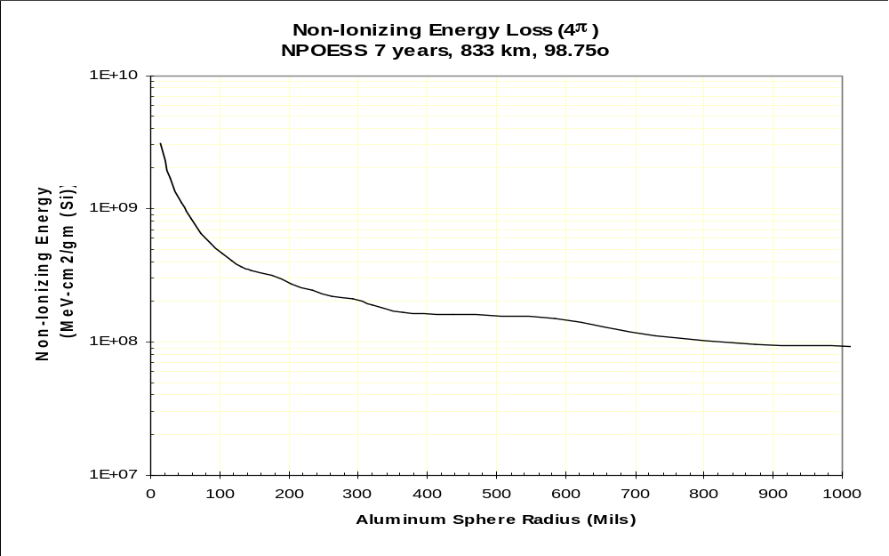
Figure 3.2.6.1.2.2 Depth Displacement Damage Curve
GIID3.2.6.1.2.2-2
Where CCD detectors are used, the design shall incorporate features that minimize the effects of displacement damage.

3.2.6.1.3 Reserved

3.2.6.1.4 Reserved

3.2.6.1.5 Spacecraft Magnetic Fields
GIID3.2.6.1.5-1
The instrument shall meet all performance requirements in the presence of the ambient magnetic field which exists on the spacecraft, where the maximum flux is (TBS).

3.2.6.1.6 Atomic Oxygen
GIID3.2.6.1.6-1
The instrument shall meet performance requirements during exposure to atomic oxygen (AO) experienced during a 833 km polar orbit for seven years. Atomic oxygen fluence is shown in Figure 3.2.6.1.6.

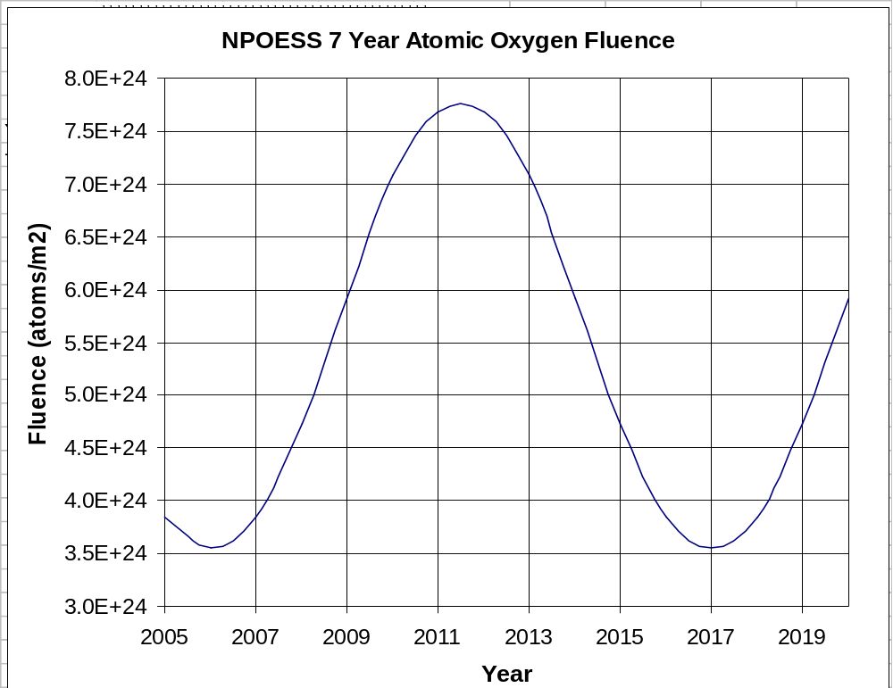

Figure 3.2.6.1.6 Atomic Oxygen Fluence

3.2.6.1.7 Spacecraft Charging from All Sources
The Spacecraft external surface will charge to approximately (TBS) V with respect to space plasma. In the auroral regions the potential may be significantly higher for brief periods (approximately 10 sec). The plasma environment is defined in Table 3.2.6.1.7.

GIID3.2.6.1.7-1
The instrument shall operate without performance degradation due to surface charging, bulk charging, and deep charging in accordance with the NPOESS EMC Control Plan.
GIID3.2.6.1.7-2
An ESD analysis shall be performed at the instrument level.

TABLE 3.2.6.1.7 PLASMA ENVIRONMENT
(Contents TBR)

Particle | Density | Temperature
Ambient electrons | 10³ ⁻ 2 x 10⁶ cm⁻³ | 0.1 - 0.39 eV
Ambient positive ions | 10³ ⁻ 2 x 10⁶ cm⁻³ | 0.07 - 0.34 eV
* High energy electron flux | 10⁸ - 10¹⁰ cm⁻³ sec⁻¹ Sr⁻¹ | 14 - 30 keV
* Note: This occurs during periods of auroral arcs. The spacecraft is exposed to
auroral environments for < 30 seconds per encounter

3.2.6.2 Launch Environment
The baseline NPOESS launch vehicle is a medium launch vehicle. The levels specified in this section reflect the Evolved Expendable Launch Vehicle (EELV) Medium Launch Vehicle (MLV) proposed environments. These values are subject to change, with appropriate revision to this document by the spacecraft contractor, in the event there is a change in launch vehicle.

Similarly, the NPP spacecraft contractor will provide recommendations for environmental levels to the NPP project office. NPP project office approval will be required before incorporation of NPP-related changes. All instruments must meet the NPOESS requirements, even if the NPP requirements are less severe.

GIID3.2.6.2-1
The instrument shall be designed to meet the launch environment described herein.

3.2.6.2.1 Thermal

3.2.6.2.1.1 Temperatures
The worst case effective internal environment in the satellite compartment within the fairing during ascent is defined in Figure 3.2.6.2.1.1. The surfaces seen by the satellite will generally fall into one of two categories: surfaces with low emissivity (e ≤ 0.3) and those of higher emissivity (e ≤ 0.9). Maximum temperatures as a function of the time from launch, 150°C for a surface emissivity of 0.3 and 93° for a surface emissivity of 0.9, are shown in the plot. The exact configuration and percentages of each type of surface is both mission specific and Launch Vehicle specific.

GIID3.2.6.2.1.1-1
Temperatures may exceed those shown below, but in no case shall the total integrated thermal energy imparted to the spacecraft exceed the maximum total integrated energy indicated by the temperature profile shown in Figure 3.2.6.2.1.1.
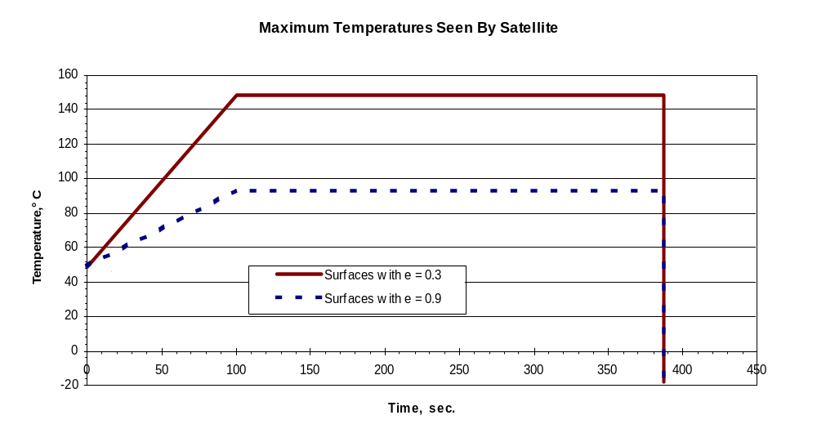
Figure 3.2.6.2.1.1 Maximum PLF Inner Temperature

3.2.6.2.1.2 Free Molecular Heating
GIID3.2.6.2.1.2-1
The instrument shall be designed to withstand a maximum, instantaneous, 3-sigma free molecular heating on instrument surfaces perpendicular to the velocity vector at the time of fairing separation of 1135 watts/m² (360 Btu/hr-ft²).

3.2.6.2.2 Shock
CH-4
The maximum shock spectrum at the Satellite Interface Plane (SIP), (value at 95% probability with 50% confidence; resonant amplification factor, Q=10) , caused by the EELV, will not exceed the levels shown in Figure 3.2.6.2.2. Location of the instrument on the spacecraft, as well as spacecraft structure design will affect the shock level seen at the instrument mounting location. Those levels will be determined once a spacecraft contractor is selected, but are expected to be lower than those shown in the table below.

GIID3.2.6.2.2-1
Based on launch vehicle and spacecraft inputs, and spacecraft structure, the spacecraft contractor shall document in the UIID the shock level which can appear at the interface to the instrument.
GIID3.2.6.2.2-2
The instrument shall be designed to meet performance requirements following
exposure to the externally induced shock environment documented in the UIID.
GIID3.2.6.2.2-3
Instruments shall be designed to survive without performance degradation the peak shocks defined in the UIID.
GIID3.2.6.2.2-4
The Instrument shall be capable of surviving, without degradation, shock resulting from self-induced events, such as deployments and other pyrotechnic devices initiated during its life.

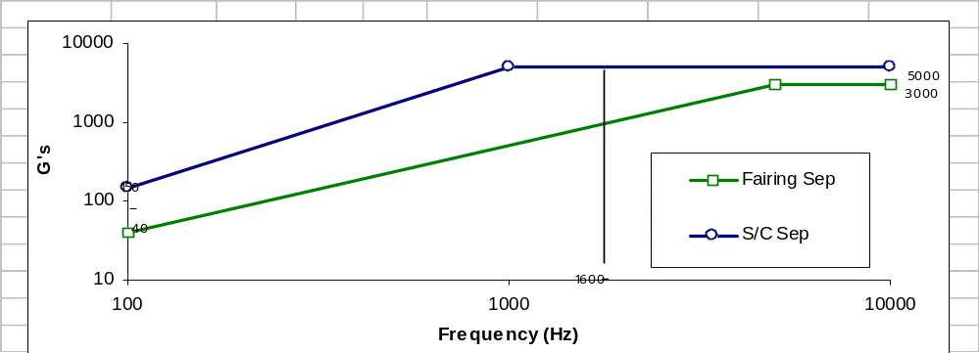
Figure 3.2.6.2.2 EELV Shock Specification

3.2.6.2.3 Deleted

3.2.6.2.4 Vibration
The maximum in-flight vibration levels will be provided by the spacecraft contractor after selection.
GIID3.2.6.2.4-1
Until such time as spacecraft-specific information is provided, instrument design shall be performed using the Expendable Evolved Launch Vehicle (EELV) acoustic data (provided in the next section).

3.2.6.2.5 Acoustics
For the EELV MLV with a typical satellite with an equivalent cross-section area fill factor of 60 %, free-field maximum predicted sound pressure levels (value at 95th percentile with a 50 % confidence), from liftoff through payload deployment, will not exceed those shown in Table 3.2.6.2. Higher fill factors may produce higher acoustic levels. Therefore, the actual acoustic levels experienced by the instrument will depend not only on the launch vehicle and fairing, but on the spacecraft design as well.

Table 3.2.6.2.5 Maximum Acoustic Levels
One-Third Octave  Center Frequency (Hz) | Noise Level (dB)  ref: 0 dB = 20µPa
25 | 118
32 | 123
40 | 127
50 | 130
63 | 132
80 | 133
100 | 133.5
125 | 134
160 | 134
200 | 134
250 | 134.5
315 | 134.5
400 | 134.5
500 | 133
630 | 128.5
800 | 127
1000 | 124
1250 | 122
1600 | 120.4
2000 | 120.9
2500 | 118
3150 | 117.2
4000 | 115.5
5000 | 114.5
6300 | 114
8000 | 113.9
10000 | 114.8
Overall | 144.4 dB

GIID3.2.6.2.5-1
After selection, the TSPR contractor shall revise the acoustics information above, as appropriate.
GIID3.2.6.2.5-2
The instruments shall be designed to withstand the acoustic tests described in section 4.2.7 of this document.

3.2.6.2.6 Launch Pressure Decay

GIID3.2.6.2.6-1
The instrument shall be designed to withstand a payload fairing internal pressure decay rate of 27.6 mb/second (2.76 kPa/second), with a single brief excursion (not exceeding 6 seconds) to 68.9 mb/second (6.89 kPa/second).

3.2.6.2.7 Physical Environment

GIID3.2.6.2.7-1
It shall be the responsibility of the spacecraft contractor to ensure that none of the instruments protrude into the dynamic envelope stay-out zones as defined in the Satellite to Launch Vehicle ICD.

3.2.6.3 On-orbit environment

3.2.6.3.1 Acceleration
GIID3.2.6.3.1-1
Instruments shall be designed to withstand a maximum acceleration of 0.05 g on-orbit, at the spacecraft-instrument mechanical interface, without degradation of performance.
GIID3.2.6.3.1-2
Instrument shall be designed to survive and recover from a maximum acceleration of 0.1g on orbit.

3.2.6.4 Test Environments
GIID3.2.6.4-1
Instrument function and performance shall be verifiable in a nominal satellite-factory environment.

3.2.7 Transportability
GIID3.2.7-1
The instrument and the support equipment that is to be transported with the instrument shall be designed for ground and air transportation in accordance with best commercial or military practices, as applicable to the mode(s) of transportation to be implemented.

3.2.8 Flexibility and Expansion

3.2.8.1 Operational Computer Resource Reserves
GIID3.2.8.1-1
The operational computer resource reserves described below shall be applicable at the time of the critical design review (CDR) of the instrument.
GIID3.2.8.1-2
Addition and modification of computer resources in instruments of later flights shall be accommodated by the instrument designs. These changes may result in a change in available reserves.

3.2.8.1.1 Computer Resource Reserves for Operational Space Elements
For the purposes of this specification, the data processing subsystems of the operational instrument are defined to comprise all computer hardware and software.
GIID3.2.8.1.1-1
The data processing subsystems of the instrument shall have 100 percent growth margin (relative to usage predicted at CDR) while meeting the original functional and performance computational requirements, including timing. This requirement allows the growth margin to be used if additional requirements are added.

3.2.8.1.1.1 Data Processing Processor Reserves
GIID3.2.8.1.1.1-1
Within the processing environment of the data processing subsystems of the space elements, each processor shall have an instruction execution rate sufficient to process a workload that is 100 percent greater than the worst case processor utilization workload predicted at the time of the CDR.

3.2.8.1.1.2 Data Processing Primary Memory Reserves
GIID3.2.8.1.1.2-1
Within the environment of the data processing subsystems of the space elements, the primary memory for each processor shall have 100 percent greater memory capacity than the worst case memory size requirement predicted for that primary memory component, if operating under a non-virtual operating system, at the time of the CDR.
GIID3.2.8.1.1.2-2
Within the environment of the data processing subsystems of the space elements, the primary memory for each processor shall have, or be capable of having, memory added (through modification, addition, or replacement) to attain a 200 percent greater memory capacity than the worst case predicted memory size requirement for that primary memory component at the time of CDR.

3.2.8.1.1.3 Data Processing Peripheral Data Storage (Secondary Memory) Reserves
GIID3.2.8.1.1.3-1
Within the environment of the data processing subsystems of the space elements, each peripheral data storage (secondary memory) component shall have 100 percent greater storage capacity than the worst case storage requirement predicted for that peripheral data storage component at the time of CDR.
GIID3.2.8.1.1.3-2
Within the environment of the data processing subsystems of the space elements, each peripheral data storage (secondary memory) component shall have, or be capable of having, storage added (through modification, addition, or replacement) to attain a 200 percent greater storage capacity than the worst case storage requirement predicted for that peripheral data storage component at the time ofCDR..

3.2.8.1.1.4 Data Processing Data Transmission Media
GIID3.2.8.1.1.4-1
Within the environment of the data processing subsystems of the space elements, each data transmission medium shall have sufficient capacity to support data throughput that is 50 percent greater than the worst case data throughput that could load that data transmission medium at the time of delivery of the first unit.
GIID3.2.8.1.1.4-2
Within the environment of the data processing subsystems of the space elements, each data transmission medium shall have, or be capable of being augmented (through modification, addition, or replacement) to have sufficient capacity to support data throughput that is 200 percent greater than the worst case data throughput that could load that data transmission medium at the time of delivery of the first unit.

3.2.8.1.1.5 Data Processing Software/Firmware
GIID3.2.8.1.1.5-1
Any hardware augmentations necessary to meet the expansion requirements shall, where practical, be designed so that the software and firmware in the data processing subsystems of the space elements are upward compatible with the implementation of those augmentations.

3.3 DESIGN AND CONSTRUCTION

3.3.1 Materials
MIL-STD-1522A should be used as a guide for design and test of all pressurized systems.
GIID3.3.1-1
Unless otherwise specified, the parts, materials, and processes shall be selected and controlled in accordance with instrument-contractor documented procedures to satisfy the specified requirements (reference MIL-STD-1543B).

3.3.1.1 Toxic Products and Formulations
GIID3.3.1.1-1
The use of combustible materials or materials that can generate toxic outgassing or toxic products of combustion shall be compliant with applicable federal, state, and local laws and regulations.

3.3.1.2 Parts Selection
Care should be exercised in the selection of materials and processes for the instrument to avoid stress corrosion cracking in highly stressed parts and to preclude failures induced by hydrogen embrittlement.
Parts, materials, and processes should be selected to ensure that any damage or deterioration from storage or the space environment or the outgassing effects in the space environment would not reduce the performance of the instrument beyond the specified limits.
GIID3.3.1.2-1
Parts for space usage shall be chosen to meet the reliability and operational service life requirements. (Use MIL-HDBK-1547A and the Preferred Parts List, PPL-21, Goddard Space Flight Center, as guides.)
GIID3.3.1.2-2
Parts shall be selected in accordance with the instrument contractor’s Parts Management Plan.
GIID3.3.1.2-3
The instrument contractor shall be able to demonstrate via design and test or analysis that all parts meet the reliability and operational service life requirements.

3.3.1.3 Material Selection
GIID3.3.1.3-1
Materials for the space equipment shall be selected for low outgassing, using NASA SP-R-0 022A (NASA JSC) as a guide, and for resistance to the effects of incident radiation.
GIID3.3.1.3-2
Materials shall be selected that have demonstrated their suitability for the intended application.
GIID3.3.1.3-3
Materials shall be corrosion resistant or be suitably treated to resist corrosion when subjected to the specified environments.
GIID3.3.1.3-4
Where practicable, fungus inert materials shall be used.
GIID3.3.1.3-5
A-basis material allowables shall be used for design of metallic elements per MIL-HDBK-5. An A-basis allowable is defined as a value where 99 percent of a population of values is expected to equal or exceed the allowable, with a confidence of 95 percent.
GIID3.3.1.3-6
Class I Ozone Depleting Substances (ODS) shall not be used in the design, test, manufacture, integration and assembly, handling, transportation, operations, maintenance, or disposal of the instrument.
GIID3.3.1.3-7
Use of Class II ODS and Emergency Planning and Community Right to Know Act (EPCRA) Section 313 chemicals shall be identified and either eliminated or minimized, justified, and controlled.
GIID3.3.1.3-8
A Hazardous Materials Management Program shall be developed in accordance with NAS 411.
GIID3.3.1.3-9
B-basis material allowables shall be used for design of composite structures. A B-basis allowable is defined as a value where 90 % of a population of values is expected to equal or exceed the allowable, with a confidence of 95%.
GIID3.3.1.3-10
Black kapton shall not be used in any instrument design unless permitted in the UIID.
GIID3.3.1.3-11
Materials with radioactivity > 1 μC shall not be used in any instrument design.
GIID3.3.1.3-12
If the instrument design uses the material beryllium, the design shall have no exposed sharp beryllium edges.

3.3.2 Electromagnetic Radiation
The requirements documents called out in this section may be tailored as described within this GIID, or as described in the spacecraft contractor’s EMC/EMI control plan.

3.3.2.1 Electromagnetic Interference (EMI) Filtering of Spacecraft Power
GIID3.3.2.1-1
The instrument shall have EMI input filters installed on the instrument side of the power interface. This does not apply to the survival heater circuits, which are purely resistive .
GIID3.3.2.1-2
The filters shall provide both common-mode and differential-mode filtering, and they shall be capable of meeting at least the requirements and intended requirements of MIL-STD-1541A.

NOTE: The word “intended” is used throughout this EMI section because MIL-STD-1541A references a superceded version of MIL-STD-461, and the current version of MIL-STD-461 uses a different nomenclature for the test names than does MIL-STD-1541A.

3.3.2.2 Electromagnetic Compatibility

3.3.2.2.1 Scope
EMI compatibility is necessary in each of the following areas:

- Self-compatibility of an instrument to itself
- Compatibility between an instrument and all internal sources and receivers on the satellite (other instruments and the spacecraft bus)
- Compatibility between an instrument and all external sources and receivers “visible” on the ground, on the launch vehicle, and on-orbit

The electromagnetic radiation environment on the NPP satellite will differ from the environment on NPOESS. For example, the EMI-sensitive SARR, SARP, ADCS, and GPSOS instruments will not fly on the NPP spacecraft. The specific EMI requirements for the NPP spacecraft and NPP satellite appear in GSFC 429-01-07-07. Instruments which are common to NPP and NPOESS must satisfy NPOESS EMI requirements.

3.3.2.2.2 Baseline Requirements

3.3.2.2.2.1 General
GIID3.3.2.2.2.1-1
The EMC requirements shall be in accordance with MIL-STD-461E and the direct and intended requirements of MIL-STD-1541A, unless otherwise superseded by the requirements of this document.
GIID3.3.2.2.2.1-2
While operating in the configurations necessary for transport, test, launch, separation and on-orbit mission activities, the spacecraft bus, instruments, ground support equipment, and test equipment shall operate together without performance degradation due to EMI from each other, or the external environment, and without interfering with equipment in the external environment. However, see Para. 3.3.2.2.3.1.
GIID3.3.2.2.2.1-3
Requirement GIID3.3.2.2.2.1-2 shall include the effects of passive intermodulation (PIM). (PIM is the unintentional production of frequency cross products of multiple transmitter signals mixing together in unshielded intentional nonlinear devices (e.g., semiconductor components) or unintentional nonlinear devices created incidentally by the random contact of conductive and semi-conductive materials on the spacecraft and payloads. Considering the large number of relatively high-level transmitters on board and the sensitivity and wide bandwidths of the instruments, there is a high potential for interference by PIM frequencies.)

3.3.2.2.2.2 Interface Margins
GIID3.3.2.2.2.2-1
Electroexplosive subsystems shall limit the power produced at each
electroexplosive device (EED) by the specified environment to at least 20 dB
below the EED's maximum pin-to-pin DC current level at which the EED shall
not fire with a probability of 0.999 at a confidence level of 95%. (See
Mil-Std-1576 (USAF), Paras. 3.1.22 , 4.4.1, and Method 2203.)

GIID3.3.2.2.2.2-2
Electroexplosive subsystems shall limit the power produced at each EED by the
specified environment to at least 6 dB below the EED's maximum pin-to-pin and
pin-to-case RF power level at which the EED shall not fire with a probability
of 0.999 at a confidence level of 95%. (See Mil-Std-1576 (USAF), Para. 3.1.22 and Method 2207.)

3.3.2.2.3 External Environment
“External” means external to the satellite, hence, from another source , either on the earth, in space, or from the launch vehicle.

3.3.2.2.3.1 External RF Environment
GIID3.3.2.2.3.1-1
The instrument shall automatically recover from, and operate without performance degradation after experiencing the external RF environments given in Table 3.3.2.2.3.1 (including appropriate modulation in addition to frequency and field strength – where these modulation characteristics are unknown, 50% amplitude modulation by a 100 Hz square wave shall be assumed) within the passband of the instrument, while in the intended operational mode for the respective phase, except that this requirement shall not extend beyond 18GHz , unless otherwise identified in the UIID.

(For example, if the system is normally powered off during ascent and is then powered on when on-orbit, it must operate properly when turned on after being exposed to 200V/m from 1-10GHz while off. Also, while performing its mission on-orbit, it must be able to withstand 110V/m at 5-10GHz without damage, and, at a minimum, automatically return to normal operational status and capabilities after the RFI stimulus is removed.)

Ideally, the upper limit would be 2 times the maximum frequency used. 18 GHz is used as a practical upper limit for testing.
Table 3.3.2.2.3.1 External EMI Environment

Frequency  Hz | Factory/TransportV/m | Launch Pad  V/m | Ascent  V/m | On Orbit  V/m
10 k - 100 M | 20 | 20 | 20 | 20
100 M - 1 G | 20 | 20 | 100 (TBR) | 20
1 G - 5 G | 100 (TBR) | 100 (TBR) | 200 (TBR) | 30
5G - 10G | 100 (TBR) | 100 (TBR) | 200 (TBR) | 110 (TBR)
10 G - 40 G | 20 | 20 | 20 | 20

Note: the large values (100-200) in the table above do not apply across the entire frequency ranges shown, but at discrete frequencies within those bands. The specific frequencies are classified and can be requested via the NPOESS IPO.
The ‘Factory/Transport’ and ‘Launch Pad’ environments may be reduced by any combination of procedures, facility shielding, or shipping container shielding. The ‘Factory Transport’ and ‘Launch Pad’ field levels assume a 40 dB shielded shipping container for transport and standard RF operation reduction practices at the launch pad. The probable launch vehicle specifications are such that the launch vehicle is allowed to produce an RF environment of 100 to 200 V/m at the space vehicle interface from 1 GHz to 10 GHz.
GIID3.3.2.2.3.1-3
The spacecraft contractor has control of some of the factors which determine the levels in the above table. The spacecraft contractor shall document in the UIID if the environment to be experienced by an instrument has been reduced or increased from the levels given above.
GIID3.3.2.2.3.1-4
The instrument shall operate without performance degradation (“operate through”) while exposed to the specified external RF environment (Table 3.3.2.2.3.1) outside its pass band while in the intended operational mode for the respective phase.

3.3.2.2.3.2 Spacecraft Charging from All Sources
GIID3.3.2.2.3.2-1
The instrument shall operate without performance degradation due to surface charging, bulk charging, and deep charging in accordance with MIL-STD-1541A (TBR).

3.3.2.2.4 Wiring
Refer to section 3.2.4.3.3.2.

3.3.2.2.5 Conducted and Radiated Interface Requirements
GIID3.3.2.2.5-1
The interfaces shall meet the requirements (except for CS 109 and RS105) of MIL-STD-461E as tailored by the intent of MIL-STD-1541A. CS114 and CS116 shall only apply to power cables

3.3.2.2.5.1 Magnetic Field Radiated Emissions, RE101
GIID3.3.2.2.5.1-1
The radiated ac magnetic field levels from the instrument shall be in accordance with MIL-STD-461E, except that only the Navy requirements (Figure RE101-2) shall apply, making appropiate allowance for power mains frequencies and harmonics.

3.3.2.2.5.2 Electric Field Radiated Emissions, RE102
GIID3.3.2.2.5.2-1
The spacecraft contractor shall ensure that intentional radiated emissions from the spacecraft bus or payload transmitters shall be below the levels shown in the “Radiated Emissions” column of Table 3.3.2.2.5.2a at the interface (TBR) between the transmitter and any EMI sensitive unit, bus or payload, except that this requirement shall not extend beyond 18GHz (TBR).

Note: Generally, RE102 is intended to place a requirement on low-level, usually unintentional emissions, not intentional high-level emissions, and is specified at 1 meter. However, the intent of this requirement is to ensure a safety margin between the actual radiated susceptibility RS103 test levels required by Para. GIID3.3.2.2.3.1-1, above, and the intentional spacecraft or payload radiated emissions which may impinge on the instruments (this requirement). Thus, external transmitters, which may intermittently illuminate the satellite on-orbit, will have no safety margin, but on-board transmitters, which may illuminate the instruments more frequently, will have a safety margin of at least 12dB in most cases. (promise no more than 5 v/m but require withstanding 20 v/m = 12 dB margin). It is felt that a risk of upset by external transmitters is more acceptable than requiring susceptibility testing to levels four times higher than the expected external environment levels given in Para. GIID3.3.2.2.3.1-1

GIID3.3.2.2.5.2-2
The instrument contractor and spacecraft contractor shall ensure that unintentional radiated emissions from any device on the satellite (their respective hardware), including PIM emissions resulting from the transmitters listed in Table 3.3.2.2.5.2a, between the frequencies of 10kHz and 18GHz (TBR), inclusive, shall be less than the levels shown in the “Radiated Emissions” column of Table 3.3.2.2.5.2b, or, where not otherwise specified, less than 56dBuV/m, at the interface (TBR) between the emissions source and the instrument for which the limit is applicable. (The 18GHz limitation is discussed at the end of Para. GIID3.3.2.2.3.1-1.)

Table 3.3.2.2.5.2a Transmitter Radiated Emissions at Receiver Locations
Frequency  MHz | Type | Bandwidth  MHz | Radiated Emissions  dBµV/m
400.328 | LRD-TX | 0.355 | 134
400.822 | LRD-TX | 0.355 | 134
465.9875 | ARGOS-TX | 3 kHz | 134
468.875 | ARGOS-bkup | 3 kHz | 134
1544.5 | SARR-TX | 800 kHz | 134
1698 | TLM-TX | 0.193 | 134
1702.5 | TLM-TX | 0.193 | 134
1707 | TLM-TX | 0.193 | 134
2202.5 | TLM-TX | 0.193 | 134
2237.5 | TLM-TX | 0.193 | 134
2247.5 | TLM-TX | 0.193 | 134
2287.5 | TLM-TX | 0.193 | 134
7849.9034 | TLM-TX | 0.193 | 134
1702.5 | HRD-TX | 9.1 | 134
7500 | HRD-TX | 18.1 | 134
7800 | HRD-TX | 17.1 | 134
25562 | HRD-S2S TX | 32 | 134
7500 | SMD-TX | 100 | 134
7800 | SMD-TX | 100 | 134
8212.5 | SMD-TX | 260 | 134
26250 | SMD -TX | 388.8 | 134
14998.5 | SMD/TDRSS | 198 | 134
26250 | SMD/TDRSS | 198 | 134
26250 | SMD/GOES | 275 | 134
8212.5 | GOES D/L | 275 | 134
26250 | GOES D/L | 275 | 134
5300 | JASON-3-TX | 320 | 134
13575 | JASON-3-TX | 320 | 134
2205.5 (TBR)* | LV-TX | 256 kHz | 146.5*
2206.5 (TBR)* | LV-TX | 200 kHz | 146.1*
5765 (TBR)* | LV-TX | 6 | 163.1*
* Launch vehicle data for information only
Note 1: Radiated emissions level at bus and instrument receiving units.
Note 2: Until final selection of all spacecraft and instrument contractors, the values in the table are subject to change.

The purpose of the table above is to provide a field strength, at the location of the instruments, which the spacecraft, through antenna design, placement of boxes, etc., can promise not to exceed as the result of intentional transmitters.

Table 3.3.2.2.5.2b Unintentional Radiated Emissions At Receiver Locations
Frequency  MHz | Type | Bandwidth  MHz | Radiated Emissions  dBµV/m
401.65 | ARGOS3-RX | Note 2 | Note 2
31.0808 | Receiver-ARGOS | 80 kHz | Note 2
339.4885 | Receiver-ARGOS | 80 kHz | Note 2
406.05 | SARR/SARP-RXs | Note 3 | Note 3
31.4192 | Receiver-SARP | 80 kHz | Note 3
343.2115 | Receiver-SARP | 80 kHz | Note 3
1575.42 | GPS-L1-RX | 20.5 | 20
1227.60 | GPS-L2-RX | 20.5 | 20
1791.748 | Command-RX | 0.193 | 25
2028.135 | Command-RX | 2.193 | 25
2206.0 | Command-RX | 1.193 | 25
8214.4 | Command-RX | 3.193 | 37
6000-200000 | CMIS-RX channels | TBD | 10-56
23800 | ATMS-RX | 270 | Note 4
31400 | ATMS-RX | 180 | Note 4
50300 | ATMS-RX | 180 | Note 4
51760 | ATMS-RX | 400 | Note 4
52800 | ATMS-RX | 400 | Note 4
53481,53711 | ATMS-RX | 2x170each | Note 4
54400 | ATMS-RX | 400 | Note 4
54940 | ATMS-RX | 400 | Note 4
55500 | ATMS-RX | 330 | Note 4
57290.344 | ATMS-RX | 330 | Note 4
57290.344± 217 | ATMS-RX | 78 | Note 4
57290.344± 322.2± 48 | ATMS-RX | 36 | Note 4
57290.344± 322.2± 22 | ATMS-RX | 16 | Note 4
57290.344± 322.2± 10 | ATMS-RX | 8 | Note 4
57290.344± 322.2± 4.5 | ATMS-RX | 3 | Note 4
87000-91900 | ATMS-RX | 2000 | Note 4
164000-167000 | ATMS-RX | 3000 | Note 4
183310±7000 | ATMS-RX | 2x2000 | Note 4
183310±4500 | ATMS-RX | 2x2000 | Note 4
183310±3000 | ATMS-RX | 2x1000 | Note 4
183310±1800 | ATMS-RX | 2x1000 | Note 4
183310±1000 | ATMS-RX | 2x500 | Note 4
1546-1698 | GPSOS | Note 5 | Note 5
1150-1320 | GPSOS | Note 5 | Note 5
18700 | JMR-RX | TBD | 13
23000 | JMR-RX | TBD | 59
34000 | JMR-RX | TBD | 59

Note 1: TBDs will be established by the appropriate vendor, based on the receiver shown in column 2.
Note 2: See Table 3.3.2.2.5.2c
Note 3: See Table 3.3.2.2.5.2d and e
Note 4: See Table 3.3.2.2.5.2f
Note 5: See Table 3.3.2.2.5.2g
Note 6: Until final selection of all spacecraft and instrument contractors, the values in the table are subject to change.

The purpose of the table above is to indicate that unintentional transmissions, in someone else’s band must be limited (through location, distance, generated signal level, etc.) to low levels.
GIID3.3.2.2.5.2-3
Antenna conducted outputs at the A-DCS-3 receiver antenna input shall not exceed the values shown in Table 3.3.2.2.5.2c.
Table 3.3.2.2.5.2c DCS Band EMI
Maximum signal level (dBm) | Frequency MHz
0 | 1-15
-20 | 15-375*
-60 | 375-385
-100 | 385-396
-125 | 396-401.570
-145 | 401.570-401.730
-125 | 401.730-406
-100 | 406-411
-60 | 411-425
-20 | 425-1000
0 | 1000-10000

*The signal level at the A-DCS-3 receiver input terminal shall not exceed -60 dBm at the following frequencies:
31.0808 MHz + 40 kHz
339.4885 MHz + 40 kHz
Until spacecraft-specific antenna information is available, an antenna gain of +3.5 dBLi should be assumed in arriving at allowed field strengths.
GIID3.3.2.2.5.2-4
Antenna conducted outputs at the SARP-3 receiver antenna input shall not exceed the values shown in Table 3.3.2.2.5.2d.
Table 3.3.2.2.5.2d SARP Band EMI

Maximum signal level (dBm) | Frequency MHz
0 | 1-15
-20 | 15-375*
-60 | 375-385
-100 | 385-401
-125 | 401-405.970
-145 | 405.970-406.130
-125 | 406.130-411
-100 | 411-425
-60 | 425-435
-20 | 435-1000
0 | 1000-10000
*The signal level at the SARP/receiver input terminals shall not exceed -60 dBm at the following frequencies:
31.4192 MHz + 40 kHz
343.2115 MHz + 40 kHz
Until spacecraft-specific antenna information is available, an antenna gain of +1.5 dBLi should be assumed in arriving at allowed field strengths.
GIID3.3.2.2.5.2-5
The signal level at the SARR receiver input terminal shall not exceed the values shown in Table 3.3.2.2.5.2e.
Table 3.3.2.2.5.2e Spurious Signal Limits at SARR Receiver Inputs

Center  Frequency | Frequency Band  (MHz) | Limit  Maximum (dBm)
SARR  406.050 MHz | 1 to 15  15 to 375  375 to 385  385 to 401  401 to 405.9  405.9 to 406.2  406.2 to 411  411 to 425  425 to 435  435 to 1000  1000 to 10000 | 0  -20  -60  -100  -125  -145  -125  -100  -60  -20  0
Until spacecraft-specific antenna information is available, an antenna gain of 0.0 dBLi should be assumed, in arriving at allowed field strengths.

GIID3.3.2.2.5.2-6
The requirements specified elsewhere in this document apply to continuous emissions. Transient or pulse noise shall be considered on a case-by-case basis, but shall not in any way detrimentally affect the normal operation of the SAR or DCS subsystems – specifically, the SARR, SARP and DCS (ARGOS) requirements of Tables 3.3.2.2.5.2c,d, and e still apply.

Table 3.3.2.2.5.2f Spurious Signal Limits at ATMS Aperture

Channel | Center Frequency | Max. Bandwidth | Frequency Range |  |  | EMI Sensitivity
 | MHz | Mhz | From (MHz) | To (MHz) | dBm
1 | 23800 | 270 | 21300.000 | 22800.000 | -51
 |  |  | 22800.000 | 23567.250 | -91
 |  |  | 23567.250 | 24032.750 | -131
 |  |  | 24032.750 | 24800.000 | -91
 |  |  | 24800.000 | 26300.000 | -51
2 | 31400 | 180 | 28900.000 | 30400.000 | -53
 |  |  | 30400.000 | 31241.500 | -93
 |  |  | 31241.500 | 31558.500 | -133
 |  |  | 31558.500 | 32400.000 | -93
 |  |  | 32400.000 | 33900.000 | -53
3 | 50300 | 180 | 47641.500 | 49300.000 | -53
 |  |  | 49300.000 | 50141.500 | -93
 |  |  | 50141.500 | 50458.500 | -133
 |  |  | 50458.500 | 51300.000 | -93
 |  |  | 51300.000 | 52800.000 | -53
4 | 51760 | 400 | 49260.000 | 50760.000 | -53
 |  |  | 50760.000 | 51425.000 | -93
 |  |  | 51425.000 | 52095.000 | -133
 |  |  | 52095.000 | 52760.000 | -93
 |  |  | 52760.000 | 54260.000 | -53
5 | 52800 | 400 | 50300.000 | 51800.000 | -49
 |  |  | 51800.000 | 52465.000 | -89
 |  |  | 52465.000 | 53135.000 | -129
 |  |  | 53135.000 | 53800.000 | -89
 |  |  | 53800.000 | 55300.000 | -49
6 | 53596 ± 115 | 170 | 51096.000 | 52596.000 | -49
 |  |  | 52596.000 | 53316.000 | -89
 |  |  | 53316.000 | 53446.000 | -129
 |  |  | 53446.000 | 53746.000 | -89
 |  |  | 53746.000 | 53876.000 | -129
 |  |  | 53876.000 | 54596.000 | -89
 |  |  | 54596.000 | 56096.000 | -49
7 | 54400 | 400 | 51900.000 | 53400.000 | -49
 |  |  | 53400.000 | 54065.000 | -89
 |  |  | 54065.000 | 54735.000 | -129
 |  |  | 54735.000 | 55400.000 | -89
 |  |  | 55400.000 | 56900.000 | -49
8 | 54940 | 400 | 52440.000 | 53940.000 | -49
 |  |  | 53940.000 | 54605.000 | -89
 |  |  | 54605.000 | 55275.000 | -129
 |  |  | 55275.000 | 55940.000 | -89
 |  |  | 55940.000 | 57440.000 | -49
9 | 55500 | 330 | 53000.000 | 54500.000 | -50
 |  |  | 54500.000 | 55217.750 | -90
 |  |  | 55217.750 | 55782.250 | -130
 |  |  | 55782.250 | 56500.000 | -90
 |  |  | 56500.000 | 58000.000 | -50
10 | 57290.344 | 330 | 54790.344 | 56290.344 | -50
 |  |  | 56290.344 | 57017.594 | -90
 |  |  | 57017.594 | 57563.094 | -130
 |  |  | 57563.094 | 58290.344 | -90
 |  |  | 58290.344 | 59790.344 | -50
11 | 57290.344 ± 217 | 78 | 54790.344 | 56290.344 | -53
 |  |  | 56290.344 | 57008.404 | -93
 |  |  | 57008.404 | 57138.194 | -133
 |  |  | 57138.194 | 57442.494 | -93
 |  |  | 57442.494 | 57572.194 | -133
 |  |  | 57572.194 | 58290.344 | -93
 |  |  | 58290.344 | 59790.344 | -53
12 | 57290.344 ± 322.2 ± 48 | 36 | 54790.344 | 56290.344 | -53
 |  |  | 56290.344 | 56889.224 | -93
 |  |  | 56889.224 | 56951.024 | -133
 |  |  | 56951.024 | 56985.224 | -93
 |  |  | 56985.224 | 57047.024 | -133
 |  |  | 57047.024 | 57533.664 | -93
 |  |  | 57533.664 | 57595.464 | -133
 |  |  | 57595.464 | 57629.664 | -93
 |  |  | 57629.664 | 57691.464 | -133
 |  |  | 57691.464 | 58290.344 | -93
 |  |  | 58290.344 | 59790.344 | -53
13 | 57290.344 ± 322.2 ± 22 | 16 | 54790.344 | 56290.344 | -57
 |  |  | 56290.344 | 56931.724 | -97
 |  |  | 56931.724 | 56960.524 | -137
 |  |  | 56960.524 | 56975.724 | -97
 |  |  | 56975.724 | 57004.524 | -137
 |  |  | 57004.524 | 57576.164 | -97
 |  |  | 57576.164 | 57604.964 | -137
 |  |  | 57604.964 | 57620.164 | -97
 |  |  | 57620.164 | 57648.964 | -137
 |  |  | 57648.964 | 58290.344 | -97
 |  |  | 58290.344 | 59790.344 | -57
14 | 57290.344 ± 322.2 ± 10 | 8 | 54790.344 | 56290.344 | -60
 |  |  | 56290.344 | 56951.024 | -100
 |  |  | 56951.024 | 56965.224 | -140
 |  |  | 56965.224 | 56971.024 | -100
 |  |  | 56971.024 | 56985.224 | -140
 |  |  | 56985.224 | 57595.464 | -100
 |  |  | 57595.464 | 57609.664 | -140
 |  |  | 57609.664 | 57615.464 | -100
 |  |  | 57615.464 | 57629.664 | -140
 |  |  | 57629.664 | 58290.344 | -100
 |  |  | 58290.344 | 59790.344 | -60
15 | 57290.344 ± 322.2 ± 4.5 | 3 | 54790.344 | 56290.344 | -64
 |  |  | 56290.344 | 56960.649 | -104
 |  |  | 56960.649 | 56966.599 | -144
 |  |  | 56966.599 | 56969.649 | -104
 |  |  | 56969.649 | 56975.599 | -144
 |  |  | 56975.599 | 57605.089 | -104
 |  |  | 57605.089 | 57611.039 | -144
 |  |  | 57611.039 | 57614.089 | -104
 |  |  | 57614.089 | 57620.039 | -144
 |  |  | 57620.039 | 58290.344 | -104
 |  |  | 58290.344 | 59790.344 | -64
16 | 87000 - 91900 | 2000 | 84500.000 | 86000.000 | -42
 |  |  | 86000.000 | 86665.000 | -82
 |  |  | 86665.000 | 92235.000 | -122
 |  |  | 92235.000 | 92900.000 | -82
 |  |  | 92900.000 | 94400.000 | -42
17 | 164000 - 167000 | 3000 | 161500.000 | 163000.000 | -57
 |  |  | 163000.000 | 163665.000 | -97
 |  |  | 163665.000 | 167335.000 | -137
 |  |  | 167335.000 | 168000.000 | -97
 |  |  | 168000.000 | 169500.000 | -57
18 | 183310±7000 | 2000 | 173810.000 | 175310.000 | -60
 |  |  | 175310.000 | 176028.060 | -100
 |  |  | 176028.060 | 176157.850 | -140
 |  |  | 176157.850 | 190462.150 | -100
 |  |  | 190462.150 | 190591.850 | -140
 |  |  | 190591.850 | 191310.000 | -100
 |  |  | 191310.000 | 192810.000 | -60
19 | 183310±4500 | 2000 | 176310.000 | 177810.000 | -60
 |  |  | 177810.000 | 178489.305 | -100
 |  |  | 178489.305 | 178495.255 | -140
 |  |  | 178495.255 | 188124.745 | -100
 |  |  | 188124.745 | 188130.695 | -140
 |  |  | 188130.695 | 188810.000 | -100
 |  |  | 188810.000 | 190310.000 | -60
20 | 183310±3000 | 1000 | 177810.000 | 179310.000 | -60
 |  |  | 179310.000 | 179989.305 | -100
 |  |  | 179989.305 | 179995.255 | -140
 |  |  | 179995.255 | 186624.745 | -100
 |  |  | 186624.745 | 186630.695 | -140
 |  |  | 186630.695 | 187310.000 | -100
 |  |  | 187310.000 | 188810.000 | -60
21 | 183310±1800 | 1000 | 179010.000 | 180510.000 | -60
 |  |  | 180510.000 | 181190.680 | -100
 |  |  | 181190.680 | 181204.880 | -140
 |  |  | 181204.880 | 185415.120 | -100
 |  |  | 185415.120 | 185429.320 | -140
 |  |  | 185429.320 | 186110.000 | -100
 |  |  | 186110.000 | 187610.000 | -60
22 | 183310±1000 | 500 | 179810.000 | 181310.000 | -60
 |  |  | 181310.000 | 181990.680 | -100
 |  |  | 181990.680 | 182004.880 | -140
 |  |  | 182004.880 | 184615.120 | -100
 |  |  | 184615.120 | 184629.320 | -140
 |  |  | 184629.320 | 185310.000 | -100
 |  |  | 185310.000 | 186810.000 | -60

GIID3.3.2.2.5.2-7
RF fields which can be tolerated by the GPSOS are a function of the allowed signal level at the input to the receiver, and the antenna characteristics. Equations (1) through (4) below shall be used, in conjunction with Table xxxxx to transform the allowed signal power P, at the input to the RF receiver, in Watts (W), to the allowed electric field intensity (E) impinging onto the antennas, in Volts/meter, and vice versa.

The following simplifications have been assumed:
- Constant gains are used in the two hemispheres and are taken as the maximum gain in the respective hemisphere in order to sustain a worst case analysis.
- The effective areas of the antennas are held constant over frequency, and are computed at the center frequency of the GPS L2 band (to represent worst case)

GVA/GAVA Antenna:
Front hemisphere of antennas (Gain= +12 dBi): P=E²(0.075/(120π) (1)
Back hemisphere of antennas (Gain= 0 dBi): P=E²(0.005/(120π) (2)

GZA Antenna:
Front hemisphere of antennas (Gain= +7 dBi): P=E²(0.025/(120π) (3)
Back hemisphere of antennas (Gain= -5 dBi): P=E²(0.0015/(120π) (4)

By definition, the spacecraft is in the back hemisphere of the antennas, as used above.

Table 3.3.2.2.5.2g GPSOS EMI

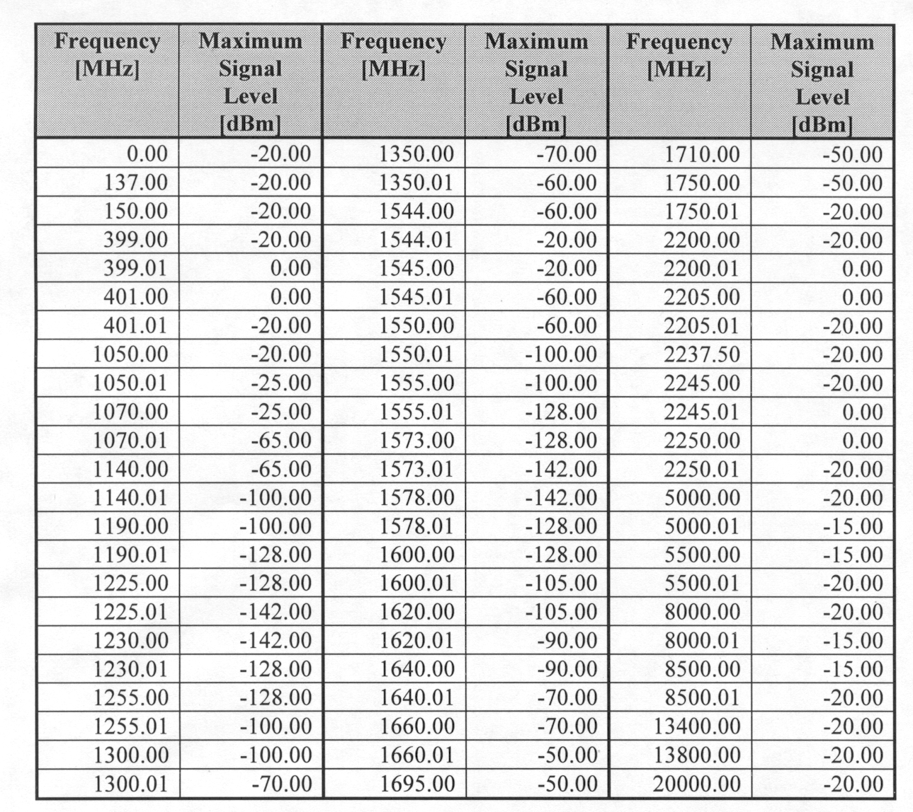
GIID3.3.2.2.5.2-8
Testing of specific instruments at specific frequencies beyond 18GHz may be required if there is reason to believe that the instrument’s emissions may interfere with another instrument’s mission performance. Such cases shall be identified in the UIID. Justification may be based on some combination of legacy experience, analysis and preliminary test results.

3.3.2.2.5.3 Radiated Susceptibility, RS101
GIID3.3.2.2.5.3-1
The instrument shall meet the requirements of MIL-STD-461E, except that RS101 shall apply (TBR), but only the Navy requirement (Figure RS101-1) (TBR) shall apply. (See comments for RE101.)

3.3.2.2.5.4 Radiated Susceptibility RS103
(Note: This paragraph specifically covers susceptibility to emissions from equipment on the NPOESS satellite. Susceptibility to emissions from external transmitters, and general RF susceptibility, is covered in paragraphs under and including paragraph 3.3.2.2.3.1.)
GIID3.3.2.2.5.4-1
The instrument shall operate without degradation when exposed to levels shown in the on-orbit column of Table 3.3.2.2.3.1 at the frequencies given in Table 3.3.2.2.5.2a outside its passband. Modulation shall be as appropriate for the given frequency/emitter, or if unknown, shall be assumed to be 50% amplitude modulation by a 100 Hz square wave.

Note: this requirement is intended to provide at least 12 dB margin between what the maximum field strength (from satellite sources) is to be in the vicinity of the instrument, and what the instrument needs to operate through. Similar margin is NOT provided against signals from external sources, which are less likely to be continuous disruptions.

3.3.3 Reserved

3.3.4 Workmanship
GIID3.3.4-1
Critical steps of fabrication which are item-peculiar shall be detailed in drawing notes and figures which include appropriate workmanship criteria.
GIID3.3.4-2
Workmanship relating to all other aspects of fabrication shall be in accordance with the Quality Control Plan approved for each manufacturing facility.

3.3.5 Interchangeability
GIID3.3.5-1
In order to expedite maintenance and repair, all instruments shall be configured so as to facilitate modular replacement .
GIID3.3.5-2
All components, assemblies, subassemblies, and modules that are identical with respect to fit, form, and function shall be interchangeable.
GIID3.3.5-3
Parts that are not functionally, electrically, and dimensionally interchangeable shall have different part numbers.

3.3.6 Safety Requirements
GIID3.3.6-1
Hazards to personnel, hardware, or the environment during design, test, manufacture, integration and assembly, handling, transportation, and operations of the instrument shall be identified and controlled or eliminated.
GIID3.3.6-2
Design and operational safety requirements shall be developed and implemented to eliminate or control personnel, hardware, or environmental hazards.
GIID3.3.6-3
Instruments and deliverable support equipment developed for this program shall comply with EWR 127-1 in the areas of design safety, launch integration, and ground operations.
GIID3.3.6-4
Software controlling hazardous systems or operations (e.g., electro-explosive devices, electromechanical release devices, etc.) shall be assessed for hazard severity and probability in accordance with AFM 91-201 and using MIL-STD-882D as a guide.
GIID3.3.6-5
An instrument safety program shall be established and maintained, using MIL-STD-882D as a guide.

3.3.6.1 Design Safety Criteria
GIID3.3.6.1-1
Space debris shall not be generated.
GIID3.3.6.1-2
Interfaces shall be designed in accordance with the safety requirements in EWR 127-1.
GIID3.3.6.1-3
Non-explosive actuators shall be preferred over pyrotechnic devices wherever practicable in order to minimize shock loads. A fast release requirement can preclude this design option (paraffin actuators are slow to release.) EEDs may be used where the use of such devices can be shown to reduce risk, as long as justification is provided.
GIID3.3.6.1-4
Non explosive release devices shall be activated (commanded) as described in the UIID.
GIID3.3.6.1-5
Paraffin and other non-explosive actuators shall use the 28 volt (TBR) power bus for actuating power.
GIID3.3.6.1-6
Electro-explosive devices, where required, shall be activated (commanded) as described in the UIID.
GIID3.3.6.1-7
The EED power shall be provided from the spacecraft 28 volt (TBR) pyro/safety power bus.
GIID3.3.6.1-8
All EEDs shall be used in accordance with manufacturer's recommendations. Connections, circuit configuration, current, firing characteristics, and command requirements shall be documented in the UIID.
GIID3.3.6.1-9
All applicable safety-related explosive ordnance design requirements shall be met.
GIID3.3.6.1-10
MIL-HDBK-83578 should be used as a guide for explosive ordnance to be installed on an instrument.
GIID3.3.6.1-11
Actuating circuitry for electro-explosive devices and safety-related non-explosive actuators shall be two-fault tolerant to unanticipated deployment or release.

This requires three electrical/mechanical interlocks, but does not require all three interlocks to be different for each actuating device.
GIID3.3.6.1-12
EED firing circuitry shall be configured so as to prevent inadvertent firing of the EED due to stray noise pickup when the circuitry is in the non-firing state.
GIID3.3.6.1-13
Where EEDs are used, the firing circuit shall utilize fusistors that clear the circuit in ≤ 2 seconds if a short circuit has occurred in the circuit.
GIID3.3.6.1-14
Safe plugs and Arm plugs for deployment actuators shall be located on the spacecraft rather than on the instrument and connected to the instrument via a dedicated instrument-mounted connector.
GIID3.3.6.1-15
The maximum and minimum impedance inserted by the ARM plug and its associated cabling shall be specified in the UIID.

GIID3.3.6.1-16
The "Safe" Plug shall:
a) interrupt (open circuit) the power and power return lines for each EED circuit
b) ensure through shunting and grounding that the EEDs can not be fired by stray noise pickups.
c) remain in place throughout spacecraft integration and testing, whenever EEDs are installed on the spacecraft, unless specifically replaced by the flight "Arm" plug for EED testing or preflight readiness.

GIID3.3.6.1-17
The "Arm" Plug shall:
a) connect the firing circuits to the EEDs while maintaining the continuity of the twisted shielded pair and without violating their independent grounding
b) replace the "Safe" plug prior to launch, according to Range Safety procedures.
GIID3.3.6.1-18
Instrument EED circuitry shall be capable of being tested 50 times at rated load, without damage or degradation to the EED or associated circuitry, using a dummy device.
GIID3.3.6.1-19
Actual EEDs shall be capable of being fired during integration and test without damage to the Instrument.

3.3.7 Human Engineering
GIID3.3.7-1
The operator-hardware and operator-software interfaces shall be designed to maximize safety, efficiency, and usability, and minimize number of personnel, resources, skills, and training.
GIID3.3.7-2
The operator-software interface shall be developed using open systems technology.
GIID3.3.7-3
The operator-software interface shall be designed using an iterative design methodology consisting of rapid prototyping, usability evaluation, and feedback to design.

3.3.8 Nuclear Control
GIID3.3.8-1
Provisions shall be made for the control of all nuclear materials, such as radioactive sources, if used in manufacturing, calibration, and checkout of mission instruments.

3.3.9 Security

3.3.9.1 Communications Security (COMSEC)
Communications security (COMSEC) measures provide protection for the transmission of sensitive information.
GIID3.3.9.1-1
The probability that the instrument will accept the following as a valid command shall be no more than once over the life of each instrument:
a. An invalid command
b. Noise
GIID3.3.9.1-2
The instrument shall check for invalid commands and execute only valid commands.
GIID3.3.9.1-3
Invalid commands shall be reported in telemetry.

3.3.9.2 Computer Security (COMPUSEC)
GIID3.3.9.2-1
Any instrument element that processes multiple security levels of data shall comply with DOD 5200.28-STD, paragraph 3.1.1.3.

3.3.10 Reserved

3.3.11 Computer Resources
Computer resources include all computer software and the associated computational equipment included within the instrument.

3.3.11.1 Operational Computer Resources

3.3.11.1.1 Operational Computational Equipment
The computational equipment includes processing units; special-purpose computational devices; main storage; peripheral data storage; input and output units.

3.3.11.1.2 Operational Application Software (TBS)

3.3.11.1.3 Operating Systems Used in Operational Computers

3.3.11.1.3.1 Instruments Flight Software Requirements

3.3.11.1.3.1.1 Instrument Flight Software Version Control
GIID3.3.11.1.3.1.1-1
All software and firmware shall be implemented with an internal identifier (embedded in the executable program) that can be included in the instrument engineering data.
GIID3.3.11.1.3.1.1-2
This identifier shall be keyed to the configuration management process so that the exact version of software and firmware residing in the instrument can be determined at any time.

3.3.11.1.3.1.2 Instrument Flight Software Load
GIID3.3.11.1.3.1.2-1
Following power-up, the instrument shall be functional without requiring a software or data upload.
GIID3.3.11.1.3.1.2-2
After power up, the instrument shall be capable of accepting software uploads and/or table uploads, as required, where the size and frequency of the uploads is identified in the UIID.

3.3.11.1.3.1.3 Instrument Flight Software On-Orbit Installation and Verification
GIID3.3.11.1.3.1.3-1
Flight software shall be designed so that complete or partial revisions can be installed and verified on-orbit, consistent with C³ constraints.

This means, for example, that loads may occur over multiple ground contacts. As such, active memory must not be altered until the complete load is received and verified, at which time the newly uplinked information can be utilized.

3.3.11.1.3.2 Programming Language

3.3.11.1.3.2.1 Language Standards
GIID3.3.11.1.3.2.1-1
Instrument software, except where implemented on digital signal processing hardware, shall be implemented using standard Ada (ANSI/ISO/IEC 8652:1995), C (ANSI/ISO/IEC 9899:1990), or C++ (ISO/IEC 14882:1998) using modern object-oriented constructs

3.3.11.1.4 Software Coding Conventions
GIID3.3.11.1.4-1
Code shall be written such that no code is modified during execution.
GIID3.3.11.1.4-2
Instrument contractors shall use CSTOL (Colorado System Test and Operations Language), or other language agreeable to the TSPR contractor, for their Instrument test procedures and shall populate the data base tables with their instrument parameters.
GIID3.3.11.1.4-3
Validated procedures and tables shall be delivered to the Spacecraft Contractor.
GIID3.3.11.1.4-4
The instrument contractor shall deliver a Software Development Plan (SDP) three months after contract award. The SDP shall specify the instrument contractor’s processes for developing both instrument and algorithm software. These processes shall reflect the complete software development life cycle (i.e., from the generation of software requirements through the verification test of delivered functionality), including all supporting activities (e.g., planning and oversight, software quality assurance, configuration management) and a description of all documentation generated.

3.3.11.2 Instrument GSE to Spacecraft I&T GSE Interface
GIID3.3.11.2-1
The instrument electrical GSE shall interface with the spacecraft electrical GSE via a local area network and point-to-point links, if necessary, for spacecraft level testing.
GIID3.3.11.2-2
Electrical instrument GSE shall receive instrument telemetry via the spacecraft electrical GSE.
GIID3.3.11.2-3
Commanding of the instrument shall be from the spacecraft electrical GSE, through the spacecraft C&DH subsystem.

3.3.12 Instrument Design Requirements
The spacecraft and instruments must survive the critical loading conditions that exist within the envelope of handling, launch environment, and mission requirements. The detailed requirements are provided in the following sections.

3.3.12.1 Structural Analyses
The launch vehicle/spacecraft coupled loads analysis will be performed by the launch vehicle contractor.
GIID3.3.12.1-1
The spacecraft contractor shall be responsible for providing the results of the launch vehicle/spacecraft coupled loads analysis in a standard format to the instrument contractors.
GIID3.3.12.1-2
The spacecraft contractor shall provide mission-specific information for maximum equivalent loads to the instrument contractor for static loads analyses.
GIID3.3.12.1-3
The instrument contractor and spacecraft contractor shall coordinate on analyses. The two parties should reach an agreement about assumptions and model development either by test or by close coordination between the two structural analysis groups.
GIID3.3.12.1-4
The spacecraft contractor shall be responsible for the combined structural dynamics analysis of the spacecraft bus and the instruments.
GIID3.3.12.1-5
The spacecraft contractor shall provide the combined structural dynamics analysis results to the instrument contractors.
GIID3.3.12.1-6
A structural analysis using maximum equivalent loads shall be conducted on the instrument.

3.3.12.2 Strength Requirements
Limit load is defined as the highest expected load, including environmental effects.

3.3.12.2.1 Yield Load
GIID3.3.12.2.1-1
The structure shall be designed to have sufficient strength to withstand simultaneously the yield loads, applied temperature, and other accompanying environmental phenomena for each design condition without experiencing yielding or detrimental deformation.

3.3.12.2.2 Ultimate Load
GIID3.3.12.2.2-1
The structure shall be designed to withstand simultaneously the ultimate loads, applied temperature, and other accompanying environmental phenomena without failure.

3.3.12.3 Stiffness Requirements

3.3.12.3.1 Dynamic Properties
GIID3.3.12.3.1-1
The structural dynamic properties of the equipment shall be such that its interaction with the instrument control subsystem does not result in unacceptable degradation of performance.

3.3.12.3.2 Structural Stiffness
GIID3.3.12.3.2-1
Stiffness of the structure and its attachments shall be controlled by the equipment performance requirements and by consideration of the handling and launch environments.
GIID3.3.12.3.2-2
Special stowage provisions shall be used, if required, to prevent excessive dynamic amplification during transient flight events.

3.3.12.3.3 Component Stiffness
GIID3.3.12.3.3-1
Except as permitted below, each separately-mounted instrument component, configured for launch, shall have a fixed-base fundamental resonant mode frequency of greater than 50 Hz.

Fixed-base is defined as follows: Each mounting point shall be constrained in those translational degrees of freedom which are rigidly attached to the spacecraft and shall be free in those translational degrees of freedom for which kinematic mounts or flexures provide flexibility.

GIID3.3.12.3.3-2
Detailed analyses of the potential responses of the component to inputs from the adjoining structure(s) shall be required for components having fundamental resonant mode frequencies of less than 50 Hertz.
GIID3.3.12.3.3-3
A test-verified (refer to paragraph 4.2.4.1.5) detailed finite element model shall be provided if the instrument exceeds 23 kilograms and the fundamental resonant mode frequency is less than 50 Hz, as shown by analysis.
GIID3.3.12.3.3-4
The spacecraft shall provide an installation frequency of ≥ 35 Hz for all components ≤ 23 kg (components is assumed rigid with the same attachment envelope).
GIID3.3.12.3.3-5
The fundamental resonant mode frequency for an instrument in its on-orbit configuration shall be 6 Hz or greater.
GIID3.3.12.3.3-6
The instrument contractor shall ensure that the instrument dynamic characteristics and control capability (e.g., a gimbaled instrument) will meet the requirements specified for the deployed frequency.

3.3.12.4 Structural Factors of Safety
The factor of safety of the structure is the ratio of the maximum stress that a structural part or other piece of material can withstand to the maximum stress estimated for it in the use for which it is designed (limit load).

3.3.12.4.1 Flight Limit Loads
GIID3.3.12.4.1-1
Limit loads shall be applied through the center of mass (CM) of the instrument, configured for launch, to design the mounting interface.
GIID3.3.12.4.1-2
The loads shall be applied simultaneously using combination of +/- loads in such a way as to produce the maximum stresses.
GIID3.3.12.4.1-3
The minimum design factors of safety of Table 3.3.12.4.1 below, for the selected option, shall be applied to all loading conditions.

Table 3.3.12.4.1 Structural Design Factors of Safety
Design/Test Options | Factors of Safety (Yield) | Factors of Safety (Ultimate) | Test Level Factors
1. Dedicated test article | 1.00 | 1.25 | 1.25
2. Test on 1st flight article | 1.25 | 1.40 | 1.25
3. Proof test each  flight article | 1.10 | 1.25 | 1.10
4. No static test | 1.60 | 2.00 | N/A

The factors of safety shown above are in addition to contractor-determined margins. The standard definitions apply, namely, no detrimental deformation at the yield value, and no failures at the ultimate value.

Option 1 - “Dedicated test article” is a qualification test article (non-flight) that will be subjected to the maximum expected loads times a test level factor of 1.25. static strength testing of subsequent units is not required.

Option 2 - “Test on 1st flight article” refers to a protoqualification on the first flight article, at the same test level factor. static strength testing of subsequent units is not required.

Option 3 – “Proof test each flight article” allows lower factors of safety and test factors, but must be performed on each unit. All composite structures and structural bonded joints fall into this category, regardless of safety factor.

Option 4 – “No static test” refers to items not undergoing static testing at all, and therefore, requiring higher factors of safety relative to yield and ultimate.

GIID3.3.12.4.1-4
All composite structures and structural bonded joints shall be proof tested, regardless of safety factor.
GIID3.3.12.4.1-5
The instrument contractor shall perform a structural analysison each separately-mounted instrument component.
GIID3.3.12.4.1-6
The structural analysis documentation shall be available for review by the spacecraft contractor.
GIID3.3.12.4.1-7
In the absence of a better definition of maximum expected loads, the load factors given in the mass-acceleration curve shown in Figure 3.3.12.4 shall be used.
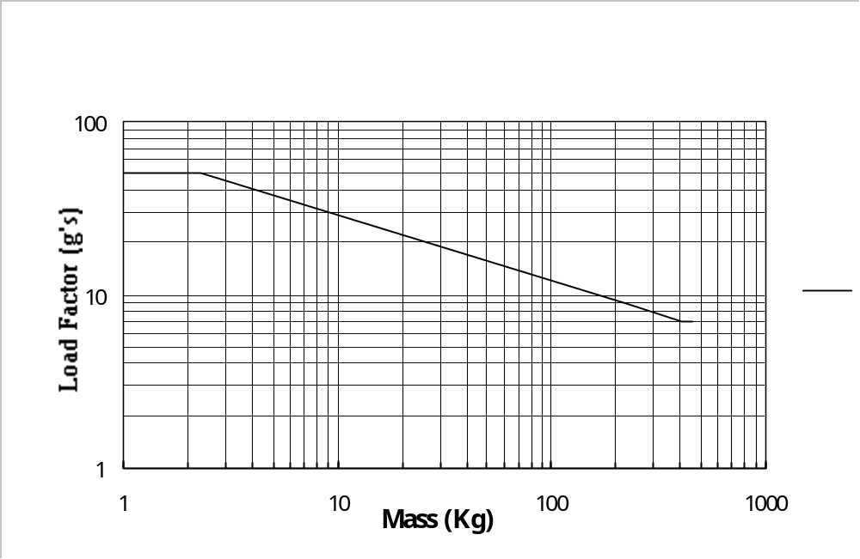
Figure 3.3.12.4 Acceleration Load Factors (Limit)

GIID3.3.12.4.1-8
The flight hardware shall be capable of withstanding all worst-case load conditions to which it may be exposed, without requiring additional recalibration or realignment. This includes handling and transportation, test, pre-launch operations, launch, and on-orbit operations.
GIID3.3.12.4.1-9
Positive structural margins of safety shall be maintained so that the instrument can meet all design requirements after being subjected to the worst-case load combinations.
GIID3.3.12.4.1-10
In those cases involving maintenance of instrument critical components for on-orbit operations, the precision elastic limits shall be used for structural materials.

This means that for critical components, a micro-yield criteria should be used, that is, a low stress level/high margin design.

3.3.12.4.2 Pressure Loads
GIID3.3.12.4.2-1
Instruments with pressurized systems shall follow the requirements in accordance with EWR 127-1 for the design of pressurized systems and using MIL-STD-1522A for guidance.
GIID3.3.12.4.2-2
Factors of safety for pressure loads shall be determined individually for each pressure vessel, based on tests to establish material characteristics and an analysis of life requirements and other environmental exposure.
GIID3.3.12.4.2-3
Proof and burst pressure factors shall be established at levels that ensure structural integrity, structural life, and safety throughout all phases, using the values listed in Table 3.3.12.4.2 below as limiting lower bounds.
Table 3.3.12.4.2 Factors of Safety for Pressurized Components
 | Design | Acceptance | Qualification
Component | (Ultimate) | (Proof) | (Burst)
Pneumatic Vessels (SVE)ª | 2.00 | 1.50b | 2.00b
Pneumatic Vessels (GSE)ª | 4.00 | 2.00^{b} | 4.00
Lines, Fittings, and Hoses
Less than 3.81 cm diameter | 4.00 | 2.00b | 4.00b
3.81 cm diameter and larger | 1.50 | 1.10b | 1.50b
Other Pressurized Components | 2.50 | 2.00b | 2.50b
See Notes below.
Notes:
ª | Factors of safety shown are minimum values applicable to metallic pressure vessels for which ductile fracture mode is predicted via a combination of stress and fracture mechanics analyses. Design of metallic pressure vessels for which brittle fracture mode is predicted by these analyses should be in accordance with fracture mechanics methodology, wherein the proof factor as well as the design ultimate factor of safety are established to provide a minimum of four times the specified service life against mission requirements. In addition, a fracture control program should be established to prevent structural failure due to the initiation or propagation of flaws or crack-like defects during fabrication, testing, and service life.
^{b} | No measurable yielding is permitted at acceptance (proof) test pressure and no rupture at qualification pressure.

3.3.12.5 Design Load Conditions
GIID3.3.12.5-1
The instrument equipment shall be capable of withstanding all design load conditions to which it is exposed in all mission phases, as applicable: ground, prelaunch, erection, post-launch, boost, and orbit.
GIID3.3.12.5-2
During the orbit phase, all of the following shall be considered: maneuvering loads, vehicle spin, meteoroid environment, radiation environment, and other environmental factors, such as thermal effects due to internal heating, solar heating, eclipses, and extreme cold due to ambient space environment.

3.3.12.6 Instrument Fluid Subsystems

3.3.12.6.1 Tubing
GIID3.3.12.6.1-1
Tubing design shall incorporate provisions for cleaning and to allow proof testing.

3.3.12.6.2 Separable Fittings
GIID3.3.12.6.2-1
Separable fittings shall have redundant sealing surfaces, such as double “O” rings, and be of the “parallel loaded” type.
“Parallel loaded” means that the fitting contains a compressed element which exerts outward pressure on the other elements of the fitting such that both seals are maintained even if relaxation occurs.
GIID3.3.12.6.2-2
Separable fittings shall have provisions for locking.
GIID3.3.12.6.2-3
Separable fittings shall be accessible for leak tests and for torque checks.
GIID3.3.12.6.2-4
Separable fittings shall not be designed or assembled with lubricants or fluids that could cause contamination or could mask leakage of a poor assembly.
GIID3.3.12.6.2-5
Separable fluid fittings shall not use “B” nuts, unless specifically allowed in the UIID.
GIID3.3.12.6.2-6
Separable fluid fittings shall be comprised of one or more compressed or internally pressure-energized members which maintain a seal even if stress relaxation occurs in any of the other components.
GIID3.3.12.6.2-7
Separable fluid fittings shall have redundant seals in series.
GIID3.3.12.6.2-8
Separable fluid fittings shall be lockwired to prevent any rotation between the fitting and the nut.
GIID3.3.12.6.2-9
The instrument shall have no open fluid reservoirs when delivered to the spacecraft contractor.

3.3.12.7 Moving Mechanical Assemblies
GIID3.3.12.7-1
Deployment mechanisms, instrument mechanisms, pointing mechanisms, drive mechanisms, de-spin mechanisms, separation mechanisms, and other moving mechanical assemblies on instruments should be in accordance with MIL-A-83577B in order to increase reliability of Moving Mechanical Assemblies (MMAs) and facilitate integration and test activities.
GIID3.3.12.7-2
System level test impacts shall be considered in the instrument design; for example, gimballing in a 1 ‘g’ environment, momentum compensation, and the use of GSE.

3.3.12.7.1 Actuating Devices (See Section 3.3.6.1)

3.3.12.7.2 Instrument Disturbance Allocation
The spacecraft contractor will provide estimates of allowable disturbance torque, vibration, and end-of-travel or latch-up loads to the instrument contractor. The design will be an iterative process to accommodate the requirements of both the spacecraft contractor and instrument contractor.
GIID3.3.12.7.2-1
The instrument contractor shall provide analysis and test data that will allow the spacecraft contractor to ensure that the “swept” or deployed volume is verified, accounting for all distortions and misalignments.
GIID3.3.12.7.2-2
Early estimates of gimbaled masses, inertia’s, and cg’s shall be provided to the spacecraft contractor to permit sizing the control components to meet pointing and stability requirements.

3.3.12.7.3 Instrument Mechanisms
GIID3.3.12.7.3-1
All instrument mechanisms which require restraint during launch shall be caged during launch without requiring power to maintain the caged condition.
GIID3.3.12.7.3-2
Instrument mechanisms which require caging and/or uncaging during test and launch site operations shall be capable of being caged and uncaged by command and by manual actuation of accessible locking/unlocking devices.
GIID3.3.12.7.3-3
Instrument mechanisms which require uncaging and/or caging on-orbit shall be capable of being caged and uncaged by command.

3.3.12.7.4 Uncompensated Momentum
GIID3.3.12.7.4-1
Each instrument having movable components shall not exceed an uncompensated momentum contribution of +/- 0.5 N-m-sec per axis.
GIID3.3.12.7.4-2
The typical uncompensated momentum contribution of the instrument shall be documented in the instrument UIID.

3.3.12.7.5 Instrument Disturbance Allocations

3.3.12.7.5.1 Periodic Disturbance Torque Limits
GIID3.3.12.7.5.1-1
The instrument contractor shall provide, in electronic format, time/magnitude plots of their disturbances, for decomposition by the spacecraft contractor, of the sum of the instrument-induced periodic disturbance torques, in order to produce the corresponding magnitude spectrum.
GIID3.3.12.7.5.1-2
The magnitude of the periodic disturbance torque, including the torque resulting from linear forces reacting from the instrument to the spacecraft) shall be in the acceptable range of Figure 3.3.12.7.5.1 for all frequencies.
The transition points for Figure 3.3.12.7.5.1 are shown in Table 3.3.12.7.5.1, for clarity.
GIID3.3.12.7.5.1-3
The instrument UIID shall specify the predicted disturbance torque contributions to the spacecraft, if any.

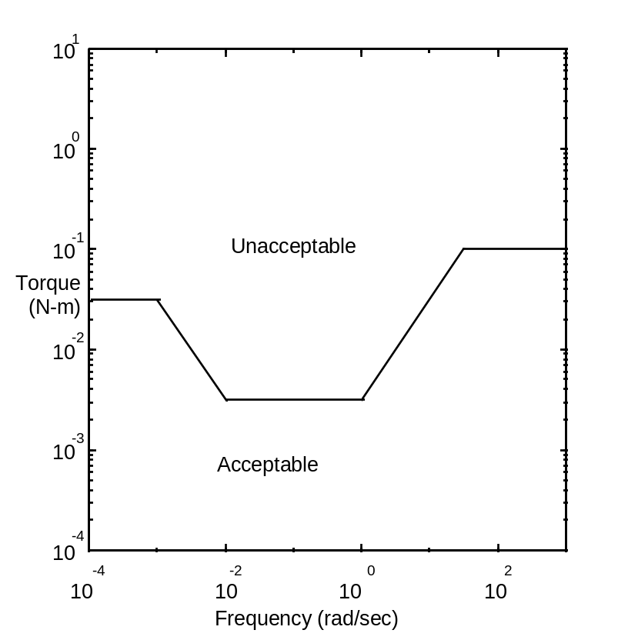
Figure 3.3.12.7.5.1 Allowed Transmitted Torque

Table 3.3.12.7.5.1 Allowable Transmitted Torque Transition Points
Frequency (rad/sec) | Torque (N-m)
< 0.001 | 0.03
0.01 | 0.003
1.0 | 0.003
> 33.3 | 0.1

3.3.12.7.5.2 Constant Disturbance Torque Limits
GIID3.3.12.7.5.2-1
Instrument-induced constant disturbances of the same polarity, separated by more than 200 seconds, shall not exceed the torque limit defined in Figure 3.3.12.7.5.2 if the duration of application is in excess of 10 seconds. For constant torques of 10 seconds duration or less, the impulse limit is 0.04 N-m-s. For constant torques of 400 seconds duration or more, the torque limit is maintained at the 400 second limit shown in Figure 3.3.12.7.5.2.
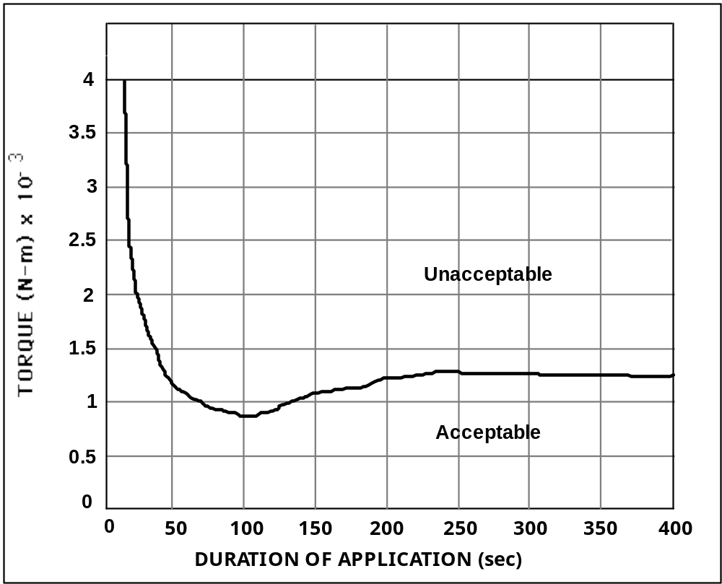

Figure 3.3.12.7.5.2 Constant Torque vs. Duration of Application

3.3.12.7.5.3 Disturbance Torque Limits for Linear Forces
GIID3.3.12.7.5.3-1
The same requirements specified above for constant and periodic torques shall apply when linear forces are converted to torques, assuming a moment arm of 2 m for motion along the pitch or yaw axes and 3 m for motion along the roll axis.

GIID3.3.12.7.5.3-2
The torques about the spacecraft CM resulting from instrument linear forces shall be documented in the instrument UIID.

3.3.12.7.5.4 Spacecraft Non-Operational Deployment Disturbance
GIID3.3.12.7.5.4-1
The on-orbit non-operational Spacecraft disturbances produced by the uncaging or deployment of any mechanism or device shall be less than 158 N-m (TBR), at the point of attachment.

3.3.12.7.5.5 Torque Profile Documentation
GIID3.3.12.7.5.5-1
The instrument contractor shall provide the typical instrument torque versus time profile to the spacecraft contractor for documentation in the UIID.

3.3.12.7.5.6 Thrust Direction Definition
GIID3.3.12.7.5.6-1
The instrument contractor shall provide to the spacecraft contractor the magnitude and direction of net thrust, timing of expulsion events, and expulsion material resulting from the expulsion of expendables by the instrument, for documentation in the UIID.

3.3.12.8 Magnetics
The use of large quantities of magnetic materials shall be avoided where possible.
GIID3.3.12.8-1
If magnets are inherent to the instrument design, early estimates of magnetic fields and residual magnetic dipole moments shall be provided to the spacecraft contractor.
GIID3.3.12.8-2
If the uncompensated magnetic moment of an instrument exceeds 0.0005 ampere-turn-meter-square (0.5 pole-cm) [where 1 pole cm = 0.2 nano Tesla at 1 meter distance] per kilogram of mass., a full magnetic survey shall be conducted and corrective action taken. This allocation is done on a per-box basis, and may not be re-allocated between instrument boxes for instruments with separately mounted units.

3.3.12.9 Access

3.3.12.9.1 Access Identification
GIID3.3.12.9.1-1
The instrument contractor shall provide to the spacecraft contractor access requirements for documentation in the UIID.

3.3.12.9.2 General Access
GIID3.3.12.9.2-1
All items to be installed, removed, or replaced at the spacecraft level shall be easily accessible without disassembly of the unit.

GIID3.3.12.9.2-2
Access requirements and clearances shall be mutually agreed-upon between the spacecraft contractor and the instrument contractor.

3.3.12.10 Mounting/Handling

3.3.12.10.1 Handling Fixtures
GIID3.3.12.10.1-1
The instrument contractor shall provide proof-tested handling fixtures for each subsystem for each separately mountable unit with a mass in excess of 2 kilograms, or which has special handling restrictions due to surfaces or delicate mechanisms.
GIID3.3.12.10.1-2
Documentation of the fixture certification shall be delivered with the fixture.
GIID3.3.12.10.1-3
Instrument handling fixtures shall be designed to 5 times limit load for ultimate and 3 times limit load for yield.
GIID3.3.12.10.1-4
Instrument handling fixtures shall be tested to 2 times working load.

3.3.12.10.2 Mounting Orientation
GIID3.3.12.10.2-1
Instrument design shall be such that the instrument is capable of being mounted to the spacecraft with the spacecraft in either the horizontal or vertical position.

Note: This requirement is intended to provide flexibility to the spacecraft contractor. Once a spacecraft contractor has been chosen, there may be a single, preferred orientation.

3.3.12.10.3 Instrument-to-Spacecraft Integration and Test Mounting
(The requirements in this section apply to both the instrument contractor and the spacecraft contractor, and requires close co-ordination between the two.)
GIID3.3.12.10.3-1
Each separately-mountable instrument component shall be capable of being installed and removed without removal of other instruments or subsystems, and without demating or removal of harness (including coax) other than for the unit being removed.
GIID3.3.12.10.3-2
Connector access for removal and reassembly of an instrument shall be accomplished without requiring removal of any equipment.
GIID3.3.12.10.3-3
Instrument mounting hardware shall be installed from the instrument side of the spacecraft – instrument mechanical interface.
GIID3.3.12.10.3-4
Installation/removal of any separately-mountable component shall not require rotation during installation/removal.

3.3.12.10.4 Non-Flight Equipment
GIID3.3.12.10.4-1
The instrument contractor shall provide to the spacecraft contractor information on all items to be installed or removed prior to flight, for identification in the UIID.

3.3.12.11 Venting

GIID3.3.12.11-1
Instrument contractors shall provide to the spacecraft contractor the location, size, path, and operation time of vents in the instruments for inclusion in the UIID.
GIID3.3.12.11-2
The instrument shall limit continuous venting forces to < 4.4482E-05 N (TBR).
GIID3.3.12.11-3
The instrument shall limit random venting impulses to < 0.1245 Newton-seconds (TBR) per orbit.
GIID3.3.12.11-4
The direction of net thrust resulting from the expulsion of expendables (venting) by the instrument shall be adjustable at the spacecraft level without compromising pointing performance or knowledge.
GIID3.3.12.11-5
The Spacecraft Contractor shall place the instrument such that the contamination products from the vents of one instrument will not directly impinge on another instrument's contamination-sensitive surface nor directly enter another instrument's aperture – unless it can be shown by analysis (by the spacecraft contractor) that the performance of the instrument will not be degraded.

3.3.13 Reserved

3.3.14 Ground support equipment
GIID3.3.14-1
All GSE requirements shall be documented in the UIID. This documentation includes, but is not limited to, to following: Power, weight, cooling requirements (if necessary), dimensions, and any special moving requirements.
GIID3.3.14-2
All instrument electrical ground support equipment (IEGSE) shall have separate and isolated grounds for DC power, telemetry, and facility AC power.
GIID3.3.14-3
IEGSE chassis shall be grounded to facility AC power ground.
GIID3.3.14-4
IEGSE required at the launch site on-stand shall be designed to be explosion proof.
GIID3.3.14-5
Instrument mechanical ground support equipment (IMGSE) shall be painted with non-shedding paint. Metal surfaces shall be painted or coated.
GIID3.3.14-6
Large lifting slings shall have grounding capability.

3.3.15 General Construction Requirements
GIID3.3.15-1
All items to be installed, removed, or replaced at the instrument or spacecraft level shall utilize captive hardware, except instrument mounting hardware.
GIID3.3.15-2
All items (non flight equipment) to be removed prior to flight shall be red with a red “Remove Before Flight” tag.
GIID3.3.15-3
All items to be installed at the launch site, such as instrument flight plugs, shall be considered “green tag” (Install Before Flight) items.

3.3.15.1 Processes and Controls for Space Equipment
Acceptance and flight certification of instrument equipment is based primarily on an evaluation of data from the manufacturing process.
GIID3.3.15.1-1
The manufacturing process for instrument equipment shall be accomplished in accordance with documented procedures and process controls which assure the reliability and quality required for the mission.
GIID3.3.15.1-2
These manufacturing procedures and process controls shall be documented to give visibility to the procedures and specifications by which all processes, operations, inspections, and tests are to be accomplished by the instrument contractor.
GIID3.3.15.1-3
Each lot shall be manufactured, tested, and stored with sequential lot numbers that indicate the date of manufacture assigned to each lot. (Typically, use three digits for the day of the year and two digits for the year.)
GIID3.3.15.1-4
Instrument contractor documentation shall include each material required.
GIID3.3.15.1-5
Instrument contractor documentation shall include the point each material enters the manufacturing flow.
GIID3.3.15.1-6
Instrument contractor documentation shall include the controlling specification or drawing.
GIID3.3.15.1-7
The documentation shall indicate required tooling corresponding to each applicable process or material listed.
GIID3.3.15.1-8
The documentation shall indicate facilities and test equipment corresponding to each applicable process or material listed.
GIID3.3.15.1-9
The documentation shall indicate the manufacturing check points corresponding to each applicable process or material listed.
GIID3.3.15.1-10
The documentation shall indicate the quality assurance verification points corresponding to each applicable process or material listed.
GIID3.3.15.1-11
The documentation shall indicate the verification procedures corresponding to each applicable process or material listed.
GIID3.3.15.1-12
The specifications, procedures, drawings, and supporting documentation shall reflect the specific revisions in effect at the time the items were produced.
GIID3.3.15.1-13
Flow charts and the referenced specifications, procedures, drawings, and supporting documentation become the manufacturing process control baseline and shall be retained by the instrument contractor for reference.
GIID3.3.15.1-14
All changes to the baseline processes used, or the baseline documents used shall be recorded by the instrument contractor following the establishment of the manufacturing baseline. It is recognized that many factors may warrant making changes to this documented baseline; however, these changes provide the basis for flight accreditation of manufactured or of subsequent flight items.
GIID3.3.15.1-15
The manufacturing process and control documents for instrument equipment shall provide an instrument contractor-controlled baseline that assures that any subsequent failure or discrepancy analysis that may be required can identify the specific manufacturing materials and processes that were used for each item. In that way, changes can be incorporated to a known baseline to correct the problems.

3.3.15.1.1 Assembly Lots
GIID3.3.15.1.1-1
To the extent practicable, parts for use in instrument equipment shall be grouped together in individual assembly lots during the various stages of their manufacture to assure that all devices assembled during the same time period use the same materials, tools, methods, and controls.
GIID3.3.15.1.1-2
Parts and devices for instrument equipment that cannot be tested adequately after assembly without destruction of the item, such as explosive ordnance devices, some propulsion components, and complex electronics, shall have lot controls implemented during their manufacture to assure a uniform quality and reliability level of the entire lot.

3.3.15.1.2 Contamination
GIID3.3.15.1.2-1
An instrument-level contamination control program shall be developed and implemented.
GIID3.3.15.1.2-2
The contamination interface requirements shall be provided to the spacecraft contractor for inclusion in the UIID. This includes contamination sensitivity of the instrument, as well as identification and characterization of all sources of contamination that can be emitted from the instrument. (see requirement –6 below)
GIID3.3.15.1.2-3
A system-level contamination plan shall be developed by the spacecraft contractor, taking into consideration instrument and other instrument equipment and facility contamination and cleanliness requirements, along with the spacecraft requirements, and the resulting contamination budget provided to each instrument contractor.
GIID3.3.15.1.2-4
As part of the contamination control analysis development, the spacecraft contractor shall perform a particulate and molecular plume flowfield analysis for all spacecraft thrusters, vents and out-gassing surfaces, providing molecular flux quantities into instrument apertures at the time they are opened on-orbit and total predicted depositions at end-of-life onto all sensitive surfaces.
GIID3.3.15.1.2-5
The spacecraft contractor’s plume analyses shall include the identity and quantity of each chemical species emitted and provide sufficient dynamic information to determine the flux rate at initial cover opening and final deposition amount on all sensitive surfaces and apertures. Margin shall be given for an additional contribution from the payload fairing and launch vehicle thrusters fired after the payload fairing has been jettisoned.
GIID3.3.15.1.2-6
The spacecraft and instrument contractors shall identify and characterize all sources of contamination, particulate or molecular, that can be emitted.
At a minimum, the characterization of molecular and particulate contamination shall include the material name, the amount, the emission rate, and its location. Data from the ASTM 1559 shall be used if available. If not, ASTM E-595 test for percent total mass loss (%TML) and percent collected volatile condensable material (%CVCM) shall be used. The out-gassing chemical species and any tendency to photodeposit in a UV or energetic particle radiation environment shall be identified and quantified.
GIID3.3.15.1.2-7
The instrument contractor shall document to the spacecraft contractor the materials released by explosive and non-explosive deployment actuators, and where such materials are determined to be excessive, shall provide containment.

The intent of this requirement is to minimize release of actuating material, and to provide containment where release would affect that instrument or any other spacecraft component.
GIID3.3.15.1.2-8
The spacecraft contractor shall perform a total spacecraft contamination analysis of all contributing deployment devices on all sensitive surfaces and document the results to the instrument contractor.
GIID3.3.15.1.2-9
The Instrument contractor shall specify, for documentation in the
UIID, if and when protective covers (such as bags, draping materials, or hard
Covers), or purging, are required to keep the instrument clean during I&T, including during shipping and storage.
GIID3.3.15.1.2-10
The Instrument contractor shall provide instrument protective covers and specify procedures for their use. The covers shall protect fragile components from minor impact as well as contamination.
GIID3.3.15.1.2-11
The spacecraft contractor shall ensure sensitive instrument surfaces are covered during Spacecraft I&T, shipment, and launch site processing.

3.3.15.1.2.1 Contamination Control Requirements
GIID3.3.15.1.2.1-1
The instrument contractor shall perform independent contamination analyses, using “MOL-FLUX” (or a similar analytical program), to identify, locate, and size components sensitive to contamination and assess, calculate, or measure the maximum allowable particulate and molecular film (nonvolatile residue (NVR)) contamination consistent with top level mission performance and lifetime specifications.

GIID3.3.15.1.2.1-2
The instrument contractor shall provide resulting contamination requirements limits to the spacecraft contractor for documentation in the UIID, including all contamination protection measures to be taken after delivery of the Instrument.

3.3.15.1.2.2 Facility Environmental Requirements
GIID3.3.15.1.2.2-1
The spacecraft contractor shall integrate the instrument with the spacecraft in a Class 10,000 cleanroom environment and maintain that environment as much as possible during the integration and test flow.
GIID3.3.15.1.2.2-2
Instruments shall be covered and purged whenever exposed to an environment worse than Class 10,000, if so indicated in the UIID.
GIID3.3.15.1.2.2-3
The instrument contractor shall describe the required integration and test environments in accordance with the definitions of FED-STD-209E or ISO/TC 209.
GIID3.3.15.1.2.2-4
Instrument and spacecraft contractor facility requirements shall be documented and shall include, as appropriate, air cleanliness, air flow and recirculation rates, temperature and humidity, and tolerance for out-of-spec conditions (i.e., intermittent spikes) as a minimum. Particle fallout data shall also be provided.
GIID3.3.15.1.2.2-5
Requirements shall include verification by standard testing methods to be performed at regular, specified intervals.

3.3.15.1.2.2.1 Ground Support Equipment (GSE) Cleanliness Requirements
GIID3.3.15.1.2.2.1-1
The instrument contractor shall document the need for contamination control of all Ground Support Equipment (GSE) entering cleanrooms.
GIID3.3.15.1.2.2.1-2
All GSE, including cables, used inside thermal/vacuum chambers shall be cleaned and verified as vacuum compatible.

3.3.15.1.2.3 Instrument Inspection and Cleaning During I&T
GIID3.3.15.1.2.3-1
Instrument contractor inspection, cleaning, and access requirements during Integration and Test (I&T) shall be coordinated and defined in the UIID.

Instrument contractors should consider having defined “pass/fail” criteria consistent with top level mission performance and lifetime specifications and the derived contamination budget for that I&T milestone. Instrument contractors should pay particular attention to any I&T activity utilizing thermal/vacuum test facilities.

3.3.15.1.2.4 Instrument Purge Requirements
GIID3.3.15.1.2.4-1
Instrument purge requirements, including type of purge gas (e.g., dry air or GN2), flow rate, gas purity specifications, filtration and desiccant requirements, and the tolerance for purge interruption, shall be provided to the spacecraft contractor for documentation in the UIID.
GIID3.3.15.1.2.4-2
Internal instrument purge hoses shall be flight compatible and will not require removal prior to flight.

3.3.15.1.2.5 Fabrication and Handling
GIID3.3.15.1.2.5-1
Fabrication and handling of instrument equipment shall be accomplished in a clean environment.
GIID3.3.15.1.2.5-2
Attention shall be given to avoiding non-particulate (chemical) as well as particulate air contamination.
GIID3.3.15.1.2.5-3
To avoid safety and contamination problems, the use of liquids shall be minimized in areas where initiators, explosive bolts, or any loaded explosive devices are exposed.
GIID3.3.15.1.2.5-4
Materials and coatings known to flake or outgas (at levels which exceed those levels identified in the instrument contractor’s contamination control plan), such as cadmium and zinc plating, shall not be used.

3.3.15.1.2.6 Device Cleanliness
GIID3.3.15.1.2.6-1
The particulate cleanliness of internal moving subassemblies shall be maintained to at least level 500, as defined in MIL-STD-1246C, or “visibly clean”, as required by the UIID.
GIID3.3.15.1.2.6-2
External surfaces shall be visibly clean.
GIID3.3.15.1.2.6-3
The instrument shall be capable of being cleaned with isopropyl alcohol, and carbon dioxide “snow” unless otherwise specified in UIID.
GIID3.3.15.1.2.6-4
Blanket material shall be cleaned and baked prior to installation onto the instrument.
GIID3.3.15.1.2.6-5
Blankets shall be fabricated in a class 10,000 cleanroom to minimize entrapment of particulates within the blankets.
GIID3.3.15.1.2.6-6
Cabling/harnessing shall be cleaned and baked prior to installation onto the spacecraft.

3.3.15.1.2.7 Outgassing Instrument Sources of Contamination
GIID3.3.15.1.2.7-1
The spacecraft contractor shall coordinate handling of the issue of material outgassing.
GIID3.3.15.1.2.7-2
Instrument contractors shall identify and characterize all sources of contamination, particulate and molecular, that can be emitted from the instrument.
GIID3.3.15.1.2.7-3
At a minimum, the characterization of particulate and molecular contamination shall include the material name, the amount, the emission rate, and its location.
GIID3.3.15.1.2.7-4
Vents and outgassing paths shall be controlled to minimize the extent to which molecular outgassing products have access to exterior surfaces.
GIID3.3.15.1.2.7-5
Data from the American Society for Testing and Materials E-1559, or, if unavailable, (ASTM) E-595 test for percent total mass loss (%TML) and percent collected volatile condensable material (%CVCM) shall be used.

Materials with the following properties are recommended: Total Mass Loss (TML) less than 1.0 %; production of Collected Volatile Condensable Material (CVCM) less than 0.1 % when tested under conditions of ASTM E595-93 or equivalent. Composite materials are an exception.
GIID3.3.15.1.2.7-6
The outgassing chemical species and any tendency to photodeposit in an ultraviolet (UV) or energetic particle radiation environment shall be identified and quantified.
GIID3.3.15.1.2.7-7
The instrument contractors shall consider effects on materials due to the planned space environment, including radiation, vacuum, thermal cycles, and atomic oxygen.
GIID3.3.15.1.2.7-8
If voltage over 100 V are present, the design shall be protected (e.g., potting, pressure vessel) against arcing, and thus, from arcing contamination.
GIID3.3.15.1.2.7-9
Items that might otherwise produce deleterious outgassing while on-orbit shall be baked for a sufficient time to drive out all but an acceptable level of outgassing products prior to installation in the experiment or instrument.

3.3.15.1.2.8 Atomic Oxygen Contamination
GIID3.3.15.1.2.8-1
Instrument materials selection shall minimize the generation of particulate and molecular film contamination via interaction with atomic oxygen (AO).
GIID3.3.15.1.2.8-2
Instrument contractors shall consider the effects of atomic oxygen in the space environment.

3.3.15.1.3 Electrostatic Discharge
GIID3.3.15.1.3-1
Appropriate provisions shall be made to avoid and to protect against the effects of static electricity generation and discharge in areas containing electrostatic sensitive devices such as microcircuits, initiators, explosive bolts, or any loaded explosive device. DOD-HDBK-263 provides examples of appropriate provisions.
GIID3.3.15.1.3-2
There shall be a capability to ground both equipment and personnel working on and around the instrument, subsystems, and components.

All support facilities, including test facilities and launch base facilities, should comply with the grounding requirements of MIL-STD-1542B and NOAA S24.809.
GIID3.3.15.1.3-3
All personnel working on or near instruments shall have ESD training.
GIID3.3.15.1.3-4
All personnel working on or around the instrument and GSE shall wear ground straps in accordance with an established ESD plan.
GIID3.3.15.1.3-5
Equipment used in the vicinity of the instrument shall be grounded.

3.4 DOCUMENTATION

3.4.1 Specifications
GIID3.4.1-1
The instrument contractor shall be responsible for documenting the functional and physical requirements for the instruments in a hierarchical set of specifications, comprising instrument, subsystem, and component levels.

MIL-STD-961D, Notice 1 provides guidance on hierarchical specifications. Lower level specifications may be used to define requirements for software or individual units.

3.4.2 Interface Control Documents
GIID3.4.2-1
After award of the spacecraft integration contract, each instrument developer and the spacecraft contractor shall jointly write a Unique Instrument Interface Document (UIID) which defines the details of the instrument-to-spacecraft interface and instrument accommodation information.

This instrument-unique UIID, together with the general interface information contained within this GIID constitute the interface control documentation between the instrument and the spacecraft for NPOESS. Except as noted in section 1 of this GIID, both documents are under the control of the spacecraft contractor.
GIID3.4.2-2
The spacecraft contractor shall be responsible for developing and controlling the UIID.

3.4.3 Drawings and Associated List
GIID3.4.3-1
Equipment designed for the instrument shall be documented in drawings and associated lists.

GIID3.4.3-2
Drawings defining/documenting the interface between the instrument and the spacecraft which are not otherwise included in the UIID shall be contained in an ICD controlled by the spacecraft contractor.

3.4.4 Software (Including Databases)
GIID3.4.4-1
Instrument software and databases should be developed and managed in accordance with EIA/IEEE J-STD-016 and NOAA S24.806 software standards. EIA/IEEE J-STD-016 will take precedence.

3.4.5 Technical Manuals
GIID3.4.5-1
Technical manuals should meet the requirements of NOAA Standards S24.801, S24.806, and S24.809 (TM 86-01).

3.4.6 Data Package
GIID3.4.6-1
Each instrument delivered shall have a data package that includes, at a minimum, the following items:
- Build & test documentation including all discrepancy reports.
- Test, handling, and operational constraints
- Operational Time Summary
- Materials & Processes List
- Contamination Report
- Mass property report
- Instrument serial-number-unique data bases
GIID3.4.6-2
Prior to the delivery of the first instrument, the instrument contractor shall furnish the following to the spacecraft contractor:
• Procedures, drawings, and generic data bases
• Command and telemetry handbook
• User’s manual showing:
- Operations
- Conditions and limitations
- Operational procedures

3.4.7 Documentation Delivery Format
GIID3.4.7-1
The format/ content/ structure of deliverable documentation shall be identified in the UIID. In the absense of other definition, Adobe text-searchable PDF format shall be used.
GIID3.4.7-2
Ground test equipment items shall have inspection records and test records maintained by serial number, for the service life of the item, and provided by the instrument contractor to the spacecraft contractor in text searchable Adobe PDF format, to the content and structure defined in the UIID. Manual records shall utilize captured PDF.

3.5 LOGISTICS
Integrated Logistics Support (ILS) will minimize the impact on NPOESS of the existing support infrastructure while ensuring the lowest NPOESS life cycle cost and while providing full and timely logistics response.

3.5.1 Maintenance Planning
GIID3.5.1-1
The instrument contractor shall submit all maintenance procedures for approval.

3.5.1.1 Instrument Maintenance Concepts
GIID3.5.1.1-1
The ground support equipment delivered to the TSPR shall be addressed by the instrument contractor.

3.5.2 Support Equipment
GIID3.5.2-1
The need for unique support equipment should be minimized by the careful selection of Commercial-Off-The-Shelf (COTS) hardware and software.

3.5.3 Packaging, Handling, Storage, and Transportation (PHS&T)
GIID3.5.3-1
The contractor shall provide a PHS&T plan by PDR which covers all PHS&T issues for the instrument.
GIID3.5.3-2
The satellite (spacecraft plus instruments) shall not be damaged by being stored in any position, with the deployables stowed.

3.5.4 Facilities (TBR)
Existing government facilities may be available for operations, maintenance, or storage of instruments.

3.6 PERSONNEL AND TRAINING
GIID3.6-1
Personnel supporting integration and test of the instrument shall be trained for working in or with the following, as required
1 ESD sensitive devices
2 Clean-room
3 Confined spaces
4 Oxygen deficient environments
5 Specific hazards identified in the spacecraft safety plan.
(training related to #5 to be provided by the spacecraft contractor).

4 QUALITY ASSURANCE AND TESTING PROVISIONS

4.1 QUALITY ASSURANCE
The high reliability required of the instrument is achieved by the designs, design margins, and by the manufacturing process controls imposed at each and every level of assembly. The design and design margins should ensure that the instrument is capable of performing its mission in the space environment. The manufacturing process controls are intended to ensure that a known quality product is manufactured to meet the design requirements and that any changes required can be made based on a known baseline. To ensure successful operation of the instrument, attention to every detail is required at every level of assembly throughout development, manufacture, qualification, and testing, starting with the parts, materials, and processes used.
GIID4.1-1
The instrument contractor shall ensure that quality assurance requirements flow down to all subcontractors.

4.1.1 Special Tests and Examinations
GIID4.1.1-1
The instrument contractor shall document the results of all tests and analyses.

4.1.1.1 Inspections and Tests of the Instrument

4.1.1.1.1 Instrument Parts, Materials, and Process Controls
GIID4.1.1.1.1-1
Parts, materials, and process controls shall be applied during production of all items to ensure that a reliable instrument is fabricated, including use of a material review board (MRB) and test/failure review board (TRB/FRB).
GIID4.1.1.1.1-2
The tools, processes, parts, and materials used in the fabrication of the instrument shall be controlled and inspected to ensure compliance with approved manufacturing processes and controls.

4.1.1.1.2 Instrument Records
GIID4.1.1.1.2-1
The instrument contractor shall maintain records documenting the status of the instrument following assignment of serial numbers.
GIID4.1.1.1.2-2
Each instrument item shall have inspection records and test records, maintained by serial number, to provide traceability from instrument usage to production lot data for the devices.
GIID4.1.1.1.2-3
The instrument contractor shall maintain complete records for the instrument items and have them available for review during the service life of the instrument.
GIID4.1.1.1.2-4
The records shall indicate all relevant test data; all rework or modifications; and all installations and removals for whatever reason.
GIID4.1.1.1.2-5
Ground test equipment items shall have inspection records and test records, maintained by serial number, for the service life of the item.

4.1.1.1.3 Instrument Manufacturing Screens
GIID4.1.1.1.3-1
The instrument contractor shall subject each level of assembly to in-process manufacturing and assembly screens to ensure compliance with the specified requirements to the extent practicable.
GIID4.1.1.1.3-2
At each level of assembly, the instrument contractor shall subject each completed unit to visual inspection to ensure that it is free of obvious defects and is meeting specified physical limits.

4.1.1.1.4 Non-conforming Material
GIID4.1.1.1.4-1
The instrument contractor shall reject all material, components, or assemblies that do not meet the established tolerance limits set for the acceptance limits in the in-process screens. The contractor shall only permit “use-as-is” status on out-of-tolerance parts that have been proven by analysis and/or test to satisfy the total system per the instrument contractor’s material review board (MRB).

Any rejected material, component, or assembly may be reworked and re-screened in accordance with established procedures, if the rework is not so extensive as to jeopardize the lot identity of the material or assembled unit. If the reworked material or assembled unit subsequently passes the in-process screens, it can again be considered part of the lot.
GIID4.1.1.1.4-2
MRB items shall be made available to the TSPR contractor for review and comment.
GIID4.1.1.1.4-3
Reassignment of assembled units to a different lot shall not be made.

4.1.1.1.5 Instrument Design Verification Tests
GIID4.1.1.1.5-1
The instrument contractor shall perform design verification testing to demonstrate that new or modified designs comply with the specified performance margins.

4.2 TESTING
GIID4.2-1
If the instrument or instrument GSE employs high voltage (>50 VDC), kill (emergency off) switches on the GSE shall be provided.
GIID4.2-2
GSE which is usen in a clean room shall be class 10,000 clean room compatible.
GIID4.2-3
GSE shall be designed for a seismic loading of 0.5g lateral.
GIID4.2-4
The instrument shall be able to perform a comprehensive performance test (CPT) on the spacecraft at the launch facility (but not the launch pad) in ambient conditions, with limitations documented in the UIID.

Although limited functional testing may be the normal extent of instrument testing after shipment to the launch facility, this present requirement is intended to provide flexibility in the event of an extended period at the launch facility, or other abnormal situation. The goal is to prevent having to return the satellite or instruments to the manufacturing facility unnecessarily.

GIID4.2-5
All covers and test plugs shall be removed, and flight plugs installed prior to encapsulation. (If necessary, purge within encapsulation can be provided until removal of the umbilical cord).
GIID4.2-6
The instrument shall be capable of being 'aliveness' tested within the fairing with only "fairing air".
GIID4.2-7
The instrument contractor shall identify all restraints, including commands, that pertain to each test environment, including testing while encapsulated at the launch pad.
GIID4.2-8
The instrument shall have internal checks for "go/no-go" determination (TBD) during the aliveness test while on the launch pad.
GIID4.2-9
Mechanical GSE shall have a 5X design safety factor.
GIID4.2-10
Mechanical GSE shall be proof load tested to a 2X required level prior to delivery.

4.2.1 Testing Philosophy
NPOESS test strategy:
- One flight unit subjected to protoqualification-level testing;
subsequent flight units acceptance-level tested.
- Instrument ”tested as flown”
- No instrument GSE electrically connected to spacecraft or instrument during spacecraft test.
- When instruments are installed on the spacecraft, all instrument tests are run from spacecraft GSE.
- No open fluids allowed during test.
6. Spacecraft powered and under test for many extended periods of time.

4.2.2 Location of Testing
Tests and evaluations of the instrument elements may be conducted at in-plant test facilities, which may include subcontractor’s facilities and/or at a government-approved test facility. Tests of parts, materials, software units, ground equipment, and computer software may also take place at in-plant test facilities, (including subcontractor's facilities or at a government-approved test bed).

4.2.3 Physical Models

4.2.3.1 Engineering Development Unit (EDU)
GIID4.2.3.1-1
An EDU, developed and fabricated by the instrument contractor, shall be provided in keeping with the spacecraft contractor’s needs and schedule
GIID4.2.3.1-2
The EDU shall have the form, fit, and function of the production unit.
GIID4.2.3.1-3
The EDU shall accurately represent (within 0.1Kg) the mass, mass-distribution, and dynamics of the actual flight instrument.
4.2.3.2 Reserved
4.2.3.3 Reserved

4.2.3.4 Spacecraft/Instrument Electrical Interface Simulator (TBR)
GIID4.2.3.4-1
The electrical interface between the spacecraft bus and the instrument shall be checked out prior to instrument delivery to the spacecraft using an electrical interface simulator provided by the spacecraft contractor.

4.2.4 Math Model Requirements
The interface requirements for the mathematical models are defined in this section.
Thermal, structural and dynamic models are required for the spacecraft and each of the mission instruments to accurately define the thermal, structural, and dynamic loads at each instrument/spacecraft interface.

GIID4.2.4-1
All models shall be exchanged in formats which are compatible with those used by the spacecraft contractor.
GIID4.2.4-2
Sufficient model documentation shall be provided to describe how the significant thermal and structural characteristics are modeled. Nodal number ranges and element number ranges should be defined for the individual components that make up the model.

4.2.4.1 Finite Element Model
These models are to be used to analyze the structural and dynamic characteristics of each instrument. The models will be used to determine the instrument structural adequacy to withstand transportation, launch, and on-orbit loads. Also, they will be used to predict instrument structural resonant frequencies. The satellite/launch vehicle loads analysis will be used in the development and definition of the instrument/spacecraft interface loads.
GIID4.2.4.1-1
A structural Finite Element Model, using NASTRAN, shall be provided for each separately-mounted instrument component regardless of mass or resonant frequency.
GIID4.2.4.1-2
A detailed Finite Element Model shall be provided if the instrument exceeds 23 kilograms and the lowest fundamental resonant frequency is less than 50 Hz, as shown by analysis. This model shall be verified by test as specified in paragrapgh 4.2.4.1.5.

4.2.4.1.1 Model Representation
Components which have fixed base frequencies greater than 100 Hz can be represented as rigid masses.

4.2.4.1.2 Finite Element Model (FEM) Requirements
GIID4.2.4.1.2-1
The FEM shall meet the following requirements:
a. NASTRAN format.
b. The model, used for dynamic analysis rather than stress analysis, therefore shall be as small as possible. Models shall be 'full" models with no symmetry assumptions made to reduce model size. "Super elements" shall not be used.
c. Model shall adequately represent all dynamic modes up to 100 Hz when rigidly supported at the interface.
d. The local coordinate system shall be rectangular with the same orientation as the Spacecraft coordinate system. Coordinate cards shall be provided to establish the local system. The origin of the local coordinate system shall be documented in the UIID.
e. All constraints internal to instruments and output shall be in the local coordinate system. There shall be no constraints external to the model upon submittal.
f. The bulk data deck shall not contain BAROR, GRDSET, PARAM K6ROT or PARAM AUTOSPC NASTRAN cards.
g. The specification of vector components for element coordinate system definition shall be used in lieu of referenced grid (i.e., CBAR, CBEAM).
h. The System Internationale (SI) units shall be used unless another consistent system of units is approved by the spacecraft contractor.
i. An instrument-unique numbering system for all NASTRAN model identification numbers shall be used (for grids, coordinates systems, elements, property and material IDs, as well as constraint and loading IDs). This number shall be of the form XXX001 through XXX999, where XXX is the instrument identification number provided by the spacecraft contractor. All instrument components which are physically separate units shall be modeled separately with unique identification numbers within the unique XXX instrument number allocation. No ID number duplications shall be allowed.
j. The NASTRAN model shall be capable of representing different dynamic response characteristics (if any) resulting from planned configuration changes between launch and deployment.

4.2.4.1.3 Deliverable NASTRAN Model Data
GIID4.2.4.1.3-1
The following data and information shall be supplied in fulfillment of the requirement of a deliverable NASTRAN math model:

a. NASTRAN structural math model of the instrument which is able to:
1. Define the loads at the instrument/support structure interface due to gravity loads and structural element temperature changes.
2. Be of sufficient detail to accurately represent the dynamic behavior of the instrument up to 100 Hz. In general, no more degrees-of-freedom than necessary should be used. Models which employ static or dynamic reduction techniques should refer to the validation requirements in section 4.2.4.1.4.
b. The method of data transfer is electronic, or by other means agreed-upon with the
spacecraft contractor.
c. Description of the model, any special modeling features used, and rationale for the modeling methodology.
d. List of all material properties used in the model.
e. Copy of the mass and stiffness calculations used in generating the input data for the model and a description of how the masses were distributed throughout the structure.
f. A description of the dynamic ASET degrees-of-freedom.
g. Detailed plots of the NASTRAN model clearly showing all grid points, element numbers, and element types. Hardcopy plots showing element connectivity shall also be supplied. Identify clearly all Spacecraft attachment points with respective degrees-of-freedom.
h. Mechanical and functional description of all mechanisms in the instrument, whether they are modeled or not.
i. Mode plots of the first three significant modes.
j. The following are to be delivered with the test verified model: Design drawings of the instrument to manufacturing standards. Copy of the stress analysis (input and output) of all loading combinations performed on the detailed model, with cross references to the NASTRAN model and drawing numbers. All fracture critical parts must be clearly labeled as such.
(The drawings referred to are intended to mean drawings already in existance and in use by the instrument contractor, not new drawings generated specifically to meet this requirement.)

4.2.4.1.4 Deliverable Model Validity Checks
GIID4.2.4.1.4-1
The following computer runs and data checks shall be made to confirm the mathematical validity of the model:

a. Static analysis for unit gravity loading in each of the three axis directions. Reaction forces given by this analysis shall equal the weight of the structure as given by the grid-point weight generator (using PARAM WTMASS card). No large displacements or forces shall be generated.
b. Eigenvalue analysis for modes up to 100 Hz with the instrument constrained at the instrument/support structure interface. Only those degrees-of-freedom actually used to attach the instrument to the support shall be constrained in this analysis.
c. Eigenvalue analysis for the modes up to 100 Hz of the instrument in the free-free (unconstrained) condition. This analysis shall be made both with and without the SUPORT NASTRAN bulk-data card. The rigid body modes from the analysis without the SUPORT card should yield frequencies less than 0.01 Hz.
d. Static analysis with unit-enforced displacements in all six degrees-of-freedom at one grid point. This analysis shall yield equivalent unit values of displacement for all grid points whose displacement coordinate system is defined as being parallel to the input coordinate system of the referenced point. In addition, no element forces greater than 0.05 Kg or moments greater than 0.1 N-M shall be observed. A grid-point force balance shall reveal no significant forces on any point in the model.
e. Grid-point weight generator (using PARAM WTMASS card) shall yield correct weight, center-of-mass location, and moments of inertia.
f. Use of case-control command "SPCFORCES=ALL" shall reveal no constraint forces at points other than legitimate boundary condition constraint points.
g. "Epsilon Sub E" error check for each static subcase shall be less than 10-11.
h. Static analysis with a unit temperature increase from ambient. The model shall contain a stress-free boundary condition, (i.e., kinematic mount or single constrained grid point), with all the thermal expansion coefficients changed to simulate identical materials. The grid-point force balance shall reveal no force greater than 0.005 Kg. Care shall be taken to ensure that rigid elements do not constrain thermal expansion.
i. A rigid-body or stiffness-equilibrium check shall be performed. Terms should be less than 10-5.
j. Modal results for reduced models shall agree with full-up model as follows:
1. Fundamental frequency should agree to 3%.
2. All remaining modes to 100 Hz should have frequencies to within 5%.
3. Cross orthogonality check with full-up model must have diagonal terms greater than 0.95 and off-diagonal terms less than 0.05.

4.2.4.1.5 NASTRAN Model Verification

GIID4.2.4.1.5-1
If either analysis or a frequency verification test show any significant mode below 50 Hz, (in a fixed base configuration) these modes shall be verified in accordance with GIID section 4.2.7.2.3.
GIID4.2.4.1.5-2
The analytical frequency predictions shall agree with dynamic test data to within 5 percent for the fundamental mode and to within 10 percent for all remaining significant modes to 50 Hz. A cross orthogonality check between test and analytical mode shapes should have diagonal terms above 0.9 and off diagonal terms below 0.1 for all significant modes up to 50 Hz.

4.2.4.2 Thermal Math Models
The instrument contractor will provide two instrument reduced thermal models (an instrument reduced surface (geometry) model and a thermal (temperature) model) which will be used by the spacecraft contractor for integrated thermal analysis. The instrument reduced surface (geometry) model will be integrated in the spacecraft overall surface model. The integrated surface model will be used to calculate radiation exchange factors and environmental heating rates (solar, albedo and earth Infrared) during various phases of the mission including launch, transfer orbit and on-orbit operation. The integrated surface model will also be modified and used to simulate the thermal environments during the spacecraft system level test.

The instrument reduced thermal (temperature) model will be integrated in the spacecraft overall thermal model. The integrated model will be used to study thermal response of the spacecraft for all spacecraft states and instrument modes over the entire length of the mission.

The calculated integrated on-orbit thermal environments and spacecraft IR backloads for all instrument external surfaces will be provided to the instrument contractor for their stand-alone thermal analyses using detailed instrument thermal models. The instrument-to-spacecraft interface conductance (radiative and conductive) will also be provided to the instrument contractor. Detailed thermal math models of the instrument are developed by the instrument contractor with the objective of demonstrating that all internal instrument critical components meet the thermal requirements during operation and testing.

GIID4.2.4.2-1
Although the detailed thermal model itself is not a deliverable item, a nodal description and the results of the analysis in terms of correlation between the detailed and reduced thermal model predictions shall be delivered to the spacecraft contractor as a test of the adequacy of the reduced node thermal model in evaluating the critical component temperature predicts against the recommended limits (temperature margins) and a means of making flight instrument predictions.
GIID4.2.4.2-2
The Instrument contractor shall use the detailed thermal model to predict and analyze the results of the instrument level thermal balance test, resulting in a validation of the math model.

4.2.4.2.1 Instrument Thermal Math Model Requirements
GIID4.2.4.2.1-1
Mathematical models shall be provided by the instrument contractor, to be used by the spacecraft contractor in defining each instrument/spacecraft thermal interface.
GIID4.2.4.2.1-2
All models shall be fully documented to permit ease of use by other contractors as deemed appropriate by the spacecraft contractor.
GIID4.2.4.2.1-3
The thermal models shall include an adequate level of detail to predict, under worst case hot and cold conditions, all critical temperatures, including those that drive operational and survival temperature limits and heater power. Worst case conditions shall include variations in season, orbit selection, orbital time, and environmental flux parameters (seasonal and spatial) and a rational combination of the effects of design tolerances, fabrication uncertainties, material differences, and degradation due to aging. See Table 3.2.4.7.3.2 for cold and hot worst case environmental parameters.
GIID4.2.4.2.1-4
Models shall use conservative property values for conduction, absorption, emission, and MLI effective emittance, and consider contact resistance. Analyses should consider beginning-of-life and end-of-life properties for external coatings.
GIID4.2.4.2.1-5
A thermal math model shall be used to correlate pretest temperature predictions with the test data from the thermal balance test.
As a goal, correlation of test results to the thermal model predictions should be within ± 3°C.
GIID4.2.4.2.1-6
The instrument contractor shall provide pretest predictions for the spacecraft/system level thermal vacuum test. Predictions shall include all critical temperatures, heater powers/duty cycles, and margins.
GIID4.2.4.2.1-7
The instrument contractor shall document the nodal description and results of the detailed thermal analysis.
GIID4.2.4.2.1-8
The Instrument contractor shall construct and deliver two math models relating to the thermal design and analysis of the instrument. (The detailed model is only deliverable if specified in the UIID):

- a reduced TRASYS22 or TSS (Thermal Synthesizer System) surface model,
- a reduced SINDA85 or GSINDA thermal model, and

The reduced surface and thermal models will be incorporated into the respective spacecraft overall models for integrated spacecraft thermal analysis.
These models will be updated several times during the design phase of the instrument, and the final model will be required after thermal balance testing of the instrument has been completed.

4.2.4.2.2 Surface Model Requirements
GIID4.2.4.2.2-1
The surface model shall comply with the following:
a. The surface model shall be developed in a Thermal Radiation Analyzer System (TRASYS22) or Thermal Synthesizer System (TSS) format.
b. The surface model shall be as small as is reasonably possible. The total number of surfaces is dependent on geometric complexity, but shall not exceed 50 surfaces unless coordinated with the spacecraft contractor.
c. The surface model shall form a completely closed volume. Even the surface area which is used for mechanical attachment to the spacecraft shall be represented by a surface. For example, a simple rectangular electronics package is represented by six rectangles.
d. In general, each external node of the instrument reduced node thermal model and detailed thermal model shall be represented by a surface or set of surfaces in the surface model. Any surface of special interest (i.e., an aperture or a radiator) shall be modeled separately.
e. The local coordinate system shall be rectangular with the same orientation as the spacecraft coordinate system. The origin of the local coordinate system shall be documented in the UIID. For each surface in the model, sufficient information shall be provided to relate each corner of the surface to the coordinate system.
f. All length dimensions shall be input in millimeters. Time units shall be in seconds.
g. An instrument-unique numbering system for all surface model identification numbers shall be used. This number shall be provided by the spacecraft contractor and documented in the UIID. All instrument components which are physically separate units shall be modeled separately with unique identification numbers within the unique instrument number allocation. There shall be no ID number duplications allowed.

GIID4.2.4.2.2-2
The following information and data shall be supplied in fulfillment of the requirement of a deliverable reduced TRASYS or TSS surface model:

1. A table shall be supplied which lists each surface with:
a. A brief description.
b. The node number in the model.
c. The area in mm2.
d. The predominant surface materials.
e. The beginning-of-life and end-of-life values of solar absorptivity and IR emissivity of the surface materials including thermal blanket outer layers. The values of the thermo-optical properties shall include tolerances for uncertainties and degradation.
2. A sample run of the TRASYS surface model of the instrument shall be supplied, assuming the worst EOL hot case with the instrument operational. The surface model input deck shall be provided on either a 3.5" IBM DOS compatible diskette in ASCII format, or sent to an Internet address specified by the spacecraft contractor at the time of delivery, or in other forms agreed-upon with the spacecraft contractor.
3. Description of the model, any special modeling features used, and the rationale for the modeling methodology.
4. Detailed plots of the surface model clearly showing all nodes and node numbers. The coordinate axes shall be clearly marked.

4.2.4.2.3 Reduced Node Thermal Model Requirements
GIID4.2.4.2.3-1
The deliverable reduced node thermal model is a reduced version of the detailed thermal model. It shall provide similar results to the detailed model in the areas of interface heat flow (both radiation and conduction) and average internal temperatures of major instrument components.

a. The reduced node thermal model shall be developed in a Systems Improved Numerical Differencing Analyzer (SINDA) SINDA85 or GSINDA format.
b. The model shall be capable of steady-state and transient analysis.
c. The model shall be as small as is reasonably possible and shall not exceed 150 nodes, unless coordinated with the spacecraft contractor.
d. All length dimensions shall be input in mm. All heat energy data shall be input in watts. Time units shall be in seconds. The Celsius temperature scale shall be used.
e. The overall energy balance summation of the reduced node thermal model with its boundaries shall agree with the detailed thermal model to ±3% for any set of boundary conditions and internal power dissipations.
f. The heat transferred by conduction or radiation from node to node of the reduced node thermal model shall agree with the heat transferred from the corresponding nodes in the detailed thermal model to within ±5% for any set of boundary conditions and internal power dissipations.
g. The temperature relationship between each flight temperature sensor and the reduced node thermal model node which contains the flight sensor shall be provided.
h. Power distribution and time-lines shall be provided for each expected mode of the mission and for ground testing.
i. Each external node of the reduced node thermal model shall have a one-to-one correspondence with a surface or group of surfaces from the surface model.
j. Required Deliverable Reduced Node Thermal Model Documentation.

GIID4.2.4.2.3-2
The following information and data shall be supplied in fulfillment of the requirement of a deliverable reduced SINDA thermal model:

1. A table shall be supplied which lists the following information for each surface modeled in the surface model that appears in the thermal model:
a. A brief description.
b. The node number in the model.
c. The area in mm2.
d. The predominant surface materials.
e. The beginning-of-life and end-of-life values of solar absorptivity and IR emissivity of the surface materials including thermal blanket outer layers. The values of the thermo-optical properties shall include tolerances for uncertainties and degradation.
2. A table shall be provided which lists the node number, a brief description, the mass (Kg), the specific heat (J/Kg/°C), and the relationship to flight temperature sensors. All tables and lists of data shall have units clearly stated.
3. A detailed description of the internal radiative and conductive networks of thermal couplings.
4. Maximum and minimum electrical power consumed and thermal dissipation, if different. Electrical heat dissipation for each node for all operating modes including survival and duty cycle (if applicable). Effects of bus voltage variations should be included.
5. The following information relating to instrument thermal control heaters shall be supplied.
a. Type of control (i.e., on/off ground command, thermostatic or proportional).
b. Nodes where heat is dissipated.
c. The node used for control.
d. Operating temperature limits.
e. Rated power at instrument voltage.
6. A table shall be provided listing the relationship between the external nodes of the reduced node thermal model and the surfaces of the surface model.
7. Any engineering assumptions made to reduce the model's complexity or to enhance the accuracy shall be stated. Any nodes using adiabatic surfaces or arithmetic nodes (zero mass nodes) shall be noted.
8. A table shall be provided which lists the maximum and minimum temperatures for each node for normal operating conditions, standby mode and survival.
9. A sample run with an appropriate orbital environment shall be supplied to provide a set of reference temperatures that can be compared with the model as it will be used in the Spacecraft model. In the sample run, the instrument shall be modeled as at normal operation under hot case end-of-life and worst case orbital conditions.
10. All calculations necessary to analytically verify that the design satisfies the thermal requirements defined in this GIID and the UIID must be included. Any assumptions that must be made to facilitate the analysis shall be clearly stated. A written report including an abstract and a statement of conclusions and/or recommendations should accompany these calculations.
11. The SINDA input deck used for the sample run shall be provided on either a 3.5" IBM DOS compatible diskette in ASCII format, or sent to an Internet address specified by the spacecraft contractor at the time of delivery, or in other forms agreed-upon with the spacecraft contractor.

4.2.4.3 Instrument Performance Math Model
GIID4.2.4.3-1
The instrument contractor shall provide a math model, and the attendant computer code with supporting documentation, that emulates the performance of the instrument, from sensed radiation in, to data out.

This model may be used to demonstrate predicted performance during the design phase, and to verify instrument algorithm requirement allocation, as well as independent verification of on-orbit instrument predicted performance. This requirement is intended to involve provision of existing models and documentation, not generation of new models and associated documentation.
GIID4.2.4.3-2
The model shall interface to instrument-contractor-provided SDR (Science Data Record) and EDR (Environmental Data Record) science code to support independent verification of algorithm performance predictions.

4.2.5 Not used

4.2.6 Developmental Testing
GIID4.2.6-1
Developmental testing shall be conducted in accordance with MIL-STD-1540C, unless otherwise called out in this GIID.

4.2.7 Acceptance and Protoqualification Testing
A comprehensive instrument test program, as defined by MIL-STD-1540C, as tailored for the NPOESS program, is to be conducted in conjunction with the spacecraft test program. This will demonstrate that the instrument can meet its performance requirements and will ensure that all interface requirements are satisfied. These interface requirements will include interface structural and thermal loads, electrical power, electrical signals, and other interface performance characteristics for ground handling, launch, deployment (where applicable), and on-orbit operations as well as for worst case systems tests conducted after delivery to the spacecraft contractor. All of the tests will be conducted by the instrument contractor before delivery of the instruments to the spacecraft contractor. Additional tests will be conducted at the satellite level after integration of the instrument onto the spacecraft.

The allocation of tests between the instrument developer and the spacecraft contractor will be coordinated by the spacecraft contractor as part of the interface control function. Coordination of testing includes such items as sequence of tests, primary test responsibility, test levels, repetition of tests, duration of tests and test location.

The types of testing to be performed by the spacecraft contractor include:

• Thermal vacuum and thermal cycling
• EMI/EMC characterization to understand and measure radiative and conductive emissions and susceptibility
• Static and dynamic structural testing (including pressure vessel and ordnance testing)
• Electrical and mechanical functional testing to demonstrate performance
GIID4.2.7-1
Instrument protoqualification level testing shall be required for one flight unit and its subsystems, with acceptance level testing for all remaining flight units and their subsystems.
GIID4.2.7-2
All instrument protoqualification and acceptance shall be done in accordance with MIL-STD-1540C unless specified otherwise in this document.
GIID4.2.7-3
All instrument protoqualification tests shall be conducted with hardware of the final design that has passed the in-process production screens.
GIID4.2.7-4
The instrument contractor shall perform comprehensive radiometric/geometric calibration at multiple levels of assembly as approved by the government.
GIID4.2.7-5
Instruments shall be thermally baked out (as a whole, or in pieces) prior to delivery, such that contamination is minimized prior to delivery to the spacecraft facility.

4.2.7.1 Random Vibration Testing
The random vibration test levels are dependent on the payload fairing internal acoustic environment and design of the spacecraft bus.

4.2.7.1.1 Acceptance Level Random Vibration Testing
The test levels currently found in Table 4.2.7.1.1 and Figure 4.2.7.1.1 are considered a conservative estimate of the random vibration environment on a representative spacecraft bus and are the minimum test levels recommended to detect workmanship defects. These values are intended for use until selection of a spacecraft, launch vehicle, fairing, etc. permit more accurate determination, and revision of the table.
GIID4.2.7.1.1-1
The test duration shall be 1 minute per axis for acceptance level testing.
GIID4.2.7.1.1-2
In no case shall the acceptance test levels for any separately-mountable instrument component be less than those shown in Table 4.2.7.1.1.
Table 4.2.7.1.1 Random Vibration - Acceptance Test Levels
Frequency | Acceleration Spectral Density (g²/Hz)
20 | 0.01
20 to 160 | +3 dB/oct
160 to 250 | 0.08
250 to 2000 | -3 dB/oct
2000 | 0.01
Overall | 7.4 g_{rms}

The plateau acceleration spectral density (ASD) level may be reduced for components between 25 Kg and 200 Kg according to the component weight (W) up to a maximum of 9 dB as follows:
dB reduction = 10 LOG(W/25)
ASD_{(plateau)}level = 0.08 x (25/W)
where: W = component weight in Kg.
GIID4.2.7.1.1-3
The sloped portions of the spectrum shall be maintained at ± 3 dB/oct. Therefore, the lower and upper break points, or frequencies at the ends of the plateau become:
F_{L} = 160 (25/W) F_{L} = frequency break point low end of plateau
F_{H} = 250 (W/25) F_{H} = frequency break point high end of plateau
GIID4.2.7.1.1-4
The test spectrum shall not go below 0.01 g²/Hz. For components whose weight is greater than 200 Kg, the workmanship test spectrum is 0.01 g²/Hz from 20 to 2000 Hz with an overall level of 4.4 g_{rms}.
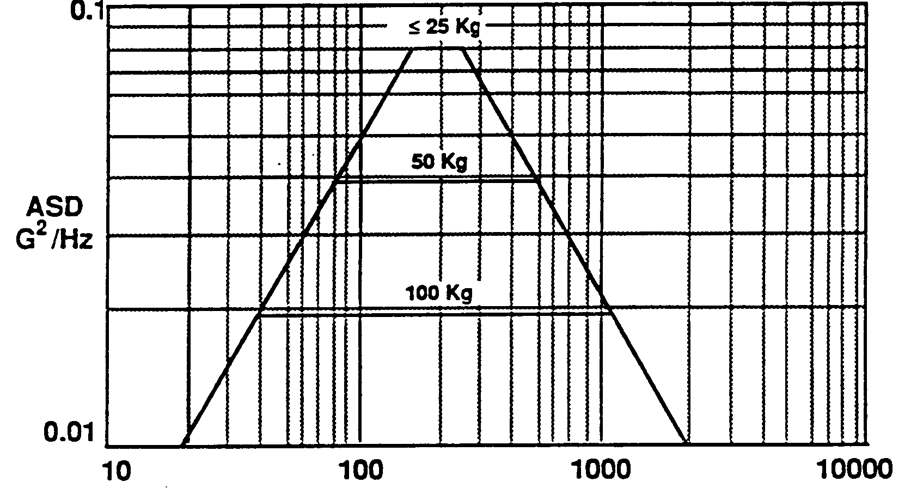
Figure 4.2.7.1.1 Random Vibration - Acceptance Levels

4.2.7.1.2 Protoqualification Level Random Vibration Testing
The test levels currently found in Table 4.2.7.1.2 and Figure 4.2.7.1.2 are considered a conservative estimate of the random vibration environment on a representative spacecraft bus and are the minimum test levels recommended to detect workmanship defects, subject to revision after selection of a spacecraft contractor.
GIID4.2.7.1.2-1
The protoqualification test duration shall be 2 minutes per axis.
GIID4.2.7.1.2-2
In no case shall the protoqualification test levels for the any separately-mountable instrument component be less than those shown in Table 4.2.7.1.2.
Table 4.2.7.1.2 Random Vibration - Protoqualification Levels
Frequency | Acceleration Spectral Density (g²/Hz)
20 | 0.026
20 to 50 | +6 dB/oct
50 to 800 | 0.16
800 to 2000 | -6 dB/oct
2000 | 0.026
Overall | 14.1 g_{rms}

The acceleration spectral density (ASD) level may be reduced for components more than 25 Kg according to:
dB reduction = 10 LOG(W/25)
ASD(25 to 400) = 0.16 x (25/W)
where: W = component mass in Kg.
GIID4.2.7.1.2-3
The slope shall be maintained at ± 6 dB/oct for components up to 65 Kg.
GIID4.2.7.1.2-4
Above 65 Kg, the slopes shall be adjusted to maintain an ASD level of 0.01 g²/Hz at 20 and 200 Hz.
GIID4.2.7.1.2-5
For components over 200 Kg, the test specification shall be maintained at the level for 200 Kg.
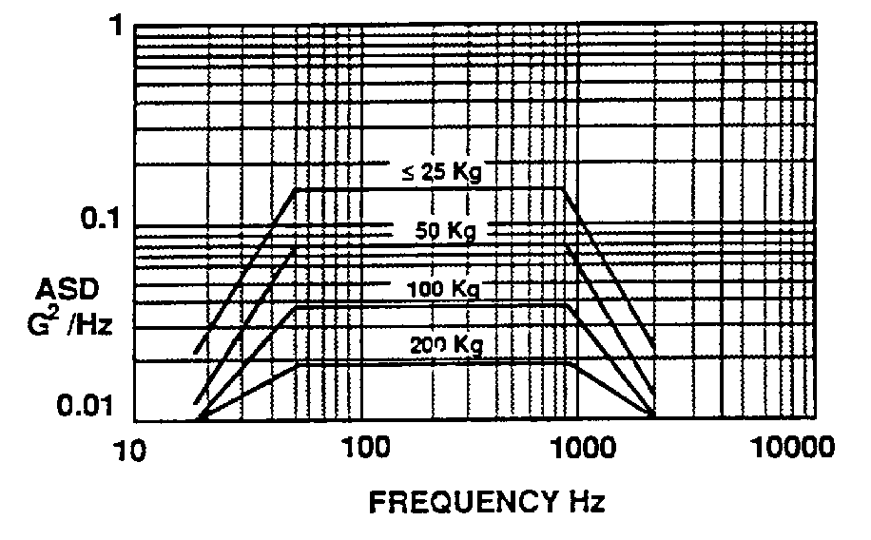
Figure 4.2.7.1.2 Random Vibration - Protoqualification Levels

4.2.7.2 Sine Vibration Testing
GIID4.2.7.2-1
This test shall be conducted with the instrument in the launch configuration.
GIID4.2.7.2-2
There shall be one sweep from 5 Hz to 50 Hz for each axis.

4.2.7.2.1 Acceptance Level Sine Vibration Testing
GIID4.2.7.2.1-1
The instrument shall be acceptance tested to the sine vibration test levels specified in Table 4.2.7.2.2 and in Figure 4.2.7.2.2 in each of three orthogonal axes.
GIID4.2.7.2.1-2
The acceptance test sweep rate shall be 4 oct/min except in the frequency range of 25-35 Hz, where the sweep rate shall be 1.5 oct/min.

4.2.7.2.2 Protoqualification Level Sine Vibration Testing
GIID4.2.7.2.2-1
For protoqual testing, the sine vibration levels shall be the same as the acceptance test levels specified in Table 4.2.7.2.2 in each of three orthogonal axes, however the sweep rates shall be reduced by a factor of two to 2 oct/min and 0.75 oct/min respectively.
Table 4.2.7.2.2 Sinusoidal Test Levels
Frequency | Amplitude/Acceleration
5 to 18 Hz | Displacement = 12 mm (double amplitude)
18 to 50 Hz | 8 g peak

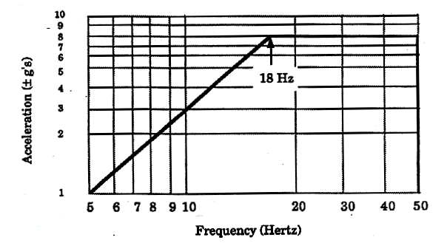
Figure 4.2.7.2.2 Sinusoidal Protoqualification Test Levels

4.2.7.2.3 Design Strength Testing
GIID4.2.7.2.3-1
Instruments whose fundamental structural modes of vibration are demonstrated by test to be above 50 Hz shall be tested in each of three axes to loads generated by applying the test factors given in Table 3.3.12.4.1.
GIID4.2.7.2.3-2
Instruments with fundamental modes of vibration below 50 Hz shall apply an additional factor of 1.5 to portions of the structure whose motion in the mode of vibration exceeds the motion of the centroid.

The factor of 1.5 may be linearly varied (reduced) along the structure to 1.0 at the centroid. The loads may be applied by acceleration testing, static load testing, or vibration testing.
GIID4.2.7.2.3-3
When a coupled loads analysis of the flight configuration is available, it shall be verified that the predicted loads times the test factor given in Table 3.3.12.4.1 are within the tested loads.
GIID4.2.7.2.3-4
The analysis shall be based upon test-verified dynamic models of the instrument for any instruments whose fundamental modes of vibration fall below 50 Hz.
GIID4.2.7.2.3-5
Those instruments with separately-mounted components with significant modes under 50 Hz (as shown by the model) shall have a full modal survey test completed in a fixed-base configuration, to obtain all mode shapes and frequencies to correlate the dynamics model.
GIID4.2.7.2.3-6
Instrument static loads test shall be conducted in accordance with MIL-STD-1540Con the first production instrument if the loads predicted by the model exceed the maximum equivalent flight values.
GIID4.2.7.2.3-7
All models shall be exchanged in NASA Structural Analysis (NASTRAN) bulk data format.

4.2.7.3 Acceleration Testing
GIID4.2.7.3-1
Instrument flight hardware shall be verified to be able to operate through/withstand the maximum on-orbit accelerations specified in section 3.2.6.3.

4.2.7.4 Shock Testing
Testing for externally induced shocks (spacecraft separation, solar array deployment, etc.) is typically accomplished at the spacecraft level.

4.2.7.4.1 General
Shock testing will be performed at the spacecraft level for payload attach fitting separation shocks, solar array deployment shocks, appendage deployment shocks, and instrument-induced shocks - if any. However, if an instrument has pyrotechnic devices onboard, then shock testing is also to be performed at the instrument level prior to delivery to the spacecraft contractor for integration with the spacecraft.
GIID4.2.7.4.1-1
Instruments shall be tested on the spacecraft for externally induced shocks (first flight spacecraft only).
GIID4.2.7.4.1-2
Shock testing shall be required at the instrument level, as a protoqual test, if there are any self induced shocks (i.e., launch lock releases, pin pullers, under-damped motions, etc.).
GIID4.2.7.4.1-3
The spacecraft contractor shall provide to the instrument contractor, analytical shock profiles.

4.2.7.4.2 Protoqualification Level Instrument Shock Testing
GIID4.2.7.4.2-1
Protoqualification testing shall be accomplished by two actuations for each self-induced shock source ( in order to account for the scatter associated with the actuation of the device), for the first flight unit, and a single actuation on subsequent units.

4.2.7.5 Acoustic Testing
GIID4.2.7.5-1
Instrument acoustic testing shall be performed for instruments with large surfaces (units with surface-to-mass ratio greater than 150 cm²/kg (50 in²/lb)), which could be excited by the acoustic field directly and for instruments greater than 180 Kg. This test may be performed on the spacecraft, rather than at instrument level, if so identified in the UIID.

4.2.7.5.1 Acceptance Level Acoustic Testing
GIID4.2.7.5.1-1
The acceptance test acoustics levels shall be as defined in Table 3.2.6.2.5
GIID4.2.7.5.1-2
The acceptance test duration shall be one minute.

4.2.7.5.2 Protoqualification Level Acoustic Testing
GIID4.2.7.5.2-1
The protoqualification test levels shall be the levels shown in Table 3.2.6.2.5 increased by 3 dB.
GIID4.2.7.5.2-2
The protoqualification test duration shall be two minutes.

4.2.7.6 Thermal Testing
GIID4.2.7.6-1
Thermal vacuum testing shall be performed in accordance with MIL-STD-1540C using the environmental temperature ranges specified in GIID Paragraph 3.2.4.7.4.
GIID4.2.7.6-2
Thermal cycle testing shall be performed in accordance with MIL-STD-1540C using the environmental temperature ranges specified in GIID Paragraph 3.2.4.7.4.
GIID4.2.7.6-3
Thermal balance testing shall be performed on the first production unit in accordance with MIL-STD-1540C using the environmental temperature ranges specified in GIID Paragraph 3.2.4.7.4.
GIID4.2.7.6-4
An assessment on the need for Solar Simulation testing shall be accomplished and the result presented to the spacecraft contractor for concurrence.
GIID4.2.7.6-5
If significant thermal backloading (energy from some other part of the satellite) on the instrument is produced by the spacecraft, the instrument-level thermal balance and thermal vacuum testing conditions shall account for that backloading.

This requirement is not applicable if a test-verified thermal model is delivered to the spacecraft contractor.

4.2.8 EMC/EMI Testing

GIID4.2.8-1
Electromagnetic verification testing shall be conducted in accordance with MIL-STD-461E, except that CS109 and RS105 do not apply.
GIID4.2.8-2
The line impedance stabilization network in MIL-STD-461E should be tailored, as necessary, to be more representative of the satellite power bus impedance.
GIID4.2.8-3
The radiated emission measurement bandwidths and frequency steps in MIL-STD-461E shall be reduced as necessary to meet the requirements in paragraph 3.3.2. The existing bandwidths in MIL-STD-461E need to be reduced to show compliance with the search and rescue receiver notches.

Note: While these requirements do not preclude the use of a shield room for testing, shield rooms do resonate causing a 15 to 25 dB amplitude error at several of the receiver frequencies in 3.3.2. This error may cause a failure where none would have been measured in an anechoic chamber.

GIID4.2.8-4
The instrument contractor shall perform electromagnetic testing to verify that the instrument operates properly if subjected to conducted or radiated emissions from maximum expected sources both internal and external to the satellite, and to verify that the design of the instrument does not result in deleterious conducted or radiated signals that might affect other mission elements. Instruments that fail to meet all MIL-STD-461E requirements may be suitable for flight if detailed analysis and system-level EMI/EMC testing shows no impact on mission operations.

GIID4.2.8-5
The instrument contractor shall perform conduction and radiation tests on the instrument, operating with expected power levels, current, and data rates.
GIID4.2.8-6
All EMC/EMI requirements shall be verified for compliance as outlined in section 4.3.2 of this GIID, and as identified in the UIID.
GIID4.2.8-7
Instrument charging verification shall be conducted in accordance with MIL-STD-1541A, as tailored.
GIID4.2.8-8
The instrument contractor shall verify that their instrument does not impact the Search and Rescue mission during any mode by verifying that the requirements of Tables
3.3.2.2.5.2c,d, and e are met.
GIID4.2.8-9
Unintentional radiated emission measurements in the SAR and DCS receiver bands shall be made in accordance with MIL-STD-461E RE102 with the EMI meter replaced by a spectrum analyzer preceded by a low-noise preamplifier such that the test system noise figure is ≤ 3 dB.
GIID4.2.8-10
The instrument under test and associated clock and control signals shall have power applied and the difference in the spectrum analyzer levels shall be noted for both white noise and spurious signals.
GIID4.2.8-11
The test antenna shall be tuned to the center of each of the frequency bands specified in Tables 3.3.2.2.5.2a and b.
GIID4.2.8-12
The noise floor of the measuring equipment shall be verified to be lower than the specified maximum signal level in a 100 Hz resolution bandwidth.
GIID4.2.8-13
Radiated emissions testing, RE102, shall be from 10 kHz to 18 GHz .
GIID4.2.8-14
For radiated susceptibility measurements, the test shall demonstrate the spacecraft and components can meet their performance objectives while exposed to the specified levels. Modulation of the applied susceptibility signal is required, simulating as closely as possible the modulation characteristics of the known emitter.
GIID4.2.8-15
If the appropriate modulation has not been established by hardware design or mission scenario, then 50 % amplitude modulation by a 100 Hz square wave shall be used.
GIID4.2.8-16
The EMI test levels and frequency range shall be increased if it is known that onboard telemetry systems or other signals in space, such as ground based radars (which are known to produce signals in space in excess of 2 V/m at frequencies at least as low as 400 MHz), could expose the spacecraft and instruments to higher levels than the standard tests.

4.2.9 Current Margin Testing
GIID4.2.9-1
For deployment circuits, the contractor identified in the UIID shall demonstrate that electrical current margins on electro-explosive ordnance circuits and on non-explosive initiator circuits will be met.

This demonstration of margins relates to both ‘all-fire’ and ‘no-fire’ conditions,under worst conditions of voltage and resistance (circuit and initiator).

4.2.10 Deployment Testing
GIID4.2.10-1
Mechanisms and deployment and latching devices shall be tested to demonstrate adequate functioning following exposure to the environments in this document.

MIL-A-83577B, Assemblies, Moving Mechanical for Space/Launch Vehicles should be used as a guide.
GIID4.2.10-2
All instrument mechanisms and deployments shall be exercised, during integration tests, on the spacecraft.

4.2.11 Outgassing
GIID4.2.11-1
Outgassing evaluation tests shall be conducted for materials, components, and sub systems whose properties are not known.

4.2.12 Requalification of Existing Designs
GIID4.2.12-1
Items that incorporate extensive changes in design, manufacturing processing, environmental levels, or performance requirements shall be requalified.

However, methodology from MIL-HDBK-340 may be used to show that existing designs or items (previously qualified for other applications) have adequately demonstrated compliance to all qualification requirements for the new designs. Deficiencies in meeting some requirements may be fulfilled by supplementing existing data with new test data.
GIID4.2.12-2
Qualification by similarity shall be permitted only with the concurrence of the government contracting officer, prior to selection of a spacecraft contractor, and by the spacecraft contractor after that time..
GIID4.2.12-3
Waiver of qualification or requalification requirements shall be approved by the government contracting officer, prior to selection of a spacecraft contractor, and by the spacecraft contractor after that time.

4.2.13 Lifetime Testing
GIID4.2.13-1
The instrument contractor shall furnish the spacecraft contractor with a list of age sensitive parts used in the instruments.
GIID4.2.13-2
Lifetime testing shall be conducted in accordance with a tailored MIL-STD-1540C.
GIID4.2.13-3
Explosive ordnance devices and other components whose performance may degrade with time shall have life extensions based on tests made on other devices from the same lot, at the time the extension is requested/necessary.

4.2.14 Pre-launch Validation Tests (TBR)

GIID4.2.14-1
Instrument design shall be such that no testing is required at the launch site other than ‘aliveness’ testing.

4.3 VERIFICATION

4.3.1 Reserved

4.3.2 Verification Methods
GIID4.3.2-1
Methods of verification shall be selected from the following:
a. Inspection. An observation or examination of the item against the applicable documentation to confirm compliance with requirements.
b. Analysis. A process used in place of or in addition to testing to verify compliance with specifications. The techniques typically include an interpretation or interpolation or extrapolation of analytical or empirical data under defined conditions or reasoning to show theoretical compliance with stated requirements.
- Demonstration. An exhibition of the operability or supportability of an item under intended service-use conditions. These verifications are usually non-repetitive and are oriented almost exclusively toward acquisition of qualitative data. Demonstrations may be accomplished by computer simulation.
d. Test. An action that verifies an item’s operability, supportability, performance capability, or other specified qualities when subjected to controlled conditions that are real or simulated. These verifications may require use of special test equipment and instruments to obtain quantitative data for analysis as well as qualitative data derived from displays and indicators inherent in the item(s) for monitor and control.
e. Similarity. Similarity is the process of comparing a current item with a previous item, taking into consideration configuration, test data, application, and/or environment. The evaluation shall be documented and shall include: the test procedures/reports of the item to which similarity is claimed; a description of the difference(s) between the items; and the rationale for verification by similarity. All in orbit experience shall be documented and available for review.
f. Not Applicable. Use of the term “Not Applicable” shall be limited to those paragraph/paragraph headings for which there is no method of verification or where verification is accomplished in subparagraphs.

4.3.3 External/Built-in Testing
GIID4.3.3-1
The instrument shall have the capability of being externally tested, while in storage and on the launch pad, to verify its performance and operational readiness.

As indicated in section 4.2, although limited functional performance may be the “norm” during these periods, the goal of this present requirement is to allow the maximum amount of testing “in-place”, rather than requiring removal and return of the instruments to the instrument contractor, wherever feasible.
GIID4.3.3-2
Each instrument shall have the capability to perform self-testing using built-in test (BIT) functions to determine its functionality, performance, and operational readiness, both on the ground and on-orbit.
GIID4.3.3-3
Instrument storage containers shall be designed to allow any required storage testing to be performed with minimum handling of the instrument. This could involve designing instrument storage containers so as to allow for access to connectors without opening the storage container (extension cables and connectors or access panels to instrument connectors). It could involve storage containers where the top and sides are removable, but the instrument remains on a baseplate, thus not requiring removal of the instrument itself, or other schemes.

5 PREPARATION FOR DELIVERY

5.1 PRESERVATION AND PACKAGING
GIID5.1-1
The instrument contractor shall pack and handle deliverable items so as to protect them against vibrations, shocks, moisture, electrostatic charge, and contamination associated with ground or air transport such that calibrations, alignment and performance are not degraded.
GIID5.1-2
The instrument contractor shall provide protection against natural environmental conditions using containers, shrouds, or covers.
GIID5.1-3
The instrument contractor shall provide access provisions for inspection and handling for all deliverable items.
GIID5.1-4
All deliverable items shall include positive means to verify compliance with shock, temperature, and moisture requirements during shipping/handling.
GIID5.1-5
Instrument shipping containers shall be designed using non-contaminating materials or must be painted or coated with non-shedding paint.

5.2 MARKINGS
GIID5.2-1
The instrument contractor shall mark deliverable units in accordance with ASTM D3951 as appropriate for the item being prepared.
GIID5.2-2
Nameplates for hardware shall contain the item or configuration item number, serial number, lot number (or contract number), manufacturer, and nomenclature.
GIID5.2-3
Software media shall be marked to display software configuration item number, serial number, contract number, manufacturer, and nomenclature.

APPENDIX A
Applicability of the GIID to the NPP Spacecraft Contractor
Legend:
Denotes Applicable
Denotes TBR-NPP

1 SCOPE
1.1 IDENTIFICATION
1.2 Terminology
1.3 DOCUMENT OVERVIEW
1.3.1 NPOESS Documentation
1.3.2 NPP Documentation
1.3.3 Conflicts
1.3.4 Requirement Weighting Factors
2 APPLICABLE DOCUMENTS
2.1 GOVERNMENT DOCUMENTS
2.2 NONGOVERNMENT DOCUMENTS
2.3 REFERENCE DOCUMENTS
3 REQUIREMENTS
3.1 DEFINITION
3.1.1 Reserved
3.1.2 Reserved
3.1.3 Instrument Modes/Functionalities
3.1.4 Operational Concept
3.2 INTERFACE CHARACTERISTICS
3.2.1 General
3.2.2 Reserved
3.2.3 Interface Requirements
3.2.4 Physical and Interface Characteristics
3.2.4.1 Mass Properties
3.2.4.2 Mechanical Requirements
3.2.4.3 Power
3.2.4.4 Survivability
3.2.4.5 Parts, Materials, and Processes
3.2.4.6 Protective Coatings and Finishes
3.2.4.7 Thermal
3.2.4.8 Command and Data Handling
3.2.5 Instrument Quality Factors
3.2.6 Environmental Conditions
3.2.6.1 Natural Environment Characteristics
3.2.6.2 Launch Environment
3.2.6.3 On-orbit environment
3.2.6.4 Test Environments
3.2.7 Transportability
3.2.8 Flexibility and Expansion
3.2.8.1 Operational Computer Resource Reserves
3.3 DESIGN AND CONSTRUCTION
3.3.1 Materials
3.3.2 Electromagnetic Radiation
3.3.3 Reserved
3.3.4 Workmanship
3.3.5 Interchangeability
3.3.6 Safety Requirements
3.3.7 Human Engineering
3.3.8 Nuclear Control
3.3.9 Security
3.3.10 Reserved
3.3.11 Computer Resources
3.3.11.1.3.1 Instruments Flight Software Requirements
3.3.11.1.3.2 Programming Language
3.3.11.1.4 Software Coding Conventions
3.3.11.2 Instrument GSE to Spacecraft I&T GSE Interface
3.3.12 Instrument Design Requirements
3.3.12.1 Structural Analysis
3.3.12.2 Strength Requirements
3.3.12.3 Stiffness Requirements
3.3.12.4 Structural Factors of Safety
3.3.12.5 Design Load Conditions
3.3.12.6 Instrument Fluid Subsystems
3.3.12.7 Moving Mechanical Assemblies
3.3.12.7.4 Uncompensated Momentum
3.3.12.7.5 Instrument Disturbance Allocations
3.3.12.8 Magnetics
3.3.12.9 Access

3.3.12.10 Mounting/Handling
3.3.12.11 Venting
3.3.13 Reserved
3.3.14 Reserved
3.3.15 General Construction Requirements
3.3.15.1 Processes and Controls for Space Equipment
3.3.15.1.2 Contamination

3.4 DOCUMENTATION
3.4.1 Specifications
3.4.2 Interface Control Documents
3.4.3 Drawings and Associated List
3.4.4 Software (Including Databases)
3.4.5 Technical Manuals
3.4.6 Data Package
3.4.7 Documentation Delivery Format
3.5 LOGISTICS (TBS)
3.5.1 Maintenace Planning
3.5.2 Support Equipment (TBS)
3.5.3 Packaging, Handling, Storage, and Transportation (PHS&T) (TBS)
3.5.4 Facilities (TBR)
3.6 PERSONNEL AND TRAINING
4 QUALITY ASSURANCE AND TESTING PROVISIONS
4.1 QUALITY ASSURANCE
4.1.1 Special Tests and Examinations
4.2 TESTING
4.2.1 Testing Philosophy
4.2.2 Location of Testing
4.2.3 Physical Models
4.2.3.1 Engineering Development Unit (EDU)
4.2.3.2 Mass Model
4.2.3.3 Spacecraft/Instrument Mechanical Interface Simulator
4.2.3.4 Spacecraft/Instrument Electrical Interface Simulator (TBR)
4.2.4 Math Model Requirements
4.2.4.1 Finite Element Model
4.2.4.2 Thermal Math Models
4.2.5 Not Used
4.2.6 Developmental Testing
4.2.7 Acceptance and Protoqualification Testing
4.2.7.1 Random Vibration Testing
4.2.7.2 Sine Vibration Testing
4.2.7.3 Acceleration Testing

4.2.7.4 Shock Testing
4.2.7.5 Acoustic Testing
4.2.7.6 Thermal Testing
4.2.8 EMC/EMI Testing
4.2.9 Current Margin Testing
4.2.10 Deployment Testing
4.2.11 Outgassing
4.2.12 Requalification of Existing Designs
4.2.13 Lifetime Testing
4.2.14 Pre-launch Validation Tests
3.3.8 Nuclear Control
3.3.9 Security
3.3.10 Reserved
4.3 VERIFICATION
4.3.1 Reserved
4.3.2 Verification Methods
4.3.3 External/Built-in Testing
5 PREPARATION FOR DELIVERY
5.1 PRESERVATION AND PACKAGING
5.2 MARKINGS

APPENDIX B

Key for Referencing NPP Interface Documentation in place of UIID

For the NPP mission:
- References to a UIID found in the following GIID requirements, in addition to referring to an NPOESS UIID, refer to the corresponding NPP UIID requirement. The NPP UIID does not apply to the NPOESS spacecraft, NPOESS instruments, or NPOESS instruments which also fly on the NPP spacecraft.

GIID Requirement | Title | Corresp. NPP UIID Req. | Title
3.2.4.1.1-3 | Instrument Mass Properties Documentation | 3.3.1.1 | Mass Allocation
3.2.4.2.3.1.1-1 | Instrument Envelope Documentation | 3.3.2.1 | Volume and FOV Allocation
3.2.4.2.3.2.2.1 | Mounting Interface Documentation | 3.3.3 | Instrument Mounting
3.2.4.2.3.3.2-6 | Alignment references | 3.4 | Pointing Allocations
3.2.4.3.1.2.1.1-1 | Operational Power Allocation | 3.2.1  3.2.1 | Average Operating Power Allocation  Peak Operating Power Allocation
3.2.4.3.1.2.1.2-1 | Survival-Mode Power Allocation | 3.2.3 | Survival-Mode Power Allocation
3.2.4.3.1.2.1.3-1 | Launch-Mode Power Allocation | 3.2.4 | Launch-Mode Power Allocation
3.2.4.8.2.2 | (Data) Bus Type | 3.1.2.1 | C&T Interface Ports
3.2.4.8.2.4-2 | Data Bus Sampling Rate | 3.1.1.1  3.1.1.2 | Average Science Data Rate Allocation  Peak Science Data Rate Allocation
3.2.4.8.3.3-1 | Pulse Commands | 3.1.4 | Discrete Interface Allocation
3.2.4.8.3.4-1 | Time of Day Pulse | 3.1.5 | Time of Day Pulse Allocation
3.2.4.8.4.2-10 | Command & Data Load Packets | 3.1.3 | Science Data APIDs
3.2.4.8.5-2 | Instrument Health & Status Telemetry | 3.1.6 | Instrument Housekeeping Data Rate Allocation
3.2.4.8.5.2-2 | Point-to-Point Telemetry | 3.1.7  3.1.8 | Instrument Discrete (Passive Analog Telemetry) Data Rate Allocation
3.2.4.8.6 | Mission Data | 3.1.1.1  3.1.1.2 | Average Science Data Rate Allocation  Peak Science Data Rate Allocation

