EPIC Analysis 020516

Date: Thu, 21 Mar 2002 11:02:45 -0800
To: Dennis Charles Evans <ee@erols.com>
From: Steve Geary <sgeary@ucsd.edu>
Subject: Fwd: Re: EPIC Raytrace Task List

At 05:28 PM 3/13/2002, Steve Geary wrote:
Bob,

Per our last EPIC Stray Light telecon, we have coordinated the following task list through Brett, Ted, Jeff, and Jay. We believe this task list accurately reflects the remaining analysis to be able to determine the extent of the stray light problem and potential solutions.

You will note we have broken the analysis into a GSFC portion and a potential LMMS portion. This approach lets us determine the extent of the problem using GSFC analysis and then if appropriate, shift the work to LMMS to determine potential hardware solutions, and their cost and complexity. This approach also reflects the fiscal reality of our situation where minimal funding is available until a new launch assignment is made.

We greatly appreciate your help in getting the GSFC tasks approved by Peter Mayman so that appropriate government expertise can be applied to the initial portion of the study.Thanks.
Steve
xxxxxxxxxxxx
1. Modify the most recent analysis performed by Dennis Evans to use the correct surface properties associated with the wavelength of our initial study (317 nm). To adequately address the effect on Ozone retrievals, duplicate the analysis at 325 nm. The measured properties of the EPIC filters were e-mailed to all addressees during the telecon. The reflection given for the filters is total reflection and the initial analysis should assign 1/2 of the value to each surface.

2. Make sure the double-filter-in-a-cell is modeled properly. This means model the absorption properties carefully. This is mostly important for reflections that begin at the CCD. Also, we know the spacing between the filter and blocker is 6 mils. WE WILL NEED MORE DETAILED INFORMATION ON THE CONSTRUCTION OF THE FILTERS...

3. Add the baffles to the model. The baffle drawings were sent via fax sent right after the last telecon.

4. Need to include all of the mechanical structures in the ray tracing. Specifically include the spider which has been seen in some of the calibration images.

5. Simulate the input collimator setup used during the GSFC tests. This information can probably be obtained from Doug Leviton. This should also fix the "out-of-focus" problem resulting from the "extended source" case.

6. The reflective properties of surfaces need to be better approximated. For grazing incidence angles, the reflectivities need to be greater. Determine the limiting case when all surfaces have a 100% reflection?

7. Conduct another informal coordination review of the analysis (via email and telecon) at this point so that all the parties understand the new results and assumptions.

8. PERFORM ANALYSIS USING DIFFERENT SOURCE SIZES, SPECTRA AND POSITION TO CORRELLATE THE MODEL WITH TEST DATA. (see table at the bottom summarizing test data)

9. Have Jay Herman SUGGEST TEST CASES TO RUN THROUGH THE ANALYTICAL MODEL TO quantify the stray light effects on his simulated Triana scenes. This would BE TO quantify the effect on planned science measurements and determine if we can live with the instrument as delivered.

Note: This should end the GSFC Code 500 portion of the analysis.

If we determine that ground data processing will not sufficiently remove artifacts from the data, we would begin analyses with LMMS to address potential hardware solutions. We envision that this work would not be started until there is a firm launch assignment.

10. Since both LMMS and GSFC use essentially the same stray light modeling tools, it should be straight forward to transfer the Code 500 work to LMMS. WHY DON'After LMMS is able to run their models and obtain similar results to Code 500, we would begin analyses that address changing portions of the EPIC design that are physically possible. Some examples of what is feasible are:

a. Analyze the stray light results after removal of the lens group. Calculate new optical performance and determine how far the focal plane needs to be moved. We have estimated that this would move the
focal plane approximately an inch.
b. Analyze the effect on stray light by adding a wedge between the filter and CCD. However, we would have LMMS first address if this approach would be physically achievable in flight hardware. The analysis would quantify the effect on optical performance degrade and the new correct orientation/position of the CCD.
c. A more easily achievable option would be to tilt the filters and/or use wedge filters. The analysis would determine the optimal tilt/wedge amount and the effect on passbands?

-----------------------------------------------------------------------------
Below are parameters corresponding to some of the channel, aperture, and image locations used during the second EPIC calibration at GSFC. (Note that the location and width of the aperture is given in units of pixels where the entire CCD array is from 1 to 2048 pixels in each direction.) When input beam size and location are being varied in the GSFC and LMMS analyses discussed above, it would be ideal if the model parameters are selected to match actual test data parameters.

Channel Aperture Center Aperture Diameter (FOV)

4 (1-10) [1024,1024] -> Centered 135 pixels (0.04 degrees)
4 (1-10) [1024,1024] -> Centered 270 pixels (0.08 degrees)
4 (1-10) [1024,1024] -> Centered 540 pixels (0.16 degrees)
4 (1-10) [1024,1024] -> Centered 660 pixels (0.20 degrees)
4 (1-10) [1024,1024] -> Centered 1075 pixels (0.32 degrees)
4 (1-10) [1024,1024] -> Centered 1705 pixels (0.48 degrees)
4 (1-10) [1024,1024] -> Centered (2310) pixels (0.65 degrees) (overfilled)
4 (1-10) [1024,1024] -> Centered (2840) pixels (0.80 degrees) (overfilled)
4,7,1,10 [1024, 512] 270 pixels (0.08 degrees)
4,7,1,10 [1024,1536] 270 pixels (0.08 degrees)
4,7 [1024, 512] 540 pixels (0.16 degrees)
4,7 [1024, 768] 540 pixels (0.16 degrees)
4,7 [1024,1280] 540 pixels (0.16 degrees)
4,7 [1024,1536] 540 pixels (0.16 degrees)

Thank You
Robert C. Smith

Triana Instrument Systems Manager
Next Generation Space Telescope Instrument Systems Manager
GSFC Code 443
Greenbelt, MD 20771

301-286-9065/4750 (phone) 301-286-1671
(fax) 301-706-3301 (cell)
~~~~~~~~~~~~~~~~~~~~~~~~~~~~~~~~~~~~~~~~~~~~~~~~~~~~~~~~~~~
http://triana.gsfc.nasa.gov/home/
http://www.ngst.nasa.gov/

1. Extended Source Positioning

Source is at 1.5E6 km from telescope entrance.
Picture is 256 pixels wide, EPIC Detector is 2048 pixels wide.




    



   







 



  

    
    



        
        
              
         
         




                
    
 













 
 
   
 
 

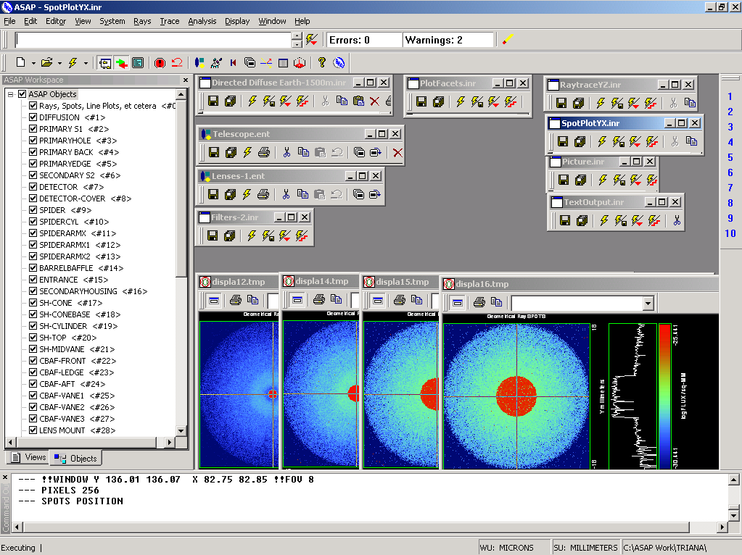

Run 01 Centered 0.04 deg 40k rays

!! Scattering Plate is at L1, Source Disk is 1 meter farther away
--- !! L1 is at 1.5E6 km 1.5E9 m 1.5E12 mm
--- !! Except for scale factor, dimensions are in km
--- SCALE=1E6 !! S=1 for mm; 1E3 m; 1E6 km
--- !! Set source offset in "km" if scale = 1E6. Usually DX or DY only.
--- DX=0*(SCALE)
--- DY=0*(SCALE) !! 0=pixel 1024, centered
--- DZ=0*(SCALE)
--- SRAD=523.6 !!=0.04 deg diam
--- !! Spherical Earth Radius = 6371 km
--- LEVEL 2 0. !! Suggested by BRO Tech Support
--- SURFACE
--- PLANE Z ((-1.5E6)*(SCALE)) ELLIPSE (SRAD*(SCALE)) (SRAD*(SCALE)) 0 (DX) (DY)
--- OBJECT 'DIFFUSION'
--- INTERFACE 0 1E-12 !! Only allow scatter rays to transmit
--- SCATTER MODEL 1 RANDOM 1 1 !! RANDOM needed to find edge, else low light problems
--- TOWARDS (EP) 1
--- RETURN
--- !! Emitter
--- NRAYS=40000 !! 1000=32 sec 40000=20 minutes 200000
--- EMIT DISK Z ((-1.500001E6)*(SCALE)) (SRAD*(SCALE)) (SRAD*(SCALE)) (NRAYS) 1 1
Total flux in rays created by this emitter is 3.0458655E-04
--- SHIFT (DX) (DY) (DZ)
--- RETURN
--- UNITS MILLIMETERS
--- WAVELENGTHS 0.950000 0.706000 0.587560 0.435000 0.300000 MICRONS
--- MEDIA; 1.45106513 1.45515708 1.45846375 1.46676272 1.48779297 'SILICA'
--- COATING PROPERTIES; 1 0 'WHITE'
--- COATING PROPERTIES; .98 0 'MIRROR'
--- COATING PROPERTIES; .11 .87 'DETECTORQE317'
--- COATING PROPERTIES; .10 .75 'DETECTORQE325'
--- COATING PROPERTIES; .05 0 'BLACK'
--- COATING PROPERTIES; 0 0 'ZERO'
--- COATING PROPERTIES; 0 1 'CLEAR'
--- STRUE=0
--- SX=0
--- SY=0
--- SZ=0
--- SCAT=1
--- ENT OBJECT;MIRROR Z 439.24 159 (1219.2/2) -1 (38.2/159) 'PRIMARY S1'
--- INTERFACE COATING MIRROR AIR AIR
--- ENT OBJECT;TUBE Z 438.5 38.2 38.2 466.53196 38.2 38.2 0.0 0.0 'PRIMARYHOLE'
--- INTERFACE COATING BLACK AIR AIR
--- SCATTER RANDOM 1 (SCAT) 1.57 ABS 1 0
--- ENT OBJECT;PLANE Z 466.5 ELLIPSE 210 210 (38.2/210) 'PRIMARY BACK'
--- INTERFACE COATING BLACK AIR AIR
--- SCATTER RANDOM 1 (SCAT) 1.57 ABS 1 0
--- ENT OBJECT;TUBE Z 429 159 159 466.5 159 159 0.0 0.0 'PRIMARYEDGE'
--- INTERFACE COATING BLACK AIR AIR
--- SCATTER RANDOM 1 (SCAT) 1.57 ABS 1 0
--- ENT OBJECT;MIRROR Z 0.0 46 (434.7/2) -2.40763 0.0 'SECONDARY S2'
--- INTERFACE COATING MIRROR AIR AIR
--- ENT OBJECT;PLANE Z 790.7429896 RECTANGLE 18 18 0 'DETECTOR'
--- INTERFACE COATING ZERO SILICA AIR
--- ENT OBJECT;PLANE Z 790.7 RECTANGLE 18 18 0 'DETECTOR-COVER'
--- INTERFACE COATING DETECTORQE317 SILICA AIR
*** SPLIT automatically set to 1
--- ENT OBJECT;PLANE Z -55.69204 ELLIPSE 210 210 (154.8315449/210) 'SPIDER'
--- INTERFACE COATING BLACK AIR AIR
--- SCATTER RANDOM 1 (SCAT) 1.57 ABS 1 0
--- ENT OBJECT;TUBE Z -55.69204 154.8315449 154.8315449 -30.29204 154.8315449 154.8315449 0.0 0.0 'SPIDERCYL'
--- INTERFACE COATING BLACK AIR AIR
--- SCATTER RANDOM 1 (SCAT) 1.57 ABS 1 0
--- ENT OBJECT;TUBE X 0 0.75 12.52 -170 0.75 15.52 1 1 'SPIDERARMX'
--- SHIFT 0 -52.578 -42.992
--- INTERFACE COATING BLACK AIR AIR
--- SCATTER RANDOM 1 (SCAT) 1.57 ABS 1 0
--- ENT OBJECT;TUBE X 0 5 12.52 -170 5 15.52 1 1 'SPIDERARMX1'
--- SHIFT 0 -52.578 -42.992
--- ROTATE Z -120 0 0
--- INTERFACE COATING BLACK AIR AIR
--- SCATTER RANDOM 1 (SCAT) 1.57 ABS 1 0
--- ENT OBJECT;TUBE X 0 0.75 12.52 -170 0.75 15.52 1 1 'SPIDERARMX2'
--- SHIFT 0 -52.578 -42.992
--- ROTATE Z -240 0 0
--- INTERFACE COATING BLACK AIR AIR
--- SCATTER RANDOM 1 (SCAT) 1.57 ABS 1 0
--- ENT OBJECT;TUBE Z -185.6 200.8 200.8 528 200.8 200.8 0.0 0.0 'BARRELBAFFLE'
--- INTERFACE COATING BLACK AIR AIR
--- SCATTER RANDOM 1 (SCAT) 1.57 ABS 1 0
--- ENT OBJECT;ELLIPSE Z -200 205 205 64 0.0 360.0 'ENTRANCE'
Default ELLIP/ROUND/OVAL segments changed to 64
--- INTERFACE COATING CLEAR AIR AIR
--- ENT OBJECT;TUBE Z (2.391*25.4) (2.546*25.4) (2.546*25.4) (2.164*25.4) (2.546*25.4) (2.546*25.4) 0.0 0.0 'SECONDARYHOUSING'
--- INTERFACE COATING BLACK AIR AIR
--- SCATTER RANDOM 1 (SCAT) 1.57 ABS 1 0
--- ENT OBJECT;TUBE Z (2.164*25.4) (2.546*25.4) (2.546*25.4) 0 (2*25.4) (2*25.4) 0.0 0.0 'SH-CONE'
--- INTERFACE COATING BLACK AIR AIR
--- SCATTER RANDOM 1 (SCAT) 1.57 ABS 1 0
--- ENT OBJECT;PLANE Z 0.0 ELLIPSE (2.45*25.4) (2.45*25.4) (2.00/2.45) 'SH-CONEBASE'
--- INTERFACE COATING BLACK AIR AIR
--- SCATTER RANDOM 1 (SCAT) 1.57 ABS 1 0
--- ENT OBJECT;TUBE Z 0.0 (2.125*25.4) (2.125*25.4) (-6.875*25.4) (2.125*25.4) (2.125*25.4) 0.0 0.0 'SH-CYLINDER'
--- INTERFACE COATING BLACK AIR AIR
--- SCATTER RANDOM 1 (SCAT) 1.57 ABS 1 0
--- ENT OBJECT;PLANE Z (-6.875*25.4) ELLIPSE (2.33*25.4) 'SH-TOP'
--- INTERFACE COATING BLACK AIR AIR
--- SCATTER RANDOM 1 (SCAT) 1.57 ABS 1 0
--- ENT OBJECT;PLANE Z (-1.9*25.4) ELLIPSE (2.546*25.4) 'SH-MIDVANE'
--- INTERFACE COATING BLACK AIR AIR
--- SCATTER RANDOM 1 (SCAT) 1.57 ABS 1 0
--- ENT OBJECT;TUBE Z 226.38766 37.465 37.465 422.98366 37.465 37.465 0.0 0.0 'CBAF-FRONT'
--- INTERFACE COATING BLACK AIR AIR
--- SCATTER RANDOM 1 (SCAT) 1.57 ABS 1 0
--- ENT OBJECT;PLANE Z 422.98366 ELLIPSE 37.485 37.485 (30.5562/37.485) 'CBAF-LEDGE'
--- INTERFACE COATING BLACK AIR AIR
--- SCATTER RANDOM 1 (SCAT) 1.57 ABS 1 0
--- ENT OBJECT;TUBE Z 422.985 32.2072 32.2072 532.45766 32.2072 32.2072 0.0 0.0 'CBAF-AFT'
--- INTERFACE COATING BLACK AIR AIR
--- SCATTER RANDOM 1 (SCAT) 1.57 ABS 1 0
--- ENT OBJECT;PLANE Z 327.98766 ELLIPSE 37.485 37.485 (35.56/37.485) 'CBAF-VANE1'
--- INTERFACE COATING BLACK AIR AIR
--- SCATTER RANDOM 1 (SCAT) 1.57 ABS 1 0
--- ENT OBJECT;PLANE Z 378.78766 ELLIPSE 37.485 37.485 (35.56/37.485) 'CBAF-VANE2'
--- INTERFACE COATING BLACK AIR AIR
--- SCATTER RANDOM 1 (SCAT) 1.57 ABS 1 0
--- ENT OBJECT;PLANE Z 505.53366 ELLIPSE 32.24 32.24 (28.6512/32.24) 'CBAF-VANE3'
--- INTERFACE COATING BLACK AIR AIR
--- SCATTER RANDOM 1 (SCAT) 1.57 ABS 1 0
--- RETURN
--- !! Geometry is being appended to system.
--- !! To not view this message, refer to ASAP preferences dialog,
--- !! or change the Options->Append Geometry menu item.
--- UNITS MILLIMETERS
--- WAVELENGTHS 0.950000 0.706000 0.587560 0.435000 0.300000 MICRONS
--- MEDIA; 1.45106513 1.45515708 1.45846375 1.46676272 1.48779297 'SILICA'
--- COATING PROPERTIES; .98 0 'MIRROR'
--- COATING PROPERTIES; .05 0 'BLACK'
--- COATING PROPERTIES; 0 0 'ZERO'
--- COATING PROPERTIES; 0 1 'CLEAR'
--- COATING PROPERTIES; .05 .95 'ARF05'
--- COATING PROPERTIES; 0.2 0.8 'ARF20'
--- ENT OBJECT;PLANE Z 615.3400000 ELLIPSE 150 150 (22/150) 'LENS MOUNT'
--- INTERFACE COATING BLACK AIR AIR
--- SCATTER RANDOM 1 (SCAT) 1.57 ABS 1 0
--- ENT OBJECT;TUBE Z 558.61966 26.7 26.7 620 26.7 26.7 0.0 0.0 'LENS TUBE-FRONT'
--- INTERFACE COATING BLACK AIR AIR
--- SCATTER RANDOM 1 (SCAT) 1.57 ABS 1 0
--- ENT OBJECT;PLANE Z 558.61966 ELLIPSE 27.7 27.7 (24.945/27.7) 'LT-FACE'
--- INTERFACE COATING BLACK AIR AIR
--- SCATTER RANDOM 1 (SCAT) 1.57 ABS 1 0
--- ENT OBJECT;PLANE Z 616.4326 ELLIPSE 27.7 27.7 (21.5/27.7) 'LT-LENS 1FACE'
--- INTERFACE COATING BLACK AIR AIR
--- SCATTER RANDOM 1 (SCAT) 1.57 ABS 1 0
--- ENT OBJECT;TUBE Z 621 25.152 25.152 657.7965 25.152 25.152 0.0 0.0 'LENS TUBE AFT'
--- INTERFACE COATING BLACK AIR AIR
--- SCATTER RANDOM 1 (SCAT) 1.57 ABS 1 0
--- ENT OBJECT;PLANE Z 657.7965 ELLIPSE 25.152 25.152 (21.26386619/25.152) 'LT-AFT FACE'
--- INTERFACE COATING BLACK AIR AIR
--- SCATTER RANDOM 1 (SCAT) 1.57 ABS 1 0
--- ENT OBJECT;OPTICAL Z 615.3400000 221.803 0 ELLIPSE 22 'LENS1F'
--- INTERFACE COATING ARF05 AIR SILICA
--- ENT OBJECT;OPTICAL Z 620.3400000 584.5 0 ELLIPSE 22 'LENS1B'
--- INTERFACE COATING ARF05 AIR SILICA
--- ENT OBJECT;OPTICAL Z 627.63 -147.027 0 ELLIPSE 22 'LENS2F'
--- INTERFACE COATING ARF05 AIR SILICA
--- ENT OBJECT;OPTICAL Z 632.63 -135.158 0 ELLIPSE 22 'LENS2B'
--- INTERFACE COATING ARF05 AIR SILICA
--- ENT OBJECT;OPTICAL Z 635.6 97.002 0 ELLIPSE 22 'LENS3F'
--- INTERFACE COATING ARF05 AIR SILICA
--- ENT OBJECT;OPTICAL Z 640.6 67.147 0 ELLIPSE 22 'LENS3B'
--- INTERFACE COATING ARF05 AIR SILICA
--- ENT OBJECT;TUBE Z 614 22 22 645 22 22 0.0 0.0 'LENSHOLDER'
--- INTERFACE COATING ZERO AIR AIR
--- SCATTER RANDOM 1 (SCAT) 1.57 ABS 1 0
--- ENT OBJECT;PLANE Z 660.84196 ELLIPSE 150 150 (25.28148817/150) 'FW-HOUSING FRONT'
--- INTERFACE COATING BLACK AIR AIR
--- SCATTER RANDOM 1 (SCAT) 1.57 ABS 1 0
--- ENT OBJECT;PLANE Z 709.10196 ELLIPSE 150 150 (25.28148817/150) 'FW-HOUSING AFT'
--- INTERFACE COATING BLACK AIR AIR
--- SCATTER RANDOM 1 (SCAT) 1.57 ABS 1 0
--- ENT OBJECT;TUBE Z (673.54196-.3) 27.5 27.5 (680.04436+.3) 27.5 27.5 0.0 0.0 'FILTERHOLDER'
--- INTERFACE COATING BLACK AIR AIR
--- SCATTER RANDOM 1 (SCAT) 1.57 ABS 1 0
--- ENT OBJECT;PLANE Z 675 ELLIPSE 150 150 (27.5/150) 'FILTER-WHEEL'
--- INTERFACE COATING BLACK AIR AIR
--- SCATTER RANDOM 1 (SCAT) 1.57 ABS 1 0
--- ENT OBJECT;TUBE Z 721.59876 19.16979665 19.16979665 723.53932 22.558 22.558 0.0 0.0 'EXIT CONE FRONT'
--- INTERFACE COATING BLACK AIR AIR
--- SCATTER RANDOM 1 (SCAT) 1.57 ABS 1 0
--- ENT OBJECT;TUBE Z 723.53932 22.558 22.558 781.84248 22.558 22.558 0.0 0.0 'EC-CYLINDER'
--- INTERFACE COATING BLACK AIR AIR
--- SCATTER RANDOM 1 (SCAT) 1.57 ABS 1 0
--- ENT OBJECT;PLANE Z 781.84248 ELLIPSE 22.558 22.558 (16.89/22.558) 'EC-SHELF'
--- INTERFACE COATING BLACK AIR AIR
--- SCATTER RANDOM 1 (SCAT) 1.57 ABS 1 0
--- ENT OBJECT;TUBE Z 781.84248 16.89 16.89 783.87448 20.41280351 20.41280351 0.0 0.0 'EC-EXITCONE'
--- INTERFACE COATING BLACK AIR AIR
--- SCATTER RANDOM 1 (SCAT) 1.57 ABS 1 0
--- ENT OBJECT;PLANE Z 783.87448 ELLIPSE 50 50 (20.41280351/50) 'EC-EXIT'
--- INTERFACE COATING BLACK AIR AIR
--- SCATTER RANDOM 1 (SCAT) 1.57 ABS 1 0
--- RETURN
--- $IO "ASAPTEMP.INR"
Opening 1 C:\ASAP Work\TRIANA\asaptemp.inr

Closing 7 C:\ASAP Work\TRIANA\bro007.dat
Opening 7 C:\ASAP Work\TRIANA\asaptemp.usr

Closing 20 C:\ASAP Work\TRIANA\bro020.dat
Creating 20 C:\ASAP Work\TRIANA\asaptemp.plr

Closing 30 C:\ASAP Work\TRIANA\bro030.dat
Creating 30 C:\ASAP Work\TRIANA\asaptemp.vcr

--- !! Filters-2 from .ent/copy/.inr to allow ABSORBing media
--- UNITS MILLIMETERS
--- WAVELENGTHS 0.950000 0.706000 0.587560 0.435000 0.300000 MICRONS
--- MEDIA; 1.45106513 1.45515708 1.45846375 1.46676272 1.48779297 'SILICA'
--- !!COATING PROPERTIES; .98 0 'MIRROR'
--- !!COATING PROPERTIES; .05 0 'BLACK'
--- !!COATING PROPERTIES; 0 0 'ZERO'
--- !!COATING PROPERTIES; 0 1 'CLEAR'
--- COATING PROPERTIES; .0745 .9255 'ARF0745'
--- COATING PROPERTIES; .0525 .9475 'ARF0525'
--- COATING PROPERTIES; .05 .95 'ARF05'
--- COATING PROPERTIES; .005 .995 'ARF005'
--- !!COATING PROPERTIES; 0.2 0.8 'ARF20'
--- !!!!!!!!!!!!!!!!!!!!!!!!!!!!!!!!!!!!!!!!!!!!!!!!!!
--- WAVELENGTH 0.317 MICRONS
--- MEDIA
--- 1.48342884 ABSORB 0.13168 'BLOCKER317'
--- MEDIA
--- 1.48342884 ABSORB 0.00307 'ETALON317'
--- !!!!!!!!!!!!!!!!!!!!!!!!!!!!!!!!!!!!!!!!!!!!!!!!!!
--- !!WAVELENGTH 0.325 MICRONS
--- !!MEDIA
--- !! 1.48163777 ABSORB 0.08074 'BLOCKER325'
--- !!MEDIA
--- !! 1.48163777 ABSORB 0.0415179525 'ETALON325'
--- !!!!!!!!!!!!!!!!!!!!!!!!!!!!!!!!!!!!!!!!!!!!!!!!!!!!!
--- ENT OBJECT;PLANE Z 673.54196 ELLIPSE 27.5 'FILTERUVE-F'
--- INTERFACE COATING ARF0525 AIR ETALON317
--- !! INTERFACE COATING ARF0745 AIR ETALON325
--- ENT OBJECT;PLANE Z 676.71696 ELLIPSE 27.5 'FILTERUVE-B'
--- INTERFACE COATING ARF0525 AIR ETALON317
--- !! INTERFACE COATING ARF0745 AIR ETALON325
--- ENT OBJECT;PLANE Z 676.86936 ELLIPSE 27.5 'FILTERUVB-F'
--- INTERFACE COATING ARF005 AIR BLOCKER317
--- !! INTERFACE COATING ARF005 AIR BLOCKER325
--- ENT OBJECT;PLANE Z 680.04436 ELLIPSE 27.5 'FILTERUVB-B'
--- INTERFACE COATING ARF005 AIR BLOCKER317
--- !! INTERFACE COATING ARF005 AIR BLOCKER325
--- !!RETURN
--- $IO "ASAPTEMP.INR"
Opening 1 C:\ASAP Work\TRIANA\asaptemp.inr

Closing 7 C:\ASAP Work\TRIANA\bro007.dat
Opening 7 C:\ASAP Work\TRIANA\asaptemp.usr

Closing 20 C:\ASAP Work\TRIANA\bro020.dat
Creating 20 C:\ASAP Work\TRIANA\asaptemp.plr

Closing 30 C:\ASAP Work\TRIANA\bro030.dat
Creating 30 C:\ASAP Work\TRIANA\asaptemp.vcr

--- TITLE DCE *Raytrace
--- !! WAVELENGTHS 0.317 MICRONS !! Normally set in filters
--- !!SPLIT 0 !! Direct Trace Only
--- !!SPLIT 1 !! For Rect Sources
--- SPLIT 2
--- PLOT FACETS 5 5
Window Vertical: Y = -.523601E+09 to 0.523601E+09 (0.104720E+10)
Horizontal: Z = -.150001E+13 to 791.121 (0.150001E+13)

--- CONSIDER ALL
--- !!CONSIDER ONLY 15
--- ARROWS OFF
--- SEGMENTS 9
--- WINDOW Y Z
--- OBLIQUE 0 0
--- MISSED LINE 50
--- TRACE PLOT 500 OVERLAY
Window Vertical: Y = -.523601E+09 to 0.523601E+09 (0.104720E+10)
Horizontal: Z = -.150001E+13 to 791.121 (0.150001E+13)

16.00 seconds ( 15.57 seconds CPU) to trace 80,000
out of 226,694
54.52 seconds ( 53.06 seconds CPU) to trace 160,000
out of 647,341
108.54 seconds ( 105.18 seconds CPU) to trace 240,000
out of 1,275,762
2.73 minutes ( 2.63 minutes CPU) to trace 320,000
out of 1,909,180
3.40 minutes ( 3.25 minutes CPU) to trace 400,000
out of 2,099,429
4.00 minutes ( 3.82 minutes CPU) to trace 480,000
out of 2,198,725
4.60 minutes ( 4.39 minutes CPU) to trace 560,000
out of 2,300,614
5.23 minutes ( 4.96 minutes CPU) to trace 640,000
out of 2,402,555
5.83 minutes ( 5.53 minutes CPU) to trace 720,000
out of 2,503,058
6.43 minutes ( 6.10 minutes CPU) to trace 800,000
out of 2,605,482
7.03 minutes ( 6.67 minutes CPU) to trace 880,000
out of 2,706,162
7.63 minutes ( 7.24 minutes CPU) to trace 960,000
out of 2,808,015
8.22 minutes ( 7.81 minutes CPU) to trace 1,040,000
out of 2,910,010
8.82 minutes ( 8.38 minutes CPU) to trace 1,120,000
out of 3,010,794
9.42 minutes ( 8.95 minutes CPU) to trace 1,200,000
out of 3,112,426
10.01 minutes ( 9.52 minutes CPU) to trace 1,280,000
out of 3,214,540
10.61 minutes ( 10.09 minutes CPU) to trace 1,360,000
out of 3,315,702
11.22 minutes ( 10.66 minutes CPU) to trace 1,440,000
out of 3,417,260
11.82 minutes ( 11.24 minutes CPU) to trace 1,520,000
out of 3,517,495
12.48 minutes ( 11.81 minutes CPU) to trace 1,600,000
out of 3,617,322
13.08 minutes ( 12.38 minutes CPU) to trace 1,680,000
out of 3,719,913
13.68 minutes ( 12.95 minutes CPU) to trace 1,760,000
out of 3,821,424
14.28 minutes ( 13.52 minutes CPU) to trace 1,840,000
out of 3,922,358
14.98 minutes ( 14.10 minutes CPU) to trace 1,920,000
out of 4,024,322
15.65 minutes ( 14.67 minutes CPU) to trace 2,000,000
out of 4,125,440
15.95 minutes ( 14.96 minutes CPU) to trace 2,080,000
out of 4,143,365
16.19 minutes ( 15.18 minutes CPU) to trace 2,160,000
16.44 minutes ( 15.40 minutes CPU) to trace 2,240,000
16.67 minutes ( 15.63 minutes CPU) to trace 2,320,000
16.91 minutes ( 15.85 minutes CPU) to trace 2,400,000
17.15 minutes ( 16.07 minutes CPU) to trace 2,480,000
17.38 minutes ( 16.29 minutes CPU) to trace 2,560,000
17.62 minutes ( 16.51 minutes CPU) to trace 2,640,000
17.85 minutes ( 16.73 minutes CPU) to trace 2,720,000
18.09 minutes ( 16.96 minutes CPU) to trace 2,800,000
18.33 minutes ( 17.18 minutes CPU) to trace 2,880,000
18.56 minutes ( 17.40 minutes CPU) to trace 2,960,000
18.81 minutes ( 17.63 minutes CPU) to trace 3,040,000
19.04 minutes ( 17.85 minutes CPU) to trace 3,120,000
19.28 minutes ( 18.07 minutes CPU) to trace 3,200,000
19.52 minutes ( 18.30 minutes CPU) to trace 3,280,000
19.76 minutes ( 18.52 minutes CPU) to trace 3,360,000
20.01 minutes ( 18.75 minutes CPU) to trace 3,440,000
20.24 minutes ( 18.97 minutes CPU) to trace 3,520,000
20.48 minutes ( 19.19 minutes CPU) to trace 3,600,000
20.72 minutes ( 19.42 minutes CPU) to trace 3,680,000
20.96 minutes ( 19.64 minutes CPU) to trace 3,760,000
21.21 minutes ( 19.86 minutes CPU) to trace 3,840,000
21.45 minutes ( 20.09 minutes CPU) to trace 3,920,000
21.69 minutes ( 20.31 minutes CPU) to trace 4,000,000
21.96 minutes ( 20.53 minutes CPU) to trace 4,080,000
22.15 minutes ( 20.71 minutes CPU) to trace 4,143,365

Total of 3179515 PARENT warnings
Missed Multiple Wrong Low Evanescent Wrong Absorbed
Obj Total After Bounce Side Flux (TIR) Direc After
1 163998 84064 79934 DIFFUSION
2 907 43 676 188 PRIMARY S1
3 2574 379 8 2187 PRIMARYHOLE
4 95796 32963 345 62488 PRIMARY BACK
5 24677 20 24657 PRIMARYEDGE
6 815 313 502 SECONDARY S2
7 683 683 DETECTOR
8 5651 61 4720 870 DETECTOR-COVER
9 43983 1857 90 42036 SPIDER
10 15040 155 50 14835 SPIDERCYL
11 4962 117 13 4832 SPIDERARMX
12 9043 138 33 8872 SPIDERARMX1
13 5057 126 16 4915 SPIDERARMX2
14 335108 3583 1112 330413 BARRELBAFFLE
15 338703 338316 387 ENTRANCE
16 7732 7 15 7710 SECONDARYHOUSING
17 65538 522 165 64851 SH-CONE
18 14993 19 22 14952 SH-CONEBASE
19 106365 1780 313 104272 SH-CYLINDER
20 950 34 3 913 SH-TOP
21 99022 9 229 98784 SH-MIDVANE
22 326353 747 1333 324273 CBAF-FRONT
23 24259 114 24145 CBAF-LEDGE
24 200052 39731 658 159663 CBAF-AFT
25 9137 12 48 9077 CBAF-VANE1
26 10137 4 39 10094 CBAF-VANE2
27 14382 1289 111 12982 CBAF-VANE3
28 73544 31650 236 41658 LENS MOUNT
29 66367 3256 616 62495 LENS TUBE-FRONT
30 8546 368 70 8108 LT-FACE
31 1826 28 40 1758 LT-LENS 1FACE
32 8259 70 271 7918 LENS TUBE AFT
33 3980 32 254 3694 LT-AFT FACE
34 7155 997 2395 3763 LENS1F
35 7729 1095 2510 4124 LENS1B
36 7522 1012 4097 2413 LENS2F
37 10918 2197 7328 1393 LENS2B
38 18444 2278 10979 5187 LENS3F
39 12441 2393 3245 6803 LENS3B
40 781 376 405 LENSHOLDER
41 35064 7965 515 26584 FW-HOUSING FRONT
42 474598 333211 1332 140055 FW-HOUSING AFT
43 2983 1112 71 1720 80 FILTERHOLDER
44 179302 65845 1744 111713 FILTER-WHEEL
45 27407 6331 663 20413 EXIT CONE FRONT
46 229970 32499 3560 193911 EC-CYLINDER
47 19058 2 703 18353 EC-SHELF
48 4538 3596 19 923 EC-EXITCONE
49 17200 11511 427 5262 EC-EXIT
50 6860 47 3661 2413 719 20 FILTERUVE-F
51 3090 1786 602 694 8 FILTERUVE-B
52 16702 4608 10100 906 1088 FILTERUVB-F
53 9314 5457 1884 53 916 1004 FILTERUVB-B

Total of 92732 CHILD warnings
Missed Multiple Wrong Low Evanescent Wrong Absorbed
Obj Total After Bounce Side Flux (TIR) Direc After
8 3086 3086 DETECTOR-COVER
34 7883 7883 LENS1F
35 7891 7891 LENS1B
36 9076 9076 LENS2F
37 9301 9301 LENS2B
38 9179 9179 LENS3F
39 9133 9133 LENS3B
50 8816 8816 FILTERUVE-F
51 8842 8842 FILTERUVE-B
52 9752 9752 FILTERUVB-F
53 9773 9773 FILTERUVB-B
27267514 ray-objects encountered at 21943 per CPU second
299552861 order-intersections done at 241062 per CPU second
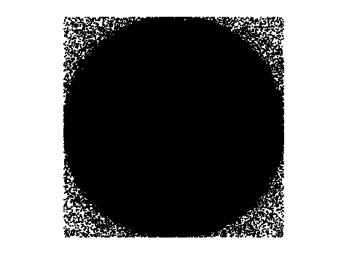

SPOT PLOT Run 01

--- ! Spot Plot (Run Ray Trace First)
--- !!CONSIDER ONLY 6 !!Grid Detector=6
--- CONSIDER ONLY 7 !! Earth Detector=7
--- OBLIQUE OFF
--- !!TITLE 'FOV1-9/19^2 mm^2=15503 Rays'
--- !!TITLE 'FOV8 Rect Source Det=2170 total rays'
--- !!TITLE 'FOV8 RctSrc Det=1357-1348=11 rays from Pedestals DetImplBafOnly'
--- !!TITLE 'FOV8 RctSrc Det=750 rays "On"Mrlts Pd&SbS=0 DtImplBfOnly'
--- !!TITLE 'FOV8 RctSrc Det=754 rays "On"Mrlts Pd=1 SbS=0 DtImplBfOnly'
--- !!TITLE 'FOV8 3x3 Pt Src =215 rays "On"Mrlts Pd=1 SbS=0 DtImplBfOnly'
--- TITLE '1000 KM Source'
--- !!WINDOW Y X
--- WINDOW Y -18 18 X -18 18
--- !!WINDOW Y 11 14 X -1.5 1.5
--- !!TITLE 'FOV8 23x23 1358-678=680 Rays/.109 mm^2 = 6238 Rays/mm^2 5.5%'
--- !!WINDOW Y 135.75 136.25 X 82.5 83 !!FOV 8
--- !!TITLE 'FOV8 3x3 Core 678 Rays/.006mm^2 = 113000 Rays/mm^2'
--- !!WINDOW Y 136.01 136.07 X 82.75 82.85 !!FOV 8
--- PIXELS 256
--- SPOTS POSITION

Distribution of data within:
Window Vertical: Y = -18.0000 to 18.0000 ( 36.0000 )
Horizontal: X = -18.0000 to 18.0000 ( 36.0000 )

Opening NEW distribution file 9: C:\ASAP Work\TRIANA\bro009.dat
Rays Flux
855237 0.983214E-24
Maximum = 3.8253551E-25 minimum = 0.0000000E+00
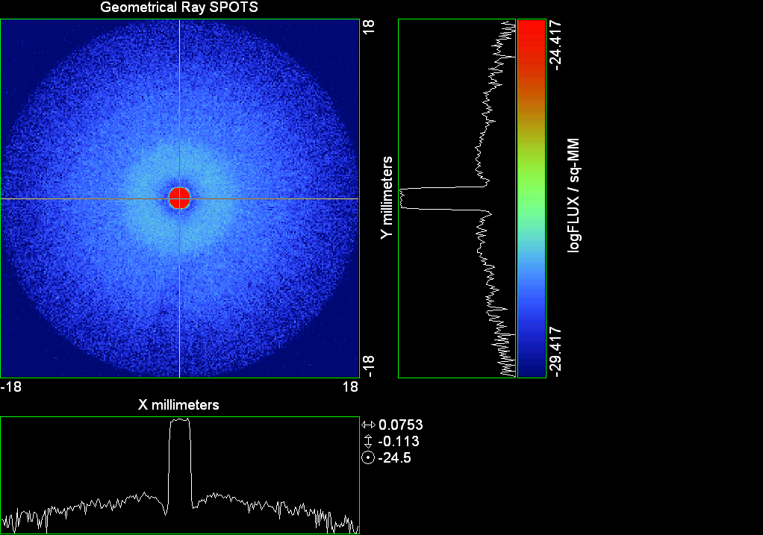

--- !! PICTURE (Run Ray Trace and Spots Position First)
--- !! Picks size from Spots Position window size
--- TITLE 'EPIC'
--- CONSIDER ONLY 7 !! Detector = 6 for Grid, 7 for Earth
--- !!WINDOW X -1.5 1.5 Y 11 14
--- WINDOW Y X
--- DISPLAY
Opening OLD distribution file 9: C:\ASAP Work\TRIANA\bro009.dat

File header:
Geometrical Ray SPOTS 1
Z 790.7430 FLUX / sq-MM
X millimeters -18.00000 18.00000 256
Y millimeters -18.00000 18.00000 256

Statistics on 256 by 256 data set:
FLUX / sq-MM Location Y millimeters X millimeters
Minimum 0.000000 1 1 -17.92969 -17.92969
Maximum 0.3825355E-24 133 130 0.6328125 0.2109375
Average 0.7586486E-27 129 129 0.7031250E-01 0.7031250E-01
TOTAL FLUX = 0.9832085E-24

--- AVERAGE 0 0
Statistics on 256 by 256 data set:
FLUX / sq-MM Location Y millimeters X millimeters
Minimum 0.000000 1 1 -17.92969 -17.92969
Maximum 0.3825355E-24 133 130 0.6328125 0.2109375
Average 0.7586486E-27 129 129 0.7031250E-01 0.7031250E-01
TOTAL FLUX = 0.9832085E-24

--- FORM -5
Statistics on 256 by 256 data set:
FLUX / sq-MM Location Y millimeters X millimeters
Minimum -29.41733 1 1 -17.92969 -17.92969
Maximum -24.41733 133 130 0.6328125 0.2109375
Average -28.71826 129 128 0.7031250E-01 -0.7031250E-01
Integral = -37218.86

--- !!CONTOUR .001 .005 .01 .05 .1 .2 .3 .4 .5 .6 .7 .8 .85 .9 .95 GRID 2
--- PICTURE
Opening NEW distribution file 10: C:\ASAP Work\TRIANA\i.dis

Run 01 Centered 0.04 deg 40k rays.xls
Run 00 Centered 0.04 deg 40k rays Split0

--- END

System database and settings have been reinitialized
--- $IO "ASAPTEMP.INR"
Opening 1 C:\ASAP Work\TRIANA\asaptemp.inr

Closing 7 C:\ASAP Work\TRIANA\bro007.dat
Opening 7 C:\ASAP Work\TRIANA\asaptemp.usr

Closing 20 C:\ASAP Work\TRIANA\bro020.dat
Creating 20 C:\ASAP Work\TRIANA\asaptemp.plr

Closing 30 C:\ASAP Work\TRIANA\bro030.dat
Creating 30 C:\ASAP Work\TRIANA\asaptemp.vcr

--- !! Directed Diffuser Example
--- !! Create a source (Disk or Grid)
--- !! Source hits a diffuser in close proximity to source
--- !! diffuser scatters towards an edge for efficient ray tracing
--- SYSTEM NEW
--- RESET
--- UNITS MILLIMETERS
--- !! Setup for 1500 meter test
--- EDGE (EP=1000) !! Assign edge number to reference later with TOWARDS
--- ELLIPSE Z -200 225 225
--- !! Diffusion Model
--- MODEL
--- LAMBERTIAN 1
Angle Relative TIS Sampling
0.0 1.00 1000 radial

--- RETURN
--- CUTOFF (1.0E-40) 50 !! Default=1.0E-18 1/4pir2=3.5E-26
--- !! Scattering Plate is at L1, Source Disk is 1 meter farther away
--- !! L1 is at 1.5E6 km 1.5E9 m 1.5E12 mm
--- !! Except for scale factor, dimensions are in km
--- SCALE=1E6 !! S=1 for mm; 1E3 m; 1E6 km
--- !! Set source offset in "km" if scale = 1E6. Usually DX or DY only.
--- DX=0*(SCALE)
--- DY=0*(SCALE) !! 0=pixel 1024, centered
--- DZ=0*(SCALE)
--- SRAD=523.6 !!=0.04 deg diam
--- !! Spherical Earth Radius = 6371 km
--- LEVEL 2 0. !! Suggested by BRO Tech Support
--- SURFACE
--- PLANE Z ((-1.5E6)*(SCALE)) ELLIPSE (SRAD*(SCALE)) (SRAD*(SCALE)) 0 (DX) (DY)
--- OBJECT 'DIFFUSION'
--- INTERFACE 0 1E-12 !! Only allow scatter rays to transmit
--- SCATTER MODEL 1 RANDOM 1 1 !! RANDOM needed to find edge, else low light problems
--- TOWARDS (EP) 1
--- RETURN
--- !! Emitter
--- NRAYS=40000 !! 1000=32 sec 40000=20 minutes 200000
--- EMIT DISK Z ((-1.500001E6)*(SCALE)) (SRAD*(SCALE)) (SRAD*(SCALE)) (NRAYS) 1 1
Total flux in rays created by this emitter is 3.0458655E-04
--- SHIFT (DX) (DY) (DZ)
--- RETURN
--- UNITS MILLIMETERS
--- WAVELENGTHS 0.950000 0.706000 0.587560 0.435000 0.300000 MICRONS
--- MEDIA; 1.45106513 1.45515708 1.45846375 1.46676272 1.48779297 'SILICA'
--- COATING PROPERTIES; 1 0 'WHITE'
--- COATING PROPERTIES; .98 0 'MIRROR'
--- COATING PROPERTIES; .11 .87 'DETECTORQE317'
--- COATING PROPERTIES; .10 .75 'DETECTORQE325'
--- COATING PROPERTIES; .05 0 'BLACK'
--- COATING PROPERTIES; 0 0 'ZERO'
--- COATING PROPERTIES; 0 1 'CLEAR'
--- STRUE=0
--- SX=0
--- SY=0
--- SZ=0
--- SCAT=1
--- ENT OBJECT;MIRROR Z 439.24 159 (1219.2/2) -1 (38.2/159) 'PRIMARY S1'
--- INTERFACE COATING MIRROR AIR AIR
--- ENT OBJECT;TUBE Z 438.5 38.2 38.2 466.53196 38.2 38.2 0.0 0.0 'PRIMARYHOLE'
--- INTERFACE COATING BLACK AIR AIR
--- SCATTER RANDOM 1 (SCAT) 1.57 ABS 1 0
--- ENT OBJECT;PLANE Z 466.5 ELLIPSE 210 210 (38.2/210) 'PRIMARY BACK'
--- INTERFACE COATING BLACK AIR AIR
--- SCATTER RANDOM 1 (SCAT) 1.57 ABS 1 0
--- ENT OBJECT;TUBE Z 429 159 159 466.5 159 159 0.0 0.0 'PRIMARYEDGE'
--- INTERFACE COATING BLACK AIR AIR
--- SCATTER RANDOM 1 (SCAT) 1.57 ABS 1 0
--- ENT OBJECT;MIRROR Z 0.0 46 (434.7/2) -2.40763 0.0 'SECONDARY S2'
--- INTERFACE COATING MIRROR AIR AIR
--- ENT OBJECT;PLANE Z 790.7429896 RECTANGLE 18 18 0 'DETECTOR'
--- INTERFACE COATING ZERO SILICA AIR
--- ENT OBJECT;PLANE Z 790.7 RECTANGLE 18 18 0 'DETECTOR-COVER'
--- INTERFACE COATING DETECTORQE317 SILICA AIR
*** SPLIT automatically set to 1
--- ENT OBJECT;PLANE Z -55.69204 ELLIPSE 210 210 (154.8315449/210) 'SPIDER'
--- INTERFACE COATING BLACK AIR AIR
--- SCATTER RANDOM 1 (SCAT) 1.57 ABS 1 0
--- ENT OBJECT;TUBE Z -55.69204 154.8315449 154.8315449 -30.29204 154.8315449 154.8315449 0.0 0.0 'SPIDERCYL'
--- INTERFACE COATING BLACK AIR AIR
--- SCATTER RANDOM 1 (SCAT) 1.57 ABS 1 0
--- ENT OBJECT;TUBE X 0 0.75 12.52 -170 0.75 15.52 1 1 'SPIDERARMX'
--- SHIFT 0 -52.578 -42.992
--- INTERFACE COATING BLACK AIR AIR
--- SCATTER RANDOM 1 (SCAT) 1.57 ABS 1 0
--- ENT OBJECT;TUBE X 0 5 12.52 -170 5 15.52 1 1 'SPIDERARMX1'
--- SHIFT 0 -52.578 -42.992
--- ROTATE Z -120 0 0
--- INTERFACE COATING BLACK AIR AIR
--- SCATTER RANDOM 1 (SCAT) 1.57 ABS 1 0
--- ENT OBJECT;TUBE X 0 0.75 12.52 -170 0.75 15.52 1 1 'SPIDERARMX2'
--- SHIFT 0 -52.578 -42.992
--- ROTATE Z -240 0 0
--- INTERFACE COATING BLACK AIR AIR
--- SCATTER RANDOM 1 (SCAT) 1.57 ABS 1 0
--- ENT OBJECT;TUBE Z -185.6 200.8 200.8 528 200.8 200.8 0.0 0.0 'BARRELBAFFLE'
--- INTERFACE COATING BLACK AIR AIR
--- SCATTER RANDOM 1 (SCAT) 1.57 ABS 1 0
--- ENT OBJECT;ELLIPSE Z -200 205 205 64 0.0 360.0 'ENTRANCE'
Default ELLIP/ROUND/OVAL segments changed to 64
--- INTERFACE COATING CLEAR AIR AIR
--- ENT OBJECT;TUBE Z (2.391*25.4) (2.546*25.4) (2.546*25.4) (2.164*25.4) (2.546*25.4) (2.546*25.4) 0.0 0.0 'SECONDARYHOUSING'
--- INTERFACE COATING BLACK AIR AIR
--- SCATTER RANDOM 1 (SCAT) 1.57 ABS 1 0
--- ENT OBJECT;TUBE Z (2.164*25.4) (2.546*25.4) (2.546*25.4) 0 (2*25.4) (2*25.4) 0.0 0.0 'SH-CONE'
--- INTERFACE COATING BLACK AIR AIR
--- SCATTER RANDOM 1 (SCAT) 1.57 ABS 1 0
--- ENT OBJECT;PLANE Z 0.0 ELLIPSE (2.45*25.4) (2.45*25.4) (2.00/2.45) 'SH-CONEBASE'
--- INTERFACE COATING BLACK AIR AIR
--- SCATTER RANDOM 1 (SCAT) 1.57 ABS 1 0
--- ENT OBJECT;TUBE Z 0.0 (2.125*25.4) (2.125*25.4) (-6.875*25.4) (2.125*25.4) (2.125*25.4) 0.0 0.0 'SH-CYLINDER'
--- INTERFACE COATING BLACK AIR AIR
--- SCATTER RANDOM 1 (SCAT) 1.57 ABS 1 0
--- ENT OBJECT;PLANE Z (-6.875*25.4) ELLIPSE (2.33*25.4) 'SH-TOP'
--- INTERFACE COATING BLACK AIR AIR
--- SCATTER RANDOM 1 (SCAT) 1.57 ABS 1 0
--- ENT OBJECT;PLANE Z (-1.9*25.4) ELLIPSE (2.546*25.4) 'SH-MIDVANE'
--- INTERFACE COATING BLACK AIR AIR
--- SCATTER RANDOM 1 (SCAT) 1.57 ABS 1 0
--- ENT OBJECT;TUBE Z 226.38766 37.465 37.465 422.98366 37.465 37.465 0.0 0.0 'CBAF-FRONT'
--- INTERFACE COATING BLACK AIR AIR
--- SCATTER RANDOM 1 (SCAT) 1.57 ABS 1 0
--- ENT OBJECT;PLANE Z 422.98366 ELLIPSE 37.485 37.485 (30.5562/37.485) 'CBAF-LEDGE'
--- INTERFACE COATING BLACK AIR AIR
--- SCATTER RANDOM 1 (SCAT) 1.57 ABS 1 0
--- ENT OBJECT;TUBE Z 422.985 32.2072 32.2072 532.45766 32.2072 32.2072 0.0 0.0 'CBAF-AFT'
--- INTERFACE COATING BLACK AIR AIR
--- SCATTER RANDOM 1 (SCAT) 1.57 ABS 1 0
--- ENT OBJECT;PLANE Z 327.98766 ELLIPSE 37.485 37.485 (35.56/37.485) 'CBAF-VANE1'
--- INTERFACE COATING BLACK AIR AIR
--- SCATTER RANDOM 1 (SCAT) 1.57 ABS 1 0
--- ENT OBJECT;PLANE Z 378.78766 ELLIPSE 37.485 37.485 (35.56/37.485) 'CBAF-VANE2'
--- INTERFACE COATING BLACK AIR AIR
--- SCATTER RANDOM 1 (SCAT) 1.57 ABS 1 0
--- ENT OBJECT;PLANE Z 505.53366 ELLIPSE 32.24 32.24 (28.6512/32.24) 'CBAF-VANE3'
--- INTERFACE COATING BLACK AIR AIR
--- SCATTER RANDOM 1 (SCAT) 1.57 ABS 1 0
--- RETURN
--- !! Geometry is being appended to system.
--- !! To not view this message, refer to ASAP preferences dialog,
--- !! or change the Options->Append Geometry menu item.
--- UNITS MILLIMETERS
--- WAVELENGTHS 0.950000 0.706000 0.587560 0.435000 0.300000 MICRONS
--- MEDIA; 1.45106513 1.45515708 1.45846375 1.46676272 1.48779297 'SILICA'
--- COATING PROPERTIES; .98 0 'MIRROR'
--- COATING PROPERTIES; .05 0 'BLACK'
--- COATING PROPERTIES; 0 0 'ZERO'
--- COATING PROPERTIES; 0 1 'CLEAR'
--- COATING PROPERTIES; .05 .95 'ARF05'
--- COATING PROPERTIES; 0.2 0.8 'ARF20'
--- ENT OBJECT;PLANE Z 615.3400000 ELLIPSE 150 150 (22/150) 'LENS MOUNT'
--- INTERFACE COATING BLACK AIR AIR
--- SCATTER RANDOM 1 (SCAT) 1.57 ABS 1 0
--- ENT OBJECT;TUBE Z 558.61966 26.7 26.7 620 26.7 26.7 0.0 0.0 'LENS TUBE-FRONT'
--- INTERFACE COATING BLACK AIR AIR
--- SCATTER RANDOM 1 (SCAT) 1.57 ABS 1 0
--- ENT OBJECT;PLANE Z 558.61966 ELLIPSE 27.7 27.7 (24.945/27.7) 'LT-FACE'
--- INTERFACE COATING BLACK AIR AIR
--- SCATTER RANDOM 1 (SCAT) 1.57 ABS 1 0
--- ENT OBJECT;PLANE Z 616.4326 ELLIPSE 27.7 27.7 (21.5/27.7) 'LT-LENS 1FACE'
--- INTERFACE COATING BLACK AIR AIR
--- SCATTER RANDOM 1 (SCAT) 1.57 ABS 1 0
--- ENT OBJECT;TUBE Z 621 25.152 25.152 657.7965 25.152 25.152 0.0 0.0 'LENS TUBE AFT'
--- INTERFACE COATING BLACK AIR AIR
--- SCATTER RANDOM 1 (SCAT) 1.57 ABS 1 0
--- ENT OBJECT;PLANE Z 657.7965 ELLIPSE 25.152 25.152 (21.26386619/25.152) 'LT-AFT FACE'
--- INTERFACE COATING BLACK AIR AIR
--- SCATTER RANDOM 1 (SCAT) 1.57 ABS 1 0
--- ENT OBJECT;OPTICAL Z 615.3400000 221.803 0 ELLIPSE 22 'LENS1F'
--- INTERFACE COATING ARF05 AIR SILICA
--- ENT OBJECT;OPTICAL Z 620.3400000 584.5 0 ELLIPSE 22 'LENS1B'
--- INTERFACE COATING ARF05 AIR SILICA
--- ENT OBJECT;OPTICAL Z 627.63 -147.027 0 ELLIPSE 22 'LENS2F'
--- INTERFACE COATING ARF05 AIR SILICA
--- ENT OBJECT;OPTICAL Z 632.63 -135.158 0 ELLIPSE 22 'LENS2B'
--- INTERFACE COATING ARF05 AIR SILICA
--- ENT OBJECT;OPTICAL Z 635.6 97.002 0 ELLIPSE 22 'LENS3F'
--- INTERFACE COATING ARF05 AIR SILICA
--- ENT OBJECT;OPTICAL Z 640.6 67.147 0 ELLIPSE 22 'LENS3B'
--- INTERFACE COATING ARF05 AIR SILICA
--- ENT OBJECT;TUBE Z 614 22 22 645 22 22 0.0 0.0 'LENSHOLDER'
--- INTERFACE COATING ZERO AIR AIR
--- SCATTER RANDOM 1 (SCAT) 1.57 ABS 1 0
--- ENT OBJECT;PLANE Z 660.84196 ELLIPSE 150 150 (25.28148817/150) 'FW-HOUSING FRONT'
--- INTERFACE COATING BLACK AIR AIR
--- SCATTER RANDOM 1 (SCAT) 1.57 ABS 1 0
--- ENT OBJECT;PLANE Z 709.10196 ELLIPSE 150 150 (25.28148817/150) 'FW-HOUSING AFT'
--- INTERFACE COATING BLACK AIR AIR
--- SCATTER RANDOM 1 (SCAT) 1.57 ABS 1 0
--- ENT OBJECT;TUBE Z (673.54196-.3) 27.5 27.5 (680.04436+.3) 27.5 27.5 0.0 0.0 'FILTERHOLDER'
--- INTERFACE COATING BLACK AIR AIR
--- SCATTER RANDOM 1 (SCAT) 1.57 ABS 1 0
--- ENT OBJECT;PLANE Z 675 ELLIPSE 150 150 (27.5/150) 'FILTER-WHEEL'
--- INTERFACE COATING BLACK AIR AIR
--- SCATTER RANDOM 1 (SCAT) 1.57 ABS 1 0
--- ENT OBJECT;TUBE Z 721.59876 19.16979665 19.16979665 723.53932 22.558 22.558 0.0 0.0 'EXIT CONE FRONT'
--- INTERFACE COATING BLACK AIR AIR
--- SCATTER RANDOM 1 (SCAT) 1.57 ABS 1 0
--- ENT OBJECT;TUBE Z 723.53932 22.558 22.558 781.84248 22.558 22.558 0.0 0.0 'EC-CYLINDER'
--- INTERFACE COATING BLACK AIR AIR
--- SCATTER RANDOM 1 (SCAT) 1.57 ABS 1 0
--- ENT OBJECT;PLANE Z 781.84248 ELLIPSE 22.558 22.558 (16.89/22.558) 'EC-SHELF'
--- INTERFACE COATING BLACK AIR AIR
--- SCATTER RANDOM 1 (SCAT) 1.57 ABS 1 0
--- ENT OBJECT;TUBE Z 781.84248 16.89 16.89 783.87448 20.41280351 20.41280351 0.0 0.0 'EC-EXITCONE'
--- INTERFACE COATING BLACK AIR AIR
--- SCATTER RANDOM 1 (SCAT) 1.57 ABS 1 0
--- ENT OBJECT;PLANE Z 783.87448 ELLIPSE 50 50 (20.41280351/50) 'EC-EXIT'
--- INTERFACE COATING BLACK AIR AIR
--- SCATTER RANDOM 1 (SCAT) 1.57 ABS 1 0
--- RETURN
--- $IO "ASAPTEMP.INR"
Opening 1 C:\ASAP Work\TRIANA\asaptemp.inr

Closing 7 C:\ASAP Work\TRIANA\bro007.dat
Opening 7 C:\ASAP Work\TRIANA\asaptemp.usr

Closing 20 C:\ASAP Work\TRIANA\bro020.dat
Creating 20 C:\ASAP Work\TRIANA\asaptemp.plr

Closing 30 C:\ASAP Work\TRIANA\bro030.dat
Creating 30 C:\ASAP Work\TRIANA\asaptemp.vcr

--- !! Filters-2 from .ent/copy/.inr to allow ABSORBing media
--- UNITS MILLIMETERS
--- WAVELENGTHS 0.950000 0.706000 0.587560 0.435000 0.300000 MICRONS
--- MEDIA; 1.45106513 1.45515708 1.45846375 1.46676272 1.48779297 'SILICA'
--- !!COATING PROPERTIES; .98 0 'MIRROR'
--- !!COATING PROPERTIES; .05 0 'BLACK'
--- !!COATING PROPERTIES; 0 0 'ZERO'
--- !!COATING PROPERTIES; 0 1 'CLEAR'
--- COATING PROPERTIES; .0745 .9255 'ARF0745'
--- COATING PROPERTIES; .0525 .9475 'ARF0525'
--- COATING PROPERTIES; .05 .95 'ARF05'
--- COATING PROPERTIES; .005 .995 'ARF005'
--- !!COATING PROPERTIES; 0.2 0.8 'ARF20'
--- !!!!!!!!!!!!!!!!!!!!!!!!!!!!!!!!!!!!!!!!!!!!!!!!!!
--- WAVELENGTH 0.317 MICRONS
--- MEDIA
--- 1.48342884 ABSORB 0.13168 'BLOCKER317'
--- MEDIA
--- 1.48342884 ABSORB 0.00307 'ETALON317'
--- !!!!!!!!!!!!!!!!!!!!!!!!!!!!!!!!!!!!!!!!!!!!!!!!!!
--- !!WAVELENGTH 0.325 MICRONS
--- !!MEDIA
--- !! 1.48163777 ABSORB 0.08074 'BLOCKER325'
--- !!MEDIA
--- !! 1.48163777 ABSORB 0.0415179525 'ETALON325'
--- !!!!!!!!!!!!!!!!!!!!!!!!!!!!!!!!!!!!!!!!!!!!!!!!!!!!!
--- ENT OBJECT;PLANE Z 673.54196 ELLIPSE 27.5 'FILTERUVE-F'
--- INTERFACE COATING ARF0525 AIR ETALON317
--- !! INTERFACE COATING ARF0745 AIR ETALON325
--- ENT OBJECT;PLANE Z 676.71696 ELLIPSE 27.5 'FILTERUVE-B'
--- INTERFACE COATING ARF0525 AIR ETALON317
--- !! INTERFACE COATING ARF0745 AIR ETALON325
--- ENT OBJECT;PLANE Z 676.86936 ELLIPSE 27.5 'FILTERUVB-F'
--- INTERFACE COATING ARF005 AIR BLOCKER317
--- !! INTERFACE COATING ARF005 AIR BLOCKER325
--- ENT OBJECT;PLANE Z 680.04436 ELLIPSE 27.5 'FILTERUVB-B'
--- INTERFACE COATING ARF005 AIR BLOCKER317
--- !! INTERFACE COATING ARF005 AIR BLOCKER325
--- !!RETURN



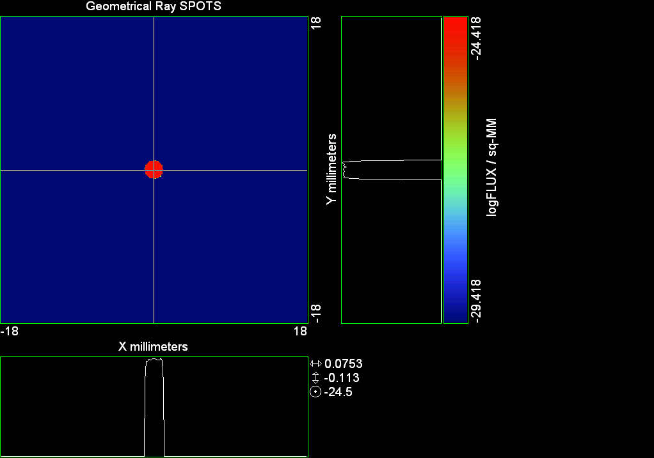

--- ! Spot Plot (Run Ray Trace First)
--- !!CONSIDER ONLY 6 !!Grid Detector=6
--- CONSIDER ONLY 7 !! Earth Detector=7
--- OBLIQUE OFF
--- !!TITLE 'FOV1-9/19^2 mm^2=15503 Rays'
--- !!TITLE 'FOV8 Rect Source Det=2170 total rays'
--- !!TITLE 'FOV8 RctSrc Det=1357-1348=11 rays from Pedestals DetImplBafOnly'
--- !!TITLE 'FOV8 RctSrc Det=750 rays "On"Mrlts Pd&SbS=0 DtImplBfOnly'
--- !!TITLE 'FOV8 RctSrc Det=754 rays "On"Mrlts Pd=1 SbS=0 DtImplBfOnly'
--- !!TITLE 'FOV8 3x3 Pt Src =215 rays "On"Mrlts Pd=1 SbS=0 DtImplBfOnly'
--- TITLE '1000 KM Source'
--- !!WINDOW Y X
--- WINDOW Y -18 18 X -18 18
--- !!WINDOW Y 11 14 X -1.5 1.5
--- !!TITLE 'FOV8 23x23 1358-678=680 Rays/.109 mm^2 = 6238 Rays/mm^2 5.5%'
--- !!WINDOW Y 135.75 136.25 X 82.5 83 !!FOV 8
--- !!TITLE 'FOV8 3x3 Core 678 Rays/.006mm^2 = 113000 Rays/mm^2'
--- !!WINDOW Y 136.01 136.07 X 82.75 82.85 !!FOV 8
--- PIXELS 256
--- SPOTS POSITION

Distribution of data within:
Window Vertical: Y = -18.0000 to 18.0000 ( 36.0000 )
Horizontal: X = -18.0000 to 18.0000 ( 36.0000 )

Opening NEW distribution file 9: C:\ASAP Work\TRIANA\bro009.dat
Rays Flux
15746 0.935399E-24
Maximum = 3.8153206E-25 minimum = 0.0000000E+00
--- $IO "ASAPTEMP.INR"
Opening 1 C:\ASAP Work\TRIANA\asaptemp.inr

Closing 7 C:\ASAP Work\TRIANA\bro007.dat
Opening 7 C:\ASAP Work\TRIANA\asaptemp.usr

Closing 20 C:\ASAP Work\TRIANA\bro020.dat
Opening 20 C:\ASAP Work\TRIANA\asaptemp.plr

Closing 30 C:\ASAP Work\TRIANA\bro030.dat
Opening 30 C:\ASAP Work\TRIANA\asaptemp.vcr

--- !! PICTURE (Run Ray Trace and Spots Position First)
--- !! Picks size from Spots Position window size
--- TITLE 'EPIC'
--- CONSIDER ONLY 7 !! Detector = 6 for Grid, 7 for Earth
--- !!WINDOW X -1.5 1.5 Y 11 14
--- WINDOW Y X
--- DISPLAY
Opening OLD distribution file 9: C:\ASAP Work\TRIANA\bro009.dat

File header:
Geometrical Ray SPOTS 1
Z 790.7430 FLUX / sq-MM
X millimeters -18.00000 18.00000 256
Y millimeters -18.00000 18.00000 256

Statistics on 256 by 256 data set:
FLUX / sq-MM Location Y millimeters X millimeters
Minimum 0.000000 1 1 -17.92969 -17.92969
Maximum 0.3815321E-24 133 130 0.6328125 0.2109375
Average 0.7217577E-27 128 129 -0.7031250E-01 0.7031250E-01
TOTAL FLUX = 0.9353980E-24

--- AVERAGE 0 0
Statistics on 256 by 256 data set:
FLUX / sq-MM Location Y millimeters X millimeters
Minimum 0.000000 1 1 -17.92969 -17.92969
Maximum 0.3815321E-24 133 130 0.6328125 0.2109375
Average 0.7217577E-27 128 129 -0.7031250E-01 0.7031250E-01
TOTAL FLUX = 0.9353980E-24

--- FORM -5
Statistics on 256 by 256 data set:
FLUX / sq-MM Location Y millimeters X millimeters
Minimum -29.41847 1 1 -17.92969 -17.92969
Maximum -24.41847 133 130 0.6328125 0.2109375
Average -29.40515 128 129 -0.7031250E-01 0.7031250E-01
Integral = -38109.07

--- !!CONTOUR .001 .005 .01 .05 .1 .2 .3 .4 .5 .6 .7 .8 .85 .9 .95 GRID 2
--- PICTURE
Opening NEW distribution file 10: C:\ASAP Work\TRIANA\i.dis
--- $IO "ASAPTEMP.INR"
Opening 1 C:\ASAP Work\TRIANA\asaptemp.inr

Closing 7 C:\ASAP Work\TRIANA\bro007.dat
Opening 7 C:\ASAP Work\TRIANA\asaptemp.usr

Closing 20 C:\ASAP Work\TRIANA\bro020.dat
Creating 20 C:\ASAP Work\TRIANA\asaptemp.plr

Closing 30 C:\ASAP Work\TRIANA\bro030.dat
Creating 30 C:\ASAP Work\TRIANA\asaptemp.vcr

--- DISPLAY
Opening OLD distribution file 9: C:\ASAP Work\TRIANA\bro009.dat

File header:
Geometrical Ray SPOTS 1
Z 790.7430 FLUX / sq-MM
X millimeters -18.00000 18.00000 256
Y millimeters -18.00000 18.00000 256

Statistics on 256 by 256 data set:
FLUX / sq-MM Location Y millimeters X millimeters
Minimum 0.000000 1 1 -17.92969 -17.92969
Maximum 0.3815321E-24 133 130 0.6328125 0.2109375
Average 0.7217577E-27 128 129 -0.7031250E-01 0.7031250E-01
TOTAL FLUX = 0.9353980E-24

--- TEXTFILE X_Text_Output !!Names Text File, overwrites without warning
--- DATA 'E12.5' !! Format with single blank space
--- EOF

Run 02 Centered 0.08 deg 40k rays

--- END

System database and settings have been reinitialized
--- $IO "ASAPTEMP.INR"
Opening 1 C:\ASAP Work\TRIANA\asaptemp.inr

Closing 7 C:\ASAP Work\TRIANA\bro007.dat
Opening 7 C:\ASAP Work\TRIANA\asaptemp.usr

Closing 20 C:\ASAP Work\TRIANA\bro020.dat
Creating 20 C:\ASAP Work\TRIANA\asaptemp.plr

Closing 30 C:\ASAP Work\TRIANA\bro030.dat
Creating 30 C:\ASAP Work\TRIANA\asaptemp.vcr

--- !! Directed Diffuser Example
--- !! Create a source (Disk or Grid)
--- !! Source hits a diffuser in close proximity to source
--- !! diffuser scatters towards an edge for efficient ray tracing
--- SYSTEM NEW
--- RESET
--- UNITS MILLIMETERS
--- !! Setup for 1500 meter test
--- EDGE (EP=1000) !! Assign edge number to reference later with TOWARDS
--- ELLIPSE Z -200 225 225
--- !! Diffusion Model
--- MODEL
--- LAMBERTIAN 1
Angle Relative TIS Sampling
0.0 1.00 1000 radial

--- RETURN
--- CUTOFF (1.0E-40) 50 !! Default=1.0E-18 1/4pir2=3.5E-26
--- !! Scattering Plate is at L1, Source Disk is 1 meter farther away
--- !! L1 is at 1.5E6 km 1.5E9 m 1.5E12 mm
--- !! Except for scale factor, dimensions are in km
--- SCALE=1E6 !! S=1 for mm; 1E3 m; 1E6 km
--- !! Set source offset in "km" if scale = 1E6. Usually DX or DY only.
--- DX=0*(SCALE)
--- DY=0*(SCALE) !! 0=pixel 1024, centered
--- DZ=0*(SCALE)
--- !!SRAD=523.6 !!=0.04 deg diam
--- SRAD=1047.2 !!=0.08 deg diam
--- !! Spherical Earth Radius = 6371 km
--- LEVEL 2 0. !! Suggested by BRO Tech Support
--- SURFACE
--- PLANE Z ((-1.5E6)*(SCALE)) ELLIPSE (SRAD*(SCALE)) (SRAD*(SCALE)) 0 (DX) (DY)
--- OBJECT 'DIFFUSION'
--- INTERFACE 0 1E-12 !! Only allow scatter rays to transmit
--- SCATTER MODEL 1 RANDOM 1 1 !! RANDOM needed to find edge, else low light problems
--- TOWARDS (EP) 1
--- RETURN
--- !! Emitter
--- NRAYS=40000 !! 1000=32 sec 40000=20 minutes 200000
--- EMIT DISK Z ((-1.500001E6)*(SCALE)) (SRAD*(SCALE)) (SRAD*(SCALE)) (NRAYS) 1 1
Total flux in rays created by this emitter is 3.0458655E-04
--- SHIFT (DX) (DY) (DZ)
--- RETURN
--- UNITS MILLIMETERS
--- WAVELENGTHS 0.950000 0.706000 0.587560 0.435000 0.300000 MICRONS
--- MEDIA; 1.45106513 1.45515708 1.45846375 1.46676272 1.48779297 'SILICA'
--- COATING PROPERTIES; 1 0 'WHITE'
--- COATING PROPERTIES; .98 0 'MIRROR'
--- COATING PROPERTIES; .11 .87 'DETECTORQE317'
--- COATING PROPERTIES; .10 .75 'DETECTORQE325'
--- COATING PROPERTIES; .05 0 'BLACK'
--- COATING PROPERTIES; 0 0 'ZERO'
--- COATING PROPERTIES; 0 1 'CLEAR'
--- STRUE=0
--- SX=0
--- SY=0
--- SZ=0
--- SCAT=1
--- ENT OBJECT;MIRROR Z 439.24 159 (1219.2/2) -1 (38.2/159) 'PRIMARY S1'
--- INTERFACE COATING MIRROR AIR AIR
--- ENT OBJECT;TUBE Z 438.5 38.2 38.2 466.53196 38.2 38.2 0.0 0.0 'PRIMARYHOLE'
--- INTERFACE COATING BLACK AIR AIR
--- SCATTER RANDOM 1 (SCAT) 1.57 ABS 1 0
--- ENT OBJECT;PLANE Z 466.5 ELLIPSE 210 210 (38.2/210) 'PRIMARY BACK'
--- INTERFACE COATING BLACK AIR AIR
--- SCATTER RANDOM 1 (SCAT) 1.57 ABS 1 0
--- ENT OBJECT;TUBE Z 429 159 159 466.5 159 159 0.0 0.0 'PRIMARYEDGE'
--- INTERFACE COATING BLACK AIR AIR
--- SCATTER RANDOM 1 (SCAT) 1.57 ABS 1 0
--- ENT OBJECT;MIRROR Z 0.0 46 (434.7/2) -2.40763 0.0 'SECONDARY S2'
--- INTERFACE COATING MIRROR AIR AIR
--- ENT OBJECT;PLANE Z 790.7429896 RECTANGLE 18 18 0 'DETECTOR'
--- INTERFACE COATING ZERO SILICA AIR
--- ENT OBJECT;PLANE Z 790.7 RECTANGLE 18 18 0 'DETECTOR-COVER'
--- INTERFACE COATING DETECTORQE317 SILICA AIR
*** SPLIT automatically set to 1
--- ENT OBJECT;PLANE Z -55.69204 ELLIPSE 210 210 (154.8315449/210) 'SPIDER'
--- INTERFACE COATING BLACK AIR AIR
--- SCATTER RANDOM 1 (SCAT) 1.57 ABS 1 0
--- ENT OBJECT;TUBE Z -55.69204 154.8315449 154.8315449 -30.29204 154.8315449 154.8315449 0.0 0.0 'SPIDERCYL'
--- INTERFACE COATING BLACK AIR AIR
--- SCATTER RANDOM 1 (SCAT) 1.57 ABS 1 0
--- ENT OBJECT;TUBE X 0 0.75 12.52 -170 0.75 15.52 1 1 'SPIDERARMX'
--- SHIFT 0 -52.578 -42.992
--- INTERFACE COATING BLACK AIR AIR
--- SCATTER RANDOM 1 (SCAT) 1.57 ABS 1 0
--- ENT OBJECT;TUBE X 0 5 12.52 -170 5 15.52 1 1 'SPIDERARMX1'
--- SHIFT 0 -52.578 -42.992
--- ROTATE Z -120 0 0
--- INTERFACE COATING BLACK AIR AIR
--- SCATTER RANDOM 1 (SCAT) 1.57 ABS 1 0
--- ENT OBJECT;TUBE X 0 0.75 12.52 -170 0.75 15.52 1 1 'SPIDERARMX2'
--- SHIFT 0 -52.578 -42.992
--- ROTATE Z -240 0 0
--- INTERFACE COATING BLACK AIR AIR
--- SCATTER RANDOM 1 (SCAT) 1.57 ABS 1 0
--- ENT OBJECT;TUBE Z -185.6 200.8 200.8 528 200.8 200.8 0.0 0.0 'BARRELBAFFLE'
--- INTERFACE COATING BLACK AIR AIR
--- SCATTER RANDOM 1 (SCAT) 1.57 ABS 1 0
--- ENT OBJECT;ELLIPSE Z -200 205 205 64 0.0 360.0 'ENTRANCE'
Default ELLIP/ROUND/OVAL segments changed to 64
--- INTERFACE COATING CLEAR AIR AIR
--- ENT OBJECT;TUBE Z (2.391*25.4) (2.546*25.4) (2.546*25.4) (2.164*25.4) (2.546*25.4) (2.546*25.4) 0.0 0.0 'SECONDARYHOUSING'
--- INTERFACE COATING BLACK AIR AIR
--- SCATTER RANDOM 1 (SCAT) 1.57 ABS 1 0
--- ENT OBJECT;TUBE Z (2.164*25.4) (2.546*25.4) (2.546*25.4) 0 (2*25.4) (2*25.4) 0.0 0.0 'SH-CONE'
--- INTERFACE COATING BLACK AIR AIR
--- SCATTER RANDOM 1 (SCAT) 1.57 ABS 1 0
--- ENT OBJECT;PLANE Z 0.0 ELLIPSE (2.45*25.4) (2.45*25.4) (2.00/2.45) 'SH-CONEBASE'
--- INTERFACE COATING BLACK AIR AIR
--- SCATTER RANDOM 1 (SCAT) 1.57 ABS 1 0
--- ENT OBJECT;TUBE Z 0.0 (2.125*25.4) (2.125*25.4) (-6.875*25.4) (2.125*25.4) (2.125*25.4) 0.0 0.0 'SH-CYLINDER'
--- INTERFACE COATING BLACK AIR AIR
--- SCATTER RANDOM 1 (SCAT) 1.57 ABS 1 0
--- ENT OBJECT;PLANE Z (-6.875*25.4) ELLIPSE (2.33*25.4) 'SH-TOP'
--- INTERFACE COATING BLACK AIR AIR
--- SCATTER RANDOM 1 (SCAT) 1.57 ABS 1 0
--- ENT OBJECT;PLANE Z (-1.9*25.4) ELLIPSE (2.546*25.4) 'SH-MIDVANE'
--- INTERFACE COATING BLACK AIR AIR
--- SCATTER RANDOM 1 (SCAT) 1.57 ABS 1 0
--- ENT OBJECT;TUBE Z 226.38766 37.465 37.465 422.98366 37.465 37.465 0.0 0.0 'CBAF-FRONT'
--- INTERFACE COATING BLACK AIR AIR
--- SCATTER RANDOM 1 (SCAT) 1.57 ABS 1 0
--- ENT OBJECT;PLANE Z 422.98366 ELLIPSE 37.485 37.485 (30.5562/37.485) 'CBAF-LEDGE'
--- INTERFACE COATING BLACK AIR AIR
--- SCATTER RANDOM 1 (SCAT) 1.57 ABS 1 0
--- ENT OBJECT;TUBE Z 422.985 32.2072 32.2072 532.45766 32.2072 32.2072 0.0 0.0 'CBAF-AFT'
--- INTERFACE COATING BLACK AIR AIR
--- SCATTER RANDOM 1 (SCAT) 1.57 ABS 1 0
--- ENT OBJECT;PLANE Z 327.98766 ELLIPSE 37.485 37.485 (35.56/37.485) 'CBAF-VANE1'
--- INTERFACE COATING BLACK AIR AIR
--- SCATTER RANDOM 1 (SCAT) 1.57 ABS 1 0
--- ENT OBJECT;PLANE Z 378.78766 ELLIPSE 37.485 37.485 (35.56/37.485) 'CBAF-VANE2'
--- INTERFACE COATING BLACK AIR AIR
--- SCATTER RANDOM 1 (SCAT) 1.57 ABS 1 0
--- ENT OBJECT;PLANE Z 505.53366 ELLIPSE 32.24 32.24 (28.6512/32.24) 'CBAF-VANE3'
--- INTERFACE COATING BLACK AIR AIR
--- SCATTER RANDOM 1 (SCAT) 1.57 ABS 1 0
--- RETURN
--- !! Geometry is being appended to system.
--- !! To not view this message, refer to ASAP preferences dialog,
--- !! or change the Options->Append Geometry menu item.
--- UNITS MILLIMETERS
--- WAVELENGTHS 0.950000 0.706000 0.587560 0.435000 0.300000 MICRONS
--- MEDIA; 1.45106513 1.45515708 1.45846375 1.46676272 1.48779297 'SILICA'
--- COATING PROPERTIES; .98 0 'MIRROR'
--- COATING PROPERTIES; .05 0 'BLACK'
--- COATING PROPERTIES; 0 0 'ZERO'
--- COATING PROPERTIES; 0 1 'CLEAR'
--- COATING PROPERTIES; .05 .95 'ARF05'
--- COATING PROPERTIES; 0.2 0.8 'ARF20'
--- ENT OBJECT;PLANE Z 615.3400000 ELLIPSE 150 150 (22/150) 'LENS MOUNT'
--- INTERFACE COATING BLACK AIR AIR
--- SCATTER RANDOM 1 (SCAT) 1.57 ABS 1 0
--- ENT OBJECT;TUBE Z 558.61966 26.7 26.7 620 26.7 26.7 0.0 0.0 'LENS TUBE-FRONT'
--- INTERFACE COATING BLACK AIR AIR
--- SCATTER RANDOM 1 (SCAT) 1.57 ABS 1 0
--- ENT OBJECT;PLANE Z 558.61966 ELLIPSE 27.7 27.7 (24.945/27.7) 'LT-FACE'
--- INTERFACE COATING BLACK AIR AIR
--- SCATTER RANDOM 1 (SCAT) 1.57 ABS 1 0
--- ENT OBJECT;PLANE Z 616.4326 ELLIPSE 27.7 27.7 (21.5/27.7) 'LT-LENS 1FACE'
--- INTERFACE COATING BLACK AIR AIR
--- SCATTER RANDOM 1 (SCAT) 1.57 ABS 1 0
--- ENT OBJECT;TUBE Z 621 25.152 25.152 657.7965 25.152 25.152 0.0 0.0 'LENS TUBE AFT'
--- INTERFACE COATING BLACK AIR AIR
--- SCATTER RANDOM 1 (SCAT) 1.57 ABS 1 0
--- ENT OBJECT;PLANE Z 657.7965 ELLIPSE 25.152 25.152 (21.26386619/25.152) 'LT-AFT FACE'
--- INTERFACE COATING BLACK AIR AIR
--- SCATTER RANDOM 1 (SCAT) 1.57 ABS 1 0
--- ENT OBJECT;OPTICAL Z 615.3400000 221.803 0 ELLIPSE 22 'LENS1F'
--- INTERFACE COATING ARF05 AIR SILICA
--- ENT OBJECT;OPTICAL Z 620.3400000 584.5 0 ELLIPSE 22 'LENS1B'
--- INTERFACE COATING ARF05 AIR SILICA
--- ENT OBJECT;OPTICAL Z 627.63 -147.027 0 ELLIPSE 22 'LENS2F'
--- INTERFACE COATING ARF05 AIR SILICA
--- ENT OBJECT;OPTICAL Z 632.63 -135.158 0 ELLIPSE 22 'LENS2B'
--- INTERFACE COATING ARF05 AIR SILICA
--- ENT OBJECT;OPTICAL Z 635.6 97.002 0 ELLIPSE 22 'LENS3F'
--- INTERFACE COATING ARF05 AIR SILICA
--- ENT OBJECT;OPTICAL Z 640.6 67.147 0 ELLIPSE 22 'LENS3B'
--- INTERFACE COATING ARF05 AIR SILICA
--- ENT OBJECT;TUBE Z 614 22 22 645 22 22 0.0 0.0 'LENSHOLDER'
--- INTERFACE COATING ZERO AIR AIR
--- SCATTER RANDOM 1 (SCAT) 1.57 ABS 1 0
--- ENT OBJECT;PLANE Z 660.84196 ELLIPSE 150 150 (25.28148817/150) 'FW-HOUSING FRONT'
--- INTERFACE COATING BLACK AIR AIR
--- SCATTER RANDOM 1 (SCAT) 1.57 ABS 1 0
--- ENT OBJECT;PLANE Z 709.10196 ELLIPSE 150 150 (25.28148817/150) 'FW-HOUSING AFT'
--- INTERFACE COATING BLACK AIR AIR
--- SCATTER RANDOM 1 (SCAT) 1.57 ABS 1 0
--- ENT OBJECT;TUBE Z (673.54196-.3) 27.5 27.5 (680.04436+.3) 27.5 27.5 0.0 0.0 'FILTERHOLDER'
--- INTERFACE COATING BLACK AIR AIR
--- SCATTER RANDOM 1 (SCAT) 1.57 ABS 1 0
--- ENT OBJECT;PLANE Z 675 ELLIPSE 150 150 (27.5/150) 'FILTER-WHEEL'
--- INTERFACE COATING BLACK AIR AIR
--- SCATTER RANDOM 1 (SCAT) 1.57 ABS 1 0
--- ENT OBJECT;TUBE Z 721.59876 19.16979665 19.16979665 723.53932 22.558 22.558 0.0 0.0 'EXIT CONE FRONT'
--- INTERFACE COATING BLACK AIR AIR
--- SCATTER RANDOM 1 (SCAT) 1.57 ABS 1 0
--- ENT OBJECT;TUBE Z 723.53932 22.558 22.558 781.84248 22.558 22.558 0.0 0.0 'EC-CYLINDER'
--- INTERFACE COATING BLACK AIR AIR
--- SCATTER RANDOM 1 (SCAT) 1.57 ABS 1 0
--- ENT OBJECT;PLANE Z 781.84248 ELLIPSE 22.558 22.558 (16.89/22.558) 'EC-SHELF'
--- INTERFACE COATING BLACK AIR AIR
--- SCATTER RANDOM 1 (SCAT) 1.57 ABS 1 0
--- ENT OBJECT;TUBE Z 781.84248 16.89 16.89 783.87448 20.41280351 20.41280351 0.0 0.0 'EC-EXITCONE'
--- INTERFACE COATING BLACK AIR AIR
--- SCATTER RANDOM 1 (SCAT) 1.57 ABS 1 0
--- ENT OBJECT;PLANE Z 783.87448 ELLIPSE 50 50 (20.41280351/50) 'EC-EXIT'
--- INTERFACE COATING BLACK AIR AIR
--- SCATTER RANDOM 1 (SCAT) 1.57 ABS 1 0
--- RETURN
--- $IO "ASAPTEMP.INR"
Opening 1 C:\ASAP Work\TRIANA\asaptemp.inr

Closing 7 C:\ASAP Work\TRIANA\bro007.dat
Opening 7 C:\ASAP Work\TRIANA\asaptemp.usr

Closing 20 C:\ASAP Work\TRIANA\bro020.dat
Creating 20 C:\ASAP Work\TRIANA\asaptemp.plr

Closing 30 C:\ASAP Work\TRIANA\bro030.dat
Creating 30 C:\ASAP Work\TRIANA\asaptemp.vcr

--- !! Filters-2 from .ent/copy/.inr to allow ABSORBing media
--- UNITS MILLIMETERS
--- WAVELENGTHS 0.950000 0.706000 0.587560 0.435000 0.300000 MICRONS
--- MEDIA; 1.45106513 1.45515708 1.45846375 1.46676272 1.48779297 'SILICA'
--- !!COATING PROPERTIES; .98 0 'MIRROR'
--- !!COATING PROPERTIES; .05 0 'BLACK'
--- !!COATING PROPERTIES; 0 0 'ZERO'
--- !!COATING PROPERTIES; 0 1 'CLEAR'
--- COATING PROPERTIES; .0745 .9255 'ARF0745'
--- COATING PROPERTIES; .0525 .9475 'ARF0525'
--- COATING PROPERTIES; .05 .95 'ARF05'
--- COATING PROPERTIES; .005 .995 'ARF005'
--- !!COATING PROPERTIES; 0.2 0.8 'ARF20'
--- !!!!!!!!!!!!!!!!!!!!!!!!!!!!!!!!!!!!!!!!!!!!!!!!!!
--- WAVELENGTH 0.317 MICRONS
--- MEDIA
--- 1.48342884 ABSORB 0.13168 'BLOCKER317'
--- MEDIA
--- 1.48342884 ABSORB 0.00307 'ETALON317'
--- !!!!!!!!!!!!!!!!!!!!!!!!!!!!!!!!!!!!!!!!!!!!!!!!!!
--- !!WAVELENGTH 0.325 MICRONS
--- !!MEDIA
--- !! 1.48163777 ABSORB 0.08074 'BLOCKER325'
--- !!MEDIA
--- !! 1.48163777 ABSORB 0.0415179525 'ETALON325'
--- !!!!!!!!!!!!!!!!!!!!!!!!!!!!!!!!!!!!!!!!!!!!!!!!!!!!!
--- ENT OBJECT;PLANE Z 673.54196 ELLIPSE 27.5 'FILTERUVE-F'
--- INTERFACE COATING ARF0525 AIR ETALON317
--- !! INTERFACE COATING ARF0745 AIR ETALON325
--- ENT OBJECT;PLANE Z 676.71696 ELLIPSE 27.5 'FILTERUVE-B'
--- INTERFACE COATING ARF0525 AIR ETALON317
--- !! INTERFACE COATING ARF0745 AIR ETALON325
--- ENT OBJECT;PLANE Z 676.86936 ELLIPSE 27.5 'FILTERUVB-F'
--- INTERFACE COATING ARF005 AIR BLOCKER317
--- !! INTERFACE COATING ARF005 AIR BLOCKER325
--- ENT OBJECT;PLANE Z 680.04436 ELLIPSE 27.5 'FILTERUVB-B'
--- INTERFACE COATING ARF005 AIR BLOCKER317
--- !! INTERFACE COATING ARF005 AIR BLOCKER325
--- !!RETURN

--- TITLE DCE *Raytrace
--- !! WAVELENGTHS 0.317 MICRONS !! Normally set in filters
--- !!SPLIT 0 !! Direct Trace Only
--- !!SPLIT 1 !! For Rect Sources
--- SPLIT 2 !! For double reflection in lens & filters
--- PLOT FACETS 5 5
Window Vertical: Y = -.104720E+10 to 0.104720E+10 (0.209440E+10)
Horizontal: Z = -.150002E+13 to 791.121 (0.150002E+13)

--- CONSIDER ALL
--- !!CONSIDER ONLY 15
--- ARROWS OFF
--- SEGMENTS 9
--- WINDOW Y Z
--- OBLIQUE 0 0
--- MISSED LINE 50
--- TRACE PLOT 1000 OVERLAY
Window Vertical: Y = -.104720E+10 to 0.104720E+10 (0.209440E+10)
Horizontal: Z = -.150002E+13 to 791.121 (0.150002E+13)

Warning *** Convergence failure in root polishing .4138869E-04
2 *** Convergence failure in root polishing .1026085E-04
15.71 seconds ( 15.08 seconds CPU) to trace 80,000
out of 226,585
52.95 seconds ( 51.20 seconds CPU) to trace 160,000
out of 643,662
106.33 seconds ( 101.12 seconds CPU) to trace 240,000
out of 1,262,604
2.74 minutes ( 2.53 minutes CPU) to trace 320,000
out of 1,887,644
3.37 minutes ( 3.13 minutes CPU) to trace 400,000
out of 2,076,184
3.96 minutes ( 3.68 minutes CPU) to trace 480,000
out of 2,178,400
4.57 minutes ( 4.24 minutes CPU) to trace 560,000
out of 2,282,201
5.16 minutes ( 4.79 minutes CPU) to trace 640,000
out of 2,386,225
5.74 minutes ( 5.35 minutes CPU) to trace 720,000
out of 2,489,514
6.32 minutes ( 5.90 minutes CPU) to trace 800,000
out of 2,593,440
6.90 minutes ( 6.45 minutes CPU) to trace 880,000
out of 2,696,361
7.47 minutes ( 7.00 minutes CPU) to trace 960,000
out of 2,799,098
8.05 minutes ( 7.55 minutes CPU) to trace 1,040,000
out of 2,903,335
8.64 minutes ( 8.10 minutes CPU) to trace 1,120,000
out of 3,007,049
9.22 minutes ( 8.65 minutes CPU) to trace 1,200,000
out of 3,111,088
9.81 minutes ( 9.20 minutes CPU) to trace 1,280,000
out of 3,213,516
10.39 minutes ( 9.76 minutes CPU) to trace 1,360,000
out of 3,316,690
10.98 minutes ( 10.31 minutes CPU) to trace 1,440,000
out of 3,420,525
11.57 minutes ( 10.87 minutes CPU) to trace 1,520,000
out of 3,525,311
12.16 minutes ( 11.42 minutes CPU) to trace 1,600,000
out of 3,630,202
12.75 minutes ( 11.98 minutes CPU) to trace 1,680,000
out of 3,734,237
13.33 minutes ( 12.53 minutes CPU) to trace 1,760,000
out of 3,838,627
13.91 minutes ( 13.09 minutes CPU) to trace 1,840,000
out of 3,941,823
14.49 minutes ( 13.65 minutes CPU) to trace 1,920,000
out of 4,045,544
15.02 minutes ( 14.15 minutes CPU) to trace 2,000,000
out of 4,134,377
15.34 minutes ( 14.37 minutes CPU) to trace 2,080,000
15.58 minutes ( 14.59 minutes CPU) to trace 2,160,000
15.81 minutes ( 14.80 minutes CPU) to trace 2,240,000
16.04 minutes ( 15.02 minutes CPU) to trace 2,320,000
16.27 minutes ( 15.24 minutes CPU) to trace 2,400,000
16.50 minutes ( 15.45 minutes CPU) to trace 2,480,000
16.73 minutes ( 15.66 minutes CPU) to trace 2,560,000
16.96 minutes ( 15.88 minutes CPU) to trace 2,640,000
17.19 minutes ( 16.10 minutes CPU) to trace 2,720,000
17.42 minutes ( 16.31 minutes CPU) to trace 2,800,000
17.65 minutes ( 16.53 minutes CPU) to trace 2,880,000
17.88 minutes ( 16.74 minutes CPU) to trace 2,960,000
18.11 minutes ( 16.96 minutes CPU) to trace 3,040,000
18.34 minutes ( 17.18 minutes CPU) to trace 3,120,000
18.57 minutes ( 17.39 minutes CPU) to trace 3,200,000
18.80 minutes ( 17.61 minutes CPU) to trace 3,280,000
19.04 minutes ( 17.83 minutes CPU) to trace 3,360,000
19.27 minutes ( 18.04 minutes CPU) to trace 3,440,000
19.50 minutes ( 18.26 minutes CPU) to trace 3,520,000
19.73 minutes ( 18.48 minutes CPU) to trace 3,600,000
19.96 minutes ( 18.70 minutes CPU) to trace 3,680,000
20.20 minutes ( 18.92 minutes CPU) to trace 3,760,000
20.44 minutes ( 19.14 minutes CPU) to trace 3,840,000
20.66 minutes ( 19.35 minutes CPU) to trace 3,920,000
20.89 minutes ( 19.57 minutes CPU) to trace 4,000,000
21.13 minutes ( 19.79 minutes CPU) to trace 4,080,000
21.30 minutes ( 19.94 minutes CPU) to trace 4,134,377

Total of 3192004 PARENT warnings
Missed Multiple Wrong Low Evanescent Wrong Absorbed
Obj Total After Bounce Side Flux (TIR) Direc After
1 173814 88961 84853 DIFFUSION
2 906 25 695 186 PRIMARY S1
3 2589 411 16 2162 PRIMARYHOLE
4 99500 34189 295 65016 PRIMARY BACK
5 24497 30 24467 PRIMARYEDGE
6 819 351 468 SECONDARY S2
7 723 723 DETECTOR
8 5579 47 4581 951 DETECTOR-COVER
9 43036 1886 107 41043 SPIDER
10 15026 147 52 14827 SPIDERCYL
11 5008 126 10 4872 SPIDERARMX
12 8927 119 31 8777 SPIDERARMX1
13 4918 119 12 4787 SPIDERARMX2
14 334334 3992 1084 329258 BARRELBAFFLE
15 324109 323665 444 ENTRANCE
16 7642 9 19 7614 SECONDARYHOUSING
17 64075 528 203 63344 SH-CONE
18 14800 25 20 14755 SH-CONEBASE
19 102219 1639 276 100304 SH-CYLINDER
20 988 31 5 952 SH-TOP
21 95274 8 255 95011 SH-MIDVANE
22 321612 790 1454 319368 CBAF-FRONT
23 23438 92 23346 CBAF-LEDGE
24 202164 42419 711 159034 CBAF-AFT
25 9045 12 67 8966 CBAF-VANE1
26 10130 3 58 10069 CBAF-VANE2
27 14480 1434 106 12940 CBAF-VANE3
28 78841 34118 252 44471 LENS MOUNT
29 69589 3440 692 65457 LENS TUBE-FRONT
30 8995 334 74 8587 LT-FACE
31 1893 29 49 1815 LT-LENS 1FACE
32 8972 78 298 8596 LENS TUBE AFT
33 5256 38 245 4973 LT-AFT FACE
34 7249 1113 2268 3868 LENS1F
35 7654 1103 2435 4116 LENS1B
36 8900 1179 5278 2443 LENS2F
37 11475 2989 7007 1479 LENS2B
38 17102 2394 10071 4637 LENS3F
39 12737 3187 3189 6361 LENS3B
40 759 303 456 LENSHOLDER
41 40281 9110 504 30667 FW-HOUSING FRONT
42 472088 324954 1601 145533 FW-HOUSING AFT
43 3231 1126 82 1944 79 FILTERHOLDER
44 191471 68931 1726 120814 FILTER-WHEEL
45 27216 6219 722 20275 EXIT CONE FRONT
46 226521 31310 4414 190797 EC-CYLINDER
47 20070 3 773 19294 EC-SHELF
48 4533 3532 21 980 EC-EXITCONE
49 17905 11305 407 6193 EC-EXIT
50 7018 49 3671 2373 905 20 FILTERUVE-F
51 5987 1798 1 3322 864 2 FILTERUVE-B
52 16377 4444 9590 984 1359 FILTERUVB-F
53 10232 6189 1787 42 1013 1201 FILTERUVB-B

Total of 103061 CHILD warnings
Missed Multiple Wrong Low Evanescent Wrong Absorbed
Obj Total After Bounce Side Flux (TIR) Direc After
8 3378 3378 DETECTOR-COVER
34 7918 7918 LENS1F
35 7950 7950 LENS1B
36 10250 10250 LENS2F
37 10426 10426 LENS2B
38 10285 10285 LENS3F
39 10228 10228 LENS3B
50 10047 10047 FILTERUVE-F
51 10082 10082 FILTERUVE-B
52 11227 11227 FILTERUVB-F
53 11270 11270 FILTERUVB-B
27061428 ray-objects encountered at 22622 per CPU second
295478963 order-intersections done at 247012 per CPU second



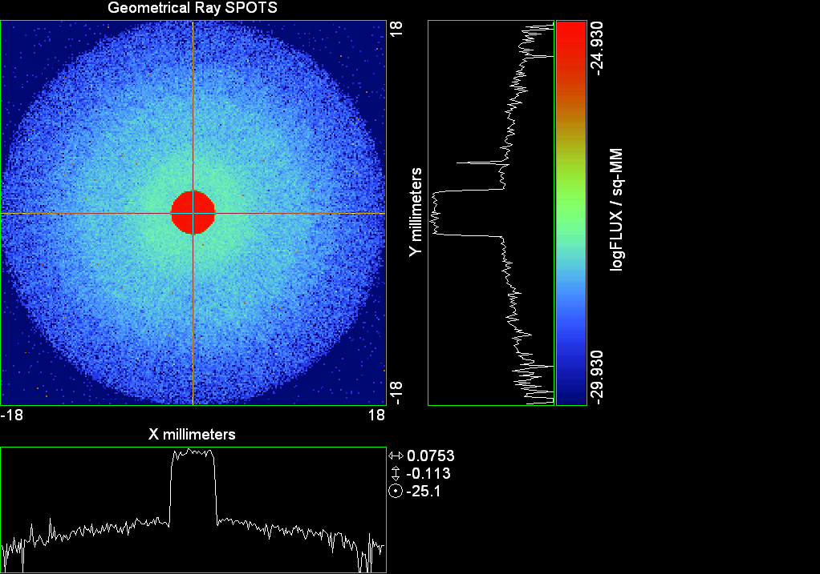

--- ! Spot Plot (Run Ray Trace First)
--- !!CONSIDER ONLY 6 !!Grid Detector=6
--- CONSIDER ONLY 7 !! Earth Detector=7
--- OBLIQUE OFF
--- !!TITLE 'FOV1-9/19^2 mm^2=15503 Rays'
--- !!TITLE 'FOV8 Rect Source Det=2170 total rays'
--- !!TITLE 'FOV8 RctSrc Det=1357-1348=11 rays from Pedestals DetImplBafOnly'
--- !!TITLE 'FOV8 RctSrc Det=750 rays "On"Mrlts Pd&SbS=0 DtImplBfOnly'
--- !!TITLE 'FOV8 RctSrc Det=754 rays "On"Mrlts Pd=1 SbS=0 DtImplBfOnly'
--- !!TITLE 'FOV8 3x3 Pt Src =215 rays "On"Mrlts Pd=1 SbS=0 DtImplBfOnly'
--- TITLE '1000 KM Source'
--- !!WINDOW Y X
--- WINDOW Y -18 18 X -18 18
--- !!WINDOW Y 11 14 X -1.5 1.5
--- !!TITLE 'FOV8 23x23 1358-678=680 Rays/.109 mm^2 = 6238 Rays/mm^2 5.5%'
--- !!WINDOW Y 135.75 136.25 X 82.5 83 !!FOV 8
--- !!TITLE 'FOV8 3x3 Core 678 Rays/.006mm^2 = 113000 Rays/mm^2'
--- !!WINDOW Y 136.01 136.07 X 82.75 82.85 !!FOV 8
--- PIXELS 256
--- SPOTS POSITION

Distribution of data within:
Window Vertical: Y = -18.0000 to 18.0000 ( 36.0000 )
Horizontal: X = -18.0000 to 18.0000 ( 36.0000 )

Opening NEW distribution file 9: C:\ASAP Work\TRIANA\bro009.dat
Rays Flux
832248 0.965451E-24
Maximum = 1.1750729E-25 minimum = 0.0000000E+00
--- $IO "ASAPTEMP.INR"
Opening 1 C:\ASAP Work\TRIANA\asaptemp.inr

Closing 7 C:\ASAP Work\TRIANA\bro007.dat
Opening 7 C:\ASAP Work\TRIANA\asaptemp.usr

Closing 20 C:\ASAP Work\TRIANA\bro020.dat
Opening 20 C:\ASAP Work\TRIANA\asaptemp.plr

Closing 30 C:\ASAP Work\TRIANA\bro030.dat
Opening 30 C:\ASAP Work\TRIANA\asaptemp.vcr

--- !! PICTURE (Run Ray Trace and Spots Position First)
--- !! Picks size from Spots Position window size
--- TITLE 'EPIC'
--- CONSIDER ONLY 7 !! Detector = 6 for Grid, 7 for Earth
--- !!WINDOW X -1.5 1.5 Y 11 14
--- WINDOW Y X
--- DISPLAY
Opening OLD distribution file 9: C:\ASAP Work\TRIANA\bro009.dat

File header:
Geometrical Ray SPOTS 1
Z 790.7430 FLUX / sq-MM
X millimeters -18.00000 18.00000 256
Y millimeters -18.00000 18.00000 256

Statistics on 256 by 256 data set:
FLUX / sq-MM Location Y millimeters X millimeters
Minimum 0.000000 1 1 -17.92969 -17.92969
Maximum 0.1175073E-24 139 130 1.476562 0.2109375
Average 0.7449465E-27 129 129 0.7031250E-01 0.7031250E-01
TOTAL FLUX = 0.9654507E-24

--- AVERAGE 0 0
Statistics on 256 by 256 data set:
FLUX / sq-MM Location Y millimeters X millimeters
Minimum 0.000000 1 1 -17.92969 -17.92969
Maximum 0.1175073E-24 139 130 1.476562 0.2109375
Average 0.7449465E-27 129 129 0.7031250E-01 0.7031250E-01
TOTAL FLUX = 0.9654507E-24

--- FORM -5
Statistics on 256 by 256 data set:
FLUX / sq-MM Location Y millimeters X millimeters
Minimum -29.92994 1 1 -17.92969 -17.92969
Maximum -24.92994 139 130 1.476562 0.2109375
Average -28.81527 129 128 0.7031250E-01 -0.7031250E-01
Integral = -37344.59

--- !!CONTOUR .001 .005 .01 .05 .1 .2 .3 .4 .5 .6 .7 .8 .85 .9 .95 GRID 2
--- PICTURE
Opening NEW distribution file 10: C:\ASAP Work\TRIANA\i.dis

Run 02 Centered 0.08 deg 40k rays.xls

Run 03 Centered 0.16 deg 40k rays

--- END

System database and settings have been reinitialized
--- $IO "ASAPTEMP.INR"
Opening 1 C:\ASAP Work\TRIANA\asaptemp.inr

Closing 7 C:\ASAP Work\TRIANA\bro007.dat
Opening 7 C:\ASAP Work\TRIANA\asaptemp.usr

Closing 20 C:\ASAP Work\TRIANA\bro020.dat
Creating 20 C:\ASAP Work\TRIANA\asaptemp.plr

Closing 30 C:\ASAP Work\TRIANA\bro030.dat
Creating 30 C:\ASAP Work\TRIANA\asaptemp.vcr

--- !! Directed Diffuser Example
--- !! Create a source (Disk or Grid)
--- !! Source hits a diffuser in close proximity to source
--- !! diffuser scatters towards an edge for efficient ray tracing
--- SYSTEM NEW
--- RESET
--- UNITS MILLIMETERS
--- !! Setup for 1500 meter test
--- EDGE (EP=1000) !! Assign edge number to reference later with TOWARDS
--- ELLIPSE Z -200 225 225
--- !! Diffusion Model
--- MODEL
--- LAMBERTIAN 1
Angle Relative TIS Sampling
0.0 1.00 1000 radial

--- RETURN
--- CUTOFF (1.0E-40) 50 !! Default=1.0E-18 1/4pir2=3.5E-26
--- !! Scattering Plate is at L1, Source Disk is 1 meter farther away
--- !! L1 is at 1.5E6 km 1.5E9 m 1.5E12 mm
--- !! Except for scale factor, dimensions are in km
--- SCALE=1E6 !! S=1 for mm; 1E3 m; 1E6 km
--- !! Set source offset in "km" if scale = 1E6. Usually DX or DY only.
--- DX=0*(SCALE)
--- DY=0*(SCALE) !! 0=pixel 1024, centered
--- DZ=0*(SCALE)
--- !!SRAD=523.6 !!=0.04 deg diam
--- !!SRAD=1047.2 !!=0.08 deg diam
--- SRAD=2094.4 !!=0.16 deg diam
--- !! Spherical Earth Radius = 6371 km
--- LEVEL 2 0. !! Suggested by BRO Tech Support
--- SURFACE
--- PLANE Z ((-1.5E6)*(SCALE)) ELLIPSE (SRAD*(SCALE)) (SRAD*(SCALE)) 0 (DX) (DY)
--- OBJECT 'DIFFUSION'
--- INTERFACE 0 1E-12 !! Only allow scatter rays to transmit
--- SCATTER MODEL 1 RANDOM 1 1 !! RANDOM needed to find edge, else low light problems
--- TOWARDS (EP) 1
--- RETURN
--- !! Emitter
--- NRAYS=40000 !! 1000=32 sec 40000=20 minutes 200000
--- EMIT DISK Z ((-1.500001E6)*(SCALE)) (SRAD*(SCALE)) (SRAD*(SCALE)) (NRAYS) 1 1
Total flux in rays created by this emitter is 3.0458655E-04
--- SHIFT (DX) (DY) (DZ)
--- RETURN
--- UNITS MILLIMETERS
--- WAVELENGTHS 0.950000 0.706000 0.587560 0.435000 0.300000 MICRONS
--- MEDIA; 1.45106513 1.45515708 1.45846375 1.46676272 1.48779297 'SILICA'
--- COATING PROPERTIES; 1 0 'WHITE'
--- COATING PROPERTIES; .98 0 'MIRROR'
--- COATING PROPERTIES; .11 .87 'DETECTORQE317'
--- COATING PROPERTIES; .10 .75 'DETECTORQE325'
--- COATING PROPERTIES; .05 0 'BLACK'
--- COATING PROPERTIES; 0 0 'ZERO'
--- COATING PROPERTIES; 0 1 'CLEAR'
--- STRUE=0
--- SX=0
--- SY=0
--- SZ=0
--- SCAT=1
--- ENT OBJECT;MIRROR Z 439.24 159 (1219.2/2) -1 (38.2/159) 'PRIMARY S1'
--- INTERFACE COATING MIRROR AIR AIR
--- ENT OBJECT;TUBE Z 438.5 38.2 38.2 466.53196 38.2 38.2 0.0 0.0 'PRIMARYHOLE'
--- INTERFACE COATING BLACK AIR AIR
--- SCATTER RANDOM 1 (SCAT) 1.57 ABS 1 0
--- ENT OBJECT;PLANE Z 466.5 ELLIPSE 210 210 (38.2/210) 'PRIMARY BACK'
--- INTERFACE COATING BLACK AIR AIR
--- SCATTER RANDOM 1 (SCAT) 1.57 ABS 1 0
--- ENT OBJECT;TUBE Z 429 159 159 466.5 159 159 0.0 0.0 'PRIMARYEDGE'
--- INTERFACE COATING BLACK AIR AIR
--- SCATTER RANDOM 1 (SCAT) 1.57 ABS 1 0
--- ENT OBJECT;MIRROR Z 0.0 46 (434.7/2) -2.40763 0.0 'SECONDARY S2'
--- INTERFACE COATING MIRROR AIR AIR
--- ENT OBJECT;PLANE Z 790.7429896 RECTANGLE 18 18 0 'DETECTOR'
--- INTERFACE COATING ZERO SILICA AIR
--- ENT OBJECT;PLANE Z 790.7 RECTANGLE 18 18 0 'DETECTOR-COVER'
--- INTERFACE COATING DETECTORQE317 SILICA AIR
*** SPLIT automatically set to 1
--- ENT OBJECT;PLANE Z -55.69204 ELLIPSE 210 210 (154.8315449/210) 'SPIDER'
--- INTERFACE COATING BLACK AIR AIR
--- SCATTER RANDOM 1 (SCAT) 1.57 ABS 1 0
--- ENT OBJECT;TUBE Z -55.69204 154.8315449 154.8315449 -30.29204 154.8315449 154.8315449 0.0 0.0 'SPIDERCYL'
--- INTERFACE COATING BLACK AIR AIR
--- SCATTER RANDOM 1 (SCAT) 1.57 ABS 1 0
--- ENT OBJECT;TUBE X 0 0.75 12.52 -170 0.75 15.52 1 1 'SPIDERARMX'
--- SHIFT 0 -52.578 -42.992
--- INTERFACE COATING BLACK AIR AIR
--- SCATTER RANDOM 1 (SCAT) 1.57 ABS 1 0
--- ENT OBJECT;TUBE X 0 5 12.52 -170 5 15.52 1 1 'SPIDERARMX1'
--- SHIFT 0 -52.578 -42.992
--- ROTATE Z -120 0 0
--- INTERFACE COATING BLACK AIR AIR
--- SCATTER RANDOM 1 (SCAT) 1.57 ABS 1 0
--- ENT OBJECT;TUBE X 0 0.75 12.52 -170 0.75 15.52 1 1 'SPIDERARMX2'
--- SHIFT 0 -52.578 -42.992
--- ROTATE Z -240 0 0
--- INTERFACE COATING BLACK AIR AIR
--- SCATTER RANDOM 1 (SCAT) 1.57 ABS 1 0
--- ENT OBJECT;TUBE Z -185.6 200.8 200.8 528 200.8 200.8 0.0 0.0 'BARRELBAFFLE'
--- INTERFACE COATING BLACK AIR AIR
--- SCATTER RANDOM 1 (SCAT) 1.57 ABS 1 0
--- ENT OBJECT;ELLIPSE Z -200 205 205 64 0.0 360.0 'ENTRANCE'
Default ELLIP/ROUND/OVAL segments changed to 64
--- INTERFACE COATING CLEAR AIR AIR
--- ENT OBJECT;TUBE Z (2.391*25.4) (2.546*25.4) (2.546*25.4) (2.164*25.4) (2.546*25.4) (2.546*25.4) 0.0 0.0 'SECONDARYHOUSING'
--- INTERFACE COATING BLACK AIR AIR
--- SCATTER RANDOM 1 (SCAT) 1.57 ABS 1 0
--- ENT OBJECT;TUBE Z (2.164*25.4) (2.546*25.4) (2.546*25.4) 0 (2*25.4) (2*25.4) 0.0 0.0 'SH-CONE'
--- INTERFACE COATING BLACK AIR AIR
--- SCATTER RANDOM 1 (SCAT) 1.57 ABS 1 0
--- ENT OBJECT;PLANE Z 0.0 ELLIPSE (2.45*25.4) (2.45*25.4) (2.00/2.45) 'SH-CONEBASE'
--- INTERFACE COATING BLACK AIR AIR
--- SCATTER RANDOM 1 (SCAT) 1.57 ABS 1 0
--- ENT OBJECT;TUBE Z 0.0 (2.125*25.4) (2.125*25.4) (-6.875*25.4) (2.125*25.4) (2.125*25.4) 0.0 0.0 'SH-CYLINDER'
--- INTERFACE COATING BLACK AIR AIR
--- SCATTER RANDOM 1 (SCAT) 1.57 ABS 1 0
--- ENT OBJECT;PLANE Z (-6.875*25.4) ELLIPSE (2.33*25.4) 'SH-TOP'
--- INTERFACE COATING BLACK AIR AIR
--- SCATTER RANDOM 1 (SCAT) 1.57 ABS 1 0
--- ENT OBJECT;PLANE Z (-1.9*25.4) ELLIPSE (2.546*25.4) 'SH-MIDVANE'
--- INTERFACE COATING BLACK AIR AIR
--- SCATTER RANDOM 1 (SCAT) 1.57 ABS 1 0
--- ENT OBJECT;TUBE Z 226.38766 37.465 37.465 422.98366 37.465 37.465 0.0 0.0 'CBAF-FRONT'
--- INTERFACE COATING BLACK AIR AIR
--- SCATTER RANDOM 1 (SCAT) 1.57 ABS 1 0
--- ENT OBJECT;PLANE Z 422.98366 ELLIPSE 37.485 37.485 (30.5562/37.485) 'CBAF-LEDGE'
--- INTERFACE COATING BLACK AIR AIR
--- SCATTER RANDOM 1 (SCAT) 1.57 ABS 1 0
--- ENT OBJECT;TUBE Z 422.985 32.2072 32.2072 532.45766 32.2072 32.2072 0.0 0.0 'CBAF-AFT'
--- INTERFACE COATING BLACK AIR AIR
--- SCATTER RANDOM 1 (SCAT) 1.57 ABS 1 0
--- ENT OBJECT;PLANE Z 327.98766 ELLIPSE 37.485 37.485 (35.56/37.485) 'CBAF-VANE1'
--- INTERFACE COATING BLACK AIR AIR
--- SCATTER RANDOM 1 (SCAT) 1.57 ABS 1 0
--- ENT OBJECT;PLANE Z 378.78766 ELLIPSE 37.485 37.485 (35.56/37.485) 'CBAF-VANE2'
--- INTERFACE COATING BLACK AIR AIR
--- SCATTER RANDOM 1 (SCAT) 1.57 ABS 1 0
--- ENT OBJECT;PLANE Z 505.53366 ELLIPSE 32.24 32.24 (28.6512/32.24) 'CBAF-VANE3'
--- INTERFACE COATING BLACK AIR AIR
--- SCATTER RANDOM 1 (SCAT) 1.57 ABS 1 0
--- RETURN
--- !! Geometry is being appended to system.
--- !! To not view this message, refer to ASAP preferences dialog,
--- !! or change the Options->Append Geometry menu item.
--- UNITS MILLIMETERS
--- WAVELENGTHS 0.950000 0.706000 0.587560 0.435000 0.300000 MICRONS
--- MEDIA; 1.45106513 1.45515708 1.45846375 1.46676272 1.48779297 'SILICA'
--- COATING PROPERTIES; .98 0 'MIRROR'
--- COATING PROPERTIES; .05 0 'BLACK'
--- COATING PROPERTIES; 0 0 'ZERO'
--- COATING PROPERTIES; 0 1 'CLEAR'
--- COATING PROPERTIES; .05 .95 'ARF05'
--- COATING PROPERTIES; 0.2 0.8 'ARF20'
--- ENT OBJECT;PLANE Z 615.3400000 ELLIPSE 150 150 (22/150) 'LENS MOUNT'
--- INTERFACE COATING BLACK AIR AIR
--- SCATTER RANDOM 1 (SCAT) 1.57 ABS 1 0
--- ENT OBJECT;TUBE Z 558.61966 26.7 26.7 620 26.7 26.7 0.0 0.0 'LENS TUBE-FRONT'
--- INTERFACE COATING BLACK AIR AIR
--- SCATTER RANDOM 1 (SCAT) 1.57 ABS 1 0
--- ENT OBJECT;PLANE Z 558.61966 ELLIPSE 27.7 27.7 (24.945/27.7) 'LT-FACE'
--- INTERFACE COATING BLACK AIR AIR
--- SCATTER RANDOM 1 (SCAT) 1.57 ABS 1 0
--- ENT OBJECT;PLANE Z 616.4326 ELLIPSE 27.7 27.7 (21.5/27.7) 'LT-LENS 1FACE'
--- INTERFACE COATING BLACK AIR AIR
--- SCATTER RANDOM 1 (SCAT) 1.57 ABS 1 0
--- ENT OBJECT;TUBE Z 621 25.152 25.152 657.7965 25.152 25.152 0.0 0.0 'LENS TUBE AFT'
--- INTERFACE COATING BLACK AIR AIR
--- SCATTER RANDOM 1 (SCAT) 1.57 ABS 1 0
--- ENT OBJECT;PLANE Z 657.7965 ELLIPSE 25.152 25.152 (21.26386619/25.152) 'LT-AFT FACE'
--- INTERFACE COATING BLACK AIR AIR
--- SCATTER RANDOM 1 (SCAT) 1.57 ABS 1 0
--- ENT OBJECT;OPTICAL Z 615.3400000 221.803 0 ELLIPSE 22 'LENS1F'
--- INTERFACE COATING ARF05 AIR SILICA
--- ENT OBJECT;OPTICAL Z 620.3400000 584.5 0 ELLIPSE 22 'LENS1B'
--- INTERFACE COATING ARF05 AIR SILICA
--- ENT OBJECT;OPTICAL Z 627.63 -147.027 0 ELLIPSE 22 'LENS2F'
--- INTERFACE COATING ARF05 AIR SILICA
--- ENT OBJECT;OPTICAL Z 632.63 -135.158 0 ELLIPSE 22 'LENS2B'
--- INTERFACE COATING ARF05 AIR SILICA
--- ENT OBJECT;OPTICAL Z 635.6 97.002 0 ELLIPSE 22 'LENS3F'
--- INTERFACE COATING ARF05 AIR SILICA
--- ENT OBJECT;OPTICAL Z 640.6 67.147 0 ELLIPSE 22 'LENS3B'
--- INTERFACE COATING ARF05 AIR SILICA
--- ENT OBJECT;TUBE Z 614 22 22 645 22 22 0.0 0.0 'LENSHOLDER'
--- INTERFACE COATING ZERO AIR AIR
--- SCATTER RANDOM 1 (SCAT) 1.57 ABS 1 0
--- ENT OBJECT;PLANE Z 660.84196 ELLIPSE 150 150 (25.28148817/150) 'FW-HOUSING FRONT'
--- INTERFACE COATING BLACK AIR AIR
--- SCATTER RANDOM 1 (SCAT) 1.57 ABS 1 0
--- ENT OBJECT;PLANE Z 709.10196 ELLIPSE 150 150 (25.28148817/150) 'FW-HOUSING AFT'
--- INTERFACE COATING BLACK AIR AIR
--- SCATTER RANDOM 1 (SCAT) 1.57 ABS 1 0
--- ENT OBJECT;TUBE Z (673.54196-.3) 27.5 27.5 (680.04436+.3) 27.5 27.5 0.0 0.0 'FILTERHOLDER'
--- INTERFACE COATING BLACK AIR AIR
--- SCATTER RANDOM 1 (SCAT) 1.57 ABS 1 0
--- ENT OBJECT;PLANE Z 675 ELLIPSE 150 150 (27.5/150) 'FILTER-WHEEL'
--- INTERFACE COATING BLACK AIR AIR
--- SCATTER RANDOM 1 (SCAT) 1.57 ABS 1 0
--- ENT OBJECT;TUBE Z 721.59876 19.16979665 19.16979665 723.53932 22.558 22.558 0.0 0.0 'EXIT CONE FRONT'
--- INTERFACE COATING BLACK AIR AIR
--- SCATTER RANDOM 1 (SCAT) 1.57 ABS 1 0
--- ENT OBJECT;TUBE Z 723.53932 22.558 22.558 781.84248 22.558 22.558 0.0 0.0 'EC-CYLINDER'
--- INTERFACE COATING BLACK AIR AIR
--- SCATTER RANDOM 1 (SCAT) 1.57 ABS 1 0
--- ENT OBJECT;PLANE Z 781.84248 ELLIPSE 22.558 22.558 (16.89/22.558) 'EC-SHELF'
--- INTERFACE COATING BLACK AIR AIR
--- SCATTER RANDOM 1 (SCAT) 1.57 ABS 1 0
--- ENT OBJECT;TUBE Z 781.84248 16.89 16.89 783.87448 20.41280351 20.41280351 0.0 0.0 'EC-EXITCONE'
--- INTERFACE COATING BLACK AIR AIR
--- SCATTER RANDOM 1 (SCAT) 1.57 ABS 1 0
--- ENT OBJECT;PLANE Z 783.87448 ELLIPSE 50 50 (20.41280351/50) 'EC-EXIT'
--- INTERFACE COATING BLACK AIR AIR
--- SCATTER RANDOM 1 (SCAT) 1.57 ABS 1 0
--- RETURN
--- $IO "ASAPTEMP.INR"
Opening 1 C:\ASAP Work\TRIANA\asaptemp.inr

Closing 7 C:\ASAP Work\TRIANA\bro007.dat
Opening 7 C:\ASAP Work\TRIANA\asaptemp.usr

Closing 20 C:\ASAP Work\TRIANA\bro020.dat
Creating 20 C:\ASAP Work\TRIANA\asaptemp.plr

Closing 30 C:\ASAP Work\TRIANA\bro030.dat
Creating 30 C:\ASAP Work\TRIANA\asaptemp.vcr

--- !! Filters-2 from .ent/copy/.inr to allow ABSORBing media
--- UNITS MILLIMETERS
--- WAVELENGTHS 0.950000 0.706000 0.587560 0.435000 0.300000 MICRONS
--- MEDIA; 1.45106513 1.45515708 1.45846375 1.46676272 1.48779297 'SILICA'
--- !!COATING PROPERTIES; .98 0 'MIRROR'
--- !!COATING PROPERTIES; .05 0 'BLACK'
--- !!COATING PROPERTIES; 0 0 'ZERO'
--- !!COATING PROPERTIES; 0 1 'CLEAR'
--- COATING PROPERTIES; .0745 .9255 'ARF0745'
--- COATING PROPERTIES; .0525 .9475 'ARF0525'
--- COATING PROPERTIES; .05 .95 'ARF05'
--- COATING PROPERTIES; .005 .995 'ARF005'
--- !!COATING PROPERTIES; 0.2 0.8 'ARF20'
--- !!!!!!!!!!!!!!!!!!!!!!!!!!!!!!!!!!!!!!!!!!!!!!!!!!
--- WAVELENGTH 0.317 MICRONS
--- MEDIA
--- 1.48342884 ABSORB 0.13168 'BLOCKER317'
--- MEDIA
--- 1.48342884 ABSORB 0.00307 'ETALON317'
--- !!!!!!!!!!!!!!!!!!!!!!!!!!!!!!!!!!!!!!!!!!!!!!!!!!
--- !!WAVELENGTH 0.325 MICRONS
--- !!MEDIA
--- !! 1.48163777 ABSORB 0.08074 'BLOCKER325'
--- !!MEDIA
--- !! 1.48163777 ABSORB 0.0415179525 'ETALON325'
--- !!!!!!!!!!!!!!!!!!!!!!!!!!!!!!!!!!!!!!!!!!!!!!!!!!!!!
--- ENT OBJECT;PLANE Z 673.54196 ELLIPSE 27.5 'FILTERUVE-F'
--- INTERFACE COATING ARF0525 AIR ETALON317
--- !! INTERFACE COATING ARF0745 AIR ETALON325
--- ENT OBJECT;PLANE Z 676.71696 ELLIPSE 27.5 'FILTERUVE-B'
--- INTERFACE COATING ARF0525 AIR ETALON317
--- !! INTERFACE COATING ARF0745 AIR ETALON325
--- ENT OBJECT;PLANE Z 676.86936 ELLIPSE 27.5 'FILTERUVB-F'
--- INTERFACE COATING ARF005 AIR BLOCKER317
--- !! INTERFACE COATING ARF005 AIR BLOCKER325
--- ENT OBJECT;PLANE Z 680.04436 ELLIPSE 27.5 'FILTERUVB-B'
--- INTERFACE COATING ARF005 AIR BLOCKER317
--- !! INTERFACE COATING ARF005 AIR BLOCKER325
--- !!RETURN

--- TITLE DCE *Raytrace
--- !! WAVELENGTHS 0.317 MICRONS !! Normally set in filters
--- !!SPLIT 0 !! Direct Trace Only
--- !!SPLIT 1 !! For Rect Sources
--- SPLIT 2 !! For double reflection in lens & filters
--- PLOT FACETS 5 5
Window Vertical: Y = -.209440E+10 to 0.209440E+10 (0.418880E+10)
Horizontal: Z = -.150004E+13 to 791.121 (0.150004E+13)

--- CONSIDER ALL
--- !!CONSIDER ONLY 15
--- ARROWS OFF
--- SEGMENTS 9
--- WINDOW Y Z
--- OBLIQUE 0 0
--- MISSED LINE 50
--- TRACE PLOT 1000 OVERLAY
Window Vertical: Y = -.209440E+10 to 0.209440E+10 (0.418880E+10)
Horizontal: Z = -.150004E+13 to 791.121 (0.150004E+13)

Warning *** Convergence failure in root polishing .3045701E-04
20 *** Convergence failure in root polishing .1205466E-04
15.56 seconds ( 15.01 seconds CPU) to trace 80,000
out of 223,879
Warning *** Convergence failure in root polishing .2327589E-03
15 *** Convergence failure in root polishing .6754122E-03
50.70 seconds ( 49.25 seconds CPU) to trace 160,000
out of 612,617
99.87 seconds ( 96.50 seconds CPU) to trace 240,000
out of 1,187,651
2.52 minutes ( 2.40 minutes CPU) to trace 320,000
out of 1,764,025
3.13 minutes ( 2.98 minutes CPU) to trace 400,000
out of 1,919,434
3.73 minutes ( 3.54 minutes CPU) to trace 480,000
out of 2,027,278
4.31 minutes ( 4.10 minutes CPU) to trace 560,000
out of 2,138,454
4.89 minutes ( 4.64 minutes CPU) to trace 640,000
out of 2,244,306
5.48 minutes ( 5.20 minutes CPU) to trace 720,000
out of 2,354,994
6.06 minutes ( 5.76 minutes CPU) to trace 800,000
out of 2,463,272
6.64 minutes ( 6.31 minutes CPU) to trace 880,000
out of 2,570,355
7.29 minutes ( 6.86 minutes CPU) to trace 960,000
out of 2,679,327
7.87 minutes ( 7.41 minutes CPU) to trace 1,040,000
out of 2,787,584
8.47 minutes ( 7.97 minutes CPU) to trace 1,120,000
out of 2,896,302
9.07 minutes ( 8.52 minutes CPU) to trace 1,200,000
out of 3,003,338
9.65 minutes ( 9.08 minutes CPU) to trace 1,280,000
out of 3,112,592
10.23 minutes ( 9.63 minutes CPU) to trace 1,360,000
out of 3,220,191
10.81 minutes ( 10.18 minutes CPU) to trace 1,440,000
out of 3,326,604
11.40 minutes ( 10.74 minutes CPU) to trace 1,520,000
out of 3,436,380
11.97 minutes ( 11.30 minutes CPU) to trace 1,600,000
out of 3,544,929
12.56 minutes ( 11.85 minutes CPU) to trace 1,680,000
out of 3,650,781
13.27 minutes ( 12.39 minutes CPU) to trace 1,760,000
out of 3,757,964
13.77 minutes ( 12.87 minutes CPU) to trace 1,840,000
out of 3,842,101
14.00 minutes ( 13.08 minutes CPU) to trace 1,920,000
14.24 minutes ( 13.30 minutes CPU) to trace 2,000,000
14.46 minutes ( 13.51 minutes CPU) to trace 2,080,000
14.70 minutes ( 13.73 minutes CPU) to trace 2,160,000
14.93 minutes ( 13.94 minutes CPU) to trace 2,240,000
15.16 minutes ( 14.16 minutes CPU) to trace 2,320,000
15.39 minutes ( 14.37 minutes CPU) to trace 2,400,000
15.63 minutes ( 14.59 minutes CPU) to trace 2,480,000
15.86 minutes ( 14.81 minutes CPU) to trace 2,560,000
16.10 minutes ( 15.02 minutes CPU) to trace 2,640,000
16.32 minutes ( 15.24 minutes CPU) to trace 2,720,000
16.56 minutes ( 15.45 minutes CPU) to trace 2,800,000
16.79 minutes ( 15.67 minutes CPU) to trace 2,880,000
17.01 minutes ( 15.88 minutes CPU) to trace 2,960,000
17.24 minutes ( 16.10 minutes CPU) to trace 3,040,000
17.47 minutes ( 16.32 minutes CPU) to trace 3,120,000
17.70 minutes ( 16.53 minutes CPU) to trace 3,200,000
17.93 minutes ( 16.75 minutes CPU) to trace 3,280,000
18.17 minutes ( 16.96 minutes CPU) to trace 3,360,000
18.40 minutes ( 17.18 minutes CPU) to trace 3,440,000
18.65 minutes ( 17.39 minutes CPU) to trace 3,520,000
18.88 minutes ( 17.61 minutes CPU) to trace 3,600,000
19.11 minutes ( 17.82 minutes CPU) to trace 3,680,000
19.34 minutes ( 18.04 minutes CPU) to trace 3,760,000
19.57 minutes ( 18.25 minutes CPU) to trace 3,840,000
19.58 minutes ( 18.26 minutes CPU) to trace 3,842,101

Total of 3002080 PARENT warnings
Missed Multiple Wrong Low Evanescent Wrong Absorbed
Obj Total After Bounce Side Flux (TIR) Direc After
1 196952 100516 96436 DIFFUSION
2 939 30 704 205 PRIMARY S1
3 2291 315 8 1968 PRIMARYHOLE
4 96899 32791 334 63774 PRIMARY BACK
5 22677 35 22642 PRIMARYEDGE
6 931 521 410 SECONDARY S2
7 859 859 DETECTOR
8 5157 44 3795 1318 DETECTOR-COVER
9 39467 1993 154 37320 SPIDER
10 13717 151 64 13502 SPIDERCYL
11 4428 99 17 4312 SPIDERARMX
12 7873 123 51 7699 SPIDERARMX1
13 4346 114 27 4205 SPIDERARMX2
14 306050 4557 1295 300198 BARRELBAFFLE
15 274601 274033 568 ENTRANCE
16 6714 7 25 6682 SECONDARYHOUSING
17 56038 488 250 55300 SH-CONE
18 13116 11 46 13059 SH-CONEBASE
19 89283 1529 435 87319 SH-CYLINDER
20 817 37 7 773 SH-TOP
21 82452 12 328 82112 SH-MIDVANE
22 292447 776 1708 289963 CBAF-FRONT
23 20885 137 20748 CBAF-LEDGE
24 184673 40450 721 143502 CBAF-AFT
25 8260 21 86 8153 CBAF-VANE1
26 9307 6 71 9230 CBAF-VANE2
27 12676 1312 111 11253 CBAF-VANE3
28 76193 32714 263 43216 LENS MOUNT
29 67861 3585 637 63639 LENS TUBE-FRONT
30 8246 305 91 7850 LT-FACE
31 1876 29 48 1799 LT-LENS 1FACE
32 9475 126 274 9075 LENS TUBE AFT
33 5353 35 234 5084 LT-AFT FACE
34 6759 1144 1969 3646 LENS1F
35 7426 1058 2239 4129 LENS1B
36 9404 1228 6018 2158 LENS2F
37 10642 3474 5803 1365 LENS2B
38 14169 2254 8063 3852 LENS3F
39 11561 3526 2580 5455 LENS3B
40 627 226 401 LENSHOLDER
41 44377 10024 480 33873 FW-HOUSING FRONT
42 438054 292823 1557 143674 FW-HOUSING AFT
43 3209 1059 95 1964 91 FILTERHOLDER
44 196071 70346 1583 124142 FILTER-WHEEL
45 25482 5595 656 19231 EXIT CONE FRONT
46 230584 31876 4706 194002 EC-CYLINDER
47 21150 1 753 20396 EC-SHELF
48 4434 3395 21 1018 EC-EXITCONE
49 16360 10173 357 5830 EC-EXIT
50 6369 70 3498 1856 923 22 FILTERUVE-F
51 8818 1668 6202 944 4 FILTERUVE-B
52 13885 3911 7340 1003 1631 FILTERUVB-F
53 9840 6185 1442 52 1028 1133 FILTERUVB-B

Total of 113921 CHILD warnings
Missed Multiple Wrong Low Evanescent Wrong Absorbed
Obj Total After Bounce Side Flux (TIR) Direc After
8 3743 3743 DETECTOR-COVER
34 8290 8290 LENS1F
35 8272 8272 LENS1B
36 11507 11507 LENS2F
37 11616 11616 LENS2B
38 11491 11491 LENS3F
39 11443 11443 LENS3B
50 11260 11260 FILTERUVE-F
51 11286 11286 FILTERUVE-B
52 12479 12479 FILTERUVB-F
53 12534 12534 FILTERUVB-B
24809006 ray-objects encountered at 22645 per CPU second
267710451 order-intersections done at 244367 per CPU second

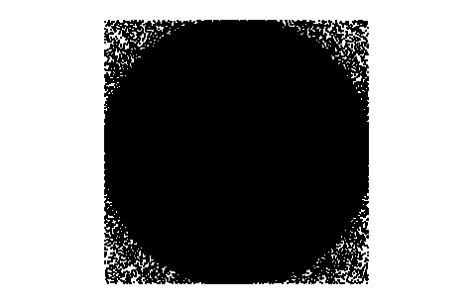

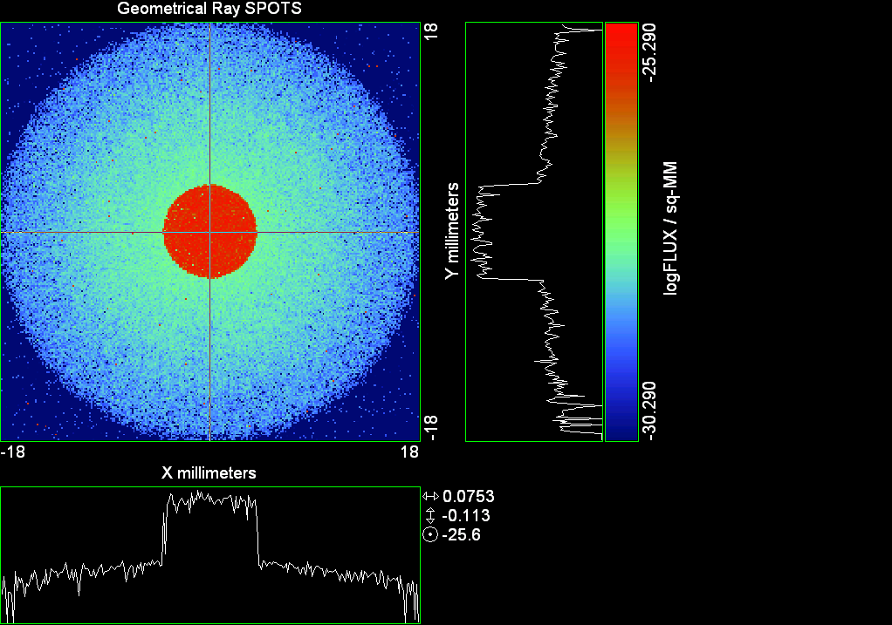

--- ! Spot Plot (Run Ray Trace First)
--- !!CONSIDER ONLY 6 !!Grid Detector=6
--- CONSIDER ONLY 7 !! Earth Detector=7
--- OBLIQUE OFF
--- !!TITLE 'FOV1-9/19^2 mm^2=15503 Rays'
--- !!TITLE 'FOV8 Rect Source Det=2170 total rays'
--- !!TITLE 'FOV8 RctSrc Det=1357-1348=11 rays from Pedestals DetImplBafOnly'
--- !!TITLE 'FOV8 RctSrc Det=750 rays "On"Mrlts Pd&SbS=0 DtImplBfOnly'
--- !!TITLE 'FOV8 RctSrc Det=754 rays "On"Mrlts Pd=1 SbS=0 DtImplBfOnly'
--- !!TITLE 'FOV8 3x3 Pt Src =215 rays "On"Mrlts Pd=1 SbS=0 DtImplBfOnly'
--- TITLE '1000 KM Source'
--- !!WINDOW Y X
--- WINDOW Y -18 18 X -18 18
--- !!WINDOW Y 11 14 X -1.5 1.5
--- !!TITLE 'FOV8 23x23 1358-678=680 Rays/.109 mm^2 = 6238 Rays/mm^2 5.5%'
--- !!WINDOW Y 135.75 136.25 X 82.5 83 !!FOV 8
--- !!TITLE 'FOV8 3x3 Core 678 Rays/.006mm^2 = 113000 Rays/mm^2'
--- !!WINDOW Y 136.01 136.07 X 82.75 82.85 !!FOV 8
--- PIXELS 256
--- SPOTS POSITION

Distribution of data within:
Window Vertical: Y = -18.0000 to 18.0000 ( 36.0000 )
Horizontal: X = -18.0000 to 18.0000 ( 36.0000 )

Opening NEW distribution file 9: C:\ASAP Work\TRIANA\bro009.dat
Rays Flux
729879 0.861731E-24
Maximum = 5.1235927E-26 minimum = 0.0000000E+00
--- $IO "ASAPTEMP.INR"
Opening 1 C:\ASAP Work\TRIANA\asaptemp.inr

Closing 7 C:\ASAP Work\TRIANA\bro007.dat
Opening 7 C:\ASAP Work\TRIANA\asaptemp.usr

Closing 20 C:\ASAP Work\TRIANA\bro020.dat
Opening 20 C:\ASAP Work\TRIANA\asaptemp.plr

Closing 30 C:\ASAP Work\TRIANA\bro030.dat
Opening 30 C:\ASAP Work\TRIANA\asaptemp.vcr

--- !! PICTURE (Run Ray Trace and Spots Position First)
--- !! Picks size from Spots Position window size
--- TITLE 'EPIC'
--- CONSIDER ONLY 7 !! Detector = 6 for Grid, 7 for Earth
--- !!WINDOW X -1.5 1.5 Y 11 14
--- WINDOW Y X
--- DISPLAY
Opening OLD distribution file 9: C:\ASAP Work\TRIANA\bro009.dat

File header:
Geometrical Ray SPOTS 1
Z 790.7430 FLUX / sq-MM
X millimeters -18.00000 18.00000 256
Y millimeters -18.00000 18.00000 256

Statistics on 256 by 256 data set:
FLUX / sq-MM Location Y millimeters X millimeters
Minimum 0.000000 1 1 -17.92969 -17.92969
Maximum 0.5123593E-25 153 132 3.445312 0.4921875
Average 0.6649157E-27 128 129 -0.7031250E-01 0.7031250E-01
TOTAL FLUX = 0.8617306E-24

--- AVERAGE 0 0
Statistics on 256 by 256 data set:
FLUX / sq-MM Location Y millimeters X millimeters
Minimum 0.000000 1 1 -17.92969 -17.92969
Maximum 0.5123593E-25 153 132 3.445312 0.4921875
Average 0.6649157E-27 128 129 -0.7031250E-01 0.7031250E-01
TOTAL FLUX = 0.8617306E-24

--- FORM -5
Statistics on 256 by 256 data set:
FLUX / sq-MM Location Y millimeters X millimeters
Minimum -30.29043 1 1 -17.92969 -17.92969
Maximum -25.29043 153 132 3.445312 0.4921875
Average -28.85715 129 129 0.7031250E-01 0.7031250E-01
Integral = -37398.87

--- !!CONTOUR .001 .005 .01 .05 .1 .2 .3 .4 .5 .6 .7 .8 .85 .9 .95 GRID 2
--- PICTURE
Opening NEW distribution file 10: C:\ASAP Work\TRIANA\i.dis

Run 03 Centered 0.16 deg 40k rays.xls

Run 04 Centered 0.20 deg 40k rays

--- END

System database and settings have been reinitialized
--- $IO "ASAPTEMP.INR"
Opening 1 C:\ASAP Work\TRIANA\asaptemp.inr

Closing 7 C:\ASAP Work\TRIANA\bro007.dat
Opening 7 C:\ASAP Work\TRIANA\asaptemp.usr

Closing 20 C:\ASAP Work\TRIANA\bro020.dat
Creating 20 C:\ASAP Work\TRIANA\asaptemp.plr

Closing 30 C:\ASAP Work\TRIANA\bro030.dat
Creating 30 C:\ASAP Work\TRIANA\asaptemp.vcr

--- !! Directed Diffuser Example
--- !! Create a source (Disk or Grid)
--- !! Source hits a diffuser in close proximity to source
--- !! diffuser scatters towards an edge for efficient ray tracing
--- SYSTEM NEW
--- RESET
--- UNITS MILLIMETERS
--- !! Setup for 1500 meter test
--- EDGE (EP=1000) !! Assign edge number to reference later with TOWARDS
--- ELLIPSE Z -200 225 225
--- !! Diffusion Model
--- MODEL
--- LAMBERTIAN 1
Angle Relative TIS Sampling
0.0 1.00 1000 radial

--- RETURN
--- CUTOFF (1.0E-40) 50 !! Default=1.0E-18 1/4pir2=3.5E-26
--- !! Scattering Plate is at L1, Source Disk is 1 meter farther away
--- !! L1 is at 1.5E6 km 1.5E9 m 1.5E12 mm
--- !! Except for scale factor, dimensions are in km
--- SCALE=1E6 !! S=1 for mm; 1E3 m; 1E6 km
--- !! Set source offset in "km" if scale = 1E6. Usually DX or DY only.
--- DX=0*(SCALE)
--- DY=0*(SCALE) !! 0=pixel 1024, centered
--- DZ=0*(SCALE)
--- !!SRAD=523.6 !!=0.04 deg diam
--- !!SRAD=1047.2 !!=0.08 deg diam
--- !!SRAD=2094.4 !!=0.16 deg diam
--- SRAD=2618.0 !!=0.20 deg diam
--- !! Spherical Earth Radius = 6371 km
--- LEVEL 2 0. !! Suggested by BRO Tech Support
--- SURFACE
--- PLANE Z ((-1.5E6)*(SCALE)) ELLIPSE (SRAD*(SCALE)) (SRAD*(SCALE)) 0 (DX) (DY)
--- OBJECT 'DIFFUSION'
--- INTERFACE 0 1E-12 !! Only allow scatter rays to transmit
--- SCATTER MODEL 1 RANDOM 1 1 !! RANDOM needed to find edge, else low light problems
--- TOWARDS (EP) 1
--- RETURN
--- !! Emitter
--- NRAYS=40000 !! 1000=32 sec 40000=20 minutes 200000
--- EMIT DISK Z ((-1.500001E6)*(SCALE)) (SRAD*(SCALE)) (SRAD*(SCALE)) (NRAYS) 1 1
Total flux in rays created by this emitter is 3.0458655E-04
--- SHIFT (DX) (DY) (DZ)
--- RETURN
--- UNITS MILLIMETERS
--- WAVELENGTHS 0.950000 0.706000 0.587560 0.435000 0.300000 MICRONS
--- MEDIA; 1.45106513 1.45515708 1.45846375 1.46676272 1.48779297 'SILICA'
--- COATING PROPERTIES; 1 0 'WHITE'
--- COATING PROPERTIES; .98 0 'MIRROR'
--- COATING PROPERTIES; .11 .87 'DETECTORQE317'
--- COATING PROPERTIES; .10 .75 'DETECTORQE325'
--- COATING PROPERTIES; .05 0 'BLACK'
--- COATING PROPERTIES; 0 0 'ZERO'
--- COATING PROPERTIES; 0 1 'CLEAR'
--- STRUE=0
--- SX=0
--- SY=0
--- SZ=0
--- SCAT=1
--- ENT OBJECT;MIRROR Z 439.24 159 (1219.2/2) -1 (38.2/159) 'PRIMARY S1'
--- INTERFACE COATING MIRROR AIR AIR
--- ENT OBJECT;TUBE Z 438.5 38.2 38.2 466.53196 38.2 38.2 0.0 0.0 'PRIMARYHOLE'
--- INTERFACE COATING BLACK AIR AIR
--- SCATTER RANDOM 1 (SCAT) 1.57 ABS 1 0
--- ENT OBJECT;PLANE Z 466.5 ELLIPSE 210 210 (38.2/210) 'PRIMARY BACK'
--- INTERFACE COATING BLACK AIR AIR
--- SCATTER RANDOM 1 (SCAT) 1.57 ABS 1 0
--- ENT OBJECT;TUBE Z 429 159 159 466.5 159 159 0.0 0.0 'PRIMARYEDGE'
--- INTERFACE COATING BLACK AIR AIR
--- SCATTER RANDOM 1 (SCAT) 1.57 ABS 1 0
--- ENT OBJECT;MIRROR Z 0.0 46 (434.7/2) -2.40763 0.0 'SECONDARY S2'
--- INTERFACE COATING MIRROR AIR AIR
--- ENT OBJECT;PLANE Z 790.7429896 RECTANGLE 18 18 0 'DETECTOR'
--- INTERFACE COATING ZERO SILICA AIR
--- ENT OBJECT;PLANE Z 790.7 RECTANGLE 18 18 0 'DETECTOR-COVER'
--- INTERFACE COATING DETECTORQE317 SILICA AIR
*** SPLIT automatically set to 1
--- ENT OBJECT;PLANE Z -55.69204 ELLIPSE 210 210 (154.8315449/210) 'SPIDER'
--- INTERFACE COATING BLACK AIR AIR
--- SCATTER RANDOM 1 (SCAT) 1.57 ABS 1 0
--- ENT OBJECT;TUBE Z -55.69204 154.8315449 154.8315449 -30.29204 154.8315449 154.8315449 0.0 0.0 'SPIDERCYL'
--- INTERFACE COATING BLACK AIR AIR
--- SCATTER RANDOM 1 (SCAT) 1.57 ABS 1 0
--- ENT OBJECT;TUBE X 0 0.75 12.52 -170 0.75 15.52 1 1 'SPIDERARMX'
--- SHIFT 0 -52.578 -42.992
--- INTERFACE COATING BLACK AIR AIR
--- SCATTER RANDOM 1 (SCAT) 1.57 ABS 1 0
--- ENT OBJECT;TUBE X 0 5 12.52 -170 5 15.52 1 1 'SPIDERARMX1'
--- SHIFT 0 -52.578 -42.992
--- ROTATE Z -120 0 0
--- INTERFACE COATING BLACK AIR AIR
--- SCATTER RANDOM 1 (SCAT) 1.57 ABS 1 0
--- ENT OBJECT;TUBE X 0 0.75 12.52 -170 0.75 15.52 1 1 'SPIDERARMX2'
--- SHIFT 0 -52.578 -42.992
--- ROTATE Z -240 0 0
--- INTERFACE COATING BLACK AIR AIR
--- SCATTER RANDOM 1 (SCAT) 1.57 ABS 1 0
--- ENT OBJECT;TUBE Z -185.6 200.8 200.8 528 200.8 200.8 0.0 0.0 'BARRELBAFFLE'
--- INTERFACE COATING BLACK AIR AIR
--- SCATTER RANDOM 1 (SCAT) 1.57 ABS 1 0
--- ENT OBJECT;ELLIPSE Z -200 205 205 64 0.0 360.0 'ENTRANCE'
Default ELLIP/ROUND/OVAL segments changed to 64
--- INTERFACE COATING CLEAR AIR AIR
--- ENT OBJECT;TUBE Z (2.391*25.4) (2.546*25.4) (2.546*25.4) (2.164*25.4) (2.546*25.4) (2.546*25.4) 0.0 0.0 'SECONDARYHOUSING'
--- INTERFACE COATING BLACK AIR AIR
--- SCATTER RANDOM 1 (SCAT) 1.57 ABS 1 0
--- ENT OBJECT;TUBE Z (2.164*25.4) (2.546*25.4) (2.546*25.4) 0 (2*25.4) (2*25.4) 0.0 0.0 'SH-CONE'
--- INTERFACE COATING BLACK AIR AIR
--- SCATTER RANDOM 1 (SCAT) 1.57 ABS 1 0
--- ENT OBJECT;PLANE Z 0.0 ELLIPSE (2.45*25.4) (2.45*25.4) (2.00/2.45) 'SH-CONEBASE'
--- INTERFACE COATING BLACK AIR AIR
--- SCATTER RANDOM 1 (SCAT) 1.57 ABS 1 0
--- ENT OBJECT;TUBE Z 0.0 (2.125*25.4) (2.125*25.4) (-6.875*25.4) (2.125*25.4) (2.125*25.4) 0.0 0.0 'SH-CYLINDER'
--- INTERFACE COATING BLACK AIR AIR
--- SCATTER RANDOM 1 (SCAT) 1.57 ABS 1 0
--- ENT OBJECT;PLANE Z (-6.875*25.4) ELLIPSE (2.33*25.4) 'SH-TOP'
--- INTERFACE COATING BLACK AIR AIR
--- SCATTER RANDOM 1 (SCAT) 1.57 ABS 1 0
--- ENT OBJECT;PLANE Z (-1.9*25.4) ELLIPSE (2.546*25.4) 'SH-MIDVANE'
--- INTERFACE COATING BLACK AIR AIR
--- SCATTER RANDOM 1 (SCAT) 1.57 ABS 1 0
--- ENT OBJECT;TUBE Z 226.38766 37.465 37.465 422.98366 37.465 37.465 0.0 0.0 'CBAF-FRONT'
--- INTERFACE COATING BLACK AIR AIR
--- SCATTER RANDOM 1 (SCAT) 1.57 ABS 1 0
--- ENT OBJECT;PLANE Z 422.98366 ELLIPSE 37.485 37.485 (30.5562/37.485) 'CBAF-LEDGE'
--- INTERFACE COATING BLACK AIR AIR
--- SCATTER RANDOM 1 (SCAT) 1.57 ABS 1 0
--- ENT OBJECT;TUBE Z 422.985 32.2072 32.2072 532.45766 32.2072 32.2072 0.0 0.0 'CBAF-AFT'
--- INTERFACE COATING BLACK AIR AIR
--- SCATTER RANDOM 1 (SCAT) 1.57 ABS 1 0
--- ENT OBJECT;PLANE Z 327.98766 ELLIPSE 37.485 37.485 (35.56/37.485) 'CBAF-VANE1'
--- INTERFACE COATING BLACK AIR AIR
--- SCATTER RANDOM 1 (SCAT) 1.57 ABS 1 0
--- ENT OBJECT;PLANE Z 378.78766 ELLIPSE 37.485 37.485 (35.56/37.485) 'CBAF-VANE2'
--- INTERFACE COATING BLACK AIR AIR
--- SCATTER RANDOM 1 (SCAT) 1.57 ABS 1 0
--- ENT OBJECT;PLANE Z 505.53366 ELLIPSE 32.24 32.24 (28.6512/32.24) 'CBAF-VANE3'
--- INTERFACE COATING BLACK AIR AIR
--- SCATTER RANDOM 1 (SCAT) 1.57 ABS 1 0
--- RETURN
--- !! Geometry is being appended to system.
--- !! To not view this message, refer to ASAP preferences dialog,
--- !! or change the Options->Append Geometry menu item.
--- UNITS MILLIMETERS
--- WAVELENGTHS 0.950000 0.706000 0.587560 0.435000 0.300000 MICRONS
--- MEDIA; 1.45106513 1.45515708 1.45846375 1.46676272 1.48779297 'SILICA'
--- COATING PROPERTIES; .98 0 'MIRROR'
--- COATING PROPERTIES; .05 0 'BLACK'
--- COATING PROPERTIES; 0 0 'ZERO'
--- COATING PROPERTIES; 0 1 'CLEAR'
--- COATING PROPERTIES; .05 .95 'ARF05'
--- COATING PROPERTIES; 0.2 0.8 'ARF20'
--- ENT OBJECT;PLANE Z 615.3400000 ELLIPSE 150 150 (22/150) 'LENS MOUNT'
--- INTERFACE COATING BLACK AIR AIR
--- SCATTER RANDOM 1 (SCAT) 1.57 ABS 1 0
--- ENT OBJECT;TUBE Z 558.61966 26.7 26.7 620 26.7 26.7 0.0 0.0 'LENS TUBE-FRONT'
--- INTERFACE COATING BLACK AIR AIR
--- SCATTER RANDOM 1 (SCAT) 1.57 ABS 1 0
--- ENT OBJECT;PLANE Z 558.61966 ELLIPSE 27.7 27.7 (24.945/27.7) 'LT-FACE'
--- INTERFACE COATING BLACK AIR AIR
--- SCATTER RANDOM 1 (SCAT) 1.57 ABS 1 0
--- ENT OBJECT;PLANE Z 616.4326 ELLIPSE 27.7 27.7 (21.5/27.7) 'LT-LENS 1FACE'
--- INTERFACE COATING BLACK AIR AIR
--- SCATTER RANDOM 1 (SCAT) 1.57 ABS 1 0
--- ENT OBJECT;TUBE Z 621 25.152 25.152 657.7965 25.152 25.152 0.0 0.0 'LENS TUBE AFT'
--- INTERFACE COATING BLACK AIR AIR
--- SCATTER RANDOM 1 (SCAT) 1.57 ABS 1 0
--- ENT OBJECT;PLANE Z 657.7965 ELLIPSE 25.152 25.152 (21.26386619/25.152) 'LT-AFT FACE'
--- INTERFACE COATING BLACK AIR AIR
--- SCATTER RANDOM 1 (SCAT) 1.57 ABS 1 0
--- ENT OBJECT;OPTICAL Z 615.3400000 221.803 0 ELLIPSE 22 'LENS1F'
--- INTERFACE COATING ARF05 AIR SILICA
--- ENT OBJECT;OPTICAL Z 620.3400000 584.5 0 ELLIPSE 22 'LENS1B'
--- INTERFACE COATING ARF05 AIR SILICA
--- ENT OBJECT;OPTICAL Z 627.63 -147.027 0 ELLIPSE 22 'LENS2F'
--- INTERFACE COATING ARF05 AIR SILICA
--- ENT OBJECT;OPTICAL Z 632.63 -135.158 0 ELLIPSE 22 'LENS2B'
--- INTERFACE COATING ARF05 AIR SILICA
--- ENT OBJECT;OPTICAL Z 635.6 97.002 0 ELLIPSE 22 'LENS3F'
--- INTERFACE COATING ARF05 AIR SILICA
--- ENT OBJECT;OPTICAL Z 640.6 67.147 0 ELLIPSE 22 'LENS3B'
--- INTERFACE COATING ARF05 AIR SILICA
--- ENT OBJECT;TUBE Z 614 22 22 645 22 22 0.0 0.0 'LENSHOLDER'
--- INTERFACE COATING ZERO AIR AIR
--- SCATTER RANDOM 1 (SCAT) 1.57 ABS 1 0
--- ENT OBJECT;PLANE Z 660.84196 ELLIPSE 150 150 (25.28148817/150) 'FW-HOUSING FRONT'
--- INTERFACE COATING BLACK AIR AIR
--- SCATTER RANDOM 1 (SCAT) 1.57 ABS 1 0
--- ENT OBJECT;PLANE Z 709.10196 ELLIPSE 150 150 (25.28148817/150) 'FW-HOUSING AFT'
--- INTERFACE COATING BLACK AIR AIR
--- SCATTER RANDOM 1 (SCAT) 1.57 ABS 1 0
--- ENT OBJECT;TUBE Z (673.54196-.3) 27.5 27.5 (680.04436+.3) 27.5 27.5 0.0 0.0 'FILTERHOLDER'
--- INTERFACE COATING BLACK AIR AIR
--- SCATTER RANDOM 1 (SCAT) 1.57 ABS 1 0
--- ENT OBJECT;PLANE Z 675 ELLIPSE 150 150 (27.5/150) 'FILTER-WHEEL'
--- INTERFACE COATING BLACK AIR AIR
--- SCATTER RANDOM 1 (SCAT) 1.57 ABS 1 0
--- ENT OBJECT;TUBE Z 721.59876 19.16979665 19.16979665 723.53932 22.558 22.558 0.0 0.0 'EXIT CONE FRONT'
--- INTERFACE COATING BLACK AIR AIR
--- SCATTER RANDOM 1 (SCAT) 1.57 ABS 1 0
--- ENT OBJECT;TUBE Z 723.53932 22.558 22.558 781.84248 22.558 22.558 0.0 0.0 'EC-CYLINDER'
--- INTERFACE COATING BLACK AIR AIR
--- SCATTER RANDOM 1 (SCAT) 1.57 ABS 1 0
--- ENT OBJECT;PLANE Z 781.84248 ELLIPSE 22.558 22.558 (16.89/22.558) 'EC-SHELF'
--- INTERFACE COATING BLACK AIR AIR
--- SCATTER RANDOM 1 (SCAT) 1.57 ABS 1 0
--- ENT OBJECT;TUBE Z 781.84248 16.89 16.89 783.87448 20.41280351 20.41280351 0.0 0.0 'EC-EXITCONE'
--- INTERFACE COATING BLACK AIR AIR
--- SCATTER RANDOM 1 (SCAT) 1.57 ABS 1 0
--- ENT OBJECT;PLANE Z 783.87448 ELLIPSE 50 50 (20.41280351/50) 'EC-EXIT'
--- INTERFACE COATING BLACK AIR AIR
--- SCATTER RANDOM 1 (SCAT) 1.57 ABS 1 0
--- RETURN
--- $IO "ASAPTEMP.INR"
Opening 1 C:\ASAP Work\TRIANA\asaptemp.inr

Closing 7 C:\ASAP Work\TRIANA\bro007.dat
Opening 7 C:\ASAP Work\TRIANA\asaptemp.usr

Closing 20 C:\ASAP Work\TRIANA\bro020.dat
Creating 20 C:\ASAP Work\TRIANA\asaptemp.plr

Closing 30 C:\ASAP Work\TRIANA\bro030.dat
Creating 30 C:\ASAP Work\TRIANA\asaptemp.vcr

--- !! Filters-2 from .ent/copy/.inr to allow ABSORBing media
--- UNITS MILLIMETERS
--- WAVELENGTHS 0.950000 0.706000 0.587560 0.435000 0.300000 MICRONS
--- MEDIA; 1.45106513 1.45515708 1.45846375 1.46676272 1.48779297 'SILICA'
--- !!COATING PROPERTIES; .98 0 'MIRROR'
--- !!COATING PROPERTIES; .05 0 'BLACK'
--- !!COATING PROPERTIES; 0 0 'ZERO'
--- !!COATING PROPERTIES; 0 1 'CLEAR'
--- COATING PROPERTIES; .0745 .9255 'ARF0745'
--- COATING PROPERTIES; .0525 .9475 'ARF0525'
--- COATING PROPERTIES; .05 .95 'ARF05'
--- COATING PROPERTIES; .005 .995 'ARF005'
--- !!COATING PROPERTIES; 0.2 0.8 'ARF20'
--- !!!!!!!!!!!!!!!!!!!!!!!!!!!!!!!!!!!!!!!!!!!!!!!!!!
--- WAVELENGTH 0.317 MICRONS
--- MEDIA
--- 1.48342884 ABSORB 0.13168 'BLOCKER317'
--- MEDIA
--- 1.48342884 ABSORB 0.00307 'ETALON317'
--- !!!!!!!!!!!!!!!!!!!!!!!!!!!!!!!!!!!!!!!!!!!!!!!!!!
--- !!WAVELENGTH 0.325 MICRONS
--- !!MEDIA
--- !! 1.48163777 ABSORB 0.08074 'BLOCKER325'
--- !!MEDIA
--- !! 1.48163777 ABSORB 0.0415179525 'ETALON325'
--- !!!!!!!!!!!!!!!!!!!!!!!!!!!!!!!!!!!!!!!!!!!!!!!!!!!!!
--- ENT OBJECT;PLANE Z 673.54196 ELLIPSE 27.5 'FILTERUVE-F'
--- INTERFACE COATING ARF0525 AIR ETALON317
--- !! INTERFACE COATING ARF0745 AIR ETALON325
--- ENT OBJECT;PLANE Z 676.71696 ELLIPSE 27.5 'FILTERUVE-B'
--- INTERFACE COATING ARF0525 AIR ETALON317
--- !! INTERFACE COATING ARF0745 AIR ETALON325
--- ENT OBJECT;PLANE Z 676.86936 ELLIPSE 27.5 'FILTERUVB-F'
--- INTERFACE COATING ARF005 AIR BLOCKER317
--- !! INTERFACE COATING ARF005 AIR BLOCKER325
--- ENT OBJECT;PLANE Z 680.04436 ELLIPSE 27.5 'FILTERUVB-B'
--- INTERFACE COATING ARF005 AIR BLOCKER317
--- !! INTERFACE COATING ARF005 AIR BLOCKER325
--- !!RETURN

--- TITLE DCE *Raytrace
--- !! WAVELENGTHS 0.317 MICRONS !! Normally set in filters
--- !!SPLIT 0 !! Direct Trace Only
--- !!SPLIT 1 !! For Rect Sources
--- SPLIT 2 !! For double reflection in lens & filters
--- PLOT FACETS 5 5
Window Vertical: Y = -.261800E+10 to 0.261800E+10 (0.523600E+10)
Horizontal: Z = -.150005E+13 to 791.121 (0.150005E+13)

--- CONSIDER ALL
--- !!CONSIDER ONLY 15
--- ARROWS OFF
--- SEGMENTS 9
--- WINDOW Y Z
--- OBLIQUE 0 0
--- MISSED LINE 50
--- TRACE PLOT 1000 OVERLAY
Window Vertical: Y = -.261800E+10 to 0.261800E+10 (0.523600E+10)
Horizontal: Z = -.150005E+13 to 791.121 (0.150005E+13)

Warning *** Convergence failure in root polishing .1546037E-04
21 *** Convergence failure in root polishing .5912128E-04
15.44 seconds ( 15.06 seconds CPU) to trace 80,000
out of 223,624
Warning *** Convergence failure in root polishing .5250369E-04
11 *** Convergence failure in root polishing .4133943E-04
51.32 seconds ( 49.79 seconds CPU) to trace 160,000
out of 613,154
100.54 seconds ( 97.35 seconds CPU) to trace 240,000
out of 1,181,281
2.52 minutes ( 2.42 minutes CPU) to trace 320,000
out of 1,752,466
3.16 minutes ( 3.02 minutes CPU) to trace 400,000
out of 1,908,146
3.78 minutes ( 3.58 minutes CPU) to trace 480,000
out of 2,019,249
4.45 minutes ( 4.15 minutes CPU) to trace 560,000
out of 2,132,364
5.04 minutes ( 4.72 minutes CPU) to trace 640,000
out of 2,242,380
5.66 minutes ( 5.28 minutes CPU) to trace 720,000
out of 2,357,827
6.27 minutes ( 5.85 minutes CPU) to trace 800,000
out of 2,470,017
6.86 minutes ( 6.41 minutes CPU) to trace 880,000
out of 2,581,363
7.45 minutes ( 6.98 minutes CPU) to trace 960,000
out of 2,693,080
8.05 minutes ( 7.55 minutes CPU) to trace 1,040,000
out of 2,805,740
8.64 minutes ( 8.11 minutes CPU) to trace 1,120,000
out of 2,918,511
9.24 minutes ( 8.67 minutes CPU) to trace 1,200,000
out of 3,029,061
9.84 minutes ( 9.24 minutes CPU) to trace 1,280,000
out of 3,140,474
10.43 minutes ( 9.81 minutes CPU) to trace 1,360,000
out of 3,251,677
11.04 minutes ( 10.37 minutes CPU) to trace 1,440,000
out of 3,361,521
11.63 minutes ( 10.94 minutes CPU) to trace 1,520,000
out of 3,474,428
12.23 minutes ( 11.50 minutes CPU) to trace 1,600,000
out of 3,584,530
12.82 minutes ( 12.06 minutes CPU) to trace 1,680,000
out of 3,693,733
13.43 minutes ( 12.63 minutes CPU) to trace 1,760,000
out of 3,805,965
13.86 minutes ( 13.04 minutes CPU) to trace 1,840,000
out of 3,867,763
14.09 minutes ( 13.25 minutes CPU) to trace 1,920,000
14.33 minutes ( 13.47 minutes CPU) to trace 2,000,000
14.56 minutes ( 13.69 minutes CPU) to trace 2,080,000
14.79 minutes ( 13.90 minutes CPU) to trace 2,160,000
15.02 minutes ( 14.12 minutes CPU) to trace 2,240,000
15.25 minutes ( 14.33 minutes CPU) to trace 2,320,000
15.49 minutes ( 14.55 minutes CPU) to trace 2,400,000
15.72 minutes ( 14.77 minutes CPU) to trace 2,480,000
15.96 minutes ( 14.99 minutes CPU) to trace 2,560,000
16.20 minutes ( 15.21 minutes CPU) to trace 2,640,000
16.43 minutes ( 15.43 minutes CPU) to trace 2,720,000
16.75 minutes ( 15.64 minutes CPU) to trace 2,800,000
17.00 minutes ( 15.87 minutes CPU) to trace 2,880,000
17.24 minutes ( 16.08 minutes CPU) to trace 2,960,000
17.47 minutes ( 16.30 minutes CPU) to trace 3,040,000
17.70 minutes ( 16.52 minutes CPU) to trace 3,120,000
17.93 minutes ( 16.74 minutes CPU) to trace 3,200,000
18.16 minutes ( 16.96 minutes CPU) to trace 3,280,000
18.41 minutes ( 17.17 minutes CPU) to trace 3,360,000
18.64 minutes ( 17.39 minutes CPU) to trace 3,440,000
18.87 minutes ( 17.61 minutes CPU) to trace 3,520,000
19.10 minutes ( 17.82 minutes CPU) to trace 3,600,000
19.33 minutes ( 18.04 minutes CPU) to trace 3,680,000
19.57 minutes ( 18.26 minutes CPU) to trace 3,760,000
19.80 minutes ( 18.47 minutes CPU) to trace 3,840,000
19.89 minutes ( 18.55 minutes CPU) to trace 3,867,763

Total of 3043552 PARENT warnings
Missed Multiple Wrong Low Evanescent Wrong Absorbed
Obj Total After Bounce Side Flux (TIR) Direc After
1 206245 105150 101095 DIFFUSION
2 982 29 786 167 PRIMARY S1
3 2196 278 12 1906 PRIMARYHOLE
4 97475 33259 348 63868 PRIMARY BACK
5 22849 36 22813 PRIMARYEDGE
6 909 601 308 SECONDARY S2
7 822 822 DETECTOR
8 5355 50 3766 1539 DETECTOR-COVER
9 41037 2079 172 38786 SPIDER
10 13775 133 65 13577 SPIDERCYL
11 4429 107 19 4303 SPIDERARMX
12 8067 118 39 7910 SPIDERARMX1
13 4544 85 20 4439 SPIDERARMX2
14 305944 4667 1474 299803 BARRELBAFFLE
15 263654 263047 607 ENTRANCE
16 6645 5 21 6619 SECONDARYHOUSING
17 54935 439 262 54234 SH-CONE
18 14428 20 50 14358 SH-CONEBASE
19 91022 1574 529 88919 SH-CYLINDER
20 869 28 12 829 SH-TOP
21 83301 10 352 82939 SH-MIDVANE
22 289005 874 1951 286180 CBAF-FRONT
23 20160 124 20036 CBAF-LEDGE
24 180633 39523 835 140275 CBAF-AFT
25 8016 17 90 7909 CBAF-VANE1
26 9212 2 109 9101 CBAF-VANE2
27 12354 1282 106 10966 CBAF-VANE3
28 75047 32105 240 42702 LENS MOUNT
29 67259 3606 634 63019 LENS TUBE-FRONT
30 8246 279 81 7886 LT-FACE
31 1890 26 51 1813 LT-LENS 1FACE
32 10467 146 200 10121 LENS TUBE AFT
33 5697 31 222 5444 LT-AFT FACE
34 6740 1260 1852 3628 LENS1F
35 7386 1092 2131 4163 LENS1B
36 9444 1291 6022 2131 LENS2F
37 10316 3548 5402 1366 LENS2B
38 13572 2372 7677 3523 LENS3F
39 11218 3595 2295 5328 LENS3B
40 588 207 381 LENSHOLDER
41 46054 10297 408 35349 FW-HOUSING FRONT
42 436300 288617 1459 146224 FW-HOUSING AFT
43 3380 1113 97 2062 108 FILTERHOLDER
44 203811 73238 1536 129037 FILTER-WHEEL
45 27637 5637 654 21346 EXIT CONE FRONT
46 266122 36346 4607 225169 EC-CYLINDER
47 23513 766 22747 EC-SHELF
48 4736 3579 26 1131 EC-EXITCONE
49 15865 9868 355 5642 EC-EXIT
50 7035 62 3466 2521 963 23 FILTERUVE-F
51 9520 1655 6942 917 6 FILTERUVE-B
52 12836 3887 6262 1045 1642 FILTERUVB-F
53 10010 6359 1452 42 1027 1130 FILTERUVB-B

Total of 119480 CHILD warnings
Missed Multiple Wrong Low Evanescent Wrong Absorbed
Obj Total After Bounce Side Flux (TIR) Direc After
8 4344 4344 DETECTOR-COVER
34 8810 8810 LENS1F
35 8756 8756 LENS1B
36 12040 12040 LENS2F
37 12106 12106 LENS2B
38 11978 11978 LENS3F
39 11941 11941 LENS3B
50 11760 11760 FILTERUVE-F
51 11806 11806 FILTERUVE-B
52 12919 12919 FILTERUVB-F
53 13020 13020 FILTERUVB-B
24856239 ray-objects encountered at 22331 per CPU second
265579677 order-intersections done at 238605 per CPU second

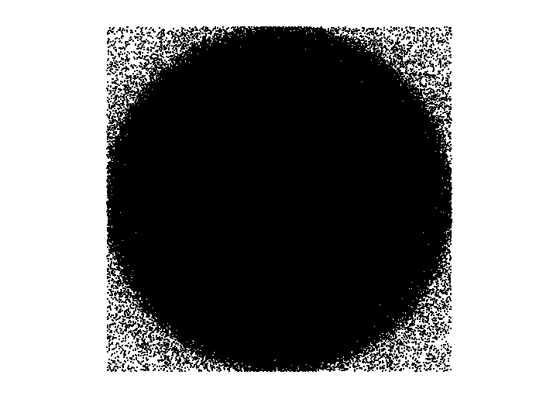

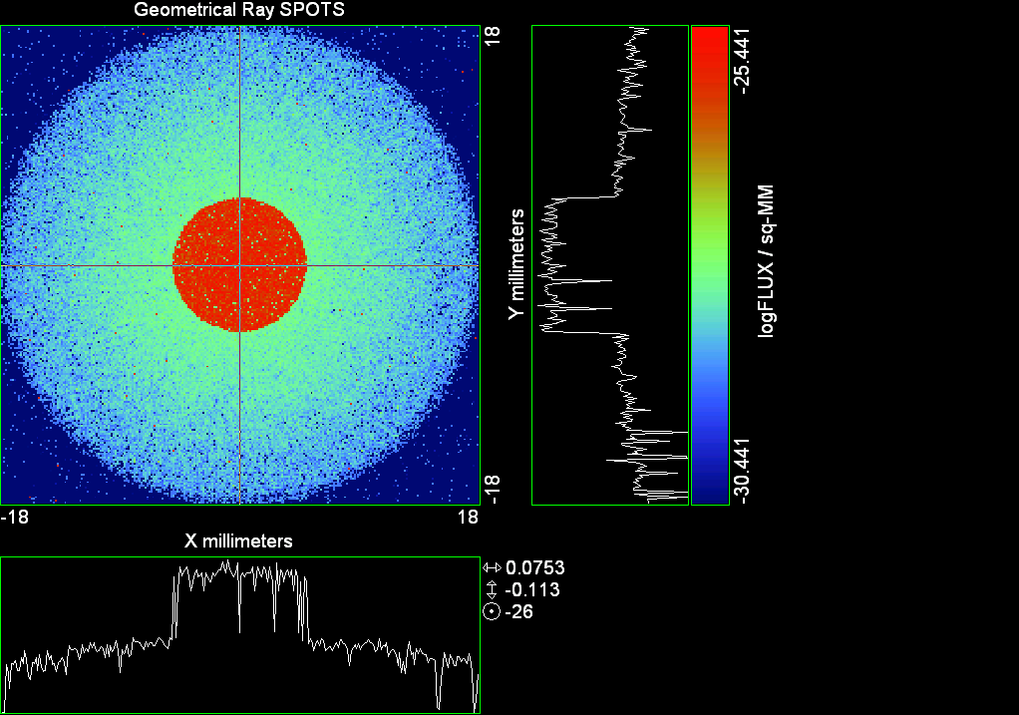

--- ! Spot Plot (Run Ray Trace First)
--- !!CONSIDER ONLY 6 !!Grid Detector=6
--- CONSIDER ONLY 7 !! Earth Detector=7
--- OBLIQUE OFF
--- !!TITLE 'FOV1-9/19^2 mm^2=15503 Rays'
--- !!TITLE 'FOV8 Rect Source Det=2170 total rays'
--- !!TITLE 'FOV8 RctSrc Det=1357-1348=11 rays from Pedestals DetImplBafOnly'
--- !!TITLE 'FOV8 RctSrc Det=750 rays "On"Mrlts Pd&SbS=0 DtImplBfOnly'
--- !!TITLE 'FOV8 RctSrc Det=754 rays "On"Mrlts Pd=1 SbS=0 DtImplBfOnly'
--- !!TITLE 'FOV8 3x3 Pt Src =215 rays "On"Mrlts Pd=1 SbS=0 DtImplBfOnly'
--- TITLE '1000 KM Source'
--- !!WINDOW Y X
--- WINDOW Y -18 18 X -18 18
--- !!WINDOW Y 11 14 X -1.5 1.5
--- !!TITLE 'FOV8 23x23 1358-678=680 Rays/.109 mm^2 = 6238 Rays/mm^2 5.5%'
--- !!WINDOW Y 135.75 136.25 X 82.5 83 !!FOV 8
--- !!TITLE 'FOV8 3x3 Core 678 Rays/.006mm^2 = 113000 Rays/mm^2'
--- !!WINDOW Y 136.01 136.07 X 82.75 82.85 !!FOV 8
--- PIXELS 256
--- SPOTS POSITION

Distribution of data within:
Window Vertical: Y = -18.0000 to 18.0000 ( 36.0000 )
Horizontal: X = -18.0000 to 18.0000 ( 36.0000 )

Opening NEW distribution file 9: C:\ASAP Work\TRIANA\bro009.dat
Rays Flux
710767 0.853955E-24
Maximum = 3.6192190E-26 minimum = 0.0000000E+00
--- $IO "ASAPTEMP.INR"
Opening 1 C:\ASAP Work\TRIANA\asaptemp.inr

Closing 7 C:\ASAP Work\TRIANA\bro007.dat
Opening 7 C:\ASAP Work\TRIANA\asaptemp.usr

Closing 20 C:\ASAP Work\TRIANA\bro020.dat
Opening 20 C:\ASAP Work\TRIANA\asaptemp.plr

Closing 30 C:\ASAP Work\TRIANA\bro030.dat
Opening 30 C:\ASAP Work\TRIANA\asaptemp.vcr

--- !! PICTURE (Run Ray Trace and Spots Position First)
--- !! Picks size from Spots Position window size
--- TITLE 'EPIC'
--- CONSIDER ONLY 7 !! Detector = 6 for Grid, 7 for Earth
--- !!WINDOW X -1.5 1.5 Y 11 14
--- WINDOW Y X
--- DISPLAY
Opening OLD distribution file 9: C:\ASAP Work\TRIANA\bro009.dat

File header:
Geometrical Ray SPOTS 1
Z 790.7430 FLUX / sq-MM
X millimeters -18.00000 18.00000 256
Y millimeters -18.00000 18.00000 256

Statistics on 256 by 256 data set:
FLUX / sq-MM Location Y millimeters X millimeters
Minimum 0.000000 4 1 -17.50781 -17.92969
Maximum 0.3619219E-25 156 150 3.867188 3.023438
Average 0.6589150E-27 128 129 -0.7031250E-01 0.7031250E-01
TOTAL FLUX = 0.8539539E-24

--- AVERAGE 0 0
Statistics on 256 by 256 data set:
FLUX / sq-MM Location Y millimeters X millimeters
Minimum 0.000000 4 1 -17.50781 -17.92969
Maximum 0.3619219E-25 156 150 3.867188 3.023438
Average 0.6589150E-27 128 129 -0.7031250E-01 0.7031250E-01
TOTAL FLUX = 0.8539539E-24

--- FORM -5
Statistics on 256 by 256 data set:
FLUX / sq-MM Location Y millimeters X millimeters
Minimum -30.44139 1 1 -17.92969 -17.92969
Maximum -25.44139 156 150 3.867188 3.023438
Average -28.86313 129 128 0.7031250E-01 -0.7031250E-01
Integral = -37406.62

--- !!CONTOUR .001 .005 .01 .05 .1 .2 .3 .4 .5 .6 .7 .8 .85 .9 .95 GRID 2
--- PICTURE
Opening NEW distribution file 10: C:\ASAP Work\TRIANA\i.dis
--- $IO "ASAPTEMP.INR"
Opening 1 C:\ASAP Work\TRIANA\asaptemp.inr

Closing 7 C:\ASAP Work\TRIANA\bro007.dat
Opening 7 C:\ASAP Work\TRIANA\asaptemp.usr

Closing 20 C:\ASAP Work\TRIANA\bro020.dat
Creating 20 C:\ASAP Work\TRIANA\asaptemp.plr

Closing 30 C:\ASAP Work\TRIANA\bro030.dat
Creating 30 C:\ASAP Work\TRIANA\asaptemp.vcr

--- DISPLAY
Opening OLD distribution file 9: C:\ASAP Work\TRIANA\bro009.dat

File header:
Geometrical Ray SPOTS 1
Z 790.7430 FLUX / sq-MM
X millimeters -18.00000 18.00000 256
Y millimeters -18.00000 18.00000 256

Statistics on 256 by 256 data set:
FLUX / sq-MM Location Y millimeters X millimeters
Minimum 0.000000 4 1 -17.50781 -17.92969
Maximum 0.3619219E-25 156 150 3.867188 3.023438
Average 0.6589150E-27 128 129 -0.7031250E-01 0.7031250E-01
TOTAL FLUX = 0.8539539E-24

--- TEXTFILE X_Text_Output !!Names Text File, overwrites without warning
--- DATA 'E12.5' !! Format with single blank space
--- EOF

Run 04 Centered 0.20 deg 40k rays.xls

Run 05 Centered 0.32 deg 40k rays

--- END

System database and settings have been reinitialized
--- $IO "ASAPTEMP.INR"
Opening 1 C:\ASAP Work\TRIANA\asaptemp.inr

Closing 7 C:\ASAP Work\TRIANA\bro007.dat
Opening 7 C:\ASAP Work\TRIANA\asaptemp.usr

Closing 20 C:\ASAP Work\TRIANA\bro020.dat
Creating 20 C:\ASAP Work\TRIANA\asaptemp.plr

Closing 30 C:\ASAP Work\TRIANA\bro030.dat
Creating 30 C:\ASAP Work\TRIANA\asaptemp.vcr

--- !! Directed Diffuser Example
--- !! Create a source (Disk or Grid)
--- !! Source hits a diffuser in close proximity to source
--- !! diffuser scatters towards an edge for efficient ray tracing
--- SYSTEM NEW
--- RESET
--- UNITS MILLIMETERS
--- !! Setup for 1500 meter test
--- EDGE (EP=1000) !! Assign edge number to reference later with TOWARDS
--- ELLIPSE Z -200 225 225
--- !! Diffusion Model
--- MODEL
--- LAMBERTIAN 1
Angle Relative TIS Sampling
0.0 1.00 1000 radial

--- RETURN
--- CUTOFF (1.0E-40) 50 !! Default=1.0E-18 1/4pir2=3.5E-26
--- !! Scattering Plate is at L1, Source Disk is 1 meter farther away
--- !! L1 is at 1.5E6 km 1.5E9 m 1.5E12 mm
--- !! Except for scale factor, dimensions are in km
--- SCALE=1E6 !! S=1 for mm; 1E3 m; 1E6 km
--- !! Set source offset in "km" if scale = 1E6. Usually DX or DY only.
--- DX=0*(SCALE)
--- DY=0*(SCALE) !! 0=pixel 1024, centered
--- DZ=0*(SCALE)
--- !!SRAD=523.6 !!=0.04 deg diam
--- !!SRAD=1047.2 !!=0.08 deg diam
--- !!SRAD=2094.4 !!=0.16 deg diam
--- !!SRAD=2618.0 !!=0.20 deg diam
--- SRAD=4188.8 !!=0.32 deg diam
--- !! Spherical Earth Radius = 6371 km
--- LEVEL 2 0. !! Suggested by BRO Tech Support
--- SURFACE
--- PLANE Z ((-1.5E6)*(SCALE)) ELLIPSE (SRAD*(SCALE)) (SRAD*(SCALE)) 0 (DX) (DY)
--- OBJECT 'DIFFUSION'
--- INTERFACE 0 1E-12 !! Only allow scatter rays to transmit
--- SCATTER MODEL 1 RANDOM 1 1 !! RANDOM needed to find edge, else low light problems
--- TOWARDS (EP) 1
--- RETURN
--- !! Emitter
--- NRAYS=40000 !! 1000=32 sec 40000=20 minutes 200000
--- EMIT DISK Z ((-1.500001E6)*(SCALE)) (SRAD*(SCALE)) (SRAD*(SCALE)) (NRAYS) 1 1
Total flux in rays created by this emitter is 3.0458655E-04
--- SHIFT (DX) (DY) (DZ)
--- RETURN
--- UNITS MILLIMETERS
--- WAVELENGTHS 0.950000 0.706000 0.587560 0.435000 0.300000 MICRONS
--- MEDIA; 1.45106513 1.45515708 1.45846375 1.46676272 1.48779297 'SILICA'
--- COATING PROPERTIES; 1 0 'WHITE'
--- COATING PROPERTIES; .98 0 'MIRROR'
--- COATING PROPERTIES; .11 .87 'DETECTORQE317'
--- COATING PROPERTIES; .10 .75 'DETECTORQE325'
--- COATING PROPERTIES; .05 0 'BLACK'
--- COATING PROPERTIES; 0 0 'ZERO'
--- COATING PROPERTIES; 0 1 'CLEAR'
--- STRUE=0
--- SX=0
--- SY=0
--- SZ=0
--- SCAT=1
--- ENT OBJECT;MIRROR Z 439.24 159 (1219.2/2) -1 (38.2/159) 'PRIMARY S1'
--- INTERFACE COATING MIRROR AIR AIR
--- ENT OBJECT;TUBE Z 438.5 38.2 38.2 466.53196 38.2 38.2 0.0 0.0 'PRIMARYHOLE'
--- INTERFACE COATING BLACK AIR AIR
--- SCATTER RANDOM 1 (SCAT) 1.57 ABS 1 0
--- ENT OBJECT;PLANE Z 466.5 ELLIPSE 210 210 (38.2/210) 'PRIMARY BACK'
--- INTERFACE COATING BLACK AIR AIR
--- SCATTER RANDOM 1 (SCAT) 1.57 ABS 1 0
--- ENT OBJECT;TUBE Z 429 159 159 466.5 159 159 0.0 0.0 'PRIMARYEDGE'
--- INTERFACE COATING BLACK AIR AIR
--- SCATTER RANDOM 1 (SCAT) 1.57 ABS 1 0
--- ENT OBJECT;MIRROR Z 0.0 46 (434.7/2) -2.40763 0.0 'SECONDARY S2'
--- INTERFACE COATING MIRROR AIR AIR
--- ENT OBJECT;PLANE Z 790.7429896 RECTANGLE 18 18 0 'DETECTOR'
--- INTERFACE COATING ZERO SILICA AIR
--- ENT OBJECT;PLANE Z 790.7 RECTANGLE 18 18 0 'DETECTOR-COVER'
--- INTERFACE COATING DETECTORQE317 SILICA AIR
*** SPLIT automatically set to 1
--- ENT OBJECT;PLANE Z -55.69204 ELLIPSE 210 210 (154.8315449/210) 'SPIDER'
--- INTERFACE COATING BLACK AIR AIR
--- SCATTER RANDOM 1 (SCAT) 1.57 ABS 1 0
--- ENT OBJECT;TUBE Z -55.69204 154.8315449 154.8315449 -30.29204 154.8315449 154.8315449 0.0 0.0 'SPIDERCYL'
--- INTERFACE COATING BLACK AIR AIR
--- SCATTER RANDOM 1 (SCAT) 1.57 ABS 1 0
--- ENT OBJECT;TUBE X 0 0.75 12.52 -170 0.75 15.52 1 1 'SPIDERARMX'
--- SHIFT 0 -52.578 -42.992
--- INTERFACE COATING BLACK AIR AIR
--- SCATTER RANDOM 1 (SCAT) 1.57 ABS 1 0
--- ENT OBJECT;TUBE X 0 5 12.52 -170 5 15.52 1 1 'SPIDERARMX1'
--- SHIFT 0 -52.578 -42.992
--- ROTATE Z -120 0 0
--- INTERFACE COATING BLACK AIR AIR
--- SCATTER RANDOM 1 (SCAT) 1.57 ABS 1 0
--- ENT OBJECT;TUBE X 0 0.75 12.52 -170 0.75 15.52 1 1 'SPIDERARMX2'
--- SHIFT 0 -52.578 -42.992
--- ROTATE Z -240 0 0
--- INTERFACE COATING BLACK AIR AIR
--- SCATTER RANDOM 1 (SCAT) 1.57 ABS 1 0
--- ENT OBJECT;TUBE Z -185.6 200.8 200.8 528 200.8 200.8 0.0 0.0 'BARRELBAFFLE'
--- INTERFACE COATING BLACK AIR AIR
--- SCATTER RANDOM 1 (SCAT) 1.57 ABS 1 0
--- ENT OBJECT;ELLIPSE Z -200 205 205 64 0.0 360.0 'ENTRANCE'
Default ELLIP/ROUND/OVAL segments changed to 64
--- INTERFACE COATING CLEAR AIR AIR
--- ENT OBJECT;TUBE Z (2.391*25.4) (2.546*25.4) (2.546*25.4) (2.164*25.4) (2.546*25.4) (2.546*25.4) 0.0 0.0 'SECONDARYHOUSING'
--- INTERFACE COATING BLACK AIR AIR
--- SCATTER RANDOM 1 (SCAT) 1.57 ABS 1 0
--- ENT OBJECT;TUBE Z (2.164*25.4) (2.546*25.4) (2.546*25.4) 0 (2*25.4) (2*25.4) 0.0 0.0 'SH-CONE'
--- INTERFACE COATING BLACK AIR AIR
--- SCATTER RANDOM 1 (SCAT) 1.57 ABS 1 0
--- ENT OBJECT;PLANE Z 0.0 ELLIPSE (2.45*25.4) (2.45*25.4) (2.00/2.45) 'SH-CONEBASE'
--- INTERFACE COATING BLACK AIR AIR
--- SCATTER RANDOM 1 (SCAT) 1.57 ABS 1 0
--- ENT OBJECT;TUBE Z 0.0 (2.125*25.4) (2.125*25.4) (-6.875*25.4) (2.125*25.4) (2.125*25.4) 0.0 0.0 'SH-CYLINDER'
--- INTERFACE COATING BLACK AIR AIR
--- SCATTER RANDOM 1 (SCAT) 1.57 ABS 1 0
--- ENT OBJECT;PLANE Z (-6.875*25.4) ELLIPSE (2.33*25.4) 'SH-TOP'
--- INTERFACE COATING BLACK AIR AIR
--- SCATTER RANDOM 1 (SCAT) 1.57 ABS 1 0
--- ENT OBJECT;PLANE Z (-1.9*25.4) ELLIPSE (2.546*25.4) 'SH-MIDVANE'
--- INTERFACE COATING BLACK AIR AIR
--- SCATTER RANDOM 1 (SCAT) 1.57 ABS 1 0
--- ENT OBJECT;TUBE Z 226.38766 37.465 37.465 422.98366 37.465 37.465 0.0 0.0 'CBAF-FRONT'
--- INTERFACE COATING BLACK AIR AIR
--- SCATTER RANDOM 1 (SCAT) 1.57 ABS 1 0
--- ENT OBJECT;PLANE Z 422.98366 ELLIPSE 37.485 37.485 (30.5562/37.485) 'CBAF-LEDGE'
--- INTERFACE COATING BLACK AIR AIR
--- SCATTER RANDOM 1 (SCAT) 1.57 ABS 1 0
--- ENT OBJECT;TUBE Z 422.985 32.2072 32.2072 532.45766 32.2072 32.2072 0.0 0.0 'CBAF-AFT'
--- INTERFACE COATING BLACK AIR AIR
--- SCATTER RANDOM 1 (SCAT) 1.57 ABS 1 0
--- ENT OBJECT;PLANE Z 327.98766 ELLIPSE 37.485 37.485 (35.56/37.485) 'CBAF-VANE1'
--- INTERFACE COATING BLACK AIR AIR
--- SCATTER RANDOM 1 (SCAT) 1.57 ABS 1 0
--- ENT OBJECT;PLANE Z 378.78766 ELLIPSE 37.485 37.485 (35.56/37.485) 'CBAF-VANE2'
--- INTERFACE COATING BLACK AIR AIR
--- SCATTER RANDOM 1 (SCAT) 1.57 ABS 1 0
--- ENT OBJECT;PLANE Z 505.53366 ELLIPSE 32.24 32.24 (28.6512/32.24) 'CBAF-VANE3'
--- INTERFACE COATING BLACK AIR AIR
--- SCATTER RANDOM 1 (SCAT) 1.57 ABS 1 0
--- RETURN
--- !! Geometry is being appended to system.
--- !! To not view this message, refer to ASAP preferences dialog,
--- !! or change the Options->Append Geometry menu item.
--- UNITS MILLIMETERS
--- WAVELENGTHS 0.950000 0.706000 0.587560 0.435000 0.300000 MICRONS
--- MEDIA; 1.45106513 1.45515708 1.45846375 1.46676272 1.48779297 'SILICA'
--- COATING PROPERTIES; .98 0 'MIRROR'
--- COATING PROPERTIES; .05 0 'BLACK'
--- COATING PROPERTIES; 0 0 'ZERO'
--- COATING PROPERTIES; 0 1 'CLEAR'
--- COATING PROPERTIES; .05 .95 'ARF05'
--- COATING PROPERTIES; 0.2 0.8 'ARF20'
--- ENT OBJECT;PLANE Z 615.3400000 ELLIPSE 150 150 (22/150) 'LENS MOUNT'
--- INTERFACE COATING BLACK AIR AIR
--- SCATTER RANDOM 1 (SCAT) 1.57 ABS 1 0
--- ENT OBJECT;TUBE Z 558.61966 26.7 26.7 620 26.7 26.7 0.0 0.0 'LENS TUBE-FRONT'
--- INTERFACE COATING BLACK AIR AIR
--- SCATTER RANDOM 1 (SCAT) 1.57 ABS 1 0
--- ENT OBJECT;PLANE Z 558.61966 ELLIPSE 27.7 27.7 (24.945/27.7) 'LT-FACE'
--- INTERFACE COATING BLACK AIR AIR
--- SCATTER RANDOM 1 (SCAT) 1.57 ABS 1 0
--- ENT OBJECT;PLANE Z 616.4326 ELLIPSE 27.7 27.7 (21.5/27.7) 'LT-LENS 1FACE'
--- INTERFACE COATING BLACK AIR AIR
--- SCATTER RANDOM 1 (SCAT) 1.57 ABS 1 0
--- ENT OBJECT;TUBE Z 621 25.152 25.152 657.7965 25.152 25.152 0.0 0.0 'LENS TUBE AFT'
--- INTERFACE COATING BLACK AIR AIR
--- SCATTER RANDOM 1 (SCAT) 1.57 ABS 1 0
--- ENT OBJECT;PLANE Z 657.7965 ELLIPSE 25.152 25.152 (21.26386619/25.152) 'LT-AFT FACE'
--- INTERFACE COATING BLACK AIR AIR
--- SCATTER RANDOM 1 (SCAT) 1.57 ABS 1 0
--- ENT OBJECT;OPTICAL Z 615.3400000 221.803 0 ELLIPSE 22 'LENS1F'
--- INTERFACE COATING ARF05 AIR SILICA
--- ENT OBJECT;OPTICAL Z 620.3400000 584.5 0 ELLIPSE 22 'LENS1B'
--- INTERFACE COATING ARF05 AIR SILICA
--- ENT OBJECT;OPTICAL Z 627.63 -147.027 0 ELLIPSE 22 'LENS2F'
--- INTERFACE COATING ARF05 AIR SILICA
--- ENT OBJECT;OPTICAL Z 632.63 -135.158 0 ELLIPSE 22 'LENS2B'
--- INTERFACE COATING ARF05 AIR SILICA
--- ENT OBJECT;OPTICAL Z 635.6 97.002 0 ELLIPSE 22 'LENS3F'
--- INTERFACE COATING ARF05 AIR SILICA
--- ENT OBJECT;OPTICAL Z 640.6 67.147 0 ELLIPSE 22 'LENS3B'
--- INTERFACE COATING ARF05 AIR SILICA
--- ENT OBJECT;TUBE Z 614 22 22 645 22 22 0.0 0.0 'LENSHOLDER'
--- INTERFACE COATING ZERO AIR AIR
--- SCATTER RANDOM 1 (SCAT) 1.57 ABS 1 0
--- ENT OBJECT;PLANE Z 660.84196 ELLIPSE 150 150 (25.28148817/150) 'FW-HOUSING FRONT'
--- INTERFACE COATING BLACK AIR AIR
--- SCATTER RANDOM 1 (SCAT) 1.57 ABS 1 0
--- ENT OBJECT;PLANE Z 709.10196 ELLIPSE 150 150 (25.28148817/150) 'FW-HOUSING AFT'
--- INTERFACE COATING BLACK AIR AIR
--- SCATTER RANDOM 1 (SCAT) 1.57 ABS 1 0
--- ENT OBJECT;TUBE Z (673.54196-.3) 27.5 27.5 (680.04436+.3) 27.5 27.5 0.0 0.0 'FILTERHOLDER'
--- INTERFACE COATING BLACK AIR AIR
--- SCATTER RANDOM 1 (SCAT) 1.57 ABS 1 0
--- ENT OBJECT;PLANE Z 675 ELLIPSE 150 150 (27.5/150) 'FILTER-WHEEL'
--- INTERFACE COATING BLACK AIR AIR
--- SCATTER RANDOM 1 (SCAT) 1.57 ABS 1 0
--- ENT OBJECT;TUBE Z 721.59876 19.16979665 19.16979665 723.53932 22.558 22.558 0.0 0.0 'EXIT CONE FRONT'
--- INTERFACE COATING BLACK AIR AIR
--- SCATTER RANDOM 1 (SCAT) 1.57 ABS 1 0
--- ENT OBJECT;TUBE Z 723.53932 22.558 22.558 781.84248 22.558 22.558 0.0 0.0 'EC-CYLINDER'
--- INTERFACE COATING BLACK AIR AIR
--- SCATTER RANDOM 1 (SCAT) 1.57 ABS 1 0
--- ENT OBJECT;PLANE Z 781.84248 ELLIPSE 22.558 22.558 (16.89/22.558) 'EC-SHELF'
--- INTERFACE COATING BLACK AIR AIR
--- SCATTER RANDOM 1 (SCAT) 1.57 ABS 1 0
--- ENT OBJECT;TUBE Z 781.84248 16.89 16.89 783.87448 20.41280351 20.41280351 0.0 0.0 'EC-EXITCONE'
--- INTERFACE COATING BLACK AIR AIR
--- SCATTER RANDOM 1 (SCAT) 1.57 ABS 1 0
--- ENT OBJECT;PLANE Z 783.87448 ELLIPSE 50 50 (20.41280351/50) 'EC-EXIT'
--- INTERFACE COATING BLACK AIR AIR
--- SCATTER RANDOM 1 (SCAT) 1.57 ABS 1 0
--- RETURN
--- $IO "ASAPTEMP.INR"
Opening 1 C:\ASAP Work\TRIANA\asaptemp.inr

Closing 7 C:\ASAP Work\TRIANA\bro007.dat
Opening 7 C:\ASAP Work\TRIANA\asaptemp.usr

Closing 20 C:\ASAP Work\TRIANA\bro020.dat
Creating 20 C:\ASAP Work\TRIANA\asaptemp.plr

Closing 30 C:\ASAP Work\TRIANA\bro030.dat
Creating 30 C:\ASAP Work\TRIANA\asaptemp.vcr

--- !! Filters-2 from .ent/copy/.inr to allow ABSORBing media
--- UNITS MILLIMETERS
--- WAVELENGTHS 0.950000 0.706000 0.587560 0.435000 0.300000 MICRONS
--- MEDIA; 1.45106513 1.45515708 1.45846375 1.46676272 1.48779297 'SILICA'
--- !!COATING PROPERTIES; .98 0 'MIRROR'
--- !!COATING PROPERTIES; .05 0 'BLACK'
--- !!COATING PROPERTIES; 0 0 'ZERO'
--- !!COATING PROPERTIES; 0 1 'CLEAR'
--- COATING PROPERTIES; .0745 .9255 'ARF0745'
--- COATING PROPERTIES; .0525 .9475 'ARF0525'
--- COATING PROPERTIES; .05 .95 'ARF05'
--- COATING PROPERTIES; .005 .995 'ARF005'
--- !!COATING PROPERTIES; 0.2 0.8 'ARF20'
--- !!!!!!!!!!!!!!!!!!!!!!!!!!!!!!!!!!!!!!!!!!!!!!!!!!
--- WAVELENGTH 0.317 MICRONS
--- MEDIA
--- 1.48342884 ABSORB 0.13168 'BLOCKER317'
--- MEDIA
--- 1.48342884 ABSORB 0.00307 'ETALON317'
--- !!!!!!!!!!!!!!!!!!!!!!!!!!!!!!!!!!!!!!!!!!!!!!!!!!
--- !!WAVELENGTH 0.325 MICRONS
--- !!MEDIA
--- !! 1.48163777 ABSORB 0.08074 'BLOCKER325'
--- !!MEDIA
--- !! 1.48163777 ABSORB 0.0415179525 'ETALON325'
--- !!!!!!!!!!!!!!!!!!!!!!!!!!!!!!!!!!!!!!!!!!!!!!!!!!!!!
--- ENT OBJECT;PLANE Z 673.54196 ELLIPSE 27.5 'FILTERUVE-F'
--- INTERFACE COATING ARF0525 AIR ETALON317
--- !! INTERFACE COATING ARF0745 AIR ETALON325
--- ENT OBJECT;PLANE Z 676.71696 ELLIPSE 27.5 'FILTERUVE-B'
--- INTERFACE COATING ARF0525 AIR ETALON317
--- !! INTERFACE COATING ARF0745 AIR ETALON325
--- ENT OBJECT;PLANE Z 676.86936 ELLIPSE 27.5 'FILTERUVB-F'
--- INTERFACE COATING ARF005 AIR BLOCKER317
--- !! INTERFACE COATING ARF005 AIR BLOCKER325
--- ENT OBJECT;PLANE Z 680.04436 ELLIPSE 27.5 'FILTERUVB-B'
--- INTERFACE COATING ARF005 AIR BLOCKER317
--- !! INTERFACE COATING ARF005 AIR BLOCKER325
--- !!RETURN

--- TITLE DCE *Raytrace
--- !! WAVELENGTHS 0.317 MICRONS !! Normally set in filters
--- !!SPLIT 0 !! Direct Trace Only
--- !!SPLIT 1 !! For Rect Sources
--- SPLIT 2 !! For double reflection in lens & filters
--- PLOT FACETS 5 5
Window Vertical: Y = -.418880E+10 to 0.418880E+10 (0.837761E+10)
Horizontal: Z = -.150009E+13 to 791.121 (0.150009E+13)

--- CONSIDER ALL
--- !!CONSIDER ONLY 15
--- ARROWS OFF
--- SEGMENTS 9
--- WINDOW Y Z
--- OBLIQUE 0 0
--- MISSED LINE 50
--- TRACE PLOT 1000 OVERLAY
Window Vertical: Y = -.418880E+10 to 0.418880E+10 (0.837761E+10)
Horizontal: Z = -.150009E+13 to 791.121 (0.150009E+13)

Warning *** Convergence failure in root polishing .2441278E-04
37 *** Convergence failure in root polishing .4280917E-04
15.61 seconds ( 15.13 seconds CPU) to trace 80,000
out of 223,124
Warning *** Convergence failure in root polishing .1341582E-04
47 *** Convergence failure in root polishing .1682129E-04
50.58 seconds ( 49.11 seconds CPU) to trace 160,000
out of 602,459
97.56 seconds ( 94.69 seconds CPU) to trace 240,000
out of 1,148,831
2.41 minutes ( 2.33 minutes CPU) to trace 320,000
out of 1,696,628
3.03 minutes ( 2.92 minutes CPU) to trace 400,000
out of 1,848,912
3.63 minutes ( 3.48 minutes CPU) to trace 480,000
out of 1,969,253
4.24 minutes ( 4.05 minutes CPU) to trace 560,000
out of 2,089,474
4.83 minutes ( 4.61 minutes CPU) to trace 640,000
out of 2,206,346
5.43 minutes ( 5.18 minutes CPU) to trace 720,000
out of 2,327,150
6.02 minutes ( 5.74 minutes CPU) to trace 800,000
out of 2,445,289
6.66 minutes ( 6.30 minutes CPU) to trace 880,000
out of 2,564,693
7.26 minutes ( 6.87 minutes CPU) to trace 960,000
out of 2,685,998
7.86 minutes ( 7.44 minutes CPU) to trace 1,040,000
out of 2,804,717
8.46 minutes ( 8.00 minutes CPU) to trace 1,120,000
out of 2,923,128
9.05 minutes ( 8.56 minutes CPU) to trace 1,200,000
out of 3,041,224
9.65 minutes ( 9.14 minutes CPU) to trace 1,280,000
out of 3,162,068
10.25 minutes ( 9.70 minutes CPU) to trace 1,360,000
out of 3,280,493
10.85 minutes ( 10.27 minutes CPU) to trace 1,440,000
out of 3,399,985
11.44 minutes ( 10.83 minutes CPU) to trace 1,520,000
out of 3,517,150
12.03 minutes ( 11.40 minutes CPU) to trace 1,600,000
out of 3,636,975
12.63 minutes ( 11.97 minutes CPU) to trace 1,680,000
out of 3,757,755
13.13 minutes ( 12.44 minutes CPU) to trace 1,760,000
out of 3,845,596
13.37 minutes ( 12.65 minutes CPU) to trace 1,840,000
13.60 minutes ( 12.87 minutes CPU) to trace 1,920,000
13.85 minutes ( 13.08 minutes CPU) to trace 2,000,000
14.10 minutes ( 13.29 minutes CPU) to trace 2,080,000
14.33 minutes ( 13.51 minutes CPU) to trace 2,160,000
14.55 minutes ( 13.72 minutes CPU) to trace 2,240,000
14.78 minutes ( 13.94 minutes CPU) to trace 2,320,000
15.01 minutes ( 14.15 minutes CPU) to trace 2,400,000
15.24 minutes ( 14.36 minutes CPU) to trace 2,480,000
15.47 minutes ( 14.58 minutes CPU) to trace 2,560,000
15.71 minutes ( 14.79 minutes CPU) to trace 2,640,000
15.94 minutes ( 15.01 minutes CPU) to trace 2,720,000
16.17 minutes ( 15.23 minutes CPU) to trace 2,800,000
16.39 minutes ( 15.44 minutes CPU) to trace 2,880,000
16.62 minutes ( 15.65 minutes CPU) to trace 2,960,000
16.85 minutes ( 15.86 minutes CPU) to trace 3,040,000
17.08 minutes ( 16.08 minutes CPU) to trace 3,120,000
17.31 minutes ( 16.29 minutes CPU) to trace 3,200,000
17.54 minutes ( 16.51 minutes CPU) to trace 3,280,000
17.77 minutes ( 16.72 minutes CPU) to trace 3,360,000
18.00 minutes ( 16.94 minutes CPU) to trace 3,440,000
18.42 minutes ( 17.15 minutes CPU) to trace 3,520,000
18.65 minutes ( 17.36 minutes CPU) to trace 3,600,000
18.88 minutes ( 17.57 minutes CPU) to trace 3,680,000
19.11 minutes ( 17.79 minutes CPU) to trace 3,760,000
19.35 minutes ( 18.00 minutes CPU) to trace 3,840,000
19.36 minutes ( 18.02 minutes CPU) to trace 3,845,596

Total of 3097262 PARENT warnings
Missed Multiple Wrong Low Evanescent Wrong Absorbed
Obj Total After Bounce Side Flux (TIR) Direc After
1 239629 121804 25 117800 DIFFUSION
2 1384 34 1035 315 PRIMARY S1
3 2155 293 7 1855 PRIMARYHOLE
4 97878 33759 355 63764 PRIMARY BACK
5 22227 43 22184 PRIMARYEDGE
6 1376 994 382 SECONDARY S2
7 823 823 DETECTOR
8 4850 72 3276 1502 DETECTOR-COVER
9 44421 2154 193 42074 SPIDER
10 13619 142 108 13369 SPIDERCYL
11 4283 107 26 4150 SPIDERARMX
12 7632 99 71 7462 SPIDERARMX1
13 4207 86 29 4092 SPIDERARMX2
14 304178 5089 1744 297345 BARRELBAFFLE
15 237159 236321 838 ENTRANCE
16 6556 3 35 6518 SECONDARYHOUSING
17 54584 441 350 53793 SH-CONE
18 13918 18 72 13828 SH-CONEBASE
19 86338 1424 690 84224 SH-CYLINDER
20 877 29 9 839 SH-TOP
21 79123 12 456 78655 SH-MIDVANE
22 292010 880 2066 289064 CBAF-FRONT
23 19886 128 19758 CBAF-LEDGE
24 179069 38769 829 139471 CBAF-AFT
25 8504 14 70 8420 CBAF-VANE1
26 10071 1 75 9995 CBAF-VANE2
27 13701 1260 111 12330 CBAF-VANE3
28 73984 31563 214 42207 LENS MOUNT
29 66643 3477 590 62576 LENS TUBE-FRONT
30 7799 291 81 7427 LT-FACE
31 2354 17 39 2298 LT-LENS 1FACE
32 13300 170 237 12893 LENS TUBE AFT
33 6377 44 228 6105 LT-AFT FACE
34 6321 1240 1546 3535 LENS1F
35 6919 1016 1991 3912 LENS1B
36 8426 1273 4986 2167 LENS2F
37 8662 3017 4265 1380 LENS2B
38 12644 2128 7164 3352 LENS3F
39 13774 3187 5553 5034 LENS3B
40 557 194 363 LENSHOLDER
41 50404 11026 426 38952 FW-HOUSING FRONT
42 456936 311000 1522 144414 FW-HOUSING AFT
43 3475 1121 96 2164 94 FILTERHOLDER
44 205911 72209 1358 132344 FILTER-WHEEL
45 29701 6903 588 22210 EXIT CONE FRONT
46 281632 37748 4026 239858 EC-CYLINDER
47 26927 2 850 26075 EC-SHELF
48 5331 4084 18 1229 EC-EXITCONE
49 15815 9530 396 5889 EC-EXIT
50 9654 59 3126 5464 951 54 FILTERUVE-F
51 10648 1736 1 7917 987 7 FILTERUVE-B
52 10555 3791 2 4094 1065 1603 FILTERUVB-F
53 12055 8393 1476 35 1031 1120 FILTERUVB-B

Total of 116131 CHILD warnings
Missed Multiple Wrong Low Evanescent Wrong Absorbed
Obj Total After Bounce Side Flux (TIR) Direc After
8 4350 4350 DETECTOR-COVER
34 9056 9056 LENS1F
35 9004 9004 LENS1B
36 11593 11593 LENS2F
37 11584 11584 LENS2B
38 11450 11450 LENS3F
39 11410 11410 LENS3B
50 11249 11249 FILTERUVE-F
51 11269 11269 FILTERUVE-B
52 12534 12534 FILTERUVB-F
53 12632 12632 FILTERUVB-B
24366019 ray-objects encountered at 22535 per CPU second
257834716 order-intersections done at 238463 per CPU second

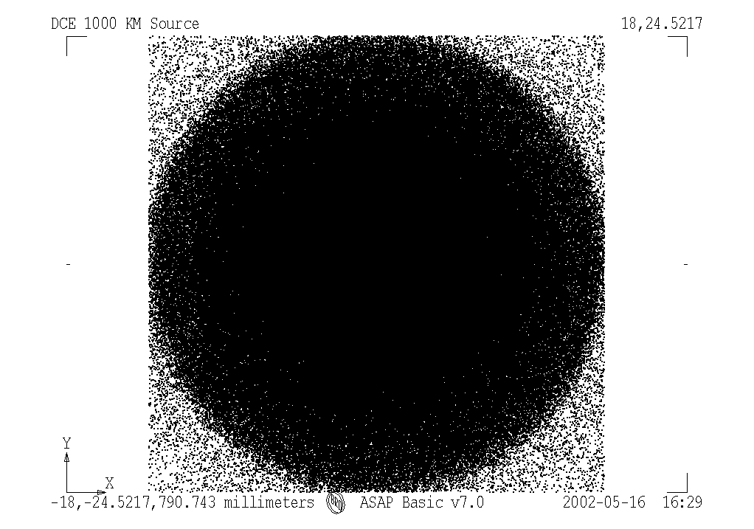

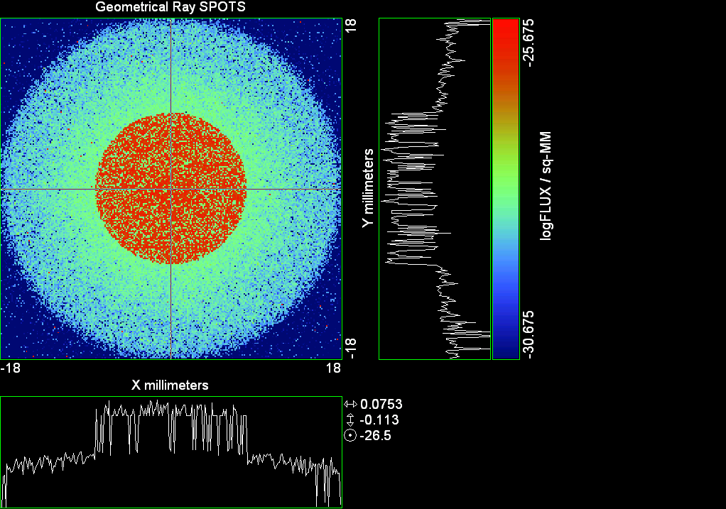

--- ! Spot Plot (Run Ray Trace First)
--- !!CONSIDER ONLY 6 !!Grid Detector=6
--- CONSIDER ONLY 7 !! Earth Detector=7
--- OBLIQUE OFF
--- !!TITLE 'FOV1-9/19^2 mm^2=15503 Rays'
--- !!TITLE 'FOV8 Rect Source Det=2170 total rays'
--- !!TITLE 'FOV8 RctSrc Det=1357-1348=11 rays from Pedestals DetImplBafOnly'
--- !!TITLE 'FOV8 RctSrc Det=750 rays "On"Mrlts Pd&SbS=0 DtImplBfOnly'
--- !!TITLE 'FOV8 RctSrc Det=754 rays "On"Mrlts Pd=1 SbS=0 DtImplBfOnly'
--- !!TITLE 'FOV8 3x3 Pt Src =215 rays "On"Mrlts Pd=1 SbS=0 DtImplBfOnly'
--- TITLE '1000 KM Source'
--- !!WINDOW Y X
--- WINDOW Y -18 18 X -18 18
--- !!WINDOW Y 11 14 X -1.5 1.5
--- !!TITLE 'FOV8 23x23 1358-678=680 Rays/.109 mm^2 = 6238 Rays/mm^2 5.5%'
--- !!WINDOW Y 135.75 136.25 X 82.5 83 !!FOV 8
--- !!TITLE 'FOV8 3x3 Core 678 Rays/.006mm^2 = 113000 Rays/mm^2'
--- !!WINDOW Y 136.01 136.07 X 82.75 82.85 !!FOV 8
--- PIXELS 256
--- SPOTS POSITION

Distribution of data within:
Window Vertical: Y = -18.0000 to 18.0000 ( 36.0000 )
Horizontal: X = -18.0000 to 18.0000 ( 36.0000 )

Opening NEW distribution file 9: C:\ASAP Work\TRIANA\bro009.dat
Rays Flux
622643 0.808107E-24
Maximum = 2.1111553E-26 minimum = 0.0000000E+00
--- $IO "ASAPTEMP.INR"
Opening 1 C:\ASAP Work\TRIANA\asaptemp.inr

Closing 7 C:\ASAP Work\TRIANA\bro007.dat
Opening 7 C:\ASAP Work\TRIANA\asaptemp.usr

Closing 20 C:\ASAP Work\TRIANA\bro020.dat
Opening 20 C:\ASAP Work\TRIANA\asaptemp.plr

Closing 30 C:\ASAP Work\TRIANA\bro030.dat
Opening 30 C:\ASAP Work\TRIANA\asaptemp.vcr

--- ! Spot Plot (Run Ray Trace First)
--- !!CONSIDER ONLY 6 !!Grid Detector=6
--- CONSIDER ONLY 7 !! Earth Detector=7
--- OBLIQUE OFF
--- !!TITLE 'FOV1-9/19^2 mm^2=15503 Rays'
--- !!TITLE 'FOV8 Rect Source Det=2170 total rays'
--- !!TITLE 'FOV8 RctSrc Det=1357-1348=11 rays from Pedestals DetImplBafOnly'
--- !!TITLE 'FOV8 RctSrc Det=750 rays "On"Mrlts Pd&SbS=0 DtImplBfOnly'
--- !!TITLE 'FOV8 RctSrc Det=754 rays "On"Mrlts Pd=1 SbS=0 DtImplBfOnly'
--- !!TITLE 'FOV8 3x3 Pt Src =215 rays "On"Mrlts Pd=1 SbS=0 DtImplBfOnly'
--- TITLE '1000 KM Source'
--- !!WINDOW Y X
--- WINDOW Y -18 18 X -18 18
--- !!WINDOW Y 11 14 X -1.5 1.5
--- !!TITLE 'FOV8 23x23 1358-678=680 Rays/.109 mm^2 = 6238 Rays/mm^2 5.5%'
--- !!WINDOW Y 135.75 136.25 X 82.5 83 !!FOV 8
--- !!TITLE 'FOV8 3x3 Core 678 Rays/.006mm^2 = 113000 Rays/mm^2'
--- !!WINDOW Y 136.01 136.07 X 82.75 82.85 !!FOV 8
--- PIXELS 256
--- SPOTS POSITION

Distribution of data within:
Window Vertical: Y = -18.0000 to 18.0000 ( 36.0000 )
Horizontal: X = -18.0000 to 18.0000 ( 36.0000 )

Opening NEW distribution file 9: C:\ASAP Work\TRIANA\bro009.dat
Rays Flux
622643 0.808107E-24
Maximum = 2.1111553E-26 minimum = 0.0000000E+00
--- $IO "ASAPTEMP.INR"
Opening 1 C:\ASAP Work\TRIANA\asaptemp.inr

Closing 7 C:\ASAP Work\TRIANA\bro007.dat
Opening 7 C:\ASAP Work\TRIANA\asaptemp.usr

Closing 20 C:\ASAP Work\TRIANA\bro020.dat
Opening 20 C:\ASAP Work\TRIANA\asaptemp.plr

Closing 30 C:\ASAP Work\TRIANA\bro030.dat
Opening 30 C:\ASAP Work\TRIANA\asaptemp.vcr

--- !! PICTURE (Run Ray Trace and Spots Position First)
--- !! Picks size from Spots Position window size
--- TITLE 'EPIC'
--- CONSIDER ONLY 7 !! Detector = 6 for Grid, 7 for Earth
--- !!WINDOW X -1.5 1.5 Y 11 14
--- WINDOW Y X
--- DISPLAY
Opening OLD distribution file 9: C:\ASAP Work\TRIANA\bro009.dat

File header:
Geometrical Ray SPOTS 1
Z 790.7430 FLUX / sq-MM
X millimeters -18.00000 18.00000 256
Y millimeters -18.00000 18.00000 256

Statistics on 256 by 256 data set:
FLUX / sq-MM Location Y millimeters X millimeters
Minimum 0.000000 1 1 -17.92969 -17.92969
Maximum 0.2111155E-25 94 130 -4.851562 0.2109375
Average 0.6235391E-27 128 129 -0.7031250E-01 0.7031250E-01
TOTAL FLUX = 0.8081066E-24

--- AVERAGE 0 0
Statistics on 256 by 256 data set:
FLUX / sq-MM Location Y millimeters X millimeters
Minimum 0.000000 1 1 -17.92969 -17.92969
Maximum 0.2111155E-25 94 130 -4.851562 0.2109375
Average 0.6235391E-27 128 129 -0.7031250E-01 0.7031250E-01
TOTAL FLUX = 0.8081066E-24

--- FORM -5
Statistics on 256 by 256 data set:
FLUX / sq-MM Location Y millimeters X millimeters
Minimum -30.67548 1 1 -17.92969 -17.92969
Maximum -25.67548 94 130 -4.851562 0.2109375
Average -28.87389 129 128 0.7031250E-01 -0.7031250E-01
Integral = -37420.55

--- !!CONTOUR .001 .005 .01 .05 .1 .2 .3 .4 .5 .6 .7 .8 .85 .9 .95 GRID 2
--- PICTURE
Opening NEW distribution file 10: C:\ASAP Work\TRIANA\i.dis

Run 05 Centered 0.32 deg 40k rays.xls

Run 06 Centered 0.48 deg 40k rays

--- END

System database and settings have been reinitialized
--- $IO "ASAPTEMP.INR"
Opening 1 C:\ASAP Work\TRIANA\asaptemp.inr

Closing 7 C:\ASAP Work\TRIANA\bro007.dat
Opening 7 C:\ASAP Work\TRIANA\asaptemp.usr

Closing 20 C:\ASAP Work\TRIANA\bro020.dat
Creating 20 C:\ASAP Work\TRIANA\asaptemp.plr

Closing 30 C:\ASAP Work\TRIANA\bro030.dat
Creating 30 C:\ASAP Work\TRIANA\asaptemp.vcr

--- !! Directed Diffuser Example
--- !! Create a source (Disk or Grid)
--- !! Source hits a diffuser in close proximity to source
--- !! diffuser scatters towards an edge for efficient ray tracing
--- SYSTEM NEW
--- RESET
--- UNITS MILLIMETERS
--- !! Setup for 1500 meter test
--- EDGE (EP=1000) !! Assign edge number to reference later with TOWARDS
--- ELLIPSE Z -200 225 225
--- !! Diffusion Model
--- MODEL
--- LAMBERTIAN 1
Angle Relative TIS Sampling
0.0 1.00 1000 radial

--- RETURN
--- CUTOFF (1.0E-40) 50 !! Default=1.0E-18 1/4pir2=3.5E-26
--- !! Scattering Plate is at L1, Source Disk is 1 meter farther away
--- !! L1 is at 1.5E6 km 1.5E9 m 1.5E12 mm
--- !! Except for scale factor, dimensions are in km
--- SCALE=1E6 !! S=1 for mm; 1E3 m; 1E6 km
--- !! Set source offset in "km" if scale = 1E6. Usually DX or DY only.
--- DX=0*(SCALE)
--- DY=0*(SCALE) !! 0=pixel 1024, centered
--- DZ=0*(SCALE)
--- !!SRAD=523.6 !!=0.04 deg diam
--- !!SRAD=1047.2 !!=0.08 deg diam
--- !!SRAD=2094.4 !!=0.16 deg diam
--- !!SRAD=2618.0 !!=0.20 deg diam
--- !!SRAD=4188.8 !!=0.32 deg diam
--- SRAD=6283.2 !!=0.48 deg diam
--- !! Spherical Earth Radius = 6371 km
--- LEVEL 2 0. !! Suggested by BRO Tech Support
--- SURFACE
--- PLANE Z ((-1.5E6)*(SCALE)) ELLIPSE (SRAD*(SCALE)) (SRAD*(SCALE)) 0 (DX) (DY)
--- OBJECT 'DIFFUSION'
--- INTERFACE 0 1E-12 !! Only allow scatter rays to transmit
--- SCATTER MODEL 1 RANDOM 1 1 !! RANDOM needed to find edge, else low light problems
--- TOWARDS (EP) 1
--- RETURN
--- !! Emitter
--- NRAYS=40000 !! 1000=32 sec 40000=20 minutes 200000
--- EMIT DISK Z ((-1.500001E6)*(SCALE)) (SRAD*(SCALE)) (SRAD*(SCALE)) (NRAYS) 1 1
Total flux in rays created by this emitter is 3.0458655E-04
--- SHIFT (DX) (DY) (DZ)
--- RETURN
--- UNITS MILLIMETERS
--- WAVELENGTHS 0.950000 0.706000 0.587560 0.435000 0.300000 MICRONS
--- MEDIA; 1.45106513 1.45515708 1.45846375 1.46676272 1.48779297 'SILICA'
--- COATING PROPERTIES; 1 0 'WHITE'
--- COATING PROPERTIES; .98 0 'MIRROR'
--- COATING PROPERTIES; .11 .87 'DETECTORQE317'
--- COATING PROPERTIES; .10 .75 'DETECTORQE325'
--- COATING PROPERTIES; .05 0 'BLACK'
--- COATING PROPERTIES; 0 0 'ZERO'
--- COATING PROPERTIES; 0 1 'CLEAR'
--- STRUE=0
--- SX=0
--- SY=0
--- SZ=0
--- SCAT=1
--- ENT OBJECT;MIRROR Z 439.24 159 (1219.2/2) -1 (38.2/159) 'PRIMARY S1'
--- INTERFACE COATING MIRROR AIR AIR
--- ENT OBJECT;TUBE Z 438.5 38.2 38.2 466.53196 38.2 38.2 0.0 0.0 'PRIMARYHOLE'
--- INTERFACE COATING BLACK AIR AIR
--- SCATTER RANDOM 1 (SCAT) 1.57 ABS 1 0
--- ENT OBJECT;PLANE Z 466.5 ELLIPSE 210 210 (38.2/210) 'PRIMARY BACK'
--- INTERFACE COATING BLACK AIR AIR
--- SCATTER RANDOM 1 (SCAT) 1.57 ABS 1 0
--- ENT OBJECT;TUBE Z 429 159 159 466.5 159 159 0.0 0.0 'PRIMARYEDGE'
--- INTERFACE COATING BLACK AIR AIR
--- SCATTER RANDOM 1 (SCAT) 1.57 ABS 1 0
--- ENT OBJECT;MIRROR Z 0.0 46 (434.7/2) -2.40763 0.0 'SECONDARY S2'
--- INTERFACE COATING MIRROR AIR AIR
--- ENT OBJECT;PLANE Z 790.7429896 RECTANGLE 18 18 0 'DETECTOR'
--- INTERFACE COATING ZERO SILICA AIR
--- ENT OBJECT;PLANE Z 790.7 RECTANGLE 18 18 0 'DETECTOR-COVER'
--- INTERFACE COATING DETECTORQE317 SILICA AIR
*** SPLIT automatically set to 1
--- ENT OBJECT;PLANE Z -55.69204 ELLIPSE 210 210 (154.8315449/210) 'SPIDER'
--- INTERFACE COATING BLACK AIR AIR
--- SCATTER RANDOM 1 (SCAT) 1.57 ABS 1 0
--- ENT OBJECT;TUBE Z -55.69204 154.8315449 154.8315449 -30.29204 154.8315449 154.8315449 0.0 0.0 'SPIDERCYL'
--- INTERFACE COATING BLACK AIR AIR
--- SCATTER RANDOM 1 (SCAT) 1.57 ABS 1 0
--- ENT OBJECT;TUBE X 0 0.75 12.52 -170 0.75 15.52 1 1 'SPIDERARMX'
--- SHIFT 0 -52.578 -42.992
--- INTERFACE COATING BLACK AIR AIR
--- SCATTER RANDOM 1 (SCAT) 1.57 ABS 1 0
--- ENT OBJECT;TUBE X 0 5 12.52 -170 5 15.52 1 1 'SPIDERARMX1'
--- SHIFT 0 -52.578 -42.992
--- ROTATE Z -120 0 0
--- INTERFACE COATING BLACK AIR AIR
--- SCATTER RANDOM 1 (SCAT) 1.57 ABS 1 0
--- ENT OBJECT;TUBE X 0 0.75 12.52 -170 0.75 15.52 1 1 'SPIDERARMX2'
--- SHIFT 0 -52.578 -42.992
--- ROTATE Z -240 0 0
--- INTERFACE COATING BLACK AIR AIR
--- SCATTER RANDOM 1 (SCAT) 1.57 ABS 1 0
--- ENT OBJECT;TUBE Z -185.6 200.8 200.8 528 200.8 200.8 0.0 0.0 'BARRELBAFFLE'
--- INTERFACE COATING BLACK AIR AIR
--- SCATTER RANDOM 1 (SCAT) 1.57 ABS 1 0
--- ENT OBJECT;ELLIPSE Z -200 205 205 64 0.0 360.0 'ENTRANCE'
Default ELLIP/ROUND/OVAL segments changed to 64
--- INTERFACE COATING CLEAR AIR AIR
--- ENT OBJECT;TUBE Z (2.391*25.4) (2.546*25.4) (2.546*25.4) (2.164*25.4) (2.546*25.4) (2.546*25.4) 0.0 0.0 'SECONDARYHOUSING'
--- INTERFACE COATING BLACK AIR AIR
--- SCATTER RANDOM 1 (SCAT) 1.57 ABS 1 0
--- ENT OBJECT;TUBE Z (2.164*25.4) (2.546*25.4) (2.546*25.4) 0 (2*25.4) (2*25.4) 0.0 0.0 'SH-CONE'
--- INTERFACE COATING BLACK AIR AIR
--- SCATTER RANDOM 1 (SCAT) 1.57 ABS 1 0
--- ENT OBJECT;PLANE Z 0.0 ELLIPSE (2.45*25.4) (2.45*25.4) (2.00/2.45) 'SH-CONEBASE'
--- INTERFACE COATING BLACK AIR AIR
--- SCATTER RANDOM 1 (SCAT) 1.57 ABS 1 0
--- ENT OBJECT;TUBE Z 0.0 (2.125*25.4) (2.125*25.4) (-6.875*25.4) (2.125*25.4) (2.125*25.4) 0.0 0.0 'SH-CYLINDER'
--- INTERFACE COATING BLACK AIR AIR
--- SCATTER RANDOM 1 (SCAT) 1.57 ABS 1 0
--- ENT OBJECT;PLANE Z (-6.875*25.4) ELLIPSE (2.33*25.4) 'SH-TOP'
--- INTERFACE COATING BLACK AIR AIR
--- SCATTER RANDOM 1 (SCAT) 1.57 ABS 1 0
--- ENT OBJECT;PLANE Z (-1.9*25.4) ELLIPSE (2.546*25.4) 'SH-MIDVANE'
--- INTERFACE COATING BLACK AIR AIR
--- SCATTER RANDOM 1 (SCAT) 1.57 ABS 1 0
--- ENT OBJECT;TUBE Z 226.38766 37.465 37.465 422.98366 37.465 37.465 0.0 0.0 'CBAF-FRONT'
--- INTERFACE COATING BLACK AIR AIR
--- SCATTER RANDOM 1 (SCAT) 1.57 ABS 1 0
--- ENT OBJECT;PLANE Z 422.98366 ELLIPSE 37.485 37.485 (30.5562/37.485) 'CBAF-LEDGE'
--- INTERFACE COATING BLACK AIR AIR
--- SCATTER RANDOM 1 (SCAT) 1.57 ABS 1 0
--- ENT OBJECT;TUBE Z 422.985 32.2072 32.2072 532.45766 32.2072 32.2072 0.0 0.0 'CBAF-AFT'
--- INTERFACE COATING BLACK AIR AIR
--- SCATTER RANDOM 1 (SCAT) 1.57 ABS 1 0
--- ENT OBJECT;PLANE Z 327.98766 ELLIPSE 37.485 37.485 (35.56/37.485) 'CBAF-VANE1'
--- INTERFACE COATING BLACK AIR AIR
--- SCATTER RANDOM 1 (SCAT) 1.57 ABS 1 0
--- ENT OBJECT;PLANE Z 378.78766 ELLIPSE 37.485 37.485 (35.56/37.485) 'CBAF-VANE2'
--- INTERFACE COATING BLACK AIR AIR
--- SCATTER RANDOM 1 (SCAT) 1.57 ABS 1 0
--- ENT OBJECT;PLANE Z 505.53366 ELLIPSE 32.24 32.24 (28.6512/32.24) 'CBAF-VANE3'
--- INTERFACE COATING BLACK AIR AIR
--- SCATTER RANDOM 1 (SCAT) 1.57 ABS 1 0
--- RETURN
--- !! Geometry is being appended to system.
--- !! To not view this message, refer to ASAP preferences dialog,
--- !! or change the Options->Append Geometry menu item.
--- UNITS MILLIMETERS
--- WAVELENGTHS 0.950000 0.706000 0.587560 0.435000 0.300000 MICRONS
--- MEDIA; 1.45106513 1.45515708 1.45846375 1.46676272 1.48779297 'SILICA'
--- COATING PROPERTIES; .98 0 'MIRROR'
--- COATING PROPERTIES; .05 0 'BLACK'
--- COATING PROPERTIES; 0 0 'ZERO'
--- COATING PROPERTIES; 0 1 'CLEAR'
--- COATING PROPERTIES; .05 .95 'ARF05'
--- COATING PROPERTIES; 0.2 0.8 'ARF20'
--- ENT OBJECT;PLANE Z 615.3400000 ELLIPSE 150 150 (22/150) 'LENS MOUNT'
--- INTERFACE COATING BLACK AIR AIR
--- SCATTER RANDOM 1 (SCAT) 1.57 ABS 1 0
--- ENT OBJECT;TUBE Z 558.61966 26.7 26.7 620 26.7 26.7 0.0 0.0 'LENS TUBE-FRONT'
--- INTERFACE COATING BLACK AIR AIR
--- SCATTER RANDOM 1 (SCAT) 1.57 ABS 1 0
--- ENT OBJECT;PLANE Z 558.61966 ELLIPSE 27.7 27.7 (24.945/27.7) 'LT-FACE'
--- INTERFACE COATING BLACK AIR AIR
--- SCATTER RANDOM 1 (SCAT) 1.57 ABS 1 0
--- ENT OBJECT;PLANE Z 616.4326 ELLIPSE 27.7 27.7 (21.5/27.7) 'LT-LENS 1FACE'
--- INTERFACE COATING BLACK AIR AIR
--- SCATTER RANDOM 1 (SCAT) 1.57 ABS 1 0
--- ENT OBJECT;TUBE Z 621 25.152 25.152 657.7965 25.152 25.152 0.0 0.0 'LENS TUBE AFT'
--- INTERFACE COATING BLACK AIR AIR
--- SCATTER RANDOM 1 (SCAT) 1.57 ABS 1 0
--- ENT OBJECT;PLANE Z 657.7965 ELLIPSE 25.152 25.152 (21.26386619/25.152) 'LT-AFT FACE'
--- INTERFACE COATING BLACK AIR AIR
--- SCATTER RANDOM 1 (SCAT) 1.57 ABS 1 0
--- ENT OBJECT;OPTICAL Z 615.3400000 221.803 0 ELLIPSE 22 'LENS1F'
--- INTERFACE COATING ARF05 AIR SILICA
--- ENT OBJECT;OPTICAL Z 620.3400000 584.5 0 ELLIPSE 22 'LENS1B'
--- INTERFACE COATING ARF05 AIR SILICA
--- ENT OBJECT;OPTICAL Z 627.63 -147.027 0 ELLIPSE 22 'LENS2F'
--- INTERFACE COATING ARF05 AIR SILICA
--- ENT OBJECT;OPTICAL Z 632.63 -135.158 0 ELLIPSE 22 'LENS2B'
--- INTERFACE COATING ARF05 AIR SILICA
--- ENT OBJECT;OPTICAL Z 635.6 97.002 0 ELLIPSE 22 'LENS3F'
--- INTERFACE COATING ARF05 AIR SILICA
--- ENT OBJECT;OPTICAL Z 640.6 67.147 0 ELLIPSE 22 'LENS3B'
--- INTERFACE COATING ARF05 AIR SILICA
--- ENT OBJECT;TUBE Z 614 22 22 645 22 22 0.0 0.0 'LENSHOLDER'
--- INTERFACE COATING ZERO AIR AIR
--- SCATTER RANDOM 1 (SCAT) 1.57 ABS 1 0
--- ENT OBJECT;PLANE Z 660.84196 ELLIPSE 150 150 (25.28148817/150) 'FW-HOUSING FRONT'
--- INTERFACE COATING BLACK AIR AIR
--- SCATTER RANDOM 1 (SCAT) 1.57 ABS 1 0
--- ENT OBJECT;PLANE Z 709.10196 ELLIPSE 150 150 (25.28148817/150) 'FW-HOUSING AFT'
--- INTERFACE COATING BLACK AIR AIR
--- SCATTER RANDOM 1 (SCAT) 1.57 ABS 1 0
--- ENT OBJECT;TUBE Z (673.54196-.3) 27.5 27.5 (680.04436+.3) 27.5 27.5 0.0 0.0 'FILTERHOLDER'
--- INTERFACE COATING BLACK AIR AIR
--- SCATTER RANDOM 1 (SCAT) 1.57 ABS 1 0
--- ENT OBJECT;PLANE Z 675 ELLIPSE 150 150 (27.5/150) 'FILTER-WHEEL'
--- INTERFACE COATING BLACK AIR AIR
--- SCATTER RANDOM 1 (SCAT) 1.57 ABS 1 0
--- ENT OBJECT;TUBE Z 721.59876 19.16979665 19.16979665 723.53932 22.558 22.558 0.0 0.0 'EXIT CONE FRONT'
--- INTERFACE COATING BLACK AIR AIR
--- SCATTER RANDOM 1 (SCAT) 1.57 ABS 1 0
--- ENT OBJECT;TUBE Z 723.53932 22.558 22.558 781.84248 22.558 22.558 0.0 0.0 'EC-CYLINDER'
--- INTERFACE COATING BLACK AIR AIR
--- SCATTER RANDOM 1 (SCAT) 1.57 ABS 1 0
--- ENT OBJECT;PLANE Z 781.84248 ELLIPSE 22.558 22.558 (16.89/22.558) 'EC-SHELF'
--- INTERFACE COATING BLACK AIR AIR
--- SCATTER RANDOM 1 (SCAT) 1.57 ABS 1 0
--- ENT OBJECT;TUBE Z 781.84248 16.89 16.89 783.87448 20.41280351 20.41280351 0.0 0.0 'EC-EXITCONE'
--- INTERFACE COATING BLACK AIR AIR
--- SCATTER RANDOM 1 (SCAT) 1.57 ABS 1 0
--- ENT OBJECT;PLANE Z 783.87448 ELLIPSE 50 50 (20.41280351/50) 'EC-EXIT'
--- INTERFACE COATING BLACK AIR AIR
--- SCATTER RANDOM 1 (SCAT) 1.57 ABS 1 0
--- RETURN
--- $IO "ASAPTEMP.INR"
Opening 1 C:\ASAP Work\TRIANA\asaptemp.inr

Closing 7 C:\ASAP Work\TRIANA\bro007.dat
Opening 7 C:\ASAP Work\TRIANA\asaptemp.usr

Closing 20 C:\ASAP Work\TRIANA\bro020.dat
Creating 20 C:\ASAP Work\TRIANA\asaptemp.plr

Closing 30 C:\ASAP Work\TRIANA\bro030.dat
Creating 30 C:\ASAP Work\TRIANA\asaptemp.vcr

--- !! Filters-2 from .ent/copy/.inr to allow ABSORBing media
--- UNITS MILLIMETERS
--- WAVELENGTHS 0.950000 0.706000 0.587560 0.435000 0.300000 MICRONS
--- MEDIA; 1.45106513 1.45515708 1.45846375 1.46676272 1.48779297 'SILICA'
--- !!COATING PROPERTIES; .98 0 'MIRROR'
--- !!COATING PROPERTIES; .05 0 'BLACK'
--- !!COATING PROPERTIES; 0 0 'ZERO'
--- !!COATING PROPERTIES; 0 1 'CLEAR'
--- COATING PROPERTIES; .0745 .9255 'ARF0745'
--- COATING PROPERTIES; .0525 .9475 'ARF0525'
--- COATING PROPERTIES; .05 .95 'ARF05'
--- COATING PROPERTIES; .005 .995 'ARF005'
--- !!COATING PROPERTIES; 0.2 0.8 'ARF20'
--- !!!!!!!!!!!!!!!!!!!!!!!!!!!!!!!!!!!!!!!!!!!!!!!!!!
--- WAVELENGTH 0.317 MICRONS
--- MEDIA
--- 1.48342884 ABSORB 0.13168 'BLOCKER317'
--- MEDIA
--- 1.48342884 ABSORB 0.00307 'ETALON317'
--- !!!!!!!!!!!!!!!!!!!!!!!!!!!!!!!!!!!!!!!!!!!!!!!!!!
--- !!WAVELENGTH 0.325 MICRONS
--- !!MEDIA
--- !! 1.48163777 ABSORB 0.08074 'BLOCKER325'
--- !!MEDIA
--- !! 1.48163777 ABSORB 0.0415179525 'ETALON325'
--- !!!!!!!!!!!!!!!!!!!!!!!!!!!!!!!!!!!!!!!!!!!!!!!!!!!!!
--- ENT OBJECT;PLANE Z 673.54196 ELLIPSE 27.5 'FILTERUVE-F'
--- INTERFACE COATING ARF0525 AIR ETALON317
--- !! INTERFACE COATING ARF0745 AIR ETALON325
--- ENT OBJECT;PLANE Z 676.71696 ELLIPSE 27.5 'FILTERUVE-B'
--- INTERFACE COATING ARF0525 AIR ETALON317
--- !! INTERFACE COATING ARF0745 AIR ETALON325
--- ENT OBJECT;PLANE Z 676.86936 ELLIPSE 27.5 'FILTERUVB-F'
--- INTERFACE COATING ARF005 AIR BLOCKER317
--- !! INTERFACE COATING ARF005 AIR BLOCKER325
--- ENT OBJECT;PLANE Z 680.04436 ELLIPSE 27.5 'FILTERUVB-B'
--- INTERFACE COATING ARF005 AIR BLOCKER317
--- !! INTERFACE COATING ARF005 AIR BLOCKER325
--- !!RETURN

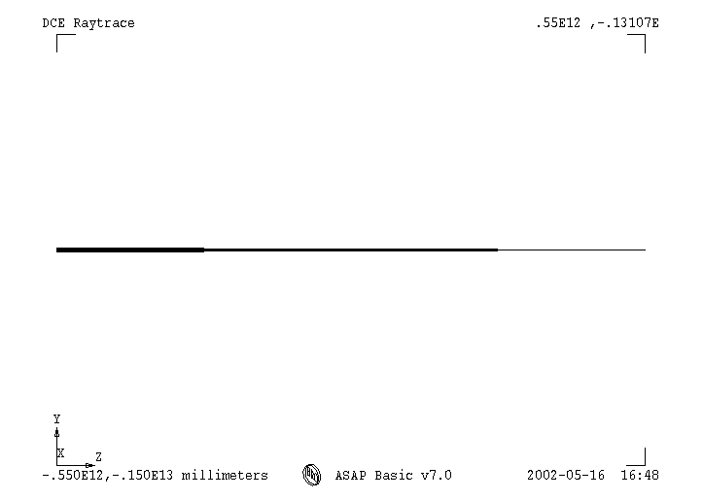

--- TITLE DCE *Raytrace
--- !! WAVELENGTHS 0.317 MICRONS !! Normally set in filters
--- !!SPLIT 0 !! Direct Trace Only
--- !!SPLIT 1 !! For Rect Sources
--- SPLIT 2 !! For double reflection in lens & filters
--- PLOT FACETS 5 5
Window Vertical: Y = -.628321E+10 to 0.628321E+10 (0.125664E+11)
Horizontal: Z = -.150013E+13 to 791.121 (0.150013E+13)

--- CONSIDER ALL
--- !!CONSIDER ONLY 15
--- ARROWS OFF
--- SEGMENTS 9
--- WINDOW Y Z
--- OBLIQUE 0 0
--- MISSED LINE 50
--- TRACE PLOT 1000 OVERLAY
Window Vertical: Y = -.628321E+10 to 0.628321E+10 (0.125664E+11)
Horizontal: Z = -.150013E+13 to 791.121 (0.150013E+13)

Warning *** Convergence failure in root polishing .2860011E-04
71 *** Convergence failure in root polishing .4143929E-04
15.86 seconds ( 15.34 seconds CPU) to trace 80,000
out of 223,285
Warning *** Convergence failure in root polishing .1881841E-04
60 *** Convergence failure in root polishing .5602798E-04
50.69 seconds ( 49.31 seconds CPU) to trace 160,000
out of 597,979
109.86 seconds ( 96.04 seconds CPU) to trace 240,000
out of 1,140,040
2.72 minutes ( 2.38 minutes CPU) to trace 320,000
out of 1,686,182
3.76 minutes ( 2.93 minutes CPU) to trace 400,000
out of 1,838,839
4.49 minutes ( 3.46 minutes CPU) to trace 480,000
out of 1,960,736
5.09 minutes ( 4.01 minutes CPU) to trace 560,000
out of 2,084,470
5.69 minutes ( 4.57 minutes CPU) to trace 640,000
out of 2,205,445
6.27 minutes ( 5.12 minutes CPU) to trace 720,000
out of 2,326,878
6.85 minutes ( 5.66 minutes CPU) to trace 800,000
out of 2,448,214
7.43 minutes ( 6.21 minutes CPU) to trace 880,000
out of 2,571,084
8.03 minutes ( 6.76 minutes CPU) to trace 960,000
out of 2,693,892
8.63 minutes ( 7.31 minutes CPU) to trace 1,040,000
out of 2,815,863
9.21 minutes ( 7.86 minutes CPU) to trace 1,120,000
out of 2,936,578
9.80 minutes ( 8.42 minutes CPU) to trace 1,200,000
out of 3,059,501
10.39 minutes ( 8.97 minutes CPU) to trace 1,280,000
out of 3,182,381
11.05 minutes ( 9.52 minutes CPU) to trace 1,360,000
out of 3,304,820
11.63 minutes ( 10.07 minutes CPU) to trace 1,440,000
out of 3,424,805
12.20 minutes ( 10.62 minutes CPU) to trace 1,520,000
out of 3,545,588
12.78 minutes ( 11.17 minutes CPU) to trace 1,600,000
out of 3,667,400
13.36 minutes ( 11.72 minutes CPU) to trace 1,680,000
out of 3,789,355
13.78 minutes ( 12.12 minutes CPU) to trace 1,760,000
out of 3,857,799
14.00 minutes ( 12.32 minutes CPU) to trace 1,840,000
14.22 minutes ( 12.53 minutes CPU) to trace 1,920,000
14.46 minutes ( 12.74 minutes CPU) to trace 2,000,000
14.68 minutes ( 12.95 minutes CPU) to trace 2,080,000
14.90 minutes ( 13.15 minutes CPU) to trace 2,160,000
15.13 minutes ( 13.36 minutes CPU) to trace 2,240,000
15.35 minutes ( 13.57 minutes CPU) to trace 2,320,000
15.57 minutes ( 13.77 minutes CPU) to trace 2,400,000
15.79 minutes ( 13.98 minutes CPU) to trace 2,480,000
16.01 minutes ( 14.19 minutes CPU) to trace 2,560,000
16.24 minutes ( 14.40 minutes CPU) to trace 2,640,000
16.46 minutes ( 14.61 minutes CPU) to trace 2,720,000
16.68 minutes ( 14.81 minutes CPU) to trace 2,800,000
17.07 minutes ( 15.02 minutes CPU) to trace 2,880,000
17.29 minutes ( 15.23 minutes CPU) to trace 2,960,000
17.52 minutes ( 15.44 minutes CPU) to trace 3,040,000
17.74 minutes ( 15.64 minutes CPU) to trace 3,120,000
17.97 minutes ( 15.85 minutes CPU) to trace 3,200,000
18.19 minutes ( 16.06 minutes CPU) to trace 3,280,000
18.42 minutes ( 16.27 minutes CPU) to trace 3,360,000
18.64 minutes ( 16.47 minutes CPU) to trace 3,440,000
18.86 minutes ( 16.68 minutes CPU) to trace 3,520,000
19.08 minutes ( 16.89 minutes CPU) to trace 3,600,000
19.30 minutes ( 17.10 minutes CPU) to trace 3,680,000
19.52 minutes ( 17.31 minutes CPU) to trace 3,760,000
19.74 minutes ( 17.52 minutes CPU) to trace 3,840,000
19.79 minutes ( 17.56 minutes CPU) to trace 3,857,799

Total of 3174670 PARENT warnings
Missed Multiple Wrong Low Evanescent Wrong Absorbed
Obj Total After Bounce Side Flux (TIR) Direc After
1 276515 140054 304 136157 DIFFUSION
2 1699 31 1257 411 PRIMARY S1
3 2100 283 9 1808 PRIMARYHOLE
4 97837 35640 378 61819 PRIMARY BACK
5 21618 81 21537 PRIMARYEDGE
6 1588 1067 521 SECONDARY S2
7 744 744 DETECTOR
8 4073 81 2402 1590 DETECTOR-COVER
9 38600 2243 274 36083 SPIDER
10 12874 127 108 12639 SPIDERCYL
11 3980 90 36 3854 SPIDERARMX
12 7142 97 88 6957 SPIDERARMX1
13 4089 84 31 3974 SPIDERARMX2
14 293515 5652 1910 285953 BARRELBAFFLE
15 208115 206802 1313 ENTRANCE
16 6445 7 38 6400 SECONDARYHOUSING
17 53335 437 377 52521 SH-CONE
18 12988 15 110 12863 SH-CONEBASE
19 81683 1419 870 79394 SH-CYLINDER
20 783 23 13 747 SH-TOP
21 74878 9 537 74332 SH-MIDVANE
22 263967 926 2013 261028 CBAF-FRONT
23 17154 124 17030 CBAF-LEDGE
24 174023 39427 863 133733 CBAF-AFT
25 7726 8 91 7627 CBAF-VANE1
26 8221 79 8142 CBAF-VANE2
27 12274 1254 112 10908 CBAF-VANE3
28 73037 31416 222 41399 LENS MOUNT
29 68253 3792 600 63861 LENS TUBE-FRONT
30 7215 266 83 6866 LT-FACE
31 2609 17 48 2544 LT-LENS 1FACE
32 15479 188 199 15092 LENS TUBE AFT
33 6870 27 197 6646 LT-AFT FACE
34 6107 1156 1318 3633 LENS1F
35 7604 950 2431 4223 LENS1B
36 8987 1270 4252 3465 LENS2F
37 8387 2568 3569 2250 LENS2B
38 11583 1911 5851 3821 LENS3F
39 12521 2592 3799 6130 LENS3B
40 514 159 355 LENSHOLDER
41 55642 12126 307 43209 FW-HOUSING FRONT
42 578393 407009 1462 169922 FW-HOUSING AFT
43 3859 1395 93 2275 96 FILTERHOLDER
44 236071 91364 1262 143445 FILTER-WHEEL
45 29441 8792 477 20172 EXIT CONE FRONT
46 254290 36839 3334 214117 EC-CYLINDER
47 26455 4 784 25667 EC-SHELF
48 5160 3872 19 1269 EC-EXITCONE
49 21863 14368 273 7222 EC-EXIT
50 7879 91 2636 3492 933 727 FILTERUVE-F
51 13388 1645 10888 848 7 FILTERUVE-B
52 8452 3112 2661 997 1682 FILTERUVB-F
53 16645 12984 1558 36 938 1129 FILTERUVB-B

Total of 120754 CHILD warnings
Missed Multiple Wrong Low Evanescent Wrong Absorbed
Obj Total After Bounce Side Flux (TIR) Direc After
8 4478 4478 DETECTOR-COVER
34 9478 9478 LENS1F
35 10010 10010 LENS1B
36 11996 11996 LENS2F
37 11894 11894 LENS2B
38 11753 11753 LENS3F
39 11695 11695 LENS3B
50 11549 11549 FILTERUVE-F
51 11578 11578 FILTERUVE-B
52 13112 13112 FILTERUVB-F
53 13211 13211 FILTERUVB-B
23490557 ray-objects encountered at 22290 per CPU second
246040260 order-intersections done at 233475 per CPU second



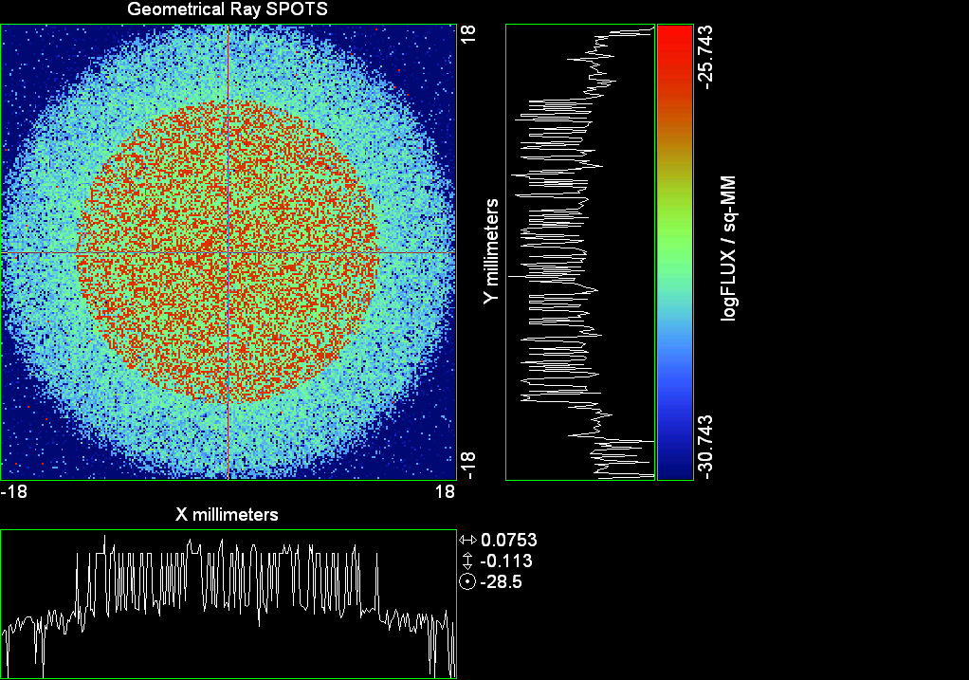

--- ! Spot Plot (Run Ray Trace First)
--- !!CONSIDER ONLY 6 !!Grid Detector=6
--- CONSIDER ONLY 7 !! Earth Detector=7
--- OBLIQUE OFF
--- !!TITLE 'FOV1-9/19^2 mm^2=15503 Rays'
--- !!TITLE 'FOV8 Rect Source Det=2170 total rays'
--- !!TITLE 'FOV8 RctSrc Det=1357-1348=11 rays from Pedestals DetImplBafOnly'
--- !!TITLE 'FOV8 RctSrc Det=750 rays "On"Mrlts Pd&SbS=0 DtImplBfOnly'
--- !!TITLE 'FOV8 RctSrc Det=754 rays "On"Mrlts Pd=1 SbS=0 DtImplBfOnly'
--- !!TITLE 'FOV8 3x3 Pt Src =215 rays "On"Mrlts Pd=1 SbS=0 DtImplBfOnly'
--- TITLE '1.5E6 KM to Source at L1 Distance'
--- !!WINDOW Y X
--- WINDOW Y -18 18 X -18 18
--- !!WINDOW Y 11 14 X -1.5 1.5
--- !!TITLE 'FOV8 23x23 1358-678=680 Rays/.109 mm^2 = 6238 Rays/mm^2 5.5%'
--- !!WINDOW Y 135.75 136.25 X 82.5 83 !!FOV 8
--- !!TITLE 'FOV8 3x3 Core 678 Rays/.006mm^2 = 113000 Rays/mm^2'
--- !!WINDOW Y 136.01 136.07 X 82.75 82.85 !!FOV 8
--- PIXELS 256
--- SPOTS POSITION

Distribution of data within:
Window Vertical: Y = -18.0000 to 18.0000 ( 36.0000 )
Horizontal: X = -18.0000 to 18.0000 ( 36.0000 )

Opening NEW distribution file 9: C:\ASAP Work\TRIANA\bro009.dat
Rays Flux
539368 0.786039E-24
Maximum = 1.8056156E-26 minimum = 0.0000000E+00
--- $IO "ASAPTEMP.INR"
Opening 1 C:\ASAP Work\TRIANA\asaptemp.inr

Closing 7 C:\ASAP Work\TRIANA\bro007.dat
Opening 7 C:\ASAP Work\TRIANA\asaptemp.usr

Closing 20 C:\ASAP Work\TRIANA\bro020.dat
Opening 20 C:\ASAP Work\TRIANA\asaptemp.plr

Closing 30 C:\ASAP Work\TRIANA\bro030.dat
Opening 30 C:\ASAP Work\TRIANA\asaptemp.vcr

--- !! PICTURE (Run Ray Trace and Spots Position First)
--- !! Picks size from Spots Position window size
--- TITLE 'EPIC'
--- CONSIDER ONLY 7 !! Detector = 6 for Grid, 7 for Earth
--- !!WINDOW X -1.5 1.5 Y 11 14
--- WINDOW Y X
--- DISPLAY
Opening OLD distribution file 9: C:\ASAP Work\TRIANA\bro009.dat

File header:
Geometrical Ray SPOTS 1
Z 790.7430 FLUX / sq-MM
X millimeters -18.00000 18.00000 256
Y millimeters -18.00000 18.00000 256

Statistics on 256 by 256 data set:
FLUX / sq-MM Location Y millimeters X millimeters
Minimum 0.000000 1 1 -17.92969 -17.92969
Maximum 0.1805616E-25 205 92 10.75781 -5.132812
Average 0.6065114E-27 129 129 0.7031250E-01 0.7031250E-01
TOTAL FLUX = 0.7860387E-24

--- AVERAGE 0 0
Statistics on 256 by 256 data set:
FLUX / sq-MM Location Y millimeters X millimeters
Minimum 0.000000 1 1 -17.92969 -17.92969
Maximum 0.1805616E-25 205 92 10.75781 -5.132812
Average 0.6065114E-27 129 129 0.7031250E-01 0.7031250E-01
TOTAL FLUX = 0.7860387E-24

--- FORM -5
Statistics on 256 by 256 data set:
FLUX / sq-MM Location Y millimeters X millimeters
Minimum -30.74337 1 1 -17.92969 -17.92969
Maximum -25.74337 205 92 10.75781 -5.132812
Average -28.87386 129 128 0.7031250E-01 -0.7031250E-01
Integral = -37420.53

--- !!CONTOUR .001 .005 .01 .05 .1 .2 .3 .4 .5 .6 .7 .8 .85 .9 .95 GRID 2
--- PICTURE
Opening NEW distribution file 10: C:\ASAP Work\TRIANA\i.dis

Run 06 Centered 0.48 deg 40k rays.xls

Run 07 Centered 0.65 deg 40k rays

--- END

System database and settings have been reinitialized
--- $IO "ASAPTEMP.INR"
Opening 1 C:\ASAP Work\TRIANA\asaptemp.inr

Closing 7 C:\ASAP Work\TRIANA\bro007.dat
Opening 7 C:\ASAP Work\TRIANA\asaptemp.usr

Closing 20 C:\ASAP Work\TRIANA\bro020.dat
Creating 20 C:\ASAP Work\TRIANA\asaptemp.plr

Closing 30 C:\ASAP Work\TRIANA\bro030.dat
Creating 30 C:\ASAP Work\TRIANA\asaptemp.vcr

--- !! Directed Diffuser Example
--- !! Create a source (Disk or Grid)
--- !! Source hits a diffuser in close proximity to source
--- !! diffuser scatters towards an edge for efficient ray tracing
--- SYSTEM NEW
--- RESET
--- UNITS MILLIMETERS
--- !! Setup for 1500 meter test
--- EDGE (EP=1000) !! Assign edge number to reference later with TOWARDS
--- ELLIPSE Z -200 225 225
--- !! Diffusion Model
--- MODEL
--- LAMBERTIAN 1
Angle Relative TIS Sampling
0.0 1.00 1000 radial

--- RETURN
--- CUTOFF (1.0E-40) 50 !! Default=1.0E-18 1/4pir2=3.5E-26
--- !! Scattering Plate is at L1, Source Disk is 1 meter farther away
--- !! L1 is at 1.5E6 km 1.5E9 m 1.5E12 mm
--- !! Except for scale factor, dimensions are in km
--- SCALE=1E6 !! S=1 for mm; 1E3 m; 1E6 km
--- !! Set source offset in "km" if scale = 1E6. Usually DX or DY only.
--- DX=0*(SCALE)
--- DY=0*(SCALE) !! 0=pixel 1024, centered
--- DZ=0*(SCALE)
--- !!SRAD=523.6 !!=0.04 deg diam
--- !!SRAD=1047.2 !!=0.08 deg diam
--- !!SRAD=2094.4 !!=0.16 deg diam
--- !!SRAD=2618.0 !!=0.20 deg diam
--- !!SRAD=4188.8 !!=0.32 deg diam
--- !!SRAD=6283.2 !!=0.48 deg diam
--- SRAD=8508.6 !!=0.65 deg diam
--- !! Spherical Earth Radius = 6371 km
--- LEVEL 2 0. !! Suggested by BRO Tech Support
--- SURFACE
--- PLANE Z ((-1.5E6)*(SCALE)) ELLIPSE (SRAD*(SCALE)) (SRAD*(SCALE)) 0 (DX) (DY)
--- OBJECT 'DIFFUSION'
--- INTERFACE 0 1E-12 !! Only allow scatter rays to transmit
--- SCATTER MODEL 1 RANDOM 1 1 !! RANDOM needed to find edge, else low light problems
--- TOWARDS (EP) 1
--- RETURN
--- !! Emitter
--- NRAYS=40000 !! 1000=32 sec 40000=20 minutes 200000
--- EMIT DISK Z ((-1.500001E6)*(SCALE)) (SRAD*(SCALE)) (SRAD*(SCALE)) (NRAYS) 1 1
Total flux in rays created by this emitter is 3.0458655E-04
--- SHIFT (DX) (DY) (DZ)
--- RETURN
--- UNITS MILLIMETERS
--- WAVELENGTHS 0.950000 0.706000 0.587560 0.435000 0.300000 MICRONS
--- MEDIA; 1.45106513 1.45515708 1.45846375 1.46676272 1.48779297 'SILICA'
--- COATING PROPERTIES; 1 0 'WHITE'
--- COATING PROPERTIES; .98 0 'MIRROR'
--- COATING PROPERTIES; .11 .87 'DETECTORQE317'
--- COATING PROPERTIES; .10 .75 'DETECTORQE325'
--- COATING PROPERTIES; .05 0 'BLACK'
--- COATING PROPERTIES; 0 0 'ZERO'
--- COATING PROPERTIES; 0 1 'CLEAR'
--- STRUE=0
--- SX=0
--- SY=0
--- SZ=0
--- SCAT=1
--- ENT OBJECT;MIRROR Z 439.24 159 (1219.2/2) -1 (38.2/159) 'PRIMARY S1'
--- INTERFACE COATING MIRROR AIR AIR
--- ENT OBJECT;TUBE Z 438.5 38.2 38.2 466.53196 38.2 38.2 0.0 0.0 'PRIMARYHOLE'
--- INTERFACE COATING BLACK AIR AIR
--- SCATTER RANDOM 1 (SCAT) 1.57 ABS 1 0
--- ENT OBJECT;PLANE Z 466.5 ELLIPSE 210 210 (38.2/210) 'PRIMARY BACK'
--- INTERFACE COATING BLACK AIR AIR
--- SCATTER RANDOM 1 (SCAT) 1.57 ABS 1 0
--- ENT OBJECT;TUBE Z 429 159 159 466.5 159 159 0.0 0.0 'PRIMARYEDGE'
--- INTERFACE COATING BLACK AIR AIR
--- SCATTER RANDOM 1 (SCAT) 1.57 ABS 1 0
--- ENT OBJECT;MIRROR Z 0.0 46 (434.7/2) -2.40763 0.0 'SECONDARY S2'
--- INTERFACE COATING MIRROR AIR AIR
--- ENT OBJECT;PLANE Z 790.7429896 RECTANGLE 18 18 0 'DETECTOR'
--- INTERFACE COATING ZERO SILICA AIR
--- ENT OBJECT;PLANE Z 790.7 RECTANGLE 18 18 0 'DETECTOR-COVER'
--- INTERFACE COATING DETECTORQE317 SILICA AIR
*** SPLIT automatically set to 1
--- ENT OBJECT;PLANE Z -55.69204 ELLIPSE 210 210 (154.8315449/210) 'SPIDER'
--- INTERFACE COATING BLACK AIR AIR
--- SCATTER RANDOM 1 (SCAT) 1.57 ABS 1 0
--- ENT OBJECT;TUBE Z -55.69204 154.8315449 154.8315449 -30.29204 154.8315449 154.8315449 0.0 0.0 'SPIDERCYL'
--- INTERFACE COATING BLACK AIR AIR
--- SCATTER RANDOM 1 (SCAT) 1.57 ABS 1 0
--- ENT OBJECT;TUBE X 0 0.75 12.52 -170 0.75 15.52 1 1 'SPIDERARMX'
--- SHIFT 0 -52.578 -42.992
--- INTERFACE COATING BLACK AIR AIR
--- SCATTER RANDOM 1 (SCAT) 1.57 ABS 1 0
--- ENT OBJECT;TUBE X 0 5 12.52 -170 5 15.52 1 1 'SPIDERARMX1'
--- SHIFT 0 -52.578 -42.992
--- ROTATE Z -120 0 0
--- INTERFACE COATING BLACK AIR AIR
--- SCATTER RANDOM 1 (SCAT) 1.57 ABS 1 0
--- ENT OBJECT;TUBE X 0 0.75 12.52 -170 0.75 15.52 1 1 'SPIDERARMX2'
--- SHIFT 0 -52.578 -42.992
--- ROTATE Z -240 0 0
--- INTERFACE COATING BLACK AIR AIR
--- SCATTER RANDOM 1 (SCAT) 1.57 ABS 1 0
--- ENT OBJECT;TUBE Z -185.6 200.8 200.8 528 200.8 200.8 0.0 0.0 'BARRELBAFFLE'
--- INTERFACE COATING BLACK AIR AIR
--- SCATTER RANDOM 1 (SCAT) 1.57 ABS 1 0
--- ENT OBJECT;ELLIPSE Z -200 205 205 64 0.0 360.0 'ENTRANCE'
Default ELLIP/ROUND/OVAL segments changed to 64
--- INTERFACE COATING CLEAR AIR AIR
--- ENT OBJECT;TUBE Z (2.391*25.4) (2.546*25.4) (2.546*25.4) (2.164*25.4) (2.546*25.4) (2.546*25.4) 0.0 0.0 'SECONDARYHOUSING'
--- INTERFACE COATING BLACK AIR AIR
--- SCATTER RANDOM 1 (SCAT) 1.57 ABS 1 0
--- ENT OBJECT;TUBE Z (2.164*25.4) (2.546*25.4) (2.546*25.4) 0 (2*25.4) (2*25.4) 0.0 0.0 'SH-CONE'
--- INTERFACE COATING BLACK AIR AIR
--- SCATTER RANDOM 1 (SCAT) 1.57 ABS 1 0
--- ENT OBJECT;PLANE Z 0.0 ELLIPSE (2.45*25.4) (2.45*25.4) (2.00/2.45) 'SH-CONEBASE'
--- INTERFACE COATING BLACK AIR AIR
--- SCATTER RANDOM 1 (SCAT) 1.57 ABS 1 0
--- ENT OBJECT;TUBE Z 0.0 (2.125*25.4) (2.125*25.4) (-6.875*25.4) (2.125*25.4) (2.125*25.4) 0.0 0.0 'SH-CYLINDER'
--- INTERFACE COATING BLACK AIR AIR
--- SCATTER RANDOM 1 (SCAT) 1.57 ABS 1 0
--- ENT OBJECT;PLANE Z (-6.875*25.4) ELLIPSE (2.33*25.4) 'SH-TOP'
--- INTERFACE COATING BLACK AIR AIR
--- SCATTER RANDOM 1 (SCAT) 1.57 ABS 1 0
--- ENT OBJECT;PLANE Z (-1.9*25.4) ELLIPSE (2.546*25.4) 'SH-MIDVANE'
--- INTERFACE COATING BLACK AIR AIR
--- SCATTER RANDOM 1 (SCAT) 1.57 ABS 1 0
--- ENT OBJECT;TUBE Z 226.38766 37.465 37.465 422.98366 37.465 37.465 0.0 0.0 'CBAF-FRONT'
--- INTERFACE COATING BLACK AIR AIR
--- SCATTER RANDOM 1 (SCAT) 1.57 ABS 1 0
--- ENT OBJECT;PLANE Z 422.98366 ELLIPSE 37.485 37.485 (30.5562/37.485) 'CBAF-LEDGE'
--- INTERFACE COATING BLACK AIR AIR
--- SCATTER RANDOM 1 (SCAT) 1.57 ABS 1 0
--- ENT OBJECT;TUBE Z 422.985 32.2072 32.2072 532.45766 32.2072 32.2072 0.0 0.0 'CBAF-AFT'
--- INTERFACE COATING BLACK AIR AIR
--- SCATTER RANDOM 1 (SCAT) 1.57 ABS 1 0
--- ENT OBJECT;PLANE Z 327.98766 ELLIPSE 37.485 37.485 (35.56/37.485) 'CBAF-VANE1'
--- INTERFACE COATING BLACK AIR AIR
--- SCATTER RANDOM 1 (SCAT) 1.57 ABS 1 0
--- ENT OBJECT;PLANE Z 378.78766 ELLIPSE 37.485 37.485 (35.56/37.485) 'CBAF-VANE2'
--- INTERFACE COATING BLACK AIR AIR
--- SCATTER RANDOM 1 (SCAT) 1.57 ABS 1 0
--- ENT OBJECT;PLANE Z 505.53366 ELLIPSE 32.24 32.24 (28.6512/32.24) 'CBAF-VANE3'
--- INTERFACE COATING BLACK AIR AIR
--- SCATTER RANDOM 1 (SCAT) 1.57 ABS 1 0
--- RETURN
--- !! Geometry is being appended to system.
--- !! To not view this message, refer to ASAP preferences dialog,
--- !! or change the Options->Append Geometry menu item.
--- UNITS MILLIMETERS
--- WAVELENGTHS 0.950000 0.706000 0.587560 0.435000 0.300000 MICRONS
--- MEDIA; 1.45106513 1.45515708 1.45846375 1.46676272 1.48779297 'SILICA'
--- COATING PROPERTIES; .98 0 'MIRROR'
--- COATING PROPERTIES; .05 0 'BLACK'
--- COATING PROPERTIES; 0 0 'ZERO'
--- COATING PROPERTIES; 0 1 'CLEAR'
--- COATING PROPERTIES; .05 .95 'ARF05'
--- COATING PROPERTIES; 0.2 0.8 'ARF20'
--- ENT OBJECT;PLANE Z 615.3400000 ELLIPSE 150 150 (22/150) 'LENS MOUNT'
--- INTERFACE COATING BLACK AIR AIR
--- SCATTER RANDOM 1 (SCAT) 1.57 ABS 1 0
--- ENT OBJECT;TUBE Z 558.61966 26.7 26.7 620 26.7 26.7 0.0 0.0 'LENS TUBE-FRONT'
--- INTERFACE COATING BLACK AIR AIR
--- SCATTER RANDOM 1 (SCAT) 1.57 ABS 1 0
--- ENT OBJECT;PLANE Z 558.61966 ELLIPSE 27.7 27.7 (24.945/27.7) 'LT-FACE'
--- INTERFACE COATING BLACK AIR AIR
--- SCATTER RANDOM 1 (SCAT) 1.57 ABS 1 0
--- ENT OBJECT;PLANE Z 616.4326 ELLIPSE 27.7 27.7 (21.5/27.7) 'LT-LENS 1FACE'
--- INTERFACE COATING BLACK AIR AIR
--- SCATTER RANDOM 1 (SCAT) 1.57 ABS 1 0
--- ENT OBJECT;TUBE Z 621 25.152 25.152 657.7965 25.152 25.152 0.0 0.0 'LENS TUBE AFT'
--- INTERFACE COATING BLACK AIR AIR
--- SCATTER RANDOM 1 (SCAT) 1.57 ABS 1 0
--- ENT OBJECT;PLANE Z 657.7965 ELLIPSE 25.152 25.152 (21.26386619/25.152) 'LT-AFT FACE'
--- INTERFACE COATING BLACK AIR AIR
--- SCATTER RANDOM 1 (SCAT) 1.57 ABS 1 0
--- ENT OBJECT;OPTICAL Z 615.3400000 221.803 0 ELLIPSE 22 'LENS1F'
--- INTERFACE COATING ARF05 AIR SILICA
--- ENT OBJECT;OPTICAL Z 620.3400000 584.5 0 ELLIPSE 22 'LENS1B'
--- INTERFACE COATING ARF05 AIR SILICA
--- ENT OBJECT;OPTICAL Z 627.63 -147.027 0 ELLIPSE 22 'LENS2F'
--- INTERFACE COATING ARF05 AIR SILICA
--- ENT OBJECT;OPTICAL Z 632.63 -135.158 0 ELLIPSE 22 'LENS2B'
--- INTERFACE COATING ARF05 AIR SILICA
--- ENT OBJECT;OPTICAL Z 635.6 97.002 0 ELLIPSE 22 'LENS3F'
--- INTERFACE COATING ARF05 AIR SILICA
--- ENT OBJECT;OPTICAL Z 640.6 67.147 0 ELLIPSE 22 'LENS3B'
--- INTERFACE COATING ARF05 AIR SILICA
--- ENT OBJECT;TUBE Z 614 22 22 645 22 22 0.0 0.0 'LENSHOLDER'
--- INTERFACE COATING ZERO AIR AIR
--- SCATTER RANDOM 1 (SCAT) 1.57 ABS 1 0
--- ENT OBJECT;PLANE Z 660.84196 ELLIPSE 150 150 (25.28148817/150) 'FW-HOUSING FRONT'
--- INTERFACE COATING BLACK AIR AIR
--- SCATTER RANDOM 1 (SCAT) 1.57 ABS 1 0
--- ENT OBJECT;PLANE Z 709.10196 ELLIPSE 150 150 (25.28148817/150) 'FW-HOUSING AFT'
--- INTERFACE COATING BLACK AIR AIR
--- SCATTER RANDOM 1 (SCAT) 1.57 ABS 1 0
--- ENT OBJECT;TUBE Z (673.54196-.3) 27.5 27.5 (680.04436+.3) 27.5 27.5 0.0 0.0 'FILTERHOLDER'
--- INTERFACE COATING BLACK AIR AIR
--- SCATTER RANDOM 1 (SCAT) 1.57 ABS 1 0
--- ENT OBJECT;PLANE Z 675 ELLIPSE 150 150 (27.5/150) 'FILTER-WHEEL'
--- INTERFACE COATING BLACK AIR AIR
--- SCATTER RANDOM 1 (SCAT) 1.57 ABS 1 0
--- ENT OBJECT;TUBE Z 721.59876 19.16979665 19.16979665 723.53932 22.558 22.558 0.0 0.0 'EXIT CONE FRONT'
--- INTERFACE COATING BLACK AIR AIR
--- SCATTER RANDOM 1 (SCAT) 1.57 ABS 1 0
--- ENT OBJECT;TUBE Z 723.53932 22.558 22.558 781.84248 22.558 22.558 0.0 0.0 'EC-CYLINDER'
--- INTERFACE COATING BLACK AIR AIR
--- SCATTER RANDOM 1 (SCAT) 1.57 ABS 1 0
--- ENT OBJECT;PLANE Z 781.84248 ELLIPSE 22.558 22.558 (16.89/22.558) 'EC-SHELF'
--- INTERFACE COATING BLACK AIR AIR
--- SCATTER RANDOM 1 (SCAT) 1.57 ABS 1 0
--- ENT OBJECT;TUBE Z 781.84248 16.89 16.89 783.87448 20.41280351 20.41280351 0.0 0.0 'EC-EXITCONE'
--- INTERFACE COATING BLACK AIR AIR
--- SCATTER RANDOM 1 (SCAT) 1.57 ABS 1 0
--- ENT OBJECT;PLANE Z 783.87448 ELLIPSE 50 50 (20.41280351/50) 'EC-EXIT'
--- INTERFACE COATING BLACK AIR AIR
--- SCATTER RANDOM 1 (SCAT) 1.57 ABS 1 0
--- RETURN
--- $IO "ASAPTEMP.INR"
Opening 1 C:\ASAP Work\TRIANA\asaptemp.inr

Closing 7 C:\ASAP Work\TRIANA\bro007.dat
Opening 7 C:\ASAP Work\TRIANA\asaptemp.usr

Closing 20 C:\ASAP Work\TRIANA\bro020.dat
Creating 20 C:\ASAP Work\TRIANA\asaptemp.plr

Closing 30 C:\ASAP Work\TRIANA\bro030.dat
Creating 30 C:\ASAP Work\TRIANA\asaptemp.vcr

--- !! Filters-2 from .ent/copy/.inr to allow ABSORBing media
--- UNITS MILLIMETERS
--- WAVELENGTHS 0.950000 0.706000 0.587560 0.435000 0.300000 MICRONS
--- MEDIA; 1.45106513 1.45515708 1.45846375 1.46676272 1.48779297 'SILICA'
--- !!COATING PROPERTIES; .98 0 'MIRROR'
--- !!COATING PROPERTIES; .05 0 'BLACK'
--- !!COATING PROPERTIES; 0 0 'ZERO'
--- !!COATING PROPERTIES; 0 1 'CLEAR'
--- COATING PROPERTIES; .0745 .9255 'ARF0745'
--- COATING PROPERTIES; .0525 .9475 'ARF0525'
--- COATING PROPERTIES; .05 .95 'ARF05'
--- COATING PROPERTIES; .005 .995 'ARF005'
--- !!COATING PROPERTIES; 0.2 0.8 'ARF20'
--- !!!!!!!!!!!!!!!!!!!!!!!!!!!!!!!!!!!!!!!!!!!!!!!!!!
--- WAVELENGTH 0.317 MICRONS
--- MEDIA
--- 1.48342884 ABSORB 0.13168 'BLOCKER317'
--- MEDIA
--- 1.48342884 ABSORB 0.00307 'ETALON317'
--- !!!!!!!!!!!!!!!!!!!!!!!!!!!!!!!!!!!!!!!!!!!!!!!!!!
--- !!WAVELENGTH 0.325 MICRONS
--- !!MEDIA
--- !! 1.48163777 ABSORB 0.08074 'BLOCKER325'
--- !!MEDIA
--- !! 1.48163777 ABSORB 0.0415179525 'ETALON325'
--- !!!!!!!!!!!!!!!!!!!!!!!!!!!!!!!!!!!!!!!!!!!!!!!!!!!!!
--- ENT OBJECT;PLANE Z 673.54196 ELLIPSE 27.5 'FILTERUVE-F'
--- INTERFACE COATING ARF0525 AIR ETALON317
--- !! INTERFACE COATING ARF0745 AIR ETALON325
--- ENT OBJECT;PLANE Z 676.71696 ELLIPSE 27.5 'FILTERUVE-B'
--- INTERFACE COATING ARF0525 AIR ETALON317
--- !! INTERFACE COATING ARF0745 AIR ETALON325
--- ENT OBJECT;PLANE Z 676.86936 ELLIPSE 27.5 'FILTERUVB-F'
--- INTERFACE COATING ARF005 AIR BLOCKER317
--- !! INTERFACE COATING ARF005 AIR BLOCKER325
--- ENT OBJECT;PLANE Z 680.04436 ELLIPSE 27.5 'FILTERUVB-B'
--- INTERFACE COATING ARF005 AIR BLOCKER317
--- !! INTERFACE COATING ARF005 AIR BLOCKER325
--- !!RETURN

--- TITLE DCE *Raytrace
--- !! WAVELENGTHS 0.317 MICRONS !! Normally set in filters
--- !!SPLIT 0 !! Direct Trace Only
--- !!SPLIT 1 !! For Rect Sources
--- SPLIT 2 !! For double reflection in lens & filters
--- PLOT FACETS 5 5
Window Vertical: Y = -.850861E+10 to 0.850861E+10 (0.170172E+11)
Horizontal: Z = -.150018E+13 to 791.121 (0.150018E+13)

--- CONSIDER ALL
--- !!CONSIDER ONLY 15
--- ARROWS OFF
--- SEGMENTS 9
--- WINDOW Y Z
--- OBLIQUE 0 0
--- MISSED LINE 50
--- TRACE PLOT 1000 OVERLAY
Window Vertical: Y = -.850861E+10 to 0.850861E+10 (0.170172E+11)
Horizontal: Z = -.150018E+13 to 791.121 (0.150018E+13)

Warning *** Convergence failure in root polishing .1178289E-04
98 *** Convergence failure in root polishing .410639E-04
16.00 seconds ( 15.46 seconds CPU) to trace 80,000
out of 223,169
Warning *** Convergence failure in root polishing .1744079E-04
98 *** Convergence failure in root polishing .3664687E-04
50.64 seconds ( 49.25 seconds CPU) to trace 160,000
out of 596,122
96.89 seconds ( 93.83 seconds CPU) to trace 240,000
out of 1,128,448
2.46 minutes ( 2.31 minutes CPU) to trace 320,000
out of 1,664,030
3.04 minutes ( 2.86 minutes CPU) to trace 400,000
out of 1,820,885
3.61 minutes ( 3.39 minutes CPU) to trace 480,000
out of 1,947,625
4.26 minutes ( 3.93 minutes CPU) to trace 560,000
out of 2,074,167
4.81 minutes ( 4.46 minutes CPU) to trace 640,000
out of 2,199,322
5.37 minutes ( 4.99 minutes CPU) to trace 720,000
out of 2,325,984
5.94 minutes ( 5.52 minutes CPU) to trace 800,000
out of 2,451,525
6.51 minutes ( 6.05 minutes CPU) to trace 880,000
out of 2,577,705
7.07 minutes ( 6.58 minutes CPU) to trace 960,000
out of 2,703,007
7.63 minutes ( 7.10 minutes CPU) to trace 1,040,000
out of 2,826,243
8.18 minutes ( 7.63 minutes CPU) to trace 1,120,000
out of 2,951,799
8.75 minutes ( 8.17 minutes CPU) to trace 1,200,000
out of 3,078,336
9.31 minutes ( 8.70 minutes CPU) to trace 1,280,000
out of 3,203,619
9.87 minutes ( 9.23 minutes CPU) to trace 1,360,000
out of 3,329,023
10.44 minutes ( 9.76 minutes CPU) to trace 1,440,000
out of 3,453,860
11.01 minutes ( 10.29 minutes CPU) to trace 1,520,000
out of 3,578,484
11.57 minutes ( 10.82 minutes CPU) to trace 1,600,000
out of 3,702,348
12.12 minutes ( 11.34 minutes CPU) to trace 1,680,000
out of 3,826,851
12.48 minutes ( 11.65 minutes CPU) to trace 1,760,000
out of 3,868,213
12.71 minutes ( 11.86 minutes CPU) to trace 1,840,000
12.93 minutes ( 12.06 minutes CPU) to trace 1,920,000
13.14 minutes ( 12.26 minutes CPU) to trace 2,000,000
13.36 minutes ( 12.47 minutes CPU) to trace 2,080,000
13.58 minutes ( 12.67 minutes CPU) to trace 2,160,000
13.80 minutes ( 12.88 minutes CPU) to trace 2,240,000
14.01 minutes ( 13.08 minutes CPU) to trace 2,320,000
14.23 minutes ( 13.29 minutes CPU) to trace 2,400,000
14.45 minutes ( 13.49 minutes CPU) to trace 2,480,000
14.67 minutes ( 13.70 minutes CPU) to trace 2,560,000
14.89 minutes ( 13.90 minutes CPU) to trace 2,640,000
15.11 minutes ( 14.11 minutes CPU) to trace 2,720,000
15.33 minutes ( 14.31 minutes CPU) to trace 2,800,000
15.55 minutes ( 14.52 minutes CPU) to trace 2,880,000
15.77 minutes ( 14.73 minutes CPU) to trace 2,960,000
16.06 minutes ( 14.93 minutes CPU) to trace 3,040,000
16.28 minutes ( 15.14 minutes CPU) to trace 3,120,000
16.66 minutes ( 15.34 minutes CPU) to trace 3,200,000
16.94 minutes ( 15.55 minutes CPU) to trace 3,280,000
17.16 minutes ( 15.75 minutes CPU) to trace 3,360,000
17.37 minutes ( 15.96 minutes CPU) to trace 3,440,000
17.59 minutes ( 16.16 minutes CPU) to trace 3,520,000
17.82 minutes ( 16.37 minutes CPU) to trace 3,600,000
18.03 minutes ( 16.57 minutes CPU) to trace 3,680,000
18.26 minutes ( 16.78 minutes CPU) to trace 3,760,000
18.49 minutes ( 16.99 minutes CPU) to trace 3,840,000
18.56 minutes ( 17.06 minutes CPU) to trace 3,868,213

Total of 3204770 PARENT warnings
Missed Multiple Wrong Low Evanescent Wrong Absorbed
Obj Total After Bounce Side Flux (TIR) Direc After
1 293563 148479 421 144663 DIFFUSION
2 1200 22 905 273 PRIMARY S1
3 1949 252 15 1682 PRIMARYHOLE
4 95169 36434 386 58349 PRIMARY BACK
5 20583 70 20513 PRIMARYEDGE
6 1575 1208 367 SECONDARY S2
7 542 542 DETECTOR
8 3880 76 1721 2083 DETECTOR-COVER
9 34712 2318 247 32147 SPIDER
10 12120 121 105 11894 SPIDERCYL
11 3805 103 49 3653 SPIDERARMX
12 6789 96 85 6608 SPIDERARMX1
13 3746 85 36 3625 SPIDERARMX2
14 271279 5795 1871 263613 BARRELBAFFLE
15 176462 175379 1083 ENTRANCE
16 6491 8 41 6442 SECONDARYHOUSING
17 51374 364 363 50647 SH-CONE
18 12350 5 180 12165 SH-CONEBASE
19 77843 1323 1127 75393 SH-CYLINDER
20 741 30 20 691 SH-TOP
21 68925 11 743 68171 SH-MIDVANE
22 247489 928 2189 244372 CBAF-FRONT
23 15161 147 15014 CBAF-LEDGE
24 163738 38220 895 124623 CBAF-AFT
25 7461 2 95 7364 CBAF-VANE1
26 7553 2 63 7488 CBAF-VANE2
27 11223 1201 116 9906 CBAF-VANE3
28 72039 31485 218 40336 LENS MOUNT
29 67480 3803 560 63117 LENS TUBE-FRONT
30 6591 222 84 6285 LT-FACE
31 3459 25 41 3393 LT-LENS 1FACE
32 19757 294 194 19269 LENS TUBE AFT
33 7784 50 177 7557 LT-AFT FACE
34 5977 934 1250 3793 LENS1F
35 8824 886 3350 4588 LENS1B
36 9678 1162 3503 5013 LENS2F
37 9365 2059 3999 3307 LENS2B
38 11428 1604 5452 4372 LENS3F
39 11809 2040 1 2304 7464 LENS3B
40 409 121 288 LENSHOLDER
41 66827 15514 290 51023 FW-HOUSING FRONT
42 619602 400318 1316 217968 FW-HOUSING AFT
43 4516 1778 80 2553 105 FILTERHOLDER
44 298516 124225 1299 172992 FILTER-WHEEL
45 29532 9294 406 19832 EXIT CONE FRONT
46 243548 33854 2883 206811 EC-CYLINDER
47 28116 713 27403 EC-SHELF
48 4818 3595 10 1213 EC-EXITCONE
49 23359 13376 289 9694 EC-EXIT
50 6210 79 2218 2011 961 941 FILTERUVE-F
51 12269 1395 1 9951 917 5 FILTERUVE-B
52 6852 2559 1599 983 1711 FILTERUVB-F
53 28282 24090 1453 40 1024 1675 FILTERUVB-B

Total of 137703 CHILD warnings
Missed Multiple Wrong Low Evanescent Wrong Absorbed
Obj Total After Bounce Side Flux (TIR) Direc After
8 5465 5465 DETECTOR-COVER
34 10917 10917 LENS1F
35 12235 12235 LENS1B
36 13638 13638 LENS2F
37 13555 13555 LENS2B
38 13366 13366 LENS3F
39 13291 13291 LENS3B
50 12900 12900 FILTERUVE-F
51 12921 12921 FILTERUVE-B
52 14692 14692 FILTERUVB-F
53 14723 14723 FILTERUVB-B
23026349 ray-objects encountered at 22494 per CPU second
234697181 order-intersections done at 229272 per CPU second

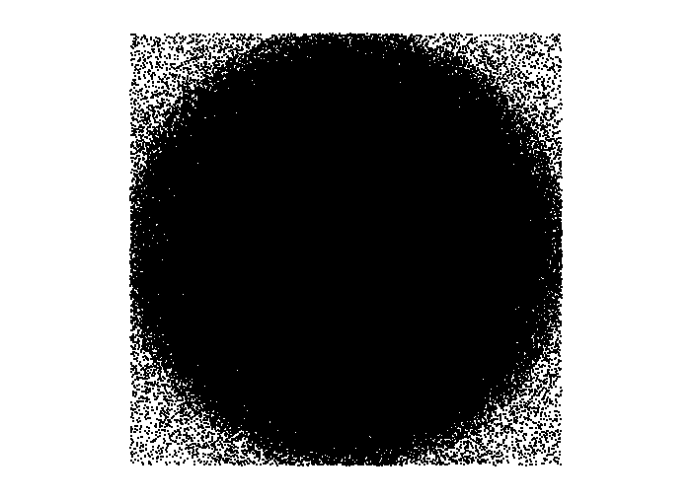

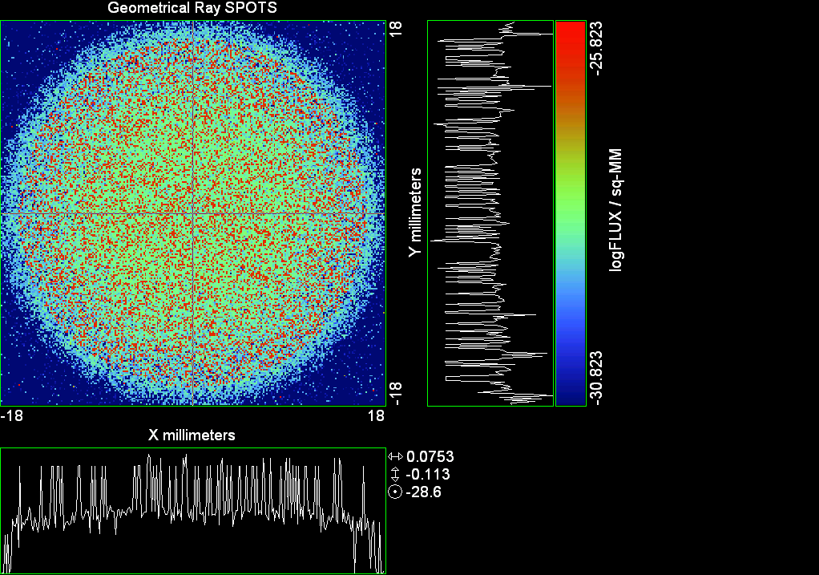

--- ! Spot Plot (Run Ray Trace First)
--- !!CONSIDER ONLY 6 !!Grid Detector=6
--- CONSIDER ONLY 7 !! Earth Detector=7
--- OBLIQUE OFF
--- !!TITLE 'FOV1-9/19^2 mm^2=15503 Rays'
--- !!TITLE 'FOV8 Rect Source Det=2170 total rays'
--- !!TITLE 'FOV8 RctSrc Det=1357-1348=11 rays from Pedestals DetImplBafOnly'
--- !!TITLE 'FOV8 RctSrc Det=750 rays "On"Mrlts Pd&SbS=0 DtImplBfOnly'
--- !!TITLE 'FOV8 RctSrc Det=754 rays "On"Mrlts Pd=1 SbS=0 DtImplBfOnly'
--- !!TITLE 'FOV8 3x3 Pt Src =215 rays "On"Mrlts Pd=1 SbS=0 DtImplBfOnly'
--- TITLE '1.5E6 KM to Source at L1 Distance'
--- !!WINDOW Y X
--- WINDOW Y -18 18 X -18 18
--- !!WINDOW Y 11 14 X -1.5 1.5
--- !!TITLE 'FOV8 23x23 1358-678=680 Rays/.109 mm^2 = 6238 Rays/mm^2 5.5%'
--- !!WINDOW Y 135.75 136.25 X 82.5 83 !!FOV 8
--- !!TITLE 'FOV8 3x3 Core 678 Rays/.006mm^2 = 113000 Rays/mm^2'
--- !!WINDOW Y 136.01 136.07 X 82.75 82.85 !!FOV 8
--- PIXELS 256
--- SPOTS POSITION

Distribution of data within:
Window Vertical: Y = -18.0000 to 18.0000 ( 36.0000 )
Horizontal: X = -18.0000 to 18.0000 ( 36.0000 )

Opening NEW distribution file 9: C:\ASAP Work\TRIANA\bro009.dat
Rays Flux
477043 0.780240E-24
Maximum = 1.5038920E-26 minimum = 0.0000000E+00
--- $IO "ASAPTEMP.INR"
Opening 1 C:\ASAP Work\TRIANA\asaptemp.inr

Closing 7 C:\ASAP Work\TRIANA\bro007.dat
Opening 7 C:\ASAP Work\TRIANA\asaptemp.usr

Closing 20 C:\ASAP Work\TRIANA\bro020.dat
Opening 20 C:\ASAP Work\TRIANA\asaptemp.plr

Closing 30 C:\ASAP Work\TRIANA\bro030.dat
Opening 30 C:\ASAP Work\TRIANA\asaptemp.vcr

--- !! PICTURE (Run Ray Trace and Spots Position First)
--- !! Picks size from Spots Position window size
--- TITLE 'EPIC'
--- CONSIDER ONLY 7 !! Detector = 6 for Grid, 7 for Earth
--- !!WINDOW X -1.5 1.5 Y 11 14
--- WINDOW Y X
--- DISPLAY
Opening OLD distribution file 9: C:\ASAP Work\TRIANA\bro009.dat

File header:
Geometrical Ray SPOTS 1
Z 790.7430 FLUX / sq-MM
X millimeters -18.00000 18.00000 256
Y millimeters -18.00000 18.00000 256

Statistics on 256 by 256 data set:
FLUX / sq-MM Location Y millimeters X millimeters
Minimum 0.000000 1 1 -17.92969 -17.92969
Maximum 0.1503892E-25 232 79 14.55469 -6.960938
Average 0.6020362E-27 129 129 0.7031250E-01 0.7031250E-01
TOTAL FLUX = 0.7802390E-24

--- AVERAGE 0 0
Statistics on 256 by 256 data set:
FLUX / sq-MM Location Y millimeters X millimeters
Minimum 0.000000 1 1 -17.92969 -17.92969
Maximum 0.1503892E-25 232 79 14.55469 -6.960938
Average 0.6020362E-27 129 129 0.7031250E-01 0.7031250E-01
TOTAL FLUX = 0.7802390E-24

--- FORM -5
Statistics on 256 by 256 data set:
FLUX / sq-MM Location Y millimeters X millimeters
Minimum -30.82278 1 1 -17.92969 -17.92969
Maximum -25.82278 232 79 14.55469 -6.960938
Average -28.89051 129 129 0.7031250E-01 0.7031250E-01
Integral = -37442.10

--- !!CONTOUR .001 .005 .01 .05 .1 .2 .3 .4 .5 .6 .7 .8 .85 .9 .95 GRID 2
--- PICTURE
Opening NEW distribution file 10: C:\ASAP Work\TRIANA\i.dis

Run 07 Centered 0.65 deg 40k rays.xls

Run 08 Centered 0.80 deg 40k rays

--- END

System database and settings have been reinitialized
--- $IO "ASAPTEMP.INR"
Opening 1 C:\ASAP Work\TRIANA\asaptemp.inr

Closing 7 C:\ASAP Work\TRIANA\bro007.dat
Opening 7 C:\ASAP Work\TRIANA\asaptemp.usr

Closing 20 C:\ASAP Work\TRIANA\bro020.dat
Creating 20 C:\ASAP Work\TRIANA\asaptemp.plr

Closing 30 C:\ASAP Work\TRIANA\bro030.dat
Creating 30 C:\ASAP Work\TRIANA\asaptemp.vcr

--- !! Directed Diffuser Example
--- !! Create a source (Disk or Grid)
--- !! Source hits a diffuser in close proximity to source
--- !! diffuser scatters towards an edge for efficient ray tracing
--- SYSTEM NEW
--- RESET
--- UNITS MILLIMETERS
--- !! Setup for 1500 meter test
--- EDGE (EP=1000) !! Assign edge number to reference later with TOWARDS
--- ELLIPSE Z -200 225 225
--- !! Diffusion Model
--- MODEL
--- LAMBERTIAN 1
Angle Relative TIS Sampling
0.0 1.00 1000 radial

--- RETURN
--- CUTOFF (1.0E-40) 50 !! Default=1.0E-18 1/4pir2=3.5E-26
--- !! Scattering Plate is at L1, Source Disk is 1 meter farther away
--- !! L1 is at 1.5E6 km 1.5E9 m 1.5E12 mm
--- !! Except for scale factor, dimensions are in km
--- SCALE=1E6 !! S=1 for mm; 1E3 m; 1E6 km
--- !! Set source offset in "km" if scale = 1E6. Usually DX or DY only.
--- DX=0*(SCALE)
--- DY=0*(SCALE) !! 0=pixel 1024, centered
--- DZ=0*(SCALE)
--- !!SRAD=523.6 !!=0.04 deg diam
--- !!SRAD=1047.2 !!=0.08 deg diam
--- !!SRAD=2094.4 !!=0.16 deg diam
--- !!SRAD=2618.0 !!=0.20 deg diam
--- !!SRAD=4188.8 !!=0.32 deg diam
--- !!SRAD=6283.2 !!=0.48 deg diam
--- !!SRAD=8508.6 !!=0.65 deg diam
--- SRAD=10472.1 !!=0.80 deg diam
--- !! Spherical Earth Radius = 6371 km
--- LEVEL 2 0. !! Suggested by BRO Tech Support
--- SURFACE
--- PLANE Z ((-1.5E6)*(SCALE)) ELLIPSE (SRAD*(SCALE)) (SRAD*(SCALE)) 0 (DX) (DY)
--- OBJECT 'DIFFUSION'
--- INTERFACE 0 1E-12 !! Only allow scatter rays to transmit
--- SCATTER MODEL 1 RANDOM 1 1 !! RANDOM needed to find edge, else low light problems
--- TOWARDS (EP) 1
--- RETURN
--- !! Emitter
--- NRAYS=40000 !! 1000=32 sec 40000=20 minutes 200000
--- EMIT DISK Z ((-1.500001E6)*(SCALE)) (SRAD*(SCALE)) (SRAD*(SCALE)) (NRAYS) 1 1
Total flux in rays created by this emitter is 3.0458655E-04
--- SHIFT (DX) (DY) (DZ)
--- RETURN
--- UNITS MILLIMETERS
--- WAVELENGTHS 0.950000 0.706000 0.587560 0.435000 0.300000 MICRONS
--- MEDIA; 1.45106513 1.45515708 1.45846375 1.46676272 1.48779297 'SILICA'
--- COATING PROPERTIES; 1 0 'WHITE'
--- COATING PROPERTIES; .98 0 'MIRROR'
--- COATING PROPERTIES; .11 .87 'DETECTORQE317'
--- COATING PROPERTIES; .10 .75 'DETECTORQE325'
--- COATING PROPERTIES; .05 0 'BLACK'
--- COATING PROPERTIES; 0 0 'ZERO'
--- COATING PROPERTIES; 0 1 'CLEAR'
--- STRUE=0
--- SX=0
--- SY=0
--- SZ=0
--- SCAT=1
--- ENT OBJECT;MIRROR Z 439.24 159 (1219.2/2) -1 (38.2/159) 'PRIMARY S1'
--- INTERFACE COATING MIRROR AIR AIR
--- ENT OBJECT;TUBE Z 438.5 38.2 38.2 466.53196 38.2 38.2 0.0 0.0 'PRIMARYHOLE'
--- INTERFACE COATING BLACK AIR AIR
--- SCATTER RANDOM 1 (SCAT) 1.57 ABS 1 0
--- ENT OBJECT;PLANE Z 466.5 ELLIPSE 210 210 (38.2/210) 'PRIMARY BACK'
--- INTERFACE COATING BLACK AIR AIR
--- SCATTER RANDOM 1 (SCAT) 1.57 ABS 1 0
--- ENT OBJECT;TUBE Z 429 159 159 466.5 159 159 0.0 0.0 'PRIMARYEDGE'
--- INTERFACE COATING BLACK AIR AIR
--- SCATTER RANDOM 1 (SCAT) 1.57 ABS 1 0
--- ENT OBJECT;MIRROR Z 0.0 46 (434.7/2) -2.40763 0.0 'SECONDARY S2'
--- INTERFACE COATING MIRROR AIR AIR
--- ENT OBJECT;PLANE Z 790.7429896 RECTANGLE 18 18 0 'DETECTOR'
--- INTERFACE COATING ZERO SILICA AIR
--- ENT OBJECT;PLANE Z 790.7 RECTANGLE 18 18 0 'DETECTOR-COVER'
--- INTERFACE COATING DETECTORQE317 SILICA AIR
*** SPLIT automatically set to 1
--- ENT OBJECT;PLANE Z -55.69204 ELLIPSE 210 210 (154.8315449/210) 'SPIDER'
--- INTERFACE COATING BLACK AIR AIR
--- SCATTER RANDOM 1 (SCAT) 1.57 ABS 1 0
--- ENT OBJECT;TUBE Z -55.69204 154.8315449 154.8315449 -30.29204 154.8315449 154.8315449 0.0 0.0 'SPIDERCYL'
--- INTERFACE COATING BLACK AIR AIR
--- SCATTER RANDOM 1 (SCAT) 1.57 ABS 1 0
--- ENT OBJECT;TUBE X 0 0.75 12.52 -170 0.75 15.52 1 1 'SPIDERARMX'
--- SHIFT 0 -52.578 -42.992
--- INTERFACE COATING BLACK AIR AIR
--- SCATTER RANDOM 1 (SCAT) 1.57 ABS 1 0
--- ENT OBJECT;TUBE X 0 5 12.52 -170 5 15.52 1 1 'SPIDERARMX1'
--- SHIFT 0 -52.578 -42.992
--- ROTATE Z -120 0 0
--- INTERFACE COATING BLACK AIR AIR
--- SCATTER RANDOM 1 (SCAT) 1.57 ABS 1 0
--- ENT OBJECT;TUBE X 0 0.75 12.52 -170 0.75 15.52 1 1 'SPIDERARMX2'
--- SHIFT 0 -52.578 -42.992
--- ROTATE Z -240 0 0
--- INTERFACE COATING BLACK AIR AIR
--- SCATTER RANDOM 1 (SCAT) 1.57 ABS 1 0
--- ENT OBJECT;TUBE Z -185.6 200.8 200.8 528 200.8 200.8 0.0 0.0 'BARRELBAFFLE'
--- INTERFACE COATING BLACK AIR AIR
--- SCATTER RANDOM 1 (SCAT) 1.57 ABS 1 0
--- ENT OBJECT;ELLIPSE Z -200 205 205 64 0.0 360.0 'ENTRANCE'
Default ELLIP/ROUND/OVAL segments changed to 64
--- INTERFACE COATING CLEAR AIR AIR
--- ENT OBJECT;TUBE Z (2.391*25.4) (2.546*25.4) (2.546*25.4) (2.164*25.4) (2.546*25.4) (2.546*25.4) 0.0 0.0 'SECONDARYHOUSING'
--- INTERFACE COATING BLACK AIR AIR
--- SCATTER RANDOM 1 (SCAT) 1.57 ABS 1 0
--- ENT OBJECT;TUBE Z (2.164*25.4) (2.546*25.4) (2.546*25.4) 0 (2*25.4) (2*25.4) 0.0 0.0 'SH-CONE'
--- INTERFACE COATING BLACK AIR AIR
--- SCATTER RANDOM 1 (SCAT) 1.57 ABS 1 0
--- ENT OBJECT;PLANE Z 0.0 ELLIPSE (2.45*25.4) (2.45*25.4) (2.00/2.45) 'SH-CONEBASE'
--- INTERFACE COATING BLACK AIR AIR
--- SCATTER RANDOM 1 (SCAT) 1.57 ABS 1 0
--- ENT OBJECT;TUBE Z 0.0 (2.125*25.4) (2.125*25.4) (-6.875*25.4) (2.125*25.4) (2.125*25.4) 0.0 0.0 'SH-CYLINDER'
--- INTERFACE COATING BLACK AIR AIR
--- SCATTER RANDOM 1 (SCAT) 1.57 ABS 1 0
--- ENT OBJECT;PLANE Z (-6.875*25.4) ELLIPSE (2.33*25.4) 'SH-TOP'
--- INTERFACE COATING BLACK AIR AIR
--- SCATTER RANDOM 1 (SCAT) 1.57 ABS 1 0
--- ENT OBJECT;PLANE Z (-1.9*25.4) ELLIPSE (2.546*25.4) 'SH-MIDVANE'
--- INTERFACE COATING BLACK AIR AIR
--- SCATTER RANDOM 1 (SCAT) 1.57 ABS 1 0
--- ENT OBJECT;TUBE Z 226.38766 37.465 37.465 422.98366 37.465 37.465 0.0 0.0 'CBAF-FRONT'
--- INTERFACE COATING BLACK AIR AIR
--- SCATTER RANDOM 1 (SCAT) 1.57 ABS 1 0
--- ENT OBJECT;PLANE Z 422.98366 ELLIPSE 37.485 37.485 (30.5562/37.485) 'CBAF-LEDGE'
--- INTERFACE COATING BLACK AIR AIR
--- SCATTER RANDOM 1 (SCAT) 1.57 ABS 1 0
--- ENT OBJECT;TUBE Z 422.985 32.2072 32.2072 532.45766 32.2072 32.2072 0.0 0.0 'CBAF-AFT'
--- INTERFACE COATING BLACK AIR AIR
--- SCATTER RANDOM 1 (SCAT) 1.57 ABS 1 0
--- ENT OBJECT;PLANE Z 327.98766 ELLIPSE 37.485 37.485 (35.56/37.485) 'CBAF-VANE1'
--- INTERFACE COATING BLACK AIR AIR
--- SCATTER RANDOM 1 (SCAT) 1.57 ABS 1 0
--- ENT OBJECT;PLANE Z 378.78766 ELLIPSE 37.485 37.485 (35.56/37.485) 'CBAF-VANE2'
--- INTERFACE COATING BLACK AIR AIR
--- SCATTER RANDOM 1 (SCAT) 1.57 ABS 1 0
--- ENT OBJECT;PLANE Z 505.53366 ELLIPSE 32.24 32.24 (28.6512/32.24) 'CBAF-VANE3'
--- INTERFACE COATING BLACK AIR AIR
--- SCATTER RANDOM 1 (SCAT) 1.57 ABS 1 0
--- RETURN
--- !! Geometry is being appended to system.
--- !! To not view this message, refer to ASAP preferences dialog,
--- !! or change the Options->Append Geometry menu item.
--- UNITS MILLIMETERS
--- WAVELENGTHS 0.950000 0.706000 0.587560 0.435000 0.300000 MICRONS
--- MEDIA; 1.45106513 1.45515708 1.45846375 1.46676272 1.48779297 'SILICA'
--- COATING PROPERTIES; .98 0 'MIRROR'
--- COATING PROPERTIES; .05 0 'BLACK'
--- COATING PROPERTIES; 0 0 'ZERO'
--- COATING PROPERTIES; 0 1 'CLEAR'
--- COATING PROPERTIES; .05 .95 'ARF05'
--- COATING PROPERTIES; 0.2 0.8 'ARF20'
--- ENT OBJECT;PLANE Z 615.3400000 ELLIPSE 150 150 (22/150) 'LENS MOUNT'
--- INTERFACE COATING BLACK AIR AIR
--- SCATTER RANDOM 1 (SCAT) 1.57 ABS 1 0
--- ENT OBJECT;TUBE Z 558.61966 26.7 26.7 620 26.7 26.7 0.0 0.0 'LENS TUBE-FRONT'
--- INTERFACE COATING BLACK AIR AIR
--- SCATTER RANDOM 1 (SCAT) 1.57 ABS 1 0
--- ENT OBJECT;PLANE Z 558.61966 ELLIPSE 27.7 27.7 (24.945/27.7) 'LT-FACE'
--- INTERFACE COATING BLACK AIR AIR
--- SCATTER RANDOM 1 (SCAT) 1.57 ABS 1 0
--- ENT OBJECT;PLANE Z 616.4326 ELLIPSE 27.7 27.7 (21.5/27.7) 'LT-LENS 1FACE'
--- INTERFACE COATING BLACK AIR AIR
--- SCATTER RANDOM 1 (SCAT) 1.57 ABS 1 0
--- ENT OBJECT;TUBE Z 621 25.152 25.152 657.7965 25.152 25.152 0.0 0.0 'LENS TUBE AFT'
--- INTERFACE COATING BLACK AIR AIR
--- SCATTER RANDOM 1 (SCAT) 1.57 ABS 1 0
--- ENT OBJECT;PLANE Z 657.7965 ELLIPSE 25.152 25.152 (21.26386619/25.152) 'LT-AFT FACE'
--- INTERFACE COATING BLACK AIR AIR
--- SCATTER RANDOM 1 (SCAT) 1.57 ABS 1 0
--- ENT OBJECT;OPTICAL Z 615.3400000 221.803 0 ELLIPSE 22 'LENS1F'
--- INTERFACE COATING ARF05 AIR SILICA
--- ENT OBJECT;OPTICAL Z 620.3400000 584.5 0 ELLIPSE 22 'LENS1B'
--- INTERFACE COATING ARF05 AIR SILICA
--- ENT OBJECT;OPTICAL Z 627.63 -147.027 0 ELLIPSE 22 'LENS2F'
--- INTERFACE COATING ARF05 AIR SILICA
--- ENT OBJECT;OPTICAL Z 632.63 -135.158 0 ELLIPSE 22 'LENS2B'
--- INTERFACE COATING ARF05 AIR SILICA
--- ENT OBJECT;OPTICAL Z 635.6 97.002 0 ELLIPSE 22 'LENS3F'
--- INTERFACE COATING ARF05 AIR SILICA
--- ENT OBJECT;OPTICAL Z 640.6 67.147 0 ELLIPSE 22 'LENS3B'
--- INTERFACE COATING ARF05 AIR SILICA
--- ENT OBJECT;TUBE Z 614 22 22 645 22 22 0.0 0.0 'LENSHOLDER'
--- INTERFACE COATING ZERO AIR AIR
--- SCATTER RANDOM 1 (SCAT) 1.57 ABS 1 0
--- ENT OBJECT;PLANE Z 660.84196 ELLIPSE 150 150 (25.28148817/150) 'FW-HOUSING FRONT'
--- INTERFACE COATING BLACK AIR AIR
--- SCATTER RANDOM 1 (SCAT) 1.57 ABS 1 0
--- ENT OBJECT;PLANE Z 709.10196 ELLIPSE 150 150 (25.28148817/150) 'FW-HOUSING AFT'
--- INTERFACE COATING BLACK AIR AIR
--- SCATTER RANDOM 1 (SCAT) 1.57 ABS 1 0
--- ENT OBJECT;TUBE Z (673.54196-.3) 27.5 27.5 (680.04436+.3) 27.5 27.5 0.0 0.0 'FILTERHOLDER'
--- INTERFACE COATING BLACK AIR AIR
--- SCATTER RANDOM 1 (SCAT) 1.57 ABS 1 0
--- ENT OBJECT;PLANE Z 675 ELLIPSE 150 150 (27.5/150) 'FILTER-WHEEL'
--- INTERFACE COATING BLACK AIR AIR
--- SCATTER RANDOM 1 (SCAT) 1.57 ABS 1 0
--- ENT OBJECT;TUBE Z 721.59876 19.16979665 19.16979665 723.53932 22.558 22.558 0.0 0.0 'EXIT CONE FRONT'
--- INTERFACE COATING BLACK AIR AIR
--- SCATTER RANDOM 1 (SCAT) 1.57 ABS 1 0
--- ENT OBJECT;TUBE Z 723.53932 22.558 22.558 781.84248 22.558 22.558 0.0 0.0 'EC-CYLINDER'
--- INTERFACE COATING BLACK AIR AIR
--- SCATTER RANDOM 1 (SCAT) 1.57 ABS 1 0
--- ENT OBJECT;PLANE Z 781.84248 ELLIPSE 22.558 22.558 (16.89/22.558) 'EC-SHELF'
--- INTERFACE COATING BLACK AIR AIR
--- SCATTER RANDOM 1 (SCAT) 1.57 ABS 1 0
--- ENT OBJECT;TUBE Z 781.84248 16.89 16.89 783.87448 20.41280351 20.41280351 0.0 0.0 'EC-EXITCONE'
--- INTERFACE COATING BLACK AIR AIR
--- SCATTER RANDOM 1 (SCAT) 1.57 ABS 1 0
--- ENT OBJECT;PLANE Z 783.87448 ELLIPSE 50 50 (20.41280351/50) 'EC-EXIT'
--- INTERFACE COATING BLACK AIR AIR
--- SCATTER RANDOM 1 (SCAT) 1.57 ABS 1 0
--- RETURN
--- $IO "ASAPTEMP.INR"
Opening 1 C:\ASAP Work\TRIANA\asaptemp.inr

Closing 7 C:\ASAP Work\TRIANA\bro007.dat
Opening 7 C:\ASAP Work\TRIANA\asaptemp.usr

Closing 20 C:\ASAP Work\TRIANA\bro020.dat
Creating 20 C:\ASAP Work\TRIANA\asaptemp.plr

Closing 30 C:\ASAP Work\TRIANA\bro030.dat
Creating 30 C:\ASAP Work\TRIANA\asaptemp.vcr

--- !! Filters-2 from .ent/copy/.inr to allow ABSORBing media
--- UNITS MILLIMETERS
--- WAVELENGTHS 0.950000 0.706000 0.587560 0.435000 0.300000 MICRONS
--- MEDIA; 1.45106513 1.45515708 1.45846375 1.46676272 1.48779297 'SILICA'
--- !!COATING PROPERTIES; .98 0 'MIRROR'
--- !!COATING PROPERTIES; .05 0 'BLACK'
--- !!COATING PROPERTIES; 0 0 'ZERO'
--- !!COATING PROPERTIES; 0 1 'CLEAR'
--- COATING PROPERTIES; .0745 .9255 'ARF0745'
--- COATING PROPERTIES; .0525 .9475 'ARF0525'
--- COATING PROPERTIES; .05 .95 'ARF05'
--- COATING PROPERTIES; .005 .995 'ARF005'
--- !!COATING PROPERTIES; 0.2 0.8 'ARF20'
--- !!!!!!!!!!!!!!!!!!!!!!!!!!!!!!!!!!!!!!!!!!!!!!!!!!
--- WAVELENGTH 0.317 MICRONS
--- MEDIA
--- 1.48342884 ABSORB 0.13168 'BLOCKER317'
--- MEDIA
--- 1.48342884 ABSORB 0.00307 'ETALON317'
--- !!!!!!!!!!!!!!!!!!!!!!!!!!!!!!!!!!!!!!!!!!!!!!!!!!
--- !!WAVELENGTH 0.325 MICRONS
--- !!MEDIA
--- !! 1.48163777 ABSORB 0.08074 'BLOCKER325'
--- !!MEDIA
--- !! 1.48163777 ABSORB 0.0415179525 'ETALON325'
--- !!!!!!!!!!!!!!!!!!!!!!!!!!!!!!!!!!!!!!!!!!!!!!!!!!!!!
--- ENT OBJECT;PLANE Z 673.54196 ELLIPSE 27.5 'FILTERUVE-F'
--- INTERFACE COATING ARF0525 AIR ETALON317
--- !! INTERFACE COATING ARF0745 AIR ETALON325
--- ENT OBJECT;PLANE Z 676.71696 ELLIPSE 27.5 'FILTERUVE-B'
--- INTERFACE COATING ARF0525 AIR ETALON317
--- !! INTERFACE COATING ARF0745 AIR ETALON325
--- ENT OBJECT;PLANE Z 676.86936 ELLIPSE 27.5 'FILTERUVB-F'
--- INTERFACE COATING ARF005 AIR BLOCKER317
--- !! INTERFACE COATING ARF005 AIR BLOCKER325
--- ENT OBJECT;PLANE Z 680.04436 ELLIPSE 27.5 'FILTERUVB-B'
--- INTERFACE COATING ARF005 AIR BLOCKER317
--- !! INTERFACE COATING ARF005 AIR BLOCKER325
--- !!RETURN

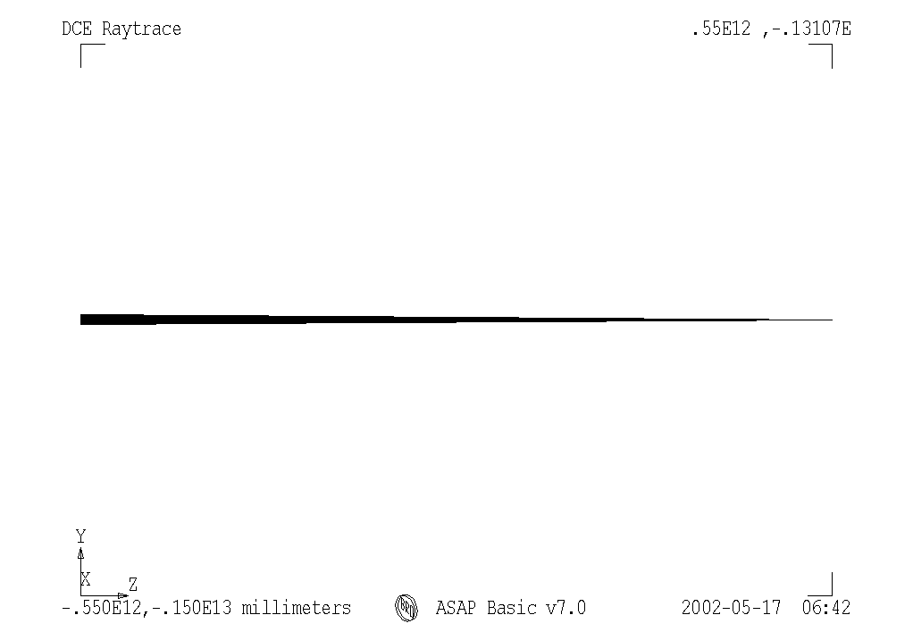

--- END

System database and settings have been reinitialized
--- $IO "ASAPTEMP.INR"
Opening 1 C:\ASAP Work\TRIANA\asaptemp.inr

Closing 7 C:\ASAP Work\TRIANA\bro007.dat
Opening 7 C:\ASAP Work\TRIANA\asaptemp.usr

Closing 20 C:\ASAP Work\TRIANA\bro020.dat
Creating 20 C:\ASAP Work\TRIANA\asaptemp.plr

Closing 30 C:\ASAP Work\TRIANA\bro030.dat
Creating 30 C:\ASAP Work\TRIANA\asaptemp.vcr

--- !! Directed Diffuser Example
--- !! Create a source (Disk or Grid)
--- !! Source hits a diffuser in close proximity to source
--- !! diffuser scatters towards an edge for efficient ray tracing
--- SYSTEM NEW
--- RESET
--- UNITS MILLIMETERS
--- !! Setup for 1500 meter test
--- EDGE (EP=1000) !! Assign edge number to reference later with TOWARDS
--- ELLIPSE Z -200 225 225
--- !! Diffusion Model
--- MODEL
--- LAMBERTIAN 1
Angle Relative TIS Sampling
0.0 1.00 1000 radial

--- RETURN
--- CUTOFF (1.0E-40) 50 !! Default=1.0E-18 1/4pir2=3.5E-26
--- !! Scattering Plate is at L1, Source Disk is 1 meter farther away
--- !! L1 is at 1.5E6 km 1.5E9 m 1.5E12 mm
--- !! Except for scale factor, dimensions are in km
--- SCALE=1E6 !! S=1 for mm; 1E3 m; 1E6 km
--- !! Set source offset in "km" if scale = 1E6. Usually DX or DY only.
--- DX=0*(SCALE)
--- DY=0*(SCALE) !! 0=pixel 1024, centered
--- DZ=0*(SCALE)
--- !!SRAD=523.6 !!=0.04 deg diam
--- !!SRAD=1047.2 !!=0.08 deg diam
--- !!SRAD=2094.4 !!=0.16 deg diam
--- !!SRAD=2618.0 !!=0.20 deg diam
--- !!SRAD=4188.8 !!=0.32 deg diam
--- !!SRAD=6283.2 !!=0.48 deg diam
--- !!SRAD=8508.6 !!=0.65 deg diam
--- SRAD=10472.1 !!=0.80 deg diam
--- !! Spherical Earth Radius = 6371 km
--- LEVEL 2 0. !! Suggested by BRO Tech Support
--- SURFACE
--- PLANE Z ((-1.5E6)*(SCALE)) ELLIPSE (SRAD*(SCALE)) (SRAD*(SCALE)) 0 (DX) (DY)
--- OBJECT 'DIFFUSION'
--- INTERFACE 0 1E-12 !! Only allow scatter rays to transmit
--- SCATTER MODEL 1 RANDOM 1 1 !! RANDOM needed to find edge, else low light problems
--- TOWARDS (EP) 1
--- RETURN
--- !! Emitter
--- NRAYS=40000 !! 1000=32 sec 40000=20 minutes 200000
--- EMIT DISK Z ((-1.500001E6)*(SCALE)) (SRAD*(SCALE)) (SRAD*(SCALE)) (NRAYS) 1 1
Total flux in rays created by this emitter is 3.0458655E-04
--- SHIFT (DX) (DY) (DZ)
--- RETURN

--- UNITS MILLIMETERS
--- WAVELENGTHS 0.950000 0.706000 0.587560 0.435000 0.300000 MICRONS
--- MEDIA; 1.45106513 1.45515708 1.45846375 1.46676272 1.48779297 'SILICA'
--- COATING PROPERTIES; 1 0 'WHITE'
--- COATING PROPERTIES; .98 0 'MIRROR'
--- COATING PROPERTIES; .11 .87 'DETECTORQE317'
--- COATING PROPERTIES; .10 .75 'DETECTORQE325'
--- COATING PROPERTIES; .05 0 'BLACK'
--- COATING PROPERTIES; 0 0 'ZERO'
--- COATING PROPERTIES; 0 1 'CLEAR'
--- STRUE=0
--- SX=0
--- SY=0
--- SZ=0
--- SCAT=1
--- ENT OBJECT;MIRROR Z 439.24 159 (1219.2/2) -1 (38.2/159) 'PRIMARY S1'
--- INTERFACE COATING MIRROR AIR AIR
--- ENT OBJECT;TUBE Z 438.5 38.2 38.2 466.53196 38.2 38.2 0.0 0.0 'PRIMARYHOLE'
--- INTERFACE COATING BLACK AIR AIR
--- SCATTER RANDOM 1 (SCAT) 1.57 ABS 1 0
--- ENT OBJECT;PLANE Z 466.5 ELLIPSE 210 210 (38.2/210) 'PRIMARY BACK'
--- INTERFACE COATING BLACK AIR AIR
--- SCATTER RANDOM 1 (SCAT) 1.57 ABS 1 0
--- ENT OBJECT;TUBE Z 429 159 159 466.5 159 159 0.0 0.0 'PRIMARYEDGE'
--- INTERFACE COATING BLACK AIR AIR
--- SCATTER RANDOM 1 (SCAT) 1.57 ABS 1 0
--- ENT OBJECT;MIRROR Z 0.0 46 (434.7/2) -2.40763 0.0 'SECONDARY S2'
--- INTERFACE COATING MIRROR AIR AIR
--- ENT OBJECT;PLANE Z 790.7429896 RECTANGLE 18 18 0 'DETECTOR'
--- INTERFACE COATING ZERO SILICA AIR
--- ENT OBJECT;PLANE Z 790.7 RECTANGLE 18 18 0 'DETECTOR-COVER'
--- INTERFACE COATING DETECTORQE317 SILICA AIR
*** SPLIT automatically set to 1
--- ENT OBJECT;PLANE Z -55.69204 ELLIPSE 210 210 (154.8315449/210) 'SPIDER'
--- INTERFACE COATING BLACK AIR AIR
--- SCATTER RANDOM 1 (SCAT) 1.57 ABS 1 0
--- ENT OBJECT;TUBE Z -55.69204 154.8315449 154.8315449 -30.29204 154.8315449 154.8315449 0.0 0.0 'SPIDERCYL'
--- INTERFACE COATING BLACK AIR AIR
--- SCATTER RANDOM 1 (SCAT) 1.57 ABS 1 0
--- ENT OBJECT;TUBE X 0 0.75 12.52 -170 0.75 15.52 1 1 'SPIDERARMX'
--- SHIFT 0 -52.578 -42.992
--- INTERFACE COATING BLACK AIR AIR
--- SCATTER RANDOM 1 (SCAT) 1.57 ABS 1 0
--- ENT OBJECT;TUBE X 0 5 12.52 -170 5 15.52 1 1 'SPIDERARMX1'
--- SHIFT 0 -52.578 -42.992
--- ROTATE Z -120 0 0
--- INTERFACE COATING BLACK AIR AIR
--- SCATTER RANDOM 1 (SCAT) 1.57 ABS 1 0
--- ENT OBJECT;TUBE X 0 0.75 12.52 -170 0.75 15.52 1 1 'SPIDERARMX2'
--- SHIFT 0 -52.578 -42.992
--- ROTATE Z -240 0 0
--- INTERFACE COATING BLACK AIR AIR
--- SCATTER RANDOM 1 (SCAT) 1.57 ABS 1 0
--- ENT OBJECT;TUBE Z -185.6 200.8 200.8 528 200.8 200.8 0.0 0.0 'BARRELBAFFLE'
--- INTERFACE COATING BLACK AIR AIR
--- SCATTER RANDOM 1 (SCAT) 1.57 ABS 1 0
--- ENT OBJECT;ELLIPSE Z -200 205 205 64 0.0 360.0 'ENTRANCE'
Default ELLIP/ROUND/OVAL segments changed to 64
--- INTERFACE COATING CLEAR AIR AIR
--- ENT OBJECT;TUBE Z (2.391*25.4) (2.546*25.4) (2.546*25.4) (2.164*25.4) (2.546*25.4) (2.546*25.4) 0.0 0.0 'SECONDARYHOUSING'
--- INTERFACE COATING BLACK AIR AIR
--- SCATTER RANDOM 1 (SCAT) 1.57 ABS 1 0
--- ENT OBJECT;TUBE Z (2.164*25.4) (2.546*25.4) (2.546*25.4) 0 (2*25.4) (2*25.4) 0.0 0.0 'SH-CONE'
--- INTERFACE COATING BLACK AIR AIR
--- SCATTER RANDOM 1 (SCAT) 1.57 ABS 1 0
--- ENT OBJECT;PLANE Z 0.0 ELLIPSE (2.45*25.4) (2.45*25.4) (2.00/2.45) 'SH-CONEBASE'
--- INTERFACE COATING BLACK AIR AIR
--- SCATTER RANDOM 1 (SCAT) 1.57 ABS 1 0
--- ENT OBJECT;TUBE Z 0.0 (2.125*25.4) (2.125*25.4) (-6.875*25.4) (2.125*25.4) (2.125*25.4) 0.0 0.0 'SH-CYLINDER'
--- INTERFACE COATING BLACK AIR AIR
--- SCATTER RANDOM 1 (SCAT) 1.57 ABS 1 0
--- ENT OBJECT;PLANE Z (-6.875*25.4) ELLIPSE (2.33*25.4) 'SH-TOP'
--- INTERFACE COATING BLACK AIR AIR
--- SCATTER RANDOM 1 (SCAT) 1.57 ABS 1 0
--- ENT OBJECT;PLANE Z (-1.9*25.4) ELLIPSE (2.546*25.4) 'SH-MIDVANE'
--- INTERFACE COATING BLACK AIR AIR
--- SCATTER RANDOM 1 (SCAT) 1.57 ABS 1 0
--- ENT OBJECT;TUBE Z 226.38766 37.465 37.465 422.98366 37.465 37.465 0.0 0.0 'CBAF-FRONT'
--- INTERFACE COATING BLACK AIR AIR
--- SCATTER RANDOM 1 (SCAT) 1.57 ABS 1 0
--- ENT OBJECT;PLANE Z 422.98366 ELLIPSE 37.485 37.485 (30.5562/37.485) 'CBAF-LEDGE'
--- INTERFACE COATING BLACK AIR AIR
--- SCATTER RANDOM 1 (SCAT) 1.57 ABS 1 0
--- ENT OBJECT;TUBE Z 422.985 32.2072 32.2072 532.45766 32.2072 32.2072 0.0 0.0 'CBAF-AFT'
--- INTERFACE COATING BLACK AIR AIR
--- SCATTER RANDOM 1 (SCAT) 1.57 ABS 1 0
--- ENT OBJECT;PLANE Z 327.98766 ELLIPSE 37.485 37.485 (35.56/37.485) 'CBAF-VANE1'
--- INTERFACE COATING BLACK AIR AIR
--- SCATTER RANDOM 1 (SCAT) 1.57 ABS 1 0
--- ENT OBJECT;PLANE Z 378.78766 ELLIPSE 37.485 37.485 (35.56/37.485) 'CBAF-VANE2'
--- INTERFACE COATING BLACK AIR AIR
--- SCATTER RANDOM 1 (SCAT) 1.57 ABS 1 0
--- ENT OBJECT;PLANE Z 505.53366 ELLIPSE 32.24 32.24 (28.6512/32.24) 'CBAF-VANE3'
--- INTERFACE COATING BLACK AIR AIR
--- SCATTER RANDOM 1 (SCAT) 1.57 ABS 1 0
--- RETURN
--- !! Geometry is being appended to system.
--- !! To not view this message, refer to ASAP preferences dialog,
--- !! or change the Options->Append Geometry menu item.
--- UNITS MILLIMETERS
--- WAVELENGTHS 0.950000 0.706000 0.587560 0.435000 0.300000 MICRONS
--- MEDIA; 1.45106513 1.45515708 1.45846375 1.46676272 1.48779297 'SILICA'
--- COATING PROPERTIES; .98 0 'MIRROR'
--- COATING PROPERTIES; .05 0 'BLACK'
--- COATING PROPERTIES; 0 0 'ZERO'
--- COATING PROPERTIES; 0 1 'CLEAR'
--- COATING PROPERTIES; .05 .95 'ARF05'
--- COATING PROPERTIES; 0.2 0.8 'ARF20'
--- ENT OBJECT;PLANE Z 615.3400000 ELLIPSE 150 150 (22/150) 'LENS MOUNT'
--- INTERFACE COATING BLACK AIR AIR
--- SCATTER RANDOM 1 (SCAT) 1.57 ABS 1 0
--- ENT OBJECT;TUBE Z 558.61966 26.7 26.7 620 26.7 26.7 0.0 0.0 'LENS TUBE-FRONT'
--- INTERFACE COATING BLACK AIR AIR
--- SCATTER RANDOM 1 (SCAT) 1.57 ABS 1 0
--- ENT OBJECT;PLANE Z 558.61966 ELLIPSE 27.7 27.7 (24.945/27.7) 'LT-FACE'
--- INTERFACE COATING BLACK AIR AIR
--- SCATTER RANDOM 1 (SCAT) 1.57 ABS 1 0
--- ENT OBJECT;PLANE Z 616.4326 ELLIPSE 27.7 27.7 (21.5/27.7) 'LT-LENS 1FACE'
--- INTERFACE COATING BLACK AIR AIR
--- SCATTER RANDOM 1 (SCAT) 1.57 ABS 1 0
--- ENT OBJECT;TUBE Z 621 25.152 25.152 657.7965 25.152 25.152 0.0 0.0 'LENS TUBE AFT'
--- INTERFACE COATING BLACK AIR AIR
--- SCATTER RANDOM 1 (SCAT) 1.57 ABS 1 0
--- ENT OBJECT;PLANE Z 657.7965 ELLIPSE 25.152 25.152 (21.26386619/25.152) 'LT-AFT FACE'
--- INTERFACE COATING BLACK AIR AIR
--- SCATTER RANDOM 1 (SCAT) 1.57 ABS 1 0
--- ENT OBJECT;OPTICAL Z 615.3400000 221.803 0 ELLIPSE 22 'LENS1F'
--- INTERFACE COATING ARF05 AIR SILICA
--- ENT OBJECT;OPTICAL Z 620.3400000 584.5 0 ELLIPSE 22 'LENS1B'
--- INTERFACE COATING ARF05 AIR SILICA
--- ENT OBJECT;OPTICAL Z 627.63 -147.027 0 ELLIPSE 22 'LENS2F'
--- INTERFACE COATING ARF05 AIR SILICA
--- ENT OBJECT;OPTICAL Z 632.63 -135.158 0 ELLIPSE 22 'LENS2B'
--- INTERFACE COATING ARF05 AIR SILICA
--- ENT OBJECT;OPTICAL Z 635.6 97.002 0 ELLIPSE 22 'LENS3F'
--- INTERFACE COATING ARF05 AIR SILICA
--- ENT OBJECT;OPTICAL Z 640.6 67.147 0 ELLIPSE 22 'LENS3B'
--- INTERFACE COATING ARF05 AIR SILICA
--- ENT OBJECT;TUBE Z 614 22 22 645 22 22 0.0 0.0 'LENSHOLDER'
--- INTERFACE COATING ZERO AIR AIR
--- SCATTER RANDOM 1 (SCAT) 1.57 ABS 1 0
--- ENT OBJECT;PLANE Z 660.84196 ELLIPSE 150 150 (25.28148817/150) 'FW-HOUSING FRONT'
--- INTERFACE COATING BLACK AIR AIR
--- SCATTER RANDOM 1 (SCAT) 1.57 ABS 1 0
--- ENT OBJECT;PLANE Z 709.10196 ELLIPSE 150 150 (25.28148817/150) 'FW-HOUSING AFT'
--- INTERFACE COATING BLACK AIR AIR
--- SCATTER RANDOM 1 (SCAT) 1.57 ABS 1 0
--- ENT OBJECT;TUBE Z (673.54196-.3) 27.5 27.5 (680.04436+.3) 27.5 27.5 0.0 0.0 'FILTERHOLDER'
--- INTERFACE COATING BLACK AIR AIR
--- SCATTER RANDOM 1 (SCAT) 1.57 ABS 1 0
--- ENT OBJECT;PLANE Z 675 ELLIPSE 150 150 (27.5/150) 'FILTER-WHEEL'
--- INTERFACE COATING BLACK AIR AIR
--- SCATTER RANDOM 1 (SCAT) 1.57 ABS 1 0
--- ENT OBJECT;TUBE Z 721.59876 19.16979665 19.16979665 723.53932 22.558 22.558 0.0 0.0 'EXIT CONE FRONT'
--- INTERFACE COATING BLACK AIR AIR
--- SCATTER RANDOM 1 (SCAT) 1.57 ABS 1 0
--- ENT OBJECT;TUBE Z 723.53932 22.558 22.558 781.84248 22.558 22.558 0.0 0.0 'EC-CYLINDER'
--- INTERFACE COATING BLACK AIR AIR
--- SCATTER RANDOM 1 (SCAT) 1.57 ABS 1 0
--- ENT OBJECT;PLANE Z 781.84248 ELLIPSE 22.558 22.558 (16.89/22.558) 'EC-SHELF'
--- INTERFACE COATING BLACK AIR AIR
--- SCATTER RANDOM 1 (SCAT) 1.57 ABS 1 0
--- ENT OBJECT;TUBE Z 781.84248 16.89 16.89 783.87448 20.41280351 20.41280351 0.0 0.0 'EC-EXITCONE'
--- INTERFACE COATING BLACK AIR AIR
--- SCATTER RANDOM 1 (SCAT) 1.57 ABS 1 0
--- ENT OBJECT;PLANE Z 783.87448 ELLIPSE 50 50 (20.41280351/50) 'EC-EXIT'
--- INTERFACE COATING BLACK AIR AIR
--- SCATTER RANDOM 1 (SCAT) 1.57 ABS 1 0
--- RETURN
--- $IO "ASAPTEMP.INR"
Opening 1 C:\ASAP Work\TRIANA\asaptemp.inr

Closing 7 C:\ASAP Work\TRIANA\bro007.dat
Opening 7 C:\ASAP Work\TRIANA\asaptemp.usr

Closing 20 C:\ASAP Work\TRIANA\bro020.dat
Creating 20 C:\ASAP Work\TRIANA\asaptemp.plr

Closing 30 C:\ASAP Work\TRIANA\bro030.dat
Creating 30 C:\ASAP Work\TRIANA\asaptemp.vcr

--- !! Filters-2 from .ent/copy/.inr to allow ABSORBing media
--- UNITS MILLIMETERS
--- WAVELENGTHS 0.950000 0.706000 0.587560 0.435000 0.300000 MICRONS
--- MEDIA; 1.45106513 1.45515708 1.45846375 1.46676272 1.48779297 'SILICA'
--- !!COATING PROPERTIES; .98 0 'MIRROR'
--- !!COATING PROPERTIES; .05 0 'BLACK'
--- !!COATING PROPERTIES; 0 0 'ZERO'
--- !!COATING PROPERTIES; 0 1 'CLEAR'
--- COATING PROPERTIES; .0745 .9255 'ARF0745'
--- COATING PROPERTIES; .0525 .9475 'ARF0525'
--- COATING PROPERTIES; .05 .95 'ARF05'
--- COATING PROPERTIES; .005 .995 'ARF005'
--- !!COATING PROPERTIES; 0.2 0.8 'ARF20'
--- !!!!!!!!!!!!!!!!!!!!!!!!!!!!!!!!!!!!!!!!!!!!!!!!!!
--- WAVELENGTH 0.317 MICRONS
--- MEDIA
--- 1.48342884 ABSORB 0.13168 'BLOCKER317'
--- MEDIA
--- 1.48342884 ABSORB 0.00307 'ETALON317'
--- !!!!!!!!!!!!!!!!!!!!!!!!!!!!!!!!!!!!!!!!!!!!!!!!!!
--- !!WAVELENGTH 0.325 MICRONS
--- !!MEDIA
--- !! 1.48163777 ABSORB 0.08074 'BLOCKER325'
--- !!MEDIA
--- !! 1.48163777 ABSORB 0.0415179525 'ETALON325'
--- !!!!!!!!!!!!!!!!!!!!!!!!!!!!!!!!!!!!!!!!!!!!!!!!!!!!!
--- ENT OBJECT;PLANE Z 673.54196 ELLIPSE 27.5 'FILTERUVE-F'
--- INTERFACE COATING ARF0525 AIR ETALON317
--- !! INTERFACE COATING ARF0745 AIR ETALON325
--- ENT OBJECT;PLANE Z 676.71696 ELLIPSE 27.5 'FILTERUVE-B'
--- INTERFACE COATING ARF0525 AIR ETALON317
--- !! INTERFACE COATING ARF0745 AIR ETALON325
--- ENT OBJECT;PLANE Z 676.86936 ELLIPSE 27.5 'FILTERUVB-F'
--- INTERFACE COATING ARF005 AIR BLOCKER317
--- !! INTERFACE COATING ARF005 AIR BLOCKER325
--- ENT OBJECT;PLANE Z 680.04436 ELLIPSE 27.5 'FILTERUVB-B'
--- INTERFACE COATING ARF005 AIR BLOCKER317
--- !! INTERFACE COATING ARF005 AIR BLOCKER325
--- !!RETURN
--- $IO "ASAPTEMP.INR"
Opening 1 C:\ASAP Work\TRIANA\asaptemp.inr

Closing 7 C:\ASAP Work\TRIANA\bro007.dat
Opening 7 C:\ASAP Work\TRIANA\asaptemp.usr

Closing 20 C:\ASAP Work\TRIANA\bro020.dat
Creating 20 C:\ASAP Work\TRIANA\asaptemp.plr

Closing 30 C:\ASAP Work\TRIANA\bro030.dat
Creating 30 C:\ASAP Work\TRIANA\asaptemp.vcr

--- TITLE DCE *Raytrace
--- !! WAVELENGTHS 0.317 MICRONS !! Normally set in filters
--- !!SPLIT 0 !! Direct Trace Only
--- !!SPLIT 1 !! For Rect Sources
--- SPLIT 2 !! For double reflection in lens & filters
--- PLOT FACETS 5 5
Window Vertical: Y = -.104721E+11 to 0.104721E+11 (0.209442E+11)
Horizontal: Z = -.150022E+13 to 791.121 (0.150022E+13)

--- CONSIDER ALL
--- !!CONSIDER ONLY 15
--- ARROWS OFF
--- SEGMENTS 9
--- WINDOW Y Z
--- OBLIQUE 0 0
--- MISSED LINE 50
--- TRACE PLOT 1000 OVERLAY
Window Vertical: Y = -.104721E+11 to 0.104721E+11 (0.209442E+11)
Horizontal: Z = -.150022E+13 to 791.121 (0.150022E+13)

Warning *** Convergence failure in root polishing .6012744E-04
114 *** Convergence failure in root polishing .1287122E-04
16.37 seconds ( 15.64 seconds CPU) to trace 80,000
out of 229,540
Warning *** Convergence failure in root polishing .5301971E-04
133 *** Convergence failure in root polishing .2317351E-04
48.99 seconds ( 47.41 seconds CPU) to trace 160,000
out of 578,124
90.41 seconds ( 87.61 seconds CPU) to trace 240,000
out of 1,054,066
2.22 minutes ( 2.14 minutes CPU) to trace 320,000
out of 1,537,150
2.83 minutes ( 2.70 minutes CPU) to trace 400,000
out of 1,748,007
3.39 minutes ( 3.23 minutes CPU) to trace 480,000
out of 1,874,971
3.96 minutes ( 3.75 minutes CPU) to trace 560,000
out of 2,000,015
4.51 minutes ( 4.27 minutes CPU) to trace 640,000
out of 2,124,388
5.06 minutes ( 4.80 minutes CPU) to trace 720,000
out of 2,249,396
5.62 minutes ( 5.32 minutes CPU) to trace 800,000
out of 2,374,630
6.17 minutes ( 5.84 minutes CPU) to trace 880,000
out of 2,501,596
6.72 minutes ( 6.37 minutes CPU) to trace 960,000
out of 2,628,039
7.32 minutes ( 6.89 minutes CPU) to trace 1,040,000
out of 2,754,611
7.87 minutes ( 7.40 minutes CPU) to trace 1,120,000
out of 2,880,925
8.42 minutes ( 7.93 minutes CPU) to trace 1,200,000
out of 3,006,264
8.98 minutes ( 8.46 minutes CPU) to trace 1,280,000
out of 3,132,665
9.53 minutes ( 8.98 minutes CPU) to trace 1,360,000
out of 3,259,066
10.08 minutes ( 9.51 minutes CPU) to trace 1,440,000
out of 3,384,910
10.78 minutes ( 10.02 minutes CPU) to trace 1,520,000
out of 3,510,966
11.34 minutes ( 10.55 minutes CPU) to trace 1,600,000
out of 3,637,593
11.77 minutes ( 10.96 minutes CPU) to trace 1,680,000
out of 3,719,081
12.00 minutes ( 11.17 minutes CPU) to trace 1,760,000
12.22 minutes ( 11.38 minutes CPU) to trace 1,840,000
12.44 minutes ( 11.59 minutes CPU) to trace 1,920,000
12.67 minutes ( 11.80 minutes CPU) to trace 2,000,000
12.99 minutes ( 12.00 minutes CPU) to trace 2,080,000
13.22 minutes ( 12.21 minutes CPU) to trace 2,160,000
13.47 minutes ( 12.42 minutes CPU) to trace 2,240,000
13.69 minutes ( 12.63 minutes CPU) to trace 2,320,000
13.93 minutes ( 12.84 minutes CPU) to trace 2,400,000
14.15 minutes ( 13.05 minutes CPU) to trace 2,480,000
14.37 minutes ( 13.26 minutes CPU) to trace 2,560,000
14.60 minutes ( 13.47 minutes CPU) to trace 2,640,000
14.83 minutes ( 13.68 minutes CPU) to trace 2,720,000
15.06 minutes ( 13.89 minutes CPU) to trace 2,800,000
15.29 minutes ( 14.09 minutes CPU) to trace 2,880,000
15.52 minutes ( 14.31 minutes CPU) to trace 2,960,000
15.74 minutes ( 14.52 minutes CPU) to trace 3,040,000
15.97 minutes ( 14.73 minutes CPU) to trace 3,120,000
16.19 minutes ( 14.94 minutes CPU) to trace 3,200,000
16.41 minutes ( 15.15 minutes CPU) to trace 3,280,000
16.65 minutes ( 15.36 minutes CPU) to trace 3,360,000
16.87 minutes ( 15.57 minutes CPU) to trace 3,440,000
17.11 minutes ( 15.78 minutes CPU) to trace 3,520,000
17.33 minutes ( 15.99 minutes CPU) to trace 3,600,000
17.55 minutes ( 16.19 minutes CPU) to trace 3,680,000
17.67 minutes ( 16.29 minutes CPU) to trace 3,719,081

Total of 3090247 PARENT warnings
Missed Multiple Wrong Low Evanescent Wrong Absorbed
Obj Total After Bounce Side Flux (TIR) Direc After
1 300356 151427 587 148342 DIFFUSION
2 1134 23 853 258 PRIMARY S1
3 1947 200 16 1731 PRIMARYHOLE
4 92088 36181 419 55488 PRIMARY BACK
5 19182 89 19093 PRIMARYEDGE
6 1522 1169 353 SECONDARY S2
7 681 681 DETECTOR
8 3919 59 1325 2535 DETECTOR-COVER
9 32010 2305 264 29441 SPIDER
10 11329 109 109 11111 SPIDERCYL
11 3358 71 29 3258 SPIDERARMX
12 6062 69 88 5905 SPIDERARMX1
13 3477 82 56 3339 SPIDERARMX2
14 259419 5814 1873 251732 BARRELBAFFLE
15 158486 157610 875 1 ENTRANCE
16 6328 5 37 6286 SECONDARYHOUSING
17 56508 365 380 55763 SH-CONE
18 11638 6 126 11506 SH-CONEBASE
19 71978 1176 1098 69704 SH-CYLINDER
20 723 35 36 652 SH-TOP
21 61307 15 857 60435 SH-MIDVANE
22 246184 931 2176 243077 CBAF-FRONT
23 14921 136 14785 CBAF-LEDGE
24 162682 37394 1066 124222 CBAF-AFT
25 6983 7 91 6885 CBAF-VANE1
26 7452 4 71 7377 CBAF-VANE2
27 11013 1121 165 9727 CBAF-VANE3
28 68416 29736 231 38449 LENS MOUNT
29 66856 3763 555 62538 LENS TUBE-FRONT
30 6334 186 83 6065 LT-FACE
31 4049 23 34 3992 LT-LENS 1FACE
32 24955 351 197 24407 LENS TUBE AFT
33 8804 24 177 8603 LT-AFT FACE
34 6181 1222 1244 3715 LENS1F
35 8838 1087 3294 4457 LENS1B
36 9728 1278 2792 5658 LENS2F
37 9500 1946 4198 3356 LENS2B
38 12993 1604 5180 6209 LENS3F
39 13991 2398 1 1735 9857 LENS3B
40 469 125 344 LENSHOLDER
41 69922 16193 322 53407 FW-HOUSING FRONT
42 555636 361154 1223 193259 FW-HOUSING AFT
43 4951 1527 85 3189 150 FILTERHOLDER
44 269116 107334 1201 160581 FILTER-WHEEL
45 31047 10251 410 20386 EXIT CONE FRONT
46 251308 33654 2334 215320 EC-CYLINDER
47 31857 2 701 31154 EC-SHELF
48 4818 3729 9 1080 EC-EXITCONE
49 19384 11083 205 8096 EC-EXIT
50 5796 78 2025 3 1476 1033 1181 FILTERUVE-F
51 10304 1861 7418 1020 5 FILTERUVE-B
52 6305 2262 1102 1201 1740 FILTERUVB-F
53 36002 30860 1906 36 1243 1957 FILTERUVB-B

Total of 136850 CHILD warnings
Missed Multiple Wrong Low Evanescent Wrong Absorbed
Obj Total After Bounce Side Flux (TIR) Direc After
8 6734 6734 DETECTOR-COVER
34 11031 11031 LENS1F
35 12644 12644 LENS1B
36 13439 13439 LENS2F
37 13318 13318 LENS2B
38 13140 13140 LENS3F
39 13050 13050 LENS3B
50 12376 12376 FILTERUVE-F
51 12417 12417 FILTERUVE-B
52 14330 14330 FILTERUVB-F
53 14371 14371 FILTERUVB-B
22057315 ray-objects encountered at 22561 per CPU second
225065664 order-intersections done at 230209 per CPU second
--- $IO "ASAPTEMP.INR"
Opening 1 C:\ASAP Work\TRIANA\asaptemp.inr

Closing 7 C:\ASAP Work\TRIANA\bro007.dat
Opening 7 C:\ASAP Work\TRIANA\asaptemp.usr

Closing 20 C:\ASAP Work\TRIANA\bro020.dat
Opening 20 C:\ASAP Work\TRIANA\asaptemp.plr

Closing 30 C:\ASAP Work\TRIANA\bro030.dat
Opening 30 C:\ASAP Work\TRIANA\asaptemp.vcr

--- ! Spot Plot (Run Ray Trace First)
--- !!CONSIDER ONLY 6 !!Grid Detector=6
--- CONSIDER ONLY 7 !! Earth Detector=7
--- OBLIQUE OFF
--- !!TITLE 'FOV1-9/19^2 mm^2=15503 Rays'
--- !!TITLE 'FOV8 Rect Source Det=2170 total rays'
--- !!TITLE 'FOV8 RctSrc Det=1357-1348=11 rays from Pedestals DetImplBafOnly'
--- !!TITLE 'FOV8 RctSrc Det=750 rays "On"Mrlts Pd&SbS=0 DtImplBfOnly'
--- !!TITLE 'FOV8 RctSrc Det=754 rays "On"Mrlts Pd=1 SbS=0 DtImplBfOnly'
--- !!TITLE 'FOV8 3x3 Pt Src =215 rays "On"Mrlts Pd=1 SbS=0 DtImplBfOnly'
--- TITLE '1.5E6 KM to Source at L1 Distance'
--- !!WINDOW Y X
--- WINDOW Y -18 18 X -18 18
--- !!WINDOW Y 11 14 X -1.5 1.5
--- !!TITLE 'FOV8 23x23 1358-678=680 Rays/.109 mm^2 = 6238 Rays/mm^2 5.5%'
--- !!WINDOW Y 135.75 136.25 X 82.5 83 !!FOV 8
--- !!TITLE 'FOV8 3x3 Core 678 Rays/.006mm^2 = 113000 Rays/mm^2'
--- !!WINDOW Y 136.01 136.07 X 82.75 82.85 !!FOV 8
--- PIXELS 256
--- SPOTS POSITION

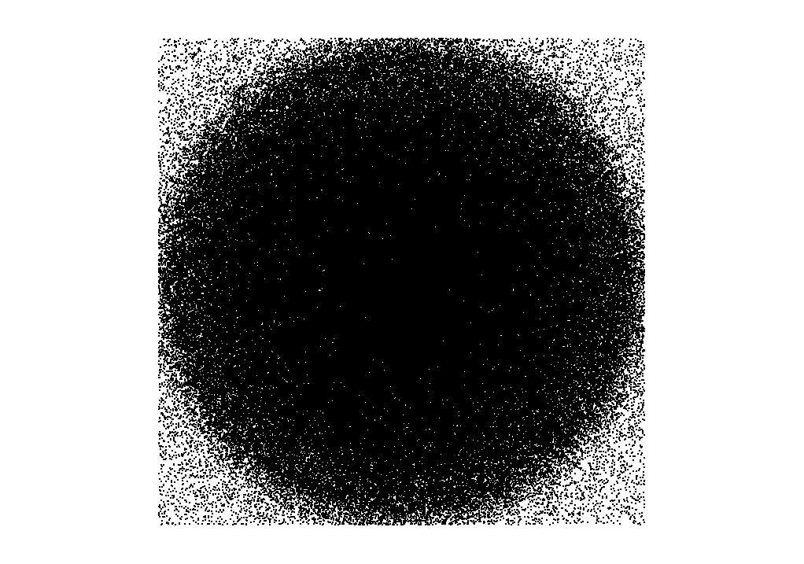

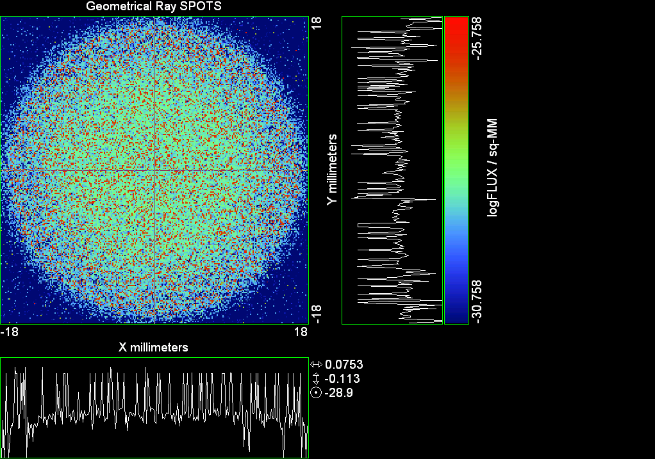

--- ! Spot Plot (Run Ray Trace First)
--- !!CONSIDER ONLY 6 !!Grid Detector=6
--- CONSIDER ONLY 7 !! Earth Detector=7
--- OBLIQUE OFF
--- !!TITLE 'FOV1-9/19^2 mm^2=15503 Rays'
--- !!TITLE 'FOV8 Rect Source Det=2170 total rays'
--- !!TITLE 'FOV8 RctSrc Det=1357-1348=11 rays from Pedestals DetImplBafOnly'
--- !!TITLE 'FOV8 RctSrc Det=750 rays "On"Mrlts Pd&SbS=0 DtImplBfOnly'
--- !!TITLE 'FOV8 RctSrc Det=754 rays "On"Mrlts Pd=1 SbS=0 DtImplBfOnly'
--- !!TITLE 'FOV8 3x3 Pt Src =215 rays "On"Mrlts Pd=1 SbS=0 DtImplBfOnly'
--- TITLE '1.5E6 KM to Source at L1 Distance'
--- !!WINDOW Y X
--- WINDOW Y -18 18 X -18 18
--- !!WINDOW Y 11 14 X -1.5 1.5
--- !!TITLE 'FOV8 23x23 1358-678=680 Rays/.109 mm^2 = 6238 Rays/mm^2 5.5%'
--- !!WINDOW Y 135.75 136.25 X 82.5 83 !!FOV 8
--- !!TITLE 'FOV8 3x3 Core 678 Rays/.006mm^2 = 113000 Rays/mm^2'
--- !!WINDOW Y 136.01 136.07 X 82.75 82.85 !!FOV 8
--- PIXELS 256
--- SPOTS POSITION

Distribution of data within:
Window Vertical: Y = -18.0000 to 18.0000 ( 36.0000 )
Horizontal: X = -18.0000 to 18.0000 ( 36.0000 )

Opening NEW distribution file 9: C:\ASAP Work\TRIANA\bro009.dat
Rays Flux
411154 0.567855E-24
Maximum = 1.7468708E-26 minimum = 0.0000000E+00
--- $IO "ASAPTEMP.INR"
Opening 1 C:\ASAP Work\TRIANA\asaptemp.inr

Closing 7 C:\ASAP Work\TRIANA\bro007.dat
Opening 7 C:\ASAP Work\TRIANA\asaptemp.usr

Closing 20 C:\ASAP Work\TRIANA\bro020.dat
Opening 20 C:\ASAP Work\TRIANA\asaptemp.plr

Closing 30 C:\ASAP Work\TRIANA\bro030.dat
Opening 30 C:\ASAP Work\TRIANA\asaptemp.vcr

--- !! PICTURE (Run Ray Trace and Spots Position First)
--- !! Picks size from Spots Position window size
--- TITLE 'EPIC'
--- CONSIDER ONLY 7 !! Detector = 6 for Grid, 7 for Earth
--- !!WINDOW X -1.5 1.5 Y 11 14
--- WINDOW Y X
--- DISPLAY
Opening OLD distribution file 9: C:\ASAP Work\TRIANA\bro009.dat

File header:
Geometrical Ray SPOTS 1
Z 790.7430 FLUX / sq-MM
X millimeters -18.00000 18.00000 256
Y millimeters -18.00000 18.00000 256

Statistics on 256 by 256 data set:
FLUX / sq-MM Location Y millimeters X millimeters
Minimum 0.000000 1 1 -17.92969 -17.92969
Maximum 0.1746871E-25 79 83 -6.960938 -6.398438
Average 0.4381593E-27 129 129 0.7031250E-01 0.7031250E-01
TOTAL FLUX = 0.5678545E-24

--- AVERAGE 0 0
Statistics on 256 by 256 data set:
FLUX / sq-MM Location Y millimeters X millimeters
Minimum 0.000000 1 1 -17.92969 -17.92969
Maximum 0.1746871E-25 79 83 -6.960938 -6.398438
Average 0.4381593E-27 129 129 0.7031250E-01 0.7031250E-01
TOTAL FLUX = 0.5678545E-24

--- FORM -5
Statistics on 256 by 256 data set:
FLUX / sq-MM Location Y millimeters X millimeters
Minimum -30.75774 1 1 -17.92969 -17.92969
Maximum -25.75774 79 83 -6.960938 -6.398438
Average -29.04583 129 128 0.7031250E-01 -0.7031250E-01
Integral = -37643.39

--- !!CONTOUR .001 .005 .01 .05 .1 .2 .3 .4 .5 .6 .7 .8 .85 .9 .95 GRID 2
--- PICTURE
Opening NEW distribution file 10: C:\ASAP Work\TRIANA\i.dis

Run 08 Centered 0.80 deg 40k rays.xls

Run 9 Offset -0.25 0.08 deg 40k rays

--- END

System database and settings have been reinitialized
--- $IO "ASAPTEMP.INR"
Opening 1 C:\ASAP Work\TRIANA\asaptemp.inr

Closing 7 C:\ASAP Work\TRIANA\bro007.dat
Opening 7 C:\ASAP Work\TRIANA\asaptemp.usr

Closing 20 C:\ASAP Work\TRIANA\bro020.dat
Creating 20 C:\ASAP Work\TRIANA\asaptemp.plr

Closing 30 C:\ASAP Work\TRIANA\bro030.dat
Creating 30 C:\ASAP Work\TRIANA\asaptemp.vcr

--- !! Directed Diffuser Example
--- !! Create a source (Disk or Grid)
--- !! Source hits a diffuser in close proximity to source
--- !! diffuser scatters towards an edge for efficient ray tracing
--- SYSTEM NEW
--- RESET
--- UNITS MILLIMETERS
--- !! Setup for 1500 meter test
--- EDGE (EP=1000) !! Assign edge number to reference later with TOWARDS
--- ELLIPSE Z -200 225 225
--- !! Diffusion Model
--- MODEL
--- LAMBERTIAN 1
Angle Relative TIS Sampling
0.0 1.00 1000 radial

--- RETURN
--- CUTOFF (1.0E-40) 50 !! Default=1.0E-18 1/4pir2=3.5E-26
--- !! Scattering Plate is at L1, Source Disk is 1 meter farther away
--- !! L1 is at 1.5E6 km 1.5E9 m 1.5E12 mm
--- !! Except for scale factor, dimensions are in km
--- SCALE=1E6 !! S=1 for mm; 1E3 m; 1E6 km
--- !! Set source offset in "km" if scale = 1E6. Usually DX or DY only.
--- DX=0*(SCALE)
--- !!DY=0*(SCALE) !! 0=pixel 1024, centered
--- DY=-4718*(SCALE) !! -4718=pixel 512, centered
--- DZ=0*(SCALE)
--- !!SRAD=523.6 !!=0.04 deg diam
--- SRAD=1047.2 !!=0.08 deg diam
--- !!SRAD=2094.4 !!=0.16 deg diam
--- !!SRAD=2618.0 !!=0.20 deg diam
--- !!SRAD=4188.8 !!=0.32 deg diam
--- !!SRAD=6283.2 !!=0.48 deg diam
--- !!SRAD=8508.6 !!=0.65 deg diam
--- !!SRAD=10472.1 !!=0.80 deg diam
--- !! Spherical Earth Radius = 6371 km
--- LEVEL 2 0. !! Suggested by BRO Tech Support
--- SURFACE
--- PLANE Z ((-1.5E6)*(SCALE)) ELLIPSE (SRAD*(SCALE)) (SRAD*(SCALE)) 0 (DX) (DY)
--- OBJECT 'DIFFUSION'
--- INTERFACE 0 1E-12 !! Only allow scatter rays to transmit
--- SCATTER MODEL 1 RANDOM 1 1 !! RANDOM needed to find edge, else low light problems
--- TOWARDS (EP) 1
--- RETURN
--- !! Emitter
--- NRAYS=40000 !! 1000=32 sec 40000=20 minutes 200000
--- EMIT DISK Z ((-1.500001E6)*(SCALE)) (SRAD*(SCALE)) (SRAD*(SCALE)) (NRAYS) 1 1
Total flux in rays created by this emitter is 3.0458655E-04
--- SHIFT (DX) (DY) (DZ)
--- RETURN
--- UNITS MILLIMETERS
--- WAVELENGTHS 0.950000 0.706000 0.587560 0.435000 0.300000 MICRONS
--- MEDIA; 1.45106513 1.45515708 1.45846375 1.46676272 1.48779297 'SILICA'
--- COATING PROPERTIES; 1 0 'WHITE'
--- COATING PROPERTIES; .98 0 'MIRROR'
--- COATING PROPERTIES; .11 .87 'DETECTORQE317'
--- COATING PROPERTIES; .10 .75 'DETECTORQE325'
--- COATING PROPERTIES; .05 0 'BLACK'
--- COATING PROPERTIES; 0 0 'ZERO'
--- COATING PROPERTIES; 0 1 'CLEAR'
--- STRUE=0
--- SX=0
--- SY=0
--- SZ=0
--- SCAT=1
--- ENT OBJECT;MIRROR Z 439.24 159 (1219.2/2) -1 (38.2/159) 'PRIMARY S1'
--- INTERFACE COATING MIRROR AIR AIR
--- ENT OBJECT;TUBE Z 438.5 38.2 38.2 466.53196 38.2 38.2 0.0 0.0 'PRIMARYHOLE'
--- INTERFACE COATING BLACK AIR AIR
--- SCATTER RANDOM 1 (SCAT) 1.57 ABS 1 0
--- ENT OBJECT;PLANE Z 466.5 ELLIPSE 210 210 (38.2/210) 'PRIMARY BACK'
--- INTERFACE COATING BLACK AIR AIR
--- SCATTER RANDOM 1 (SCAT) 1.57 ABS 1 0
--- ENT OBJECT;TUBE Z 429 159 159 466.5 159 159 0.0 0.0 'PRIMARYEDGE'
--- INTERFACE COATING BLACK AIR AIR
--- SCATTER RANDOM 1 (SCAT) 1.57 ABS 1 0
--- ENT OBJECT;MIRROR Z 0.0 46 (434.7/2) -2.40763 0.0 'SECONDARY S2'
--- INTERFACE COATING MIRROR AIR AIR
--- ENT OBJECT;PLANE Z 790.7429896 RECTANGLE 18 18 0 'DETECTOR'
--- INTERFACE COATING ZERO SILICA AIR
--- ENT OBJECT;PLANE Z 790.7 RECTANGLE 18 18 0 'DETECTOR-COVER'
--- INTERFACE COATING DETECTORQE317 SILICA AIR
*** SPLIT automatically set to 1
--- ENT OBJECT;PLANE Z -55.69204 ELLIPSE 210 210 (154.8315449/210) 'SPIDER'
--- INTERFACE COATING BLACK AIR AIR
--- SCATTER RANDOM 1 (SCAT) 1.57 ABS 1 0
--- ENT OBJECT;TUBE Z -55.69204 154.8315449 154.8315449 -30.29204 154.8315449 154.8315449 0.0 0.0 'SPIDERCYL'
--- INTERFACE COATING BLACK AIR AIR
--- SCATTER RANDOM 1 (SCAT) 1.57 ABS 1 0
--- ENT OBJECT;TUBE X 0 0.75 12.52 -170 0.75 15.52 1 1 'SPIDERARMX'
--- SHIFT 0 -52.578 -42.992
--- INTERFACE COATING BLACK AIR AIR
--- SCATTER RANDOM 1 (SCAT) 1.57 ABS 1 0
--- ENT OBJECT;TUBE X 0 5 12.52 -170 5 15.52 1 1 'SPIDERARMX1'
--- SHIFT 0 -52.578 -42.992
--- ROTATE Z -120 0 0
--- INTERFACE COATING BLACK AIR AIR
--- SCATTER RANDOM 1 (SCAT) 1.57 ABS 1 0
--- ENT OBJECT;TUBE X 0 0.75 12.52 -170 0.75 15.52 1 1 'SPIDERARMX2'
--- SHIFT 0 -52.578 -42.992
--- ROTATE Z -240 0 0
--- INTERFACE COATING BLACK AIR AIR
--- SCATTER RANDOM 1 (SCAT) 1.57 ABS 1 0
--- ENT OBJECT;TUBE Z -185.6 200.8 200.8 528 200.8 200.8 0.0 0.0 'BARRELBAFFLE'
--- INTERFACE COATING BLACK AIR AIR
--- SCATTER RANDOM 1 (SCAT) 1.57 ABS 1 0
--- ENT OBJECT;ELLIPSE Z -200 205 205 64 0.0 360.0 'ENTRANCE'
Default ELLIP/ROUND/OVAL segments changed to 64
--- INTERFACE COATING CLEAR AIR AIR
--- ENT OBJECT;TUBE Z (2.391*25.4) (2.546*25.4) (2.546*25.4) (2.164*25.4) (2.546*25.4) (2.546*25.4) 0.0 0.0 'SECONDARYHOUSING'
--- INTERFACE COATING BLACK AIR AIR
--- SCATTER RANDOM 1 (SCAT) 1.57 ABS 1 0
--- ENT OBJECT;TUBE Z (2.164*25.4) (2.546*25.4) (2.546*25.4) 0 (2*25.4) (2*25.4) 0.0 0.0 'SH-CONE'
--- INTERFACE COATING BLACK AIR AIR
--- SCATTER RANDOM 1 (SCAT) 1.57 ABS 1 0
--- ENT OBJECT;PLANE Z 0.0 ELLIPSE (2.45*25.4) (2.45*25.4) (2.00/2.45) 'SH-CONEBASE'
--- INTERFACE COATING BLACK AIR AIR
--- SCATTER RANDOM 1 (SCAT) 1.57 ABS 1 0
--- ENT OBJECT;TUBE Z 0.0 (2.125*25.4) (2.125*25.4) (-6.875*25.4) (2.125*25.4) (2.125*25.4) 0.0 0.0 'SH-CYLINDER'
--- INTERFACE COATING BLACK AIR AIR
--- SCATTER RANDOM 1 (SCAT) 1.57 ABS 1 0
--- ENT OBJECT;PLANE Z (-6.875*25.4) ELLIPSE (2.33*25.4) 'SH-TOP'
--- INTERFACE COATING BLACK AIR AIR
--- SCATTER RANDOM 1 (SCAT) 1.57 ABS 1 0
--- ENT OBJECT;PLANE Z (-1.9*25.4) ELLIPSE (2.546*25.4) 'SH-MIDVANE'
--- INTERFACE COATING BLACK AIR AIR
--- SCATTER RANDOM 1 (SCAT) 1.57 ABS 1 0
--- ENT OBJECT;TUBE Z 226.38766 37.465 37.465 422.98366 37.465 37.465 0.0 0.0 'CBAF-FRONT'
--- INTERFACE COATING BLACK AIR AIR
--- SCATTER RANDOM 1 (SCAT) 1.57 ABS 1 0
--- ENT OBJECT;PLANE Z 422.98366 ELLIPSE 37.485 37.485 (30.5562/37.485) 'CBAF-LEDGE'
--- INTERFACE COATING BLACK AIR AIR
--- SCATTER RANDOM 1 (SCAT) 1.57 ABS 1 0
--- ENT OBJECT;TUBE Z 422.985 32.2072 32.2072 532.45766 32.2072 32.2072 0.0 0.0 'CBAF-AFT'
--- INTERFACE COATING BLACK AIR AIR
--- SCATTER RANDOM 1 (SCAT) 1.57 ABS 1 0
--- ENT OBJECT;PLANE Z 327.98766 ELLIPSE 37.485 37.485 (35.56/37.485) 'CBAF-VANE1'
--- INTERFACE COATING BLACK AIR AIR
--- SCATTER RANDOM 1 (SCAT) 1.57 ABS 1 0
--- ENT OBJECT;PLANE Z 378.78766 ELLIPSE 37.485 37.485 (35.56/37.485) 'CBAF-VANE2'
--- INTERFACE COATING BLACK AIR AIR
--- SCATTER RANDOM 1 (SCAT) 1.57 ABS 1 0
--- ENT OBJECT;PLANE Z 505.53366 ELLIPSE 32.24 32.24 (28.6512/32.24) 'CBAF-VANE3'
--- INTERFACE COATING BLACK AIR AIR
--- SCATTER RANDOM 1 (SCAT) 1.57 ABS 1 0
--- RETURN
--- !! Geometry is being appended to system.
--- !! To not view this message, refer to ASAP preferences dialog,
--- !! or change the Options->Append Geometry menu item.
--- UNITS MILLIMETERS
--- WAVELENGTHS 0.950000 0.706000 0.587560 0.435000 0.300000 MICRONS
--- MEDIA; 1.45106513 1.45515708 1.45846375 1.46676272 1.48779297 'SILICA'
--- COATING PROPERTIES; .98 0 'MIRROR'
--- COATING PROPERTIES; .05 0 'BLACK'
--- COATING PROPERTIES; 0 0 'ZERO'
--- COATING PROPERTIES; 0 1 'CLEAR'
--- COATING PROPERTIES; .05 .95 'ARF05'
--- COATING PROPERTIES; 0.2 0.8 'ARF20'
--- ENT OBJECT;PLANE Z 615.3400000 ELLIPSE 150 150 (22/150) 'LENS MOUNT'
--- INTERFACE COATING BLACK AIR AIR
--- SCATTER RANDOM 1 (SCAT) 1.57 ABS 1 0
--- ENT OBJECT;TUBE Z 558.61966 26.7 26.7 620 26.7 26.7 0.0 0.0 'LENS TUBE-FRONT'
--- INTERFACE COATING BLACK AIR AIR
--- SCATTER RANDOM 1 (SCAT) 1.57 ABS 1 0
--- ENT OBJECT;PLANE Z 558.61966 ELLIPSE 27.7 27.7 (24.945/27.7) 'LT-FACE'
--- INTERFACE COATING BLACK AIR AIR
--- SCATTER RANDOM 1 (SCAT) 1.57 ABS 1 0
--- ENT OBJECT;PLANE Z 616.4326 ELLIPSE 27.7 27.7 (21.5/27.7) 'LT-LENS 1FACE'
--- INTERFACE COATING BLACK AIR AIR
--- SCATTER RANDOM 1 (SCAT) 1.57 ABS 1 0
--- ENT OBJECT;TUBE Z 621 25.152 25.152 657.7965 25.152 25.152 0.0 0.0 'LENS TUBE AFT'
--- INTERFACE COATING BLACK AIR AIR
--- SCATTER RANDOM 1 (SCAT) 1.57 ABS 1 0
--- ENT OBJECT;PLANE Z 657.7965 ELLIPSE 25.152 25.152 (21.26386619/25.152) 'LT-AFT FACE'
--- INTERFACE COATING BLACK AIR AIR
--- SCATTER RANDOM 1 (SCAT) 1.57 ABS 1 0
--- ENT OBJECT;OPTICAL Z 615.3400000 221.803 0 ELLIPSE 22 'LENS1F'
--- INTERFACE COATING ARF05 AIR SILICA
--- ENT OBJECT;OPTICAL Z 620.3400000 584.5 0 ELLIPSE 22 'LENS1B'
--- INTERFACE COATING ARF05 AIR SILICA
--- ENT OBJECT;OPTICAL Z 627.63 -147.027 0 ELLIPSE 22 'LENS2F'
--- INTERFACE COATING ARF05 AIR SILICA
--- ENT OBJECT;OPTICAL Z 632.63 -135.158 0 ELLIPSE 22 'LENS2B'
--- INTERFACE COATING ARF05 AIR SILICA
--- ENT OBJECT;OPTICAL Z 635.6 97.002 0 ELLIPSE 22 'LENS3F'
--- INTERFACE COATING ARF05 AIR SILICA
--- ENT OBJECT;OPTICAL Z 640.6 67.147 0 ELLIPSE 22 'LENS3B'
--- INTERFACE COATING ARF05 AIR SILICA
--- ENT OBJECT;TUBE Z 614 22 22 645 22 22 0.0 0.0 'LENSHOLDER'
--- INTERFACE COATING ZERO AIR AIR
--- SCATTER RANDOM 1 (SCAT) 1.57 ABS 1 0
--- ENT OBJECT;PLANE Z 660.84196 ELLIPSE 150 150 (25.28148817/150) 'FW-HOUSING FRONT'
--- INTERFACE COATING BLACK AIR AIR
--- SCATTER RANDOM 1 (SCAT) 1.57 ABS 1 0
--- ENT OBJECT;PLANE Z 709.10196 ELLIPSE 150 150 (25.28148817/150) 'FW-HOUSING AFT'
--- INTERFACE COATING BLACK AIR AIR
--- SCATTER RANDOM 1 (SCAT) 1.57 ABS 1 0
--- ENT OBJECT;TUBE Z (673.54196-.3) 27.5 27.5 (680.04436+.3) 27.5 27.5 0.0 0.0 'FILTERHOLDER'
--- INTERFACE COATING BLACK AIR AIR
--- SCATTER RANDOM 1 (SCAT) 1.57 ABS 1 0
--- ENT OBJECT;PLANE Z 675 ELLIPSE 150 150 (27.5/150) 'FILTER-WHEEL'
--- INTERFACE COATING BLACK AIR AIR
--- SCATTER RANDOM 1 (SCAT) 1.57 ABS 1 0
--- ENT OBJECT;TUBE Z 721.59876 19.16979665 19.16979665 723.53932 22.558 22.558 0.0 0.0 'EXIT CONE FRONT'
--- INTERFACE COATING BLACK AIR AIR
--- SCATTER RANDOM 1 (SCAT) 1.57 ABS 1 0
--- ENT OBJECT;TUBE Z 723.53932 22.558 22.558 781.84248 22.558 22.558 0.0 0.0 'EC-CYLINDER'
--- INTERFACE COATING BLACK AIR AIR
--- SCATTER RANDOM 1 (SCAT) 1.57 ABS 1 0
--- ENT OBJECT;PLANE Z 781.84248 ELLIPSE 22.558 22.558 (16.89/22.558) 'EC-SHELF'
--- INTERFACE COATING BLACK AIR AIR
--- SCATTER RANDOM 1 (SCAT) 1.57 ABS 1 0
--- ENT OBJECT;TUBE Z 781.84248 16.89 16.89 783.87448 20.41280351 20.41280351 0.0 0.0 'EC-EXITCONE'
--- INTERFACE COATING BLACK AIR AIR
--- SCATTER RANDOM 1 (SCAT) 1.57 ABS 1 0
--- ENT OBJECT;PLANE Z 783.87448 ELLIPSE 50 50 (20.41280351/50) 'EC-EXIT'
--- INTERFACE COATING BLACK AIR AIR
--- SCATTER RANDOM 1 (SCAT) 1.57 ABS 1 0
--- RETURN
--- $IO "ASAPTEMP.INR"
Opening 1 C:\ASAP Work\TRIANA\asaptemp.inr

Closing 7 C:\ASAP Work\TRIANA\bro007.dat
Opening 7 C:\ASAP Work\TRIANA\asaptemp.usr

Closing 20 C:\ASAP Work\TRIANA\bro020.dat
Creating 20 C:\ASAP Work\TRIANA\asaptemp.plr

Closing 30 C:\ASAP Work\TRIANA\bro030.dat
Creating 30 C:\ASAP Work\TRIANA\asaptemp.vcr

--- !! Filters-2 from .ent/copy/.inr to allow ABSORBing media
--- UNITS MILLIMETERS
--- WAVELENGTHS 0.950000 0.706000 0.587560 0.435000 0.300000 MICRONS
--- MEDIA; 1.45106513 1.45515708 1.45846375 1.46676272 1.48779297 'SILICA'
--- !!COATING PROPERTIES; .98 0 'MIRROR'
--- !!COATING PROPERTIES; .05 0 'BLACK'
--- !!COATING PROPERTIES; 0 0 'ZERO'
--- !!COATING PROPERTIES; 0 1 'CLEAR'
--- COATING PROPERTIES; .0745 .9255 'ARF0745'
--- COATING PROPERTIES; .0525 .9475 'ARF0525'
--- COATING PROPERTIES; .05 .95 'ARF05'
--- COATING PROPERTIES; .005 .995 'ARF005'
--- !!COATING PROPERTIES; 0.2 0.8 'ARF20'
--- !!!!!!!!!!!!!!!!!!!!!!!!!!!!!!!!!!!!!!!!!!!!!!!!!!
--- WAVELENGTH 0.317 MICRONS
--- MEDIA
--- 1.48342884 ABSORB 0.13168 'BLOCKER317'
--- MEDIA
--- 1.48342884 ABSORB 0.00307 'ETALON317'
--- !!!!!!!!!!!!!!!!!!!!!!!!!!!!!!!!!!!!!!!!!!!!!!!!!!
--- !!WAVELENGTH 0.325 MICRONS
--- !!MEDIA
--- !! 1.48163777 ABSORB 0.08074 'BLOCKER325'
--- !!MEDIA
--- !! 1.48163777 ABSORB 0.0415179525 'ETALON325'
--- !!!!!!!!!!!!!!!!!!!!!!!!!!!!!!!!!!!!!!!!!!!!!!!!!!!!!
--- ENT OBJECT;PLANE Z 673.54196 ELLIPSE 27.5 'FILTERUVE-F'
--- INTERFACE COATING ARF0525 AIR ETALON317
--- !! INTERFACE COATING ARF0745 AIR ETALON325
--- ENT OBJECT;PLANE Z 676.71696 ELLIPSE 27.5 'FILTERUVE-B'
--- INTERFACE COATING ARF0525 AIR ETALON317
--- !! INTERFACE COATING ARF0745 AIR ETALON325
--- ENT OBJECT;PLANE Z 676.86936 ELLIPSE 27.5 'FILTERUVB-F'
--- INTERFACE COATING ARF005 AIR BLOCKER317
--- !! INTERFACE COATING ARF005 AIR BLOCKER325
--- ENT OBJECT;PLANE Z 680.04436 ELLIPSE 27.5 'FILTERUVB-B'
--- INTERFACE COATING ARF005 AIR BLOCKER317
--- !! INTERFACE COATING ARF005 AIR BLOCKER325
--- !!RETURN

--- TITLE DCE *Raytrace
--- !! WAVELENGTHS 0.317 MICRONS !! Normally set in filters
--- !!SPLIT 0 !! Direct Trace Only
--- !!SPLIT 1 !! For Rect Sources
--- SPLIT 2 !! For double reflection in lens & filters
--- PLOT FACETS 5 5
Window Vertical: Y = -.576521E+10 to 210.000 (0.576521E+10)
Horizontal: Z = -.150002E+13 to 791.121 (0.150002E+13)

--- CONSIDER ALL
--- !!CONSIDER ONLY 15
--- ARROWS OFF
--- SEGMENTS 9
--- WINDOW Y Z
--- OBLIQUE 0 0
--- MISSED LINE 50
--- TRACE PLOT 1000 OVERLAY
Window Vertical: Y = -.576521E+10 to 210.000 (0.576521E+10)
Horizontal: Z = -.150002E+13 to 791.121 (0.150002E+13)

Warning *** Convergence failure in root polishing .1694437E-04
61 *** Convergence failure in root polishing .1135736E-04
24.66 seconds ( 14.09 seconds CPU) to trace 80,000
out of 214,737
Warning *** Convergence failure in root polishing .1300005E-04
55 *** Convergence failure in root polishing .3235211E-04
65.13 seconds ( 48.39 seconds CPU) to trace 160,000
out of 599,753
115.20 seconds ( 96.78 seconds CPU) to trace 240,000
out of 1,179,523
2.75 minutes ( 2.39 minutes CPU) to trace 320,000
out of 1,706,107
3.33 minutes ( 2.94 minutes CPU) to trace 400,000
out of 1,830,671
3.92 minutes ( 3.49 minutes CPU) to trace 480,000
out of 1,954,811
4.49 minutes ( 4.03 minutes CPU) to trace 560,000
out of 2,077,287
5.07 minutes ( 4.58 minutes CPU) to trace 640,000
out of 2,200,458
5.64 minutes ( 5.13 minutes CPU) to trace 720,000
out of 2,324,223
6.23 minutes ( 5.68 minutes CPU) to trace 800,000
out of 2,446,932
6.81 minutes ( 6.23 minutes CPU) to trace 880,000
out of 2,571,632
7.39 minutes ( 6.77 minutes CPU) to trace 960,000
out of 2,693,787
7.97 minutes ( 7.33 minutes CPU) to trace 1,040,000
out of 2,816,556
8.56 minutes ( 7.87 minutes CPU) to trace 1,120,000
out of 2,939,127
9.14 minutes ( 8.42 minutes CPU) to trace 1,200,000
out of 3,063,147
9.75 minutes ( 8.97 minutes CPU) to trace 1,280,000
out of 3,185,957
10.33 minutes ( 9.53 minutes CPU) to trace 1,360,000
out of 3,310,188
10.91 minutes ( 10.07 minutes CPU) to trace 1,440,000
out of 3,433,120
11.51 minutes ( 10.62 minutes CPU) to trace 1,520,000
out of 3,558,591
12.10 minutes ( 11.18 minutes CPU) to trace 1,600,000
out of 3,682,761
12.67 minutes ( 11.72 minutes CPU) to trace 1,680,000
out of 3,805,544
12.94 minutes ( 11.98 minutes CPU) to trace 1,760,000
out of 3,821,752
13.31 minutes ( 12.18 minutes CPU) to trace 1,840,000
13.64 minutes ( 12.39 minutes CPU) to trace 1,920,000
13.87 minutes ( 12.60 minutes CPU) to trace 2,000,000
14.10 minutes ( 12.80 minutes CPU) to trace 2,080,000
14.32 minutes ( 13.01 minutes CPU) to trace 2,160,000
14.55 minutes ( 13.22 minutes CPU) to trace 2,240,000
14.77 minutes ( 13.42 minutes CPU) to trace 2,320,000
15.00 minutes ( 13.63 minutes CPU) to trace 2,400,000
15.23 minutes ( 13.83 minutes CPU) to trace 2,480,000
15.45 minutes ( 14.04 minutes CPU) to trace 2,560,000
15.67 minutes ( 14.25 minutes CPU) to trace 2,640,000
15.90 minutes ( 14.45 minutes CPU) to trace 2,720,000
16.12 minutes ( 14.66 minutes CPU) to trace 2,800,000
16.34 minutes ( 14.87 minutes CPU) to trace 2,880,000
16.57 minutes ( 15.07 minutes CPU) to trace 2,960,000
16.80 minutes ( 15.28 minutes CPU) to trace 3,040,000
17.03 minutes ( 15.48 minutes CPU) to trace 3,120,000
17.25 minutes ( 15.69 minutes CPU) to trace 3,200,000
17.48 minutes ( 15.90 minutes CPU) to trace 3,280,000
17.71 minutes ( 16.11 minutes CPU) to trace 3,360,000
17.96 minutes ( 16.32 minutes CPU) to trace 3,440,000
18.18 minutes ( 16.53 minutes CPU) to trace 3,520,000
18.42 minutes ( 16.74 minutes CPU) to trace 3,600,000
18.64 minutes ( 16.94 minutes CPU) to trace 3,680,000
18.86 minutes ( 17.15 minutes CPU) to trace 3,760,000
19.04 minutes ( 17.31 minutes CPU) to trace 3,821,752

Total of 3154730 PARENT warnings
Missed Multiple Wrong Low Evanescent Wrong Absorbed
Obj Total After Bounce Side Flux (TIR) Direc After
1 98180 51081 1 47098 DIFFUSION
2 1830 28 1265 537 PRIMARY S1
3 2091 249 10 1832 PRIMARYHOLE
4 97112 35675 458 60979 PRIMARY BACK
5 22279 98 22181 PRIMARYEDGE
6 1703 1054 649 SECONDARY S2
7 665 665 DETECTOR
8 3494 72 1976 1446 DETECTOR-COVER
9 37960 3692 334 33934 SPIDER
10 12967 132 111 12724 SPIDERCYL
11 4156 70 60 4026 SPIDERARMX
12 7447 99 56 7292 SPIDERARMX1
13 4065 87 34 3944 SPIDERARMX2
14 297864 5710 2229 289925 BARRELBAFFLE
15 305264 303509 1755 ENTRANCE
16 6474 7 42 6425 SECONDARYHOUSING
17 54391 380 354 53657 SH-CONE
18 13573 16 107 13450 SH-CONEBASE
19 86700 1469 852 84379 SH-CYLINDER
20 823 19 44 760 SH-TOP
21 79366 8 575 78783 SH-MIDVANE
22 263681 949 1736 260996 CBAF-FRONT
23 16972 94 16878 CBAF-LEDGE
24 180123 41413 836 137874 CBAF-AFT
25 7612 6 63 7543 CBAF-VANE1
26 8137 2 56 8079 CBAF-VANE2
27 12261 1323 155 10783 CBAF-VANE3
28 72969 32172 168 40629 LENS MOUNT
29 69702 3834 640 65228 LENS TUBE-FRONT
30 6910 250 72 6588 LT-FACE
31 2696 30 49 2617 LT-LENS 1FACE
32 17671 257 228 17186 LENS TUBE AFT
33 7038 28 180 6830 LT-AFT FACE
34 5930 1036 1165 3729 LENS1F
35 7679 862 2436 4381 LENS1B
36 8524 1043 3805 3676 LENS2F
37 7681 2234 3008 2439 LENS2B
38 11056 1544 5490 4022 LENS3F
39 13860 2182 5185 6493 LENS3B
40 471 143 328 LENSHOLDER
41 56988 12563 320 44105 FW-HOUSING FRONT
42 629094 472594 1488 155012 FW-HOUSING AFT
43 3654 1254 83 2229 88 FILTERHOLDER
44 221687 83239 1312 137136 FILTER-WHEEL
45 30936 10692 399 19845 EXIT CONE FRONT
46 247382 37947 2870 206565 EC-CYLINDER
47 27990 4 732 27254 EC-SHELF
48 5195 3928 11 1256 EC-EXITCONE
49 25721 17653 232 7836 EC-EXIT
50 8051 56 2189 3773 1051 982 FILTERUVE-F
51 14475 1463 12143 864 5 FILTERUVE-B
52 7211 2555 2043 910 1703 FILTERUVB-F
53 16969 13492 1495 36 917 1029 FILTERUVB-B

Total of 120427 CHILD warnings
Missed Multiple Wrong Low Evanescent Wrong Absorbed
Obj Total After Bounce Side Flux (TIR) Direc After
8 4478 4478 DETECTOR-COVER
34 9689 9689 LENS1F
35 10428 10428 LENS1B
36 11967 11967 LENS2F
37 11879 11879 LENS2B
38 11714 11714 LENS3F
39 11626 11626 LENS3B
50 11349 11349 FILTERUVE-F
51 11368 11368 FILTERUVE-B
52 12929 12929 FILTERUVB-F
53 13000 13000 FILTERUVB-B
23431972 ray-objects encountered at 22562 per CPU second
247744511 order-intersections done at 238554 per CPU second

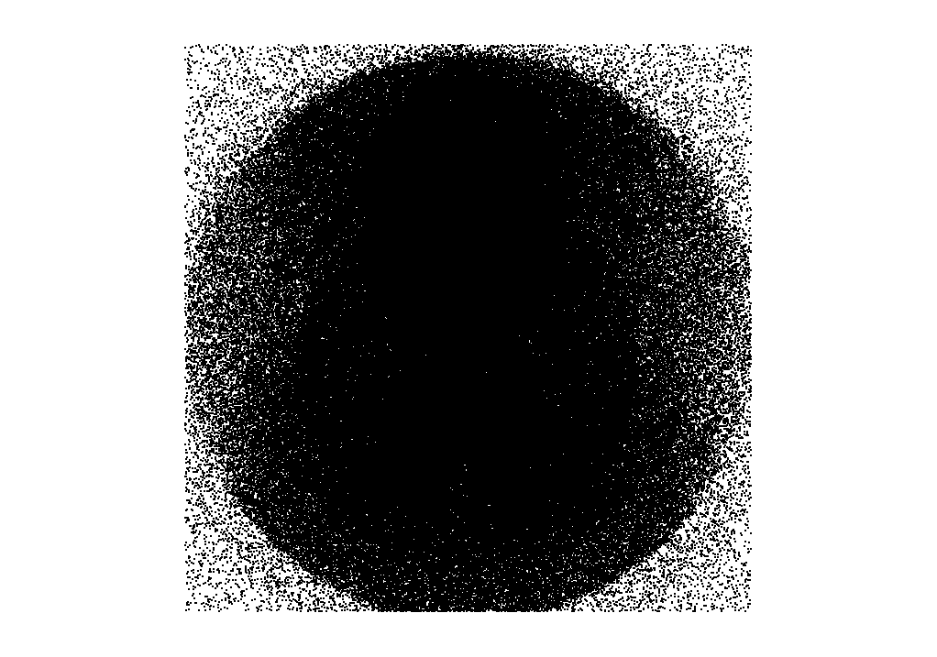

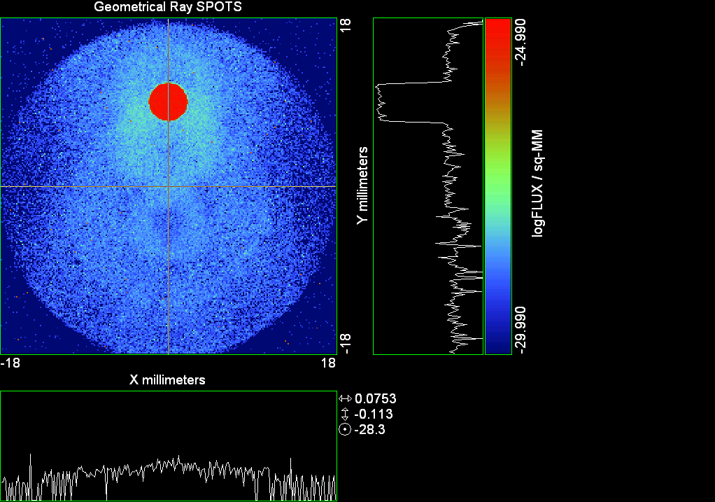

--- ! Spot Plot (Run Ray Trace First)
--- !!CONSIDER ONLY 6 !!Grid Detector=6
--- CONSIDER ONLY 7 !! Earth Detector=7
--- OBLIQUE OFF
--- !!TITLE 'FOV1-9/19^2 mm^2=15503 Rays'
--- !!TITLE 'FOV8 Rect Source Det=2170 total rays'
--- !!TITLE 'FOV8 RctSrc Det=1357-1348=11 rays from Pedestals DetImplBafOnly'
--- !!TITLE 'FOV8 RctSrc Det=750 rays "On"Mrlts Pd&SbS=0 DtImplBfOnly'
--- !!TITLE 'FOV8 RctSrc Det=754 rays "On"Mrlts Pd=1 SbS=0 DtImplBfOnly'
--- !!TITLE 'FOV8 3x3 Pt Src =215 rays "On"Mrlts Pd=1 SbS=0 DtImplBfOnly'
--- TITLE '1.5E6 KM to Source at L1 Distance'
--- !!WINDOW Y X
--- WINDOW Y -18 18 X -18 18
--- !!WINDOW Y 11 14 X -1.5 1.5
--- !!TITLE 'FOV8 23x23 1358-678=680 Rays/.109 mm^2 = 6238 Rays/mm^2 5.5%'
--- !!WINDOW Y 135.75 136.25 X 82.5 83 !!FOV 8
--- !!TITLE 'FOV8 3x3 Core 678 Rays/.006mm^2 = 113000 Rays/mm^2'
--- !!WINDOW Y 136.01 136.07 X 82.75 82.85 !!FOV 8
--- PIXELS 256
--- SPOTS POSITION

Distribution of data within:
Window Vertical: Y = -18.0000 to 18.0000 ( 36.0000 )
Horizontal: X = -18.0000 to 18.0000 ( 36.0000 )

Opening NEW distribution file 9: C:\ASAP Work\TRIANA\bro009.dat
Rays Flux
513110 0.783950E-24
Maximum = 1.0240684E-25 minimum = 0.0000000E+00
--- $IO "ASAPTEMP.INR"
Opening 1 C:\ASAP Work\TRIANA\asaptemp.inr

Closing 7 C:\ASAP Work\TRIANA\bro007.dat
Opening 7 C:\ASAP Work\TRIANA\asaptemp.usr

Closing 20 C:\ASAP Work\TRIANA\bro020.dat
Opening 20 C:\ASAP Work\TRIANA\asaptemp.plr

Closing 30 C:\ASAP Work\TRIANA\bro030.dat
Opening 30 C:\ASAP Work\TRIANA\asaptemp.vcr

--- !! PICTURE (Run Ray Trace and Spots Position First)
--- !! Picks size from Spots Position window size
--- TITLE 'EPIC'
--- CONSIDER ONLY 7 !! Detector = 6 for Grid, 7 for Earth
--- !!WINDOW X -1.5 1.5 Y 11 14
--- WINDOW Y X
--- DISPLAY
Opening OLD distribution file 9: C:\ASAP Work\TRIANA\bro009.dat

File header:
Geometrical Ray SPOTS 1
Z 790.7430 FLUX / sq-MM
X millimeters -18.00000 18.00000 256
Y millimeters -18.00000 18.00000 256

Statistics on 256 by 256 data set:
FLUX / sq-MM Location Y millimeters X millimeters
Minimum 0.000000 2 1 -17.78906 -17.92969
Maximum 0.1024068E-24 188 139 8.367188 1.476562
Average 0.6048994E-27 190 128 8.648438 -0.7031250E-01
TOTAL FLUX = 0.7839496E-24

--- AVERAGE 0 0
Statistics on 256 by 256 data set:
FLUX / sq-MM Location Y millimeters X millimeters
Minimum 0.000000 2 1 -17.78906 -17.92969
Maximum 0.1024068E-24 188 139 8.367188 1.476562
Average 0.6048994E-27 190 128 8.648438 -0.7031250E-01
TOTAL FLUX = 0.7839496E-24

--- FORM -5
Statistics on 256 by 256 data set:
FLUX / sq-MM Location Y millimeters X millimeters
Minimum -29.98967 1 1 -17.92969 -17.92969
Maximum -24.98967 188 139 8.367188 1.476562
Average -29.08137 133 128 0.6328125 -0.7031250E-01
Integral = -37689.45

--- !!CONTOUR .001 .005 .01 .05 .1 .2 .3 .4 .5 .6 .7 .8 .85 .9 .95 GRID 2
--- PICTURE
Opening NEW distribution file 10: C:\ASAP Work\TRIANA\i.dis
--- $IO "ASAPTEMP.INR"
Opening 1 C:\ASAP Work\TRIANA\asaptemp.inr

Closing 7 C:\ASAP Work\TRIANA\bro007.dat
Opening 7 C:\ASAP Work\TRIANA\asaptemp.usr

Closing 20 C:\ASAP Work\TRIANA\bro020.dat
Creating 20 C:\ASAP Work\TRIANA\asaptemp.plr

Closing 30 C:\ASAP Work\TRIANA\bro030.dat
Creating 30 C:\ASAP Work\TRIANA\asaptemp.vcr

--- DISPLAY
Opening OLD distribution file 9: C:\ASAP Work\TRIANA\bro009.dat

File header:
Geometrical Ray SPOTS 1
Z 790.7430 FLUX / sq-MM
X millimeters -18.00000 18.00000 256
Y millimeters -18.00000 18.00000 256

Statistics on 256 by 256 data set:
FLUX / sq-MM Location Y millimeters X millimeters
Minimum 0.000000 2 1 -17.78906 -17.92969
Maximum 0.1024068E-24 188 139 8.367188 1.476562
Average 0.6048994E-27 190 128 8.648438 -0.7031250E-01
TOTAL FLUX = 0.7839496E-24

--- TEXTFILE X_Text_Output !!Names Text File, overwrites without warning
--- DATA 'E12.5' !! Format with single blank space
--- EOF

Run 09 Offset 0.25 0.08 deg 40k rays.xls

Run 10 Offset 0.75 0.08 deg 40k rays

--- END

System database and settings have been reinitialized
--- $IO "ASAPTEMP.INR"
Opening 1 C:\ASAP Work\TRIANA\asaptemp.inr

Closing 7 C:\ASAP Work\TRIANA\bro007.dat
Opening 7 C:\ASAP Work\TRIANA\asaptemp.usr

Closing 20 C:\ASAP Work\TRIANA\bro020.dat
Creating 20 C:\ASAP Work\TRIANA\asaptemp.plr

Closing 30 C:\ASAP Work\TRIANA\bro030.dat
Creating 30 C:\ASAP Work\TRIANA\asaptemp.vcr

--- !! Directed Diffuser Example
--- !! Create a source (Disk or Grid)
--- !! Source hits a diffuser in close proximity to source
--- !! diffuser scatters towards an edge for efficient ray tracing
--- SYSTEM NEW
--- RESET
--- UNITS MILLIMETERS
--- !! Setup for 1500 meter test
--- EDGE (EP=1000) !! Assign edge number to reference later with TOWARDS
--- ELLIPSE Z -200 225 225
--- !! Diffusion Model
--- MODEL
--- LAMBERTIAN 1
Angle Relative TIS Sampling
0.0 1.00 1000 radial

--- RETURN
--- CUTOFF (1.0E-40) 50 !! Default=1.0E-18 1/4pir2=3.5E-26
--- !! Scattering Plate is at L1, Source Disk is 1 meter farther away
--- !! L1 is at 1.5E6 km 1.5E9 m 1.5E12 mm
--- !! Except for scale factor, dimensions are in km
--- SCALE=1E6 !! S=1 for mm; 1E3 m; 1E6 km
--- !! Set source offset in "km" if scale = 1E6. Usually DX or DY only.
--- DX=0*(SCALE)
--- !!DY=0*(SCALE) !! 0=pixel 1024, centered
--- DY=4718*(SCALE) !! -4718=pixel 512, +4718=pixel 1536,centered
--- DZ=0*(SCALE)
--- !!SRAD=523.6 !!=0.04 deg diam
--- SRAD=1047.2 !!=0.08 deg diam
--- !!SRAD=2094.4 !!=0.16 deg diam
--- !!SRAD=2618.0 !!=0.20 deg diam
--- !!SRAD=4188.8 !!=0.32 deg diam
--- !!SRAD=6283.2 !!=0.48 deg diam
--- !!SRAD=8508.6 !!=0.65 deg diam
--- !!SRAD=10472.1 !!=0.80 deg diam
--- !! Spherical Earth Radius = 6371 km
--- LEVEL 2 0. !! Suggested by BRO Tech Support
--- SURFACE
--- PLANE Z ((-1.5E6)*(SCALE)) ELLIPSE (SRAD*(SCALE)) (SRAD*(SCALE)) 0 (DX) (DY)
--- OBJECT 'DIFFUSION'
--- INTERFACE 0 1E-12 !! Only allow scatter rays to transmit
--- SCATTER MODEL 1 RANDOM 1 1 !! RANDOM needed to find edge, else low light problems
--- TOWARDS (EP) 1
--- RETURN
--- !! Emitter
--- NRAYS=40000 !! 1000=32 sec 40000=20 minutes 200000
--- EMIT DISK Z ((-1.500001E6)*(SCALE)) (SRAD*(SCALE)) (SRAD*(SCALE)) (NRAYS) 1 1
Total flux in rays created by this emitter is 3.0458655E-04
--- SHIFT (DX) (DY) (DZ)
--- RETURN
--- UNITS MILLIMETERS
--- WAVELENGTHS 0.950000 0.706000 0.587560 0.435000 0.300000 MICRONS
--- MEDIA; 1.45106513 1.45515708 1.45846375 1.46676272 1.48779297 'SILICA'
--- COATING PROPERTIES; 1 0 'WHITE'
--- COATING PROPERTIES; .98 0 'MIRROR'
--- COATING PROPERTIES; .11 .87 'DETECTORQE317'
--- COATING PROPERTIES; .10 .75 'DETECTORQE325'
--- COATING PROPERTIES; .05 0 'BLACK'
--- COATING PROPERTIES; 0 0 'ZERO'
--- COATING PROPERTIES; 0 1 'CLEAR'
--- STRUE=0
--- SX=0
--- SY=0
--- SZ=0
--- SCAT=1
--- ENT OBJECT;MIRROR Z 439.24 159 (1219.2/2) -1 (38.2/159) 'PRIMARY S1'
--- INTERFACE COATING MIRROR AIR AIR
--- ENT OBJECT;TUBE Z 438.5 38.2 38.2 466.53196 38.2 38.2 0.0 0.0 'PRIMARYHOLE'
--- INTERFACE COATING BLACK AIR AIR
--- SCATTER RANDOM 1 (SCAT) 1.57 ABS 1 0
--- ENT OBJECT;PLANE Z 466.5 ELLIPSE 210 210 (38.2/210) 'PRIMARY BACK'
--- INTERFACE COATING BLACK AIR AIR
--- SCATTER RANDOM 1 (SCAT) 1.57 ABS 1 0
--- ENT OBJECT;TUBE Z 429 159 159 466.5 159 159 0.0 0.0 'PRIMARYEDGE'
--- INTERFACE COATING BLACK AIR AIR
--- SCATTER RANDOM 1 (SCAT) 1.57 ABS 1 0
--- ENT OBJECT;MIRROR Z 0.0 46 (434.7/2) -2.40763 0.0 'SECONDARY S2'
--- INTERFACE COATING MIRROR AIR AIR
--- ENT OBJECT;PLANE Z 790.7429896 RECTANGLE 18 18 0 'DETECTOR'
--- INTERFACE COATING ZERO SILICA AIR
--- ENT OBJECT;PLANE Z 790.7 RECTANGLE 18 18 0 'DETECTOR-COVER'
--- INTERFACE COATING DETECTORQE317 SILICA AIR
*** SPLIT automatically set to 1
--- ENT OBJECT;PLANE Z -55.69204 ELLIPSE 210 210 (154.8315449/210) 'SPIDER'
--- INTERFACE COATING BLACK AIR AIR
--- SCATTER RANDOM 1 (SCAT) 1.57 ABS 1 0
--- ENT OBJECT;TUBE Z -55.69204 154.8315449 154.8315449 -30.29204 154.8315449 154.8315449 0.0 0.0 'SPIDERCYL'
--- INTERFACE COATING BLACK AIR AIR
--- SCATTER RANDOM 1 (SCAT) 1.57 ABS 1 0
--- ENT OBJECT;TUBE X 0 0.75 12.52 -170 0.75 15.52 1 1 'SPIDERARMX'
--- SHIFT 0 -52.578 -42.992
--- INTERFACE COATING BLACK AIR AIR
--- SCATTER RANDOM 1 (SCAT) 1.57 ABS 1 0
--- ENT OBJECT;TUBE X 0 5 12.52 -170 5 15.52 1 1 'SPIDERARMX1'
--- SHIFT 0 -52.578 -42.992
--- ROTATE Z -120 0 0
--- INTERFACE COATING BLACK AIR AIR
--- SCATTER RANDOM 1 (SCAT) 1.57 ABS 1 0
--- ENT OBJECT;TUBE X 0 0.75 12.52 -170 0.75 15.52 1 1 'SPIDERARMX2'
--- SHIFT 0 -52.578 -42.992
--- ROTATE Z -240 0 0
--- INTERFACE COATING BLACK AIR AIR
--- SCATTER RANDOM 1 (SCAT) 1.57 ABS 1 0
--- ENT OBJECT;TUBE Z -185.6 200.8 200.8 528 200.8 200.8 0.0 0.0 'BARRELBAFFLE'
--- INTERFACE COATING BLACK AIR AIR
--- SCATTER RANDOM 1 (SCAT) 1.57 ABS 1 0
--- ENT OBJECT;ELLIPSE Z -200 205 205 64 0.0 360.0 'ENTRANCE'
Default ELLIP/ROUND/OVAL segments changed to 64
--- INTERFACE COATING CLEAR AIR AIR
--- ENT OBJECT;TUBE Z (2.391*25.4) (2.546*25.4) (2.546*25.4) (2.164*25.4) (2.546*25.4) (2.546*25.4) 0.0 0.0 'SECONDARYHOUSING'
--- INTERFACE COATING BLACK AIR AIR
--- SCATTER RANDOM 1 (SCAT) 1.57 ABS 1 0
--- ENT OBJECT;TUBE Z (2.164*25.4) (2.546*25.4) (2.546*25.4) 0 (2*25.4) (2*25.4) 0.0 0.0 'SH-CONE'
--- INTERFACE COATING BLACK AIR AIR
--- SCATTER RANDOM 1 (SCAT) 1.57 ABS 1 0
--- ENT OBJECT;PLANE Z 0.0 ELLIPSE (2.45*25.4) (2.45*25.4) (2.00/2.45) 'SH-CONEBASE'
--- INTERFACE COATING BLACK AIR AIR
--- SCATTER RANDOM 1 (SCAT) 1.57 ABS 1 0
--- ENT OBJECT;TUBE Z 0.0 (2.125*25.4) (2.125*25.4) (-6.875*25.4) (2.125*25.4) (2.125*25.4) 0.0 0.0 'SH-CYLINDER'
--- INTERFACE COATING BLACK AIR AIR
--- SCATTER RANDOM 1 (SCAT) 1.57 ABS 1 0
--- ENT OBJECT;PLANE Z (-6.875*25.4) ELLIPSE (2.33*25.4) 'SH-TOP'
--- INTERFACE COATING BLACK AIR AIR
--- SCATTER RANDOM 1 (SCAT) 1.57 ABS 1 0
--- ENT OBJECT;PLANE Z (-1.9*25.4) ELLIPSE (2.546*25.4) 'SH-MIDVANE'
--- INTERFACE COATING BLACK AIR AIR
--- SCATTER RANDOM 1 (SCAT) 1.57 ABS 1 0
--- ENT OBJECT;TUBE Z 226.38766 37.465 37.465 422.98366 37.465 37.465 0.0 0.0 'CBAF-FRONT'
--- INTERFACE COATING BLACK AIR AIR
--- SCATTER RANDOM 1 (SCAT) 1.57 ABS 1 0
--- ENT OBJECT;PLANE Z 422.98366 ELLIPSE 37.485 37.485 (30.5562/37.485) 'CBAF-LEDGE'
--- INTERFACE COATING BLACK AIR AIR
--- SCATTER RANDOM 1 (SCAT) 1.57 ABS 1 0
--- ENT OBJECT;TUBE Z 422.985 32.2072 32.2072 532.45766 32.2072 32.2072 0.0 0.0 'CBAF-AFT'
--- INTERFACE COATING BLACK AIR AIR
--- SCATTER RANDOM 1 (SCAT) 1.57 ABS 1 0
--- ENT OBJECT;PLANE Z 327.98766 ELLIPSE 37.485 37.485 (35.56/37.485) 'CBAF-VANE1'
--- INTERFACE COATING BLACK AIR AIR
--- SCATTER RANDOM 1 (SCAT) 1.57 ABS 1 0
--- ENT OBJECT;PLANE Z 378.78766 ELLIPSE 37.485 37.485 (35.56/37.485) 'CBAF-VANE2'
--- INTERFACE COATING BLACK AIR AIR
--- SCATTER RANDOM 1 (SCAT) 1.57 ABS 1 0
--- ENT OBJECT;PLANE Z 505.53366 ELLIPSE 32.24 32.24 (28.6512/32.24) 'CBAF-VANE3'
--- INTERFACE COATING BLACK AIR AIR
--- SCATTER RANDOM 1 (SCAT) 1.57 ABS 1 0
--- RETURN
--- !! Geometry is being appended to system.
--- !! To not view this message, refer to ASAP preferences dialog,
--- !! or change the Options->Append Geometry menu item.
--- UNITS MILLIMETERS
--- WAVELENGTHS 0.950000 0.706000 0.587560 0.435000 0.300000 MICRONS
--- MEDIA; 1.45106513 1.45515708 1.45846375 1.46676272 1.48779297 'SILICA'
--- COATING PROPERTIES; .98 0 'MIRROR'
--- COATING PROPERTIES; .05 0 'BLACK'
--- COATING PROPERTIES; 0 0 'ZERO'
--- COATING PROPERTIES; 0 1 'CLEAR'
--- COATING PROPERTIES; .05 .95 'ARF05'
--- COATING PROPERTIES; 0.2 0.8 'ARF20'
--- ENT OBJECT;PLANE Z 615.3400000 ELLIPSE 150 150 (22/150) 'LENS MOUNT'
--- INTERFACE COATING BLACK AIR AIR
--- SCATTER RANDOM 1 (SCAT) 1.57 ABS 1 0
--- ENT OBJECT;TUBE Z 558.61966 26.7 26.7 620 26.7 26.7 0.0 0.0 'LENS TUBE-FRONT'
--- INTERFACE COATING BLACK AIR AIR
--- SCATTER RANDOM 1 (SCAT) 1.57 ABS 1 0
--- ENT OBJECT;PLANE Z 558.61966 ELLIPSE 27.7 27.7 (24.945/27.7) 'LT-FACE'
--- INTERFACE COATING BLACK AIR AIR
--- SCATTER RANDOM 1 (SCAT) 1.57 ABS 1 0
--- ENT OBJECT;PLANE Z 616.4326 ELLIPSE 27.7 27.7 (21.5/27.7) 'LT-LENS 1FACE'
--- INTERFACE COATING BLACK AIR AIR
--- SCATTER RANDOM 1 (SCAT) 1.57 ABS 1 0
--- ENT OBJECT;TUBE Z 621 25.152 25.152 657.7965 25.152 25.152 0.0 0.0 'LENS TUBE AFT'
--- INTERFACE COATING BLACK AIR AIR
--- SCATTER RANDOM 1 (SCAT) 1.57 ABS 1 0
--- ENT OBJECT;PLANE Z 657.7965 ELLIPSE 25.152 25.152 (21.26386619/25.152) 'LT-AFT FACE'
--- INTERFACE COATING BLACK AIR AIR
--- SCATTER RANDOM 1 (SCAT) 1.57 ABS 1 0
--- ENT OBJECT;OPTICAL Z 615.3400000 221.803 0 ELLIPSE 22 'LENS1F'
--- INTERFACE COATING ARF05 AIR SILICA
--- ENT OBJECT;OPTICAL Z 620.3400000 584.5 0 ELLIPSE 22 'LENS1B'
--- INTERFACE COATING ARF05 AIR SILICA
--- ENT OBJECT;OPTICAL Z 627.63 -147.027 0 ELLIPSE 22 'LENS2F'
--- INTERFACE COATING ARF05 AIR SILICA
--- ENT OBJECT;OPTICAL Z 632.63 -135.158 0 ELLIPSE 22 'LENS2B'
--- INTERFACE COATING ARF05 AIR SILICA
--- ENT OBJECT;OPTICAL Z 635.6 97.002 0 ELLIPSE 22 'LENS3F'
--- INTERFACE COATING ARF05 AIR SILICA
--- ENT OBJECT;OPTICAL Z 640.6 67.147 0 ELLIPSE 22 'LENS3B'
--- INTERFACE COATING ARF05 AIR SILICA
--- ENT OBJECT;TUBE Z 614 22 22 645 22 22 0.0 0.0 'LENSHOLDER'
--- INTERFACE COATING ZERO AIR AIR
--- SCATTER RANDOM 1 (SCAT) 1.57 ABS 1 0
--- ENT OBJECT;PLANE Z 660.84196 ELLIPSE 150 150 (25.28148817/150) 'FW-HOUSING FRONT'
--- INTERFACE COATING BLACK AIR AIR
--- SCATTER RANDOM 1 (SCAT) 1.57 ABS 1 0
--- ENT OBJECT;PLANE Z 709.10196 ELLIPSE 150 150 (25.28148817/150) 'FW-HOUSING AFT'
--- INTERFACE COATING BLACK AIR AIR
--- SCATTER RANDOM 1 (SCAT) 1.57 ABS 1 0
--- ENT OBJECT;TUBE Z (673.54196-.3) 27.5 27.5 (680.04436+.3) 27.5 27.5 0.0 0.0 'FILTERHOLDER'
--- INTERFACE COATING BLACK AIR AIR
--- SCATTER RANDOM 1 (SCAT) 1.57 ABS 1 0
--- ENT OBJECT;PLANE Z 675 ELLIPSE 150 150 (27.5/150) 'FILTER-WHEEL'
--- INTERFACE COATING BLACK AIR AIR
--- SCATTER RANDOM 1 (SCAT) 1.57 ABS 1 0
--- ENT OBJECT;TUBE Z 721.59876 19.16979665 19.16979665 723.53932 22.558 22.558 0.0 0.0 'EXIT CONE FRONT'
--- INTERFACE COATING BLACK AIR AIR
--- SCATTER RANDOM 1 (SCAT) 1.57 ABS 1 0
--- ENT OBJECT;TUBE Z 723.53932 22.558 22.558 781.84248 22.558 22.558 0.0 0.0 'EC-CYLINDER'
--- INTERFACE COATING BLACK AIR AIR
--- SCATTER RANDOM 1 (SCAT) 1.57 ABS 1 0
--- ENT OBJECT;PLANE Z 781.84248 ELLIPSE 22.558 22.558 (16.89/22.558) 'EC-SHELF'
--- INTERFACE COATING BLACK AIR AIR
--- SCATTER RANDOM 1 (SCAT) 1.57 ABS 1 0
--- ENT OBJECT;TUBE Z 781.84248 16.89 16.89 783.87448 20.41280351 20.41280351 0.0 0.0 'EC-EXITCONE'
--- INTERFACE COATING BLACK AIR AIR
--- SCATTER RANDOM 1 (SCAT) 1.57 ABS 1 0
--- ENT OBJECT;PLANE Z 783.87448 ELLIPSE 50 50 (20.41280351/50) 'EC-EXIT'
--- INTERFACE COATING BLACK AIR AIR
--- SCATTER RANDOM 1 (SCAT) 1.57 ABS 1 0
--- RETURN
--- $IO "ASAPTEMP.INR"
Opening 1 C:\ASAP Work\TRIANA\asaptemp.inr

Closing 7 C:\ASAP Work\TRIANA\bro007.dat
Opening 7 C:\ASAP Work\TRIANA\asaptemp.usr

Closing 20 C:\ASAP Work\TRIANA\bro020.dat
Creating 20 C:\ASAP Work\TRIANA\asaptemp.plr

Closing 30 C:\ASAP Work\TRIANA\bro030.dat
Creating 30 C:\ASAP Work\TRIANA\asaptemp.vcr

--- !! Filters-2 from .ent/copy/.inr to allow ABSORBing media
--- UNITS MILLIMETERS
--- WAVELENGTHS 0.950000 0.706000 0.587560 0.435000 0.300000 MICRONS
--- MEDIA; 1.45106513 1.45515708 1.45846375 1.46676272 1.48779297 'SILICA'
--- !!COATING PROPERTIES; .98 0 'MIRROR'
--- !!COATING PROPERTIES; .05 0 'BLACK'
--- !!COATING PROPERTIES; 0 0 'ZERO'
--- !!COATING PROPERTIES; 0 1 'CLEAR'
--- COATING PROPERTIES; .0745 .9255 'ARF0745'
--- COATING PROPERTIES; .0525 .9475 'ARF0525'
--- COATING PROPERTIES; .05 .95 'ARF05'
--- COATING PROPERTIES; .005 .995 'ARF005'
--- !!COATING PROPERTIES; 0.2 0.8 'ARF20'
--- !!!!!!!!!!!!!!!!!!!!!!!!!!!!!!!!!!!!!!!!!!!!!!!!!!
--- WAVELENGTH 0.317 MICRONS
--- MEDIA
--- 1.48342884 ABSORB 0.13168 'BLOCKER317'
--- MEDIA
--- 1.48342884 ABSORB 0.00307 'ETALON317'
--- !!!!!!!!!!!!!!!!!!!!!!!!!!!!!!!!!!!!!!!!!!!!!!!!!!
--- !!WAVELENGTH 0.325 MICRONS
--- !!MEDIA
--- !! 1.48163777 ABSORB 0.08074 'BLOCKER325'
--- !!MEDIA
--- !! 1.48163777 ABSORB 0.0415179525 'ETALON325'
--- !!!!!!!!!!!!!!!!!!!!!!!!!!!!!!!!!!!!!!!!!!!!!!!!!!!!!
--- ENT OBJECT;PLANE Z 673.54196 ELLIPSE 27.5 'FILTERUVE-F'
--- INTERFACE COATING ARF0525 AIR ETALON317
--- !! INTERFACE COATING ARF0745 AIR ETALON325
--- ENT OBJECT;PLANE Z 676.71696 ELLIPSE 27.5 'FILTERUVE-B'
--- INTERFACE COATING ARF0525 AIR ETALON317
--- !! INTERFACE COATING ARF0745 AIR ETALON325
--- ENT OBJECT;PLANE Z 676.86936 ELLIPSE 27.5 'FILTERUVB-F'
--- INTERFACE COATING ARF005 AIR BLOCKER317
--- !! INTERFACE COATING ARF005 AIR BLOCKER325
--- ENT OBJECT;PLANE Z 680.04436 ELLIPSE 27.5 'FILTERUVB-B'
--- INTERFACE COATING ARF005 AIR BLOCKER317
--- !! INTERFACE COATING ARF005 AIR BLOCKER325
--- !!RETURN

--- TITLE DCE *Raytrace
--- !! WAVELENGTHS 0.317 MICRONS !! Normally set in filters
--- !!SPLIT 0 !! Direct Trace Only
--- !!SPLIT 1 !! For Rect Sources
--- SPLIT 2 !! For double reflection in lens & filters
--- PLOT FACETS 5 5
Window Vertical: Y = -210.000 to 0.576521E+10 (0.576521E+10)
Horizontal: Z = -.150002E+13 to 791.121 (0.150002E+13)

--- CONSIDER ALL
--- !!CONSIDER ONLY 15
--- ARROWS OFF
--- SEGMENTS 9
--- WINDOW Y Z
--- OBLIQUE 0 0
--- MISSED LINE 50
--- TRACE PLOT 1000 OVERLAY
Window Vertical: Y = -210.000 to 0.576521E+10 (0.576521E+10)
Horizontal: Z = -.150002E+13 to 791.121 (0.150002E+13)

Warning *** Convergence failure in root polishing .2599714E-04
51 *** Convergence failure in root polishing .2354136E-04
23.09 seconds ( 13.98 seconds CPU) to trace 80,000
out of 215,076
Warning *** Convergence failure in root polishing .135711E-04
57 *** Convergence failure in root polishing .1159126E-03
72.39 seconds ( 47.34 seconds CPU) to trace 160,000
out of 603,438
2.02 minutes ( 94.51 seconds CPU) to trace 240,000
out of 1,183,592
2.86 minutes ( 2.35 minutes CPU) to trace 320,000
out of 1,714,257
3.46 minutes ( 2.89 minutes CPU) to trace 400,000
out of 1,841,333
4.04 minutes ( 3.44 minutes CPU) to trace 480,000
out of 1,966,000
4.62 minutes ( 3.99 minutes CPU) to trace 560,000
out of 2,090,181
5.21 minutes ( 4.54 minutes CPU) to trace 640,000
out of 2,215,803
5.79 minutes ( 5.09 minutes CPU) to trace 720,000
out of 2,340,310
6.37 minutes ( 5.65 minutes CPU) to trace 800,000
out of 2,464,780
6.95 minutes ( 6.19 minutes CPU) to trace 880,000
out of 2,588,119
7.53 minutes ( 6.74 minutes CPU) to trace 960,000
out of 2,712,538
8.11 minutes ( 7.30 minutes CPU) to trace 1,040,000
out of 2,836,883
8.70 minutes ( 7.84 minutes CPU) to trace 1,120,000
out of 2,960,821
9.28 minutes ( 8.39 minutes CPU) to trace 1,200,000
out of 3,086,090
9.86 minutes ( 8.94 minutes CPU) to trace 1,280,000
out of 3,209,984
10.44 minutes ( 9.49 minutes CPU) to trace 1,360,000
out of 3,335,328
11.02 minutes ( 10.04 minutes CPU) to trace 1,440,000
out of 3,459,979
11.59 minutes ( 10.58 minutes CPU) to trace 1,520,000
out of 3,583,963
12.18 minutes ( 11.13 minutes CPU) to trace 1,600,000
out of 3,709,049
12.78 minutes ( 11.69 minutes CPU) to trace 1,680,000
out of 3,834,683
13.10 minutes ( 11.98 minutes CPU) to trace 1,760,000
out of 3,863,772
13.33 minutes ( 12.18 minutes CPU) to trace 1,840,000
13.55 minutes ( 12.39 minutes CPU) to trace 1,920,000
13.77 minutes ( 12.59 minutes CPU) to trace 2,000,000
13.99 minutes ( 12.80 minutes CPU) to trace 2,080,000
14.21 minutes ( 13.01 minutes CPU) to trace 2,160,000
14.44 minutes ( 13.22 minutes CPU) to trace 2,240,000
14.76 minutes ( 13.42 minutes CPU) to trace 2,320,000
14.99 minutes ( 13.63 minutes CPU) to trace 2,400,000
15.21 minutes ( 13.84 minutes CPU) to trace 2,480,000
15.44 minutes ( 14.05 minutes CPU) to trace 2,560,000
15.67 minutes ( 14.26 minutes CPU) to trace 2,640,000
15.89 minutes ( 14.46 minutes CPU) to trace 2,720,000
16.11 minutes ( 14.67 minutes CPU) to trace 2,800,000
16.33 minutes ( 14.88 minutes CPU) to trace 2,880,000
16.56 minutes ( 15.08 minutes CPU) to trace 2,960,000
16.78 minutes ( 15.29 minutes CPU) to trace 3,040,000
17.00 minutes ( 15.50 minutes CPU) to trace 3,120,000
17.22 minutes ( 15.71 minutes CPU) to trace 3,200,000
17.44 minutes ( 15.91 minutes CPU) to trace 3,280,000
17.67 minutes ( 16.12 minutes CPU) to trace 3,360,000
17.89 minutes ( 16.33 minutes CPU) to trace 3,440,000
18.11 minutes ( 16.54 minutes CPU) to trace 3,520,000
18.34 minutes ( 16.75 minutes CPU) to trace 3,600,000
18.56 minutes ( 16.95 minutes CPU) to trace 3,680,000
18.78 minutes ( 17.16 minutes CPU) to trace 3,760,000
19.01 minutes ( 17.37 minutes CPU) to trace 3,840,000
19.07 minutes ( 17.43 minutes CPU) to trace 3,863,772

Total of 3196109 PARENT warnings
Missed Multiple Wrong Low Evanescent Wrong Absorbed
Obj Total After Bounce Side Flux (TIR) Direc After
1 98533 51269 1 47263 DIFFUSION
2 2346 23 1793 530 PRIMARY S1
3 2202 292 12 1898 PRIMARYHOLE
4 99754 36658 493 62603 PRIMARY BACK
5 22750 138 22612 PRIMARYEDGE
6 2132 1489 643 SECONDARY S2
7 749 749 DETECTOR
8 3814 82 2151 1581 DETECTOR-COVER
9 38943 3737 360 34846 SPIDER
10 13039 127 145 12767 SPIDERCYL
11 4135 79 31 4025 SPIDERARMX
12 8231 109 220 7902 SPIDERARMX1
13 4275 88 34 4153 SPIDERARMX2
14 302762 5638 2778 294346 BARRELBAFFLE
15 307580 305751 1829 ENTRANCE
16 6728 4 60 6664 SECONDARYHOUSING
17 56078 373 453 55252 SH-CONE
18 13643 17 141 13485 SH-CONEBASE
19 89235 1503 947 86785 SH-CYLINDER
20 830 31 29 770 SH-TOP
21 80827 12 597 80218 SH-MIDVANE
22 271083 998 3152 266933 CBAF-FRONT
23 17131 154 16977 CBAF-LEDGE
24 182058 41864 979 139215 CBAF-AFT
25 7902 9 133 7760 CBAF-VANE1
26 8343 4 114 8225 CBAF-VANE2
27 12281 1214 142 10925 CBAF-VANE3
28 73835 32285 241 41309 LENS MOUNT
29 70402 3823 687 65892 LENS TUBE-FRONT
30 7067 260 75 6732 LT-FACE
31 2686 17 50 2619 LT-LENS 1FACE
32 18026 246 236 17544 LENS TUBE AFT
33 7051 27 174 6850 LT-AFT FACE
34 6334 1256 1176 3902 LENS1F
35 8006 1057 2541 4408 LENS1B
36 8856 1287 3826 3743 LENS2F
37 7709 2371 2975 2363 LENS2B
38 11482 1925 5500 4057 LENS3F
39 13969 2438 5024 6507 LENS3B
40 495 128 367 LENSHOLDER
41 57396 12434 354 44608 FW-HOUSING FRONT
42 635877 477117 1631 157129 FW-HOUSING AFT
43 3764 1260 71 2336 97 FILTERHOLDER
44 222248 83968 1266 137014 FILTER-WHEEL
45 30731 10468 455 19808 EXIT CONE FRONT
46 246554 38146 3033 205375 EC-CYLINDER
47 27411 1 697 26713 EC-SHELF
48 5132 3790 17 1325 EC-EXITCONE
49 26011 17796 292 7923 EC-EXIT
50 8087 68 2465 1 3626 954 973 FILTERUVE-F
51 15073 1633 12522 917 1 FILTERUVE-B
52 7531 2870 2041 925 1695 FILTERUVB-F
53 16992 13438 1583 35 918 1018 FILTERUVB-B

Total of 117567 CHILD warnings
Missed Multiple Wrong Low Evanescent Wrong Absorbed
Obj Total After Bounce Side Flux (TIR) Direc After
8 4296 4296 DETECTOR-COVER
34 9385 9385 LENS1F
35 10164 10164 LENS1B
36 11716 11716 LENS2F
37 11612 11612 LENS2B
38 11444 11444 LENS3F
39 11370 11370 LENS3B
50 11078 11078 FILTERUVE-F
51 11090 11090 FILTERUVE-B
52 12654 12654 FILTERUVB-F
53 12758 12758 FILTERUVB-B
23685990 ray-objects encountered at 22643 per CPU second
250528179 order-intersections done at 239502 per CPU second

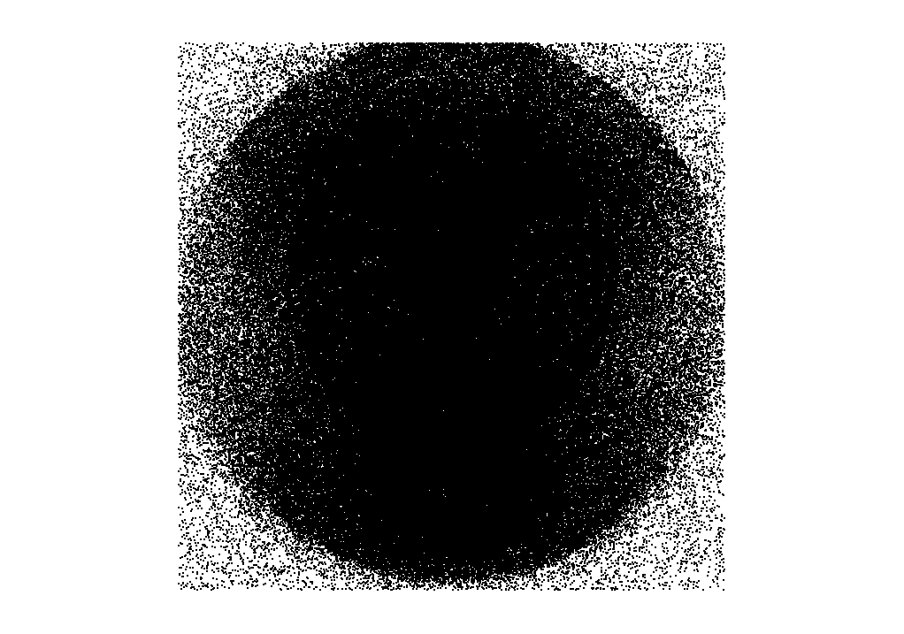

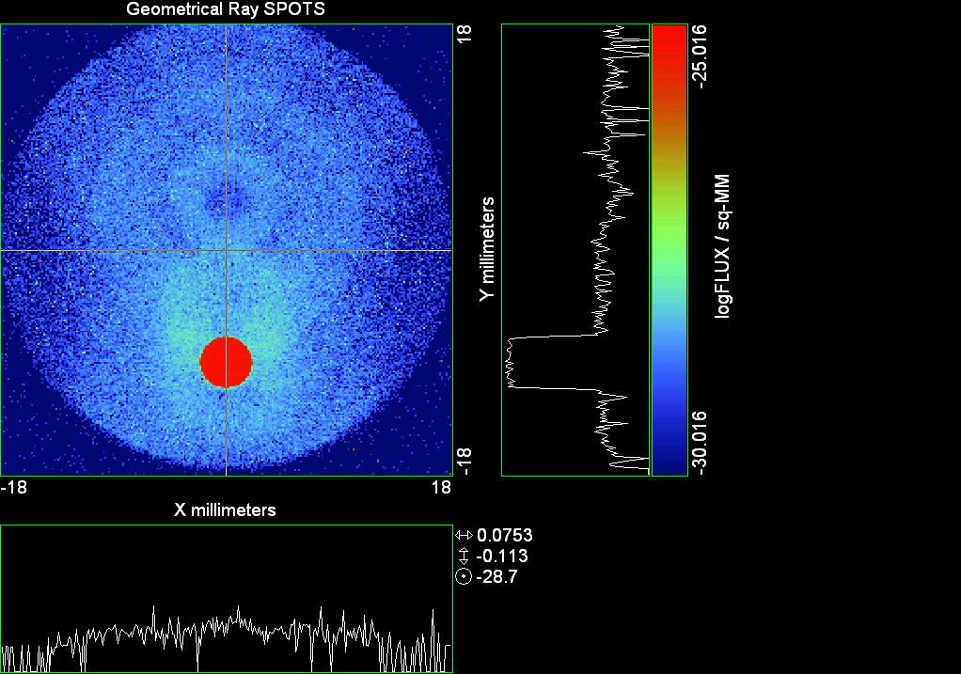

--- ! Spot Plot (Run Ray Trace First)
--- !!CONSIDER ONLY 6 !!Grid Detector=6
--- CONSIDER ONLY 7 !! Earth Detector=7
--- OBLIQUE OFF
--- !!TITLE 'FOV1-9/19^2 mm^2=15503 Rays'
--- !!TITLE 'FOV8 Rect Source Det=2170 total rays'
--- !!TITLE 'FOV8 RctSrc Det=1357-1348=11 rays from Pedestals DetImplBafOnly'
--- !!TITLE 'FOV8 RctSrc Det=750 rays "On"Mrlts Pd&SbS=0 DtImplBfOnly'
--- !!TITLE 'FOV8 RctSrc Det=754 rays "On"Mrlts Pd=1 SbS=0 DtImplBfOnly'
--- !!TITLE 'FOV8 3x3 Pt Src =215 rays "On"Mrlts Pd=1 SbS=0 DtImplBfOnly'
--- TITLE '1.5E6 KM to Source at L1 Distance'
--- !!WINDOW Y X
--- WINDOW Y -18 18 X -18 18
--- !!WINDOW Y 11 14 X -1.5 1.5
--- !!TITLE 'FOV8 23x23 1358-678=680 Rays/.109 mm^2 = 6238 Rays/mm^2 5.5%'
--- !!WINDOW Y 135.75 136.25 X 82.5 83 !!FOV 8
--- !!TITLE 'FOV8 3x3 Core 678 Rays/.006mm^2 = 113000 Rays/mm^2'
--- !!WINDOW Y 136.01 136.07 X 82.75 82.85 !!FOV 8
--- PIXELS 256
--- SPOTS POSITION

Distribution of data within:
Window Vertical: Y = -18.0000 to 18.0000 ( 36.0000 )
Horizontal: X = -18.0000 to 18.0000 ( 36.0000 )

Opening NEW distribution file 9: C:\ASAP Work\TRIANA\bro009.dat
Rays Flux
513531 0.786054E-24
Maximum = 9.6317273E-26 minimum = 0.0000000E+00
--- $IO "ASAPTEMP.INR"
Opening 1 C:\ASAP Work\TRIANA\asaptemp.inr

Closing 7 C:\ASAP Work\TRIANA\bro007.dat
Opening 7 C:\ASAP Work\TRIANA\asaptemp.usr

Closing 20 C:\ASAP Work\TRIANA\bro020.dat
Opening 20 C:\ASAP Work\TRIANA\asaptemp.plr

Closing 30 C:\ASAP Work\TRIANA\bro030.dat
Opening 30 C:\ASAP Work\TRIANA\asaptemp.vcr

--- !! PICTURE (Run Ray Trace and Spots Position First)
--- !! Picks size from Spots Position window size
--- TITLE 'EPIC'
--- CONSIDER ONLY 7 !! Detector = 6 for Grid, 7 for Earth
--- !!WINDOW X -1.5 1.5 Y 11 14
--- WINDOW Y X
--- DISPLAY
Opening OLD distribution file 9: C:\ASAP Work\TRIANA\bro009.dat

File header:
Geometrical Ray SPOTS 1
Z 790.7430 FLUX / sq-MM
X millimeters -18.00000 18.00000 256
Y millimeters -18.00000 18.00000 256

Statistics on 256 by 256 data set:
FLUX / sq-MM Location Y millimeters X millimeters
Minimum 0.000000 1 1 -17.92969 -17.92969
Maximum 0.9631727E-25 55 126 -10.33594 -0.3515625
Average 0.6065232E-27 67 129 -8.648438 0.7031250E-01
TOTAL FLUX = 0.7860540E-24

--- AVERAGE 0 0
Statistics on 256 by 256 data set:
FLUX / sq-MM Location Y millimeters X millimeters
Minimum 0.000000 1 1 -17.92969 -17.92969
Maximum 0.9631727E-25 55 126 -10.33594 -0.3515625
Average 0.6065232E-27 67 129 -8.648438 0.7031250E-01
TOTAL FLUX = 0.7860540E-24

--- FORM -5
Statistics on 256 by 256 data set:
FLUX / sq-MM Location Y millimeters X millimeters
Minimum -30.01630 1 1 -17.92969 -17.92969
Maximum -25.01630 55 126 -10.33594 -0.3515625
Average -29.08891 124 128 -0.6328125 -0.7031250E-01
Integral = -37699.22

--- !!CONTOUR .001 .005 .01 .05 .1 .2 .3 .4 .5 .6 .7 .8 .85 .9 .95 GRID 2
--- PICTURE
Opening NEW distribution file 10: C:\ASAP Work\TRIANA\i.dis
--- $IO "ASAPTEMP.INR"
Opening 1 C:\ASAP Work\TRIANA\asaptemp.inr

Closing 7 C:\ASAP Work\TRIANA\bro007.dat
Opening 7 C:\ASAP Work\TRIANA\asaptemp.usr

Closing 20 C:\ASAP Work\TRIANA\bro020.dat
Creating 20 C:\ASAP Work\TRIANA\asaptemp.plr

Closing 30 C:\ASAP Work\TRIANA\bro030.dat
Creating 30 C:\ASAP Work\TRIANA\asaptemp.vcr

--- DISPLAY
Opening OLD distribution file 9: C:\ASAP Work\TRIANA\bro009.dat

File header:
Geometrical Ray SPOTS 1
Z 790.7430 FLUX / sq-MM
X millimeters -18.00000 18.00000 256
Y millimeters -18.00000 18.00000 256

Statistics on 256 by 256 data set:
FLUX / sq-MM Location Y millimeters X millimeters
Minimum 0.000000 1 1 -17.92969 -17.92969
Maximum 0.9631727E-25 55 126 -10.33594 -0.3515625
Average 0.6065232E-27 67 129 -8.648438 0.7031250E-01
TOTAL FLUX = 0.7860540E-24

--- TEXTFILE X_Text_Output !!Names Text File, overwrites without warning
--- DATA 'E12.5' !! Format with single blank space
--- EOF

Run 10 Offset 0.75 0.08 deg 40k rays.xls

Run 11 Offset 0.25 0.16 deg 40k rays

--- END

System database and settings have been reinitialized
--- $IO "ASAPTEMP.INR"
Opening 1 C:\ASAP Work\TRIANA\asaptemp.inr

Closing 7 C:\ASAP Work\TRIANA\bro007.dat
Opening 7 C:\ASAP Work\TRIANA\asaptemp.usr

Closing 20 C:\ASAP Work\TRIANA\bro020.dat
Creating 20 C:\ASAP Work\TRIANA\asaptemp.plr

Closing 30 C:\ASAP Work\TRIANA\bro030.dat
Creating 30 C:\ASAP Work\TRIANA\asaptemp.vcr

--- !! Directed Diffuser Example
--- !! Create a source (Disk or Grid)
--- !! Source hits a diffuser in close proximity to source
--- !! diffuser scatters towards an edge for efficient ray tracing
--- SYSTEM NEW
--- RESET
--- UNITS MILLIMETERS
--- !! Setup for 1500 meter test
--- EDGE (EP=1000) !! Assign edge number to reference later with TOWARDS
--- ELLIPSE Z -200 225 225
--- !! Diffusion Model
--- MODEL
--- LAMBERTIAN 1
Angle Relative TIS Sampling
0.0 1.00 1000 radial

--- RETURN
--- CUTOFF (1.0E-40) 50 !! Default=1.0E-18 1/4pir2=3.5E-26
--- !! Scattering Plate is at L1, Source Disk is 1 meter farther away
--- !! L1 is at 1.5E6 km 1.5E9 m 1.5E12 mm
--- !! Except for scale factor, dimensions are in km
--- SCALE=1E6 !! S=1 for mm; 1E3 m; 1E6 km
--- !! Set source offset in "km" if scale = 1E6. Usually DX or DY only.
--- DX=0*(SCALE)
--- !!DY=0*(SCALE) !! 0=pixel 1024, centered
--- DY=-4718*(SCALE) !! -4718=pixel 512, +4718=pixel 1536,centered
--- DZ=0*(SCALE)
--- !!SRAD=523.6 !!=0.04 deg diam
--- !!SRAD=1047.2 !!=0.08 deg diam
--- SRAD=2094.4 !!=0.16 deg diam
--- !!SRAD=2618.0 !!=0.20 deg diam
--- !!SRAD=4188.8 !!=0.32 deg diam
--- !!SRAD=6283.2 !!=0.48 deg diam
--- !!SRAD=8508.6 !!=0.65 deg diam
--- !!SRAD=10472.1 !!=0.80 deg diam
--- !! Spherical Earth Radius = 6371 km
--- LEVEL 2 0. !! Suggested by BRO Tech Support
--- SURFACE
--- PLANE Z ((-1.5E6)*(SCALE)) ELLIPSE (SRAD*(SCALE)) (SRAD*(SCALE)) 0 (DX) (DY)
--- OBJECT 'DIFFUSION'
--- INTERFACE 0 1E-12 !! Only allow scatter rays to transmit
--- SCATTER MODEL 1 RANDOM 1 1 !! RANDOM needed to find edge, else low light problems
--- TOWARDS (EP) 1
--- RETURN
--- !! Emitter
--- NRAYS=40000 !! 1000=32 sec 40000=20 minutes 200000
--- EMIT DISK Z ((-1.500001E6)*(SCALE)) (SRAD*(SCALE)) (SRAD*(SCALE)) (NRAYS) 1 1
Total flux in rays created by this emitter is 3.0458655E-04
--- SHIFT (DX) (DY) (DZ)
--- RETURN
--- UNITS MILLIMETERS
--- WAVELENGTHS 0.950000 0.706000 0.587560 0.435000 0.300000 MICRONS
--- MEDIA; 1.45106513 1.45515708 1.45846375 1.46676272 1.48779297 'SILICA'
--- COATING PROPERTIES; 1 0 'WHITE'
--- COATING PROPERTIES; .98 0 'MIRROR'
--- COATING PROPERTIES; .11 .87 'DETECTORQE317'
--- COATING PROPERTIES; .10 .75 'DETECTORQE325'
--- COATING PROPERTIES; .05 0 'BLACK'
--- COATING PROPERTIES; 0 0 'ZERO'
--- COATING PROPERTIES; 0 1 'CLEAR'
--- STRUE=0
--- SX=0
--- SY=0
--- SZ=0
--- SCAT=1
--- ENT OBJECT;MIRROR Z 439.24 159 (1219.2/2) -1 (38.2/159) 'PRIMARY S1'
--- INTERFACE COATING MIRROR AIR AIR
--- ENT OBJECT;TUBE Z 438.5 38.2 38.2 466.53196 38.2 38.2 0.0 0.0 'PRIMARYHOLE'
--- INTERFACE COATING BLACK AIR AIR
--- SCATTER RANDOM 1 (SCAT) 1.57 ABS 1 0
--- ENT OBJECT;PLANE Z 466.5 ELLIPSE 210 210 (38.2/210) 'PRIMARY BACK'
--- INTERFACE COATING BLACK AIR AIR
--- SCATTER RANDOM 1 (SCAT) 1.57 ABS 1 0
--- ENT OBJECT;TUBE Z 429 159 159 466.5 159 159 0.0 0.0 'PRIMARYEDGE'
--- INTERFACE COATING BLACK AIR AIR
--- SCATTER RANDOM 1 (SCAT) 1.57 ABS 1 0
--- ENT OBJECT;MIRROR Z 0.0 46 (434.7/2) -2.40763 0.0 'SECONDARY S2'
--- INTERFACE COATING MIRROR AIR AIR
--- ENT OBJECT;PLANE Z 790.7429896 RECTANGLE 18 18 0 'DETECTOR'
--- INTERFACE COATING ZERO SILICA AIR
--- ENT OBJECT;PLANE Z 790.7 RECTANGLE 18 18 0 'DETECTOR-COVER'
--- INTERFACE COATING DETECTORQE317 SILICA AIR
*** SPLIT automatically set to 1
--- ENT OBJECT;PLANE Z -55.69204 ELLIPSE 210 210 (154.8315449/210) 'SPIDER'
--- INTERFACE COATING BLACK AIR AIR
--- SCATTER RANDOM 1 (SCAT) 1.57 ABS 1 0
--- ENT OBJECT;TUBE Z -55.69204 154.8315449 154.8315449 -30.29204 154.8315449 154.8315449 0.0 0.0 'SPIDERCYL'
--- INTERFACE COATING BLACK AIR AIR
--- SCATTER RANDOM 1 (SCAT) 1.57 ABS 1 0
--- ENT OBJECT;TUBE X 0 0.75 12.52 -170 0.75 15.52 1 1 'SPIDERARMX'
--- SHIFT 0 -52.578 -42.992
--- INTERFACE COATING BLACK AIR AIR
--- SCATTER RANDOM 1 (SCAT) 1.57 ABS 1 0
--- ENT OBJECT;TUBE X 0 5 12.52 -170 5 15.52 1 1 'SPIDERARMX1'
--- SHIFT 0 -52.578 -42.992
--- ROTATE Z -120 0 0
--- INTERFACE COATING BLACK AIR AIR
--- SCATTER RANDOM 1 (SCAT) 1.57 ABS 1 0
--- ENT OBJECT;TUBE X 0 0.75 12.52 -170 0.75 15.52 1 1 'SPIDERARMX2'
--- SHIFT 0 -52.578 -42.992
--- ROTATE Z -240 0 0
--- INTERFACE COATING BLACK AIR AIR
--- SCATTER RANDOM 1 (SCAT) 1.57 ABS 1 0
--- ENT OBJECT;TUBE Z -185.6 200.8 200.8 528 200.8 200.8 0.0 0.0 'BARRELBAFFLE'
--- INTERFACE COATING BLACK AIR AIR
--- SCATTER RANDOM 1 (SCAT) 1.57 ABS 1 0
--- ENT OBJECT;ELLIPSE Z -200 205 205 64 0.0 360.0 'ENTRANCE'
Default ELLIP/ROUND/OVAL segments changed to 64
--- INTERFACE COATING CLEAR AIR AIR
--- ENT OBJECT;TUBE Z (2.391*25.4) (2.546*25.4) (2.546*25.4) (2.164*25.4) (2.546*25.4) (2.546*25.4) 0.0 0.0 'SECONDARYHOUSING'
--- INTERFACE COATING BLACK AIR AIR
--- SCATTER RANDOM 1 (SCAT) 1.57 ABS 1 0
--- ENT OBJECT;TUBE Z (2.164*25.4) (2.546*25.4) (2.546*25.4) 0 (2*25.4) (2*25.4) 0.0 0.0 'SH-CONE'
--- INTERFACE COATING BLACK AIR AIR
--- SCATTER RANDOM 1 (SCAT) 1.57 ABS 1 0
--- ENT OBJECT;PLANE Z 0.0 ELLIPSE (2.45*25.4) (2.45*25.4) (2.00/2.45) 'SH-CONEBASE'
--- INTERFACE COATING BLACK AIR AIR
--- SCATTER RANDOM 1 (SCAT) 1.57 ABS 1 0
--- ENT OBJECT;TUBE Z 0.0 (2.125*25.4) (2.125*25.4) (-6.875*25.4) (2.125*25.4) (2.125*25.4) 0.0 0.0 'SH-CYLINDER'
--- INTERFACE COATING BLACK AIR AIR
--- SCATTER RANDOM 1 (SCAT) 1.57 ABS 1 0
--- ENT OBJECT;PLANE Z (-6.875*25.4) ELLIPSE (2.33*25.4) 'SH-TOP'
--- INTERFACE COATING BLACK AIR AIR
--- SCATTER RANDOM 1 (SCAT) 1.57 ABS 1 0
--- ENT OBJECT;PLANE Z (-1.9*25.4) ELLIPSE (2.546*25.4) 'SH-MIDVANE'
--- INTERFACE COATING BLACK AIR AIR
--- SCATTER RANDOM 1 (SCAT) 1.57 ABS 1 0
--- ENT OBJECT;TUBE Z 226.38766 37.465 37.465 422.98366 37.465 37.465 0.0 0.0 'CBAF-FRONT'
--- INTERFACE COATING BLACK AIR AIR
--- SCATTER RANDOM 1 (SCAT) 1.57 ABS 1 0
--- ENT OBJECT;PLANE Z 422.98366 ELLIPSE 37.485 37.485 (30.5562/37.485) 'CBAF-LEDGE'
--- INTERFACE COATING BLACK AIR AIR
--- SCATTER RANDOM 1 (SCAT) 1.57 ABS 1 0
--- ENT OBJECT;TUBE Z 422.985 32.2072 32.2072 532.45766 32.2072 32.2072 0.0 0.0 'CBAF-AFT'
--- INTERFACE COATING BLACK AIR AIR
--- SCATTER RANDOM 1 (SCAT) 1.57 ABS 1 0
--- ENT OBJECT;PLANE Z 327.98766 ELLIPSE 37.485 37.485 (35.56/37.485) 'CBAF-VANE1'
--- INTERFACE COATING BLACK AIR AIR
--- SCATTER RANDOM 1 (SCAT) 1.57 ABS 1 0
--- ENT OBJECT;PLANE Z 378.78766 ELLIPSE 37.485 37.485 (35.56/37.485) 'CBAF-VANE2'
--- INTERFACE COATING BLACK AIR AIR
--- SCATTER RANDOM 1 (SCAT) 1.57 ABS 1 0
--- ENT OBJECT;PLANE Z 505.53366 ELLIPSE 32.24 32.24 (28.6512/32.24) 'CBAF-VANE3'
--- INTERFACE COATING BLACK AIR AIR
--- SCATTER RANDOM 1 (SCAT) 1.57 ABS 1 0
--- RETURN
--- !! Geometry is being appended to system.
--- !! To not view this message, refer to ASAP preferences dialog,
--- !! or change the Options->Append Geometry menu item.
--- UNITS MILLIMETERS
--- WAVELENGTHS 0.950000 0.706000 0.587560 0.435000 0.300000 MICRONS
--- MEDIA; 1.45106513 1.45515708 1.45846375 1.46676272 1.48779297 'SILICA'
--- COATING PROPERTIES; .98 0 'MIRROR'
--- COATING PROPERTIES; .05 0 'BLACK'
--- COATING PROPERTIES; 0 0 'ZERO'
--- COATING PROPERTIES; 0 1 'CLEAR'
--- COATING PROPERTIES; .05 .95 'ARF05'
--- COATING PROPERTIES; 0.2 0.8 'ARF20'
--- ENT OBJECT;PLANE Z 615.3400000 ELLIPSE 150 150 (22/150) 'LENS MOUNT'
--- INTERFACE COATING BLACK AIR AIR
--- SCATTER RANDOM 1 (SCAT) 1.57 ABS 1 0
--- ENT OBJECT;TUBE Z 558.61966 26.7 26.7 620 26.7 26.7 0.0 0.0 'LENS TUBE-FRONT'
--- INTERFACE COATING BLACK AIR AIR
--- SCATTER RANDOM 1 (SCAT) 1.57 ABS 1 0
--- ENT OBJECT;PLANE Z 558.61966 ELLIPSE 27.7 27.7 (24.945/27.7) 'LT-FACE'
--- INTERFACE COATING BLACK AIR AIR
--- SCATTER RANDOM 1 (SCAT) 1.57 ABS 1 0
--- ENT OBJECT;PLANE Z 616.4326 ELLIPSE 27.7 27.7 (21.5/27.7) 'LT-LENS 1FACE'
--- INTERFACE COATING BLACK AIR AIR
--- SCATTER RANDOM 1 (SCAT) 1.57 ABS 1 0
--- ENT OBJECT;TUBE Z 621 25.152 25.152 657.7965 25.152 25.152 0.0 0.0 'LENS TUBE AFT'
--- INTERFACE COATING BLACK AIR AIR
--- SCATTER RANDOM 1 (SCAT) 1.57 ABS 1 0
--- ENT OBJECT;PLANE Z 657.7965 ELLIPSE 25.152 25.152 (21.26386619/25.152) 'LT-AFT FACE'
--- INTERFACE COATING BLACK AIR AIR
--- SCATTER RANDOM 1 (SCAT) 1.57 ABS 1 0
--- ENT OBJECT;OPTICAL Z 615.3400000 221.803 0 ELLIPSE 22 'LENS1F'
--- INTERFACE COATING ARF05 AIR SILICA
--- ENT OBJECT;OPTICAL Z 620.3400000 584.5 0 ELLIPSE 22 'LENS1B'
--- INTERFACE COATING ARF05 AIR SILICA
--- ENT OBJECT;OPTICAL Z 627.63 -147.027 0 ELLIPSE 22 'LENS2F'
--- INTERFACE COATING ARF05 AIR SILICA
--- ENT OBJECT;OPTICAL Z 632.63 -135.158 0 ELLIPSE 22 'LENS2B'
--- INTERFACE COATING ARF05 AIR SILICA
--- ENT OBJECT;OPTICAL Z 635.6 97.002 0 ELLIPSE 22 'LENS3F'
--- INTERFACE COATING ARF05 AIR SILICA
--- ENT OBJECT;OPTICAL Z 640.6 67.147 0 ELLIPSE 22 'LENS3B'
--- INTERFACE COATING ARF05 AIR SILICA
--- ENT OBJECT;TUBE Z 614 22 22 645 22 22 0.0 0.0 'LENSHOLDER'
--- INTERFACE COATING ZERO AIR AIR
--- SCATTER RANDOM 1 (SCAT) 1.57 ABS 1 0
--- ENT OBJECT;PLANE Z 660.84196 ELLIPSE 150 150 (25.28148817/150) 'FW-HOUSING FRONT'
--- INTERFACE COATING BLACK AIR AIR
--- SCATTER RANDOM 1 (SCAT) 1.57 ABS 1 0
--- ENT OBJECT;PLANE Z 709.10196 ELLIPSE 150 150 (25.28148817/150) 'FW-HOUSING AFT'
--- INTERFACE COATING BLACK AIR AIR
--- SCATTER RANDOM 1 (SCAT) 1.57 ABS 1 0
--- ENT OBJECT;TUBE Z (673.54196-.3) 27.5 27.5 (680.04436+.3) 27.5 27.5 0.0 0.0 'FILTERHOLDER'
--- INTERFACE COATING BLACK AIR AIR
--- SCATTER RANDOM 1 (SCAT) 1.57 ABS 1 0
--- ENT OBJECT;PLANE Z 675 ELLIPSE 150 150 (27.5/150) 'FILTER-WHEEL'
--- INTERFACE COATING BLACK AIR AIR
--- SCATTER RANDOM 1 (SCAT) 1.57 ABS 1 0
--- ENT OBJECT;TUBE Z 721.59876 19.16979665 19.16979665 723.53932 22.558 22.558 0.0 0.0 'EXIT CONE FRONT'
--- INTERFACE COATING BLACK AIR AIR
--- SCATTER RANDOM 1 (SCAT) 1.57 ABS 1 0
--- ENT OBJECT;TUBE Z 723.53932 22.558 22.558 781.84248 22.558 22.558 0.0 0.0 'EC-CYLINDER'
--- INTERFACE COATING BLACK AIR AIR
--- SCATTER RANDOM 1 (SCAT) 1.57 ABS 1 0
--- ENT OBJECT;PLANE Z 781.84248 ELLIPSE 22.558 22.558 (16.89/22.558) 'EC-SHELF'
--- INTERFACE COATING BLACK AIR AIR
--- SCATTER RANDOM 1 (SCAT) 1.57 ABS 1 0
--- ENT OBJECT;TUBE Z 781.84248 16.89 16.89 783.87448 20.41280351 20.41280351 0.0 0.0 'EC-EXITCONE'
--- INTERFACE COATING BLACK AIR AIR
--- SCATTER RANDOM 1 (SCAT) 1.57 ABS 1 0
--- ENT OBJECT;PLANE Z 783.87448 ELLIPSE 50 50 (20.41280351/50) 'EC-EXIT'
--- INTERFACE COATING BLACK AIR AIR
--- SCATTER RANDOM 1 (SCAT) 1.57 ABS 1 0
--- RETURN

--- TITLE DCE *Raytrace
--- !! WAVELENGTHS 0.317 MICRONS !! Normally set in filters
--- !!SPLIT 0 !! Direct Trace Only
--- !!SPLIT 1 !! For Rect Sources
--- SPLIT 2 !! For double reflection in lens & filters
--- PLOT FACETS 5 5
Window Vertical: Y = -.681241E+10 to 210.000 (0.681241E+10)
Horizontal: Z = -.150004E+13 to 791.121 (0.150004E+13)

--- CONSIDER ALL
--- !!CONSIDER ONLY 15
--- ARROWS OFF
--- SEGMENTS 9
--- WINDOW Y Z
--- OBLIQUE 0 0
--- MISSED LINE 50
--- TRACE PLOT 1000 OVERLAY
Window Vertical: Y = -.681241E+10 to 210.000 (0.681241E+10)
Horizontal: Z = -.150004E+13 to 791.121 (0.150004E+13)

Warning *** Convergence failure in root polishing .2453893E-04
65 *** Convergence failure in root polishing .135309E-03
22.38 seconds ( 13.20 seconds CPU) to trace 80,000
out of 189,402
Warning *** Convergence failure in root polishing .107587E-03
58 *** Convergence failure in root polishing .2188367E-04
67.55 seconds ( 40.03 seconds CPU) to trace 160,000
out of 454,720
112.06 seconds ( 76.23 seconds CPU) to trace 240,000
out of 847,416
2.36 minutes ( 105.01 seconds CPU) to trace 320,000
out of 1,031,895
2.82 minutes ( 2.19 minutes CPU) to trace 400,000
out of 1,155,490
3.31 minutes ( 2.65 minutes CPU) to trace 480,000
out of 1,279,325
3.81 minutes ( 3.10 minutes CPU) to trace 560,000
out of 1,402,241
4.29 minutes ( 3.56 minutes CPU) to trace 640,000
out of 1,524,910
4.77 minutes ( 4.01 minutes CPU) to trace 720,000
out of 1,648,789
5.25 minutes ( 4.46 minutes CPU) to trace 800,000
out of 1,771,481
5.73 minutes ( 4.92 minutes CPU) to trace 880,000
out of 1,895,620
6.14 minutes ( 5.31 minutes CPU) to trace 960,000
out of 1,982,997
6.44 minutes ( 5.52 minutes CPU) to trace 1,040,000
6.66 minutes ( 5.73 minutes CPU) to trace 1,120,000
6.89 minutes ( 5.94 minutes CPU) to trace 1,200,000
7.12 minutes ( 6.15 minutes CPU) to trace 1,280,000
7.34 minutes ( 6.36 minutes CPU) to trace 1,360,000
7.57 minutes ( 6.57 minutes CPU) to trace 1,440,000
7.79 minutes ( 6.78 minutes CPU) to trace 1,520,000
8.02 minutes ( 6.99 minutes CPU) to trace 1,600,000
8.24 minutes ( 7.20 minutes CPU) to trace 1,680,000
8.47 minutes ( 7.41 minutes CPU) to trace 1,760,000
8.69 minutes ( 7.63 minutes CPU) to trace 1,840,000
8.91 minutes ( 7.83 minutes CPU) to trace 1,920,000
9.07 minutes ( 7.99 minutes CPU) to trace 1,982,997

Total of 1698667 PARENT warnings
Missed Multiple Wrong Low Evanescent Wrong Absorbed
Obj Total After Bounce Side Flux (TIR) Direc After
1 100752 52370 48382 DIFFUSION
2 22 16 6 PRIMARY S1
3 1223 144 1079 PRIMARYHOLE
4 63398 25332 6 38060 PRIMARY BACK
5 13446 13446 PRIMARYEDGE
6 45 45 SECONDARY S2
7 1 1 DETECTOR
8 163 31 3 125 4 DETECTOR-COVER
9 25160 3763 21397 SPIDER
10 7900 73 1 7826 SPIDERCYL
11 2146 67 2079 SPIDERARMX
12 3825 58 3767 SPIDERARMX1
13 2225 49 2176 SPIDERARMX2
14 168507 5159 12 163336 BARRELBAFFLE
15 164820 164815 1 4 ENTRANCE
16 3466 4 3462 SECONDARYHOUSING
17 30849 249 30600 SH-CONE
18 7229 10 7219 SH-CONEBASE
19 39707 885 1 38821 SH-CYLINDER
20 463 30 433 SH-TOP
21 35582 13 35569 SH-MIDVANE
22 151525 744 21 150760 CBAF-FRONT
23 8773 2 8771 CBAF-LEDGE
24 110985 26848 34 84103 CBAF-AFT
25 4188 7 4181 CBAF-VANE1
26 4582 2 4580 CBAF-VANE2
27 8038 813 2 7223 CBAF-VANE3
28 39507 18577 8 20922 LENS MOUNT
29 42662 2334 42 40286 LENS TUBE-FRONT
30 4341 129 3 4209 LT-FACE
31 2213 9 2204 LT-LENS 1FACE
32 15805 2412 6 13387 LENS TUBE AFT
33 4487 195 5 4287 LT-AFT FACE
34 2361 17 430 1914 LENS1F
35 2665 15 417 2233 LENS1B
36 3203 10 181 3012 LENS2F
37 2168 7 177 1984 LENS2B
38 2596 6 165 2425 LENS3F
39 11116 6578 29 139 4370 LENS3B
40 72 66 6 LENSHOLDER
41 19729 6281 1 13447 FW-HOUSING FRONT
42 308944 208863 5 100076 FW-HOUSING AFT
43 4637 3155 1 1481 FILTERHOLDER
44 114448 59089 4 55355 FILTER-WHEEL
45 14268 4749 9519 EXIT CONE FRONT
46 115222 17310 5 97907 EC-CYLINDER
47 14151 3 14148 EC-SHELF
48 2561 2090 471 EC-EXITCONE
49 12491 7436 1 5054 EC-EXIT

Total of 57508 CHILD warnings
Missed Multiple Wrong Low Evanescent Wrong Absorbed
Obj Total After Bounce Side Flux (TIR) Direc After
8 2365 2365 DETECTOR-COVER
34 9463 9463 LENS1F
35 9358 9358 LENS1B
36 9211 9211 LENS2F
37 9144 9144 LENS2B
38 9018 9018 LENS3F
39 8949 8949 LENS3B
10199305 ray-objects encountered at 21270 per CPU second
120200000 order-intersections done at 250678 per CPU second

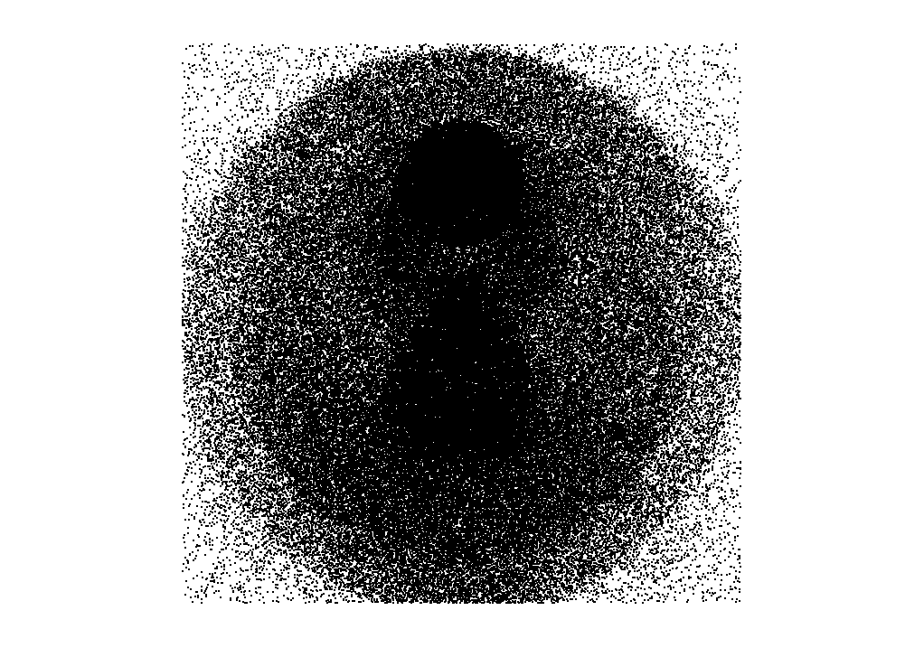

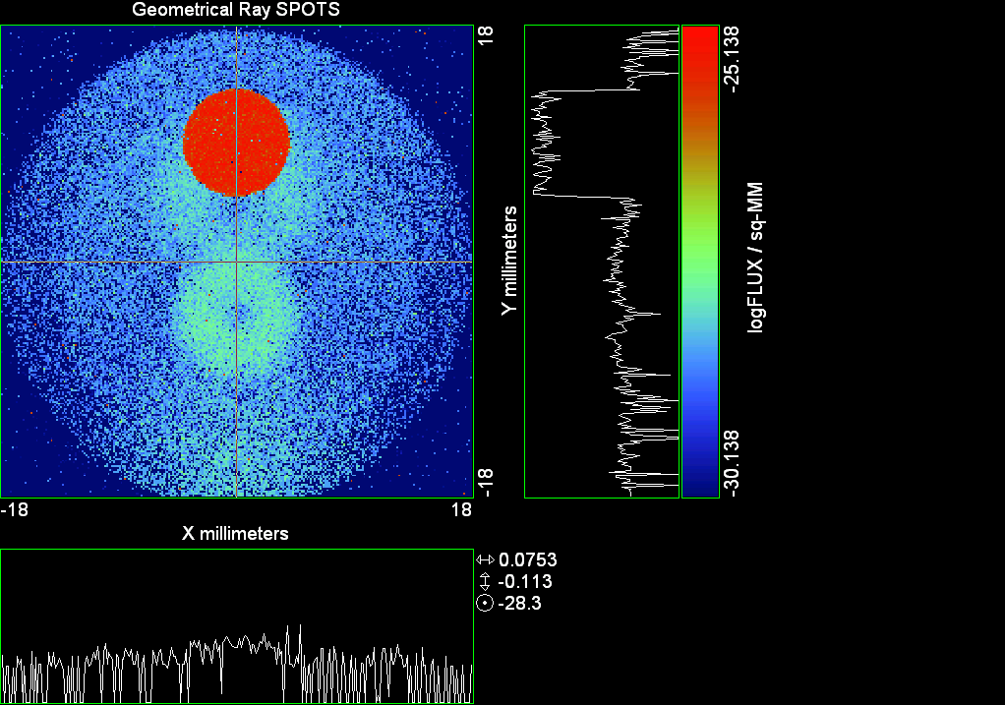

--- ! Spot Plot (Run Ray Trace First)
--- !!CONSIDER ONLY 6 !!Grid Detector=6
--- CONSIDER ONLY 7 !! Earth Detector=7
--- OBLIQUE OFF
--- !!TITLE 'FOV1-9/19^2 mm^2=15503 Rays'
--- !!TITLE 'FOV8 Rect Source Det=2170 total rays'
--- !!TITLE 'FOV8 RctSrc Det=1357-1348=11 rays from Pedestals DetImplBafOnly'
--- !!TITLE 'FOV8 RctSrc Det=750 rays "On"Mrlts Pd&SbS=0 DtImplBfOnly'
--- !!TITLE 'FOV8 RctSrc Det=754 rays "On"Mrlts Pd=1 SbS=0 DtImplBfOnly'
--- !!TITLE 'FOV8 3x3 Pt Src =215 rays "On"Mrlts Pd=1 SbS=0 DtImplBfOnly'
--- TITLE '1.5E6 KM to Source at L1 Distance'
--- !!WINDOW Y X
--- WINDOW Y -18 18 X -18 18
--- !!WINDOW Y 11 14 X -1.5 1.5
--- !!TITLE 'FOV8 23x23 1358-678=680 Rays/.109 mm^2 = 6238 Rays/mm^2 5.5%'
--- !!WINDOW Y 135.75 136.25 X 82.5 83 !!FOV 8
--- !!TITLE 'FOV8 3x3 Core 678 Rays/.006mm^2 = 113000 Rays/mm^2'
--- !!WINDOW Y 136.01 136.07 X 82.75 82.85 !!FOV 8
--- PIXELS 256
--- SPOTS POSITION

Distribution of data within:
Window Vertical: Y = -18.0000 to 18.0000 ( 36.0000 )
Horizontal: X = -18.0000 to 18.0000 ( 36.0000 )

Opening NEW distribution file 9: C:\ASAP Work\TRIANA\bro009.dat
Rays Flux
174133 0.133415E-23
Maximum = 7.2702875E-26 minimum = 0.0000000E+00
--- $IO "ASAPTEMP.INR"
Opening 1 C:\ASAP Work\TRIANA\asaptemp.inr

Closing 7 C:\ASAP Work\TRIANA\bro007.dat
Opening 7 C:\ASAP Work\TRIANA\asaptemp.usr

Closing 20 C:\ASAP Work\TRIANA\bro020.dat
Opening 20 C:\ASAP Work\TRIANA\asaptemp.plr

Closing 30 C:\ASAP Work\TRIANA\bro030.dat
Opening 30 C:\ASAP Work\TRIANA\asaptemp.vcr

--- !! PICTURE (Run Ray Trace and Spots Position First)
--- !! Picks size from Spots Position window size
--- TITLE 'EPIC'
--- CONSIDER ONLY 7 !! Detector = 6 for Grid, 7 for Earth
--- !!WINDOW X -1.5 1.5 Y 11 14
--- WINDOW Y X
--- DISPLAY
Opening OLD distribution file 9: C:\ASAP Work\TRIANA\bro009.dat

File header:
Geometrical Ray SPOTS 1
Z 790.7430 FLUX / sq-MM
X millimeters -18.00000 18.00000 256
Y millimeters -18.00000 18.00000 256

Statistics on 256 by 256 data set:
FLUX / sq-MM Location Y millimeters X millimeters
Minimum 0.000000 1 1 -17.92969 -17.92969
Maximum 0.7270288E-25 195 130 9.351562 0.2109375
Average 0.1029437E-26 191 129 8.789062 0.7031250E-01
TOTAL FLUX = 0.1334150E-23

--- AVERAGE 0 0
Statistics on 256 by 256 data set:
FLUX / sq-MM Location Y millimeters X millimeters
Minimum 0.000000 1 1 -17.92969 -17.92969
Maximum 0.7270288E-25 195 130 9.351562 0.2109375
Average 0.1029437E-26 191 129 8.789062 0.7031250E-01
TOTAL FLUX = 0.1334150E-23

--- FORM -5
Statistics on 256 by 256 data set:
FLUX / sq-MM Location Y millimeters X millimeters
Minimum -30.13845 1 1 -17.92969 -17.92969
Maximum -25.13845 195 130 9.351562 0.2109375
Average -29.11553 136 129 1.054688 0.7031250E-01
Integral = -37733.73

--- !!CONTOUR .001 .005 .01 .05 .1 .2 .3 .4 .5 .6 .7 .8 .85 .9 .95 GRID 2
--- PICTURE
Opening NEW distribution file 10: C:\ASAP Work\TRIANA\i.dis
--- $IO "ASAPTEMP.INR"
Opening 1 C:\ASAP Work\TRIANA\asaptemp.inr

Closing 7 C:\ASAP Work\TRIANA\bro007.dat
Opening 7 C:\ASAP Work\TRIANA\asaptemp.usr

Closing 20 C:\ASAP Work\TRIANA\bro020.dat
Creating 20 C:\ASAP Work\TRIANA\asaptemp.plr

Closing 30 C:\ASAP Work\TRIANA\bro030.dat
Creating 30 C:\ASAP Work\TRIANA\asaptemp.vcr

--- DISPLAY
Opening OLD distribution file 9: C:\ASAP Work\TRIANA\bro009.dat

File header:
Geometrical Ray SPOTS 1
Z 790.7430 FLUX / sq-MM
X millimeters -18.00000 18.00000 256
Y millimeters -18.00000 18.00000 256

Statistics on 256 by 256 data set:
FLUX / sq-MM Location Y millimeters X millimeters
Minimum 0.000000 1 1 -17.92969 -17.92969
Maximum 0.7270288E-25 195 130 9.351562 0.2109375
Average 0.1029437E-26 191 129 8.789062 0.7031250E-01
TOTAL FLUX = 0.1334150E-23

--- TEXTFILE X_Text_Output !!Names Text File, overwrites without warning
--- DATA 'E12.5' !! Format with single blank space
--- EOF

Run 11 Offset 0.25 0.16 deg 40k rays.xls

Run 12 Offset 0.375 0.16 deg 40k rays

--- END

System database and settings have been reinitialized
--- $IO "ASAPTEMP.INR"
Opening 1 C:\ASAP Work\TRIANA\asaptemp.inr

Closing 7 C:\ASAP Work\TRIANA\bro007.dat
Opening 7 C:\ASAP Work\TRIANA\asaptemp.usr

Closing 20 C:\ASAP Work\TRIANA\bro020.dat
Creating 20 C:\ASAP Work\TRIANA\asaptemp.plr

Closing 30 C:\ASAP Work\TRIANA\bro030.dat
Creating 30 C:\ASAP Work\TRIANA\asaptemp.vcr

--- !! Directed Diffuser Example
--- !! Create a source (Disk or Grid)
--- !! Source hits a diffuser in close proximity to source
--- !! diffuser scatters towards an edge for efficient ray tracing
--- SYSTEM NEW
--- RESET
--- UNITS MILLIMETERS
--- !! Setup for 1500 meter test
--- EDGE (EP=1000) !! Assign edge number to reference later with TOWARDS
--- ELLIPSE Z -200 225 225
--- !! Diffusion Model
--- MODEL
--- LAMBERTIAN 1
Angle Relative TIS Sampling
0.0 1.00 1000 radial

--- RETURN
--- CUTOFF (1.0E-40) 50 !! Default=1.0E-18 1/4pir2=3.5E-26
--- !! Scattering Plate is at L1, Source Disk is 1 meter farther away
--- !! L1 is at 1.5E6 km 1.5E9 m 1.5E12 mm
--- !! Except for scale factor, dimensions are in km
--- SCALE=1E6 !! S=1 for mm; 1E3 m; 1E6 km
--- !! Set source offset in "km" if scale = 1E6. Usually DX or DY only.
--- DX=0*(SCALE)
--- !!DY=0*(SCALE) !! 0=pixel 1024, centered
--- !!DY=-4718*(SCALE) !! -4718=pixel 512, +4718=pixel 1536, centered
--- DY=-2359*(SCALE) !! -2359=pixel 768, +2359=pixel 1280, centered
--- DZ=0*(SCALE)
--- !!SRAD=523.6 !!=0.04 deg diam
--- !!SRAD=1047.2 !!=0.08 deg diam
--- SRAD=2094.4 !!=0.16 deg diam
--- !!SRAD=2618.0 !!=0.20 deg diam
--- !!SRAD=4188.8 !!=0.32 deg diam
--- !!SRAD=6283.2 !!=0.48 deg diam
--- !!SRAD=8508.6 !!=0.65 deg diam
--- !!SRAD=10472.1 !!=0.80 deg diam
--- !! Spherical Earth Radius = 6371 km
--- LEVEL 2 0. !! Suggested by BRO Tech Support
--- SURFACE
--- PLANE Z ((-1.5E6)*(SCALE)) ELLIPSE (SRAD*(SCALE)) (SRAD*(SCALE)) 0 (DX) (DY)
--- OBJECT 'DIFFUSION'
--- INTERFACE 0 1E-12 !! Only allow scatter rays to transmit
--- SCATTER MODEL 1 RANDOM 1 1 !! RANDOM needed to find edge, else low light problems
--- TOWARDS (EP) 1
--- RETURN
--- !! Emitter
--- NRAYS=40000 !! 1000=32 sec 40000=20 minutes 200000
--- EMIT DISK Z ((-1.500001E6)*(SCALE)) (SRAD*(SCALE)) (SRAD*(SCALE)) (NRAYS) 1 1
Total flux in rays created by this emitter is 3.0458655E-04
--- SHIFT (DX) (DY) (DZ)
--- RETURN
--- UNITS MILLIMETERS
--- WAVELENGTHS 0.950000 0.706000 0.587560 0.435000 0.300000 MICRONS
--- MEDIA; 1.45106513 1.45515708 1.45846375 1.46676272 1.48779297 'SILICA'
--- COATING PROPERTIES; 1 0 'WHITE'
--- COATING PROPERTIES; .98 0 'MIRROR'
--- COATING PROPERTIES; .11 .87 'DETECTORQE317'
--- COATING PROPERTIES; .10 .75 'DETECTORQE325'
--- COATING PROPERTIES; .05 0 'BLACK'
--- COATING PROPERTIES; 0 0 'ZERO'
--- COATING PROPERTIES; 0 1 'CLEAR'
--- STRUE=0
--- SX=0
--- SY=0
--- SZ=0
--- SCAT=1
--- ENT OBJECT;MIRROR Z 439.24 159 (1219.2/2) -1 (38.2/159) 'PRIMARY S1'
--- INTERFACE COATING MIRROR AIR AIR
--- ENT OBJECT;TUBE Z 438.5 38.2 38.2 466.53196 38.2 38.2 0.0 0.0 'PRIMARYHOLE'
--- INTERFACE COATING BLACK AIR AIR
--- SCATTER RANDOM 1 (SCAT) 1.57 ABS 1 0
--- ENT OBJECT;PLANE Z 466.5 ELLIPSE 210 210 (38.2/210) 'PRIMARY BACK'
--- INTERFACE COATING BLACK AIR AIR
--- SCATTER RANDOM 1 (SCAT) 1.57 ABS 1 0
--- ENT OBJECT;TUBE Z 429 159 159 466.5 159 159 0.0 0.0 'PRIMARYEDGE'
--- INTERFACE COATING BLACK AIR AIR
--- SCATTER RANDOM 1 (SCAT) 1.57 ABS 1 0
--- ENT OBJECT;MIRROR Z 0.0 46 (434.7/2) -2.40763 0.0 'SECONDARY S2'
--- INTERFACE COATING MIRROR AIR AIR
--- ENT OBJECT;PLANE Z 790.7429896 RECTANGLE 18 18 0 'DETECTOR'
--- INTERFACE COATING ZERO SILICA AIR
--- ENT OBJECT;PLANE Z 790.7 RECTANGLE 18 18 0 'DETECTOR-COVER'
--- INTERFACE COATING DETECTORQE317 SILICA AIR
*** SPLIT automatically set to 1
--- ENT OBJECT;PLANE Z -55.69204 ELLIPSE 210 210 (154.8315449/210) 'SPIDER'
--- INTERFACE COATING BLACK AIR AIR
--- SCATTER RANDOM 1 (SCAT) 1.57 ABS 1 0
--- ENT OBJECT;TUBE Z -55.69204 154.8315449 154.8315449 -30.29204 154.8315449 154.8315449 0.0 0.0 'SPIDERCYL'
--- INTERFACE COATING BLACK AIR AIR
--- SCATTER RANDOM 1 (SCAT) 1.57 ABS 1 0
--- ENT OBJECT;TUBE X 0 0.75 12.52 -170 0.75 15.52 1 1 'SPIDERARMX'
--- SHIFT 0 -52.578 -42.992
--- INTERFACE COATING BLACK AIR AIR
--- SCATTER RANDOM 1 (SCAT) 1.57 ABS 1 0
--- ENT OBJECT;TUBE X 0 5 12.52 -170 5 15.52 1 1 'SPIDERARMX1'
--- SHIFT 0 -52.578 -42.992
--- ROTATE Z -120 0 0
--- INTERFACE COATING BLACK AIR AIR
--- SCATTER RANDOM 1 (SCAT) 1.57 ABS 1 0
--- ENT OBJECT;TUBE X 0 0.75 12.52 -170 0.75 15.52 1 1 'SPIDERARMX2'
--- SHIFT 0 -52.578 -42.992
--- ROTATE Z -240 0 0
--- INTERFACE COATING BLACK AIR AIR
--- SCATTER RANDOM 1 (SCAT) 1.57 ABS 1 0
--- ENT OBJECT;TUBE Z -185.6 200.8 200.8 528 200.8 200.8 0.0 0.0 'BARRELBAFFLE'
--- INTERFACE COATING BLACK AIR AIR
--- SCATTER RANDOM 1 (SCAT) 1.57 ABS 1 0
--- ENT OBJECT;ELLIPSE Z -200 205 205 64 0.0 360.0 'ENTRANCE'
Default ELLIP/ROUND/OVAL segments changed to 64
--- INTERFACE COATING CLEAR AIR AIR
--- ENT OBJECT;TUBE Z (2.391*25.4) (2.546*25.4) (2.546*25.4) (2.164*25.4) (2.546*25.4) (2.546*25.4) 0.0 0.0 'SECONDARYHOUSING'
--- INTERFACE COATING BLACK AIR AIR
--- SCATTER RANDOM 1 (SCAT) 1.57 ABS 1 0
--- ENT OBJECT;TUBE Z (2.164*25.4) (2.546*25.4) (2.546*25.4) 0 (2*25.4) (2*25.4) 0.0 0.0 'SH-CONE'
--- INTERFACE COATING BLACK AIR AIR
--- SCATTER RANDOM 1 (SCAT) 1.57 ABS 1 0
--- ENT OBJECT;PLANE Z 0.0 ELLIPSE (2.45*25.4) (2.45*25.4) (2.00/2.45) 'SH-CONEBASE'
--- INTERFACE COATING BLACK AIR AIR
--- SCATTER RANDOM 1 (SCAT) 1.57 ABS 1 0
--- ENT OBJECT;TUBE Z 0.0 (2.125*25.4) (2.125*25.4) (-6.875*25.4) (2.125*25.4) (2.125*25.4) 0.0 0.0 'SH-CYLINDER'
--- INTERFACE COATING BLACK AIR AIR
--- SCATTER RANDOM 1 (SCAT) 1.57 ABS 1 0
--- ENT OBJECT;PLANE Z (-6.875*25.4) ELLIPSE (2.33*25.4) 'SH-TOP'
--- INTERFACE COATING BLACK AIR AIR
--- SCATTER RANDOM 1 (SCAT) 1.57 ABS 1 0
--- ENT OBJECT;PLANE Z (-1.9*25.4) ELLIPSE (2.546*25.4) 'SH-MIDVANE'
--- INTERFACE COATING BLACK AIR AIR
--- SCATTER RANDOM 1 (SCAT) 1.57 ABS 1 0
--- ENT OBJECT;TUBE Z 226.38766 37.465 37.465 422.98366 37.465 37.465 0.0 0.0 'CBAF-FRONT'
--- INTERFACE COATING BLACK AIR AIR
--- SCATTER RANDOM 1 (SCAT) 1.57 ABS 1 0
--- ENT OBJECT;PLANE Z 422.98366 ELLIPSE 37.485 37.485 (30.5562/37.485) 'CBAF-LEDGE'
--- INTERFACE COATING BLACK AIR AIR
--- SCATTER RANDOM 1 (SCAT) 1.57 ABS 1 0
--- ENT OBJECT;TUBE Z 422.985 32.2072 32.2072 532.45766 32.2072 32.2072 0.0 0.0 'CBAF-AFT'
--- INTERFACE COATING BLACK AIR AIR
--- SCATTER RANDOM 1 (SCAT) 1.57 ABS 1 0
--- ENT OBJECT;PLANE Z 327.98766 ELLIPSE 37.485 37.485 (35.56/37.485) 'CBAF-VANE1'
--- INTERFACE COATING BLACK AIR AIR
--- SCATTER RANDOM 1 (SCAT) 1.57 ABS 1 0
--- ENT OBJECT;PLANE Z 378.78766 ELLIPSE 37.485 37.485 (35.56/37.485) 'CBAF-VANE2'
--- INTERFACE COATING BLACK AIR AIR
--- SCATTER RANDOM 1 (SCAT) 1.57 ABS 1 0
--- ENT OBJECT;PLANE Z 505.53366 ELLIPSE 32.24 32.24 (28.6512/32.24) 'CBAF-VANE3'
--- INTERFACE COATING BLACK AIR AIR
--- SCATTER RANDOM 1 (SCAT) 1.57 ABS 1 0
--- RETURN
--- !! Geometry is being appended to system.
--- !! To not view this message, refer to ASAP preferences dialog,
--- !! or change the Options->Append Geometry menu item.
--- UNITS MILLIMETERS
--- WAVELENGTHS 0.950000 0.706000 0.587560 0.435000 0.300000 MICRONS
--- MEDIA; 1.45106513 1.45515708 1.45846375 1.46676272 1.48779297 'SILICA'
--- COATING PROPERTIES; .98 0 'MIRROR'
--- COATING PROPERTIES; .05 0 'BLACK'
--- COATING PROPERTIES; 0 0 'ZERO'
--- COATING PROPERTIES; 0 1 'CLEAR'
--- COATING PROPERTIES; .05 .95 'ARF05'
--- COATING PROPERTIES; 0.2 0.8 'ARF20'
--- ENT OBJECT;PLANE Z 615.3400000 ELLIPSE 150 150 (22/150) 'LENS MOUNT'
--- INTERFACE COATING BLACK AIR AIR
--- SCATTER RANDOM 1 (SCAT) 1.57 ABS 1 0
--- ENT OBJECT;TUBE Z 558.61966 26.7 26.7 620 26.7 26.7 0.0 0.0 'LENS TUBE-FRONT'
--- INTERFACE COATING BLACK AIR AIR
--- SCATTER RANDOM 1 (SCAT) 1.57 ABS 1 0
--- ENT OBJECT;PLANE Z 558.61966 ELLIPSE 27.7 27.7 (24.945/27.7) 'LT-FACE'
--- INTERFACE COATING BLACK AIR AIR
--- SCATTER RANDOM 1 (SCAT) 1.57 ABS 1 0
--- ENT OBJECT;PLANE Z 616.4326 ELLIPSE 27.7 27.7 (21.5/27.7) 'LT-LENS 1FACE'
--- INTERFACE COATING BLACK AIR AIR
--- SCATTER RANDOM 1 (SCAT) 1.57 ABS 1 0
--- ENT OBJECT;TUBE Z 621 25.152 25.152 657.7965 25.152 25.152 0.0 0.0 'LENS TUBE AFT'
--- INTERFACE COATING BLACK AIR AIR
--- SCATTER RANDOM 1 (SCAT) 1.57 ABS 1 0
--- ENT OBJECT;PLANE Z 657.7965 ELLIPSE 25.152 25.152 (21.26386619/25.152) 'LT-AFT FACE'
--- INTERFACE COATING BLACK AIR AIR
--- SCATTER RANDOM 1 (SCAT) 1.57 ABS 1 0
--- ENT OBJECT;OPTICAL Z 615.3400000 221.803 0 ELLIPSE 22 'LENS1F'
--- INTERFACE COATING ARF05 AIR SILICA
--- ENT OBJECT;OPTICAL Z 620.3400000 584.5 0 ELLIPSE 22 'LENS1B'
--- INTERFACE COATING ARF05 AIR SILICA
--- ENT OBJECT;OPTICAL Z 627.63 -147.027 0 ELLIPSE 22 'LENS2F'
--- INTERFACE COATING ARF05 AIR SILICA
--- ENT OBJECT;OPTICAL Z 632.63 -135.158 0 ELLIPSE 22 'LENS2B'
--- INTERFACE COATING ARF05 AIR SILICA
--- ENT OBJECT;OPTICAL Z 635.6 97.002 0 ELLIPSE 22 'LENS3F'
--- INTERFACE COATING ARF05 AIR SILICA
--- ENT OBJECT;OPTICAL Z 640.6 67.147 0 ELLIPSE 22 'LENS3B'
--- INTERFACE COATING ARF05 AIR SILICA
--- ENT OBJECT;TUBE Z 614 22 22 645 22 22 0.0 0.0 'LENSHOLDER'
--- INTERFACE COATING ZERO AIR AIR
--- SCATTER RANDOM 1 (SCAT) 1.57 ABS 1 0
--- ENT OBJECT;PLANE Z 660.84196 ELLIPSE 150 150 (25.28148817/150) 'FW-HOUSING FRONT'
--- INTERFACE COATING BLACK AIR AIR
--- SCATTER RANDOM 1 (SCAT) 1.57 ABS 1 0
--- ENT OBJECT;PLANE Z 709.10196 ELLIPSE 150 150 (25.28148817/150) 'FW-HOUSING AFT'
--- INTERFACE COATING BLACK AIR AIR
--- SCATTER RANDOM 1 (SCAT) 1.57 ABS 1 0
--- ENT OBJECT;TUBE Z (673.54196-.3) 27.5 27.5 (680.04436+.3) 27.5 27.5 0.0 0.0 'FILTERHOLDER'
--- INTERFACE COATING BLACK AIR AIR
--- SCATTER RANDOM 1 (SCAT) 1.57 ABS 1 0
--- ENT OBJECT;PLANE Z 675 ELLIPSE 150 150 (27.5/150) 'FILTER-WHEEL'
--- INTERFACE COATING BLACK AIR AIR
--- SCATTER RANDOM 1 (SCAT) 1.57 ABS 1 0
--- ENT OBJECT;TUBE Z 721.59876 19.16979665 19.16979665 723.53932 22.558 22.558 0.0 0.0 'EXIT CONE FRONT'
--- INTERFACE COATING BLACK AIR AIR
--- SCATTER RANDOM 1 (SCAT) 1.57 ABS 1 0
--- ENT OBJECT;TUBE Z 723.53932 22.558 22.558 781.84248 22.558 22.558 0.0 0.0 'EC-CYLINDER'
--- INTERFACE COATING BLACK AIR AIR
--- SCATTER RANDOM 1 (SCAT) 1.57 ABS 1 0
--- ENT OBJECT;PLANE Z 781.84248 ELLIPSE 22.558 22.558 (16.89/22.558) 'EC-SHELF'
--- INTERFACE COATING BLACK AIR AIR
--- SCATTER RANDOM 1 (SCAT) 1.57 ABS 1 0
--- ENT OBJECT;TUBE Z 781.84248 16.89 16.89 783.87448 20.41280351 20.41280351 0.0 0.0 'EC-EXITCONE'
--- INTERFACE COATING BLACK AIR AIR
--- SCATTER RANDOM 1 (SCAT) 1.57 ABS 1 0
--- ENT OBJECT;PLANE Z 783.87448 ELLIPSE 50 50 (20.41280351/50) 'EC-EXIT'
--- INTERFACE COATING BLACK AIR AIR
--- SCATTER RANDOM 1 (SCAT) 1.57 ABS 1 0
--- RETURN
--- $IO "ASAPTEMP.INR"
Opening 1 C:\ASAP Work\TRIANA\asaptemp.inr

Closing 7 C:\ASAP Work\TRIANA\bro007.dat
Opening 7 C:\ASAP Work\TRIANA\asaptemp.usr

Closing 20 C:\ASAP Work\TRIANA\bro020.dat
Creating 20 C:\ASAP Work\TRIANA\asaptemp.plr

Closing 30 C:\ASAP Work\TRIANA\bro030.dat
Creating 30 C:\ASAP Work\TRIANA\asaptemp.vcr

--- !! Filters-2 from .ent/copy/.inr to allow ABSORBing media
--- UNITS MILLIMETERS
--- WAVELENGTHS 0.950000 0.706000 0.587560 0.435000 0.300000 MICRONS
--- MEDIA; 1.45106513 1.45515708 1.45846375 1.46676272 1.48779297 'SILICA'
--- !!COATING PROPERTIES; .98 0 'MIRROR'
--- !!COATING PROPERTIES; .05 0 'BLACK'
--- !!COATING PROPERTIES; 0 0 'ZERO'
--- !!COATING PROPERTIES; 0 1 'CLEAR'
--- COATING PROPERTIES; .0745 .9255 'ARF0745'
--- COATING PROPERTIES; .0525 .9475 'ARF0525'
--- COATING PROPERTIES; .05 .95 'ARF05'
--- COATING PROPERTIES; .005 .995 'ARF005'
--- !!COATING PROPERTIES; 0.2 0.8 'ARF20'
--- !!!!!!!!!!!!!!!!!!!!!!!!!!!!!!!!!!!!!!!!!!!!!!!!!!
--- WAVELENGTH 0.317 MICRONS
--- MEDIA
--- 1.48342884 ABSORB 0.13168 'BLOCKER317'
--- MEDIA
--- 1.48342884 ABSORB 0.00307 'ETALON317'
--- !!!!!!!!!!!!!!!!!!!!!!!!!!!!!!!!!!!!!!!!!!!!!!!!!!
--- !!WAVELENGTH 0.325 MICRONS
--- !!MEDIA
--- !! 1.48163777 ABSORB 0.08074 'BLOCKER325'
--- !!MEDIA
--- !! 1.48163777 ABSORB 0.0415179525 'ETALON325'
--- !!!!!!!!!!!!!!!!!!!!!!!!!!!!!!!!!!!!!!!!!!!!!!!!!!!!!
--- ENT OBJECT;PLANE Z 673.54196 ELLIPSE 27.5 'FILTERUVE-F'
--- INTERFACE COATING ARF0525 AIR ETALON317
--- !! INTERFACE COATING ARF0745 AIR ETALON325
--- ENT OBJECT;PLANE Z 676.71696 ELLIPSE 27.5 'FILTERUVE-B'
--- INTERFACE COATING ARF0525 AIR ETALON317
--- !! INTERFACE COATING ARF0745 AIR ETALON325
--- ENT OBJECT;PLANE Z 676.86936 ELLIPSE 27.5 'FILTERUVB-F'
--- INTERFACE COATING ARF005 AIR BLOCKER317
--- !! INTERFACE COATING ARF005 AIR BLOCKER325
--- ENT OBJECT;PLANE Z 680.04436 ELLIPSE 27.5 'FILTERUVB-B'
--- INTERFACE COATING ARF005 AIR BLOCKER317
--- !! INTERFACE COATING ARF005 AIR BLOCKER325
--- !!RETURN

--- TITLE DCE *Raytrace
--- !! WAVELENGTHS 0.317 MICRONS !! Normally set in filters
--- !!SPLIT 0 !! Direct Trace Only
--- !!SPLIT 1 !! For Rect Sources
--- SPLIT 2 !! For double reflection in lens & filters
--- PLOT FACETS 5 5
Window Vertical: Y = -.445340E+10 to 210.000 (0.445340E+10)
Horizontal: Z = -.150004E+13 to 791.121 (0.150004E+13)

--- CONSIDER ALL
--- !!CONSIDER ONLY 15
--- ARROWS OFF
--- SEGMENTS 9
--- WINDOW Y Z
--- OBLIQUE 0 0
--- MISSED LINE 50
--- TRACE PLOT 1000 OVERLAY
Window Vertical: Y = -.445340E+10 to 210.000 (0.445340E+10)
Horizontal: Z = -.150004E+13 to 791.121 (0.150004E+13)

Warning *** Convergence failure in root polishing .9543505E-04
33 *** Convergence failure in root polishing .1369194E-04
15.78 seconds ( 15.26 seconds CPU) to trace 80,000
out of 214,241
Warning *** Convergence failure in root polishing .1950762E-04
43 *** Convergence failure in root polishing .1189529E-04
52.96 seconds ( 51.50 seconds CPU) to trace 160,000
out of 607,795
105.29 seconds ( 101.95 seconds CPU) to trace 240,000
out of 1,203,545
2.64 minutes ( 2.51 minutes CPU) to trace 320,000
out of 1,735,215
3.26 minutes ( 3.10 minutes CPU) to trace 400,000
out of 1,855,768
3.88 minutes ( 3.68 minutes CPU) to trace 480,000
out of 1,974,809
4.50 minutes ( 4.27 minutes CPU) to trace 560,000
out of 2,094,564
5.12 minutes ( 4.86 minutes CPU) to trace 640,000
out of 2,214,487
5.74 minutes ( 5.44 minutes CPU) to trace 720,000
out of 2,332,334
6.35 minutes ( 6.02 minutes CPU) to trace 800,000
out of 2,449,324
6.97 minutes ( 6.61 minutes CPU) to trace 880,000
out of 2,568,877
7.60 minutes ( 7.19 minutes CPU) to trace 960,000
out of 2,687,456
8.23 minutes ( 7.77 minutes CPU) to trace 1,040,000
out of 2,805,913
8.85 minutes ( 8.35 minutes CPU) to trace 1,120,000
out of 2,922,205
9.48 minutes ( 8.93 minutes CPU) to trace 1,200,000
out of 3,042,253
10.11 minutes ( 9.52 minutes CPU) to trace 1,280,000
out of 3,161,618
10.73 minutes ( 10.10 minutes CPU) to trace 1,360,000
out of 3,278,655
11.37 minutes ( 10.68 minutes CPU) to trace 1,440,000
out of 3,397,802
11.98 minutes ( 11.26 minutes CPU) to trace 1,520,000
out of 3,515,303
12.60 minutes ( 11.85 minutes CPU) to trace 1,600,000
out of 3,635,752
13.22 minutes ( 12.44 minutes CPU) to trace 1,680,000
out of 3,757,125
13.73 minutes ( 12.84 minutes CPU) to trace 1,760,000
out of 3,814,825
13.98 minutes ( 13.06 minutes CPU) to trace 1,840,000
14.21 minutes ( 13.28 minutes CPU) to trace 1,920,000
14.45 minutes ( 13.50 minutes CPU) to trace 2,000,000
14.69 minutes ( 13.72 minutes CPU) to trace 2,080,000
14.92 minutes ( 13.94 minutes CPU) to trace 2,160,000
15.18 minutes ( 14.16 minutes CPU) to trace 2,240,000
15.41 minutes ( 14.37 minutes CPU) to trace 2,320,000
15.64 minutes ( 14.59 minutes CPU) to trace 2,400,000
15.87 minutes ( 14.80 minutes CPU) to trace 2,480,000
16.10 minutes ( 15.02 minutes CPU) to trace 2,560,000
16.35 minutes ( 15.24 minutes CPU) to trace 2,640,000
16.58 minutes ( 15.45 minutes CPU) to trace 2,720,000
16.81 minutes ( 15.67 minutes CPU) to trace 2,800,000
17.04 minutes ( 15.89 minutes CPU) to trace 2,880,000
17.28 minutes ( 16.10 minutes CPU) to trace 2,960,000
17.50 minutes ( 16.32 minutes CPU) to trace 3,040,000
17.74 minutes ( 16.54 minutes CPU) to trace 3,120,000
17.98 minutes ( 16.75 minutes CPU) to trace 3,200,000
18.21 minutes ( 16.97 minutes CPU) to trace 3,280,000
18.44 minutes ( 17.18 minutes CPU) to trace 3,360,000
18.67 minutes ( 17.40 minutes CPU) to trace 3,440,000
18.90 minutes ( 17.61 minutes CPU) to trace 3,520,000
19.13 minutes ( 17.83 minutes CPU) to trace 3,600,000
19.37 minutes ( 18.04 minutes CPU) to trace 3,680,000
19.60 minutes ( 18.26 minutes CPU) to trace 3,760,000
19.76 minutes ( 18.41 minutes CPU) to trace 3,814,825

Total of 3052017 PARENT warnings
Missed Multiple Wrong Low Evanescent Wrong Absorbed
Obj Total After Bounce Side Flux (TIR) Direc After
1 119574 61800 15 57759 DIFFUSION
2 1339 26 1020 293 PRIMARY S1
3 2202 290 14 1898 PRIMARYHOLE
4 98670 34031 372 64267 PRIMARY BACK
5 22602 59 22543 PRIMARYEDGE
6 1239 872 367 SECONDARY S2
7 772 772 DETECTOR
8 4844 84 3300 1460 DETECTOR-COVER
9 45434 3598 205 41631 SPIDER
10 13881 140 106 13635 SPIDERCYL
11 4479 97 19 4363 SPIDERARMX
12 7514 127 52 7335 SPIDERARMX1
13 4489 76 29 4384 SPIDERARMX2
14 308076 5232 1804 301040 BARRELBAFFLE
15 297387 296547 840 ENTRANCE
16 6697 6 36 6655 SECONDARYHOUSING
17 55334 482 328 54524 SH-CONE
18 14214 12 60 14142 SH-CONEBASE
19 87665 1428 615 85622 SH-CYLINDER
20 849 29 11 809 SH-TOP
21 81056 6 381 80669 SH-MIDVANE
22 293148 896 2053 290199 CBAF-FRONT
23 20419 132 20287 CBAF-LEDGE
24 180427 38917 889 140621 CBAF-AFT
25 8572 11 92 8469 CBAF-VANE1
26 10024 4 74 9946 CBAF-VANE2
27 13589 1242 102 12245 CBAF-VANE3
28 74643 31766 219 42658 LENS MOUNT
29 68107 3614 632 63861 LENS TUBE-FRONT
30 8139 287 78 7774 LT-FACE
31 2450 20 38 2392 LT-LENS 1FACE
32 12645 131 262 12252 LENS TUBE AFT
33 6523 32 236 6255 LT-AFT FACE
34 6354 1229 1614 3511 LENS1F
35 7293 1053 2011 4229 LENS1B
36 8614 1323 5079 2212 LENS2F
37 9202 3169 4580 1453 LENS2B
38 12987 2267 7161 3559 LENS3F
39 13281 3195 4911 5175 LENS3B
40 631 233 398 LENSHOLDER
41 50510 10951 389 39170 FW-HOUSING FRONT
42 455273 308317 1521 145435 FW-HOUSING AFT
43 3443 1058 89 2171 125 FILTERHOLDER
44 207974 73189 1475 133310 FILTER-WHEEL
45 29370 6614 636 22120 EXIT CONE FRONT
46 280261 37329 3971 238961 EC-CYLINDER
47 26157 1 811 25345 EC-SHELF
48 5276 4062 23 1191 EC-EXITCONE
49 15451 9445 433 5573 EC-EXIT
50 9108 70 3177 2 4813 988 58 FILTERUVE-F
51 10732 1718 1 8012 998 3 FILTERUVE-B
52 11123 3751 4642 1088 1642 FILTERUVB-F
53 11974 8136 1503 36 1122 1177 FILTERUVB-B

Total of 115325 CHILD warnings
Missed Multiple Wrong Low Evanescent Wrong Absorbed
Obj Total After Bounce Side Flux (TIR) Direc After
8 4236 4236 DETECTOR-COVER
34 8857 8857 LENS1F
35 8851 8851 LENS1B
36 11510 11510 LENS2F
37 11519 11519 LENS2B
38 11400 11400 LENS3F
39 11348 11348 LENS3B
50 11241 11241 FILTERUVE-F
51 11292 11292 FILTERUVE-B
52 12495 12495 FILTERUVB-F
53 12576 12576 FILTERUVB-B
24524635 ray-objects encountered at 22202 per CPU second
260094602 order-intersections done at 235463 per CPU second

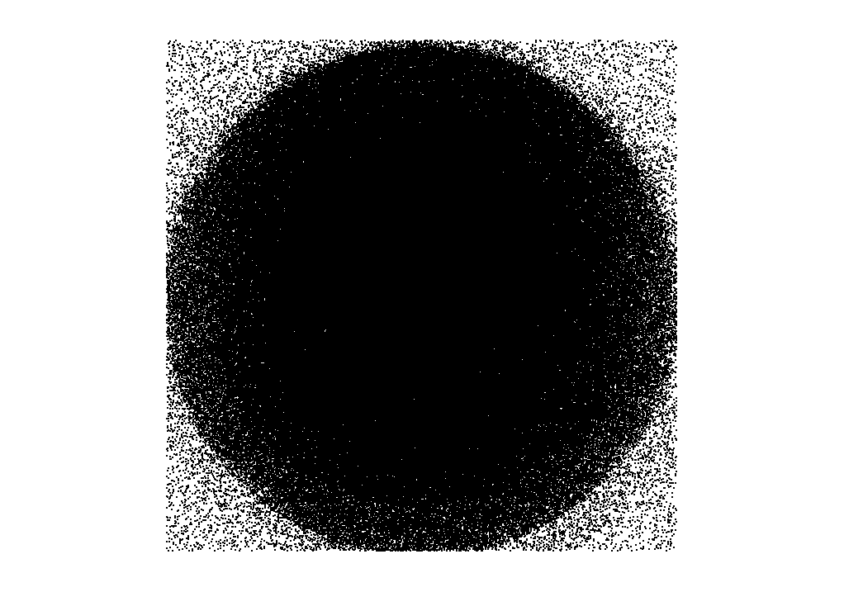

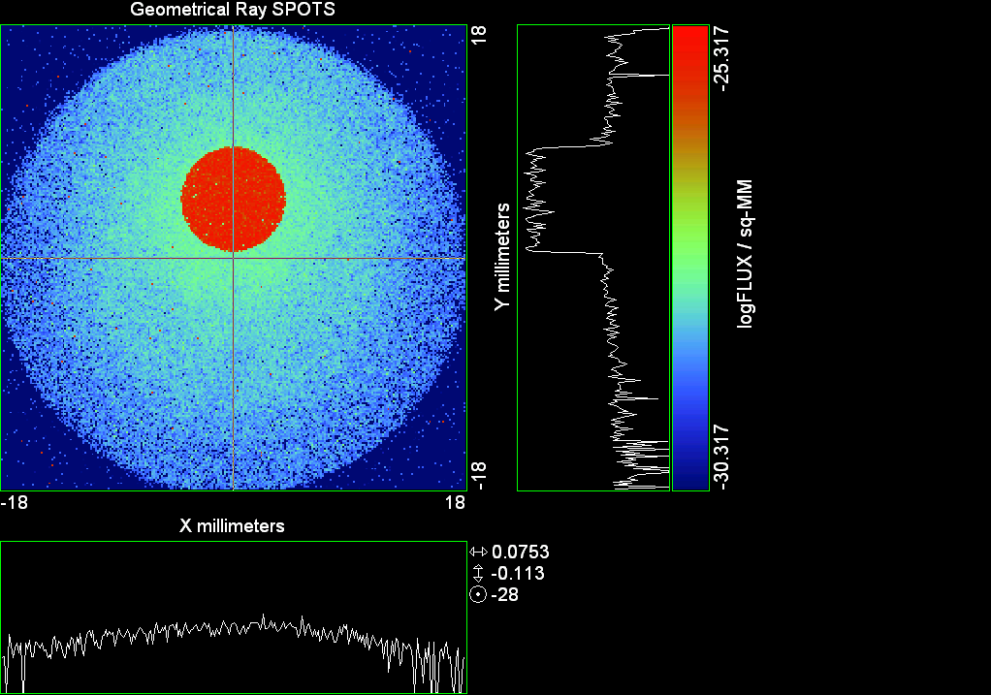

--- ! Spot Plot (Run Ray Trace First)
--- !!CONSIDER ONLY 6 !!Grid Detector=6
--- CONSIDER ONLY 7 !! Earth Detector=7
--- OBLIQUE OFF
--- !!TITLE 'FOV1-9/19^2 mm^2=15503 Rays'
--- !!TITLE 'FOV8 Rect Source Det=2170 total rays'
--- !!TITLE 'FOV8 RctSrc Det=1357-1348=11 rays from Pedestals DetImplBafOnly'
--- !!TITLE 'FOV8 RctSrc Det=750 rays "On"Mrlts Pd&SbS=0 DtImplBfOnly'
--- !!TITLE 'FOV8 RctSrc Det=754 rays "On"Mrlts Pd=1 SbS=0 DtImplBfOnly'
--- !!TITLE 'FOV8 3x3 Pt Src =215 rays "On"Mrlts Pd=1 SbS=0 DtImplBfOnly'
--- TITLE '1.5E6 KM to Source at L1 Distance'
--- !!WINDOW Y X
--- WINDOW Y -18 18 X -18 18
--- !!WINDOW Y 11 14 X -1.5 1.5
--- !!TITLE 'FOV8 23x23 1358-678=680 Rays/.109 mm^2 = 6238 Rays/mm^2 5.5%'
--- !!WINDOW Y 135.75 136.25 X 82.5 83 !!FOV 8
--- !!TITLE 'FOV8 3x3 Core 678 Rays/.006mm^2 = 113000 Rays/mm^2'
--- !!WINDOW Y 136.01 136.07 X 82.75 82.85 !!FOV 8
--- PIXELS 256
--- SPOTS POSITION

Distribution of data within:
Window Vertical: Y = -18.0000 to 18.0000 ( 36.0000 )
Horizontal: X = -18.0000 to 18.0000 ( 36.0000 )

Opening NEW distribution file 9: C:\ASAP Work\TRIANA\bro009.dat
Rays Flux
638440 0.818408E-24
Maximum = 4.8161949E-26 minimum = 0.0000000E+00
--- $IO "ASAPTEMP.INR"
Opening 1 C:\ASAP Work\TRIANA\asaptemp.inr

Closing 7 C:\ASAP Work\TRIANA\bro007.dat
Opening 7 C:\ASAP Work\TRIANA\asaptemp.usr

Closing 20 C:\ASAP Work\TRIANA\bro020.dat
Opening 20 C:\ASAP Work\TRIANA\asaptemp.plr

Closing 30 C:\ASAP Work\TRIANA\bro030.dat
Opening 30 C:\ASAP Work\TRIANA\asaptemp.vcr

--- !! PICTURE (Run Ray Trace and Spots Position First)
--- !! Picks size from Spots Position window size
--- TITLE 'EPIC'
--- CONSIDER ONLY 7 !! Detector = 6 for Grid, 7 for Earth
--- !!WINDOW X -1.5 1.5 Y 11 14
--- WINDOW Y X
--- DISPLAY
Opening OLD distribution file 9: C:\ASAP Work\TRIANA\bro009.dat

File header:
Geometrical Ray SPOTS 1
Z 790.7430 FLUX / sq-MM
X millimeters -18.00000 18.00000 256
Y millimeters -18.00000 18.00000 256

Statistics on 256 by 256 data set:
FLUX / sq-MM Location Y millimeters X millimeters
Minimum 0.000000 3 1 -17.64844 -17.92969
Maximum 0.4816195E-25 185 132 7.945312 0.4921875
Average 0.6314872E-27 159 128 4.289062 -0.7031250E-01
TOTAL FLUX = 0.8184073E-24

--- AVERAGE 0 0
Statistics on 256 by 256 data set:
FLUX / sq-MM Location Y millimeters X millimeters
Minimum 0.000000 3 1 -17.64844 -17.92969
Maximum 0.4816195E-25 185 132 7.945312 0.4921875
Average 0.6314872E-27 159 128 4.289062 -0.7031250E-01
TOTAL FLUX = 0.8184073E-24

--- FORM -5
Statistics on 256 by 256 data set:
FLUX / sq-MM Location Y millimeters X millimeters
Minimum -30.31730 1 1 -17.92969 -17.92969
Maximum -25.31730 185 132 7.945312 0.4921875
Average -28.94223 134 128 0.7734375 -0.7031250E-01
Integral = -37509.14

--- !!CONTOUR .001 .005 .01 .05 .1 .2 .3 .4 .5 .6 .7 .8 .85 .9 .95 GRID 2
--- PICTURE
Opening NEW distribution file 10: C:\ASAP Work\TRIANA\i.dis
--- $IO "ASAPTEMP.INR"
Opening 1 C:\ASAP Work\TRIANA\asaptemp.inr

Closing 7 C:\ASAP Work\TRIANA\bro007.dat
Opening 7 C:\ASAP Work\TRIANA\asaptemp.usr

Closing 20 C:\ASAP Work\TRIANA\bro020.dat
Creating 20 C:\ASAP Work\TRIANA\asaptemp.plr

Closing 30 C:\ASAP Work\TRIANA\bro030.dat
Creating 30 C:\ASAP Work\TRIANA\asaptemp.vcr

--- DISPLAY
Opening OLD distribution file 9: C:\ASAP Work\TRIANA\bro009.dat

File header:
Geometrical Ray SPOTS 1
Z 790.7430 FLUX / sq-MM
X millimeters -18.00000 18.00000 256
Y millimeters -18.00000 18.00000 256

Statistics on 256 by 256 data set:
FLUX / sq-MM Location Y millimeters X millimeters
Minimum 0.000000 3 1 -17.64844 -17.92969
Maximum 0.4816195E-25 185 132 7.945312 0.4921875
Average 0.6314872E-27 159 128 4.289062 -0.7031250E-01
TOTAL FLUX = 0.8184073E-24

--- TEXTFILE X_Text_Output !!Names Text File, overwrites without warning
--- DATA 'E12.5' !! Format with single blank space
--- EOF

Run 12 Offset 0.375 0.16 deg 40k rays.xls

Run 13 Offset 0.625 0.16 deg 40k rays

--- END

System database and settings have been reinitialized
--- $IO "ASAPTEMP.INR"
Opening 1 C:\ASAP Work\TRIANA\asaptemp.inr

Closing 7 C:\ASAP Work\TRIANA\bro007.dat
Opening 7 C:\ASAP Work\TRIANA\asaptemp.usr

Closing 20 C:\ASAP Work\TRIANA\bro020.dat
Creating 20 C:\ASAP Work\TRIANA\asaptemp.plr

Closing 30 C:\ASAP Work\TRIANA\bro030.dat
Creating 30 C:\ASAP Work\TRIANA\asaptemp.vcr

--- !! Directed Diffuser Example
--- !! Create a source (Disk or Grid)
--- !! Source hits a diffuser in close proximity to source
--- !! diffuser scatters towards an edge for efficient ray tracing
--- SYSTEM NEW
--- RESET
--- UNITS MILLIMETERS
--- !! Setup for 1500 meter test
--- EDGE (EP=1000) !! Assign edge number to reference later with TOWARDS
--- ELLIPSE Z -200 225 225
--- !! Diffusion Model
--- MODEL
--- LAMBERTIAN 1
Angle Relative TIS Sampling
0.0 1.00 1000 radial

--- RETURN
--- CUTOFF (1.0E-40) 50 !! Default=1.0E-18 1/4pir2=3.5E-26
--- !! Scattering Plate is at L1, Source Disk is 1 meter farther away
--- !! L1 is at 1.5E6 km 1.5E9 m 1.5E12 mm
--- !! Except for scale factor, dimensions are in km
--- SCALE=1E6 !! S=1 for mm; 1E3 m; 1E6 km
--- !! Set source offset in "km" if scale = 1E6. Usually DX or DY only.
--- DX=0*(SCALE)
--- !!DY=0*(SCALE) !! 0=pixel 1024, centered
--- !!DY=-4718*(SCALE) !! -4718=pixel 512, +4718=pixel 1536, centered
--- DY=2359*(SCALE) !! -2359=pixel 768, +2359=pixel 1280, centered
--- DZ=0*(SCALE)
--- !!SRAD=523.6 !!=0.04 deg diam
--- !!SRAD=1047.2 !!=0.08 deg diam
--- SRAD=2094.4 !!=0.16 deg diam
--- !!SRAD=2618.0 !!=0.20 deg diam
--- !!SRAD=4188.8 !!=0.32 deg diam
--- !!SRAD=6283.2 !!=0.48 deg diam
--- !!SRAD=8508.6 !!=0.65 deg diam
--- !!SRAD=10472.1 !!=0.80 deg diam
--- !! Spherical Earth Radius = 6371 km
--- LEVEL 2 0. !! Suggested by BRO Tech Support
--- SURFACE
--- PLANE Z ((-1.5E6)*(SCALE)) ELLIPSE (SRAD*(SCALE)) (SRAD*(SCALE)) 0 (DX) (DY)
--- OBJECT 'DIFFUSION'
--- INTERFACE 0 1E-12 !! Only allow scatter rays to transmit
--- SCATTER MODEL 1 RANDOM 1 1 !! RANDOM needed to find edge, else low light problems
--- TOWARDS (EP) 1
--- RETURN
--- !! Emitter
--- NRAYS=40000 !! 1000=32 sec 40000=20 minutes 200000
--- EMIT DISK Z ((-1.500001E6)*(SCALE)) (SRAD*(SCALE)) (SRAD*(SCALE)) (NRAYS) 1 1
Total flux in rays created by this emitter is 3.0458655E-04
--- SHIFT (DX) (DY) (DZ)
--- RETURN
--- UNITS MILLIMETERS
--- WAVELENGTHS 0.950000 0.706000 0.587560 0.435000 0.300000 MICRONS
--- MEDIA; 1.45106513 1.45515708 1.45846375 1.46676272 1.48779297 'SILICA'
--- COATING PROPERTIES; 1 0 'WHITE'
--- COATING PROPERTIES; .98 0 'MIRROR'
--- COATING PROPERTIES; .11 .87 'DETECTORQE317'
--- COATING PROPERTIES; .10 .75 'DETECTORQE325'
--- COATING PROPERTIES; .05 0 'BLACK'
--- COATING PROPERTIES; 0 0 'ZERO'
--- COATING PROPERTIES; 0 1 'CLEAR'
--- STRUE=0
--- SX=0
--- SY=0
--- SZ=0
--- SCAT=1
--- ENT OBJECT;MIRROR Z 439.24 159 (1219.2/2) -1 (38.2/159) 'PRIMARY S1'
--- INTERFACE COATING MIRROR AIR AIR
--- ENT OBJECT;TUBE Z 438.5 38.2 38.2 466.53196 38.2 38.2 0.0 0.0 'PRIMARYHOLE'
--- INTERFACE COATING BLACK AIR AIR
--- SCATTER RANDOM 1 (SCAT) 1.57 ABS 1 0
--- ENT OBJECT;PLANE Z 466.5 ELLIPSE 210 210 (38.2/210) 'PRIMARY BACK'
--- INTERFACE COATING BLACK AIR AIR
--- SCATTER RANDOM 1 (SCAT) 1.57 ABS 1 0
--- ENT OBJECT;TUBE Z 429 159 159 466.5 159 159 0.0 0.0 'PRIMARYEDGE'
--- INTERFACE COATING BLACK AIR AIR
--- SCATTER RANDOM 1 (SCAT) 1.57 ABS 1 0
--- ENT OBJECT;MIRROR Z 0.0 46 (434.7/2) -2.40763 0.0 'SECONDARY S2'
--- INTERFACE COATING MIRROR AIR AIR
--- ENT OBJECT;PLANE Z 790.7429896 RECTANGLE 18 18 0 'DETECTOR'
--- INTERFACE COATING ZERO SILICA AIR
--- ENT OBJECT;PLANE Z 790.7 RECTANGLE 18 18 0 'DETECTOR-COVER'
--- INTERFACE COATING DETECTORQE317 SILICA AIR
*** SPLIT automatically set to 1
--- ENT OBJECT;PLANE Z -55.69204 ELLIPSE 210 210 (154.8315449/210) 'SPIDER'
--- INTERFACE COATING BLACK AIR AIR
--- SCATTER RANDOM 1 (SCAT) 1.57 ABS 1 0
--- ENT OBJECT;TUBE Z -55.69204 154.8315449 154.8315449 -30.29204 154.8315449 154.8315449 0.0 0.0 'SPIDERCYL'
--- INTERFACE COATING BLACK AIR AIR
--- SCATTER RANDOM 1 (SCAT) 1.57 ABS 1 0
--- ENT OBJECT;TUBE X 0 0.75 12.52 -170 0.75 15.52 1 1 'SPIDERARMX'
--- SHIFT 0 -52.578 -42.992
--- INTERFACE COATING BLACK AIR AIR
--- SCATTER RANDOM 1 (SCAT) 1.57 ABS 1 0
--- ENT OBJECT;TUBE X 0 5 12.52 -170 5 15.52 1 1 'SPIDERARMX1'
--- SHIFT 0 -52.578 -42.992
--- ROTATE Z -120 0 0
--- INTERFACE COATING BLACK AIR AIR
--- SCATTER RANDOM 1 (SCAT) 1.57 ABS 1 0
--- ENT OBJECT;TUBE X 0 0.75 12.52 -170 0.75 15.52 1 1 'SPIDERARMX2'
--- SHIFT 0 -52.578 -42.992
--- ROTATE Z -240 0 0
--- INTERFACE COATING BLACK AIR AIR
--- SCATTER RANDOM 1 (SCAT) 1.57 ABS 1 0
--- ENT OBJECT;TUBE Z -185.6 200.8 200.8 528 200.8 200.8 0.0 0.0 'BARRELBAFFLE'
--- INTERFACE COATING BLACK AIR AIR
--- SCATTER RANDOM 1 (SCAT) 1.57 ABS 1 0
--- ENT OBJECT;ELLIPSE Z -200 205 205 64 0.0 360.0 'ENTRANCE'
Default ELLIP/ROUND/OVAL segments changed to 64
--- INTERFACE COATING CLEAR AIR AIR
--- ENT OBJECT;TUBE Z (2.391*25.4) (2.546*25.4) (2.546*25.4) (2.164*25.4) (2.546*25.4) (2.546*25.4) 0.0 0.0 'SECONDARYHOUSING'
--- INTERFACE COATING BLACK AIR AIR
--- SCATTER RANDOM 1 (SCAT) 1.57 ABS 1 0
--- ENT OBJECT;TUBE Z (2.164*25.4) (2.546*25.4) (2.546*25.4) 0 (2*25.4) (2*25.4) 0.0 0.0 'SH-CONE'
--- INTERFACE COATING BLACK AIR AIR
--- SCATTER RANDOM 1 (SCAT) 1.57 ABS 1 0
--- ENT OBJECT;PLANE Z 0.0 ELLIPSE (2.45*25.4) (2.45*25.4) (2.00/2.45) 'SH-CONEBASE'
--- INTERFACE COATING BLACK AIR AIR
--- SCATTER RANDOM 1 (SCAT) 1.57 ABS 1 0
--- ENT OBJECT;TUBE Z 0.0 (2.125*25.4) (2.125*25.4) (-6.875*25.4) (2.125*25.4) (2.125*25.4) 0.0 0.0 'SH-CYLINDER'
--- INTERFACE COATING BLACK AIR AIR
--- SCATTER RANDOM 1 (SCAT) 1.57 ABS 1 0
--- ENT OBJECT;PLANE Z (-6.875*25.4) ELLIPSE (2.33*25.4) 'SH-TOP'
--- INTERFACE COATING BLACK AIR AIR
--- SCATTER RANDOM 1 (SCAT) 1.57 ABS 1 0
--- ENT OBJECT;PLANE Z (-1.9*25.4) ELLIPSE (2.546*25.4) 'SH-MIDVANE'
--- INTERFACE COATING BLACK AIR AIR
--- SCATTER RANDOM 1 (SCAT) 1.57 ABS 1 0
--- ENT OBJECT;TUBE Z 226.38766 37.465 37.465 422.98366 37.465 37.465 0.0 0.0 'CBAF-FRONT'
--- INTERFACE COATING BLACK AIR AIR
--- SCATTER RANDOM 1 (SCAT) 1.57 ABS 1 0
--- ENT OBJECT;PLANE Z 422.98366 ELLIPSE 37.485 37.485 (30.5562/37.485) 'CBAF-LEDGE'
--- INTERFACE COATING BLACK AIR AIR
--- SCATTER RANDOM 1 (SCAT) 1.57 ABS 1 0
--- ENT OBJECT;TUBE Z 422.985 32.2072 32.2072 532.45766 32.2072 32.2072 0.0 0.0 'CBAF-AFT'
--- INTERFACE COATING BLACK AIR AIR
--- SCATTER RANDOM 1 (SCAT) 1.57 ABS 1 0
--- ENT OBJECT;PLANE Z 327.98766 ELLIPSE 37.485 37.485 (35.56/37.485) 'CBAF-VANE1'
--- INTERFACE COATING BLACK AIR AIR
--- SCATTER RANDOM 1 (SCAT) 1.57 ABS 1 0
--- ENT OBJECT;PLANE Z 378.78766 ELLIPSE 37.485 37.485 (35.56/37.485) 'CBAF-VANE2'
--- INTERFACE COATING BLACK AIR AIR
--- SCATTER RANDOM 1 (SCAT) 1.57 ABS 1 0
--- ENT OBJECT;PLANE Z 505.53366 ELLIPSE 32.24 32.24 (28.6512/32.24) 'CBAF-VANE3'
--- INTERFACE COATING BLACK AIR AIR
--- SCATTER RANDOM 1 (SCAT) 1.57 ABS 1 0
--- RETURN
--- !! Geometry is being appended to system.
--- !! To not view this message, refer to ASAP preferences dialog,
--- !! or change the Options->Append Geometry menu item.
--- UNITS MILLIMETERS
--- WAVELENGTHS 0.950000 0.706000 0.587560 0.435000 0.300000 MICRONS
--- MEDIA; 1.45106513 1.45515708 1.45846375 1.46676272 1.48779297 'SILICA'
--- COATING PROPERTIES; .98 0 'MIRROR'
--- COATING PROPERTIES; .05 0 'BLACK'
--- COATING PROPERTIES; 0 0 'ZERO'
--- COATING PROPERTIES; 0 1 'CLEAR'
--- COATING PROPERTIES; .05 .95 'ARF05'
--- COATING PROPERTIES; 0.2 0.8 'ARF20'
--- ENT OBJECT;PLANE Z 615.3400000 ELLIPSE 150 150 (22/150) 'LENS MOUNT'
--- INTERFACE COATING BLACK AIR AIR
--- SCATTER RANDOM 1 (SCAT) 1.57 ABS 1 0
--- ENT OBJECT;TUBE Z 558.61966 26.7 26.7 620 26.7 26.7 0.0 0.0 'LENS TUBE-FRONT'
--- INTERFACE COATING BLACK AIR AIR
--- SCATTER RANDOM 1 (SCAT) 1.57 ABS 1 0
--- ENT OBJECT;PLANE Z 558.61966 ELLIPSE 27.7 27.7 (24.945/27.7) 'LT-FACE'
--- INTERFACE COATING BLACK AIR AIR
--- SCATTER RANDOM 1 (SCAT) 1.57 ABS 1 0
--- ENT OBJECT;PLANE Z 616.4326 ELLIPSE 27.7 27.7 (21.5/27.7) 'LT-LENS 1FACE'
--- INTERFACE COATING BLACK AIR AIR
--- SCATTER RANDOM 1 (SCAT) 1.57 ABS 1 0
--- ENT OBJECT;TUBE Z 621 25.152 25.152 657.7965 25.152 25.152 0.0 0.0 'LENS TUBE AFT'
--- INTERFACE COATING BLACK AIR AIR
--- SCATTER RANDOM 1 (SCAT) 1.57 ABS 1 0
--- ENT OBJECT;PLANE Z 657.7965 ELLIPSE 25.152 25.152 (21.26386619/25.152) 'LT-AFT FACE'
--- INTERFACE COATING BLACK AIR AIR
--- SCATTER RANDOM 1 (SCAT) 1.57 ABS 1 0
--- ENT OBJECT;OPTICAL Z 615.3400000 221.803 0 ELLIPSE 22 'LENS1F'
--- INTERFACE COATING ARF05 AIR SILICA
--- ENT OBJECT;OPTICAL Z 620.3400000 584.5 0 ELLIPSE 22 'LENS1B'
--- INTERFACE COATING ARF05 AIR SILICA
--- ENT OBJECT;OPTICAL Z 627.63 -147.027 0 ELLIPSE 22 'LENS2F'
--- INTERFACE COATING ARF05 AIR SILICA
--- ENT OBJECT;OPTICAL Z 632.63 -135.158 0 ELLIPSE 22 'LENS2B'
--- INTERFACE COATING ARF05 AIR SILICA
--- ENT OBJECT;OPTICAL Z 635.6 97.002 0 ELLIPSE 22 'LENS3F'
--- INTERFACE COATING ARF05 AIR SILICA
--- ENT OBJECT;OPTICAL Z 640.6 67.147 0 ELLIPSE 22 'LENS3B'
--- INTERFACE COATING ARF05 AIR SILICA
--- ENT OBJECT;TUBE Z 614 22 22 645 22 22 0.0 0.0 'LENSHOLDER'
--- INTERFACE COATING ZERO AIR AIR
--- SCATTER RANDOM 1 (SCAT) 1.57 ABS 1 0
--- ENT OBJECT;PLANE Z 660.84196 ELLIPSE 150 150 (25.28148817/150) 'FW-HOUSING FRONT'
--- INTERFACE COATING BLACK AIR AIR
--- SCATTER RANDOM 1 (SCAT) 1.57 ABS 1 0
--- ENT OBJECT;PLANE Z 709.10196 ELLIPSE 150 150 (25.28148817/150) 'FW-HOUSING AFT'
--- INTERFACE COATING BLACK AIR AIR
--- SCATTER RANDOM 1 (SCAT) 1.57 ABS 1 0
--- ENT OBJECT;TUBE Z (673.54196-.3) 27.5 27.5 (680.04436+.3) 27.5 27.5 0.0 0.0 'FILTERHOLDER'
--- INTERFACE COATING BLACK AIR AIR
--- SCATTER RANDOM 1 (SCAT) 1.57 ABS 1 0
--- ENT OBJECT;PLANE Z 675 ELLIPSE 150 150 (27.5/150) 'FILTER-WHEEL'
--- INTERFACE COATING BLACK AIR AIR
--- SCATTER RANDOM 1 (SCAT) 1.57 ABS 1 0
--- ENT OBJECT;TUBE Z 721.59876 19.16979665 19.16979665 723.53932 22.558 22.558 0.0 0.0 'EXIT CONE FRONT'
--- INTERFACE COATING BLACK AIR AIR
--- SCATTER RANDOM 1 (SCAT) 1.57 ABS 1 0
--- ENT OBJECT;TUBE Z 723.53932 22.558 22.558 781.84248 22.558 22.558 0.0 0.0 'EC-CYLINDER'
--- INTERFACE COATING BLACK AIR AIR
--- SCATTER RANDOM 1 (SCAT) 1.57 ABS 1 0
--- ENT OBJECT;PLANE Z 781.84248 ELLIPSE 22.558 22.558 (16.89/22.558) 'EC-SHELF'
--- INTERFACE COATING BLACK AIR AIR
--- SCATTER RANDOM 1 (SCAT) 1.57 ABS 1 0
--- ENT OBJECT;TUBE Z 781.84248 16.89 16.89 783.87448 20.41280351 20.41280351 0.0 0.0 'EC-EXITCONE'
--- INTERFACE COATING BLACK AIR AIR
--- SCATTER RANDOM 1 (SCAT) 1.57 ABS 1 0
--- ENT OBJECT;PLANE Z 783.87448 ELLIPSE 50 50 (20.41280351/50) 'EC-EXIT'
--- INTERFACE COATING BLACK AIR AIR
--- SCATTER RANDOM 1 (SCAT) 1.57 ABS 1 0
--- RETURN
--- $IO "ASAPTEMP.INR"
Opening 1 C:\ASAP Work\TRIANA\asaptemp.inr

Closing 7 C:\ASAP Work\TRIANA\bro007.dat
Opening 7 C:\ASAP Work\TRIANA\asaptemp.usr

Closing 20 C:\ASAP Work\TRIANA\bro020.dat
Creating 20 C:\ASAP Work\TRIANA\asaptemp.plr

Closing 30 C:\ASAP Work\TRIANA\bro030.dat
Creating 30 C:\ASAP Work\TRIANA\asaptemp.vcr

--- !! Filters-2 from .ent/copy/.inr to allow ABSORBing media
--- UNITS MILLIMETERS
--- WAVELENGTHS 0.950000 0.706000 0.587560 0.435000 0.300000 MICRONS
--- MEDIA; 1.45106513 1.45515708 1.45846375 1.46676272 1.48779297 'SILICA'
--- !!COATING PROPERTIES; .98 0 'MIRROR'
--- !!COATING PROPERTIES; .05 0 'BLACK'
--- !!COATING PROPERTIES; 0 0 'ZERO'
--- !!COATING PROPERTIES; 0 1 'CLEAR'
--- COATING PROPERTIES; .0745 .9255 'ARF0745'
--- COATING PROPERTIES; .0525 .9475 'ARF0525'
--- COATING PROPERTIES; .05 .95 'ARF05'
--- COATING PROPERTIES; .005 .995 'ARF005'
--- !!COATING PROPERTIES; 0.2 0.8 'ARF20'
--- !!!!!!!!!!!!!!!!!!!!!!!!!!!!!!!!!!!!!!!!!!!!!!!!!!
--- WAVELENGTH 0.317 MICRONS
--- MEDIA
--- 1.48342884 ABSORB 0.13168 'BLOCKER317'
--- MEDIA
--- 1.48342884 ABSORB 0.00307 'ETALON317'
--- !!!!!!!!!!!!!!!!!!!!!!!!!!!!!!!!!!!!!!!!!!!!!!!!!!
--- !!WAVELENGTH 0.325 MICRONS
--- !!MEDIA
--- !! 1.48163777 ABSORB 0.08074 'BLOCKER325'
--- !!MEDIA
--- !! 1.48163777 ABSORB 0.0415179525 'ETALON325'
--- !!!!!!!!!!!!!!!!!!!!!!!!!!!!!!!!!!!!!!!!!!!!!!!!!!!!!
--- ENT OBJECT;PLANE Z 673.54196 ELLIPSE 27.5 'FILTERUVE-F'
--- INTERFACE COATING ARF0525 AIR ETALON317
--- !! INTERFACE COATING ARF0745 AIR ETALON325
--- ENT OBJECT;PLANE Z 676.71696 ELLIPSE 27.5 'FILTERUVE-B'
--- INTERFACE COATING ARF0525 AIR ETALON317
--- !! INTERFACE COATING ARF0745 AIR ETALON325
--- ENT OBJECT;PLANE Z 676.86936 ELLIPSE 27.5 'FILTERUVB-F'
--- INTERFACE COATING ARF005 AIR BLOCKER317
--- !! INTERFACE COATING ARF005 AIR BLOCKER325
--- ENT OBJECT;PLANE Z 680.04436 ELLIPSE 27.5 'FILTERUVB-B'
--- INTERFACE COATING ARF005 AIR BLOCKER317
--- !! INTERFACE COATING ARF005 AIR BLOCKER325
--- !!RETURN

--- TITLE DCE *Raytrace
--- !! WAVELENGTHS 0.317 MICRONS !! Normally set in filters
--- !!SPLIT 0 !! Direct Trace Only
--- !!SPLIT 1 !! For Rect Sources
--- SPLIT 2 !! For double reflection in lens & filters
--- PLOT FACETS 5 5
Window Vertical: Y = -210.000 to 0.445340E+10 (0.445340E+10)
Horizontal: Z = -.150004E+13 to 791.121 (0.150004E+13)

--- CONSIDER ALL
--- !!CONSIDER ONLY 15
--- ARROWS OFF
--- SEGMENTS 9
--- WINDOW Y Z
--- OBLIQUE 0 0
--- MISSED LINE 50
--- TRACE PLOT 1000 OVERLAY
Window Vertical: Y = -210.000 to 0.445340E+10 (0.445340E+10)
Horizontal: Z = -.150004E+13 to 791.121 (0.150004E+13)

Warning *** Convergence failure in root polishing .1467731E-04
35 *** Convergence failure in root polishing .1838549E-02
24.03 seconds ( 14.59 seconds CPU) to trace 80,000
out of 214,791
Warning *** Convergence failure in root polishing .2478256E-04
35 *** Convergence failure in root polishing .2020025E-04
81.24 seconds ( 49.44 seconds CPU) to trace 160,000
out of 607,107
2.47 minutes ( 102.60 seconds CPU) to trace 240,000
out of 1,200,830
3.33 minutes ( 2.51 minutes CPU) to trace 320,000
out of 1,733,003
3.94 minutes ( 3.09 minutes CPU) to trace 400,000
out of 1,852,078
4.55 minutes ( 3.66 minutes CPU) to trace 480,000
out of 1,969,621
5.17 minutes ( 4.23 minutes CPU) to trace 560,000
out of 2,090,624
5.79 minutes ( 4.81 minutes CPU) to trace 640,000
out of 2,208,050
6.40 minutes ( 5.38 minutes CPU) to trace 720,000
out of 2,326,639
7.01 minutes ( 5.96 minutes CPU) to trace 800,000
out of 2,447,127
7.68 minutes ( 6.53 minutes CPU) to trace 880,000
out of 2,565,969
8.29 minutes ( 7.11 minutes CPU) to trace 960,000
out of 2,686,454
8.90 minutes ( 7.68 minutes CPU) to trace 1,040,000
out of 2,805,410
9.50 minutes ( 8.26 minutes CPU) to trace 1,120,000
out of 2,924,857
10.11 minutes ( 8.84 minutes CPU) to trace 1,200,000
out of 3,045,912
10.72 minutes ( 9.42 minutes CPU) to trace 1,280,000
out of 3,165,084
11.33 minutes ( 9.99 minutes CPU) to trace 1,360,000
out of 3,283,864
11.93 minutes ( 10.57 minutes CPU) to trace 1,440,000
out of 3,402,881
12.55 minutes ( 11.15 minutes CPU) to trace 1,520,000
out of 3,522,735
13.16 minutes ( 11.73 minutes CPU) to trace 1,600,000
out of 3,643,240
13.76 minutes ( 12.31 minutes CPU) to trace 1,680,000
out of 3,762,885
14.17 minutes ( 12.69 minutes CPU) to trace 1,760,000
out of 3,819,971
14.40 minutes ( 12.90 minutes CPU) to trace 1,840,000
14.63 minutes ( 13.12 minutes CPU) to trace 1,920,000
14.87 minutes ( 13.34 minutes CPU) to trace 2,000,000
15.10 minutes ( 13.55 minutes CPU) to trace 2,080,000
15.34 minutes ( 13.77 minutes CPU) to trace 2,160,000
15.57 minutes ( 13.98 minutes CPU) to trace 2,240,000
15.84 minutes ( 14.20 minutes CPU) to trace 2,320,000
16.07 minutes ( 14.42 minutes CPU) to trace 2,400,000
16.37 minutes ( 14.63 minutes CPU) to trace 2,480,000
16.60 minutes ( 14.85 minutes CPU) to trace 2,560,000
16.84 minutes ( 15.07 minutes CPU) to trace 2,640,000
17.07 minutes ( 15.29 minutes CPU) to trace 2,720,000
17.43 minutes ( 15.50 minutes CPU) to trace 2,800,000
17.75 minutes ( 15.72 minutes CPU) to trace 2,880,000
17.99 minutes ( 15.94 minutes CPU) to trace 2,960,000
18.22 minutes ( 16.15 minutes CPU) to trace 3,040,000
18.46 minutes ( 16.37 minutes CPU) to trace 3,120,000
18.71 minutes ( 16.59 minutes CPU) to trace 3,200,000
18.94 minutes ( 16.81 minutes CPU) to trace 3,280,000
19.17 minutes ( 17.02 minutes CPU) to trace 3,360,000
19.40 minutes ( 17.24 minutes CPU) to trace 3,440,000
19.64 minutes ( 17.46 minutes CPU) to trace 3,520,000
19.87 minutes ( 17.67 minutes CPU) to trace 3,600,000
20.10 minutes ( 17.89 minutes CPU) to trace 3,680,000
20.34 minutes ( 18.10 minutes CPU) to trace 3,760,000
20.51 minutes ( 18.26 minutes CPU) to trace 3,819,971

Total of 3057135 PARENT warnings
Missed Multiple Wrong Low Evanescent Wrong Absorbed
Obj Total After Bounce Side Flux (TIR) Direc After
1 121480 62763 10 58707 DIFFUSION
2 1419 29 1116 274 PRIMARY S1
3 2194 299 13 1882 PRIMARYHOLE
4 98717 34078 379 64260 PRIMARY BACK
5 22606 48 22558 PRIMARYEDGE
6 1235 922 313 SECONDARY S2
7 839 839 DETECTOR
8 5114 74 3448 1592 DETECTOR-COVER
9 45776 3546 246 41984 SPIDER
10 13701 109 92 13500 SPIDERCYL
11 4302 95 39 4168 SPIDERARMX
12 8235 111 78 8046 SPIDERARMX1
13 4383 91 24 4268 SPIDERARMX2
14 307594 5164 1900 300530 BARRELBAFFLE
15 297684 296844 840 ENTRANCE
16 6644 3 39 6602 SECONDARYHOUSING
17 55352 435 332 54585 SH-CONE
18 14210 16 51 14143 SH-CONEBASE
19 88618 1463 539 86616 SH-CYLINDER
20 917 31 6 880 SH-TOP
21 81569 7 397 81165 SH-MIDVANE
22 292786 894 2332 289560 CBAF-FRONT
23 20426 174 20252 CBAF-LEDGE
24 181488 39357 851 141280 CBAF-AFT
25 8400 14 99 8287 CBAF-VANE1
26 9874 6 106 9762 CBAF-VANE2
27 13599 1215 124 12260 CBAF-VANE3
28 74484 31774 255 42455 LENS MOUNT
29 67723 3609 655 63459 LENS TUBE-FRONT
30 7997 285 88 7624 LT-FACE
31 2222 12 32 2178 LT-LENS 1FACE
32 12522 176 244 12102 LENS TUBE AFT
33 6467 43 208 6216 LT-AFT FACE
34 6254 1293 1526 3435 LENS1F
35 7036 1063 2056 3917 LENS1B
36 8722 1348 5272 2102 LENS2F
37 9329 3240 4712 1377 LENS2B
38 12752 2245 7128 3379 LENS3F
39 13001 3307 4807 4887 LENS3B
40 569 191 378 LENSHOLDER
41 50521 10958 459 39104 FW-HOUSING FRONT
42 455243 309184 1525 144534 FW-HOUSING AFT
43 3373 1077 78 2122 96 FILTERHOLDER
44 206329 73126 1456 131747 FILTER-WHEEL
45 29246 6613 595 22038 EXIT CONE FRONT
46 283265 38072 4249 240944 EC-CYLINDER
47 26676 2 818 25856 EC-SHELF
48 5239 4006 28 1205 EC-EXITCONE
49 15930 9769 398 5763 EC-EXIT
50 8930 77 3313 4481 984 75 FILTERUVE-F
51 10935 1763 8187 982 3 FILTERUVE-B
52 11146 3896 4500 1062 1688 FILTERUVB-F
53 12062 8267 1520 37 1063 1175 FILTERUVB-B

Total of 120221 CHILD warnings
Missed Multiple Wrong Low Evanescent Wrong Absorbed
Obj Total After Bounce Side Flux (TIR) Direc After
8 4483 4483 DETECTOR-COVER
34 9252 9252 LENS1F
35 9218 9218 LENS1B
36 12024 12024 LENS2F
37 12023 12023 LENS2B
38 11907 11907 LENS3F
39 11840 11840 LENS3B
50 11730 11730 FILTERUVE-F
51 11737 11737 FILTERUVE-B
52 12967 12967 FILTERUVB-F
53 13040 13040 FILTERUVB-B
24570427 ray-objects encountered at 22422 per CPU second
260831197 order-intersections done at 238033 per CPU second

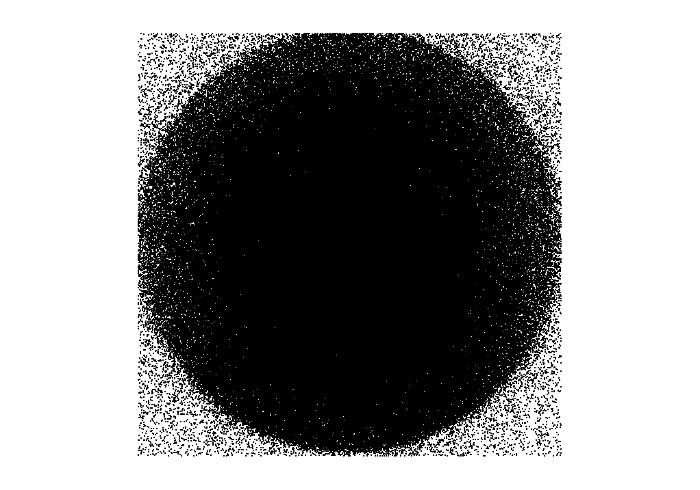

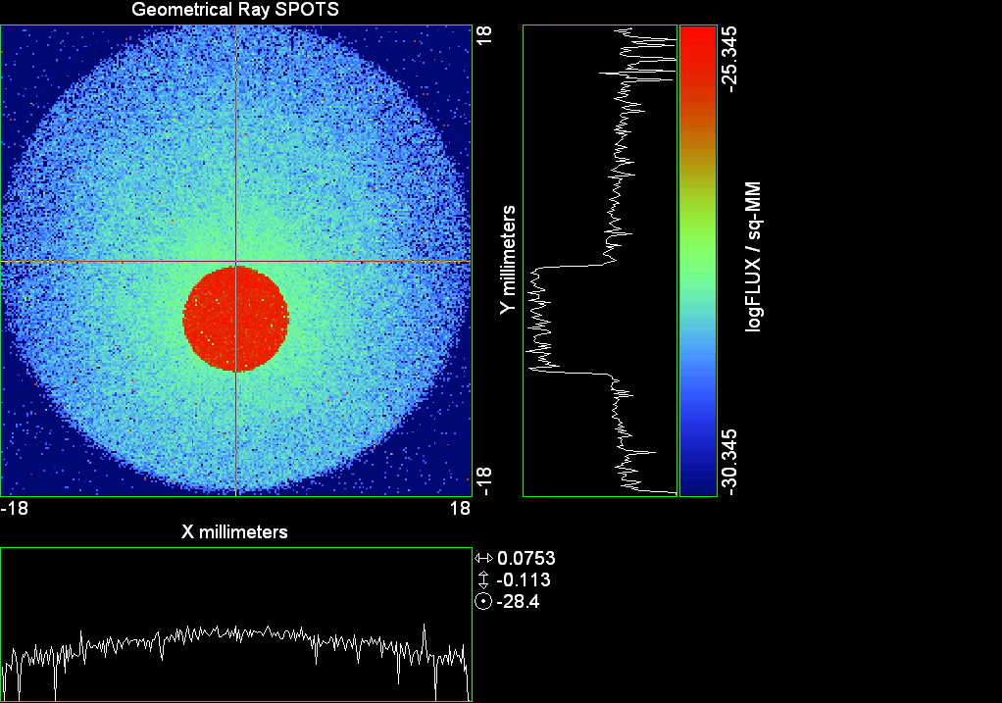

--- ! Spot Plot (Run Ray Trace First)
--- !!CONSIDER ONLY 6 !!Grid Detector=6
--- CONSIDER ONLY 7 !! Earth Detector=7
--- OBLIQUE OFF
--- !!TITLE 'FOV1-9/19^2 mm^2=15503 Rays'
--- !!TITLE 'FOV8 Rect Source Det=2170 total rays'
--- !!TITLE 'FOV8 RctSrc Det=1357-1348=11 rays from Pedestals DetImplBafOnly'
--- !!TITLE 'FOV8 RctSrc Det=750 rays "On"Mrlts Pd&SbS=0 DtImplBfOnly'
--- !!TITLE 'FOV8 RctSrc Det=754 rays "On"Mrlts Pd=1 SbS=0 DtImplBfOnly'
--- !!TITLE 'FOV8 3x3 Pt Src =215 rays "On"Mrlts Pd=1 SbS=0 DtImplBfOnly'
--- TITLE '1.5E6 KM to Source at L1 Distance'
--- !!WINDOW Y X
--- WINDOW Y -18 18 X -18 18
--- !!WINDOW Y 11 14 X -1.5 1.5
--- !!TITLE 'FOV8 23x23 1358-678=680 Rays/.109 mm^2 = 6238 Rays/mm^2 5.5%'
--- !!WINDOW Y 135.75 136.25 X 82.5 83 !!FOV 8
--- !!TITLE 'FOV8 3x3 Core 678 Rays/.006mm^2 = 113000 Rays/mm^2'
--- !!WINDOW Y 136.01 136.07 X 82.75 82.85 !!FOV 8
--- PIXELS 256
--- SPOTS POSITION

Distribution of data within:
Window Vertical: Y = -18.0000 to 18.0000 ( 36.0000 )
Horizontal: X = -18.0000 to 18.0000 ( 36.0000 )

Opening NEW distribution file 9: C:\ASAP Work\TRIANA\bro009.dat
Rays Flux
639011 0.818408E-24
Maximum = 4.5188310E-26 minimum = 0.0000000E+00
--- $IO "ASAPTEMP.INR"
Opening 1 C:\ASAP Work\TRIANA\asaptemp.inr

Closing 7 C:\ASAP Work\TRIANA\bro007.dat
Opening 7 C:\ASAP Work\TRIANA\asaptemp.usr

Closing 20 C:\ASAP Work\TRIANA\bro020.dat
Opening 20 C:\ASAP Work\TRIANA\asaptemp.plr

Closing 30 C:\ASAP Work\TRIANA\bro030.dat
Opening 30 C:\ASAP Work\TRIANA\asaptemp.vcr

--- !! PICTURE (Run Ray Trace and Spots Position First)
--- !! Picks size from Spots Position window size
--- TITLE 'EPIC'
--- CONSIDER ONLY 7 !! Detector = 6 for Grid, 7 for Earth
--- !!WINDOW X -1.5 1.5 Y 11 14
--- WINDOW Y X
--- DISPLAY
Opening OLD distribution file 9: C:\ASAP Work\TRIANA\bro009.dat

File header:
Geometrical Ray SPOTS 1
Z 790.7430 FLUX / sq-MM
X millimeters -18.00000 18.00000 256
Y millimeters -18.00000 18.00000 256

Statistics on 256 by 256 data set:
FLUX / sq-MM Location Y millimeters X millimeters
Minimum 0.000000 2 1 -17.78906 -17.92969
Maximum 0.4518831E-25 121 132 -1.054688 0.4921875
Average 0.6314869E-27 98 129 -4.289062 0.7031250E-01
TOTAL FLUX = 0.8184070E-24

--- AVERAGE 0 0
Statistics on 256 by 256 data set:
FLUX / sq-MM Location Y millimeters X millimeters
Minimum 0.000000 2 1 -17.78906 -17.92969
Maximum 0.4518831E-25 121 132 -1.054688 0.4921875
Average 0.6314869E-27 98 129 -4.289062 0.7031250E-01
TOTAL FLUX = 0.8184070E-24

--- FORM -5
Statistics on 256 by 256 data set:
FLUX / sq-MM Location Y millimeters X millimeters
Minimum -30.34497 1 1 -17.92969 -17.92969
Maximum -25.34497 121 132 -1.054688 0.4921875
Average -28.94947 124 128 -0.6328125 -0.7031250E-01
Integral = -37518.52

--- !!CONTOUR .001 .005 .01 .05 .1 .2 .3 .4 .5 .6 .7 .8 .85 .9 .95 GRID 2
--- PICTURE
Opening NEW distribution file 10: C:\ASAP Work\TRIANA\i.dis
--- $IO "ASAPTEMP.INR"
Opening 1 C:\ASAP Work\TRIANA\asaptemp.inr

Closing 7 C:\ASAP Work\TRIANA\bro007.dat
Opening 7 C:\ASAP Work\TRIANA\asaptemp.usr

Closing 20 C:\ASAP Work\TRIANA\bro020.dat
Creating 20 C:\ASAP Work\TRIANA\asaptemp.plr

Closing 30 C:\ASAP Work\TRIANA\bro030.dat
Creating 30 C:\ASAP Work\TRIANA\asaptemp.vcr

--- DISPLAY
Opening OLD distribution file 9: C:\ASAP Work\TRIANA\bro009.dat

File header:
Geometrical Ray SPOTS 1
Z 790.7430 FLUX / sq-MM
X millimeters -18.00000 18.00000 256
Y millimeters -18.00000 18.00000 256

Statistics on 256 by 256 data set:
FLUX / sq-MM Location Y millimeters X millimeters
Minimum 0.000000 2 1 -17.78906 -17.92969
Maximum 0.4518831E-25 121 132 -1.054688 0.4921875
Average 0.6314869E-27 98 129 -4.289062 0.7031250E-01
TOTAL FLUX = 0.8184070E-24

--- TEXTFILE X_Text_Output !!Names Text File, overwrites without warning
--- DATA 'E12.5' !! Format with single blank space
--- EOF

Run 13 Offset 0.625 0.16 deg 40k rays.xls

Run 14 Offset 0.75 0.16 deg 40k rays

--- END

System database and settings have been reinitialized
--- $IO "ASAPTEMP.INR"
Opening 1 C:\ASAP Work\TRIANA\asaptemp.inr

Closing 7 C:\ASAP Work\TRIANA\bro007.dat
Opening 7 C:\ASAP Work\TRIANA\asaptemp.usr

Closing 20 C:\ASAP Work\TRIANA\bro020.dat
Creating 20 C:\ASAP Work\TRIANA\asaptemp.plr

Closing 30 C:\ASAP Work\TRIANA\bro030.dat
Creating 30 C:\ASAP Work\TRIANA\asaptemp.vcr

--- !! Directed Diffuser Example
--- !! Create a source (Disk or Grid)
--- !! Source hits a diffuser in close proximity to source
--- !! diffuser scatters towards an edge for efficient ray tracing
--- SYSTEM NEW
--- RESET
--- UNITS MILLIMETERS
--- !! Setup for 1500 meter test
--- EDGE (EP=1000) !! Assign edge number to reference later with TOWARDS
--- ELLIPSE Z -200 225 225
--- !! Diffusion Model
--- MODEL
--- LAMBERTIAN 1
Angle Relative TIS Sampling
0.0 1.00 1000 radial

--- RETURN
--- CUTOFF (1.0E-40) 50 !! Default=1.0E-18 1/4pir2=3.5E-26
--- !! Scattering Plate is at L1, Source Disk is 1 meter farther away
--- !! L1 is at 1.5E6 km 1.5E9 m 1.5E12 mm
--- !! Except for scale factor, dimensions are in km
--- SCALE=1E6 !! S=1 for mm; 1E3 m; 1E6 km
--- !! Set source offset in "km" if scale = 1E6. Usually DX or DY only.
--- DX=0*(SCALE)
--- !!DY=0*(SCALE) !! 0=pixel 1024, centered
--- DY=4718*(SCALE) !! -4718=pixel 512, +4718=pixel 1536, centered
--- !!DY=2359*(SCALE) !! -2359=pixel 768, +2359=pixel 1280, centered
--- DZ=0*(SCALE)
--- !!SRAD=523.6 !!=0.04 deg diam
--- !!SRAD=1047.2 !!=0.08 deg diam
--- SRAD=2094.4 !!=0.16 deg diam
--- !!SRAD=2618.0 !!=0.20 deg diam
--- !!SRAD=4188.8 !!=0.32 deg diam
--- !!SRAD=6283.2 !!=0.48 deg diam
--- !!SRAD=8508.6 !!=0.65 deg diam
--- !!SRAD=10472.1 !!=0.80 deg diam
--- !! Spherical Earth Radius = 6371 km
--- LEVEL 2 0. !! Suggested by BRO Tech Support
--- SURFACE
--- PLANE Z ((-1.5E6)*(SCALE)) ELLIPSE (SRAD*(SCALE)) (SRAD*(SCALE)) 0 (DX) (DY)
--- OBJECT 'DIFFUSION'
--- INTERFACE 0 1E-12 !! Only allow scatter rays to transmit
--- SCATTER MODEL 1 RANDOM 1 1 !! RANDOM needed to find edge, else low light problems
--- TOWARDS (EP) 1
--- RETURN
--- !! Emitter
--- NRAYS=40000 !! 1000=32 sec 40000=20 minutes 200000
--- EMIT DISK Z ((-1.500001E6)*(SCALE)) (SRAD*(SCALE)) (SRAD*(SCALE)) (NRAYS) 1 1
Total flux in rays created by this emitter is 3.0458655E-04
--- SHIFT (DX) (DY) (DZ)
--- RETURN
--- UNITS MILLIMETERS
--- WAVELENGTHS 0.950000 0.706000 0.587560 0.435000 0.300000 MICRONS
--- MEDIA; 1.45106513 1.45515708 1.45846375 1.46676272 1.48779297 'SILICA'
--- COATING PROPERTIES; 1 0 'WHITE'
--- COATING PROPERTIES; .98 0 'MIRROR'
--- COATING PROPERTIES; .11 .87 'DETECTORQE317'
--- COATING PROPERTIES; .10 .75 'DETECTORQE325'
--- COATING PROPERTIES; .05 0 'BLACK'
--- COATING PROPERTIES; 0 0 'ZERO'
--- COATING PROPERTIES; 0 1 'CLEAR'
--- STRUE=0
--- SX=0
--- SY=0
--- SZ=0
--- SCAT=1
--- ENT OBJECT;MIRROR Z 439.24 159 (1219.2/2) -1 (38.2/159) 'PRIMARY S1'
--- INTERFACE COATING MIRROR AIR AIR
--- ENT OBJECT;TUBE Z 438.5 38.2 38.2 466.53196 38.2 38.2 0.0 0.0 'PRIMARYHOLE'
--- INTERFACE COATING BLACK AIR AIR
--- SCATTER RANDOM 1 (SCAT) 1.57 ABS 1 0
--- ENT OBJECT;PLANE Z 466.5 ELLIPSE 210 210 (38.2/210) 'PRIMARY BACK'
--- INTERFACE COATING BLACK AIR AIR
--- SCATTER RANDOM 1 (SCAT) 1.57 ABS 1 0
--- ENT OBJECT;TUBE Z 429 159 159 466.5 159 159 0.0 0.0 'PRIMARYEDGE'
--- INTERFACE COATING BLACK AIR AIR
--- SCATTER RANDOM 1 (SCAT) 1.57 ABS 1 0
--- ENT OBJECT;MIRROR Z 0.0 46 (434.7/2) -2.40763 0.0 'SECONDARY S2'
--- INTERFACE COATING MIRROR AIR AIR
--- ENT OBJECT;PLANE Z 790.7429896 RECTANGLE 18 18 0 'DETECTOR'
--- INTERFACE COATING ZERO SILICA AIR
--- ENT OBJECT;PLANE Z 790.7 RECTANGLE 18 18 0 'DETECTOR-COVER'
--- INTERFACE COATING DETECTORQE317 SILICA AIR
*** SPLIT automatically set to 1
--- ENT OBJECT;PLANE Z -55.69204 ELLIPSE 210 210 (154.8315449/210) 'SPIDER'
--- INTERFACE COATING BLACK AIR AIR
--- SCATTER RANDOM 1 (SCAT) 1.57 ABS 1 0
--- ENT OBJECT;TUBE Z -55.69204 154.8315449 154.8315449 -30.29204 154.8315449 154.8315449 0.0 0.0 'SPIDERCYL'
--- INTERFACE COATING BLACK AIR AIR
--- SCATTER RANDOM 1 (SCAT) 1.57 ABS 1 0
--- ENT OBJECT;TUBE X 0 0.75 12.52 -170 0.75 15.52 1 1 'SPIDERARMX'
--- SHIFT 0 -52.578 -42.992
--- INTERFACE COATING BLACK AIR AIR
--- SCATTER RANDOM 1 (SCAT) 1.57 ABS 1 0
--- ENT OBJECT;TUBE X 0 5 12.52 -170 5 15.52 1 1 'SPIDERARMX1'
--- SHIFT 0 -52.578 -42.992
--- ROTATE Z -120 0 0
--- INTERFACE COATING BLACK AIR AIR
--- SCATTER RANDOM 1 (SCAT) 1.57 ABS 1 0
--- ENT OBJECT;TUBE X 0 0.75 12.52 -170 0.75 15.52 1 1 'SPIDERARMX2'
--- SHIFT 0 -52.578 -42.992
--- ROTATE Z -240 0 0
--- INTERFACE COATING BLACK AIR AIR
--- SCATTER RANDOM 1 (SCAT) 1.57 ABS 1 0
--- ENT OBJECT;TUBE Z -185.6 200.8 200.8 528 200.8 200.8 0.0 0.0 'BARRELBAFFLE'
--- INTERFACE COATING BLACK AIR AIR
--- SCATTER RANDOM 1 (SCAT) 1.57 ABS 1 0
--- ENT OBJECT;ELLIPSE Z -200 205 205 64 0.0 360.0 'ENTRANCE'
Default ELLIP/ROUND/OVAL segments changed to 64
--- INTERFACE COATING CLEAR AIR AIR
--- ENT OBJECT;TUBE Z (2.391*25.4) (2.546*25.4) (2.546*25.4) (2.164*25.4) (2.546*25.4) (2.546*25.4) 0.0 0.0 'SECONDARYHOUSING'
--- INTERFACE COATING BLACK AIR AIR
--- SCATTER RANDOM 1 (SCAT) 1.57 ABS 1 0
--- ENT OBJECT;TUBE Z (2.164*25.4) (2.546*25.4) (2.546*25.4) 0 (2*25.4) (2*25.4) 0.0 0.0 'SH-CONE'
--- INTERFACE COATING BLACK AIR AIR
--- SCATTER RANDOM 1 (SCAT) 1.57 ABS 1 0
--- ENT OBJECT;PLANE Z 0.0 ELLIPSE (2.45*25.4) (2.45*25.4) (2.00/2.45) 'SH-CONEBASE'
--- INTERFACE COATING BLACK AIR AIR
--- SCATTER RANDOM 1 (SCAT) 1.57 ABS 1 0
--- ENT OBJECT;TUBE Z 0.0 (2.125*25.4) (2.125*25.4) (-6.875*25.4) (2.125*25.4) (2.125*25.4) 0.0 0.0 'SH-CYLINDER'
--- INTERFACE COATING BLACK AIR AIR
--- SCATTER RANDOM 1 (SCAT) 1.57 ABS 1 0
--- ENT OBJECT;PLANE Z (-6.875*25.4) ELLIPSE (2.33*25.4) 'SH-TOP'
--- INTERFACE COATING BLACK AIR AIR
--- SCATTER RANDOM 1 (SCAT) 1.57 ABS 1 0
--- ENT OBJECT;PLANE Z (-1.9*25.4) ELLIPSE (2.546*25.4) 'SH-MIDVANE'
--- INTERFACE COATING BLACK AIR AIR
--- SCATTER RANDOM 1 (SCAT) 1.57 ABS 1 0
--- ENT OBJECT;TUBE Z 226.38766 37.465 37.465 422.98366 37.465 37.465 0.0 0.0 'CBAF-FRONT'
--- INTERFACE COATING BLACK AIR AIR
--- SCATTER RANDOM 1 (SCAT) 1.57 ABS 1 0
--- ENT OBJECT;PLANE Z 422.98366 ELLIPSE 37.485 37.485 (30.5562/37.485) 'CBAF-LEDGE'
--- INTERFACE COATING BLACK AIR AIR
--- SCATTER RANDOM 1 (SCAT) 1.57 ABS 1 0
--- ENT OBJECT;TUBE Z 422.985 32.2072 32.2072 532.45766 32.2072 32.2072 0.0 0.0 'CBAF-AFT'
--- INTERFACE COATING BLACK AIR AIR
--- SCATTER RANDOM 1 (SCAT) 1.57 ABS 1 0
--- ENT OBJECT;PLANE Z 327.98766 ELLIPSE 37.485 37.485 (35.56/37.485) 'CBAF-VANE1'
--- INTERFACE COATING BLACK AIR AIR
--- SCATTER RANDOM 1 (SCAT) 1.57 ABS 1 0
--- ENT OBJECT;PLANE Z 378.78766 ELLIPSE 37.485 37.485 (35.56/37.485) 'CBAF-VANE2'
--- INTERFACE COATING BLACK AIR AIR
--- SCATTER RANDOM 1 (SCAT) 1.57 ABS 1 0
--- ENT OBJECT;PLANE Z 505.53366 ELLIPSE 32.24 32.24 (28.6512/32.24) 'CBAF-VANE3'
--- INTERFACE COATING BLACK AIR AIR
--- SCATTER RANDOM 1 (SCAT) 1.57 ABS 1 0
--- RETURN
--- !! Geometry is being appended to system.
--- !! To not view this message, refer to ASAP preferences dialog,
--- !! or change the Options->Append Geometry menu item.
--- UNITS MILLIMETERS
--- WAVELENGTHS 0.950000 0.706000 0.587560 0.435000 0.300000 MICRONS
--- MEDIA; 1.45106513 1.45515708 1.45846375 1.46676272 1.48779297 'SILICA'
--- COATING PROPERTIES; .98 0 'MIRROR'
--- COATING PROPERTIES; .05 0 'BLACK'
--- COATING PROPERTIES; 0 0 'ZERO'
--- COATING PROPERTIES; 0 1 'CLEAR'
--- COATING PROPERTIES; .05 .95 'ARF05'
--- COATING PROPERTIES; 0.2 0.8 'ARF20'
--- ENT OBJECT;PLANE Z 615.3400000 ELLIPSE 150 150 (22/150) 'LENS MOUNT'
--- INTERFACE COATING BLACK AIR AIR
--- SCATTER RANDOM 1 (SCAT) 1.57 ABS 1 0
--- ENT OBJECT;TUBE Z 558.61966 26.7 26.7 620 26.7 26.7 0.0 0.0 'LENS TUBE-FRONT'
--- INTERFACE COATING BLACK AIR AIR
--- SCATTER RANDOM 1 (SCAT) 1.57 ABS 1 0
--- ENT OBJECT;PLANE Z 558.61966 ELLIPSE 27.7 27.7 (24.945/27.7) 'LT-FACE'
--- INTERFACE COATING BLACK AIR AIR
--- SCATTER RANDOM 1 (SCAT) 1.57 ABS 1 0
--- ENT OBJECT;PLANE Z 616.4326 ELLIPSE 27.7 27.7 (21.5/27.7) 'LT-LENS 1FACE'
--- INTERFACE COATING BLACK AIR AIR
--- SCATTER RANDOM 1 (SCAT) 1.57 ABS 1 0
--- ENT OBJECT;TUBE Z 621 25.152 25.152 657.7965 25.152 25.152 0.0 0.0 'LENS TUBE AFT'
--- INTERFACE COATING BLACK AIR AIR
--- SCATTER RANDOM 1 (SCAT) 1.57 ABS 1 0
--- ENT OBJECT;PLANE Z 657.7965 ELLIPSE 25.152 25.152 (21.26386619/25.152) 'LT-AFT FACE'
--- INTERFACE COATING BLACK AIR AIR
--- SCATTER RANDOM 1 (SCAT) 1.57 ABS 1 0
--- ENT OBJECT;OPTICAL Z 615.3400000 221.803 0 ELLIPSE 22 'LENS1F'
--- INTERFACE COATING ARF05 AIR SILICA
--- ENT OBJECT;OPTICAL Z 620.3400000 584.5 0 ELLIPSE 22 'LENS1B'
--- INTERFACE COATING ARF05 AIR SILICA
--- ENT OBJECT;OPTICAL Z 627.63 -147.027 0 ELLIPSE 22 'LENS2F'
--- INTERFACE COATING ARF05 AIR SILICA
--- ENT OBJECT;OPTICAL Z 632.63 -135.158 0 ELLIPSE 22 'LENS2B'
--- INTERFACE COATING ARF05 AIR SILICA
--- ENT OBJECT;OPTICAL Z 635.6 97.002 0 ELLIPSE 22 'LENS3F'
--- INTERFACE COATING ARF05 AIR SILICA
--- ENT OBJECT;OPTICAL Z 640.6 67.147 0 ELLIPSE 22 'LENS3B'
--- INTERFACE COATING ARF05 AIR SILICA
--- ENT OBJECT;TUBE Z 614 22 22 645 22 22 0.0 0.0 'LENSHOLDER'
--- INTERFACE COATING ZERO AIR AIR
--- SCATTER RANDOM 1 (SCAT) 1.57 ABS 1 0
--- ENT OBJECT;PLANE Z 660.84196 ELLIPSE 150 150 (25.28148817/150) 'FW-HOUSING FRONT'
--- INTERFACE COATING BLACK AIR AIR
--- SCATTER RANDOM 1 (SCAT) 1.57 ABS 1 0
--- ENT OBJECT;PLANE Z 709.10196 ELLIPSE 150 150 (25.28148817/150) 'FW-HOUSING AFT'
--- INTERFACE COATING BLACK AIR AIR
--- SCATTER RANDOM 1 (SCAT) 1.57 ABS 1 0
--- ENT OBJECT;TUBE Z (673.54196-.3) 27.5 27.5 (680.04436+.3) 27.5 27.5 0.0 0.0 'FILTERHOLDER'
--- INTERFACE COATING BLACK AIR AIR
--- SCATTER RANDOM 1 (SCAT) 1.57 ABS 1 0
--- ENT OBJECT;PLANE Z 675 ELLIPSE 150 150 (27.5/150) 'FILTER-WHEEL'
--- INTERFACE COATING BLACK AIR AIR
--- SCATTER RANDOM 1 (SCAT) 1.57 ABS 1 0
--- ENT OBJECT;TUBE Z 721.59876 19.16979665 19.16979665 723.53932 22.558 22.558 0.0 0.0 'EXIT CONE FRONT'
--- INTERFACE COATING BLACK AIR AIR
--- SCATTER RANDOM 1 (SCAT) 1.57 ABS 1 0
--- ENT OBJECT;TUBE Z 723.53932 22.558 22.558 781.84248 22.558 22.558 0.0 0.0 'EC-CYLINDER'
--- INTERFACE COATING BLACK AIR AIR
--- SCATTER RANDOM 1 (SCAT) 1.57 ABS 1 0
--- ENT OBJECT;PLANE Z 781.84248 ELLIPSE 22.558 22.558 (16.89/22.558) 'EC-SHELF'
--- INTERFACE COATING BLACK AIR AIR
--- SCATTER RANDOM 1 (SCAT) 1.57 ABS 1 0
--- ENT OBJECT;TUBE Z 781.84248 16.89 16.89 783.87448 20.41280351 20.41280351 0.0 0.0 'EC-EXITCONE'
--- INTERFACE COATING BLACK AIR AIR
--- SCATTER RANDOM 1 (SCAT) 1.57 ABS 1 0
--- ENT OBJECT;PLANE Z 783.87448 ELLIPSE 50 50 (20.41280351/50) 'EC-EXIT'
--- INTERFACE COATING BLACK AIR AIR
--- SCATTER RANDOM 1 (SCAT) 1.57 ABS 1 0
--- RETURN
--- $IO "ASAPTEMP.INR"
Opening 1 C:\ASAP Work\TRIANA\asaptemp.inr

Closing 7 C:\ASAP Work\TRIANA\bro007.dat
Opening 7 C:\ASAP Work\TRIANA\asaptemp.usr

Closing 20 C:\ASAP Work\TRIANA\bro020.dat
Creating 20 C:\ASAP Work\TRIANA\asaptemp.plr

Closing 30 C:\ASAP Work\TRIANA\bro030.dat
Creating 30 C:\ASAP Work\TRIANA\asaptemp.vcr

--- !! Filters-2 from .ent/copy/.inr to allow ABSORBing media
--- UNITS MILLIMETERS
--- WAVELENGTHS 0.950000 0.706000 0.587560 0.435000 0.300000 MICRONS
--- MEDIA; 1.45106513 1.45515708 1.45846375 1.46676272 1.48779297 'SILICA'
--- !!COATING PROPERTIES; .98 0 'MIRROR'
--- !!COATING PROPERTIES; .05 0 'BLACK'
--- !!COATING PROPERTIES; 0 0 'ZERO'
--- !!COATING PROPERTIES; 0 1 'CLEAR'
--- COATING PROPERTIES; .0745 .9255 'ARF0745'
--- COATING PROPERTIES; .0525 .9475 'ARF0525'
--- COATING PROPERTIES; .05 .95 'ARF05'
--- COATING PROPERTIES; .005 .995 'ARF005'
--- !!COATING PROPERTIES; 0.2 0.8 'ARF20'
--- !!!!!!!!!!!!!!!!!!!!!!!!!!!!!!!!!!!!!!!!!!!!!!!!!!
--- WAVELENGTH 0.317 MICRONS
--- MEDIA
--- 1.48342884 ABSORB 0.13168 'BLOCKER317'
--- MEDIA
--- 1.48342884 ABSORB 0.00307 'ETALON317'
--- !!!!!!!!!!!!!!!!!!!!!!!!!!!!!!!!!!!!!!!!!!!!!!!!!!
--- !!WAVELENGTH 0.325 MICRONS
--- !!MEDIA
--- !! 1.48163777 ABSORB 0.08074 'BLOCKER325'
--- !!MEDIA
--- !! 1.48163777 ABSORB 0.0415179525 'ETALON325'
--- !!!!!!!!!!!!!!!!!!!!!!!!!!!!!!!!!!!!!!!!!!!!!!!!!!!!!
--- ENT OBJECT;PLANE Z 673.54196 ELLIPSE 27.5 'FILTERUVE-F'
--- INTERFACE COATING ARF0525 AIR ETALON317
--- !! INTERFACE COATING ARF0745 AIR ETALON325
--- ENT OBJECT;PLANE Z 676.71696 ELLIPSE 27.5 'FILTERUVE-B'
--- INTERFACE COATING ARF0525 AIR ETALON317
--- !! INTERFACE COATING ARF0745 AIR ETALON325
--- ENT OBJECT;PLANE Z 676.86936 ELLIPSE 27.5 'FILTERUVB-F'
--- INTERFACE COATING ARF005 AIR BLOCKER317
--- !! INTERFACE COATING ARF005 AIR BLOCKER325
--- ENT OBJECT;PLANE Z 680.04436 ELLIPSE 27.5 'FILTERUVB-B'
--- INTERFACE COATING ARF005 AIR BLOCKER317
--- !! INTERFACE COATING ARF005 AIR BLOCKER325
--- !!RETURN

--- TITLE DCE *Raytrace
--- !! WAVELENGTHS 0.317 MICRONS !! Normally set in filters
--- !!SPLIT 0 !! Direct Trace Only
--- !!SPLIT 1 !! For Rect Sources
--- SPLIT 2 !! For double reflection in lens & filters
--- PLOT FACETS 5 5
Window Vertical: Y = -210.000 to 0.681241E+10 (0.681241E+10)
Horizontal: Z = -.150004E+13 to 791.121 (0.150004E+13)

--- CONSIDER ALL
--- !!CONSIDER ONLY 15
--- ARROWS OFF
--- SEGMENTS 9
--- WINDOW Y Z
--- OBLIQUE 0 0
--- MISSED LINE 50
--- TRACE PLOT 1000 OVERLAY
Window Vertical: Y = -210.000 to 0.681241E+10 (0.681241E+10)
Horizontal: Z = -.150004E+13 to 791.121 (0.150004E+13)

Warning *** Convergence failure in root polishing .3934969E-04
81 *** Convergence failure in root polishing .1561533E-04
15.00 seconds ( 14.66 seconds CPU) to trace 80,000
out of 214,700
Warning *** Convergence failure in root polishing .1224182E-03
57 *** Convergence failure in root polishing .6278792E-02
50.21 seconds ( 48.73 seconds CPU) to trace 160,000
out of 597,387
99.35 seconds ( 96.22 seconds CPU) to trace 240,000
out of 1,175,209
2.46 minutes ( 2.37 minutes CPU) to trace 320,000
out of 1,696,493
3.05 minutes ( 2.92 minutes CPU) to trace 400,000
out of 1,824,378
3.63 minutes ( 3.48 minutes CPU) to trace 480,000
out of 1,951,301
4.21 minutes ( 4.03 minutes CPU) to trace 560,000
out of 2,078,458
4.81 minutes ( 4.58 minutes CPU) to trace 640,000
out of 2,203,879
5.40 minutes ( 5.13 minutes CPU) to trace 720,000
out of 2,330,789
5.99 minutes ( 5.68 minutes CPU) to trace 800,000
out of 2,457,630
6.57 minutes ( 6.23 minutes CPU) to trace 880,000
out of 2,583,798
7.15 minutes ( 6.78 minutes CPU) to trace 960,000
out of 2,708,997
7.73 minutes ( 7.33 minutes CPU) to trace 1,040,000
out of 2,835,587
8.31 minutes ( 7.88 minutes CPU) to trace 1,120,000
out of 2,961,035
8.89 minutes ( 8.43 minutes CPU) to trace 1,200,000
out of 3,085,981
9.48 minutes ( 8.98 minutes CPU) to trace 1,280,000
out of 3,212,548
10.05 minutes ( 9.53 minutes CPU) to trace 1,360,000
out of 3,339,208
10.65 minutes ( 10.08 minutes CPU) to trace 1,440,000
out of 3,465,173
11.23 minutes ( 10.63 minutes CPU) to trace 1,520,000
out of 3,591,563
11.81 minutes ( 11.18 minutes CPU) to trace 1,600,000
out of 3,718,395
12.39 minutes ( 11.73 minutes CPU) to trace 1,680,000
out of 3,844,190
12.61 minutes ( 11.94 minutes CPU) to trace 1,760,000
12.84 minutes ( 12.15 minutes CPU) to trace 1,840,000
13.06 minutes ( 12.35 minutes CPU) to trace 1,920,000
13.28 minutes ( 12.56 minutes CPU) to trace 2,000,000
13.50 minutes ( 12.77 minutes CPU) to trace 2,080,000
13.73 minutes ( 12.98 minutes CPU) to trace 2,160,000
13.95 minutes ( 13.18 minutes CPU) to trace 2,240,000
14.17 minutes ( 13.39 minutes CPU) to trace 2,320,000
14.40 minutes ( 13.60 minutes CPU) to trace 2,400,000
14.62 minutes ( 13.80 minutes CPU) to trace 2,480,000
14.84 minutes ( 14.01 minutes CPU) to trace 2,560,000
15.06 minutes ( 14.22 minutes CPU) to trace 2,640,000
15.29 minutes ( 14.43 minutes CPU) to trace 2,720,000
15.51 minutes ( 14.63 minutes CPU) to trace 2,800,000
15.74 minutes ( 14.84 minutes CPU) to trace 2,880,000
16.06 minutes ( 15.05 minutes CPU) to trace 2,960,000
16.28 minutes ( 15.26 minutes CPU) to trace 3,040,000
16.52 minutes ( 15.47 minutes CPU) to trace 3,120,000
16.75 minutes ( 15.68 minutes CPU) to trace 3,200,000
16.97 minutes ( 15.89 minutes CPU) to trace 3,280,000
17.20 minutes ( 16.10 minutes CPU) to trace 3,360,000
17.45 minutes ( 16.30 minutes CPU) to trace 3,440,000
17.67 minutes ( 16.51 minutes CPU) to trace 3,520,000
17.89 minutes ( 16.72 minutes CPU) to trace 3,600,000
18.12 minutes ( 16.93 minutes CPU) to trace 3,680,000
18.34 minutes ( 17.14 minutes CPU) to trace 3,760,000
18.56 minutes ( 17.34 minutes CPU) to trace 3,840,000
18.58 minutes ( 17.36 minutes CPU) to trace 3,844,190

Total of 3180980 PARENT warnings
Missed Multiple Wrong Low Evanescent Wrong Absorbed
Obj Total After Bounce Side Flux (TIR) Direc After
1 103920 53939 24 49957 DIFFUSION
2 2035 19 1556 460 PRIMARY S1
3 2104 288 13 1803 PRIMARYHOLE
4 99501 36845 482 62174 PRIMARY BACK
5 22098 96 22002 PRIMARYEDGE
6 1912 1392 520 SECONDARY S2
7 712 712 DETECTOR
8 3958 63 2206 1689 DETECTOR-COVER
9 40267 3699 328 36240 SPIDER
10 12815 145 141 12529 SPIDERCYL
11 4012 83 42 3887 SPIDERARMX
12 7660 102 162 7396 SPIDERARMX1
13 3961 91 48 3822 SPIDERARMX2
14 295859 5757 2476 287626 BARRELBAFFLE
15 293316 291693 1623 ENTRANCE
16 6543 7 51 6485 SECONDARYHOUSING
17 54395 380 441 53574 SH-CONE
18 13223 17 146 13060 SH-CONEBASE
19 83752 1346 1007 81399 SH-CYLINDER
20 851 32 27 792 SH-TOP
21 75425 9 646 74770 SH-MIDVANE
22 266590 951 2877 262762 CBAF-FRONT
23 16687 141 16546 CBAF-LEDGE
24 176943 40763 964 135216 CBAF-AFT
25 7843 9 103 7731 CBAF-VANE1
26 8722 4 83 8635 CBAF-VANE2
27 12759 1278 146 11335 CBAF-VANE3
28 73412 31896 243 41273 LENS MOUNT
29 70529 3905 676 65948 LENS TUBE-FRONT
30 7166 273 73 6820 LT-FACE
31 2839 22 53 2764 LT-LENS 1FACE
32 17179 216 247 16716 LENS TUBE AFT
33 6925 22 209 6694 LT-AFT FACE
34 6080 1153 1209 3718 LENS1F
35 8019 1020 2695 4304 LENS1B
36 9344 1366 3922 4056 LENS2F
37 8488 2477 3274 2737 LENS2B
38 11526 1942 5398 4186 LENS3F
39 13198 2491 4101 6606 LENS3B
40 508 135 373 LENSHOLDER
41 58514 12660 361 45493 FW-HOUSING FRONT
42 626089 441011 1428 183650 FW-HOUSING AFT
43 4154 1558 81 2430 85 FILTERHOLDER
44 253528 100986 1385 151157 FILTER-WHEEL
45 29901 9550 469 19882 EXIT CONE FRONT
46 250787 36659 3212 210916 EC-CYLINDER
47 27456 2 827 26627 EC-SHELF
48 5154 3946 15 1193 EC-EXITCONE
49 23462 15259 304 7899 EC-EXIT
50 7866 70 2562 3406 938 890 FILTERUVE-F
51 14394 1675 11829 882 8 FILTERUVE-B
52 7458 3040 1860 936 1622 FILTERUVB-F
53 19141 15635 1534 35 879 1058 FILTERUVB-B

Total of 124304 CHILD warnings
Missed Multiple Wrong Low Evanescent Wrong Absorbed
Obj Total After Bounce Side Flux (TIR) Direc After
8 4750 4750 DETECTOR-COVER
34 9985 9985 LENS1F
35 10750 10750 LENS1B
36 12357 12357 LENS2F
37 12266 12266 LENS2B
38 12112 12112 LENS3F
39 12001 12001 LENS3B
50 11715 11715 FILTERUVE-F
51 11734 11734 FILTERUVE-B
52 13297 13297 FILTERUVB-F
53 13337 13337 FILTERUVB-B
23580134 ray-objects encountered at 22644 per CPU second
246265724 order-intersections done at 236492 per CPU second

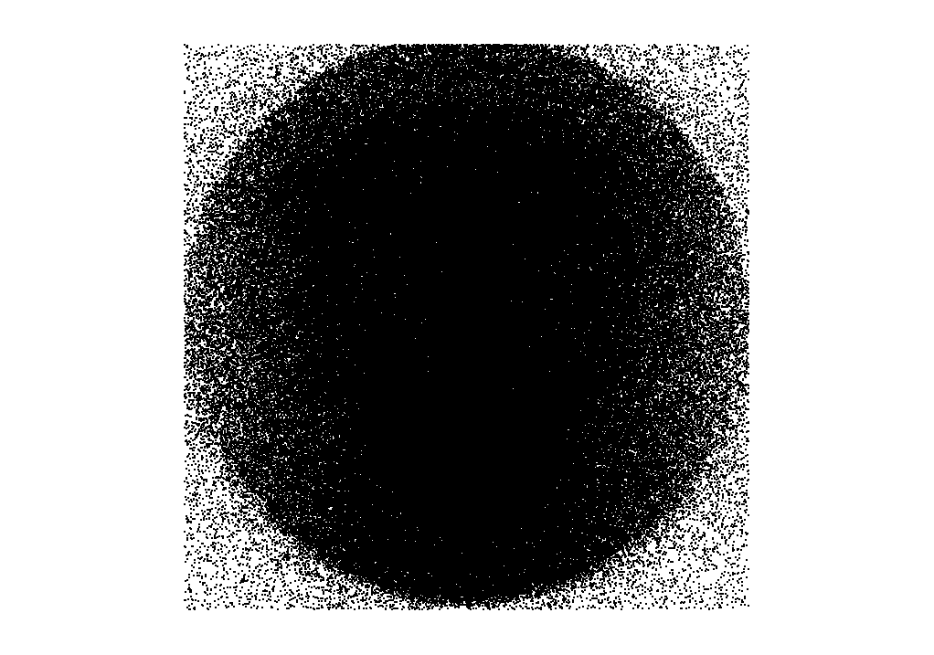

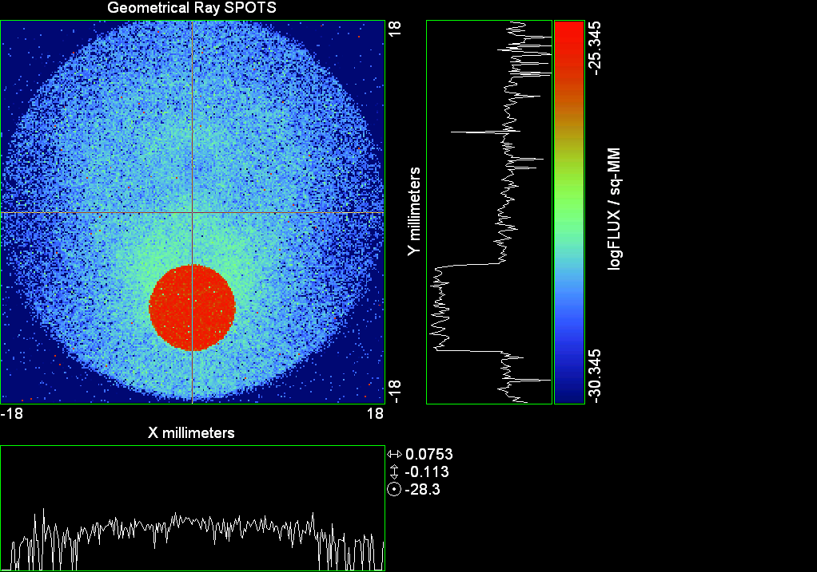

--- ! Spot Plot (Run Ray Trace First)
--- !!CONSIDER ONLY 6 !!Grid Detector=6
--- CONSIDER ONLY 7 !! Earth Detector=7
--- OBLIQUE OFF
--- !!TITLE 'FOV1-9/19^2 mm^2=15503 Rays'
--- !!TITLE 'FOV8 Rect Source Det=2170 total rays'
--- !!TITLE 'FOV8 RctSrc Det=1357-1348=11 rays from Pedestals DetImplBafOnly'
--- !!TITLE 'FOV8 RctSrc Det=750 rays "On"Mrlts Pd&SbS=0 DtImplBfOnly'
--- !!TITLE 'FOV8 RctSrc Det=754 rays "On"Mrlts Pd=1 SbS=0 DtImplBfOnly'
--- !!TITLE 'FOV8 3x3 Pt Src =215 rays "On"Mrlts Pd=1 SbS=0 DtImplBfOnly'
--- TITLE '1.5E6 KM to Source at L1 Distance'
--- !!WINDOW Y X
--- WINDOW Y -18 18 X -18 18
--- !!WINDOW Y 11 14 X -1.5 1.5
--- !!TITLE 'FOV8 23x23 1358-678=680 Rays/.109 mm^2 = 6238 Rays/mm^2 5.5%'
--- !!WINDOW Y 135.75 136.25 X 82.5 83 !!FOV 8
--- !!TITLE 'FOV8 3x3 Core 678 Rays/.006mm^2 = 113000 Rays/mm^2'
--- !!WINDOW Y 136.01 136.07 X 82.75 82.85 !!FOV 8
--- PIXELS 256
--- SPOTS POSITION

Distribution of data within:
Window Vertical: Y = -18.0000 to 18.0000 ( 36.0000 )
Horizontal: X = -18.0000 to 18.0000 ( 36.0000 )

Opening NEW distribution file 9: C:\ASAP Work\TRIANA\bro009.dat
Rays Flux
506362 0.780926E-24
Maximum = 4.5152864E-26 minimum = 0.0000000E+00
--- $IO "ASAPTEMP.INR"
Opening 1 C:\ASAP Work\TRIANA\asaptemp.inr

Closing 7 C:\ASAP Work\TRIANA\bro007.dat
Opening 7 C:\ASAP Work\TRIANA\asaptemp.usr

Closing 20 C:\ASAP Work\TRIANA\bro020.dat
Opening 20 C:\ASAP Work\TRIANA\asaptemp.plr

Closing 30 C:\ASAP Work\TRIANA\bro030.dat
Opening 30 C:\ASAP Work\TRIANA\asaptemp.vcr

--- !! PICTURE (Run Ray Trace and Spots Position First)
--- !! Picks size from Spots Position window size
--- TITLE 'EPIC'
--- CONSIDER ONLY 7 !! Detector = 6 for Grid, 7 for Earth
--- !!WINDOW X -1.5 1.5 Y 11 14
--- WINDOW Y X
--- DISPLAY
Opening OLD distribution file 9: C:\ASAP Work\TRIANA\bro009.dat

File header:
Geometrical Ray SPOTS 1
Z 790.7430 FLUX / sq-MM
X millimeters -18.00000 18.00000 256
Y millimeters -18.00000 18.00000 256

Statistics on 256 by 256 data set:
FLUX / sq-MM Location Y millimeters X millimeters
Minimum 0.000000 1 1 -17.92969 -17.92969
Maximum 0.4515286E-25 85 132 -6.117188 0.4921875
Average 0.6025657E-27 66 129 -8.789062 0.7031250E-01
TOTAL FLUX = 0.7809252E-24

--- AVERAGE 0 0
Statistics on 256 by 256 data set:
FLUX / sq-MM Location Y millimeters X millimeters
Minimum 0.000000 1 1 -17.92969 -17.92969
Maximum 0.4515286E-25 85 132 -6.117188 0.4921875
Average 0.6025657E-27 66 129 -8.789062 0.7031250E-01
TOTAL FLUX = 0.7809252E-24

--- FORM -5
Statistics on 256 by 256 data set:
FLUX / sq-MM Location Y millimeters X millimeters
Minimum -30.34531 1 1 -17.92969 -17.92969
Maximum -25.34531 85 132 -6.117188 0.4921875
Average -29.11368 122 129 -0.9140625 0.7031250E-01
Integral = -37731.34

--- !!CONTOUR .001 .005 .01 .05 .1 .2 .3 .4 .5 .6 .7 .8 .85 .9 .95 GRID 2
--- PICTURE
Opening NEW distribution file 10: C:\ASAP Work\TRIANA\i.dis
--- $IO "ASAPTEMP.INR"
Opening 1 C:\ASAP Work\TRIANA\asaptemp.inr

Closing 7 C:\ASAP Work\TRIANA\bro007.dat
Opening 7 C:\ASAP Work\TRIANA\asaptemp.usr

Closing 20 C:\ASAP Work\TRIANA\bro020.dat
Creating 20 C:\ASAP Work\TRIANA\asaptemp.plr

Closing 30 C:\ASAP Work\TRIANA\bro030.dat
Creating 30 C:\ASAP Work\TRIANA\asaptemp.vcr

--- DISPLAY
Opening OLD distribution file 9: C:\ASAP Work\TRIANA\bro009.dat

File header:
Geometrical Ray SPOTS 1
Z 790.7430 FLUX / sq-MM
X millimeters -18.00000 18.00000 256
Y millimeters -18.00000 18.00000 256

Statistics on 256 by 256 data set:
FLUX / sq-MM Location Y millimeters X millimeters
Minimum 0.000000 1 1 -17.92969 -17.92969
Maximum 0.4515286E-25 85 132 -6.117188 0.4921875
Average 0.6025657E-27 66 129 -8.789062 0.7031250E-01
TOTAL FLUX = 0.7809252E-24

--- TEXTFILE X_Text_Output !!Names Text File, overwrites without warning
--- DATA 'E12.5' !! Format with single blank space
--- EOF

Run 14 Offset 0.75 0.16 deg 40k rays.xls

Run 15 YFan 0.25 Polar Grid Random 7754 rays

--- END

System database and settings have been reinitialized
--- !! Geometry is being appended to system.
--- !! To not view this message, refer to ASAP preferences dialog,
--- !! or change the Options->Append Geometry menu item.
--- GRID POLAR Z -250 46 154.5 0 360 100 36 1 RANDOM 1
7754 rays created in a POLAR grid for a total of 7754
--- SOURCE DIR 0 4718 1500000
Source Z angle for rays
0.180 1 -7754
--- RETURN
--- UNITS MILLIMETERS
--- WAVELENGTHS 0.950000 0.706000 0.587560 0.435000 0.300000 MICRONS
--- MEDIA; 1.45106513 1.45515708 1.45846375 1.46676272 1.48779297 'SILICA'
--- COATING PROPERTIES; 1 0 'WHITE'
--- COATING PROPERTIES; .98 0 'MIRROR'
--- COATING PROPERTIES; .11 .87 'DETECTORQE317'
--- COATING PROPERTIES; .10 .75 'DETECTORQE325'
--- COATING PROPERTIES; .05 0 'BLACK'
--- COATING PROPERTIES; 0 0 'ZERO'
--- COATING PROPERTIES; 0 1 'CLEAR'
--- STRUE=0
--- SX=0
--- SY=0
--- SZ=0
--- SCAT=1
--- ENT OBJECT;MIRROR Z 439.24 159 (1219.2/2) -1 (38.2/159) 'PRIMARY S1'
--- INTERFACE COATING MIRROR AIR AIR
--- ENT OBJECT;TUBE Z 438.5 38.2 38.2 466.53196 38.2 38.2 0.0 0.0 'PRIMARYHOLE'
--- INTERFACE COATING BLACK AIR AIR
--- SCATTER RANDOM 1 (SCAT) 1.57 ABS 1 0
*** LEVEL automatically set to 1
--- ENT OBJECT;PLANE Z 466.5 ELLIPSE 210 210 (38.2/210) 'PRIMARY BACK'
--- INTERFACE COATING BLACK AIR AIR
--- SCATTER RANDOM 1 (SCAT) 1.57 ABS 1 0
--- ENT OBJECT;TUBE Z 429 159 159 466.5 159 159 0.0 0.0 'PRIMARYEDGE'
--- INTERFACE COATING BLACK AIR AIR
--- SCATTER RANDOM 1 (SCAT) 1.57 ABS 1 0
--- ENT OBJECT;MIRROR Z 0.0 46 (434.7/2) -2.40763 0.0 'SECONDARY S2'
--- INTERFACE COATING MIRROR AIR AIR
--- ENT OBJECT;PLANE Z 790.7429896 RECTANGLE 18 18 0 'DETECTOR'
--- INTERFACE COATING ZERO SILICA AIR
--- ENT OBJECT;PLANE Z 790.7 RECTANGLE 18 18 0 'DETECTOR-COVER'
--- INTERFACE COATING DETECTORQE317 SILICA AIR
*** SPLIT automatically set to 1
--- ENT OBJECT;PLANE Z -55.69204 ELLIPSE 210 210 (154.8315449/210) 'SPIDER'
--- INTERFACE COATING BLACK AIR AIR
--- SCATTER RANDOM 1 (SCAT) 1.57 ABS 1 0
--- ENT OBJECT;TUBE Z -55.69204 154.8315449 154.8315449 -30.29204 154.8315449 154.8315449 0.0 0.0 'SPIDERCYL'
--- INTERFACE COATING BLACK AIR AIR
--- SCATTER RANDOM 1 (SCAT) 1.57 ABS 1 0
--- ENT OBJECT;TUBE X 0 0.75 12.52 -170 0.75 15.52 1 1 'SPIDERARMX'
--- SHIFT 0 -52.578 -42.992
--- INTERFACE COATING BLACK AIR AIR
--- SCATTER RANDOM 1 (SCAT) 1.57 ABS 1 0
--- ENT OBJECT;TUBE X 0 5 12.52 -170 5 15.52 1 1 'SPIDERARMX1'
--- SHIFT 0 -52.578 -42.992
--- ROTATE Z -120 0 0
--- INTERFACE COATING BLACK AIR AIR
--- SCATTER RANDOM 1 (SCAT) 1.57 ABS 1 0
--- ENT OBJECT;TUBE X 0 0.75 12.52 -170 0.75 15.52 1 1 'SPIDERARMX2'
--- SHIFT 0 -52.578 -42.992
--- ROTATE Z -240 0 0
--- INTERFACE COATING BLACK AIR AIR
--- SCATTER RANDOM 1 (SCAT) 1.57 ABS 1 0
--- ENT OBJECT;TUBE Z -185.6 200.8 200.8 528 200.8 200.8 0.0 0.0 'BARRELBAFFLE'
--- INTERFACE COATING BLACK AIR AIR
--- SCATTER RANDOM 1 (SCAT) 1.57 ABS 1 0
--- ENT OBJECT;ELLIPSE Z -200 205 205 64 0.0 360.0 'ENTRANCE'
Default ELLIP/ROUND/OVAL segments changed to 64
--- INTERFACE COATING CLEAR AIR AIR
--- ENT OBJECT;TUBE Z (2.391*25.4) (2.546*25.4) (2.546*25.4) (2.164*25.4) (2.546*25.4) (2.546*25.4) 0.0 0.0 'SECONDARYHOUSING'
--- INTERFACE COATING BLACK AIR AIR
--- SCATTER RANDOM 1 (SCAT) 1.57 ABS 1 0
--- ENT OBJECT;TUBE Z (2.164*25.4) (2.546*25.4) (2.546*25.4) 0 (2*25.4) (2*25.4) 0.0 0.0 'SH-CONE'
--- INTERFACE COATING BLACK AIR AIR
--- SCATTER RANDOM 1 (SCAT) 1.57 ABS 1 0
--- ENT OBJECT;PLANE Z 0.0 ELLIPSE (2.45*25.4) (2.45*25.4) (2.00/2.45) 'SH-CONEBASE'
--- INTERFACE COATING BLACK AIR AIR
--- SCATTER RANDOM 1 (SCAT) 1.57 ABS 1 0
--- ENT OBJECT;TUBE Z 0.0 (2.125*25.4) (2.125*25.4) (-6.875*25.4) (2.125*25.4) (2.125*25.4) 0.0 0.0 'SH-CYLINDER'
--- INTERFACE COATING BLACK AIR AIR
--- SCATTER RANDOM 1 (SCAT) 1.57 ABS 1 0
--- ENT OBJECT;PLANE Z (-6.875*25.4) ELLIPSE (2.33*25.4) 'SH-TOP'
--- INTERFACE COATING BLACK AIR AIR
--- SCATTER RANDOM 1 (SCAT) 1.57 ABS 1 0
--- ENT OBJECT;PLANE Z (-1.9*25.4) ELLIPSE (2.546*25.4) 'SH-MIDVANE'
--- INTERFACE COATING BLACK AIR AIR
--- SCATTER RANDOM 1 (SCAT) 1.57 ABS 1 0
--- ENT OBJECT;TUBE Z 226.38766 37.465 37.465 422.98366 37.465 37.465 0.0 0.0 'CBAF-FRONT'
--- INTERFACE COATING BLACK AIR AIR
--- SCATTER RANDOM 1 (SCAT) 1.57 ABS 1 0
--- ENT OBJECT;PLANE Z 422.98366 ELLIPSE 37.485 37.485 (30.5562/37.485) 'CBAF-LEDGE'
--- INTERFACE COATING BLACK AIR AIR
--- SCATTER RANDOM 1 (SCAT) 1.57 ABS 1 0
--- ENT OBJECT;TUBE Z 422.985 32.2072 32.2072 532.45766 32.2072 32.2072 0.0 0.0 'CBAF-AFT'
--- INTERFACE COATING BLACK AIR AIR
--- SCATTER RANDOM 1 (SCAT) 1.57 ABS 1 0
--- ENT OBJECT;PLANE Z 327.98766 ELLIPSE 37.485 37.485 (35.56/37.485) 'CBAF-VANE1'
--- INTERFACE COATING BLACK AIR AIR
--- SCATTER RANDOM 1 (SCAT) 1.57 ABS 1 0
--- ENT OBJECT;PLANE Z 378.78766 ELLIPSE 37.485 37.485 (35.56/37.485) 'CBAF-VANE2'
--- INTERFACE COATING BLACK AIR AIR
--- SCATTER RANDOM 1 (SCAT) 1.57 ABS 1 0
--- ENT OBJECT;PLANE Z 505.53366 ELLIPSE 32.24 32.24 (28.6512/32.24) 'CBAF-VANE3'
--- INTERFACE COATING BLACK AIR AIR
--- SCATTER RANDOM 1 (SCAT) 1.57 ABS 1 0
--- RETURN
--- !! Geometry is being appended to system.
--- !! To not view this message, refer to ASAP preferences dialog,
--- !! or change the Options->Append Geometry menu item.
--- UNITS MILLIMETERS
--- WAVELENGTHS 0.950000 0.706000 0.587560 0.435000 0.300000 MICRONS
--- MEDIA; 1.45106513 1.45515708 1.45846375 1.46676272 1.48779297 'SILICA'
--- COATING PROPERTIES; .98 0 'MIRROR'
--- COATING PROPERTIES; .05 0 'BLACK'
--- COATING PROPERTIES; 0 0 'ZERO'
--- COATING PROPERTIES; 0 1 'CLEAR'
--- COATING PROPERTIES; .05 .95 'ARF05'
--- COATING PROPERTIES; 0.2 0.8 'ARF20'
--- ENT OBJECT;PLANE Z 615.3400000 ELLIPSE 150 150 (22/150) 'LENS MOUNT'
--- INTERFACE COATING BLACK AIR AIR
--- SCATTER RANDOM 1 (SCAT) 1.57 ABS 1 0
--- ENT OBJECT;TUBE Z 558.61966 26.7 26.7 620 26.7 26.7 0.0 0.0 'LENS TUBE-FRONT'
--- INTERFACE COATING BLACK AIR AIR
--- SCATTER RANDOM 1 (SCAT) 1.57 ABS 1 0
--- ENT OBJECT;PLANE Z 558.61966 ELLIPSE 27.7 27.7 (24.945/27.7) 'LT-FACE'
--- INTERFACE COATING BLACK AIR AIR
--- SCATTER RANDOM 1 (SCAT) 1.57 ABS 1 0
--- ENT OBJECT;PLANE Z 616.4326 ELLIPSE 27.7 27.7 (21.5/27.7) 'LT-LENS 1FACE'
--- INTERFACE COATING BLACK AIR AIR
--- SCATTER RANDOM 1 (SCAT) 1.57 ABS 1 0
--- ENT OBJECT;TUBE Z 621 25.152 25.152 657.7965 25.152 25.152 0.0 0.0 'LENS TUBE AFT'
--- INTERFACE COATING BLACK AIR AIR
--- SCATTER RANDOM 1 (SCAT) 1.57 ABS 1 0
--- ENT OBJECT;PLANE Z 657.7965 ELLIPSE 25.152 25.152 (21.26386619/25.152) 'LT-AFT FACE'
--- INTERFACE COATING BLACK AIR AIR
--- SCATTER RANDOM 1 (SCAT) 1.57 ABS 1 0
--- ENT OBJECT;OPTICAL Z 615.3400000 221.803 0 ELLIPSE 22 'LENS1F'
--- INTERFACE COATING ARF05 AIR SILICA
--- ENT OBJECT;OPTICAL Z 620.3400000 584.5 0 ELLIPSE 22 'LENS1B'
--- INTERFACE COATING ARF05 AIR SILICA
--- ENT OBJECT;OPTICAL Z 627.63 -147.027 0 ELLIPSE 22 'LENS2F'
--- INTERFACE COATING ARF05 AIR SILICA
--- ENT OBJECT;OPTICAL Z 632.63 -135.158 0 ELLIPSE 22 'LENS2B'
--- INTERFACE COATING ARF05 AIR SILICA
--- ENT OBJECT;OPTICAL Z 635.6 97.002 0 ELLIPSE 22 'LENS3F'
--- INTERFACE COATING ARF05 AIR SILICA
--- ENT OBJECT;OPTICAL Z 640.6 67.147 0 ELLIPSE 22 'LENS3B'
--- INTERFACE COATING ARF05 AIR SILICA
--- ENT OBJECT;TUBE Z 614 22 22 645 22 22 0.0 0.0 'LENSHOLDER'
--- INTERFACE COATING ZERO AIR AIR
--- SCATTER RANDOM 1 (SCAT) 1.57 ABS 1 0
--- ENT OBJECT;PLANE Z 660.84196 ELLIPSE 150 150 (25.28148817/150) 'FW-HOUSING FRONT'
--- INTERFACE COATING BLACK AIR AIR
--- SCATTER RANDOM 1 (SCAT) 1.57 ABS 1 0
--- ENT OBJECT;PLANE Z 709.10196 ELLIPSE 150 150 (25.28148817/150) 'FW-HOUSING AFT'
--- INTERFACE COATING BLACK AIR AIR
--- SCATTER RANDOM 1 (SCAT) 1.57 ABS 1 0
--- ENT OBJECT;TUBE Z (673.54196-.3) 27.5 27.5 (680.04436+.3) 27.5 27.5 0.0 0.0 'FILTERHOLDER'
--- INTERFACE COATING BLACK AIR AIR
--- SCATTER RANDOM 1 (SCAT) 1.57 ABS 1 0
--- ENT OBJECT;PLANE Z 675 ELLIPSE 150 150 (27.5/150) 'FILTER-WHEEL'
--- INTERFACE COATING BLACK AIR AIR
--- SCATTER RANDOM 1 (SCAT) 1.57 ABS 1 0
--- ENT OBJECT;TUBE Z 721.59876 19.16979665 19.16979665 723.53932 22.558 22.558 0.0 0.0 'EXIT CONE FRONT'
--- INTERFACE COATING BLACK AIR AIR
--- SCATTER RANDOM 1 (SCAT) 1.57 ABS 1 0
--- ENT OBJECT;TUBE Z 723.53932 22.558 22.558 781.84248 22.558 22.558 0.0 0.0 'EC-CYLINDER'
--- INTERFACE COATING BLACK AIR AIR
--- SCATTER RANDOM 1 (SCAT) 1.57 ABS 1 0
--- ENT OBJECT;PLANE Z 781.84248 ELLIPSE 22.558 22.558 (16.89/22.558) 'EC-SHELF'
--- INTERFACE COATING BLACK AIR AIR
--- SCATTER RANDOM 1 (SCAT) 1.57 ABS 1 0
--- ENT OBJECT;TUBE Z 781.84248 16.89 16.89 783.87448 20.41280351 20.41280351 0.0 0.0 'EC-EXITCONE'
--- INTERFACE COATING BLACK AIR AIR
--- SCATTER RANDOM 1 (SCAT) 1.57 ABS 1 0
--- ENT OBJECT;PLANE Z 783.87448 ELLIPSE 50 50 (20.41280351/50) 'EC-EXIT'
--- INTERFACE COATING BLACK AIR AIR
--- SCATTER RANDOM 1 (SCAT) 1.57 ABS 1 0
--- RETURN
--- $IO "ASAPTEMP.INR"
Opening 1 C:\ASAP Work\TRIANA\asaptemp.inr

Closing 7 C:\ASAP Work\TRIANA\bro007.dat
Opening 7 C:\ASAP Work\TRIANA\asaptemp.usr

Closing 20 C:\ASAP Work\TRIANA\bro020.dat
Creating 20 C:\ASAP Work\TRIANA\asaptemp.plr

Closing 30 C:\ASAP Work\TRIANA\bro030.dat
Creating 30 C:\ASAP Work\TRIANA\asaptemp.vcr

--- !! Filters-2 from .ent/copy/.inr to allow ABSORBing media
--- UNITS MILLIMETERS
--- WAVELENGTHS 0.950000 0.706000 0.587560 0.435000 0.300000 MICRONS
--- MEDIA; 1.45106513 1.45515708 1.45846375 1.46676272 1.48779297 'SILICA'
--- !!COATING PROPERTIES; .98 0 'MIRROR'
--- !!COATING PROPERTIES; .05 0 'BLACK'
--- !!COATING PROPERTIES; 0 0 'ZERO'
--- !!COATING PROPERTIES; 0 1 'CLEAR'
--- COATING PROPERTIES; .0745 .9255 'ARF0745'
--- COATING PROPERTIES; .0525 .9475 'ARF0525'
--- COATING PROPERTIES; .05 .95 'ARF05'
--- COATING PROPERTIES; .005 .995 'ARF005'
--- !!COATING PROPERTIES; 0.2 0.8 'ARF20'
--- !!!!!!!!!!!!!!!!!!!!!!!!!!!!!!!!!!!!!!!!!!!!!!!!!!
--- WAVELENGTH 0.317 MICRONS
--- MEDIA
--- 1.48342884 ABSORB 0.13168 'BLOCKER317'
--- MEDIA
--- 1.48342884 ABSORB 0.00307 'ETALON317'
--- !!!!!!!!!!!!!!!!!!!!!!!!!!!!!!!!!!!!!!!!!!!!!!!!!!
--- !!WAVELENGTH 0.325 MICRONS
--- !!MEDIA
--- !! 1.48163777 ABSORB 0.08074 'BLOCKER325'
--- !!MEDIA
--- !! 1.48163777 ABSORB 0.0415179525 'ETALON325'
--- !!!!!!!!!!!!!!!!!!!!!!!!!!!!!!!!!!!!!!!!!!!!!!!!!!!!!
--- ENT OBJECT;PLANE Z 673.54196 ELLIPSE 27.5 'FILTERUVE-F'
--- INTERFACE COATING ARF0525 AIR ETALON317
--- !! INTERFACE COATING ARF0745 AIR ETALON325
--- ENT OBJECT;PLANE Z 676.71696 ELLIPSE 27.5 'FILTERUVE-B'
--- INTERFACE COATING ARF0525 AIR ETALON317
--- !! INTERFACE COATING ARF0745 AIR ETALON325
--- ENT OBJECT;PLANE Z 676.86936 ELLIPSE 27.5 'FILTERUVB-F'
--- INTERFACE COATING ARF005 AIR BLOCKER317
--- !! INTERFACE COATING ARF005 AIR BLOCKER325
--- ENT OBJECT;PLANE Z 680.04436 ELLIPSE 27.5 'FILTERUVB-B'
--- INTERFACE COATING ARF005 AIR BLOCKER317
--- !! INTERFACE COATING ARF005 AIR BLOCKER325
--- !!RETURN

--- TITLE DCE *Raytrace
--- !! WAVELENGTHS 0.317 MICRONS !! Normally set in filters
--- !!SPLIT 0 !! Direct Trace Only
--- !!SPLIT 1 !! For Rect Sources
--- SPLIT 2 !! For double reflection in lens & filters
--- PLOT FACETS 5 5
Window Vertical: Y = -210.000 to 210.000 ( 420.000 )
Horizontal: Z = -204.100 to 791.121 ( 995.221 )

--- CONSIDER ALL
--- !!CONSIDER ONLY 15
--- ARROWS OFF
--- SEGMENTS 9
--- WINDOW Y Z
--- OBLIQUE 0 0
--- MISSED LINE 50
--- TRACE PLOT 100 OVERLAY
Window Vertical: Y = -210.000 to 210.000 ( 420.000 )
Horizontal: Z = -204.100 to 791.121 ( 995.221 )

12.08 seconds ( 11.77 seconds CPU) to trace 16,000
out of 164,414
24.77 seconds ( 24.13 seconds CPU) to trace 32,000
out of 332,886
37.18 seconds ( 36.02 seconds CPU) to trace 48,000
out of 490,962
49.01 seconds ( 47.55 seconds CPU) to trace 64,000
out of 639,690
60.87 seconds ( 59.07 seconds CPU) to trace 80,000
out of 789,862
68.71 seconds ( 66.61 seconds CPU) to trace 96,000
out of 845,713
75.01 seconds ( 72.84 seconds CPU) to trace 112,000
out of 869,769
81.62 seconds ( 79.17 seconds CPU) to trace 128,000
out of 894,945
88.20 seconds ( 85.44 seconds CPU) to trace 144,000
out of 919,928
94.67 seconds ( 91.81 seconds CPU) to trace 160,000
out of 945,511
101.41 seconds ( 98.30 seconds CPU) to trace 176,000
out of 971,264
108.07 seconds ( 104.65 seconds CPU) to trace 192,000
out of 996,590
114.65 seconds ( 111.12 seconds CPU) to trace 208,000
out of 1,022,609
2.03 minutes ( 117.62 seconds CPU) to trace 224,000
out of 1,048,698
2.14 minutes ( 2.07 minutes CPU) to trace 240,000
out of 1,075,094
2.26 minutes ( 2.18 minutes CPU) to trace 256,000
out of 1,101,086
2.37 minutes ( 2.29 minutes CPU) to trace 272,000
out of 1,127,430
2.49 minutes ( 2.39 minutes CPU) to trace 288,000
out of 1,153,339
2.60 minutes ( 2.50 minutes CPU) to trace 304,000
out of 1,178,973
2.70 minutes ( 2.61 minutes CPU) to trace 320,000
out of 1,204,159
2.82 minutes ( 2.71 minutes CPU) to trace 336,000
out of 1,229,813
2.92 minutes ( 2.82 minutes CPU) to trace 352,000
out of 1,255,613
3.03 minutes ( 2.92 minutes CPU) to trace 368,000
out of 1,281,055
3.15 minutes ( 3.03 minutes CPU) to trace 384,000
out of 1,306,637
3.25 minutes ( 3.14 minutes CPU) to trace 400,000
out of 1,332,396
3.36 minutes ( 3.24 minutes CPU) to trace 416,000
out of 1,357,643
3.48 minutes ( 3.35 minutes CPU) to trace 432,000
out of 1,382,839
3.58 minutes ( 3.45 minutes CPU) to trace 448,000
out of 1,408,242
3.69 minutes ( 3.56 minutes CPU) to trace 464,000
out of 1,433,488
3.80 minutes ( 3.66 minutes CPU) to trace 480,000
out of 1,458,383
3.93 minutes ( 3.77 minutes CPU) to trace 496,000
out of 1,483,401
4.05 minutes ( 3.88 minutes CPU) to trace 512,000
out of 1,507,607
4.16 minutes ( 3.98 minutes CPU) to trace 528,000
out of 1,532,773
4.27 minutes ( 4.09 minutes CPU) to trace 544,000
out of 1,557,907
4.38 minutes ( 4.20 minutes CPU) to trace 560,000
out of 1,582,524
4.49 minutes ( 4.30 minutes CPU) to trace 576,000
out of 1,606,701
4.60 minutes ( 4.41 minutes CPU) to trace 592,000
out of 1,631,312
4.71 minutes ( 4.51 minutes CPU) to trace 608,000
out of 1,656,047
4.83 minutes ( 4.62 minutes CPU) to trace 624,000
out of 1,680,934
4.93 minutes ( 4.72 minutes CPU) to trace 640,000
out of 1,705,816
5.05 minutes ( 4.83 minutes CPU) to trace 656,000
out of 1,730,857
5.16 minutes ( 4.93 minutes CPU) to trace 672,000
out of 1,755,614
5.27 minutes ( 5.04 minutes CPU) to trace 688,000
out of 1,779,782
5.39 minutes ( 5.15 minutes CPU) to trace 704,000
out of 1,803,921
5.51 minutes ( 5.26 minutes CPU) to trace 720,000
out of 1,827,786
5.62 minutes ( 5.36 minutes CPU) to trace 736,000
out of 1,852,154
5.73 minutes ( 5.47 minutes CPU) to trace 752,000
out of 1,876,515
5.84 minutes ( 5.58 minutes CPU) to trace 768,000
out of 1,899,821
5.95 minutes ( 5.68 minutes CPU) to trace 784,000
out of 1,923,735
6.06 minutes ( 5.79 minutes CPU) to trace 800,000
out of 1,947,991
6.18 minutes ( 5.89 minutes CPU) to trace 816,000
out of 1,970,637
6.27 minutes ( 5.98 minutes CPU) to trace 832,000
out of 1,986,556
6.31 minutes ( 6.02 minutes CPU) to trace 848,000
6.36 minutes ( 6.06 minutes CPU) to trace 864,000
6.40 minutes ( 6.10 minutes CPU) to trace 880,000
6.45 minutes ( 6.15 minutes CPU) to trace 896,000
6.50 minutes ( 6.19 minutes CPU) to trace 912,000
6.54 minutes ( 6.23 minutes CPU) to trace 928,000
6.59 minutes ( 6.28 minutes CPU) to trace 944,000
6.64 minutes ( 6.32 minutes CPU) to trace 960,000
6.69 minutes ( 6.37 minutes CPU) to trace 976,000
6.73 minutes ( 6.41 minutes CPU) to trace 992,000
6.78 minutes ( 6.45 minutes CPU) to trace 1,008,000
6.83 minutes ( 6.50 minutes CPU) to trace 1,024,000
6.88 minutes ( 6.54 minutes CPU) to trace 1,040,000
6.93 minutes ( 6.58 minutes CPU) to trace 1,056,000
6.98 minutes ( 6.63 minutes CPU) to trace 1,072,000
7.02 minutes ( 6.67 minutes CPU) to trace 1,088,000
7.07 minutes ( 6.71 minutes CPU) to trace 1,104,000
7.12 minutes ( 6.76 minutes CPU) to trace 1,120,000
7.16 minutes ( 6.80 minutes CPU) to trace 1,136,000
7.21 minutes ( 6.84 minutes CPU) to trace 1,152,000
7.26 minutes ( 6.89 minutes CPU) to trace 1,168,000
7.31 minutes ( 6.93 minutes CPU) to trace 1,184,000
7.35 minutes ( 6.98 minutes CPU) to trace 1,200,000
7.40 minutes ( 7.02 minutes CPU) to trace 1,216,000
7.45 minutes ( 7.06 minutes CPU) to trace 1,232,000
7.50 minutes ( 7.11 minutes CPU) to trace 1,248,000
7.55 minutes ( 7.15 minutes CPU) to trace 1,264,000
7.59 minutes ( 7.20 minutes CPU) to trace 1,280,000
7.64 minutes ( 7.24 minutes CPU) to trace 1,296,000
7.69 minutes ( 7.28 minutes CPU) to trace 1,312,000
7.74 minutes ( 7.33 minutes CPU) to trace 1,328,000
7.79 minutes ( 7.37 minutes CPU) to trace 1,344,000
7.84 minutes ( 7.41 minutes CPU) to trace 1,360,000
7.88 minutes ( 7.46 minutes CPU) to trace 1,376,000
7.93 minutes ( 7.50 minutes CPU) to trace 1,392,000
7.98 minutes ( 7.54 minutes CPU) to trace 1,408,000
8.02 minutes ( 7.59 minutes CPU) to trace 1,424,000
8.07 minutes ( 7.63 minutes CPU) to trace 1,440,000
8.12 minutes ( 7.67 minutes CPU) to trace 1,456,000
8.17 minutes ( 7.72 minutes CPU) to trace 1,472,000
8.21 minutes ( 7.76 minutes CPU) to trace 1,488,000
8.26 minutes ( 7.80 minutes CPU) to trace 1,504,000
8.30 minutes ( 7.85 minutes CPU) to trace 1,520,000
8.35 minutes ( 7.89 minutes CPU) to trace 1,536,000
8.40 minutes ( 7.93 minutes CPU) to trace 1,552,000
8.47 minutes ( 7.98 minutes CPU) to trace 1,568,000
8.52 minutes ( 8.02 minutes CPU) to trace 1,584,000
8.57 minutes ( 8.07 minutes CPU) to trace 1,600,000
8.62 minutes ( 8.12 minutes CPU) to trace 1,616,000
8.67 minutes ( 8.16 minutes CPU) to trace 1,632,000
8.72 minutes ( 8.21 minutes CPU) to trace 1,648,000
8.77 minutes ( 8.25 minutes CPU) to trace 1,664,000
8.82 minutes ( 8.30 minutes CPU) to trace 1,680,000
8.86 minutes ( 8.34 minutes CPU) to trace 1,696,000
8.91 minutes ( 8.38 minutes CPU) to trace 1,712,000
8.96 minutes ( 8.43 minutes CPU) to trace 1,728,000
9.01 minutes ( 8.47 minutes CPU) to trace 1,744,000
9.05 minutes ( 8.51 minutes CPU) to trace 1,760,000
9.10 minutes ( 8.56 minutes CPU) to trace 1,776,000
9.15 minutes ( 8.60 minutes CPU) to trace 1,792,000
9.19 minutes ( 8.64 minutes CPU) to trace 1,808,000
9.24 minutes ( 8.69 minutes CPU) to trace 1,824,000
9.29 minutes ( 8.73 minutes CPU) to trace 1,840,000
9.33 minutes ( 8.77 minutes CPU) to trace 1,856,000
9.38 minutes ( 8.81 minutes CPU) to trace 1,872,000
9.42 minutes ( 8.86 minutes CPU) to trace 1,888,000
9.47 minutes ( 8.90 minutes CPU) to trace 1,904,000
9.52 minutes ( 8.95 minutes CPU) to trace 1,920,000
9.56 minutes ( 8.99 minutes CPU) to trace 1,936,000
9.60 minutes ( 9.03 minutes CPU) to trace 1,952,000
9.65 minutes ( 9.07 minutes CPU) to trace 1,968,000
9.70 minutes ( 9.11 minutes CPU) to trace 1,984,000
9.71 minutes ( 9.12 minutes CPU) to trace 1,986,556

Total of 1617069 PARENT warnings
Missed Multiple Wrong Low Evanescent Wrong Absorbed
Obj Total After Bounce Side Flux (TIR) Direc After
1 15 15 PRIMARY S1
2 1357 217 1140 PRIMARYHOLE
3 50607 21415 29192 PRIMARY BACK
4 11050 11050 PRIMARYEDGE
7 829 45 784 DETECTOR-COVER
8 19402 1 19401 SPIDER
9 7709 102 7607 SPIDERCYL
10 2306 68 2238 SPIDERARMX
11 4355 71 4284 SPIDERARMX1
12 2369 64 2305 SPIDERARMX2
13 158571 2048 156523 BARRELBAFFLE
14 170588 170588 ENTRANCE
15 3754 2 3752 SECONDARYHOUSING
16 32118 227 31891 SH-CONE
17 7632 12 7620 SH-CONEBASE
18 46192 871 45321 SH-CYLINDER
19 457 9 448 SH-TOP
20 47184 3 47181 SH-MIDVANE
21 133140 515 132625 CBAF-FRONT
22 8062 8062 CBAF-LEDGE
23 96804 25365 71439 CBAF-AFT
24 3699 4 3695 CBAF-VANE1
25 4008 1 4007 CBAF-VANE2
26 6296 700 5596 CBAF-VANE3
27 40789 19880 20909 LENS MOUNT
28 35167 2305 32862 LENS TUBE-FRONT
29 3507 130 3377 LT-FACE
30 1384 5 1379 LT-LENS 1FACE
31 8976 125 8851 LENS TUBE AFT
32 2979 10 2969 LT-AFT FACE
33 2741 766 1975 LENS1F
34 4314 1972 2342 LENS1B
35 4272 2477 1795 LENS2F
36 3374 2056 1318 LENS2B
37 5241 3014 2227 LENS3F
38 5734 2362 3372 LENS3B
39 77 77 LENSHOLDER
40 31300 8405 22895 FW-HOUSING FRONT
41 349394 281743 67651 FW-HOUSING AFT
42 1314 619 674 21 FILTERHOLDER
43 105561 45621 59940 FILTER-WHEEL
44 16514 6200 10314 EXIT CONE FRONT
45 125967 22197 103770 EC-CYLINDER
46 13492 3 13489 EC-SHELF
47 2853 2276 577 EC-EXITCONE
48 13307 9882 3425 EC-EXIT
49 2203 24 1067 534 578 FILTERUVE-F
50 7729 7195 534 FILTERUVE-B
51 1822 1132 518 172 FILTERUVB-F
52 8554 6750 2 500 1302 FILTERUVB-B

Total of 60601 CHILD warnings
Missed Multiple Wrong Low Evanescent Wrong Absorbed
Obj Total After Bounce Side Flux (TIR) Direc After
7 1996 1996 DETECTOR-COVER
33 4826 4826 LENS1F
34 5284 5284 LENS1B
35 6094 6094 LENS2F
36 6035 6035 LENS2B
37 5953 5953 LENS3F
38 5919 5919 LENS3B
49 5736 5736 FILTERUVE-F
50 5736 5736 FILTERUVE-B
51 6501 6501 FILTERUVB-F
52 6521 6521 FILTERUVB-B
13299342 ray-objects encountered at 24301 per CPU second
137248603 order-intersections done at 250789 per CPU second

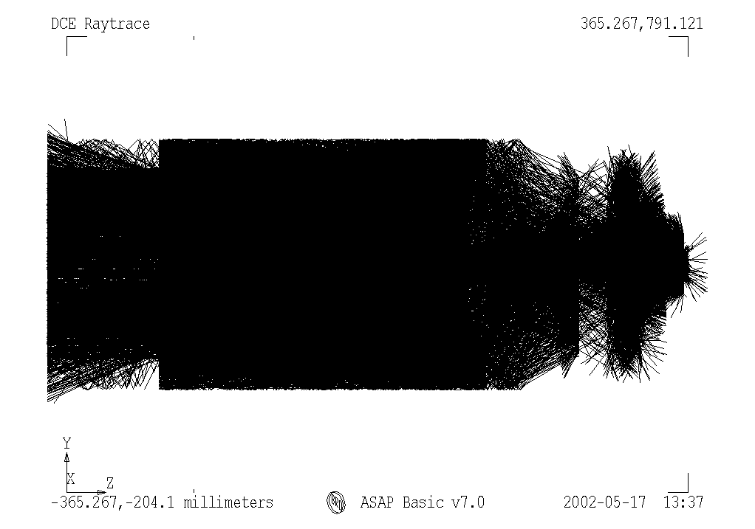

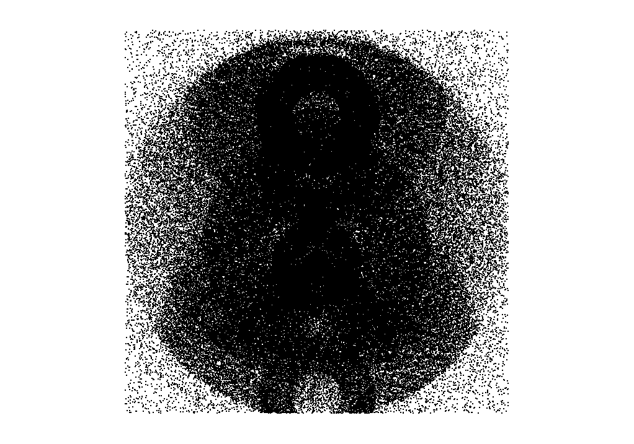

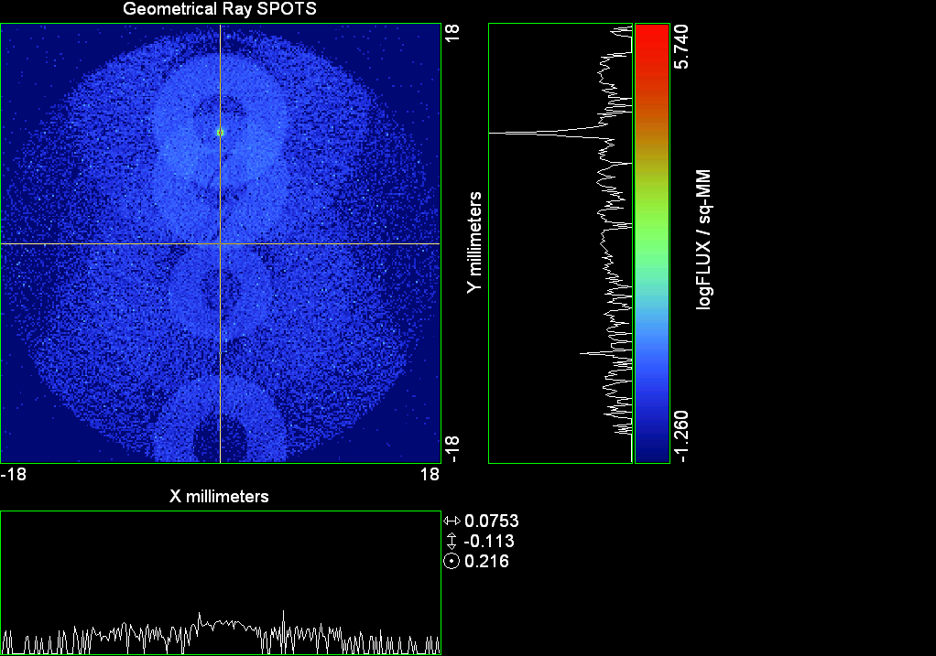

--- ! Spot Plot (Run Ray Trace First)
--- CONSIDER ONLY 6 !!Grid Detector=6
--- !!CONSIDER ONLY 7 !! Earth Detector=7
--- OBLIQUE OFF
--- !!TITLE 'FOV1-9/19^2 mm^2=15503 Rays'
--- !!TITLE 'FOV8 Rect Source Det=2170 total rays'
--- !!TITLE 'FOV8 RctSrc Det=1357-1348=11 rays from Pedestals DetImplBafOnly'
--- !!TITLE 'FOV8 RctSrc Det=750 rays "On"Mrlts Pd&SbS=0 DtImplBfOnly'
--- !!TITLE 'FOV8 RctSrc Det=754 rays "On"Mrlts Pd=1 SbS=0 DtImplBfOnly'
--- !!TITLE 'FOV8 3x3 Pt Src =215 rays "On"Mrlts Pd=1 SbS=0 DtImplBfOnly'
--- TITLE '1.5E6 KM to Source at L1 Distance'
--- !!WINDOW Y X
--- WINDOW Y -18 18 X -18 18
--- !!WINDOW Y 11 14 X -1.5 1.5
--- !!TITLE 'FOV8 23x23 1358-678=680 Rays/.109 mm^2 = 6238 Rays/mm^2 5.5%'
--- !!WINDOW Y 135.75 136.25 X 82.5 83 !!FOV 8
--- !!TITLE 'FOV8 3x3 Core 678 Rays/.006mm^2 = 113000 Rays/mm^2'
--- !!WINDOW Y 136.01 136.07 X 82.75 82.85 !!FOV 8
--- PIXELS 256
--- SPOTS POSITION

Distribution of data within:
Window Vertical: Y = -18.0000 to 18.0000 ( 36.0000 )
Horizontal: X = -18.0000 to 18.0000 ( 36.0000 )

Opening NEW distribution file 9: C:\ASAP Work\TRIANA\bro009.dat
Rays Flux
284229 22157.8
Maximum = 549186.2 minimum = 0.0000000E+00
--- $IO "ASAPTEMP.INR"
Opening 1 C:\ASAP Work\TRIANA\asaptemp.inr

Closing 7 C:\ASAP Work\TRIANA\bro007.dat
Opening 7 C:\ASAP Work\TRIANA\asaptemp.usr

Closing 20 C:\ASAP Work\TRIANA\bro020.dat
Opening 20 C:\ASAP Work\TRIANA\asaptemp.plr

Closing 30 C:\ASAP Work\TRIANA\bro030.dat
Opening 30 C:\ASAP Work\TRIANA\asaptemp.vcr

--- !! PICTURE (Run Ray Trace and Spots Position First)
--- !! Picks size from Spots Position window size
--- TITLE 'EPIC'
--- CONSIDER ONLY 7 !! Detector = 6 for Grid, 7 for Earth
--- !!WINDOW X -1.5 1.5 Y 11 14
--- WINDOW Y X
--- DISPLAY
Opening OLD distribution file 9: C:\ASAP Work\TRIANA\bro009.dat

File header:
Geometrical Ray SPOTS 1
Z 790.7430 FLUX / sq-MM
X millimeters -18.00000 18.00000 256
Y millimeters -18.00000 18.00000 256

Statistics on 256 by 256 data set:
FLUX / sq-MM Location Y millimeters X millimeters
Minimum 0.000000 1 1 -17.92969 -17.92969
Maximum 549186.2 193 129 9.070312 0.7031250E-01
Average 17.09932 191 128 8.789062 -0.7031250E-01
TOTAL FLUX = 22160.72

--- AVERAGE 0 0
Statistics on 256 by 256 data set:
FLUX / sq-MM Location Y millimeters X millimeters
Minimum 0.000000 1 1 -17.92969 -17.92969
Maximum 549186.2 193 129 9.070312 0.7031250E-01
Average 17.09932 191 128 8.789062 -0.7031250E-01
TOTAL FLUX = 22160.72

--- FORM -7
Statistics on 256 by 256 data set:
FLUX / sq-MM Location Y millimeters X millimeters
Minimum -1.260280 1 1 -17.92969 -17.92969
Maximum 5.739719 193 129 9.070312 0.7031250E-01
Average -0.6364931 133 128 0.6328125 -0.7031250E-01
Integral = -824.8950

--- !!CONTOUR .001 .005 .01 .05 .1 .2 .3 .4 .5 .6 .7 .8 .85 .9 .95 GRID 2
--- PICTURE
Opening NEW distribution file 10: C:\ASAP Work\TRIANA\i.dis
--- $IO "ASAPTEMP.INR"
Opening 1 C:\ASAP Work\TRIANA\asaptemp.inr

Closing 7 C:\ASAP Work\TRIANA\bro007.dat
Opening 7 C:\ASAP Work\TRIANA\asaptemp.usr

Closing 20 C:\ASAP Work\TRIANA\bro020.dat
Creating 20 C:\ASAP Work\TRIANA\asaptemp.plr

Closing 30 C:\ASAP Work\TRIANA\bro030.dat
Creating 30 C:\ASAP Work\TRIANA\asaptemp.vcr

--- DISPLAY
Opening OLD distribution file 9: C:\ASAP Work\TRIANA\bro009.dat

File header:
Geometrical Ray SPOTS 1
Z 790.7430 FLUX / sq-MM
X millimeters -18.00000 18.00000 256
Y millimeters -18.00000 18.00000 256

Statistics on 256 by 256 data set:
FLUX / sq-MM Location Y millimeters X millimeters
Minimum 0.000000 1 1 -17.92969 -17.92969
Maximum 549186.2 193 129 9.070312 0.7031250E-01
Average 17.09932 191 128 8.789062 -0.7031250E-01
TOTAL FLUX = 22160.72

--- TEXTFILE X_Text_Output !!Names Text File, overwrites without warning
--- DATA 'E12.5' !! Format with single blank space
--- EOF

Run 15 YFan 0.25 Polar Grid Random 7754 rays.xls

Run 16 YFan 0375 Polar Grid Random 7754 rays

--- END

System database and settings have been reinitialized
--- !! Geometry is being appended to system.
--- !! To not view this message, refer to ASAP preferences dialog,
--- !! or change the Options->Append Geometry menu item.
--- GRID POLAR Z -250 46 154.5 0 360 100 36 1 RANDOM 1
7754 rays created in a POLAR grid for a total of 7754
--- SOURCE DIR 0 2359 1500000
Source Z angle for rays
0.090 1 -7754
--- RETURN
--- UNITS MILLIMETERS
--- WAVELENGTHS 0.950000 0.706000 0.587560 0.435000 0.300000 MICRONS
--- MEDIA; 1.45106513 1.45515708 1.45846375 1.46676272 1.48779297 'SILICA'
--- COATING PROPERTIES; 1 0 'WHITE'
--- COATING PROPERTIES; .98 0 'MIRROR'
--- COATING PROPERTIES; .11 .87 'DETECTORQE317'
--- COATING PROPERTIES; .10 .75 'DETECTORQE325'
--- COATING PROPERTIES; .05 0 'BLACK'
--- COATING PROPERTIES; 0 0 'ZERO'
--- COATING PROPERTIES; 0 1 'CLEAR'
--- STRUE=0
--- SX=0
--- SY=0
--- SZ=0
--- SCAT=1
--- ENT OBJECT;MIRROR Z 439.24 159 (1219.2/2) -1 (38.2/159) 'PRIMARY S1'
--- INTERFACE COATING MIRROR AIR AIR
--- ENT OBJECT;TUBE Z 438.5 38.2 38.2 466.53196 38.2 38.2 0.0 0.0 'PRIMARYHOLE'
--- INTERFACE COATING BLACK AIR AIR
--- SCATTER RANDOM 1 (SCAT) 1.57 ABS 1 0
*** LEVEL automatically set to 1
--- ENT OBJECT;PLANE Z 466.5 ELLIPSE 210 210 (38.2/210) 'PRIMARY BACK'
--- INTERFACE COATING BLACK AIR AIR
--- SCATTER RANDOM 1 (SCAT) 1.57 ABS 1 0
--- ENT OBJECT;TUBE Z 429 159 159 466.5 159 159 0.0 0.0 'PRIMARYEDGE'
--- INTERFACE COATING BLACK AIR AIR
--- SCATTER RANDOM 1 (SCAT) 1.57 ABS 1 0
--- ENT OBJECT;MIRROR Z 0.0 46 (434.7/2) -2.40763 0.0 'SECONDARY S2'
--- INTERFACE COATING MIRROR AIR AIR
--- ENT OBJECT;PLANE Z 790.7429896 RECTANGLE 18 18 0 'DETECTOR'
--- INTERFACE COATING ZERO SILICA AIR
--- ENT OBJECT;PLANE Z 790.7 RECTANGLE 18 18 0 'DETECTOR-COVER'
--- INTERFACE COATING DETECTORQE317 SILICA AIR
*** SPLIT automatically set to 1
--- ENT OBJECT;PLANE Z -55.69204 ELLIPSE 210 210 (154.8315449/210) 'SPIDER'
--- INTERFACE COATING BLACK AIR AIR
--- SCATTER RANDOM 1 (SCAT) 1.57 ABS 1 0
--- ENT OBJECT;TUBE Z -55.69204 154.8315449 154.8315449 -30.29204 154.8315449 154.8315449 0.0 0.0 'SPIDERCYL'
--- INTERFACE COATING BLACK AIR AIR
--- SCATTER RANDOM 1 (SCAT) 1.57 ABS 1 0
--- ENT OBJECT;TUBE X 0 0.75 12.52 -170 0.75 15.52 1 1 'SPIDERARMX'
--- SHIFT 0 -52.578 -42.992
--- INTERFACE COATING BLACK AIR AIR
--- SCATTER RANDOM 1 (SCAT) 1.57 ABS 1 0
--- ENT OBJECT;TUBE X 0 5 12.52 -170 5 15.52 1 1 'SPIDERARMX1'
--- SHIFT 0 -52.578 -42.992
--- ROTATE Z -120 0 0
--- INTERFACE COATING BLACK AIR AIR
--- SCATTER RANDOM 1 (SCAT) 1.57 ABS 1 0
--- ENT OBJECT;TUBE X 0 0.75 12.52 -170 0.75 15.52 1 1 'SPIDERARMX2'
--- SHIFT 0 -52.578 -42.992
--- ROTATE Z -240 0 0
--- INTERFACE COATING BLACK AIR AIR
--- SCATTER RANDOM 1 (SCAT) 1.57 ABS 1 0
--- ENT OBJECT;TUBE Z -185.6 200.8 200.8 528 200.8 200.8 0.0 0.0 'BARRELBAFFLE'
--- INTERFACE COATING BLACK AIR AIR
--- SCATTER RANDOM 1 (SCAT) 1.57 ABS 1 0
--- ENT OBJECT;ELLIPSE Z -200 205 205 64 0.0 360.0 'ENTRANCE'
Default ELLIP/ROUND/OVAL segments changed to 64
--- INTERFACE COATING CLEAR AIR AIR
--- ENT OBJECT;TUBE Z (2.391*25.4) (2.546*25.4) (2.546*25.4) (2.164*25.4) (2.546*25.4) (2.546*25.4) 0.0 0.0 'SECONDARYHOUSING'
--- INTERFACE COATING BLACK AIR AIR
--- SCATTER RANDOM 1 (SCAT) 1.57 ABS 1 0
--- ENT OBJECT;TUBE Z (2.164*25.4) (2.546*25.4) (2.546*25.4) 0 (2*25.4) (2*25.4) 0.0 0.0 'SH-CONE'
--- INTERFACE COATING BLACK AIR AIR
--- SCATTER RANDOM 1 (SCAT) 1.57 ABS 1 0
--- ENT OBJECT;PLANE Z 0.0 ELLIPSE (2.45*25.4) (2.45*25.4) (2.00/2.45) 'SH-CONEBASE'
--- INTERFACE COATING BLACK AIR AIR
--- SCATTER RANDOM 1 (SCAT) 1.57 ABS 1 0
--- ENT OBJECT;TUBE Z 0.0 (2.125*25.4) (2.125*25.4) (-6.875*25.4) (2.125*25.4) (2.125*25.4) 0.0 0.0 'SH-CYLINDER'
--- INTERFACE COATING BLACK AIR AIR
--- SCATTER RANDOM 1 (SCAT) 1.57 ABS 1 0
--- ENT OBJECT;PLANE Z (-6.875*25.4) ELLIPSE (2.33*25.4) 'SH-TOP'
--- INTERFACE COATING BLACK AIR AIR
--- SCATTER RANDOM 1 (SCAT) 1.57 ABS 1 0
--- ENT OBJECT;PLANE Z (-1.9*25.4) ELLIPSE (2.546*25.4) 'SH-MIDVANE'
--- INTERFACE COATING BLACK AIR AIR
--- SCATTER RANDOM 1 (SCAT) 1.57 ABS 1 0
--- ENT OBJECT;TUBE Z 226.38766 37.465 37.465 422.98366 37.465 37.465 0.0 0.0 'CBAF-FRONT'
--- INTERFACE COATING BLACK AIR AIR
--- SCATTER RANDOM 1 (SCAT) 1.57 ABS 1 0
--- ENT OBJECT;PLANE Z 422.98366 ELLIPSE 37.485 37.485 (30.5562/37.485) 'CBAF-LEDGE'
--- INTERFACE COATING BLACK AIR AIR
--- SCATTER RANDOM 1 (SCAT) 1.57 ABS 1 0
--- ENT OBJECT;TUBE Z 422.985 32.2072 32.2072 532.45766 32.2072 32.2072 0.0 0.0 'CBAF-AFT'
--- INTERFACE COATING BLACK AIR AIR
--- SCATTER RANDOM 1 (SCAT) 1.57 ABS 1 0
--- ENT OBJECT;PLANE Z 327.98766 ELLIPSE 37.485 37.485 (35.56/37.485) 'CBAF-VANE1'
--- INTERFACE COATING BLACK AIR AIR
--- SCATTER RANDOM 1 (SCAT) 1.57 ABS 1 0
--- ENT OBJECT;PLANE Z 378.78766 ELLIPSE 37.485 37.485 (35.56/37.485) 'CBAF-VANE2'
--- INTERFACE COATING BLACK AIR AIR
--- SCATTER RANDOM 1 (SCAT) 1.57 ABS 1 0
--- ENT OBJECT;PLANE Z 505.53366 ELLIPSE 32.24 32.24 (28.6512/32.24) 'CBAF-VANE3'
--- INTERFACE COATING BLACK AIR AIR
--- SCATTER RANDOM 1 (SCAT) 1.57 ABS 1 0
--- RETURN
--- !! Geometry is being appended to system.
--- !! To not view this message, refer to ASAP preferences dialog,
--- !! or change the Options->Append Geometry menu item.
--- UNITS MILLIMETERS
--- WAVELENGTHS 0.950000 0.706000 0.587560 0.435000 0.300000 MICRONS
--- MEDIA; 1.45106513 1.45515708 1.45846375 1.46676272 1.48779297 'SILICA'
--- COATING PROPERTIES; .98 0 'MIRROR'
--- COATING PROPERTIES; .05 0 'BLACK'
--- COATING PROPERTIES; 0 0 'ZERO'
--- COATING PROPERTIES; 0 1 'CLEAR'
--- COATING PROPERTIES; .05 .95 'ARF05'
--- COATING PROPERTIES; 0.2 0.8 'ARF20'
--- ENT OBJECT;PLANE Z 615.3400000 ELLIPSE 150 150 (22/150) 'LENS MOUNT'
--- INTERFACE COATING BLACK AIR AIR
--- SCATTER RANDOM 1 (SCAT) 1.57 ABS 1 0
--- ENT OBJECT;TUBE Z 558.61966 26.7 26.7 620 26.7 26.7 0.0 0.0 'LENS TUBE-FRONT'
--- INTERFACE COATING BLACK AIR AIR
--- SCATTER RANDOM 1 (SCAT) 1.57 ABS 1 0
--- ENT OBJECT;PLANE Z 558.61966 ELLIPSE 27.7 27.7 (24.945/27.7) 'LT-FACE'
--- INTERFACE COATING BLACK AIR AIR
--- SCATTER RANDOM 1 (SCAT) 1.57 ABS 1 0
--- ENT OBJECT;PLANE Z 616.4326 ELLIPSE 27.7 27.7 (21.5/27.7) 'LT-LENS 1FACE'
--- INTERFACE COATING BLACK AIR AIR
--- SCATTER RANDOM 1 (SCAT) 1.57 ABS 1 0
--- ENT OBJECT;TUBE Z 621 25.152 25.152 657.7965 25.152 25.152 0.0 0.0 'LENS TUBE AFT'
--- INTERFACE COATING BLACK AIR AIR
--- SCATTER RANDOM 1 (SCAT) 1.57 ABS 1 0
--- ENT OBJECT;PLANE Z 657.7965 ELLIPSE 25.152 25.152 (21.26386619/25.152) 'LT-AFT FACE'
--- INTERFACE COATING BLACK AIR AIR
--- SCATTER RANDOM 1 (SCAT) 1.57 ABS 1 0
--- ENT OBJECT;OPTICAL Z 615.3400000 221.803 0 ELLIPSE 22 'LENS1F'
--- INTERFACE COATING ARF05 AIR SILICA
--- ENT OBJECT;OPTICAL Z 620.3400000 584.5 0 ELLIPSE 22 'LENS1B'
--- INTERFACE COATING ARF05 AIR SILICA
--- ENT OBJECT;OPTICAL Z 627.63 -147.027 0 ELLIPSE 22 'LENS2F'
--- INTERFACE COATING ARF05 AIR SILICA
--- ENT OBJECT;OPTICAL Z 632.63 -135.158 0 ELLIPSE 22 'LENS2B'
--- INTERFACE COATING ARF05 AIR SILICA
--- ENT OBJECT;OPTICAL Z 635.6 97.002 0 ELLIPSE 22 'LENS3F'
--- INTERFACE COATING ARF05 AIR SILICA
--- ENT OBJECT;OPTICAL Z 640.6 67.147 0 ELLIPSE 22 'LENS3B'
--- INTERFACE COATING ARF05 AIR SILICA
--- ENT OBJECT;TUBE Z 614 22 22 645 22 22 0.0 0.0 'LENSHOLDER'
--- INTERFACE COATING ZERO AIR AIR
--- SCATTER RANDOM 1 (SCAT) 1.57 ABS 1 0
--- ENT OBJECT;PLANE Z 660.84196 ELLIPSE 150 150 (25.28148817/150) 'FW-HOUSING FRONT'
--- INTERFACE COATING BLACK AIR AIR
--- SCATTER RANDOM 1 (SCAT) 1.57 ABS 1 0
--- ENT OBJECT;PLANE Z 709.10196 ELLIPSE 150 150 (25.28148817/150) 'FW-HOUSING AFT'
--- INTERFACE COATING BLACK AIR AIR
--- SCATTER RANDOM 1 (SCAT) 1.57 ABS 1 0
--- ENT OBJECT;TUBE Z (673.54196-.3) 27.5 27.5 (680.04436+.3) 27.5 27.5 0.0 0.0 'FILTERHOLDER'
--- INTERFACE COATING BLACK AIR AIR
--- SCATTER RANDOM 1 (SCAT) 1.57 ABS 1 0
--- ENT OBJECT;PLANE Z 675 ELLIPSE 150 150 (27.5/150) 'FILTER-WHEEL'
--- INTERFACE COATING BLACK AIR AIR
--- SCATTER RANDOM 1 (SCAT) 1.57 ABS 1 0
--- ENT OBJECT;TUBE Z 721.59876 19.16979665 19.16979665 723.53932 22.558 22.558 0.0 0.0 'EXIT CONE FRONT'
--- INTERFACE COATING BLACK AIR AIR
--- SCATTER RANDOM 1 (SCAT) 1.57 ABS 1 0
--- ENT OBJECT;TUBE Z 723.53932 22.558 22.558 781.84248 22.558 22.558 0.0 0.0 'EC-CYLINDER'
--- INTERFACE COATING BLACK AIR AIR
--- SCATTER RANDOM 1 (SCAT) 1.57 ABS 1 0
--- ENT OBJECT;PLANE Z 781.84248 ELLIPSE 22.558 22.558 (16.89/22.558) 'EC-SHELF'
--- INTERFACE COATING BLACK AIR AIR
--- SCATTER RANDOM 1 (SCAT) 1.57 ABS 1 0
--- ENT OBJECT;TUBE Z 781.84248 16.89 16.89 783.87448 20.41280351 20.41280351 0.0 0.0 'EC-EXITCONE'
--- INTERFACE COATING BLACK AIR AIR
--- SCATTER RANDOM 1 (SCAT) 1.57 ABS 1 0
--- ENT OBJECT;PLANE Z 783.87448 ELLIPSE 50 50 (20.41280351/50) 'EC-EXIT'
--- INTERFACE COATING BLACK AIR AIR
--- SCATTER RANDOM 1 (SCAT) 1.57 ABS 1 0
--- RETURN
--- $IO "ASAPTEMP.INR"
Opening 1 C:\ASAP Work\TRIANA\asaptemp.inr

Closing 7 C:\ASAP Work\TRIANA\bro007.dat
Opening 7 C:\ASAP Work\TRIANA\asaptemp.usr

Closing 20 C:\ASAP Work\TRIANA\bro020.dat
Creating 20 C:\ASAP Work\TRIANA\asaptemp.plr

Closing 30 C:\ASAP Work\TRIANA\bro030.dat
Creating 30 C:\ASAP Work\TRIANA\asaptemp.vcr

--- !! Filters-2 from .ent/copy/.inr to allow ABSORBing media
--- UNITS MILLIMETERS
--- WAVELENGTHS 0.950000 0.706000 0.587560 0.435000 0.300000 MICRONS
--- MEDIA; 1.45106513 1.45515708 1.45846375 1.46676272 1.48779297 'SILICA'
--- !!COATING PROPERTIES; .98 0 'MIRROR'
--- !!COATING PROPERTIES; .05 0 'BLACK'
--- !!COATING PROPERTIES; 0 0 'ZERO'
--- !!COATING PROPERTIES; 0 1 'CLEAR'
--- COATING PROPERTIES; .0745 .9255 'ARF0745'
--- COATING PROPERTIES; .0525 .9475 'ARF0525'
--- COATING PROPERTIES; .05 .95 'ARF05'
--- COATING PROPERTIES; .005 .995 'ARF005'
--- !!COATING PROPERTIES; 0.2 0.8 'ARF20'
--- !!!!!!!!!!!!!!!!!!!!!!!!!!!!!!!!!!!!!!!!!!!!!!!!!!
--- WAVELENGTH 0.317 MICRONS
--- MEDIA
--- 1.48342884 ABSORB 0.13168 'BLOCKER317'
--- MEDIA
--- 1.48342884 ABSORB 0.00307 'ETALON317'
--- !!!!!!!!!!!!!!!!!!!!!!!!!!!!!!!!!!!!!!!!!!!!!!!!!!
--- !!WAVELENGTH 0.325 MICRONS
--- !!MEDIA
--- !! 1.48163777 ABSORB 0.08074 'BLOCKER325'
--- !!MEDIA
--- !! 1.48163777 ABSORB 0.0415179525 'ETALON325'
--- !!!!!!!!!!!!!!!!!!!!!!!!!!!!!!!!!!!!!!!!!!!!!!!!!!!!!
--- ENT OBJECT;PLANE Z 673.54196 ELLIPSE 27.5 'FILTERUVE-F'
--- INTERFACE COATING ARF0525 AIR ETALON317
--- !! INTERFACE COATING ARF0745 AIR ETALON325
--- ENT OBJECT;PLANE Z 676.71696 ELLIPSE 27.5 'FILTERUVE-B'
--- INTERFACE COATING ARF0525 AIR ETALON317
--- !! INTERFACE COATING ARF0745 AIR ETALON325
--- ENT OBJECT;PLANE Z 676.86936 ELLIPSE 27.5 'FILTERUVB-F'
--- INTERFACE COATING ARF005 AIR BLOCKER317
--- !! INTERFACE COATING ARF005 AIR BLOCKER325
--- ENT OBJECT;PLANE Z 680.04436 ELLIPSE 27.5 'FILTERUVB-B'
--- INTERFACE COATING ARF005 AIR BLOCKER317
--- !! INTERFACE COATING ARF005 AIR BLOCKER325
--- !!RETURN

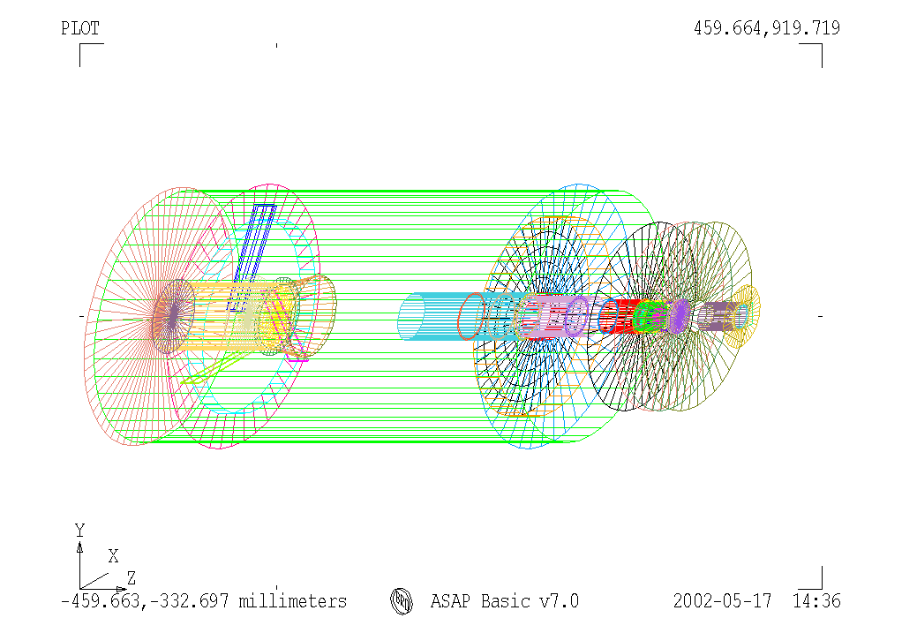

--- TITLE DCE *Raytrace
--- !! WAVELENGTHS 0.317 MICRONS !! Normally set in filters
--- !!SPLIT 0 !! Direct Trace Only
--- !!SPLIT 1 !! For Rect Sources
--- SPLIT 2 !! For double reflection in lens & filters
--- PLOT FACETS 5 5
Window Vertical: Y = -284.246 to 284.246 ( 568.492 )
Horizontal: Z = -332.698 to 919.719 ( 1252.42 )

--- CONSIDER ALL
--- !!CONSIDER ONLY 15
--- ARROWS OFF
--- SEGMENTS 9
--- WINDOW Y Z
--- OBLIQUE 0 0
--- MISSED LINE 50
--- TRACE PLOT 100 OVERLAY
Window Vertical: Y = -210.000 to 210.000 ( 420.000 )
Horizontal: Z = -204.100 to 791.121 ( 995.221 )

10.03 seconds ( 5.65 seconds CPU) to trace 8,000
out of 84,008
20.47 seconds ( 11.54 seconds CPU) to trace 16,000
out of 164,244
31.45 seconds ( 17.71 seconds CPU) to trace 24,000
out of 248,517
42.03 seconds ( 23.74 seconds CPU) to trace 32,000
out of 330,723
52.56 seconds ( 29.69 seconds CPU) to trace 40,000
out of 411,913
62.67 seconds ( 35.43 seconds CPU) to trace 48,000
out of 488,380
72.75 seconds ( 41.17 seconds CPU) to trace 56,000
out of 563,725
82.66 seconds ( 46.68 seconds CPU) to trace 64,000
out of 634,914
92.51 seconds ( 52.07 seconds CPU) to trace 72,000
out of 704,150
102.14 seconds ( 57.52 seconds CPU) to trace 80,000
out of 773,037
109.83 seconds ( 61.77 seconds CPU) to trace 88,000
out of 813,598
115.51 seconds ( 64.90 seconds CPU) to trace 96,000
out of 825,083
2.02 minutes ( 68.04 seconds CPU) to trace 104,000
out of 836,688
2.11 minutes ( 71.03 seconds CPU) to trace 112,000
out of 847,314
2.21 minutes ( 74.25 seconds CPU) to trace 120,000
out of 859,513
2.31 minutes ( 77.44 seconds CPU) to trace 128,000
out of 871,757
2.40 minutes ( 80.48 seconds CPU) to trace 136,000
out of 882,515
2.49 minutes ( 83.53 seconds CPU) to trace 144,000
out of 894,036
2.59 minutes ( 86.70 seconds CPU) to trace 152,000
out of 906,055
2.68 minutes ( 89.88 seconds CPU) to trace 160,000
out of 918,639
2.78 minutes ( 93.08 seconds CPU) to trace 168,000
out of 930,796
2.88 minutes ( 96.19 seconds CPU) to trace 176,000
out of 941,948
2.97 minutes ( 99.25 seconds CPU) to trace 184,000
out of 953,425
3.06 minutes ( 102.41 seconds CPU) to trace 192,000
out of 965,313
3.16 minutes ( 105.67 seconds CPU) to trace 200,000
out of 977,842
3.25 minutes ( 108.91 seconds CPU) to trace 208,000
out of 990,301
3.35 minutes ( 112.09 seconds CPU) to trace 216,000
out of 1,002,429
3.45 minutes ( 115.26 seconds CPU) to trace 224,000
out of 1,014,536
3.55 minutes ( 118.43 seconds CPU) to trace 232,000
out of 1,026,814
3.65 minutes ( 2.03 minutes CPU) to trace 240,000
out of 1,038,941
3.74 minutes ( 2.08 minutes CPU) to trace 248,000
out of 1,050,775
3.84 minutes ( 2.13 minutes CPU) to trace 256,000
out of 1,062,584
3.93 minutes ( 2.19 minutes CPU) to trace 264,000
out of 1,074,610
4.04 minutes ( 2.24 minutes CPU) to trace 272,000
out of 1,086,601
4.15 minutes ( 2.30 minutes CPU) to trace 280,000
out of 1,098,375
4.24 minutes ( 2.35 minutes CPU) to trace 288,000
out of 1,110,232
4.35 minutes ( 2.41 minutes CPU) to trace 296,000
out of 1,121,815
4.44 minutes ( 2.46 minutes CPU) to trace 304,000
out of 1,133,788
4.54 minutes ( 2.51 minutes CPU) to trace 312,000
out of 1,145,840
4.65 minutes ( 2.57 minutes CPU) to trace 320,000
out of 1,157,695
4.75 minutes ( 2.62 minutes CPU) to trace 328,000
out of 1,169,820
4.84 minutes ( 2.67 minutes CPU) to trace 336,000
out of 1,181,875
4.94 minutes ( 2.73 minutes CPU) to trace 344,000
out of 1,194,045
5.03 minutes ( 2.78 minutes CPU) to trace 352,000
out of 1,205,907
5.13 minutes ( 2.84 minutes CPU) to trace 360,000
out of 1,217,939
5.23 minutes ( 2.89 minutes CPU) to trace 368,000
out of 1,230,953
5.33 minutes ( 2.95 minutes CPU) to trace 376,000
out of 1,244,455
5.43 minutes ( 3.00 minutes CPU) to trace 384,000
out of 1,257,896
5.53 minutes ( 3.06 minutes CPU) to trace 392,000
out of 1,270,224
5.63 minutes ( 3.11 minutes CPU) to trace 400,000
out of 1,282,148
5.72 minutes ( 3.16 minutes CPU) to trace 408,000
out of 1,294,428
5.81 minutes ( 3.22 minutes CPU) to trace 416,000
out of 1,306,199
5.90 minutes ( 3.27 minutes CPU) to trace 424,000
out of 1,318,674
6.00 minutes ( 3.32 minutes CPU) to trace 432,000
out of 1,332,084
6.10 minutes ( 3.38 minutes CPU) to trace 440,000
out of 1,345,427
6.19 minutes ( 3.43 minutes CPU) to trace 448,000
out of 1,357,553
6.29 minutes ( 3.49 minutes CPU) to trace 456,000
out of 1,369,442
6.38 minutes ( 3.54 minutes CPU) to trace 464,000
out of 1,381,564
6.48 minutes ( 3.59 minutes CPU) to trace 472,000
out of 1,393,659
6.57 minutes ( 3.65 minutes CPU) to trace 480,000
out of 1,405,736
6.67 minutes ( 3.70 minutes CPU) to trace 488,000
out of 1,419,013
6.77 minutes ( 3.76 minutes CPU) to trace 496,000
out of 1,431,824
6.87 minutes ( 3.81 minutes CPU) to trace 504,000
out of 1,443,536
6.96 minutes ( 3.86 minutes CPU) to trace 512,000
out of 1,455,431
7.05 minutes ( 3.91 minutes CPU) to trace 520,000
out of 1,467,150
7.14 minutes ( 3.96 minutes CPU) to trace 528,000
out of 1,479,318
7.24 minutes ( 4.02 minutes CPU) to trace 536,000
out of 1,492,010
7.34 minutes ( 4.07 minutes CPU) to trace 544,000
out of 1,503,817
7.44 minutes ( 4.12 minutes CPU) to trace 552,000
out of 1,515,153
7.53 minutes ( 4.17 minutes CPU) to trace 560,000
out of 1,526,589
7.62 minutes ( 4.22 minutes CPU) to trace 568,000
out of 1,537,782
7.72 minutes ( 4.27 minutes CPU) to trace 576,000
out of 1,550,384
7.80 minutes ( 4.32 minutes CPU) to trace 584,000
out of 1,561,543
7.90 minutes ( 4.37 minutes CPU) to trace 592,000
out of 1,572,728
7.99 minutes ( 4.43 minutes CPU) to trace 600,000
out of 1,584,414
8.08 minutes ( 4.48 minutes CPU) to trace 608,000
out of 1,595,389
8.18 minutes ( 4.53 minutes CPU) to trace 616,000
out of 1,607,964
8.27 minutes ( 4.58 minutes CPU) to trace 624,000
out of 1,619,640
8.36 minutes ( 4.63 minutes CPU) to trace 632,000
out of 1,631,160
8.45 minutes ( 4.69 minutes CPU) to trace 640,000
out of 1,642,952
8.54 minutes ( 4.74 minutes CPU) to trace 648,000
out of 1,654,544
8.63 minutes ( 4.79 minutes CPU) to trace 656,000
out of 1,666,980
8.72 minutes ( 4.84 minutes CPU) to trace 664,000
out of 1,678,620
8.82 minutes ( 4.89 minutes CPU) to trace 672,000
out of 1,690,238
8.91 minutes ( 4.94 minutes CPU) to trace 680,000
out of 1,701,891
9.01 minutes ( 4.99 minutes CPU) to trace 688,000
out of 1,713,546
9.10 minutes ( 5.05 minutes CPU) to trace 696,000
out of 1,726,090
9.20 minutes ( 5.10 minutes CPU) to trace 704,000
out of 1,737,647
9.27 minutes ( 5.15 minutes CPU) to trace 712,000
out of 1,749,550
9.33 minutes ( 5.21 minutes CPU) to trace 720,000
out of 1,761,521
9.38 minutes ( 5.26 minutes CPU) to trace 728,000
out of 1,773,975
9.44 minutes ( 5.32 minutes CPU) to trace 736,000
out of 1,785,951
9.50 minutes ( 5.37 minutes CPU) to trace 744,000
out of 1,797,801
9.56 minutes ( 5.42 minutes CPU) to trace 752,000
out of 1,809,748
9.62 minutes ( 5.48 minutes CPU) to trace 760,000
out of 1,822,535
9.68 minutes ( 5.53 minutes CPU) to trace 768,000
out of 1,834,477
9.74 minutes ( 5.59 minutes CPU) to trace 776,000
out of 1,846,209
9.80 minutes ( 5.64 minutes CPU) to trace 784,000
out of 1,857,962
9.86 minutes ( 5.70 minutes CPU) to trace 792,000
out of 1,870,777
9.91 minutes ( 5.75 minutes CPU) to trace 800,000
out of 1,882,596
9.97 minutes ( 5.80 minutes CPU) to trace 808,000
out of 1,892,547
9.99 minutes ( 5.83 minutes CPU) to trace 816,000
10.02 minutes ( 5.85 minutes CPU) to trace 824,000
10.04 minutes ( 5.87 minutes CPU) to trace 832,000
10.07 minutes ( 5.90 minutes CPU) to trace 840,000
10.09 minutes ( 5.92 minutes CPU) to trace 848,000
10.12 minutes ( 5.94 minutes CPU) to trace 856,000
10.14 minutes ( 5.96 minutes CPU) to trace 864,000
10.17 minutes ( 5.99 minutes CPU) to trace 872,000
10.19 minutes ( 6.01 minutes CPU) to trace 880,000
10.22 minutes ( 6.03 minutes CPU) to trace 888,000
10.25 minutes ( 6.06 minutes CPU) to trace 896,000
10.27 minutes ( 6.08 minutes CPU) to trace 904,000
10.30 minutes ( 6.10 minutes CPU) to trace 912,000
10.33 minutes ( 6.13 minutes CPU) to trace 920,000
10.35 minutes ( 6.15 minutes CPU) to trace 928,000
10.38 minutes ( 6.18 minutes CPU) to trace 936,000
10.41 minutes ( 6.20 minutes CPU) to trace 944,000
10.43 minutes ( 6.22 minutes CPU) to trace 952,000
10.46 minutes ( 6.24 minutes CPU) to trace 960,000
10.48 minutes ( 6.27 minutes CPU) to trace 968,000
10.51 minutes ( 6.29 minutes CPU) to trace 976,000
10.53 minutes ( 6.31 minutes CPU) to trace 984,000
10.56 minutes ( 6.34 minutes CPU) to trace 992,000
10.58 minutes ( 6.36 minutes CPU) to trace 1,000,000
10.60 minutes ( 6.38 minutes CPU) to trace 1,008,000
10.63 minutes ( 6.40 minutes CPU) to trace 1,016,000
10.66 minutes ( 6.43 minutes CPU) to trace 1,024,000
10.68 minutes ( 6.45 minutes CPU) to trace 1,032,000
10.70 minutes ( 6.47 minutes CPU) to trace 1,040,000
10.74 minutes ( 6.49 minutes CPU) to trace 1,048,000
10.77 minutes ( 6.52 minutes CPU) to trace 1,056,000
10.80 minutes ( 6.54 minutes CPU) to trace 1,064,000
10.82 minutes ( 6.56 minutes CPU) to trace 1,072,000
10.84 minutes ( 6.59 minutes CPU) to trace 1,080,000
10.87 minutes ( 6.61 minutes CPU) to trace 1,088,000
10.89 minutes ( 6.63 minutes CPU) to trace 1,096,000
10.92 minutes ( 6.65 minutes CPU) to trace 1,104,000
10.94 minutes ( 6.68 minutes CPU) to trace 1,112,000
10.97 minutes ( 6.70 minutes CPU) to trace 1,120,000
10.99 minutes ( 6.72 minutes CPU) to trace 1,128,000
11.02 minutes ( 6.75 minutes CPU) to trace 1,136,000
11.04 minutes ( 6.77 minutes CPU) to trace 1,144,000
11.06 minutes ( 6.79 minutes CPU) to trace 1,152,000
11.09 minutes ( 6.81 minutes CPU) to trace 1,160,000
11.11 minutes ( 6.84 minutes CPU) to trace 1,168,000
11.14 minutes ( 6.86 minutes CPU) to trace 1,176,000
11.16 minutes ( 6.88 minutes CPU) to trace 1,184,000
11.19 minutes ( 6.91 minutes CPU) to trace 1,192,000
11.22 minutes ( 6.93 minutes CPU) to trace 1,200,000
11.25 minutes ( 6.95 minutes CPU) to trace 1,208,000
11.30 minutes ( 6.98 minutes CPU) to trace 1,216,000
11.33 minutes ( 7.00 minutes CPU) to trace 1,224,000
11.36 minutes ( 7.02 minutes CPU) to trace 1,232,000
11.38 minutes ( 7.04 minutes CPU) to trace 1,240,000
11.40 minutes ( 7.07 minutes CPU) to trace 1,248,000
11.43 minutes ( 7.09 minutes CPU) to trace 1,256,000
11.45 minutes ( 7.11 minutes CPU) to trace 1,264,000
11.48 minutes ( 7.13 minutes CPU) to trace 1,272,000
11.50 minutes ( 7.16 minutes CPU) to trace 1,280,000
11.52 minutes ( 7.18 minutes CPU) to trace 1,288,000
11.55 minutes ( 7.20 minutes CPU) to trace 1,296,000
11.57 minutes ( 7.22 minutes CPU) to trace 1,304,000
11.60 minutes ( 7.24 minutes CPU) to trace 1,312,000
11.62 minutes ( 7.27 minutes CPU) to trace 1,320,000
11.65 minutes ( 7.29 minutes CPU) to trace 1,328,000
11.67 minutes ( 7.31 minutes CPU) to trace 1,336,000
11.69 minutes ( 7.33 minutes CPU) to trace 1,344,000
11.72 minutes ( 7.35 minutes CPU) to trace 1,352,000
11.74 minutes ( 7.38 minutes CPU) to trace 1,360,000
11.76 minutes ( 7.40 minutes CPU) to trace 1,368,000
11.79 minutes ( 7.42 minutes CPU) to trace 1,376,000
11.81 minutes ( 7.45 minutes CPU) to trace 1,384,000
11.84 minutes ( 7.47 minutes CPU) to trace 1,392,000
11.86 minutes ( 7.49 minutes CPU) to trace 1,400,000
11.89 minutes ( 7.51 minutes CPU) to trace 1,408,000
11.91 minutes ( 7.53 minutes CPU) to trace 1,416,000
11.93 minutes ( 7.56 minutes CPU) to trace 1,424,000
11.96 minutes ( 7.58 minutes CPU) to trace 1,432,000

11.98 minutes ( 7.60 minutes CPU) to trace 1,440,000
12.00 minutes ( 7.62 minutes CPU) to trace 1,448,000
12.03 minutes ( 7.65 minutes CPU) to trace 1,456,000
12.05 minutes ( 7.67 minutes CPU) to trace 1,464,000
12.08 minutes ( 7.69 minutes CPU) to trace 1,472,000
12.10 minutes ( 7.71 minutes CPU) to trace 1,480,000
12.13 minutes ( 7.73 minutes CPU) to trace 1,488,000
12.15 minutes ( 7.76 minutes CPU) to trace 1,496,000
12.17 minutes ( 7.78 minutes CPU) to trace 1,504,000
12.19 minutes ( 7.80 minutes CPU) to trace 1,512,000
12.22 minutes ( 7.82 minutes CPU) to trace 1,520,000
12.25 minutes ( 7.84 minutes CPU) to trace 1,528,000
12.27 minutes ( 7.87 minutes CPU) to trace 1,536,000
12.30 minutes ( 7.89 minutes CPU) to trace 1,544,000
12.32 minutes ( 7.91 minutes CPU) to trace 1,552,000
12.35 minutes ( 7.93 minutes CPU) to trace 1,560,000
12.37 minutes ( 7.95 minutes CPU) to trace 1,568,000
12.40 minutes ( 7.98 minutes CPU) to trace 1,576,000
12.42 minutes ( 8.00 minutes CPU) to trace 1,584,000
12.44 minutes ( 8.02 minutes CPU) to trace 1,592,000
12.47 minutes ( 8.04 minutes CPU) to trace 1,600,000
12.49 minutes ( 8.07 minutes CPU) to trace 1,608,000
12.52 minutes ( 8.09 minutes CPU) to trace 1,616,000
12.54 minutes ( 8.11 minutes CPU) to trace 1,624,000
12.56 minutes ( 8.13 minutes CPU) to trace 1,632,000
12.59 minutes ( 8.15 minutes CPU) to trace 1,640,000
12.61 minutes ( 8.18 minutes CPU) to trace 1,648,000
12.63 minutes ( 8.20 minutes CPU) to trace 1,656,000
12.66 minutes ( 8.22 minutes CPU) to trace 1,664,000
12.68 minutes ( 8.24 minutes CPU) to trace 1,672,000
12.70 minutes ( 8.26 minutes CPU) to trace 1,680,000
12.73 minutes ( 8.28 minutes CPU) to trace 1,688,000
12.75 minutes ( 8.31 minutes CPU) to trace 1,696,000
12.77 minutes ( 8.33 minutes CPU) to trace 1,704,000
12.80 minutes ( 8.35 minutes CPU) to trace 1,712,000
12.82 minutes ( 8.37 minutes CPU) to trace 1,720,000
12.84 minutes ( 8.40 minutes CPU) to trace 1,728,000
12.87 minutes ( 8.42 minutes CPU) to trace 1,736,000
12.89 minutes ( 8.44 minutes CPU) to trace 1,744,000
12.92 minutes ( 8.46 minutes CPU) to trace 1,752,000
12.94 minutes ( 8.48 minutes CPU) to trace 1,760,000
12.97 minutes ( 8.51 minutes CPU) to trace 1,768,000
12.99 minutes ( 8.53 minutes CPU) to trace 1,776,000
13.01 minutes ( 8.55 minutes CPU) to trace 1,784,000
13.04 minutes ( 8.57 minutes CPU) to trace 1,792,000
13.06 minutes ( 8.60 minutes CPU) to trace 1,800,000
13.08 minutes ( 8.62 minutes CPU) to trace 1,808,000
13.11 minutes ( 8.64 minutes CPU) to trace 1,816,000
13.14 minutes ( 8.66 minutes CPU) to trace 1,824,000
13.16 minutes ( 8.69 minutes CPU) to trace 1,832,000
13.18 minutes ( 8.71 minutes CPU) to trace 1,840,000
13.21 minutes ( 8.73 minutes CPU) to trace 1,848,000
13.23 minutes ( 8.76 minutes CPU) to trace 1,856,000
13.25 minutes ( 8.78 minutes CPU) to trace 1,864,000
13.28 minutes ( 8.80 minutes CPU) to trace 1,872,000
13.31 minutes ( 8.82 minutes CPU) to trace 1,880,000
13.33 minutes ( 8.84 minutes CPU) to trace 1,888,000
13.34 minutes ( 8.86 minutes CPU) to trace 1,892,547

Total of 1471380 PARENT warnings
Missed Multiple Wrong Low Evanescent Wrong Absorbed
Obj Total After Bounce Side Flux (TIR) Direc After
1 14 14 PRIMARY S1
2 1289 208 1081 PRIMARYHOLE
3 48128 19072 29056 PRIMARY BACK
4 10506 10506 PRIMARYEDGE
7 1256 51 1205 DETECTOR-COVER
8 21794 21794 SPIDER
9 7498 87 7411 SPIDERCYL
10 2345 73 2272 SPIDERARMX
11 4231 77 4154 SPIDERARMX1
12 2282 60 2222 SPIDERARMX2
13 149878 1641 148237 BARRELBAFFLE
14 159280 159279 1 ENTRANCE
15 3494 8 3486 SECONDARYHOUSING
16 28818 265 28553 SH-CONE
17 8288 7 8281 SH-CONEBASE
18 44364 917 43447 SH-CYLINDER
19 472 9 463 SH-TOP
20 43642 6 43636 SH-MIDVANE
21 136162 486 135676 CBAF-FRONT
22 9505 9505 CBAF-LEDGE
23 86007 21262 64745 CBAF-AFT
24 3856 6 3850 CBAF-VANE1
25 4162 3 4159 CBAF-VANE2
26 5596 578 5018 CBAF-VANE3
27 38777 18825 19952 LENS MOUNT
28 31696 2059 29637 LENS TUBE-FRONT
29 3757 136 3621 LT-FACE
30 1076 19 1057 LT-LENS 1FACE
31 5087 70 5017 LENS TUBE AFT
32 2076 19 2057 LT-AFT FACE
33 2995 1101 1894 LENS1F
34 3480 1291 2189 LENS1B
35 4860 3817 1043 LENS2F
36 4279 3640 639 LENS2B
37 6094 4424 1670 LENS3F
38 3943 1473 2470 LENS3B
39 100 100 LENSHOLDER
40 25863 7187 18676 FW-HOUSING FRONT
41 230644 160239 70405 FW-HOUSING AFT
42 1174 624 522 28 FILTERHOLDER
43 110618 48096 62522 FILTER-WHEEL
44 15103 3229 11874 EXIT CONE FRONT
45 159355 24733 134622 EC-CYLINDER
46 11350 11350 EC-SHELF
47 3033 2421 612 EC-EXITCONE
48 6553 4652 1901 EC-EXIT
49 3218 29 2674 515 FILTERUVE-F
50 4690 4197 493 FILTERUVE-B
51 3195 1 2425 598 171 FILTERUVB-F
52 5497 3223 624 1650 FILTERUVB-B

Total of 64624 CHILD warnings
Missed Multiple Wrong Low Evanescent Wrong Absorbed
Obj Total After Bounce Side Flux (TIR) Direc After
7 2526 2526 DETECTOR-COVER
33 4868 4868 LENS1F
34 4829 4829 LENS1B
35 6528 6528 LENS2F
36 6527 6527 LENS2B
37 6467 6467 LENS3F
38 6446 6446 LENS3B
49 6339 6339 FILTERUVE-F
50 6352 6352 FILTERUVE-B
51 6860 6860 FILTERUVB-F
52 6882 6882 FILTERUVB-B
13402148 ray-objects encountered at 25217 per CPU second
136526343 order-intersections done at 256892 per CPU second

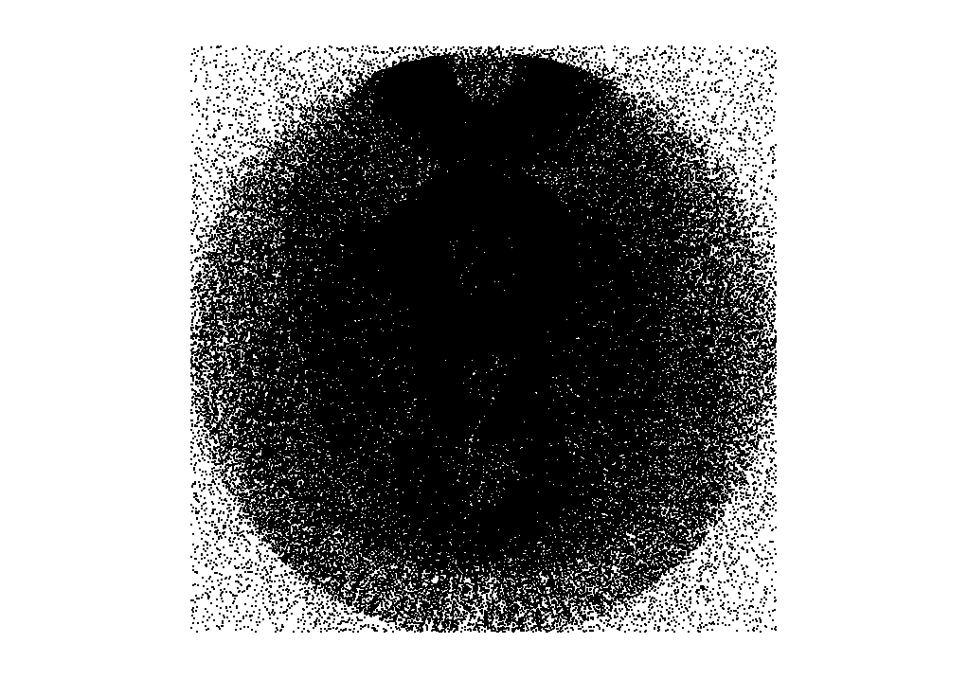

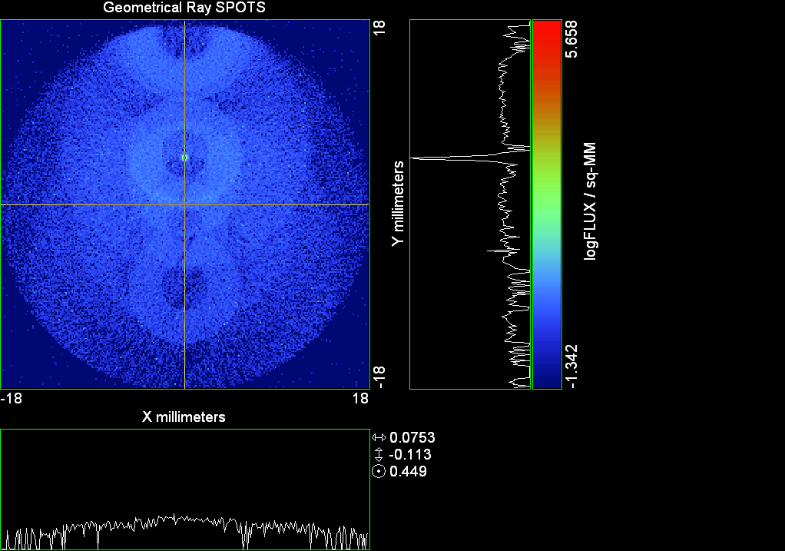

--- ! Spot Plot (Run Ray Trace First)
--- CONSIDER ONLY 6 !!Grid Detector=6
--- !!CONSIDER ONLY 7 !! Earth Detector=7
--- OBLIQUE OFF
--- !!TITLE 'FOV1-9/19^2 mm^2=15503 Rays'
--- !!TITLE 'FOV8 Rect Source Det=2170 total rays'
--- !!TITLE 'FOV8 RctSrc Det=1357-1348=11 rays from Pedestals DetImplBafOnly'
--- !!TITLE 'FOV8 RctSrc Det=750 rays "On"Mrlts Pd&SbS=0 DtImplBfOnly'
--- !!TITLE 'FOV8 RctSrc Det=754 rays "On"Mrlts Pd=1 SbS=0 DtImplBfOnly'
--- !!TITLE 'FOV8 3x3 Pt Src =215 rays "On"Mrlts Pd=1 SbS=0 DtImplBfOnly'
--- TITLE '1.5E6 KM to Source at L1 Distance'
--- !!WINDOW Y X
--- WINDOW Y -18 18 X -18 18
--- !!WINDOW Y 11 14 X -1.5 1.5
--- !!TITLE 'FOV8 23x23 1358-678=680 Rays/.109 mm^2 = 6238 Rays/mm^2 5.5%'
--- !!WINDOW Y 135.75 136.25 X 82.5 83 !!FOV 8
--- !!TITLE 'FOV8 3x3 Core 678 Rays/.006mm^2 = 113000 Rays/mm^2'
--- !!WINDOW Y 136.01 136.07 X 82.75 82.85 !!FOV 8
--- PIXELS 256
--- SPOTS POSITION

Distribution of data within:
Window Vertical: Y = -18.0000 to 18.0000 ( 36.0000 )
Horizontal: X = -18.0000 to 18.0000 ( 36.0000 )

Opening NEW distribution file 9: C:\ASAP Work\TRIANA\bro009.dat
Rays Flux
356905 22462.4
Maximum = 455354.5 minimum = 0.0000000E+00
--- $IO "ASAPTEMP.INR"
Opening 1 C:\ASAP Work\TRIANA\asaptemp.inr

Closing 7 C:\ASAP Work\TRIANA\bro007.dat
Opening 7 C:\ASAP Work\TRIANA\asaptemp.usr

Closing 20 C:\ASAP Work\TRIANA\bro020.dat
Opening 20 C:\ASAP Work\TRIANA\asaptemp.plr

Closing 30 C:\ASAP Work\TRIANA\bro030.dat
Opening 30 C:\ASAP Work\TRIANA\asaptemp.vcr

--- !! PICTURE (Run Ray Trace and Spots Position First)
--- !! Picks size from Spots Position window size
--- TITLE 'EPIC'
--- CONSIDER ONLY 7 !! Detector = 6 for Grid, 7 for Earth
--- !!WINDOW X -1.5 1.5 Y 11 14
--- WINDOW Y X
--- DISPLAY
Opening OLD distribution file 9: C:\ASAP Work\TRIANA\bro009.dat

File header:
Geometrical Ray SPOTS 1
Z 790.7430 FLUX / sq-MM
X millimeters -18.00000 18.00000 256
Y millimeters -18.00000 18.00000 256

Statistics on 256 by 256 data set:
FLUX / sq-MM Location Y millimeters X millimeters
Minimum 0.000000 1 1 -17.92969 -17.92969
Maximum 455354.5 161 129 4.570312 0.7031250E-01
Average 17.33148 160 129 4.429688 0.7031250E-01
TOTAL FLUX = 22461.60

--- AVERAGE 0 0
Statistics on 256 by 256 data set:
FLUX / sq-MM Location Y millimeters X millimeters
Minimum 0.000000 1 1 -17.92969 -17.92969
Maximum 455354.5 161 129 4.570312 0.7031250E-01
Average 17.33148 160 129 4.429688 0.7031250E-01
TOTAL FLUX = 22461.60

--- FORM -7
Statistics on 256 by 256 data set:
FLUX / sq-MM Location Y millimeters X millimeters
Minimum -1.341650 1 1 -17.92969 -17.92969
Maximum 5.658350 161 129 4.570312 0.7031250E-01
Average -0.5216923 137 129 1.195312 0.7031250E-01
Integral = -676.1133

--- !!CONTOUR .001 .005 .01 .05 .1 .2 .3 .4 .5 .6 .7 .8 .85 .9 .95 GRID 2
--- PICTURE
Opening NEW distribution file 10: C:\ASAP Work\TRIANA\i.dis
--- $IO "ASAPTEMP.INR"
Opening 1 C:\ASAP Work\TRIANA\asaptemp.inr

Closing 7 C:\ASAP Work\TRIANA\bro007.dat
Opening 7 C:\ASAP Work\TRIANA\asaptemp.usr

Closing 20 C:\ASAP Work\TRIANA\bro020.dat
Creating 20 C:\ASAP Work\TRIANA\asaptemp.plr

Closing 30 C:\ASAP Work\TRIANA\bro030.dat
Creating 30 C:\ASAP Work\TRIANA\asaptemp.vcr

--- DISPLAY
Opening OLD distribution file 9: C:\ASAP Work\TRIANA\bro009.dat

File header:
Geometrical Ray SPOTS 1
Z 790.7430 FLUX / sq-MM
X millimeters -18.00000 18.00000 256
Y millimeters -18.00000 18.00000 256

Statistics on 256 by 256 data set:
FLUX / sq-MM Location Y millimeters X millimeters
Minimum 0.000000 1 1 -17.92969 -17.92969
Maximum 455354.5 161 129 4.570312 0.7031250E-01
Average 17.33148 160 129 4.429688 0.7031250E-01
TOTAL FLUX = 22461.60

--- TEXTFILE X_Text_Output !!Names Text File, overwrites without warning
--- DATA 'E12.5' !! Format with single blank space
--- EOF

Run 16 YFan 0375 Polar Grid Random 7754 rays.xls

Run 17 YFan 0.500 Polar Grid Random 7754 rays

--- END

System database and settings have been reinitialized
--- !! Geometry is being appended to system.
--- !! To not view this message, refer to ASAP preferences dialog,
--- !! or change the Options->Append Geometry menu item.
--- GRID POLAR Z -250 46 154.5 0 360 100 36 1 RANDOM 1
7754 rays created in a POLAR grid for a total of 7754
--- SOURCE DIR 0 0 1500000
Source Z angle for rays
0.000 1 -7754
--- RETURN
--- UNITS MILLIMETERS
--- WAVELENGTHS 0.950000 0.706000 0.587560 0.435000 0.300000 MICRONS
--- MEDIA; 1.45106513 1.45515708 1.45846375 1.46676272 1.48779297 'SILICA'
--- COATING PROPERTIES; 1 0 'WHITE'
--- COATING PROPERTIES; .98 0 'MIRROR'
--- COATING PROPERTIES; .11 .87 'DETECTORQE317'
--- COATING PROPERTIES; .10 .75 'DETECTORQE325'
--- COATING PROPERTIES; .05 0 'BLACK'
--- COATING PROPERTIES; 0 0 'ZERO'
--- COATING PROPERTIES; 0 1 'CLEAR'
--- STRUE=0
--- SX=0
--- SY=0
--- SZ=0
--- SCAT=1
--- ENT OBJECT;MIRROR Z 439.24 159 (1219.2/2) -1 (38.2/159) 'PRIMARY S1'
--- INTERFACE COATING MIRROR AIR AIR
--- ENT OBJECT;TUBE Z 438.5 38.2 38.2 466.53196 38.2 38.2 0.0 0.0 'PRIMARYHOLE'
--- INTERFACE COATING BLACK AIR AIR
--- SCATTER RANDOM 1 (SCAT) 1.57 ABS 1 0
*** LEVEL automatically set to 1
--- ENT OBJECT;PLANE Z 466.5 ELLIPSE 210 210 (38.2/210) 'PRIMARY BACK'
--- INTERFACE COATING BLACK AIR AIR
--- SCATTER RANDOM 1 (SCAT) 1.57 ABS 1 0
--- ENT OBJECT;TUBE Z 429 159 159 466.5 159 159 0.0 0.0 'PRIMARYEDGE'
--- INTERFACE COATING BLACK AIR AIR
--- SCATTER RANDOM 1 (SCAT) 1.57 ABS 1 0
--- ENT OBJECT;MIRROR Z 0.0 46 (434.7/2) -2.40763 0.0 'SECONDARY S2'
--- INTERFACE COATING MIRROR AIR AIR
--- ENT OBJECT;PLANE Z 790.7429896 RECTANGLE 18 18 0 'DETECTOR'
--- INTERFACE COATING ZERO SILICA AIR
--- ENT OBJECT;PLANE Z 790.7 RECTANGLE 18 18 0 'DETECTOR-COVER'
--- INTERFACE COATING DETECTORQE317 SILICA AIR
*** SPLIT automatically set to 1
--- ENT OBJECT;PLANE Z -55.69204 ELLIPSE 210 210 (154.8315449/210) 'SPIDER'
--- INTERFACE COATING BLACK AIR AIR
--- SCATTER RANDOM 1 (SCAT) 1.57 ABS 1 0
--- ENT OBJECT;TUBE Z -55.69204 154.8315449 154.8315449 -30.29204 154.8315449 154.8315449 0.0 0.0 'SPIDERCYL'
--- INTERFACE COATING BLACK AIR AIR
--- SCATTER RANDOM 1 (SCAT) 1.57 ABS 1 0
--- ENT OBJECT;TUBE X 0 0.75 12.52 -170 0.75 15.52 1 1 'SPIDERARMX'
--- SHIFT 0 -52.578 -42.992
--- INTERFACE COATING BLACK AIR AIR
--- SCATTER RANDOM 1 (SCAT) 1.57 ABS 1 0
--- ENT OBJECT;TUBE X 0 5 12.52 -170 5 15.52 1 1 'SPIDERARMX1'
--- SHIFT 0 -52.578 -42.992
--- ROTATE Z -120 0 0
--- INTERFACE COATING BLACK AIR AIR
--- SCATTER RANDOM 1 (SCAT) 1.57 ABS 1 0
--- ENT OBJECT;TUBE X 0 0.75 12.52 -170 0.75 15.52 1 1 'SPIDERARMX2'
--- SHIFT 0 -52.578 -42.992
--- ROTATE Z -240 0 0
--- INTERFACE COATING BLACK AIR AIR
--- SCATTER RANDOM 1 (SCAT) 1.57 ABS 1 0
--- ENT OBJECT;TUBE Z -185.6 200.8 200.8 528 200.8 200.8 0.0 0.0 'BARRELBAFFLE'
--- INTERFACE COATING BLACK AIR AIR
--- SCATTER RANDOM 1 (SCAT) 1.57 ABS 1 0
--- ENT OBJECT;ELLIPSE Z -200 205 205 64 0.0 360.0 'ENTRANCE'
Default ELLIP/ROUND/OVAL segments changed to 64
--- INTERFACE COATING CLEAR AIR AIR
--- ENT OBJECT;TUBE Z (2.391*25.4) (2.546*25.4) (2.546*25.4) (2.164*25.4) (2.546*25.4) (2.546*25.4) 0.0 0.0 'SECONDARYHOUSING'
--- INTERFACE COATING BLACK AIR AIR
--- SCATTER RANDOM 1 (SCAT) 1.57 ABS 1 0
--- ENT OBJECT;TUBE Z (2.164*25.4) (2.546*25.4) (2.546*25.4) 0 (2*25.4) (2*25.4) 0.0 0.0 'SH-CONE'
--- INTERFACE COATING BLACK AIR AIR
--- SCATTER RANDOM 1 (SCAT) 1.57 ABS 1 0
--- ENT OBJECT;PLANE Z 0.0 ELLIPSE (2.45*25.4) (2.45*25.4) (2.00/2.45) 'SH-CONEBASE'
--- INTERFACE COATING BLACK AIR AIR
--- SCATTER RANDOM 1 (SCAT) 1.57 ABS 1 0
--- ENT OBJECT;TUBE Z 0.0 (2.125*25.4) (2.125*25.4) (-6.875*25.4) (2.125*25.4) (2.125*25.4) 0.0 0.0 'SH-CYLINDER'
--- INTERFACE COATING BLACK AIR AIR
--- SCATTER RANDOM 1 (SCAT) 1.57 ABS 1 0
--- ENT OBJECT;PLANE Z (-6.875*25.4) ELLIPSE (2.33*25.4) 'SH-TOP'
--- INTERFACE COATING BLACK AIR AIR
--- SCATTER RANDOM 1 (SCAT) 1.57 ABS 1 0
--- ENT OBJECT;PLANE Z (-1.9*25.4) ELLIPSE (2.546*25.4) 'SH-MIDVANE'
--- INTERFACE COATING BLACK AIR AIR
--- SCATTER RANDOM 1 (SCAT) 1.57 ABS 1 0
--- ENT OBJECT;TUBE Z 226.38766 37.465 37.465 422.98366 37.465 37.465 0.0 0.0 'CBAF-FRONT'
--- INTERFACE COATING BLACK AIR AIR
--- SCATTER RANDOM 1 (SCAT) 1.57 ABS 1 0
--- ENT OBJECT;PLANE Z 422.98366 ELLIPSE 37.485 37.485 (30.5562/37.485) 'CBAF-LEDGE'
--- INTERFACE COATING BLACK AIR AIR
--- SCATTER RANDOM 1 (SCAT) 1.57 ABS 1 0
--- ENT OBJECT;TUBE Z 422.985 32.2072 32.2072 532.45766 32.2072 32.2072 0.0 0.0 'CBAF-AFT'
--- INTERFACE COATING BLACK AIR AIR
--- SCATTER RANDOM 1 (SCAT) 1.57 ABS 1 0
--- ENT OBJECT;PLANE Z 327.98766 ELLIPSE 37.485 37.485 (35.56/37.485) 'CBAF-VANE1'
--- INTERFACE COATING BLACK AIR AIR
--- SCATTER RANDOM 1 (SCAT) 1.57 ABS 1 0
--- ENT OBJECT;PLANE Z 378.78766 ELLIPSE 37.485 37.485 (35.56/37.485) 'CBAF-VANE2'
--- INTERFACE COATING BLACK AIR AIR
--- SCATTER RANDOM 1 (SCAT) 1.57 ABS 1 0
--- ENT OBJECT;PLANE Z 505.53366 ELLIPSE 32.24 32.24 (28.6512/32.24) 'CBAF-VANE3'
--- INTERFACE COATING BLACK AIR AIR
--- SCATTER RANDOM 1 (SCAT) 1.57 ABS 1 0
--- RETURN
--- !! Geometry is being appended to system.
--- !! To not view this message, refer to ASAP preferences dialog,
--- !! or change the Options->Append Geometry menu item.
--- UNITS MILLIMETERS
--- WAVELENGTHS 0.950000 0.706000 0.587560 0.435000 0.300000 MICRONS
--- MEDIA; 1.45106513 1.45515708 1.45846375 1.46676272 1.48779297 'SILICA'
--- COATING PROPERTIES; .98 0 'MIRROR'
--- COATING PROPERTIES; .05 0 'BLACK'
--- COATING PROPERTIES; 0 0 'ZERO'
--- COATING PROPERTIES; 0 1 'CLEAR'
--- COATING PROPERTIES; .05 .95 'ARF05'
--- COATING PROPERTIES; 0.2 0.8 'ARF20'
--- ENT OBJECT;PLANE Z 615.3400000 ELLIPSE 150 150 (22/150) 'LENS MOUNT'
--- INTERFACE COATING BLACK AIR AIR
--- SCATTER RANDOM 1 (SCAT) 1.57 ABS 1 0
--- ENT OBJECT;TUBE Z 558.61966 26.7 26.7 620 26.7 26.7 0.0 0.0 'LENS TUBE-FRONT'
--- INTERFACE COATING BLACK AIR AIR
--- SCATTER RANDOM 1 (SCAT) 1.57 ABS 1 0
--- ENT OBJECT;PLANE Z 558.61966 ELLIPSE 27.7 27.7 (24.945/27.7) 'LT-FACE'
--- INTERFACE COATING BLACK AIR AIR
--- SCATTER RANDOM 1 (SCAT) 1.57 ABS 1 0
--- ENT OBJECT;PLANE Z 616.4326 ELLIPSE 27.7 27.7 (21.5/27.7) 'LT-LENS 1FACE'
--- INTERFACE COATING BLACK AIR AIR
--- SCATTER RANDOM 1 (SCAT) 1.57 ABS 1 0
--- ENT OBJECT;TUBE Z 621 25.152 25.152 657.7965 25.152 25.152 0.0 0.0 'LENS TUBE AFT'
--- INTERFACE COATING BLACK AIR AIR
--- SCATTER RANDOM 1 (SCAT) 1.57 ABS 1 0
--- ENT OBJECT;PLANE Z 657.7965 ELLIPSE 25.152 25.152 (21.26386619/25.152) 'LT-AFT FACE'
--- INTERFACE COATING BLACK AIR AIR
--- SCATTER RANDOM 1 (SCAT) 1.57 ABS 1 0
--- ENT OBJECT;OPTICAL Z 615.3400000 221.803 0 ELLIPSE 22 'LENS1F'
--- INTERFACE COATING ARF05 AIR SILICA
--- ENT OBJECT;OPTICAL Z 620.3400000 584.5 0 ELLIPSE 22 'LENS1B'
--- INTERFACE COATING ARF05 AIR SILICA
--- ENT OBJECT;OPTICAL Z 627.63 -147.027 0 ELLIPSE 22 'LENS2F'
--- INTERFACE COATING ARF05 AIR SILICA
--- ENT OBJECT;OPTICAL Z 632.63 -135.158 0 ELLIPSE 22 'LENS2B'
--- INTERFACE COATING ARF05 AIR SILICA
--- ENT OBJECT;OPTICAL Z 635.6 97.002 0 ELLIPSE 22 'LENS3F'
--- INTERFACE COATING ARF05 AIR SILICA
--- ENT OBJECT;OPTICAL Z 640.6 67.147 0 ELLIPSE 22 'LENS3B'
--- INTERFACE COATING ARF05 AIR SILICA
--- ENT OBJECT;TUBE Z 614 22 22 645 22 22 0.0 0.0 'LENSHOLDER'
--- INTERFACE COATING ZERO AIR AIR
--- SCATTER RANDOM 1 (SCAT) 1.57 ABS 1 0
--- ENT OBJECT;PLANE Z 660.84196 ELLIPSE 150 150 (25.28148817/150) 'FW-HOUSING FRONT'
--- INTERFACE COATING BLACK AIR AIR
--- SCATTER RANDOM 1 (SCAT) 1.57 ABS 1 0
--- ENT OBJECT;PLANE Z 709.10196 ELLIPSE 150 150 (25.28148817/150) 'FW-HOUSING AFT'
--- INTERFACE COATING BLACK AIR AIR
--- SCATTER RANDOM 1 (SCAT) 1.57 ABS 1 0
--- ENT OBJECT;TUBE Z (673.54196-.3) 27.5 27.5 (680.04436+.3) 27.5 27.5 0.0 0.0 'FILTERHOLDER'
--- INTERFACE COATING BLACK AIR AIR
--- SCATTER RANDOM 1 (SCAT) 1.57 ABS 1 0
--- ENT OBJECT;PLANE Z 675 ELLIPSE 150 150 (27.5/150) 'FILTER-WHEEL'
--- INTERFACE COATING BLACK AIR AIR
--- SCATTER RANDOM 1 (SCAT) 1.57 ABS 1 0
--- ENT OBJECT;TUBE Z 721.59876 19.16979665 19.16979665 723.53932 22.558 22.558 0.0 0.0 'EXIT CONE FRONT'
--- INTERFACE COATING BLACK AIR AIR
--- SCATTER RANDOM 1 (SCAT) 1.57 ABS 1 0
--- ENT OBJECT;TUBE Z 723.53932 22.558 22.558 781.84248 22.558 22.558 0.0 0.0 'EC-CYLINDER'
--- INTERFACE COATING BLACK AIR AIR
--- SCATTER RANDOM 1 (SCAT) 1.57 ABS 1 0
--- ENT OBJECT;PLANE Z 781.84248 ELLIPSE 22.558 22.558 (16.89/22.558) 'EC-SHELF'
--- INTERFACE COATING BLACK AIR AIR
--- SCATTER RANDOM 1 (SCAT) 1.57 ABS 1 0
--- ENT OBJECT;TUBE Z 781.84248 16.89 16.89 783.87448 20.41280351 20.41280351 0.0 0.0 'EC-EXITCONE'
--- INTERFACE COATING BLACK AIR AIR
--- SCATTER RANDOM 1 (SCAT) 1.57 ABS 1 0
--- ENT OBJECT;PLANE Z 783.87448 ELLIPSE 50 50 (20.41280351/50) 'EC-EXIT'
--- INTERFACE COATING BLACK AIR AIR
--- SCATTER RANDOM 1 (SCAT) 1.57 ABS 1 0
--- RETURN
--- $IO "ASAPTEMP.INR"
Opening 1 C:\ASAP Work\TRIANA\asaptemp.inr

Closing 7 C:\ASAP Work\TRIANA\bro007.dat
Opening 7 C:\ASAP Work\TRIANA\asaptemp.usr

Closing 20 C:\ASAP Work\TRIANA\bro020.dat
Creating 20 C:\ASAP Work\TRIANA\asaptemp.plr

Closing 30 C:\ASAP Work\TRIANA\bro030.dat
Creating 30 C:\ASAP Work\TRIANA\asaptemp.vcr

--- !! Filters-2 from .ent/copy/.inr to allow ABSORBing media
--- UNITS MILLIMETERS
--- WAVELENGTHS 0.950000 0.706000 0.587560 0.435000 0.300000 MICRONS
--- MEDIA; 1.45106513 1.45515708 1.45846375 1.46676272 1.48779297 'SILICA'
--- !!COATING PROPERTIES; .98 0 'MIRROR'
--- !!COATING PROPERTIES; .05 0 'BLACK'
--- !!COATING PROPERTIES; 0 0 'ZERO'
--- !!COATING PROPERTIES; 0 1 'CLEAR'
--- COATING PROPERTIES; .0745 .9255 'ARF0745'
--- COATING PROPERTIES; .0525 .9475 'ARF0525'
--- COATING PROPERTIES; .05 .95 'ARF05'
--- COATING PROPERTIES; .005 .995 'ARF005'
--- !!COATING PROPERTIES; 0.2 0.8 'ARF20'
--- !!!!!!!!!!!!!!!!!!!!!!!!!!!!!!!!!!!!!!!!!!!!!!!!!!
--- WAVELENGTH 0.317 MICRONS
--- MEDIA
--- 1.48342884 ABSORB 0.13168 'BLOCKER317'
--- MEDIA
--- 1.48342884 ABSORB 0.00307 'ETALON317'
--- !!!!!!!!!!!!!!!!!!!!!!!!!!!!!!!!!!!!!!!!!!!!!!!!!!
--- !!WAVELENGTH 0.325 MICRONS
--- !!MEDIA
--- !! 1.48163777 ABSORB 0.08074 'BLOCKER325'
--- !!MEDIA
--- !! 1.48163777 ABSORB 0.0415179525 'ETALON325'
--- !!!!!!!!!!!!!!!!!!!!!!!!!!!!!!!!!!!!!!!!!!!!!!!!!!!!!
--- ENT OBJECT;PLANE Z 673.54196 ELLIPSE 27.5 'FILTERUVE-F'
--- INTERFACE COATING ARF0525 AIR ETALON317
--- !! INTERFACE COATING ARF0745 AIR ETALON325
--- ENT OBJECT;PLANE Z 676.71696 ELLIPSE 27.5 'FILTERUVE-B'
--- INTERFACE COATING ARF0525 AIR ETALON317
--- !! INTERFACE COATING ARF0745 AIR ETALON325
--- ENT OBJECT;PLANE Z 676.86936 ELLIPSE 27.5 'FILTERUVB-F'
--- INTERFACE COATING ARF005 AIR BLOCKER317
--- !! INTERFACE COATING ARF005 AIR BLOCKER325
--- ENT OBJECT;PLANE Z 680.04436 ELLIPSE 27.5 'FILTERUVB-B'
--- INTERFACE COATING ARF005 AIR BLOCKER317
--- !! INTERFACE COATING ARF005 AIR BLOCKER325
--- !!RETURN

--- TITLE DCE *Raytrace
--- !! WAVELENGTHS 0.317 MICRONS !! Normally set in filters
--- !!SPLIT 0 !! Direct Trace Only
--- !!SPLIT 1 !! For Rect Sources
--- SPLIT 2 !! For double reflection in lens & filters
--- PLOT FACETS 5 5
Window Vertical: Y = -210.000 to 210.000 ( 420.000 )
Horizontal: Z = -204.100 to 791.121 ( 995.221 )

--- CONSIDER ALL
--- !!CONSIDER ONLY 15
--- ARROWS OFF
--- SEGMENTS 9
--- WINDOW Y Z
--- OBLIQUE 0 0
--- MISSED LINE 50
--- TRACE PLOT 100 OVERLAY
Window Vertical: Y = -210.000 to 210.000 ( 420.000 )
Horizontal: Z = -204.100 to 791.121 ( 995.221 )

10.97 seconds ( 5.73 seconds CPU) to trace 8,000
out of 84,058
23.26 seconds ( 12.33 seconds CPU) to trace 16,000
out of 184,315
35.56 seconds ( 18.99 seconds CPU) to trace 24,000
out of 283,461
46.75 seconds ( 25.09 seconds CPU) to trace 32,000
out of 361,277
57.77 seconds ( 31.09 seconds CPU) to trace 40,000
out of 440,410
67.76 seconds ( 36.53 seconds CPU) to trace 48,000
out of 505,219
76.66 seconds ( 41.33 seconds CPU) to trace 56,000
out of 561,518
85.86 seconds ( 46.39 seconds CPU) to trace 64,000
out of 622,993
95.70 seconds ( 51.68 seconds CPU) to trace 72,000
out of 692,114
105.90 seconds ( 57.33 seconds CPU) to trace 80,000
out of 769,767
114.15 seconds ( 61.92 seconds CPU) to trace 88,000
out of 811,746
2.01 minutes ( 65.40 seconds CPU) to trace 96,000
out of 820,374
2.11 minutes ( 68.56 seconds CPU) to trace 104,000
out of 827,251
2.20 minutes ( 71.75 seconds CPU) to trace 112,000
out of 835,339
2.30 minutes ( 74.97 seconds CPU) to trace 120,000
out of 845,394
2.40 minutes ( 78.37 seconds CPU) to trace 128,000
out of 856,008
2.50 minutes ( 81.92 seconds CPU) to trace 136,000
out of 868,629
2.62 minutes ( 85.66 seconds CPU) to trace 144,000
out of 882,316
2.72 minutes ( 89.28 seconds CPU) to trace 152,000
out of 895,616
2.83 minutes ( 92.92 seconds CPU) to trace 160,000
out of 909,328
2.94 minutes ( 96.73 seconds CPU) to trace 168,000
out of 921,921
3.06 minutes ( 100.54 seconds CPU) to trace 176,000
out of 933,516
3.18 minutes ( 104.42 seconds CPU) to trace 184,000
out of 946,192
3.29 minutes ( 108.31 seconds CPU) to trace 192,000
out of 960,127
3.40 minutes ( 112.22 seconds CPU) to trace 200,000
out of 973,993
3.52 minutes ( 115.85 seconds CPU) to trace 208,000
out of 987,898
3.62 minutes ( 119.46 seconds CPU) to trace 216,000
out of 1,001,202
3.73 minutes ( 2.05 minutes CPU) to trace 224,000
out of 1,013,614
3.83 minutes ( 2.11 minutes CPU) to trace 232,000
out of 1,024,811
3.92 minutes ( 2.16 minutes CPU) to trace 240,000
out of 1,034,058
4.02 minutes ( 2.21 minutes CPU) to trace 248,000
out of 1,042,074
4.11 minutes ( 2.26 minutes CPU) to trace 256,000
out of 1,051,183
4.21 minutes ( 2.32 minutes CPU) to trace 264,000
out of 1,060,411
4.30 minutes ( 2.37 minutes CPU) to trace 272,000
out of 1,068,888
4.39 minutes ( 2.41 minutes CPU) to trace 280,000
out of 1,076,702
4.48 minutes ( 2.46 minutes CPU) to trace 288,000
out of 1,084,424
4.57 minutes ( 2.51 minutes CPU) to trace 296,000
out of 1,091,994
4.66 minutes ( 2.56 minutes CPU) to trace 304,000
out of 1,102,225
4.77 minutes ( 2.62 minutes CPU) to trace 312,000
out of 1,112,992
4.86 minutes ( 2.67 minutes CPU) to trace 320,000
out of 1,122,512
4.95 minutes ( 2.72 minutes CPU) to trace 328,000
out of 1,133,107
5.04 minutes ( 2.77 minutes CPU) to trace 336,000
out of 1,142,733
5.14 minutes ( 2.82 minutes CPU) to trace 344,000
out of 1,152,626
5.23 minutes ( 2.87 minutes CPU) to trace 352,000
out of 1,162,026
5.34 minutes ( 2.93 minutes CPU) to trace 360,000
out of 1,172,443
5.44 minutes ( 2.99 minutes CPU) to trace 368,000
out of 1,184,417
5.55 minutes ( 3.05 minutes CPU) to trace 376,000
out of 1,196,575
5.65 minutes ( 3.11 minutes CPU) to trace 384,000
out of 1,208,762
5.75 minutes ( 3.16 minutes CPU) to trace 392,000
out of 1,220,820
5.85 minutes ( 3.22 minutes CPU) to trace 400,000
out of 1,232,120
5.94 minutes ( 3.27 minutes CPU) to trace 408,000
out of 1,242,829
6.04 minutes ( 3.33 minutes CPU) to trace 416,000
out of 1,253,119
6.14 minutes ( 3.38 minutes CPU) to trace 424,000
out of 1,263,426
6.23 minutes ( 3.44 minutes CPU) to trace 432,000
out of 1,273,432
6.29 minutes ( 3.49 minutes CPU) to trace 440,000
out of 1,283,267
6.35 minutes ( 3.55 minutes CPU) to trace 448,000
out of 1,292,800
6.41 minutes ( 3.60 minutes CPU) to trace 456,000
out of 1,301,854
6.46 minutes ( 3.65 minutes CPU) to trace 464,000
out of 1,310,381
6.51 minutes ( 3.69 minutes CPU) to trace 472,000
out of 1,318,013
6.56 minutes ( 3.74 minutes CPU) to trace 480,000
out of 1,324,744
6.60 minutes ( 3.78 minutes CPU) to trace 488,000
out of 1,331,281
6.65 minutes ( 3.83 minutes CPU) to trace 496,000
out of 1,337,890
6.70 minutes ( 3.87 minutes CPU) to trace 504,000
out of 1,345,098
6.75 minutes ( 3.92 minutes CPU) to trace 512,000
out of 1,352,192
6.80 minutes ( 3.96 minutes CPU) to trace 520,000
out of 1,358,836
6.84 minutes ( 4.01 minutes CPU) to trace 528,000
out of 1,365,026
6.89 minutes ( 4.05 minutes CPU) to trace 536,000
out of 1,370,792
6.93 minutes ( 4.09 minutes CPU) to trace 544,000
out of 1,377,253
6.98 minutes ( 4.14 minutes CPU) to trace 552,000
out of 1,383,510
7.03 minutes ( 4.18 minutes CPU) to trace 560,000
out of 1,390,010
7.08 minutes ( 4.23 minutes CPU) to trace 568,000
out of 1,397,891
7.13 minutes ( 4.28 minutes CPU) to trace 576,000
out of 1,406,379
7.18 minutes ( 4.32 minutes CPU) to trace 584,000
out of 1,414,299
7.23 minutes ( 4.37 minutes CPU) to trace 592,000
out of 1,422,110
7.28 minutes ( 4.42 minutes CPU) to trace 600,000
out of 1,430,098
7.33 minutes ( 4.47 minutes CPU) to trace 608,000
out of 1,438,239
7.38 minutes ( 4.52 minutes CPU) to trace 616,000
out of 1,447,179
7.43 minutes ( 4.57 minutes CPU) to trace 624,000
out of 1,455,862
7.49 minutes ( 4.62 minutes CPU) to trace 632,000
out of 1,464,647
7.55 minutes ( 4.67 minutes CPU) to trace 640,000
out of 1,473,787
7.60 minutes ( 4.73 minutes CPU) to trace 648,000
out of 1,484,424
7.66 minutes ( 4.78 minutes CPU) to trace 656,000
out of 1,495,454
7.72 minutes ( 4.84 minutes CPU) to trace 664,000
out of 1,506,533
7.78 minutes ( 4.90 minutes CPU) to trace 672,000
out of 1,516,718
7.84 minutes ( 4.96 minutes CPU) to trace 680,000
out of 1,526,664
7.91 minutes ( 5.01 minutes CPU) to trace 688,000
out of 1,537,447
7.96 minutes ( 5.07 minutes CPU) to trace 696,000
out of 1,548,942
8.03 minutes ( 5.13 minutes CPU) to trace 704,000
out of 1,559,912
8.09 minutes ( 5.19 minutes CPU) to trace 712,000
out of 1,570,999
8.15 minutes ( 5.25 minutes CPU) to trace 720,000
out of 1,583,198
8.21 minutes ( 5.31 minutes CPU) to trace 728,000
out of 1,596,110
8.28 minutes ( 5.37 minutes CPU) to trace 736,000
out of 1,609,561
8.34 minutes ( 5.43 minutes CPU) to trace 744,000
out of 1,623,349
8.40 minutes ( 5.48 minutes CPU) to trace 752,000
out of 1,637,388
8.46 minutes ( 5.54 minutes CPU) to trace 760,000
out of 1,651,575
8.53 minutes ( 5.60 minutes CPU) to trace 768,000
out of 1,664,482
8.59 minutes ( 5.66 minutes CPU) to trace 776,000
out of 1,677,652
8.65 minutes ( 5.72 minutes CPU) to trace 784,000
out of 1,690,788
8.71 minutes ( 5.78 minutes CPU) to trace 792,000
out of 1,703,884
8.77 minutes ( 5.83 minutes CPU) to trace 800,000
out of 1,717,034
8.82 minutes ( 5.89 minutes CPU) to trace 808,000
out of 1,728,698
8.85 minutes ( 5.91 minutes CPU) to trace 816,000
8.88 minutes ( 5.93 minutes CPU) to trace 824,000
8.90 minutes ( 5.96 minutes CPU) to trace 832,000
8.93 minutes ( 5.98 minutes CPU) to trace 840,000
8.96 minutes ( 6.01 minutes CPU) to trace 848,000
8.99 minutes ( 6.04 minutes CPU) to trace 856,000
9.02 minutes ( 6.06 minutes CPU) to trace 864,000
9.05 minutes ( 6.09 minutes CPU) to trace 872,000
9.07 minutes ( 6.12 minutes CPU) to trace 880,000
9.10 minutes ( 6.14 minutes CPU) to trace 888,000
9.13 minutes ( 6.17 minutes CPU) to trace 896,000
9.16 minutes ( 6.20 minutes CPU) to trace 904,000
9.19 minutes ( 6.22 minutes CPU) to trace 912,000
9.21 minutes ( 6.24 minutes CPU) to trace 920,000
9.24 minutes ( 6.27 minutes CPU) to trace 928,000
9.27 minutes ( 6.29 minutes CPU) to trace 936,000
9.29 minutes ( 6.32 minutes CPU) to trace 944,000
9.32 minutes ( 6.34 minutes CPU) to trace 952,000
9.35 minutes ( 6.37 minutes CPU) to trace 960,000
9.38 minutes ( 6.39 minutes CPU) to trace 968,000
9.40 minutes ( 6.42 minutes CPU) to trace 976,000
9.47 minutes ( 6.44 minutes CPU) to trace 984,000
9.56 minutes ( 6.47 minutes CPU) to trace 992,000
9.61 minutes ( 6.49 minutes CPU) to trace 1,000,000
9.66 minutes ( 6.51 minutes CPU) to trace 1,008,000
9.70 minutes ( 6.54 minutes CPU) to trace 1,016,000
9.73 minutes ( 6.56 minutes CPU) to trace 1,024,000
9.76 minutes ( 6.59 minutes CPU) to trace 1,032,000
9.83 minutes ( 6.61 minutes CPU) to trace 1,040,000
9.91 minutes ( 6.63 minutes CPU) to trace 1,048,000
9.94 minutes ( 6.66 minutes CPU) to trace 1,056,000
10.03 minutes ( 6.68 minutes CPU) to trace 1,064,000
10.08 minutes ( 6.70 minutes CPU) to trace 1,072,000
10.11 minutes ( 6.73 minutes CPU) to trace 1,080,000
10.16 minutes ( 6.75 minutes CPU) to trace 1,088,000
10.18 minutes ( 6.77 minutes CPU) to trace 1,096,000
10.21 minutes ( 6.80 minutes CPU) to trace 1,104,000
10.24 minutes ( 6.83 minutes CPU) to trace 1,112,000
10.27 minutes ( 6.85 minutes CPU) to trace 1,120,000
10.29 minutes ( 6.87 minutes CPU) to trace 1,128,000
10.32 minutes ( 6.90 minutes CPU) to trace 1,136,000
10.37 minutes ( 6.92 minutes CPU) to trace 1,144,000
10.39 minutes ( 6.94 minutes CPU) to trace 1,152,000
10.46 minutes ( 6.96 minutes CPU) to trace 1,160,000
10.52 minutes ( 6.99 minutes CPU) to trace 1,168,000
10.55 minutes ( 7.01 minutes CPU) to trace 1,176,000
10.57 minutes ( 7.04 minutes CPU) to trace 1,184,000
10.60 minutes ( 7.06 minutes CPU) to trace 1,192,000
10.63 minutes ( 7.08 minutes CPU) to trace 1,200,000
10.65 minutes ( 7.11 minutes CPU) to trace 1,208,000
10.67 minutes ( 7.13 minutes CPU) to trace 1,216,000
10.70 minutes ( 7.15 minutes CPU) to trace 1,224,000
10.73 minutes ( 7.18 minutes CPU) to trace 1,232,000
10.75 minutes ( 7.20 minutes CPU) to trace 1,240,000
10.77 minutes ( 7.22 minutes CPU) to trace 1,248,000
10.80 minutes ( 7.25 minutes CPU) to trace 1,256,000
10.82 minutes ( 7.27 minutes CPU) to trace 1,264,000
10.85 minutes ( 7.29 minutes CPU) to trace 1,272,000
10.87 minutes ( 7.32 minutes CPU) to trace 1,280,000
10.90 minutes ( 7.34 minutes CPU) to trace 1,288,000
10.92 minutes ( 7.36 minutes CPU) to trace 1,296,000
10.95 minutes ( 7.39 minutes CPU) to trace 1,304,000
10.97 minutes ( 7.41 minutes CPU) to trace 1,312,000
10.99 minutes ( 7.43 minutes CPU) to trace 1,320,000
11.02 minutes ( 7.45 minutes CPU) to trace 1,328,000
11.04 minutes ( 7.47 minutes CPU) to trace 1,336,000
11.06 minutes ( 7.49 minutes CPU) to trace 1,344,000
11.09 minutes ( 7.51 minutes CPU) to trace 1,352,000
11.11 minutes ( 7.53 minutes CPU) to trace 1,360,000
11.13 minutes ( 7.55 minutes CPU) to trace 1,368,000
11.15 minutes ( 7.57 minutes CPU) to trace 1,376,000
11.17 minutes ( 7.59 minutes CPU) to trace 1,384,000
11.19 minutes ( 7.61 minutes CPU) to trace 1,392,000
11.21 minutes ( 7.63 minutes CPU) to trace 1,400,000
11.24 minutes ( 7.65 minutes CPU) to trace 1,408,000
11.26 minutes ( 7.67 minutes CPU) to trace 1,416,000
11.28 minutes ( 7.69 minutes CPU) to trace 1,424,000
11.30 minutes ( 7.71 minutes CPU) to trace 1,432,000

11.32 minutes ( 7.73 minutes CPU) to trace 1,440,000
11.34 minutes ( 7.75 minutes CPU) to trace 1,448,000
11.37 minutes ( 7.77 minutes CPU) to trace 1,456,000
11.39 minutes ( 7.80 minutes CPU) to trace 1,464,000
11.42 minutes ( 7.82 minutes CPU) to trace 1,472,000
11.44 minutes ( 7.84 minutes CPU) to trace 1,480,000
11.46 minutes ( 7.86 minutes CPU) to trace 1,488,000
11.48 minutes ( 7.88 minutes CPU) to trace 1,496,000
11.51 minutes ( 7.90 minutes CPU) to trace 1,504,000
11.53 minutes ( 7.93 minutes CPU) to trace 1,512,000
11.56 minutes ( 7.95 minutes CPU) to trace 1,520,000
11.58 minutes ( 7.97 minutes CPU) to trace 1,528,000
11.60 minutes ( 7.99 minutes CPU) to trace 1,536,000
11.62 minutes ( 8.01 minutes CPU) to trace 1,544,000
11.65 minutes ( 8.03 minutes CPU) to trace 1,552,000
11.67 minutes ( 8.05 minutes CPU) to trace 1,560,000
11.69 minutes ( 8.08 minutes CPU) to trace 1,568,000
11.72 minutes ( 8.10 minutes CPU) to trace 1,576,000
11.74 minutes ( 8.12 minutes CPU) to trace 1,584,000
11.76 minutes ( 8.14 minutes CPU) to trace 1,592,000
11.78 minutes ( 8.16 minutes CPU) to trace 1,600,000
11.80 minutes ( 8.18 minutes CPU) to trace 1,608,000
11.82 minutes ( 8.20 minutes CPU) to trace 1,616,000
11.88 minutes ( 8.22 minutes CPU) to trace 1,624,000
11.90 minutes ( 8.24 minutes CPU) to trace 1,632,000
11.93 minutes ( 8.27 minutes CPU) to trace 1,640,000
11.95 minutes ( 8.29 minutes CPU) to trace 1,648,000
11.97 minutes ( 8.31 minutes CPU) to trace 1,656,000
12.00 minutes ( 8.33 minutes CPU) to trace 1,664,000
12.02 minutes ( 8.36 minutes CPU) to trace 1,672,000
12.05 minutes ( 8.38 minutes CPU) to trace 1,680,000
12.07 minutes ( 8.40 minutes CPU) to trace 1,688,000
12.09 minutes ( 8.42 minutes CPU) to trace 1,696,000
12.12 minutes ( 8.45 minutes CPU) to trace 1,704,000
12.14 minutes ( 8.47 minutes CPU) to trace 1,712,000
12.16 minutes ( 8.49 minutes CPU) to trace 1,720,000
12.19 minutes ( 8.51 minutes CPU) to trace 1,728,000
12.19 minutes ( 8.52 minutes CPU) to trace 1,728,698

Total of 1297510 PARENT warnings
Missed Multiple Wrong Low Evanescent Wrong Absorbed
Obj Total After Bounce Side Flux (TIR) Direc After
1 15 13 2 PRIMARY S1
2 1275 196 1079 PRIMARYHOLE
3 42993 16778 26215 PRIMARY BACK
4 9977 9977 PRIMARYEDGE
5 1 1 SECONDARY S2
7 809 35 774 DETECTOR-COVER
8 18959 18959 SPIDER
9 6929 79 6850 SPIDERCYL
10 2204 70 2134 SPIDERARMX
11 3876 76 3800 SPIDERARMX1
12 2197 66 2131 SPIDERARMX2
13 140312 1044 139268 BARRELBAFFLE
14 163831 163831 ENTRANCE
15 3463 3 3460 SECONDARYHOUSING
16 29440 281 29159 SH-CONE
17 6365 5 6360 SH-CONEBASE
18 43059 858 42201 SH-CYLINDER
19 396 9 387 SH-TOP
20 43104 2 43102 SH-MIDVANE
21 135956 357 135599 CBAF-FRONT
22 10491 10491 CBAF-LEDGE
23 83762 18037 65725 CBAF-AFT
24 3830 6 3824 CBAF-VANE1
25 4184 4 4180 CBAF-VANE2
26 5912 456 5456 CBAF-VANE3
27 32704 15465 17239 LENS MOUNT
28 26062 1501 24561 LENS TUBE-FRONT
29 3310 145 3165 LT-FACE
30 725 16 709 LT-LENS 1FACE
31 3150 37 3113 LENS TUBE AFT
32 1493 13 1480 LT-AFT FACE
33 2860 1252 1608 LENS1F
34 2876 1113 1763 LENS1B
35 2853 1743 1110 LENS2F
36 3857 3235 622 LENS2B
37 6970 4778 2192 LENS3F
38 4461 1434 3027 LENS3B
39 143 143 LENSHOLDER
40 16462 4644 11818 FW-HOUSING FRONT
41 211348 159531 51817 FW-HOUSING AFT
42 866 506 340 20 FILTERHOLDER
43 81759 35161 46598 FILTER-WHEEL
44 11173 2942 8231 EXIT CONE FRONT
45 93980 15454 78526 EC-CYLINDER
46 7426 7426 EC-SHELF
47 2237 1845 392 EC-EXITCONE
48 7558 5336 2222 EC-EXIT
49 1312 24 1013 275 FILTERUVE-F
50 289 37 252 FILTERUVE-B
51 4997 4603 291 103 FILTERUVB-F
52 3299 2366 5 333 595 FILTERUVB-B

Total of 36054 CHILD warnings
Missed Multiple Wrong Low Evanescent Wrong Absorbed
Obj Total After Bounce Side Flux (TIR) Direc After
7 1239 1239 DETECTOR-COVER
33 3367 3367 LENS1F
34 3347 3347 LENS1B
35 3459 3459 LENS2F
36 3554 3554 LENS2B
37 3499 3499 LENS3F
38 3460 3460 LENS3B
49 3326 3326 FILTERUVE-F
50 3339 3339 FILTERUVE-B
51 3718 3718 FILTERUVB-F
52 3746 3746 FILTERUVB-B
12440825 ray-objects encountered at 24350 per CPU second
133066259 order-intersections done at 260452 per CPU second

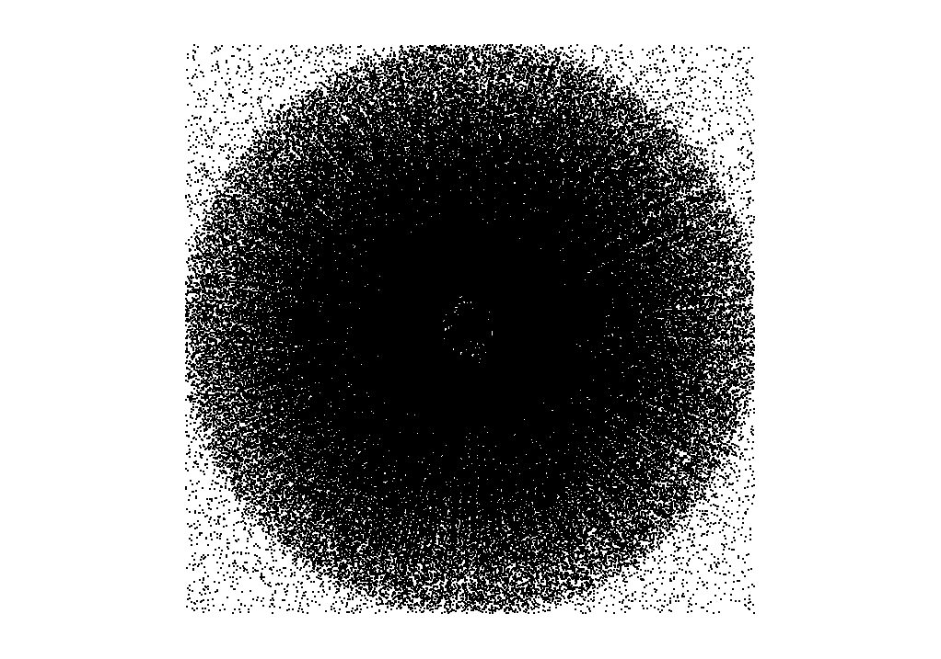

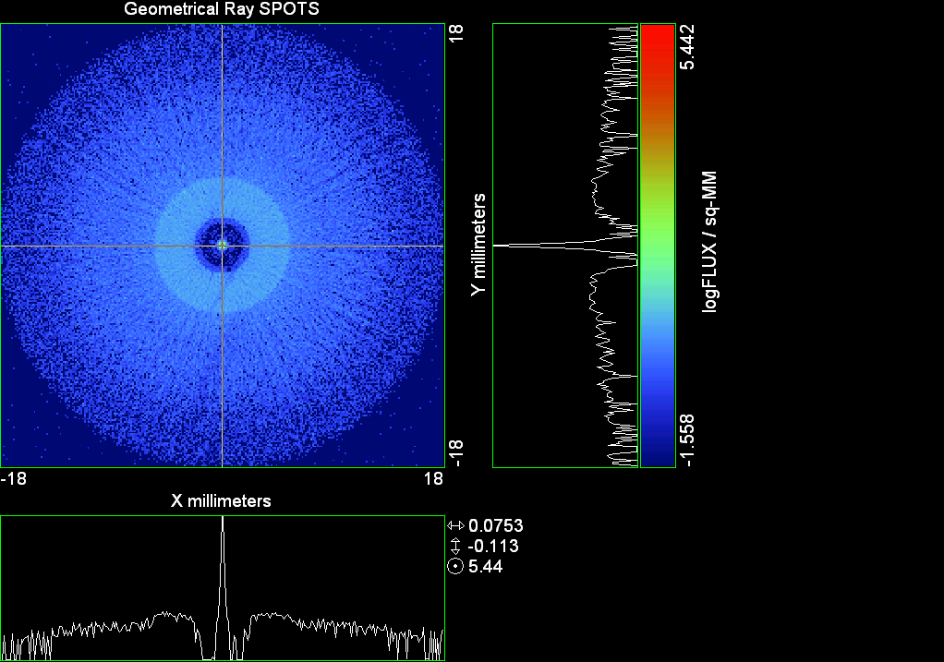

--- ! Spot Plot (Run Ray Trace First)
--- CONSIDER ONLY 6 !!Grid Detector=6
--- !!CONSIDER ONLY 7 !! Earth Detector=7
--- OBLIQUE OFF
--- !!TITLE 'FOV1-9/19^2 mm^2=15503 Rays'
--- !!TITLE 'FOV8 Rect Source Det=2170 total rays'
--- !!TITLE 'FOV8 RctSrc Det=1357-1348=11 rays from Pedestals DetImplBafOnly'
--- !!TITLE 'FOV8 RctSrc Det=750 rays "On"Mrlts Pd&SbS=0 DtImplBfOnly'
--- !!TITLE 'FOV8 RctSrc Det=754 rays "On"Mrlts Pd=1 SbS=0 DtImplBfOnly'
--- !!TITLE 'FOV8 3x3 Pt Src =215 rays "On"Mrlts Pd=1 SbS=0 DtImplBfOnly'
--- TITLE '1.5E6 KM to Source at L1 Distance'
--- !!WINDOW Y X
--- WINDOW Y -18 18 X -18 18
--- !!WINDOW Y 11 14 X -1.5 1.5
--- !!TITLE 'FOV8 23x23 1358-678=680 Rays/.109 mm^2 = 6238 Rays/mm^2 5.5%'
--- !!WINDOW Y 135.75 136.25 X 82.5 83 !!FOV 8
--- !!TITLE 'FOV8 3x3 Core 678 Rays/.006mm^2 = 113000 Rays/mm^2'
--- !!WINDOW Y 136.01 136.07 X 82.75 82.85 !!FOV 8
--- PIXELS 256
--- SPOTS POSITION

Distribution of data within:
Window Vertical: Y = -18.0000 to 18.0000 ( 36.0000 )
Horizontal: X = -18.0000 to 18.0000 ( 36.0000 )

Opening NEW distribution file 9: C:\ASAP Work\TRIANA\bro009.dat
Rays Flux
381965 22596.7
Maximum = 276639.1 minimum = 0.0000000E+00
--- $IO "ASAPTEMP.INR"
Opening 1 C:\ASAP Work\TRIANA\asaptemp.inr

Closing 7 C:\ASAP Work\TRIANA\bro007.dat
Opening 7 C:\ASAP Work\TRIANA\asaptemp.usr

Closing 20 C:\ASAP Work\TRIANA\bro020.dat
Opening 20 C:\ASAP Work\TRIANA\asaptemp.plr

Closing 30 C:\ASAP Work\TRIANA\bro030.dat
Opening 30 C:\ASAP Work\TRIANA\asaptemp.vcr

--- !! PICTURE (Run Ray Trace and Spots Position First)
--- !! Picks size from Spots Position window size
--- TITLE 'EPIC'
--- CONSIDER ONLY 7 !! Detector = 6 for Grid, 7 for Earth
--- !!WINDOW X -1.5 1.5 Y 11 14
--- WINDOW Y X
--- DISPLAY
Opening OLD distribution file 9: C:\ASAP Work\TRIANA\bro009.dat

File header:
Geometrical Ray SPOTS 1
Z 790.7430 FLUX / sq-MM
X millimeters -18.00000 18.00000 256
Y millimeters -18.00000 18.00000 256

Statistics on 256 by 256 data set:
FLUX / sq-MM Location Y millimeters X millimeters
Minimum 0.000000 1 1 -17.92969 -17.92969
Maximum 276639.1 128 129 -0.7031250E-01 0.7031250E-01
Average 17.43511 129 129 0.7031250E-01 0.7031250E-01
TOTAL FLUX = 22595.90

--- AVERAGE 0 0
Statistics on 256 by 256 data set:
FLUX / sq-MM Location Y millimeters X millimeters
Minimum 0.000000 1 1 -17.92969 -17.92969
Maximum 276639.1 128 129 -0.7031250E-01 0.7031250E-01
Average 17.43511 129 129 0.7031250E-01 0.7031250E-01
TOTAL FLUX = 22595.90

--- FORM -7
Statistics on 256 by 256 data set:
FLUX / sq-MM Location Y millimeters X millimeters
Minimum -1.558086 1 1 -17.92969 -17.92969
Maximum 5.441914 128 129 -0.7031250E-01 0.7031250E-01
Average -0.5838475 129 129 0.7031250E-01 0.7031250E-01
Integral = -756.6663

--- !!CONTOUR .001 .005 .01 .05 .1 .2 .3 .4 .5 .6 .7 .8 .85 .9 .95 GRID 2
--- PICTURE
Opening NEW distribution file 10: C:\ASAP Work\TRIANA\i.dis
--- $IO "ASAPTEMP.INR"
Opening 1 C:\ASAP Work\TRIANA\asaptemp.inr

Closing 7 C:\ASAP Work\TRIANA\bro007.dat
Opening 7 C:\ASAP Work\TRIANA\asaptemp.usr

Closing 20 C:\ASAP Work\TRIANA\bro020.dat
Creating 20 C:\ASAP Work\TRIANA\asaptemp.plr

Closing 30 C:\ASAP Work\TRIANA\bro030.dat
Creating 30 C:\ASAP Work\TRIANA\asaptemp.vcr

--- DISPLAY
Opening OLD distribution file 9: C:\ASAP Work\TRIANA\bro009.dat

File header:
Geometrical Ray SPOTS 1
Z 790.7430 FLUX / sq-MM
X millimeters -18.00000 18.00000 256
Y millimeters -18.00000 18.00000 256

Statistics on 256 by 256 data set:
FLUX / sq-MM Location Y millimeters X millimeters
Minimum 0.000000 1 1 -17.92969 -17.92969
Maximum 276639.1 128 129 -0.7031250E-01 0.7031250E-01
Average 17.43511 129 129 0.7031250E-01 0.7031250E-01
TOTAL FLUX = 22595.90

--- TEXTFILE X_Text_Output !!Names Text File, overwrites without warning
--- DATA 'E12.5' !! Format with single blank space
--- EOF

Run 18 GRID XY Check

--- END

System database and settings have been reinitialized
--- GRID POLAR Z -100 46 154.5 0 360 5 36 1
317 rays created in a POLAR grid for a total of 317
--- SOURCE DIR 6371 0 1500000
Source Z angle for rays
0.243 1 -317
--- GRID POLAR Z -100 46 154.5 0 360 5 36 1
317 rays created in a POLAR grid for a total of 634
--- SOURCE DIR 2359 0 1500000
Source Z angle for rays
0.090 318 -634
--- GRID POLAR Z -100 46 154.5 0 360 5 36 1
317 rays created in a POLAR grid for a total of 951
--- SOURCE DIR 0 0 1500000
Source Z angle for rays
0.000 635 -951
--- GRID POLAR Z -100 46 154.5 0 360 5 36 1
317 rays created in a POLAR grid for a total of 1268
--- SOURCE DIR 0 2359 1500000
Source Z angle for rays
0.090 952 -1268
--- GRID POLAR Z -100 46 154.5 0 360 5 36 1
317 rays created in a POLAR grid for a total of 1585
--- SOURCE DIR 0 4718 1500000
Source Z angle for rays
0.180 1269 -1585
--- GRID POLAR Z -100 46 154.5 0 360 5 36 1
317 rays created in a POLAR grid for a total of 1902
--- SOURCE DIR 0 6371 1500000
Source Z angle for rays
0.243 1586 -1902
--- RETURN
--- UNITS MILLIMETERS
--- WAVELENGTHS 0.950000 0.706000 0.587560 0.435000 0.300000 MICRONS
--- MEDIA; 1.45106513 1.45515708 1.45846375 1.46676272 1.48779297 'SILICA'
--- COATING PROPERTIES; 1 0 'WHITE'
--- COATING PROPERTIES; .98 0 'MIRROR'
--- COATING PROPERTIES; .11 .87 'DETECTORQE317'
--- COATING PROPERTIES; .10 .75 'DETECTORQE325'
--- COATING PROPERTIES; .05 0 'BLACK'
--- COATING PROPERTIES; 0 0 'ZERO'
--- COATING PROPERTIES; 0 1 'CLEAR'
--- STRUE=0
--- SX=0
--- SY=0
--- SZ=0
--- SCAT=1
--- ENT OBJECT;MIRROR Z 439.24 159 (1219.2/2) -1 (38.2/159) 'PRIMARY S1'
--- INTERFACE COATING MIRROR AIR AIR
--- ENT OBJECT;TUBE Z 438.5 38.2 38.2 466.53196 38.2 38.2 0.0 0.0 'PRIMARYHOLE'
--- INTERFACE COATING BLACK AIR AIR
--- SCATTER RANDOM 1 (SCAT) 1.57 ABS 1 0
*** LEVEL automatically set to 1
--- ENT OBJECT;PLANE Z 466.5 ELLIPSE 210 210 (38.2/210) 'PRIMARY BACK'
--- INTERFACE COATING BLACK AIR AIR
--- SCATTER RANDOM 1 (SCAT) 1.57 ABS 1 0
--- ENT OBJECT;TUBE Z 429 159 159 466.5 159 159 0.0 0.0 'PRIMARYEDGE'
--- INTERFACE COATING BLACK AIR AIR
--- SCATTER RANDOM 1 (SCAT) 1.57 ABS 1 0
--- ENT OBJECT;MIRROR Z 0.0 46 (434.7/2) -2.40763 0.0 'SECONDARY S2'
--- INTERFACE COATING MIRROR AIR AIR
--- ENT OBJECT;PLANE Z 790.7429896 RECTANGLE 18 18 0 'DETECTOR'
--- INTERFACE COATING ZERO SILICA AIR
--- ENT OBJECT;PLANE Z 790.7 RECTANGLE 18 18 0 'DETECTOR-COVER'
--- INTERFACE COATING DETECTORQE317 SILICA AIR
*** SPLIT automatically set to 1
--- ENT OBJECT;PLANE Z -55.69204 ELLIPSE 210 210 (154.8315449/210) 'SPIDER'
--- INTERFACE COATING BLACK AIR AIR
--- SCATTER RANDOM 1 (SCAT) 1.57 ABS 1 0
--- ENT OBJECT;TUBE Z -55.69204 154.8315449 154.8315449 -30.29204 154.8315449 154.8315449 0.0 0.0 'SPIDERCYL'
--- INTERFACE COATING BLACK AIR AIR
--- SCATTER RANDOM 1 (SCAT) 1.57 ABS 1 0
--- ENT OBJECT;TUBE X 0 0.75 12.52 -170 0.75 15.52 1 1 'SPIDERARMX'
--- SHIFT 0 -52.578 -42.992
--- INTERFACE COATING BLACK AIR AIR
--- SCATTER RANDOM 1 (SCAT) 1.57 ABS 1 0
--- ENT OBJECT;TUBE X 0 5 12.52 -170 5 15.52 1 1 'SPIDERARMX1'
--- SHIFT 0 -52.578 -42.992
--- ROTATE Z -120 0 0
--- INTERFACE COATING BLACK AIR AIR
--- SCATTER RANDOM 1 (SCAT) 1.57 ABS 1 0
--- ENT OBJECT;TUBE X 0 0.75 12.52 -170 0.75 15.52 1 1 'SPIDERARMX2'
--- SHIFT 0 -52.578 -42.992
--- ROTATE Z -240 0 0
--- INTERFACE COATING BLACK AIR AIR
--- SCATTER RANDOM 1 (SCAT) 1.57 ABS 1 0
--- ENT OBJECT;TUBE Z -185.6 200.8 200.8 528 200.8 200.8 0.0 0.0 'BARRELBAFFLE'
--- INTERFACE COATING BLACK AIR AIR
--- SCATTER RANDOM 1 (SCAT) 1.57 ABS 1 0
--- ENT OBJECT;ELLIPSE Z -200 205 205 64 0.0 360.0 'ENTRANCE'
Default ELLIP/ROUND/OVAL segments changed to 64
--- INTERFACE COATING CLEAR AIR AIR
--- ENT OBJECT;TUBE Z (2.391*25.4) (2.546*25.4) (2.546*25.4) (2.164*25.4) (2.546*25.4) (2.546*25.4) 0.0 0.0 'SECONDARYHOUSING'
--- INTERFACE COATING BLACK AIR AIR
--- SCATTER RANDOM 1 (SCAT) 1.57 ABS 1 0
--- ENT OBJECT;TUBE Z (2.164*25.4) (2.546*25.4) (2.546*25.4) 0 (2*25.4) (2*25.4) 0.0 0.0 'SH-CONE'
--- INTERFACE COATING BLACK AIR AIR
--- SCATTER RANDOM 1 (SCAT) 1.57 ABS 1 0
--- ENT OBJECT;PLANE Z 0.0 ELLIPSE (2.45*25.4) (2.45*25.4) (2.00/2.45) 'SH-CONEBASE'
--- INTERFACE COATING BLACK AIR AIR
--- SCATTER RANDOM 1 (SCAT) 1.57 ABS 1 0
--- ENT OBJECT;TUBE Z 0.0 (2.125*25.4) (2.125*25.4) (-6.875*25.4) (2.125*25.4) (2.125*25.4) 0.0 0.0 'SH-CYLINDER'
--- INTERFACE COATING BLACK AIR AIR
--- SCATTER RANDOM 1 (SCAT) 1.57 ABS 1 0
--- ENT OBJECT;PLANE Z (-6.875*25.4) ELLIPSE (2.33*25.4) 'SH-TOP'
--- INTERFACE COATING BLACK AIR AIR
--- SCATTER RANDOM 1 (SCAT) 1.57 ABS 1 0
--- ENT OBJECT;PLANE Z (-1.9*25.4) ELLIPSE (2.546*25.4) 'SH-MIDVANE'
--- INTERFACE COATING BLACK AIR AIR
--- SCATTER RANDOM 1 (SCAT) 1.57 ABS 1 0
--- ENT OBJECT;TUBE Z 226.38766 37.465 37.465 422.98366 37.465 37.465 0.0 0.0 'CBAF-FRONT'
--- INTERFACE COATING BLACK AIR AIR
--- SCATTER RANDOM 1 (SCAT) 1.57 ABS 1 0
--- ENT OBJECT;PLANE Z 422.98366 ELLIPSE 37.485 37.485 (30.5562/37.485) 'CBAF-LEDGE'
--- INTERFACE COATING BLACK AIR AIR
--- SCATTER RANDOM 1 (SCAT) 1.57 ABS 1 0
--- ENT OBJECT;TUBE Z 422.985 32.2072 32.2072 532.45766 32.2072 32.2072 0.0 0.0 'CBAF-AFT'
--- INTERFACE COATING BLACK AIR AIR
--- SCATTER RANDOM 1 (SCAT) 1.57 ABS 1 0
--- ENT OBJECT;PLANE Z 327.98766 ELLIPSE 37.485 37.485 (35.56/37.485) 'CBAF-VANE1'
--- INTERFACE COATING BLACK AIR AIR
--- SCATTER RANDOM 1 (SCAT) 1.57 ABS 1 0
--- ENT OBJECT;PLANE Z 378.78766 ELLIPSE 37.485 37.485 (35.56/37.485) 'CBAF-VANE2'
--- INTERFACE COATING BLACK AIR AIR
--- SCATTER RANDOM 1 (SCAT) 1.57 ABS 1 0
--- ENT OBJECT;PLANE Z 505.53366 ELLIPSE 32.24 32.24 (28.6512/32.24) 'CBAF-VANE3'
--- INTERFACE COATING BLACK AIR AIR
--- SCATTER RANDOM 1 (SCAT) 1.57 ABS 1 0
--- RETURN
--- !! Geometry is being appended to system.
--- !! To not view this message, refer to ASAP preferences dialog,
--- !! or change the Options->Append Geometry menu item.
--- UNITS MILLIMETERS
--- WAVELENGTHS 0.950000 0.706000 0.587560 0.435000 0.300000 MICRONS
--- MEDIA; 1.45106513 1.45515708 1.45846375 1.46676272 1.48779297 'SILICA'
--- COATING PROPERTIES; .98 0 'MIRROR'
--- COATING PROPERTIES; .05 0 'BLACK'
--- COATING PROPERTIES; 0 0 'ZERO'
--- COATING PROPERTIES; 0 1 'CLEAR'
--- COATING PROPERTIES; .05 .95 'ARF05'
--- COATING PROPERTIES; 0.2 0.8 'ARF20'
--- ENT OBJECT;PLANE Z 615.3400000 ELLIPSE 150 150 (22/150) 'LENS MOUNT'
--- INTERFACE COATING BLACK AIR AIR
--- SCATTER RANDOM 1 (SCAT) 1.57 ABS 1 0
--- ENT OBJECT;TUBE Z 558.61966 26.7 26.7 620 26.7 26.7 0.0 0.0 'LENS TUBE-FRONT'
--- INTERFACE COATING BLACK AIR AIR
--- SCATTER RANDOM 1 (SCAT) 1.57 ABS 1 0
--- ENT OBJECT;PLANE Z 558.61966 ELLIPSE 27.7 27.7 (24.945/27.7) 'LT-FACE'
--- INTERFACE COATING BLACK AIR AIR
--- SCATTER RANDOM 1 (SCAT) 1.57 ABS 1 0
--- ENT OBJECT;PLANE Z 616.4326 ELLIPSE 27.7 27.7 (21.5/27.7) 'LT-LENS 1FACE'
--- INTERFACE COATING BLACK AIR AIR
--- SCATTER RANDOM 1 (SCAT) 1.57 ABS 1 0
--- ENT OBJECT;TUBE Z 621 25.152 25.152 657.7965 25.152 25.152 0.0 0.0 'LENS TUBE AFT'
--- INTERFACE COATING BLACK AIR AIR
--- SCATTER RANDOM 1 (SCAT) 1.57 ABS 1 0
--- ENT OBJECT;PLANE Z 657.7965 ELLIPSE 25.152 25.152 (21.26386619/25.152) 'LT-AFT FACE'
--- INTERFACE COATING BLACK AIR AIR
--- SCATTER RANDOM 1 (SCAT) 1.57 ABS 1 0
--- ENT OBJECT;OPTICAL Z 615.3400000 221.803 0 ELLIPSE 22 'LENS1F'
--- INTERFACE COATING ARF05 AIR SILICA
--- ENT OBJECT;OPTICAL Z 620.3400000 584.5 0 ELLIPSE 22 'LENS1B'
--- INTERFACE COATING ARF05 AIR SILICA
--- ENT OBJECT;OPTICAL Z 627.63 -147.027 0 ELLIPSE 22 'LENS2F'
--- INTERFACE COATING ARF05 AIR SILICA
--- ENT OBJECT;OPTICAL Z 632.63 -135.158 0 ELLIPSE 22 'LENS2B'
--- INTERFACE COATING ARF05 AIR SILICA
--- ENT OBJECT;OPTICAL Z 635.6 97.002 0 ELLIPSE 22 'LENS3F'
--- INTERFACE COATING ARF05 AIR SILICA
--- ENT OBJECT;OPTICAL Z 640.6 67.147 0 ELLIPSE 22 'LENS3B'
--- INTERFACE COATING ARF05 AIR SILICA
--- ENT OBJECT;TUBE Z 614 22 22 645 22 22 0.0 0.0 'LENSHOLDER'
--- INTERFACE COATING ZERO AIR AIR
--- SCATTER RANDOM 1 (SCAT) 1.57 ABS 1 0
--- ENT OBJECT;PLANE Z 660.84196 ELLIPSE 150 150 (25.28148817/150) 'FW-HOUSING FRONT'
--- INTERFACE COATING BLACK AIR AIR
--- SCATTER RANDOM 1 (SCAT) 1.57 ABS 1 0
--- ENT OBJECT;PLANE Z 709.10196 ELLIPSE 150 150 (25.28148817/150) 'FW-HOUSING AFT'
--- INTERFACE COATING BLACK AIR AIR
--- SCATTER RANDOM 1 (SCAT) 1.57 ABS 1 0
--- ENT OBJECT;TUBE Z (673.54196-.3) 27.5 27.5 (680.04436+.3) 27.5 27.5 0.0 0.0 'FILTERHOLDER'
--- INTERFACE COATING BLACK AIR AIR
--- SCATTER RANDOM 1 (SCAT) 1.57 ABS 1 0
--- ENT OBJECT;PLANE Z 675 ELLIPSE 150 150 (27.5/150) 'FILTER-WHEEL'
--- INTERFACE COATING BLACK AIR AIR
--- SCATTER RANDOM 1 (SCAT) 1.57 ABS 1 0
--- ENT OBJECT;TUBE Z 721.59876 19.16979665 19.16979665 723.53932 22.558 22.558 0.0 0.0 'EXIT CONE FRONT'
--- INTERFACE COATING BLACK AIR AIR
--- SCATTER RANDOM 1 (SCAT) 1.57 ABS 1 0
--- ENT OBJECT;TUBE Z 723.53932 22.558 22.558 781.84248 22.558 22.558 0.0 0.0 'EC-CYLINDER'
--- INTERFACE COATING BLACK AIR AIR
--- SCATTER RANDOM 1 (SCAT) 1.57 ABS 1 0
--- ENT OBJECT;PLANE Z 781.84248 ELLIPSE 22.558 22.558 (16.89/22.558) 'EC-SHELF'
--- INTERFACE COATING BLACK AIR AIR
--- SCATTER RANDOM 1 (SCAT) 1.57 ABS 1 0
--- ENT OBJECT;TUBE Z 781.84248 16.89 16.89 783.87448 20.41280351 20.41280351 0.0 0.0 'EC-EXITCONE'
--- INTERFACE COATING BLACK AIR AIR
--- SCATTER RANDOM 1 (SCAT) 1.57 ABS 1 0
--- ENT OBJECT;PLANE Z 783.87448 ELLIPSE 50 50 (20.41280351/50) 'EC-EXIT'
--- INTERFACE COATING BLACK AIR AIR
--- SCATTER RANDOM 1 (SCAT) 1.57 ABS 1 0
--- RETURN
--- $IO "ASAPTEMP.INR"
Opening 1 C:\ASAP Work\TRIANA\asaptemp.inr

Closing 7 C:\ASAP Work\TRIANA\bro007.dat
Opening 7 C:\ASAP Work\TRIANA\asaptemp.usr

Closing 20 C:\ASAP Work\TRIANA\bro020.dat
Creating 20 C:\ASAP Work\TRIANA\asaptemp.plr

Closing 30 C:\ASAP Work\TRIANA\bro030.dat
Creating 30 C:\ASAP Work\TRIANA\asaptemp.vcr

--- !! Filters-2 from .ent/copy/.inr to allow ABSORBing media
--- UNITS MILLIMETERS
--- WAVELENGTHS 0.950000 0.706000 0.587560 0.435000 0.300000 MICRONS
--- MEDIA; 1.45106513 1.45515708 1.45846375 1.46676272 1.48779297 'SILICA'
--- !!COATING PROPERTIES; .98 0 'MIRROR'
--- !!COATING PROPERTIES; .05 0 'BLACK'
--- !!COATING PROPERTIES; 0 0 'ZERO'
--- !!COATING PROPERTIES; 0 1 'CLEAR'
--- COATING PROPERTIES; .0745 .9255 'ARF0745'
--- COATING PROPERTIES; .0525 .9475 'ARF0525'
--- COATING PROPERTIES; .05 .95 'ARF05'
--- COATING PROPERTIES; .005 .995 'ARF005'
--- !!COATING PROPERTIES; 0.2 0.8 'ARF20'
--- !!!!!!!!!!!!!!!!!!!!!!!!!!!!!!!!!!!!!!!!!!!!!!!!!!
--- WAVELENGTH 0.317 MICRONS
--- MEDIA
--- 1.48342884 ABSORB 0.13168 'BLOCKER317'
--- MEDIA
--- 1.48342884 ABSORB 0.00307 'ETALON317'
--- !!!!!!!!!!!!!!!!!!!!!!!!!!!!!!!!!!!!!!!!!!!!!!!!!!
--- !!WAVELENGTH 0.325 MICRONS
--- !!MEDIA
--- !! 1.48163777 ABSORB 0.08074 'BLOCKER325'
--- !!MEDIA
--- !! 1.48163777 ABSORB 0.0415179525 'ETALON325'
--- !!!!!!!!!!!!!!!!!!!!!!!!!!!!!!!!!!!!!!!!!!!!!!!!!!!!!
--- ENT OBJECT;PLANE Z 673.54196 ELLIPSE 27.5 'FILTERUVE-F'
--- INTERFACE COATING ARF0525 AIR ETALON317
--- !! INTERFACE COATING ARF0745 AIR ETALON325
--- ENT OBJECT;PLANE Z 676.71696 ELLIPSE 27.5 'FILTERUVE-B'
--- INTERFACE COATING ARF0525 AIR ETALON317
--- !! INTERFACE COATING ARF0745 AIR ETALON325
--- ENT OBJECT;PLANE Z 676.86936 ELLIPSE 27.5 'FILTERUVB-F'
--- INTERFACE COATING ARF005 AIR BLOCKER317
--- !! INTERFACE COATING ARF005 AIR BLOCKER325
--- ENT OBJECT;PLANE Z 680.04436 ELLIPSE 27.5 'FILTERUVB-B'
--- INTERFACE COATING ARF005 AIR BLOCKER317
--- !! INTERFACE COATING ARF005 AIR BLOCKER325
--- !!RETURN

--- TITLE DCE *Raytrace
--- !! WAVELENGTHS 0.317 MICRONS !! Normally set in filters
--- SPLIT 0 !! Direct Trace Only
--- !!SPLIT 1 !! For Rect Sources
--- !!SPLIT 2 !! For double reflection in lens & filters
--- PLOT FACETS 5 5
Window Vertical: Y = -210.000 to 210.000 ( 420.000 )
Horizontal: Z = -204.100 to 791.121 ( 995.221 )

--- CONSIDER ALL
--- !!CONSIDER ONLY 15
--- ARROWS OFF
--- SEGMENTS 9
--- WINDOW Y Z
--- OBLIQUE 0 0
--- MISSED LINE 50
--- TRACE PLOT 100 OVERLAY
Window Vertical: Y = -210.000 to 210.000 ( 420.000 )
Horizontal: Z = -204.100 to 791.121 ( 995.221 )

2.02 seconds (1261.72 millisec CPU) to trace 4,419

Total of 3045 PARENT warnings
Missed Multiple Wrong Low Evanescent Wrong Absorbed
Obj Total After Bounce Side Flux (TIR) Direc After
2 1 1 PRIMARYHOLE
3 16 16 PRIMARY BACK
4 21 21 PRIMARYEDGE
8 21 2 19 SPIDER
9 31 31 SPIDERCYL
10 11 11 SPIDERARMX
11 17 2 15 SPIDERARMX1
12 11 2 9 SPIDERARMX2
13 830 70 760 BARRELBAFFLE
14 1591 1591 ENTRANCE
15 5 5 SECONDARYHOUSING
16 20 20 SH-CONE
17 4 4 SH-CONEBASE
18 225 51 174 SH-CYLINDER
19 17 17 SH-TOP
20 183 9 174 SH-MIDVANE
21 33 33 CBAF-FRONT
22 1 1 CBAF-LEDGE
23 6 6 CBAF-AFT
27 1 1 LENS MOUNT
29793 ray-objects encountered at 23613 per CPU second
496770 order-intersections done at 393724 per CPU second



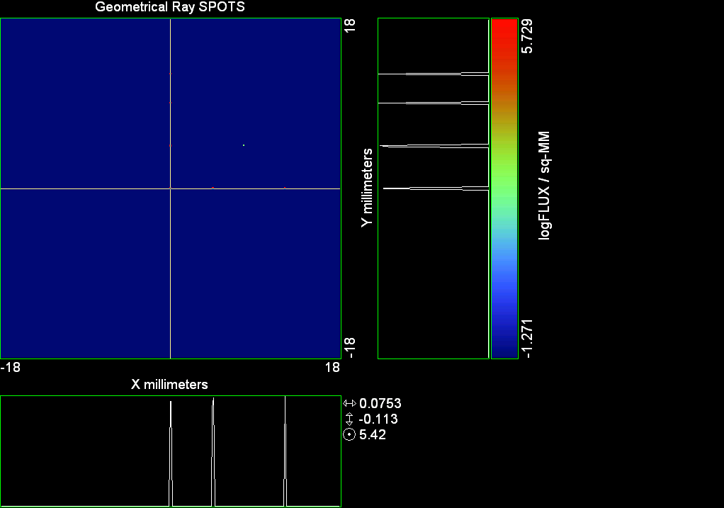

--- ! Spot Plot (Run Ray Trace First)
--- CONSIDER ONLY 6 !!Grid Detector=6
--- !!CONSIDER ONLY 7 !! Earth Detector=7
--- OBLIQUE OFF
--- !!TITLE 'FOV1-9/19^2 mm^2=15503 Rays'
--- !!TITLE 'FOV8 Rect Source Det=2170 total rays'
--- !!TITLE 'FOV8 RctSrc Det=1357-1348=11 rays from Pedestals DetImplBafOnly'
--- !!TITLE 'FOV8 RctSrc Det=750 rays "On"Mrlts Pd&SbS=0 DtImplBfOnly'
--- !!TITLE 'FOV8 RctSrc Det=754 rays "On"Mrlts Pd=1 SbS=0 DtImplBfOnly'
--- !!TITLE 'FOV8 3x3 Pt Src =215 rays "On"Mrlts Pd=1 SbS=0 DtImplBfOnly'
--- TITLE '1.5E6 KM to Source at L1 Distance'
--- !!WINDOW Y X
--- WINDOW Y -18 18 X -18 18
--- !!WINDOW Y 11 14 X -1.5 1.5
--- !!TITLE 'FOV8 23x23 1358-678=680 Rays/.109 mm^2 = 6238 Rays/mm^2 5.5%'
--- !!WINDOW Y 135.75 136.25 X 82.5 83 !!FOV 8
--- !!TITLE 'FOV8 3x3 Core 678 Rays/.006mm^2 = 113000 Rays/mm^2'
--- !!WINDOW Y 136.01 136.07 X 82.75 82.85 !!FOV 8
--- PIXELS 256
--- SPOTS POSITION

Distribution of data within:
Window Vertical: Y = -18.0000 to 18.0000 ( 36.0000 )
Horizontal: X = -18.0000 to 18.0000 ( 36.0000 )

Opening NEW distribution file 9: C:\ASAP Work\TRIANA\bro009.dat
Rays Flux
1649 126450.
Maximum = 535429.4 minimum = 0.0000000E+00
--- $IO "ASAPTEMP.INR"
Opening 1 C:\ASAP Work\TRIANA\asaptemp.inr

Closing 7 C:\ASAP Work\TRIANA\bro007.dat
Opening 7 C:\ASAP Work\TRIANA\asaptemp.usr

Closing 20 C:\ASAP Work\TRIANA\bro020.dat
Opening 20 C:\ASAP Work\TRIANA\asaptemp.plr

Closing 30 C:\ASAP Work\TRIANA\bro030.dat
Opening 30 C:\ASAP Work\TRIANA\asaptemp.vcr

--- !! PICTURE (Run Ray Trace and Spots Position First)
--- !! Picks size from Spots Position window size
--- TITLE 'EPIC'
--- CONSIDER ONLY 7 !! Detector = 6 for Grid, 7 for Earth
--- !!WINDOW X -1.5 1.5 Y 11 14
--- WINDOW Y X
--- DISPLAY
Opening OLD distribution file 9: C:\ASAP Work\TRIANA\bro009.dat

File header:
Geometrical Ray SPOTS 1
Z 790.7430 FLUX / sq-MM
X millimeters -18.00000 18.00000 256
Y millimeters -18.00000 18.00000 256

Statistics on 256 by 256 data set:
FLUX / sq-MM Location Y millimeters X millimeters
Minimum 0.000000 1 1 -17.92969 -17.92969
Maximum 535429.4 129 215 0.7031250E-01 12.16406
Average 97.56905 159 148 4.289062 2.742188
TOTAL FLUX = 126449.5

--- AVERAGE 0 0
Statistics on 256 by 256 data set:
FLUX / sq-MM Location Y millimeters X millimeters
Minimum 0.000000 1 1 -17.92969 -17.92969
Maximum 535429.4 129 215 0.7031250E-01 12.16406
Average 97.56905 159 148 4.289062 2.742188
TOTAL FLUX = 126449.5

--- FORM -7
Statistics on 256 by 256 data set:
FLUX / sq-MM Location Y millimeters X millimeters
Minimum -1.271298 1 1 -17.92969 -17.92969
Maximum 5.728702 129 215 0.7031250E-01 12.16406
Average -1.269390 153 147 3.445312 2.601562
Integral = -1645.130

--- !!CONTOUR .001 .005 .01 .05 .1 .2 .3 .4 .5 .6 .7 .8 .85 .9 .95 GRID 2
--- PICTURE
Opening NEW distribution file 10: C:\ASAP Work\TRIANA\i.dis
--- $IO "ASAPTEMP.INR"
Opening 1 C:\ASAP Work\TRIANA\asaptemp.inr

Closing 7 C:\ASAP Work\TRIANA\bro007.dat
Opening 7 C:\ASAP Work\TRIANA\asaptemp.usr

Closing 20 C:\ASAP Work\TRIANA\bro020.dat
Creating 20 C:\ASAP Work\TRIANA\asaptemp.plr

Closing 30 C:\ASAP Work\TRIANA\bro030.dat
Creating 30 C:\ASAP Work\TRIANA\asaptemp.vcr

--- DISPLAY
Opening OLD distribution file 9: C:\ASAP Work\TRIANA\bro009.dat

File header:
Geometrical Ray SPOTS 1
Z 790.7430 FLUX / sq-MM
X millimeters -18.00000 18.00000 256
Y millimeters -18.00000 18.00000 256

Statistics on 256 by 256 data set:
FLUX / sq-MM Location Y millimeters X millimeters
Minimum 0.000000 1 1 -17.92969 -17.92969
Maximum 535429.4 129 215 0.7031250E-01 12.16406
Average 97.56905 159 148 4.289062 2.742188
TOTAL FLUX = 126449.5

--- TEXTFILE X_Text_Output !!Names Text File, overwrites without warning
--- DATA 'E12.5' !! Format with single blank space
--- EOF

