NO₂ Column Amounts from Ground-based PANDORA and MF-DOAS Spectrometers using the Direct-Sun DOAS Technique:
Intercomparisons and Application to OMI Validation

Jay Herman ^{a *}
Alexander Cede ^{b}
Elena Spinei^{d}
George Mount^{d}
Maria Tzortziou ^{b}
Nader Abuhassan ^{c}

ª NASA/Goddard Space Flight Center
Greenbelt, MD, USA

^{b} University of Maryland, Earth System Science Interdisciplinary Center
College Park, MD, USA

^{c} University of Maryland Baltimore Campus
Baltimore, Maryland USA

^{d} Washington State University
Laboratory for Atmospheric Research
Pullman, Washington USA

To be submitted to: Journal of Geophysical Research Atmospheres

* Corresponding author
E-mail address: jay.r.herman@nasa.gov
Tel : 301 614 6039
Fax : 301 614 5903

Running header: Preliminary: Validation of OMI NO₂ from Ground-Based Spectrometers

Abstract:
C(NO₂) values (total vertical column amounts of NO₂) are derived from ground-based direct solar irradiance measurements using two new and independently developed spectrometer systems, PANDORA (Goddard Space Flight Center) and MF-DOAS (Washington State University). We discuss the advantages of C(NO₂) retrievals based on Direct Sun - Differential Optical Absorption Spectroscopy (DS-DOAS). C(NO₂) data are presented from field campaigns using PANDORA at Aristotle University (AU), Thessaloniki, Greece, a second field campaign involving both new instruments at Goddard Space Flight Center (GSFC), Greenbelt, Maryland, and a PANDORA time series from Dec 2006 to Oct 2008 at GSFC. PANDORA and MF-DOAS were compared at GFSC and found to closely agree, with both instruments having a clear-sky precision of 0.01 DU (2.67x10¹⁴ molecules/cm²) and a nominal accuracy of 0.1 DU. The high precision is obtained by combining laboratory and field calibration techniques at both polluted sites (Thessaloniki and GSFC). The 0.01 DU precision is sufficient to track minute-by minute changes in C(NO₂) throughout each day with typical daytime values ranging from 0.2 to 3 DU. The MF-DOAS instrument has better noise characteristics for a single measurement which permits MF-DOAS to operate at higher time resolution than PANDORA for the same precision. Since PANDORA and MF-DOAS direct-sun measurements can be made in the presence of light to moderate clouds, but with reduced precision (~0.2 DU for moderate cloud cover), a nearly continuous record can be obtained which is important for matching the OMI overpass time during satellite validation. A comparison between PANDORA and MF-DOAS with OMI is discussed for the moderately polluted GSFC site, and between PANDORA and OMI at the AU site. Validation of OMI measured C(NO₂) is essential to the scientific use of the satellite data for air-quality, atmospheric photolysis and chemistry, and for retrieval of other quantities (e.g., water leaving radiances for retrieval of ocean properties). Seasonal variation of C(NO₂), and variation by day of the week are presented based on the time series at GSFC measured by the PANDORA instrument.
1. Introduction
The PANDORA and MF-DOAS spectrometer systems can accurately determine trace gas column abundances of several constituents, including nitrogen dioxide (NO₂). NO₂ is an atmospheric constituent that plays a major role in tropospheric and stratospheric chemistry [Crutzen, 1979]. Through catalytic ozone destruction in the upper troposphere and lower stratosphere, NO₂ partly determines the ozone distribution in the Earth’s atmosphere [Logan et al., 1981; Brasseur et al., 1998]. In the lower troposphere, and especially in the boundary layer, NO₂ and O₃ concentrations and distribution directly affect air quality and human health [e.g. Seinfeld and Pandis, 1998; Environmental Protection Agency, 1998] and are regulated by the US EPA. NO₂ chemistry partly controls the oxidizing capacity of the troposphere, as well as the abundance of lower tropospheric ozone (ozone formation via photochemical smog) and the lifetimes of other greenhouse gases (e.g. methane) [Inter-governmental Panel on Climate Change (IPCC), 2001; 2007]. Moreover, observations over Boulder and Fritz Peak, Colorado, showed that high concentrations of NO₂, caused by pollution and production by lightning in convective clouds, can reduce downwelling visible radiation by about 5-12% [Solomon et al., 1999], corresponding to an estimated local radiative forcing effect that exceeds that of CO₂ [IPCC, 2001; 2007]. Neglect of absorption by NO₂ reduces the apparent amount of water leaving radiances resulting in errors in satellite retrievals of coastal ocean properties [Ziauddin et al., 2007].
Tropospheric NO₂ concentrations are highly variable in time and space and are influenced by both natural and anthropogenic emissions. Fossil fuel combustion from transportation and industrial activities (power generation) are the major sources, contributing about 50% on a regional scale and up to about 80% in local urban environments. Biomass burning is estimated to contribute about 20% globally, while lightning and soil microbial production are also important sources [Lee et al., 1997]. Other sources include aircraft emissions of NO into the troposphere with rapid conversion to NO₂, and ammonia oxidation [Logan, 1983]. High concentrations of NO₂ are typically confined to industrial areas and have relatively short lifetimes (~27 hours) in the polluted boundary layer and much longer at higher tropospheric altitudes (4 – 5 days) [Leue et al., 2001]. This gives rise to strong local diurnal variation and limited long-range transport from its sources depending on local wind speed. Decreased OH and aerosol concentrations in the middle and upper troposphere can lead to a longer NO₂ lifetime (several days to a week) [Jaegle et al., 1998; Seinfeld and Pandis, 1998; Warneck, 2000]. Under the right conditions, tropospheric NO₂ can be transported over long distances for several days contributing to transboundary pollution episodes [Leue et al., 2001; Velders et al., 2001; Wenig et al., 2003].
C(NO₂) retrievals are usually performed applying Differential Optical Absorption Spectroscopy (DOAS) [Noxon, 1975; Noxon, 1979a,b; Platt, 1994] on measurements of scattered sunlight. For ground-based instruments sky radiances are measured either in the zenith direction (zenith-sky DOAS) [e.g., Van Roozendael et al., 1997; Liley et al., 2000] or in multiple directions (multiaxis DOAS, MAXDOAS) [e.g., Leser et al., 2003]. The DOAS techniques have also been applied to derive NO₂ amounts from aircraft [e.g., Heue et al., 2005] and satellite measurements [e.g., Leue et al., 2001; Richter et al., 2004] as is currently done for the OMI, SCIAMACHY (Scanning Imaging Absorption Spectrometer for Atmospheric Cartography) and GOME (Global Ozone Monitoring Experiment) satellite instruments. DOAS retrieves the so-called slant-path column amount, i.e. the column amount along the average path of the measured photons through the atmosphere. The conversion from slant-path column amounts to vertical column abundances is achieved by calculation of the air-mass factor (AMF). For scattered light radiance measurements, the AMF depends on several atmospheric parameters, mainly the NO₂ vertical profile shape, the ground surface reflectivity, and the assumption of horizontal homogeneity of the NO₂ distribution. Lack of accurate knowledge of the above factors for estimating the AMF needed for zenith sky DOAS, MAX-DOAS, or satellite retrievals can lead to errors on the order of 50 to 100% in determination of column NO2. In addition to these sources of retrieval error, there is a dependence on unknown cloud or aerosol concentrations in the field of view [Boersma, et al., 2004].
While zenith-sky DOAS is mainly sensitive to stratospheric NO₂, MAXDOAS is sensitive to stratospheric NO₂ at high elevation angles and to tropospheric NO₂ at low elevation angles. Direct-sun DOAS (DS-DOAS) is another technique for deriving C(NO₂) from ground-based instruments using measurements of direct solar irradiance [e.g. Brewer et al., 1973; Cede et al., 2006], where the AMF is approximately cosine[SZA]. The direct-sun technique is equally sensitive to stratospheric and tropospheric NO₂, and, in contrast to the scattered radiance DOAS techniques, does not require sophisticated radiative transfer calculations, is not affected by the Ring effect, does not require prior knowledge of the NO₂ profile shape, knowledge of ground reflectivity [Cede et al., 2006], nor the assumption of horizontal homogeneity typical of zenith-sky DOAS and MAXDOAS. For example, if we assume a tropospheric layer of NO₂ between 0 and 3 km and that MAXDOAS uses a viewing angle of about 2º elevation, MAXDOAS is viewing a horizontal distance of about 86 km (3/tan(2º)) for all times of the day. In contrast, DS-DOAS views a horizontal distance approximately given by 3/tan(90º – SZA), which for SZA < 50º is a horizontal distance less than 3.6 km.

In principle, the sensitivity of DS-DOAS to small changes in C(NO₂) amount can be less than zenith-sky DOAS or MAX-DOAS because of a smaller AMF. However, we show that both of the new spectrometer systems (PANDORA and MFDOAS) have a precision of 0.01 DU with DS-DOAS, which is sufficient sensitivity to detect minute-by-minute tropospheric and stratospheric changes at polluted and clean sites. A combination of direct sun and zenith sky UV-visible differential slant column density measurements was proposed for deriving NO₂ vertical distribution and total column amounts [Schoefield et al. 2003].

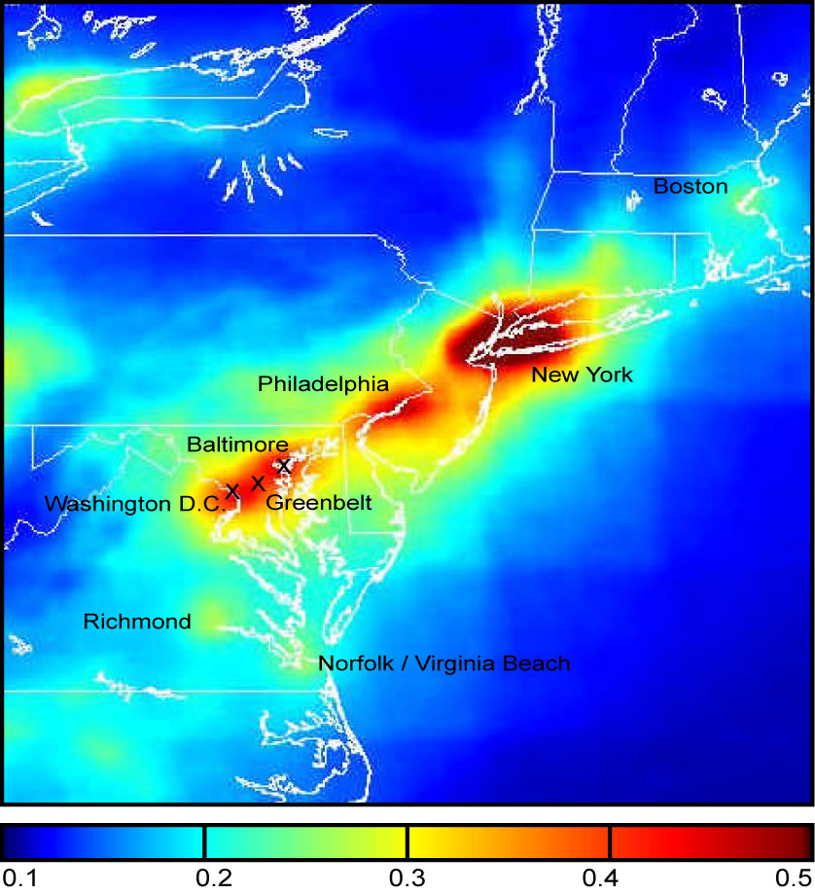 | 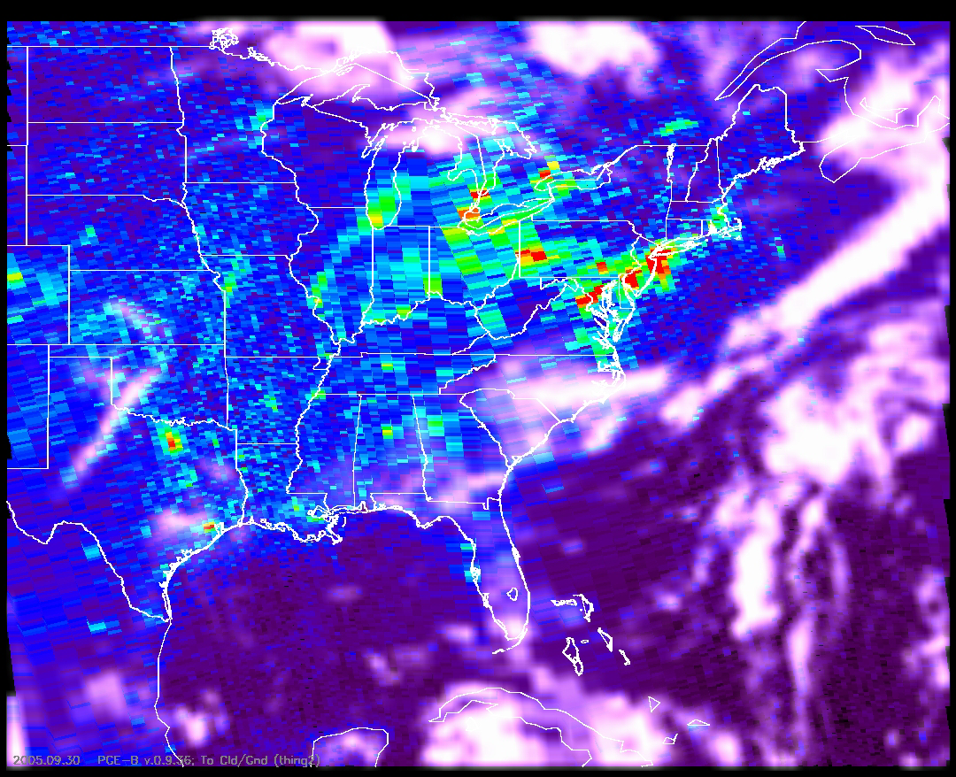
Figure 1: One year averaged tropospheric column NO₂ (DU) derived from OMI measurements for 2005. NO₂ hot-spots coincide approximately with the locations of the labeled cities. Scale is in DU; 1DU = 2.7x10¹⁶ molecules/cm². | Figure 2: NO₂ spatial variability for Sept. 30, 2005 from OMI over eastern and central US. The distribution of clouds from the OMI reflectivity channel are also shown superimposed on the NO₂ data. The scale is the same as Figure 1.

The annual average geographic distribution of C(NO₂) (total vertical column amount of NO₂) for 2005 as measured by the AURA/OMI (Ozone Measuring Instrument) over the US east coast is shown in Figure 1. Figure 2 shows the retrieved values of C(NO₂) for September 30, 2005 including the interference in the retrieval from the presence of clouds. These figures show the high spatial variability and range of values in both the annual average and in daily values. Maximum C(NO₂) values tend to be located over regions with the highest amounts of automobile traffic and industrial activity, which clearly identifies major cities. In a moderately polluted region near Greenbelt, Maryland, C(NO₂) can range between 0.2 and 3 DU with a local maximum typically around 10:30 (local time) and minima each morning and evening [Cede et al., 2006]. The NO₂ abundances in the boundary layer and lower troposphere are usually well in excess of typical stratospheric amounts (usually between 0.1 DU and 0.2DU).
Previously, a two-year C(NO₂) time series from OMI was compared with ground-based data at GSFC (Goddard Space Flight Center in Greenbelt Maryland). The C(NO₂) amounts from OMI were approximately 25% lower than values from GSFC ground-based measurements [Wenig et al., 2007] using a Brewer double monochromator [Cede et al., 2006]. There are three major reasons for the differences between ground-based and satellite measurements of C(NO₂). The AMF for satellite retrievals is sensitive to assumptions about the vertical distribution of NO₂ and the ground reflectivity, both of which are not well known. In addition, NO₂ has spatial variability at the OMI sub-pixel level (12 x 26 km²) in urban areas, so that OMI measures an average of high and low NO₂ regions compared to the usually higher values over GSFC.

The OMI observed C(NO₂) variability from region to region is more than a factor of 10, while in urban to suburban areas it can be as much as a factor of 2 (figures 1 and 2). Comparisons of nearby OMI pixels with a specific ground-based site may require a long time series to average out the regional and sub-pixel variability. The existence of sub-pixel variability has been established by MAXDOAS slant column measurements in different directions [Leigh et al., 2006]. In addition to sub-pixel variability, there is significant day-to-day and seasonal variability.
Section 2 provides a description of the technical characteristics of PANDORA, and MF-DOAS with emphasis on those necessary for C(NO₂) measurements. Section 3 describes the NO₂-retrieval algorithm and calibration methods used. Section 4 presents the acquired field data for two field campaigns at AU (July 2006) and GSFC (May 2007) and the GSFC time series (Dec 2006 to Oct 2008), including a comparison with OMI data.

2. Instrumentation Descriptions
During recent campaigns, we have deployed two independent array detector (CMOS and CCD) instruments, PANDORA (P) and MF-DOAS (M). The motivation for using an array detector spectrometer is to provide spectral oversampling (more than one detector pixel per wavelength resolution unit) and simultaneous measurements of all wavelengths.

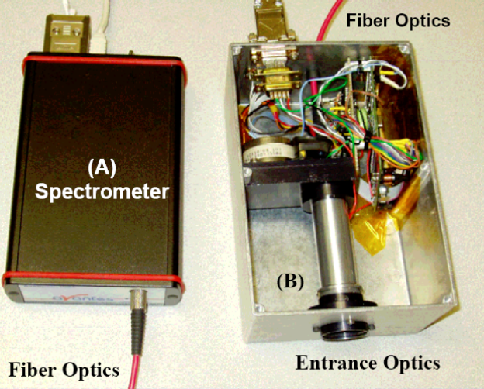  (A) (B) | 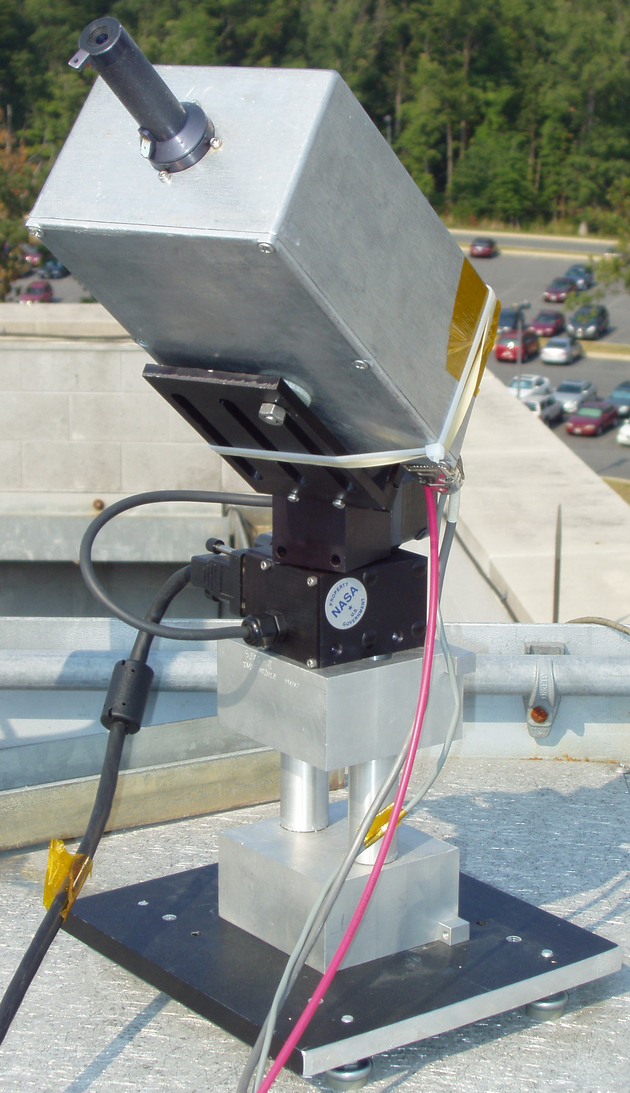 (C) | 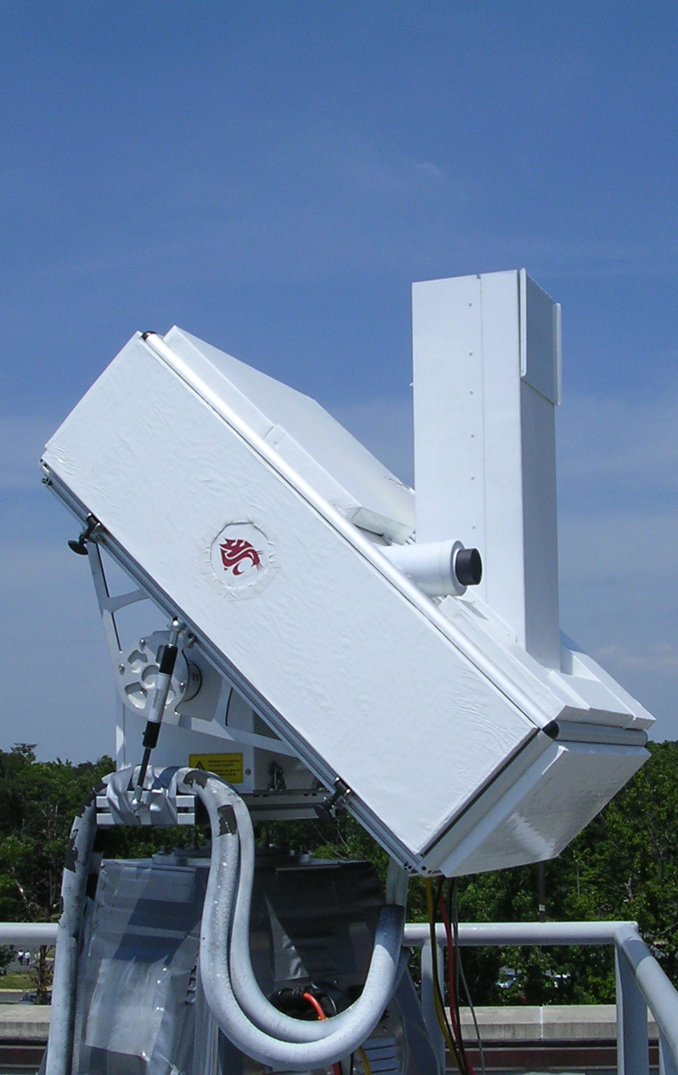 (D)
Figure 3: (A) The PANDORA small 1024 element CMOS spectrometer with fiber optics coupling to (B) sensor head with control electronics box, entrance optics, rotating filter wheel and shutter. (C) Field mounted fore optics and precision pan and tilt head with 0.01 degree pointing accuracy resolution. The aluminum box shown mounted on the Pan-Tilt head in 4C weighs less than 1 kg. (D) Washington State University MF-DOAS spectrometer, stand with internal computer, and solar tracker.

Tables 1 and 2 list technical characteristics of P and M. The spectrometers are spectrally oversampled, which permits each spectrometer’s slit function to be determined in the laboratory using spectral line lamps and improves the capability to match the spectrometer’s measurements with laboratory absorption coefficients and independently measured extraterrestrial solar irradiances. Major differences between the two spectrometer systems are different detectors leading to better signal-to-noise ratio (SNR) for MF-DOAS (M), use of fiber optic cables (P), use of an integrating sphere (M), refrigerated water cooling (M), thermoelectric cooling (P), measures sun and sky radiances (M), measures sun radiance (P), small size and low cost (P). A new CCD version of PANDORA was recently deployed that can also measure sun and sky radiances.
  Table 1 PANDORA Characteristics
  Wavelength Interval 265-500nm
  Spectral resolution (FWHM) 0.42-0.52nm
  Oversampling 3 pixels
  Spectrometer slit width 50μm
  Grating line density 1200 mm⁻¹
  Grating blaze wavelength ????
  CMOS array size (pixels) 1 x 1024
  CMOS pixel size 25 x 500 μm
  80% Full Well S/N (1 sigma) 700:1
  CMOS dynamic range 14 bit
  Minimum integration time 4 ms
  Table 2 MFDOAS Characteristics
  Wavelength interval 282-498nm
  Spectral resolution (FWHM) 0.83nm
  Oversampling 7.8 pixels
  Spectrometer slit width 100μm
  Grating line density 400 mm⁻¹
  Grating blaze wavelength 400 nm
  CCD array size (Pixels) 512 x 2048
  CCD pixel size (μm) 13.5 x 13.5
  80% Full Well S/N (400 rows) 5640:1
  CCD dynamic range 16 bit
  Integration time 20 ms- 60 s

The CMOS PANDORA system spectrometer system (Figures 3A, B, C, 4A) is based on an Avantes symmetrical Czerny-Turner optical design (Figure 3A) with a focal length of 75 mm, a 1200 lines/mm diffraction grating covering a spectral range from λ = 265 to 500 nm with a spectral resolution of ~0.5 nm, an entrance slit of 50 microns, a 1024 element Hamamatsu CMOS linear array that has very few hot pixels. The spectrometer is connected to the sensor head (Figures 3B and 4A) by a 10-meter fused silica 0.4mm diameter single-core multi-mode fiber optic cable such that the transmitted light fills the 50-micron wide entrance slit. Use of a fiber optic cable permits the temperature sensitive spectrometer to be stored away from the sun in an insulated box with a thermoelectric heater-cooler capable of maintaining the temperature at 20º2ºC. Small temperature related corrections are applied based on laboratory calibration. A temperature correction is estimated during the spectral fitting by comparing to a high-resolution extraterrestrial solar spectrum. Laboratory measurements gave a wavelength shift of –3 pico-m/°C, which we use to estimate the internal instrument temperature based on the fitted wavelength shift.

The sensor head (Figure 3B) has a multiply baffled collimating tube with a 1.6º FOV (field of view). Light that passes through the collimator then goes through a filter wheel assembly that contains two UV band-pass filters, 280-320 nm and 280-380 nm, used for O₃ and SO₂ measurements, an open hole, and a blocked region for measuring dark current after each measurement. In addition, there is a circuit board for controlling the filter wheel and sun-tracking device through an RS-232 serial computer interface. A flat quartz window constitutes the first optical element, which protects the internal optical and electrical components from rain, dust, and humidity. The optical head is connected to the cooled spectrometer using an up to 10-meter fiber optic cable. The fiber optic cable contains a 22 cm diameter service loop that minimizes changes in radiometric transmission when the cable moves. This is very effective as long as the service loop has the smallest radius of curvature anywhere along the fiber (Figure 4A).

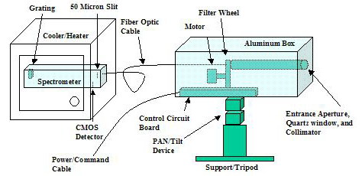 | 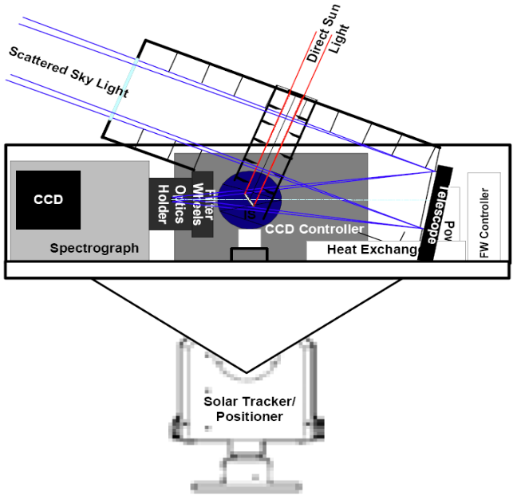
Figure 4A Block Diagram of PANDORA system showing the spectrometer in an environmental cabinet connected to the front-end optics and filter wheel assembly by a 10 m looped fiber optic cable. | Figure 4B A schematic diagram of the MF-DOAS instrument showing both direct sun and sky-radiance entrance ports. The MF-DOAS instrument is mounted approximately 2 meters high to clear roof obstructions. Computer control electronics are located inside the base.
The front-end optical assembly is mounted on a precision pan-tilt tracking device (Figures 3C and 4A, from Directed Perceptions, Inc.) capable of 0.013º pointing resolution. The position of the center of the sun is calculated from ephemeris coordinates, corrected by detecting the sun’s limb and triangulating to the center. If thick clouds are within the FOV, then just the calculated sun position is used. The front-end optics and tracking unit are mounted on a steel plate connected to a heavy-duty tripod. The steel plate and PANDORA’s optical axis is leveled to approximately 0.1º using a digital leveling device. Current versions of PANDORA eliminate this requirement by calculating a leveling correction in software based on measuring the solar position in the sky three or more times during a few hours of operation.
Figures 3D and 4B show a photograph and a schematic diagram of the MF-DOAS instrument that combines both direct sun and multi-axis scattered sky DOAS techniques. The instrument consists of telescopes for direct sun or scattered sky, a filter wheel containing various filters and polarizers, a spectrometer/detector system, a pointing device, a computer, and a water-based cooler to maintain constant temperature. The instrument incorporates a modified single-pass Czerny-Turner spectrograph (SpectraPro-2356) from Acton Research Corporation with focal length of 300 mm (f/4). A 400-groove/mm diffraction grating with a blaze wavelength of 400nm is used to disperse light. The original adjustable slit assembly was replaced by a fixed 100μm entrance slit, resulting in 0.83nm (7.8pixels FWHM) average spectral resolution. The wavelength coverage is from 282 nm to 498 nm (Table 2).
Light is detected by a back-illuminated, UV-coated charge-coupled device (PIXIS:2KBUV) from Princeton Instruments with an array size of 512 by 2048 pixels². The CCD is thermoelectrically cooled to –70ºC. Four hundred rows are co-added to increase signal to noise ratio by a factor of 20. The MF-DOAS spectrometer-detector system is the same for the direct sun and MAXDOAS modes, except for the input optics, which are dependent on the observation mode.
Direct-sun light enters the instrument through a 25 cm black anodized, baffled snout with a quartz window for weather control. A biconvex lens (2.5 cm diameter x 50mm focal length) focuses the sunlight into an 8-cm spectralon integrating sphere that moves into the spectrometer’s FOV during the direct-sun measurements. A series of baffles inside the telescope limit the direct-sun field of view to ~ 1.5º. Use of the integrating sphere assures equal illumination of the optics and minimizes the effect of pointing errors, thus eliminating a critical source of spectral residual error. The sky telescope is an off-axis paraboloid of focal length 45 cm which focuses a 1° field of view onto the entrance slit of the spectrograph. Before entering the spectrometer, light from the scattered sky or the direct sun passes through two filter wheels containing depolarizers (for sky-radiance measurements), a spectral flattening filter, and UV-transmitting and UV-cutoff filters. The instrument is enclosed into an insulated box and is temperature controlled by water-cooling (20º ± 2ºC) for radiometric and detector stability.
Solar pointing and positioning of the entire instrument is accomplished by the model 2APG sun tracker (Kipp & Zonen). In laboratory conditions it is capable of < 0.01º and < 0.05º precision and accuracy, respectively. After the initial instrument alignment the sun position is determined from ephemeris coordinates. The sun tracker is placed on the 2-m elevated stand to clear roof railings. The space inside the stand is used to protect the cooler and the instrument computer from the weather.

The larger CCD and longer focal length are two main features that give MF-DOAS improved precision and faster repetition rate compared to the CMOS PANDORA for direct-sun observations. A standard measurement of PANDORA is the average over 5 to 2500 measurements in 20 seconds depending on exposure time (8 to 4000 ms, full sun to clouds). The averaging reduces the random noise (single shot signal to noise is 700:1, table 1) to the point where they are negligible compared to the minute-by-minute variability of C(NO₂). MF-DOAS does not require the time averaging because of its 400-row CCD detector compared to the single row CMOS detector used for the first version of PANDORA..
3. Algorithm and calibration
A direct-sun NO₂ inversion method is described in detail in a paper by Cede et al. [2006] as applied to the measured irradiances from a Brewer spectrometer between 335 and 365 nm. A similar algorithm is applied to PANDORA and MF-DOAS and is described here.

3.1 Spectral fitting
The first step in the algorithm is to subtract the logarithm of the measured spectra from the logarithm of the so-called reference spectrum. The reference spectrum can be a single measured spectrum, typically taken around noon on a clear day, or also the average of many measured spectra (more details about the reference spectrum in the next section). Then a simultaneous least-squares fit is applied to the difference between measured and reference spectra (see figure 5). The fitted functions are a low-order polynomial, the absorption spectra of NO₂ and other atmospheric absorbers, and wavelength shift and squeeze functions. All the PANDORA NO₂ data presented in this paper are from the 370 to 500 nm fitting window. MF-DOAS makes a similar fit using a 405 to 430 nm spectral window. The range between 405 to 430 nm contains the region of maximum structure in the measured NO₂ absorption coefficients. We call the fitted slant column amounts “relative slant columns” SC_{REL}, since they give the difference between the absolute slant column at the time of the measurement and the absolute slant column included in the reference spectrum SC_{REF}.

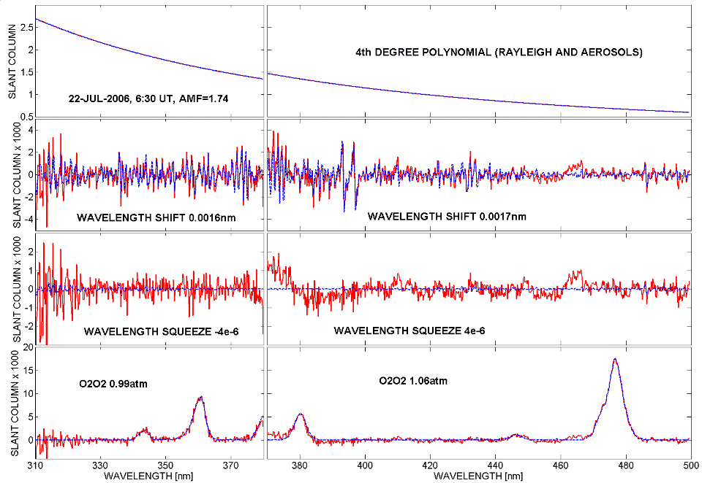
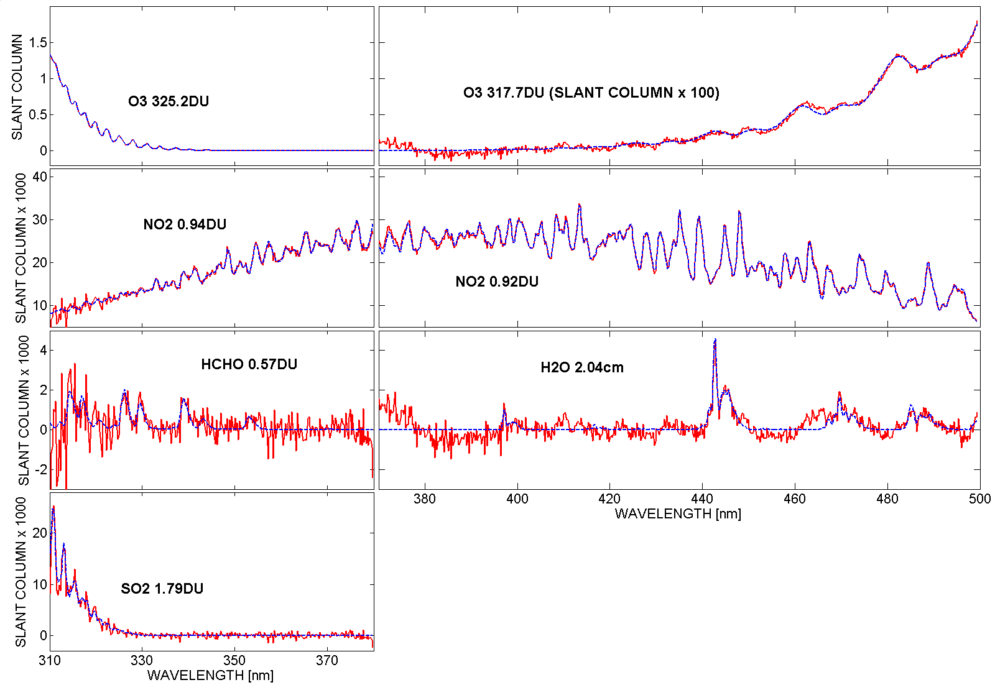
Figure 5 Upper Panel: Fitted slant column optical depths (blue) for a measurement on July 22, 2006, during the campaign in Greece (red). Left side shows the measurement with the 380nm low pass filter, right side the measurement without filter. Note that the wavelength range 370-380nm appears on both sides. The black legends give the final retrieved vertical column amounts for each atmospheric absorber.

Figure 6 shows a comparison between SC_{REL} from PANDORA and MF-DOAS during the campaign at GSFC in May 2007, where both instruments use a reference spectrum from a single measurement taken at the same time and use the NO₂ cross sections from Harder et al. [1997] at 243K. The systematic difference between the relative slant columns of the two instruments is less than 1%. For all other data in the paper, PANDORA NO₂ retrievals are compared with OMI, and so are based on the same cross sections used by OMI [Vandaele et al., 1998].
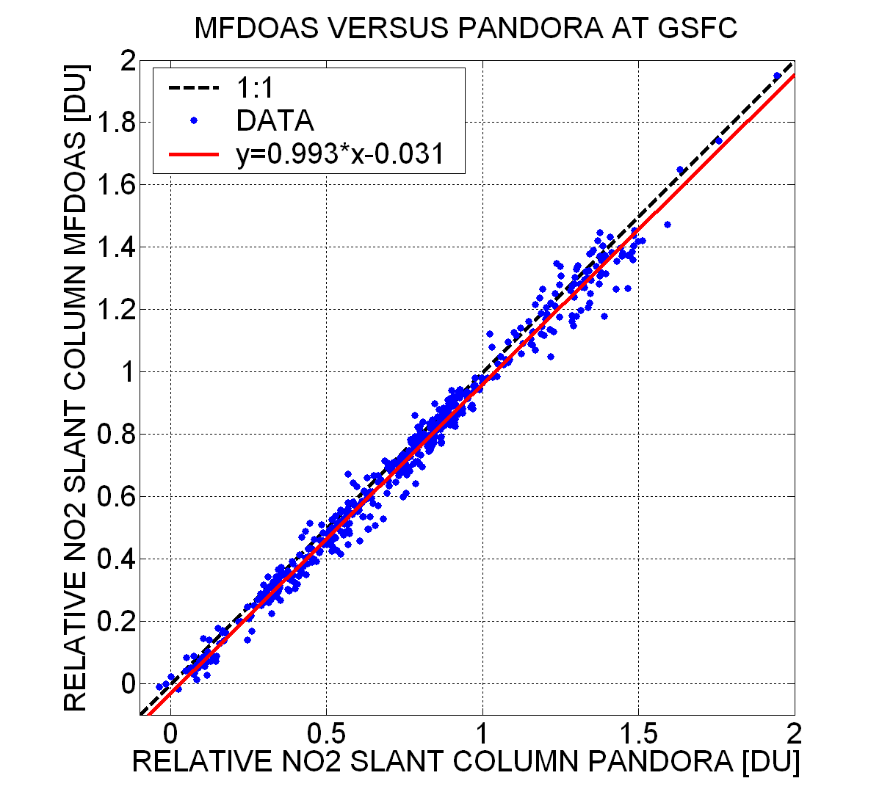
Figure 6 Comparison of relative slant columns measured by PANDORA and MF-DOAS at GSFC (May 2007)

3.2 Determining the slant column amount in the reference spectrum
The main obstacle for using DS-DOAS is in determining the absolute slant column amount in the reference spectrum SC_{REF}. This problem would not exist, if one could use an extra-terrestrial solar irradiance Io(λ) at the top of the atmosphere that is compatible with the ground-based spectrometer data. In principle, this can be done using radiometric and wavelength λ laboratory calibration of a spectrometer system to compare with an independently measured Io(λ). The independently measured Io(λ) must be at much higher spectral resolution than the spectrometer so that it can be convolved with the measured spectrometer slit function. This technique has the advantage of giving an absolute measure of C(NO₂) within the accuracy of the laboratory calibrations and the measured Io(λ) (about 3%; 1 sigma). The assumption is that the measured Io(λ) can be accurately matched (to < 0.01 nm) in wavelength to the ground-based instrument so as to permit the canceling out of the solar Fraunhofer spectral features and leaving only atmospheric spectral signatures. In practice this has proved to be difficult because of wavelength dependent errors in both the reference and measured spectra from the use of different instruments (e.g., different wavelength dependent slit functions).

Therefore we use a reference spectrum resulting from the instrument’s own measurements. In order to determine the value of SC_{REF} we use statistical approaches. Both used methods, the “Bootstrap-Estimation” (BE) method [Cede et al., 2006] and the Minimum-Amount Langley-Extrapolation (MLE), are described.
Assuming a day with no tropospheric NO₂, and with the vertical column in the stratosphere constant over the measurement period at a value VC₀, the measured relative slant columns SC_{RELi} at time i would be given by the linear relation:
(1)

SC_{i} is the absolute slant column at time i and AMF_{Si} is the stratospheric direct sun air mass factor at time i. For the calculation of the direct sun air mass factor we use equation 2.

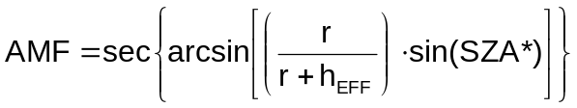 | (2)

r is the distance from the center of the Earth to the measurement location (~6370 km), SZA* is the apparent solar zenith angle (i.e. the true SZA corrected for refraction), and h_{EFF} is the assumed effective height of the NO₂ layer. Here we assume h_{EFF} =25 km for the stratosphere (AMF_{S}) and h_{EFF}=2 km for the troposphere (AMF_{T}).
If, under these conditions, SC_{RELi} is plotted as a function of AMF_{Si}, the SC_{RELi} would all be along a straight line with intercept −SC_{REF} and slope VC₀ as indicated in Equation 1.
Figure 7 shows SC_{RELi} as a function of AMFSi for MFDOAS data during a 2-week campaign in Table Mountain, California, in July 2007. A measured noontime spectrum from July 7, 2007 was selected as a reference spectrum, since that day appeared to have the smallest amount of NO₂ compared to other days. The data are not along a straight line, since the NO₂ amount was not constant over the whole measurement period.
The MLE method assumes that the minimum vertical column amount of an atmospheric parameter (NO₂ amount) is independent of AMF during some portion of the measurement period. So if we have a set of SC_{REL} measurements from a series of days, we assume that the corresponding subset of minimum NO₂ VC over the whole data series was independent of the AMF_{S}.
The measured SC_{RELi} were binned in groups of 100 data points from lowest to highest AMF_{Si}, and the minima in each AMF group were determined from the 2-percentile subset. To minimize uncertainties in the calculated AMF, we limit the analysis to AMF < 5 (i.e., SZA<80°). A straight line was fitted to the 2-percentiles from each AMF bin (red line in Figure 7).

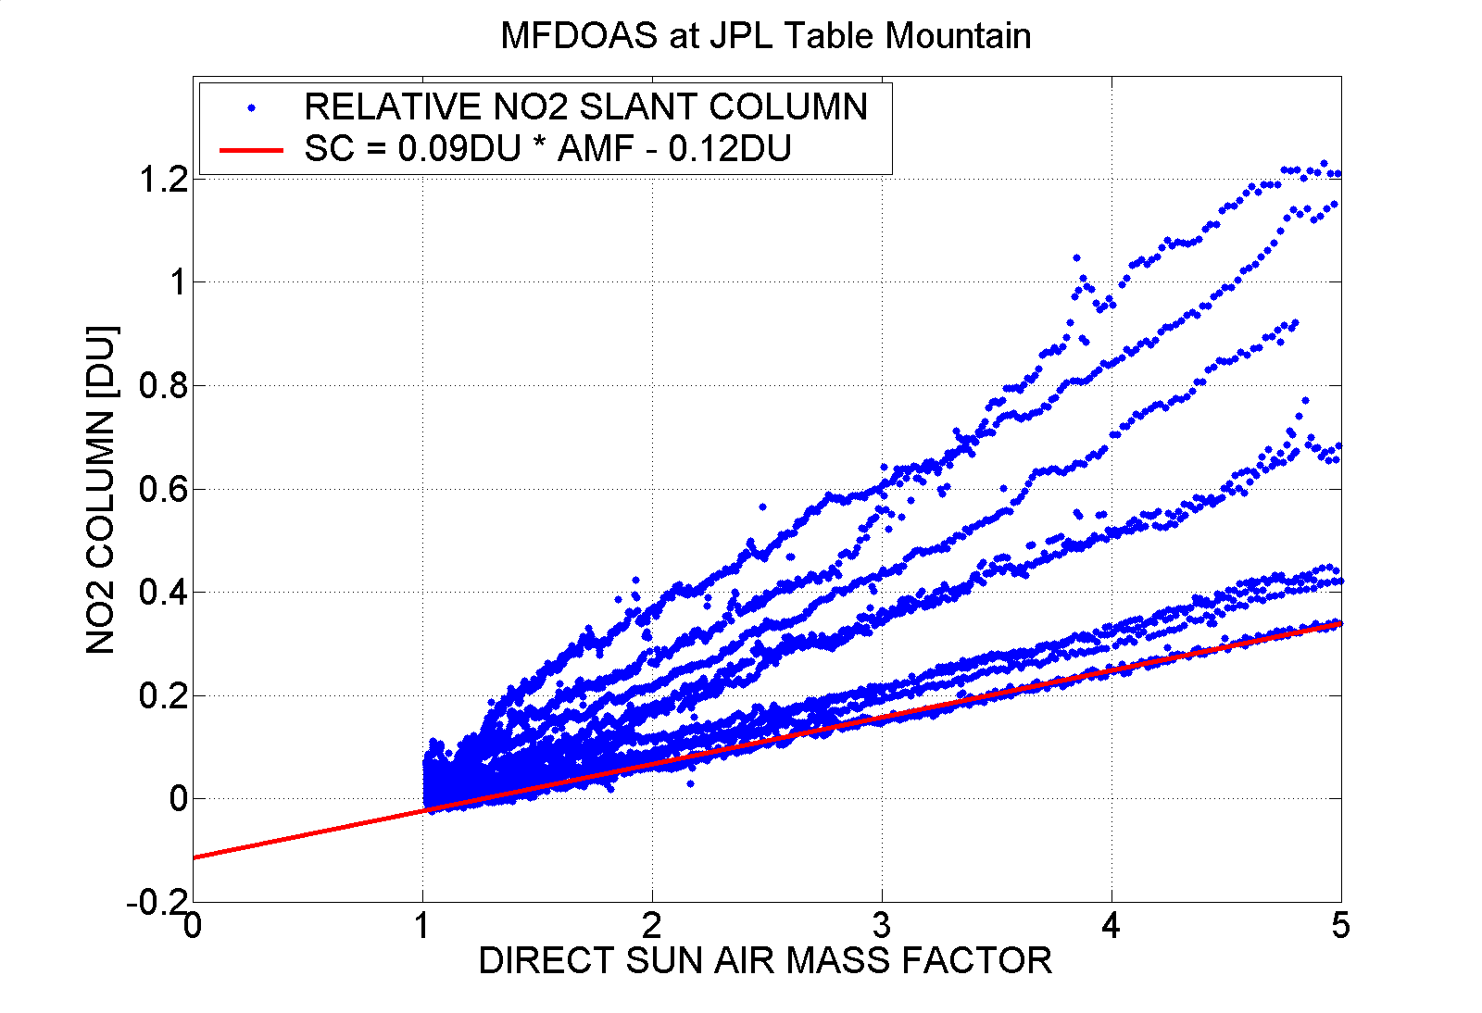
Figure 7 Relative NO₂ slant columns SC_{REL} as a function of AMF_{S} from the MF-DOAS spectrometer. The SC_{REL} use a reference spectrum from local noon on July 7, 2007.

Since the y-intercept in Figure 7 was 0.12DU, the absolute slant column in the selected reference spectrum (noon on July 7, 2007) was SC_{REF} = 0.12DU. The slope (see equation 1) of the fitted red line is VC₀ = 0.09DU, which means the minimum NO₂ data at the location had a vertical column amount of 0.09DU, which is approximately the stratospheric column. Adding SC_{REF} = 0.12DU to all of the data gives absolute slant columns, SC_{i}. The vertical columns were obtained by dividing the measured SC_{i} by the “effective” AMF.

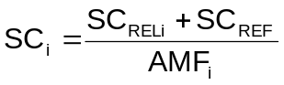 | (3)

The effective AMF is a combination of a stratospheric AMF with effective height of 25km assuming a stratospheric NO₂ vertical column of 0.1DU, and a tropospheric AMF with effective height of 2km for the tropospheric column amount. The obtained VC amounts give a nearly flat slope vs AMF (dark data points in Figure 8).

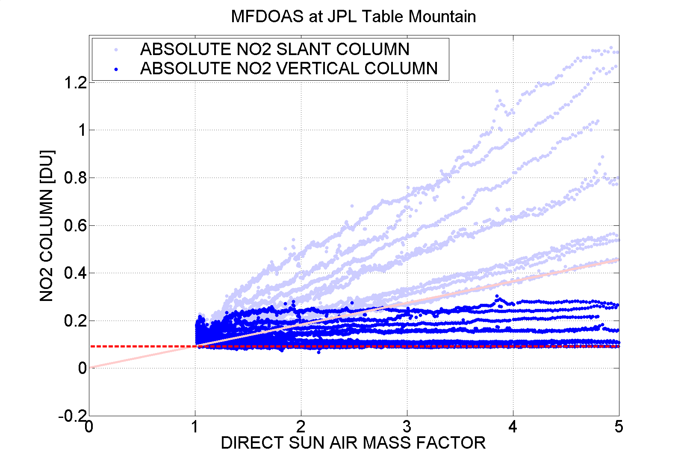
Figure 8 Absolute NO₂ slant columns SC (light lines) and vertical columns VC (dark lines) as a function of AMF_{S} from the MF-DOAS spectrometer after the 0.12 DU of NO₂ were removed from the July 7, 2007 reference spectrum.

At a polluted site, the basic MLE assumption, i.e. the minimum vertical column amounts are independent of AMF, may or may not occur during a brief campaign period. However is very likely to occur for instruments that are located at a polluted site for many months. Figure 9 is like figure 6 using the relative slant columns from the PANDORA data series at GSFC from Dec 2006 to Oct 2008. The reference spectrum is not from a single measurement, but is the average over many spectra taken at clear days.

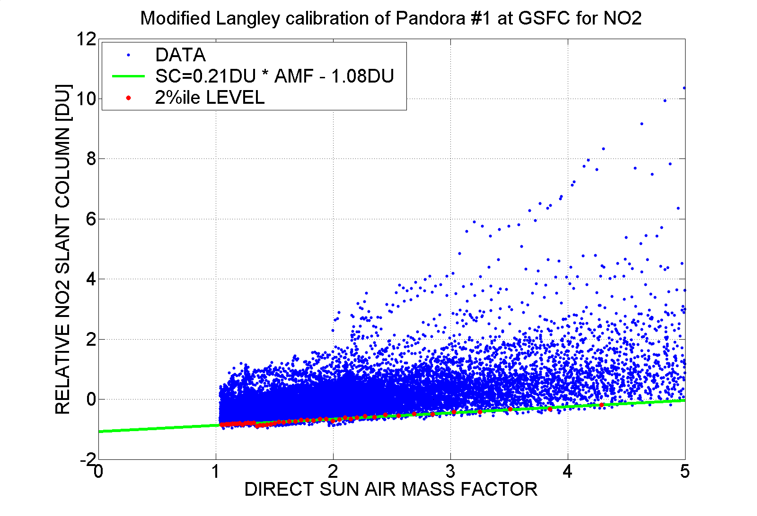

Figure 9 Similar to Figure 7, but for the GSFC data series from Dec 2006 to Oct 2008.

The individual days are not visually separable anymore in figure9. However, the lower boundary straight line is well defined and yields VC₀ = 0.21DU and SC_{REF} =1.08DU. So the minimum vertical column at GSFC of 0.21DU is about the stratospheric column and the average slant columns amount for the measurements used in the reference spectrum is 1.08DU.
The Bootstrap Estimation BE method is similar to MLE, but, instead of making no assumptions about the magnitude of the minimum vertical column in the database, VC₀ in Equation 1, VC₀ is assumed to be a specific amount, VC₀ = 0.1DU, equal to a nominal mid-latitude stratospheric value during a given campaign. Subtract this amount from the measured slant columns and Equation 1 becomes
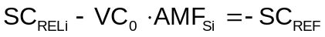 | (4)

If the left side of Equation 4 is plotted as a frequency of occurrence histogram for the MF-DOAS measurements at the Table Mountain Station, a distribution results that is sharply peaked at about –0.1 DU (Figure 10). The mode of this distribution is the bin from –0.09 to –0.10 containing 12% of the total amount of data. The 2-percentile of this distribution is –0.14, or SC_{REF} = 0.14 DU. Since the left side of the distribution is very steep, the exact choice of which percentile to use is not too critical (the 1, 2, 5, and 10-percentiles of the distribution are –0.15, –0.14, –0.13, and –0.12DU, respectively).
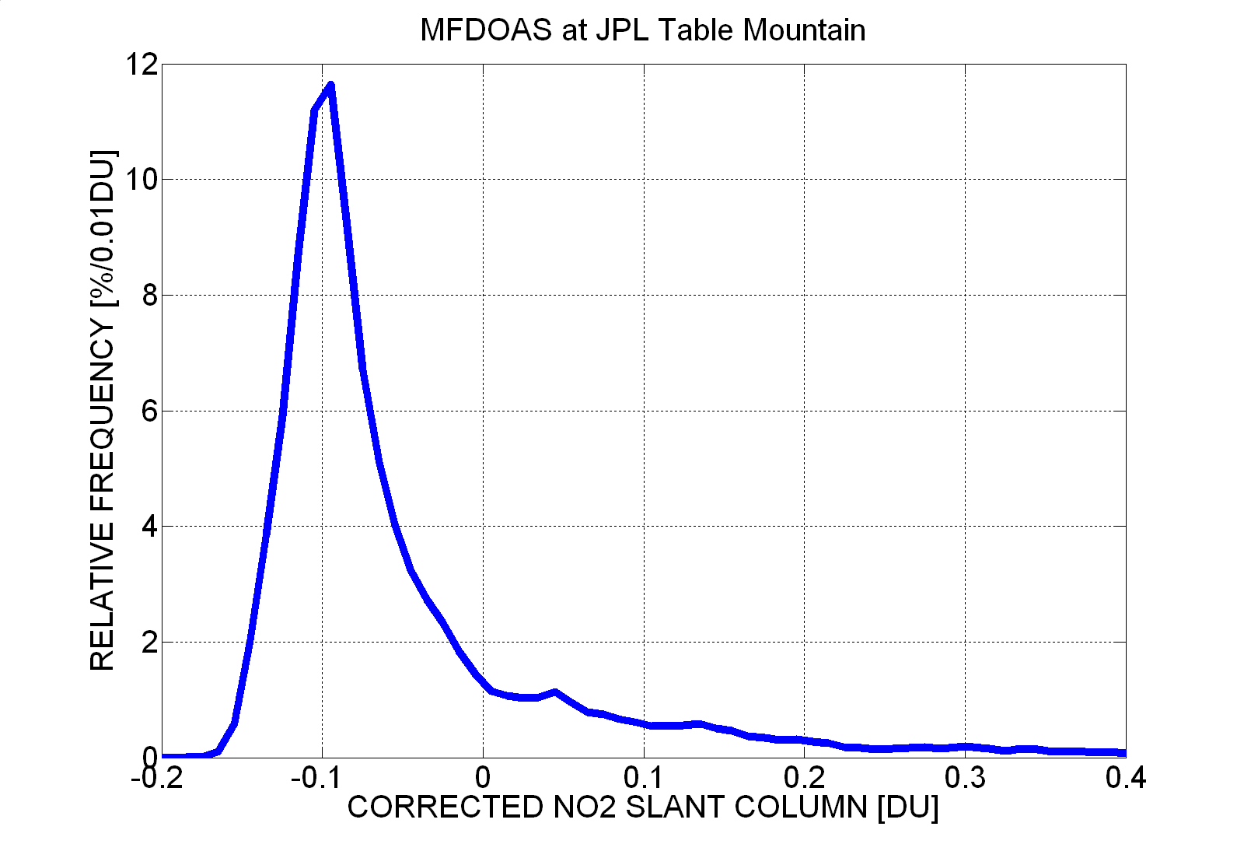
Figure 10 Distribution of the corrected relative slant column SC_{RELi} – VC_{o} – AMF_{Si} plotted as a histogram with bin size of 0.01 DU.

One qualitative way to judge whether the estimated value of SC_{REF} is reasonable is to examine the variation of C(NO₂) throughout a single day when C(NO₂) is approximately constant. If the variation shows a curve instead of a flat line (U-shape or inverse U-shape), then SC_{REF} is probably in error causing an AMF effect on the calculated NO₂ VC amounts. An example is given in the section 4.2.
An absolute validation method is through the comparison of PANDORA and MF-DOAS with the FTUVS (Fourier Transform Ultraviolet Spectrometer from NASA/JPL), which measures the absolute amount of C(NO₂) in the atmosphere (described in a separate paper) determined from two measurements on the left and right edges of the solar disk. The C(NO2) from that comparison agree well for all three instruments.

3.3 Uncertainty Estimation (PANDORA and MFDOAS)
This section estimated the errors inherent in the measurement technique that are independent of the instrument making the measurements. Both PANDORA and MF-DOAS are capable of making measurements with a precision of ε = ±0.01 DU with MF-DOAS able to achieve this level of precision using a shorter integration time than PANDORA. The additional errors are estimates of any possible offset from the exact C(NO₂) or the exact SC(NO₂).

Based on equation 3, the uncertainty in the SC is a combination of the uncertainties in SC_{REL}, SC_{REF}, and AMF.
For clear-sky conditions the precision of the SC_{REL} is about ±0.01DU. In the presence of clouds the signal to noise decreases since there are fewer photons received a fixed integration time, with the precision increasing up to ±0.2DU for thick clouds. In addition to this constant amount, we estimate another ±5% uncertainty for SC_{REL} caused by unknown temperature variations in the atmosphere and a similar systematic bias caused by uncertainties in the laboratory absorption cross sections.

Based on the above discussion of field calibration, we estimate the uncertainty of SC_{REF} to approximately half the stratospheric value of C(NO₂), or about ±0.05 DU.

The uncertainty of AMF depends mostly on the uncertainty in the assumed effective tropospheric layer height, which we have assumed to be between 1 and 3 km above the local surface. For SZA < 80° we estimate the uncertainty in the AMF to be less than 1%.
For clear sky measurements with SZA<80°, we can neglect the precision of SC_{REL} and the uncertainty in AMF in the total uncertainty budget, which means that the total uncertainty is simply given by E_{R} = ±0.05DU±5% (2 sigma level). This uncertainty is very small for the purposes of characterizing air quality or for validation of satellite data. For a measurement of 1.5 DU, this means that E_{R} = ± [0.05² + (0.05 x 1.5)² ]^{0.5} = ±0.09DU, which is consistent with the rough estimate of the measurement error of 0.1 DU for polluted sites given in the abstract.

4. Results
4.1 Thessaloniki (July 14-24, 2006)

The first set of field measurements using PANDORA was made in the city of Thessaloniki, Greece (40.6335ºN, 22.9564ºE) in the middle of the moderately polluted scene shown in Figure 11. The instrument was set up on an elevated platform on top of the Aristotle University Physics building about 60 meters above sea level about 1 km from the Aegean Sea, as part of the European Union Scout-O₃ campaign, July 2006. Besides PANDORA, measurements were also made with GSFC’s polarization insensitive double Brewer spectrophotometer, and other auxiliary instruments.
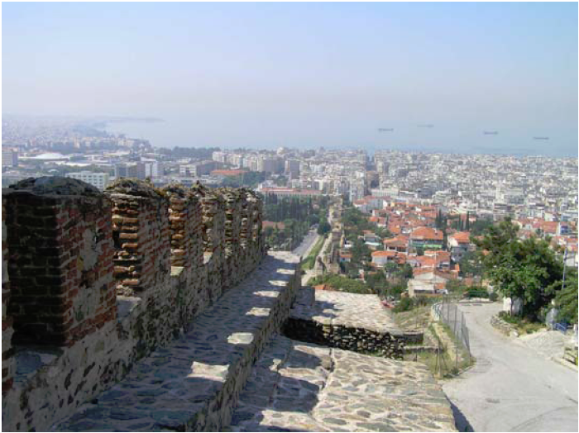
Figure 11 A view to the south from the hill above Thessaloniki University Physics building on July 15, 2006 showing the pollution in the city and over the Mediterranean Sea with an almost cloud-free sky. The mild brown color is probably from the NO₂ in the air above Thessaloniki.

Thessaloniki is a very densely built urban area with the Aegean Sea on the southwest side and mountains on the northeast. There is a high level of industrial activity leading to amounts of haze and pollution in the air that significantly reduced surface visibility (Figure 11). Trace gases and aerosols over the city originate from different sources, including local (i.e. industry and traffic) and long-range anthropogenic pollution from European countries north of Greece [Zerefos et al., 2000], a mineral dust component from the Sahara desert [Papayannis et al., 2005], which was not observed during the campaign, and a marine water-haze component [Barnaba et al., 2004]. Despite recent efforts to control emission sources, boundary layer NO₂ levels in Thessaloniki have been found to be above the European Commission air quality standards [Nikolaou, 2002]. The presence of NO₂ just above Thessaloniki is visible as a slightly brown layer as shown in Figure 11.

PANDORA operated for 10 days and we applied the Bootstrap calibration (BE) assuming VC₀=0.1DU. The retrieved C(NO₂) are shown in figure 12 for PANDORA (blue), the Brewer (red with noise estimations) [Cede et al., 2006] and OMI. (green). The Brewer NO₂ data have the same potential accuracy in SC_{REF} as PANDORA. However since there are only six wavelengths available for the Brewer, and because the Brewer operates in a reduced sensitivity region of the NO₂ absorption cross-section; it has much less precision (red dots and noise estimations in Figure 12) than PANDORA. The 0.01 DU PANDORA precision is about the width of the blue dots. The clear-sky portions of the daily variation seen by the Brewer and PANDORA usually agree with each other within the Brewer noise estimations. There are several periods, where PANDORA did not perfectly track the sun and had only part of the sun’s disk in its field of view. During these periods, highlighted by a light gray background, the PANDORA-retrieved aerosol optical depth was significantly too high. The retrievals of C(NO₂) were only marginally affected by this tracking problem. A successful sun-search routine usually brought the measurements back to the correct value (see e.g. July 15, shortly after 14:00). The tracking problem has now been solved. Open blue circles in Figure 12 are PANDORA C(NO₂) data retrieved with an rms precision > 1% because of reduced signal level due to clouds.
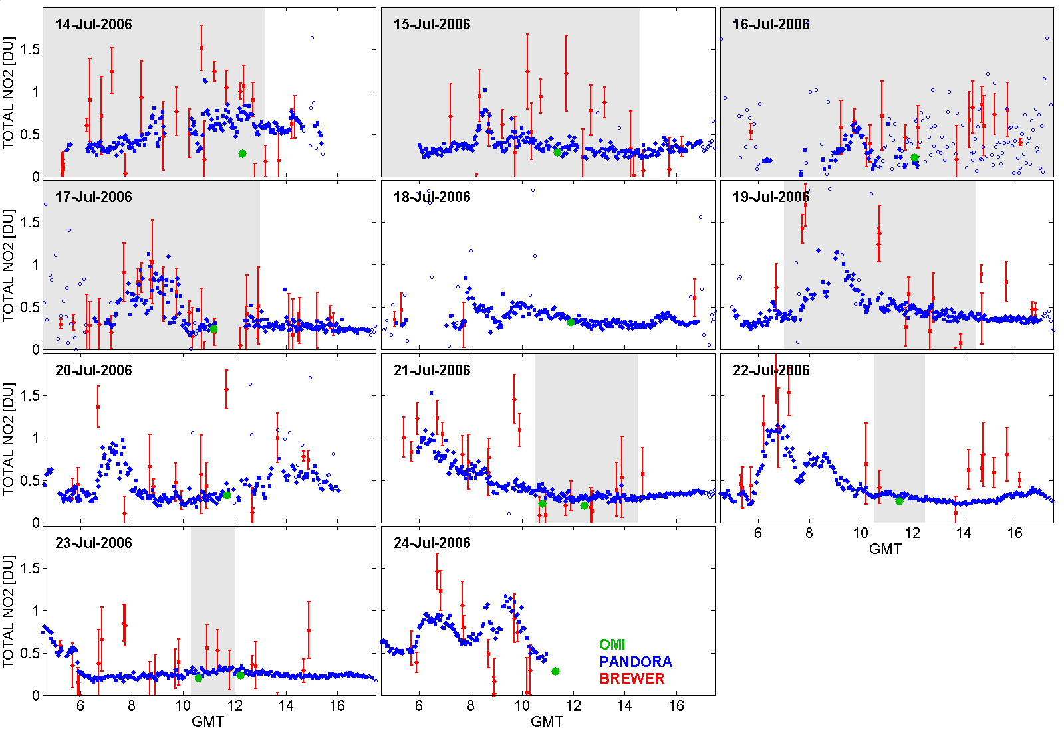
Figure 12 The daily variation of NO₂ column amounts in Thessaloniki, Greece for Friday 14 July to Monday 24 July 2006 using the Bootstrap calibration method as a function of GMT (Local time = GMT + 3). Three data sets are shown, PANDORA (blue), Brewer (red), and OMI (green). The solid blue dots represent clear-sky PANDORA data and red dots are noise estimations for the Brewer spectrometer. Light blue dots indicate the presence of clouds. The OMI overpass time is about 13:30 local time or 10:30 GMT. Shaded areas indicate periods where the sun tracking of PANDORA was not fully accurate.

The Brewer data were obtained approximately every 20 minutes, while the PANDORA data were obtained every 2 minutes, and OMI data were obtained once or twice per day. On some of the days observations were obtained during partly cloudy conditions, with the sun going in and out of thin clouds. Thin clouds only slightly degrade the PANDORA data, since the wavelengths are obtained simultaneously. The same is not true for the Brewer, where the 6 wavelengths are obtained sequentially over a short interval. Each Brewer wavelength is integrated for 0.1147 seconds, or about 0.7 seconds for all six wavelengths. This time difference between successive wavelengths is sufficient for the radiances to change as a function of wavelength because of changes in cloud and aerosol transmission during the measurement period. The result is additional scatter in the Brewer estimates of NO₂ as is clearly shown in Figure 12. This effect is particularly seen on Saturday 15 July where the PANDORA data are highly correlated from measurement to measurement, while the Brewer data show substantial random scatter that is greater than their estimated noise.

On Sunday, 16 July, there was moderately heavy cloud cover. This is clearly seen in the scatter of the PANDORA data (red dots), which persisted into Monday morning, 17 July, after which the data are again highly correlated. The days 18th and 19th are not displayed, since the sky was fully overcast. There also were less Brewer data on the 18th, since the Brewer performed different measurements routines on that day.

The more frequent data cycle and higher precision of PANDORA is an advantage over the Brewer, which misses some of the features that are clearly seen with PANDORA, such as the morning peak on 20 July. Interference by light cloud cover also causes missing Brewer data, but not in the data from PANDORA. Normally, the Brewer data are cloud-screened by requiring that the measurement noise to be less than 0.5DU, while the simultaneously retrieved aerosol optical depth at 363nm is less than 1.5.

Some common features stand out during the two weeks that measurements were made in Thessaloniki. On most workday mornings, C(NO₂) rises rapidly from its nighttime low to reach a peak value at approximately 11 a.m. (0800 GMT), and then falls steadily throughout the day. The morning peak is probably caused by the heavy automobile traffic and the startup of local industry. NO₂ amounts decrease all during the afternoon caused by tropospheric photochemical reactions and clean-air winds from the Agean. This was true on every day except 20 July when the decreasing C(NO₂) effect was postponed until about 1500 hours GMT (1800 local), when the photochemical production of NO₂ is reduced. On Sunday July 23, the amount of NO₂ is considerably less than on other days, which correlates with reduced automobile traffic and factory operation. A comparison with Thessaloniki OMI overpass data shows good agreement (green dots in Figure 12) when overpass pixel locations were near the PANDORA observing site.

4.2 Goddard Space Flight Center
The location for a first intercomparison campaign for PANDORA and MFDOAS (May 14 to 25, 2007) and for the PANDORA data series from Dec 2006 to Oct 2008 is on the roof of a building about 88 meters above sea level at Goddard Space Flight Center (GSFC, 38.993°N, 76.840°W). GSFC is close to two major highway systems and a busy local road that are strong sources of NO₂ (automobile NO emissions are quickly converted to NO₂ in the atmosphere).

The campaign at GSFC was designed to compare PANDORA with similar measurements made by the MF-DOAS spectrometer in a moderately polluted area using the same algorithm and field calibration methods. The following discussion applies to both instruments, which were always in close agreement. There were no days during the 12-day campaign where NO₂ amounts were as low as stratospheric values. This caused the bootstrap (BE) field calibration technique to disagree with the Modified Langley (MLE) method as expected, whereas at the unpolluted TMF site, both methods agreed quite closely and show nearly the same detailed dependence throughout each day. Figures 13 and 14 show the C(NO₂) retrievals for the GSFC site using BE and MLE calibration techniques, respectively. Examination of the BE calibrated data (Figure 13) appears to show a calibration artifact that is most noticeable on 21 May, where the mid-day values are below the nearly identical morning and evening C(NO₂) values in a shallow U shape.
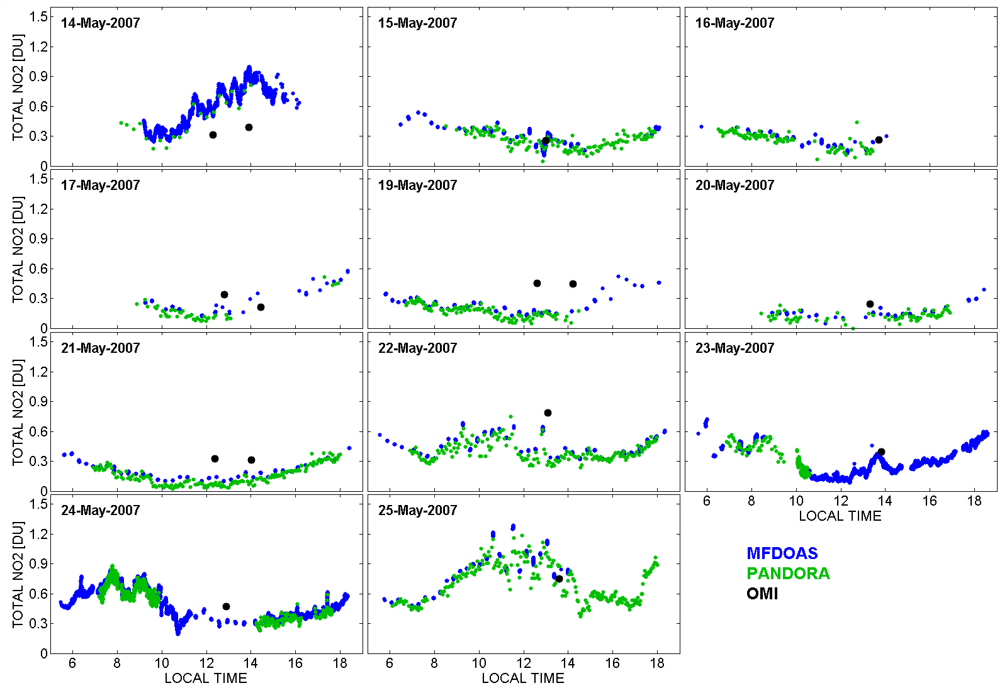
Figure 13 MFDOAS and Pandora C(NO₂) data from GSFC during May 2007 calibrated with the BE calibration method. Also shown are the OMI overpass data (both total column and the estimated stratospheric value). The MF-DOAS data (blue) are more sparse than PANDORA whenever MF-DOAS is interspersing measurements of sky radiances.

When the same data are calibrated using the MLE method, the U shape is no longer present, and the C(NO₂) values are nearly constant throughout the day. For the campaign data obtained at GSFC, there is simply not enough data to effectively use the BE method, and, only by chance, was there enough constant C(NO₂) as a function of SZA to effectively use the MLE method. Because the conditions favored the MLE method, it is likely that the curvature on 21 May shown for the BE calibration is incorrect. The conclusion is that field calibration is possible and reasonable, even for short campaigns. However, if a higher probability of obtaining a more accurate calibration is wanted, then either a longer campaign is needed, or the instruments must be sufficiently stable so that calibration can be transferred from site-to-site. This is not a problem for permanently sited instrumentation with long data records.

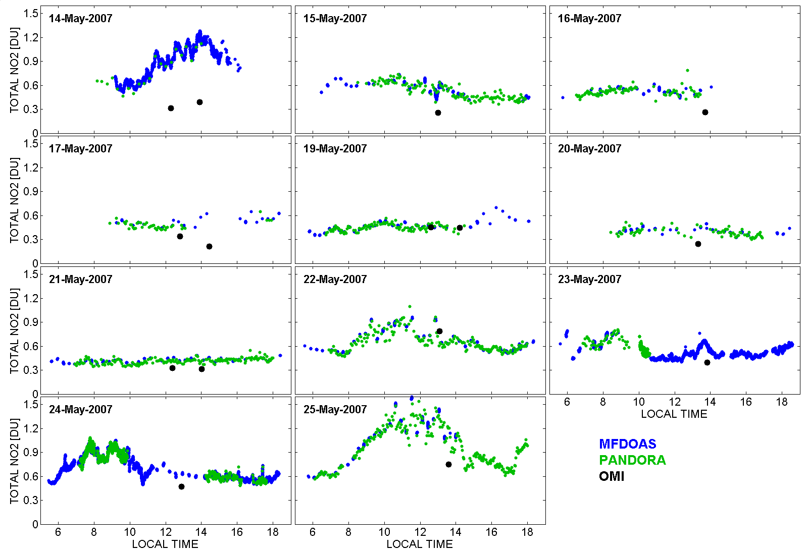
Figure 14 MFDOAS and Pandora C(NO₂) data from GSFC during May 2007 calibrated with the MLE calibration method. Also shown are the OMI overpass data (black). The MF-DOAS data (blue) are more sparse then PANDORA whenever MF-DOAS is interspersing measurements of sky radiances.

The differences between BE and MLE calibrations for short campaigns can be large enough to change the comparison conclusions about OMI C(NO₂) data. NO₂ vertical column data measured from GSFC ranges from ~0.1 to ~0.9 DU as would be expected in a moderately polluted site. Comparison of the ground-based C(NO₂) with those from OMI, during its 1:30 pm overpasses time, and from one orbit after or before (±90 minutes) shows only moderate agreement. Using the preferred MLE calibration for the May 2007 campaign suggests that OMI is lower than the ground-based measurements for the majority of the campaign days. This is exactly as expected, since the large OMI pixel averages polluted and unpolluted areas relative to the polluted GSFC site.
Do we want to show the WSU PNNL results for the 80 days that we were there (i.e. another fairly long time run) on NO2???? They could easily be fit in. One graph of WSU MFDOAS vs OMI with filtering for clouds, etc.

OK
On May 14, 2007 MFDOAS sampled every 10 seconds and Pandora every 15 minutes near local noon (Figure 15, top panel). The MFDOAS data shows that there is changing C(NO₂) amounts of up to 0.2DU/10min. The less frequent data from PANDORA generally follows that from MF-DOAS, but misses the details of the C(NO₂) variation. On the morning of May 24, 2007, the measuring cadence of PANDORA was changed to more closely match MF-DOAS. MF-DOAS sampled every 4 seconds (light blue dots) and PANDORA every 2 seconds (light red dots). Since instrumental noise becomes a problem for the short PANDORA integration times, both data sets were smoothed using running one-minute averages (solid lines).
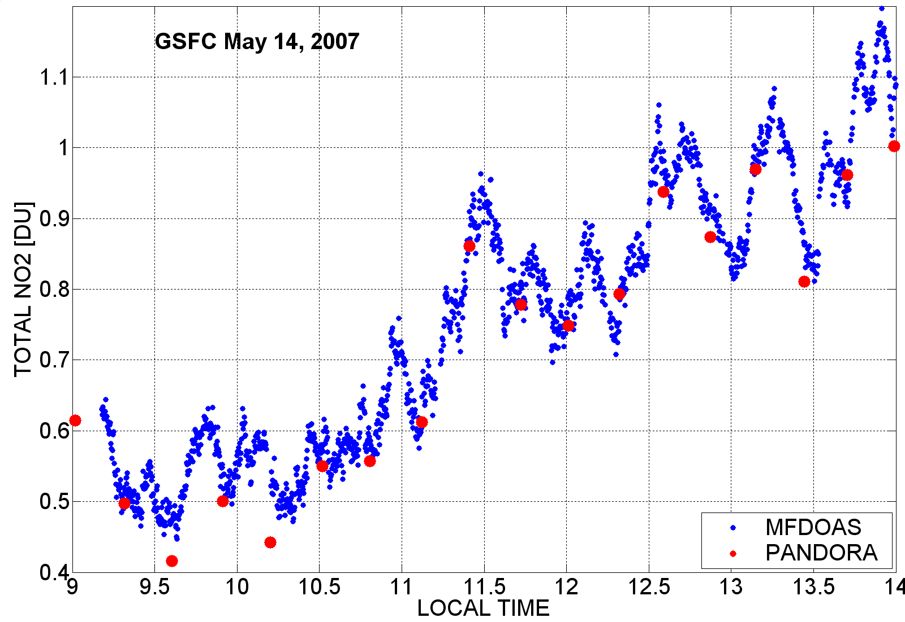
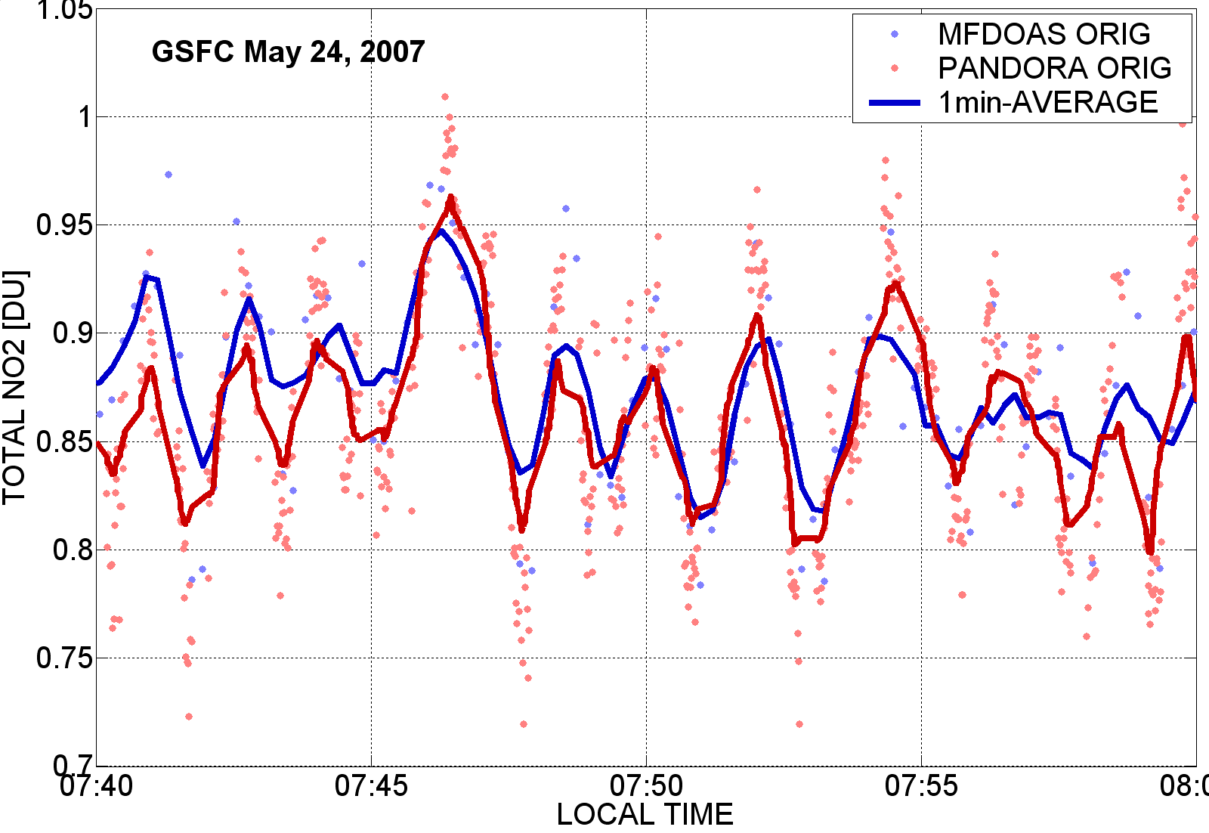
Figure 15 High time variability at GSFC observed on 14 May 2007 and 24 May 2007 by PANDORA and MF-DOAS
The averaged data shows a clear cycle with a rate of change for the C(NO₂) of 0.1DU/min and a 2-minute period. Since two independent instruments, MF-DOAS and PANDORA, observed the same variability, the observations are not instrument artifacts. Such rapid change increases the difficulty of interpreting differences with satellite overpass data, which is not precisely co-located and has a larger field of view. The rapid temporal variability of about ±20% in magnitude suggests the difficulty of accurately modeling the effects of local transport in the boundary layer on the chemistry involved with air quality. A possible, but unproven, source of the short term C(NO₂) variation is from the operation of a traffic light on a nearby busy 4-lane road. The time variation of C(NO₂) puts additional limitations on satellite validation unless high cadence measurements are used to match overpass times and more instruments are located within a satellite FOV to better match the satellite spatial average value.
Below is the agreed upon TMF lead in to the companion paper.

TMF: A third campaign, in late June 2007, was at JPL’s Table Mountain Facility, California (TMF at 34.382°N, 117.681°W), which is an extremely clean site even though it is near Los Angeles, California. PANDORA, and MF-DOAS, GSFC’s double Brewer, and UV-MFRSR were located on the same rooftop approximately 2.2 km above sea level with a view of the horizon to the east, but with other directions partly obscured by terrain, structures, or trees. Only the field calibration results from TMF are discussed (Figures 6-7), which demonstrate sensitivity and calibration at a clean site. The daily NO₂ results from TMF will be presented in a separate paper [2009], which also provides the details of a third instrument, the JPL FTUVS, using a totally independent method of observation, and whose field calibration is not dependent on the amount of C(NO₂) in the atmosphere or on obtaining a solar reference spectrum.

4.3 Comparison of PANDORA with OMI at GSFC:
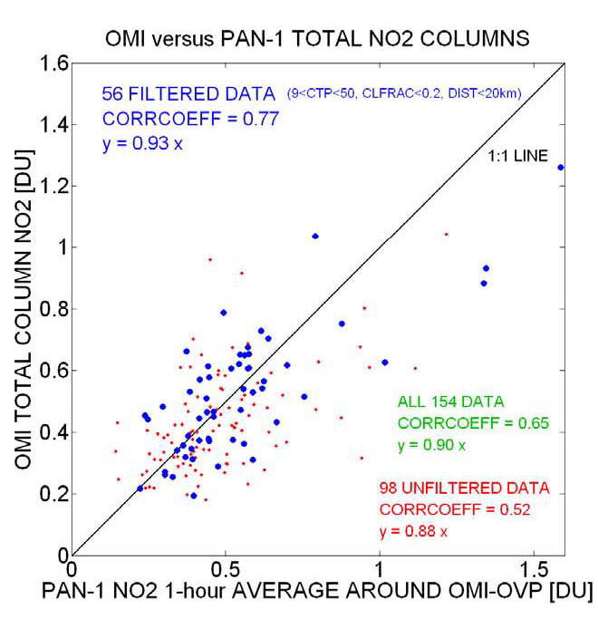
Figure 16 OMI versus PANDORA-1 total NO2 columns;
PANDORA data are cloud screened and averaged over ±30min around OMI overpass time.

A PANDORA instrument has been operating frequently for about 2 years at GSFC with breaks for field campaigns, calibration and repairs, and unfavorable weather conditions. During this time, PANDORA has obtained 154 cases of C(NO₂) data that can be compared with OMI. Of these, 56 cases are for conditions where the OMI cloud fraction was small (cloud fraction < 0.2) and where the distance of the center of the OMI pixel from the GSFC observing site was less than 20 km. For these cases (heavy blue dots in Figure 16, the linear least squares fit yielded a slope of 0.93 indicating that the OMI NO₂ column amount retrievals are more often less than observed by PANDORA. When considered as a time-ordered series, the correlation coefficient is 0.77, suggesting that there is only moderate day-to-day correlation between the points with regard to NO₂ amount. This is expected at the GSFC site where the spatial distribution of C(NO₂) is probably highly variable with distance from the NO₂ sources (nearby roads and highways). The remaining 98 cases, where the distance can be greater than 20 km and/or the cloud fraction can be greater than 0.2, have a slope of 0.88, indicating that OMI is sampling areas with much less NO₂ pollution than GSFC (e.g., areas near the Chesapeake Bay). The results indicate the importance of careful filtering of OMI pixel data for pixel location and relatively clear scenes for validation of OMI retrieved NO₂ column amounts.
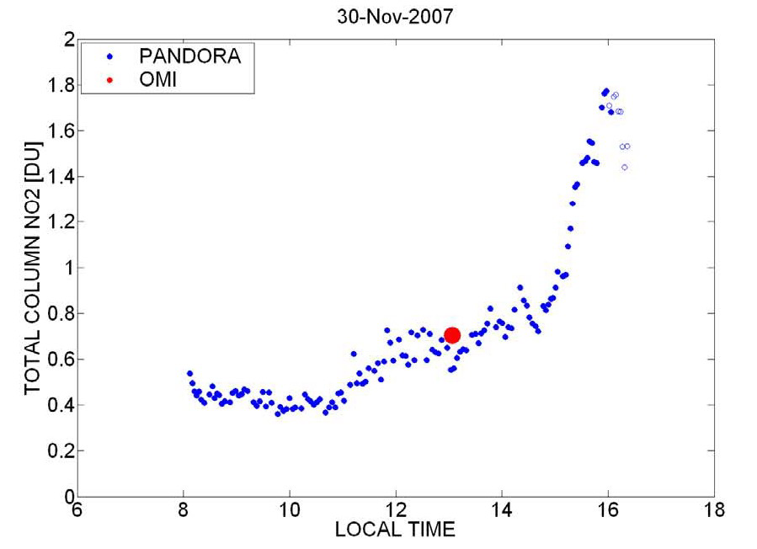 | 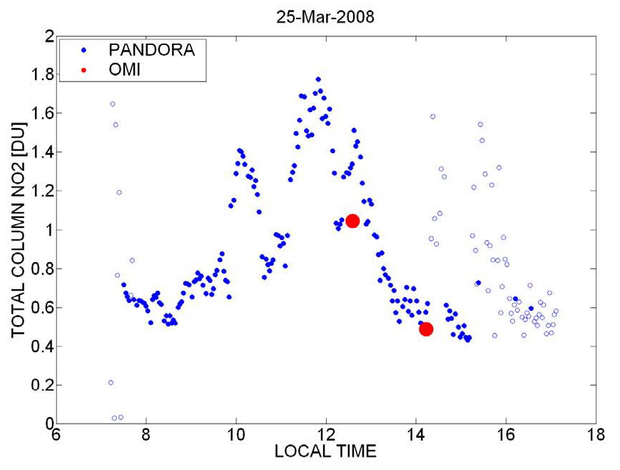 | 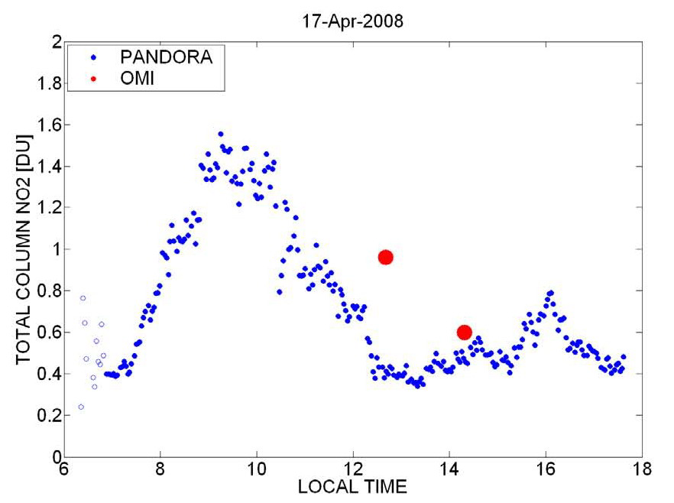
Figure 17 Three days of PANDORA NO₂ column amount data showing 5 cases OMI comparison. On 25 March 2007 and 17 April 2008 there are two cases from successive OMI orbits with different view angles. Light colored dots are when the PANDORA field of view contained clouds.

The highly variable daily time dependence of C(NO₂) is illustrated (Figure 17) for 30 November 2007, 25 March 2008, and 17 April 2008. In most cases, C(NO₂) has a small value in the morning shortly after sunrise followed by larger values later in the day. Occasionally, this is not true (see Figure 13 for Monday 21 May 2007) when the local meteorology provides very clean air. In this case, there was a coastal storm on Friday and Saturday (18th and 19th) with a cold front that cleared the area on Sunday and Monday leaving almost cloud-free sunny conditions on Monday with very low pollution levels. On 30 November 2007, the weather was clear after a cold front came through with winds in the morning allowing pollution to build up in the afternoon. As indicated by the red dot, the agreement with OMI was quite good. On 25 March 2008, the weather was calm, cool, and sunny until the afternoon when clouds appeared. This allowed pollution to build by 10:00 until noon when the weather started to change. The agreement with OMI was fair for both orbits with OMI tracking the general diurnal change. On 17 April, 2008, the weather was sunny, clear and warm with afternoon breezes. The comparison with OMI was poor on both orbits, but with OMI tracking the observed diurnal change. The 13:30 OMI pixel location was not near GSFC ( >> 20 km).

4.4 Seasonal and Day of the Week vs Local Time
(I want to try to redo figure 18 adding the OMI data in it and maybe adding two more months of data) OK
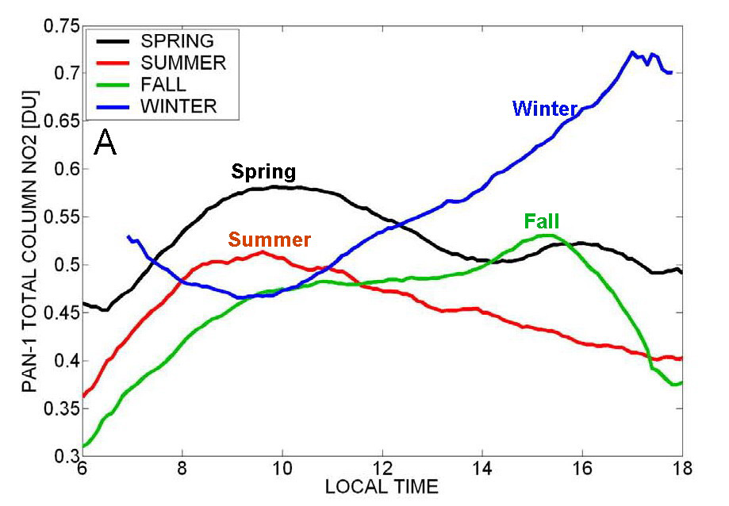 | 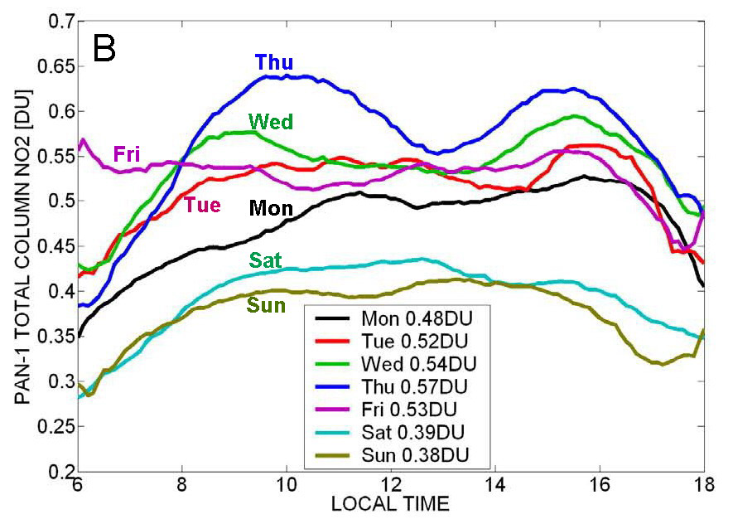
Figure 18 A. Average seasonal time dependence of C(NO₂) during the day. B. Annual average of day of the week diurnal behavior of C(NO₂) at GSFC.
Even though the day-to-day C(NO₂) has high variability, there is a general pattern with respect to seasons and with day-of-the-week as shown in Figure 18. Seasonal behavior for the Spring and Summer C(NO₂) behaviors are similar with a maximum most frequently occurring in the morning and then falling throughout the rest of the day, but with Spring C(NO₂) values significantly higher than during the Summer. The Autumn C(NO₂) increases in the morning, similarly to Spring and Summer, but continues to increase until about 15:00. The winter values decrease in the morning until about 0950, and then increase until about 1700. The day of the week behavior (Figure 18B) shows increasing pollution from Monday until it reaches a maximum on Thursday, and falls to a minimum on the weekend as would be expected from reduced traffic at a business site.

5 Summary
Total column NO₂ data are presented from two field campaigns at Thessaloniki, Greece and Greenbelt, Maryland using the small spectrometer system PANDORA, and in conjunction with MF-DOAS during the GSFC campaign. Field calibration is illustrated using data from a third campaign conducted for PANDORA and MF-DOAS at a normally clean site (TMF Table Mountain, California) where the slant columns measured each day were distinct from one another (Figure 7). A similar field calibration is presented for the polluted site at GSFC showing that field calibration is effective under most conditions if the campaign is of sufficient length. C(NO₂) retrievals from two independent ground-based spectrometer systems (PANDORA and MF-DOAS from Goddard Space Flight Center and Washington State University, respectively) that looked directly at the Sun were in close agreement. Both instruments were shown to have a precision of 0.01 DU and an accuracy of 0.1 DU based on a combination of laboratory and field calibration methods. The 0.01 DU precision is sufficient to track minute-by minute changes in column NO₂ throughout each day with typical values ranging from 0.2 to 3 DU in polluted sites (GSFC and Aristotle University). This study suggests the desirability of using MF-DOAS as a reference standard for the smaller portable PANDORA series of instruments that can be located at multiple sites to study local pollution conditions and for validation of satellite data under a wide variety of conditions. Results from the extended PANDORA data record (2 years) at GSFC were presented to show the average seasonal behavior of C(NO₂) and the behavior as a function of the day of the week. The successful intercomparison of PANDORA and MF-DOAS suggests that the DS-DOAS technique can be used for validation of satellite (e.g., OMI) retrievals of C(NO₂). Comparisons with OMI show that the agreement is good when the OMI field of view is closely coincident with the location of the ground-based instrument. At polluted sites, the large field of view of OMI (12 x 24 km²) usually measures less than PANDORA, since it is the average of clean and polluted regions. The reverse can be the case if PANDORA is located at a very clean site. The conclusion is that DS-DOAS ground-based measurements of C(NO₂) are useful for satellite validation and for measuring the minute-by-minute daily C(NO₂) variation with high precision.

Acknowledgements: The authors would like to acknowledge the organizers of the Scout-3 (Aristotle University in Thessaloniki, Greece) and Table Mountain Facility (JPL in California, USA) campaigns for their assistance and use of their facilities. The WSU instrument and field activities were supported by a grant from NASA to Washington State University.(If we do not include Jim Gleason as a co-author, we should definitely acknowledge the Omi team here)

6 References
Barnaba F., and Gobbi G.P., 2004, Aerosol seasonal variability over the Mediterranean region and relative impact of maritime, continental and Saharan dust particles over the 4: 2367-2391.
Boersma, K. F., H. J. Eskes, and E. J. Brinksma , 2004, Error analysis for tropospheric NO₂ retrieval from space, J. Geophys. Res., 109, D04311, doi:10.1029/2003JD003962.)
Brasseur, G.P., D.A. Hauglustaine, S. Walters, P.J. Rasch, J.F. Muller, C. Granier, X.X. Tie, MOZART, a global chemical transport model for ozone and related chemical tracers 1: Model description, J. Geophys. Res., 103, 28,265–28,289, 1998.
Brewer, A. W., C. T. McElroy, and J. B. Kerr, Nitrogen dioxide concentrations in the atmosphere, Nature, 246(5429), 129–133, 1973
Cede, Alexander, Jay Herman, Andreas Richter, Nickolay Krotkov and John Burrows, Measurements of Nitrogen Dioxide Total Column Amounts at Goddard Space Flight Center Using a Brewer Spectrometer in Direct Sun Mode, accepted, Journal Of Geophysical Research, Vol. 111, D05304, doi:10.1029/2005JD006585, 2006.
Crutzen, P. J., The role of NO and NO₂ in the chemistry of the troposphere and stratosphere, Ann. Rev. Earth Planet. Sci., 7, 443–472, 1979
Environmental Protection Agency, National air quality and emissions trends report 1997, Research Triangle Park, N. C, 1998
Heue, K.-P., A. Richter, T. Wagner, M. Bruns, J. P. Burrows, C. von Friedeburg, W. D. Lee, U. Platt, I. Pundt, and P. Wang, Validation of SCIAMACHY tropospheric NO₂-columns with AMAXDOAS measurements, Atmos. Chem. Phys., 5, 1039– 1051, 2005.
Intergovernmental Panel on Climate Change (IPCC), Summary for policy makers, in Climate Change 2001: The Scientific Basis, edited by J. T. Houghton et al., 8 pp., Cambridge Univ. Press, New York, 2001.
Jaegle, L., Jacob, D. J., Wang, Y., Weinheimer, A. J., Ridley, B. A., Campos, T. L., Sachse, G. W., and Hagen, D. E., Sources and chemistry of NOx in the upper troposphere over the United States, Geophys. Res. Lett., 25, 1705–1708, 1998.
Lee, D. S., I. Kohler, E. Grobler, F. Rohrer, R. Sausen, L. Gallardo-Klenner, J. G. J. Olivier, F. J. Dentener, and A. F. Bouwman, Estimations of global NOx emissions and their uncertainties, Atmos. Environ., 31, 1735–1749, 1997.
Leigh, R.J., G.K. Corlett, U. Friess, and P.S. Momks, Concurrent multiaxis differential optical absorption spectroscopy system for the measurement of tropospheric nitrogen dioxide, Applied Optics, 45, 7504-7518, 2006.
Leser, H., G. Ho¨nninger, and U. Platt, MAX-DOAS measurements of BrO and NO₂ in the marine boundary layer, Geophys. Res. Lett., 30(10), 1537, doi:10.1029/2002GL015811, 2003.
Leue, C., M. Wenig, T. Wagner, O. Klimm, U. Platt, and B. Jahne , Quantitative analysis of NOx emissions from Global Ozone Monitoring Experiment satellite image sequences, J. Geophys. Res., 106(D6), 5493– 5505, 2001.
Liley, J. B., P. V. Johnston, R. L. McKenzie, A. J. Thomas, and I. S. Boyd, 2000, Stratospheric NO₂ variations from a long time series at Lauder, New Zealand, J. Geophys. Res., 105(D9), 11,633–11,640, 2000.
Logan, J. A.; Prather, M. J.; Wofsy, S. C.; McElroy, M. B., Tropospheric chemistry - A global perspective, Journal of Geophysical Research, 86, 7210-7254, 1981.
Logan J.A., Nitrogen oxides in the troposphere: global and regional budgets, J. Geophys. Res., 88, 10,785-10,807, 1983.
Nikolaou K, 2002, Fresenius Environmental Bulletin 11 (8): 426-431 Special Issue
Papayannis A, Balis D, Amiridis V, Chourdakis G, Tsaknakis G, Zerefos C, Castanho ADA, Nickovic S, Kazadzis S, and Grabowski J, Measurements of Saharan dust aerosols over the Eastern Mediterranean using elastic backscatter-Raman lidar, spectrophotometric and satellite observations in the frame of the EARLINET project, Atmospheric Chemistry and Physics 5: 2065-2079, 2005.
Platt, U., Differential Optical Absorption Spectroscopy (DOAS), in Air Monitoring by Spectroscopic Techniques, Chem. Anal., vol. 127, edited by M. W. Sigrist, pp. 27–84, John Wiley, Hoboken, N. J., 1994.
Preston KE, Jones RL, Roscoe HK. Retrieval of NO₂ vertical pro)les from ground-based UV Visible measurements—method and validation. J Geophys Res., 102:19089–19097, 1997
Richter, A., V. Eyring, J. P. Burrows, H. Bovensmann, A. Lauer, B. Sierk, and P. J. Crutzen, 2004, Satellite measurements of NO₂ from international shipping emissions, Geophys. Res. Lett., 31, L23110, doi:10.1029/2004GL020822, 2004.
Rodgers CD. Inverse methods for atmospheric sounding, theory and practice. In: Taylor FW, editors. Series on Atmospheric, Oceanic and Planetary Physics, Singapore: World Scienti)c; 2000.
Schmid, Beat, Joseph J. Michalsky, Donald W. Slater, James C. Barnard, Rangasayi N. Halthore, James C. Liljegren, Brent N. Holben, Thomas F. Eck, John M. Livingston, Philip B. Russell, Thomas Ingold, and Ilya Slutsker, Comparison of columnar water-vapor measurements from solar transmittance methods, APPLIED OPTICS, 40, 1886-1896, 2001
Schofield R., Connor B.J., Kreher K., Johnston P.V., Rodgers C.D., 2004, The retrieval of profile and chemical information from ground-based UV-visible spectroscopic measurements, Journal of quantitative spectroscopy and radiative transfer, 86 (2): 115-131, 2004.
Seinfeld, J. H. and Pandis, S. N., 1998, Atmospheric chemistry and physics – from air pollution to climate change, John Wiley & Sons, New York, 1998.
Solomon, S., R. W. Portmann, R. W. Sanders, J. S. Daniel, W. Madsen, B. Bartram, and E. G. Dutton, On the role of nitrogen dioxide in the absorption of solar radiation, J. Geophys. Res., 104(D10), 12,047– 12,058, 1999.
Van Roozendael, M., M. de Maziere, C. Hermans, P. C. Simon, J. P. Pommereau, F. Goutail, X. X. Tie, G. Brasseur, and C. Granier, 1997, Ground-based observations of stratospheric NO₂ at high and midlatitudes in Europe after the Mount Pinatubo eruption, J. Geophys. Res., 102(D15), 19,171– 19,176, 1997.
Vandaele, A.C., C. Hermans, P.C.Simon, M. Carleer, R. Colin, S. Fally, M.F. Mérienne, A. Jenouvrier, and B. Coquart (1998), Measurements of the NO₂ absorption cross-section from 42 000 cm–1 to 10 000 cm–1 (238-1000 nm) at 220 K and 294 K, J. Quant. Spectrosc. Radiat. Transfer, 59 (3-5), 171-184, 1998.
Velders, G. J. M., C. Grainer, R. W. Portmann, K. Pfeilsticker, M. Weing, T. Wagner, U. Platt, A. Richter, and J. P. Burrows, w2`dc bzn Global tropospheric NO₂ column distributions: Comparing three-dimensional model calculations with GOME measurements, J. Geophys. Res., 106(D12), 2001.
Warneck, P., 2000, Chemistry of the natural atmosphere, second edition, Academic Press, London, 2000.
Wenig, M., N. Spichtinger, A. Stohl, G. Held, S. Beirle, T. Wagner, B. Jahne, and U. Platt, 2003, Intercontinental transport of nitrogen oxide pollution plumes, Atmos. Chem. Phys., 3, 387–393.
Ziauddin, Ahmaad, Charles R. McClain, Jay R. Herman, Bryan A. Franz, Ewa J. Kwiatkowska, Wayne D. Robinson, Eric J. Bucsela, and Maria Tzortziou, Atmospheric Correction For NO₂ Absorption In Retrieving Water-Leaving Reflectances From The Seawifs And MODIS Measurements, J. Applied Optics, 2007.
Zerefos, C., K. Ganev, K. Kourtidis, M. Tzortziou, A. Vasaras, and E. Syrakov, On the origin of SO2 above Northern Greece, Geophys. Res. Lett., 27, 365–368, 2000.

